Source ID | Source Title | URL
967010938 | Journal of Iron and Steel Research | http://www.chinamet.cn/Jweb_gtyjxb_cn/EN/current
Both Chinese and English TOC should be added.
- Go to the URL and capture the metadata as shown below.
Source title
ISSN

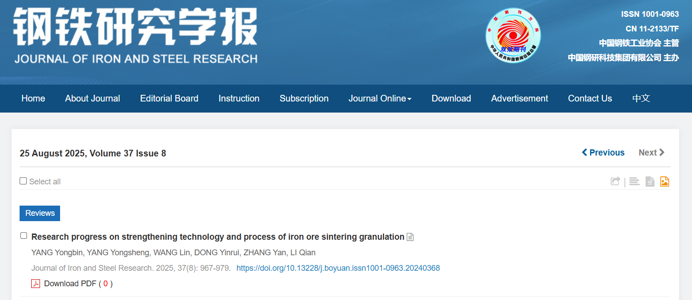
Page range
DOI
Article type
Issue
Volume
Article title
Year
Month
Day
Click to download the pdf

2.Click the article title to capture the abstract

Note: PDFs are not yet released in the latest issue for download.

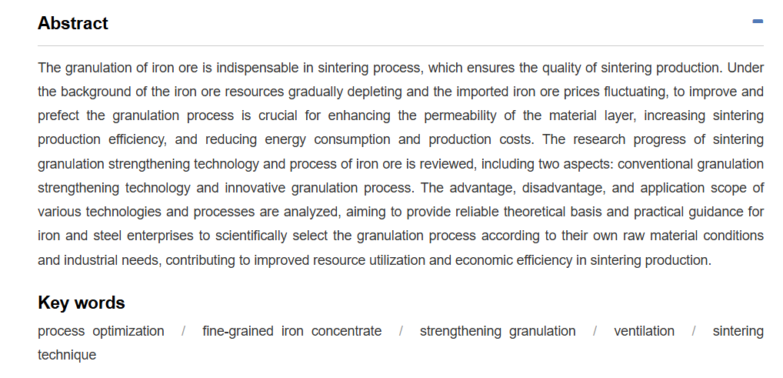
Abstract

