Source ID | Source Title | URL
951089112 | Permskij Medicinskij Zurnal | https://permmedjournal.ru/PMJ/issue/archive

1.Go to the URL and select the latest issue.
Both Russian and English TOC should be captured
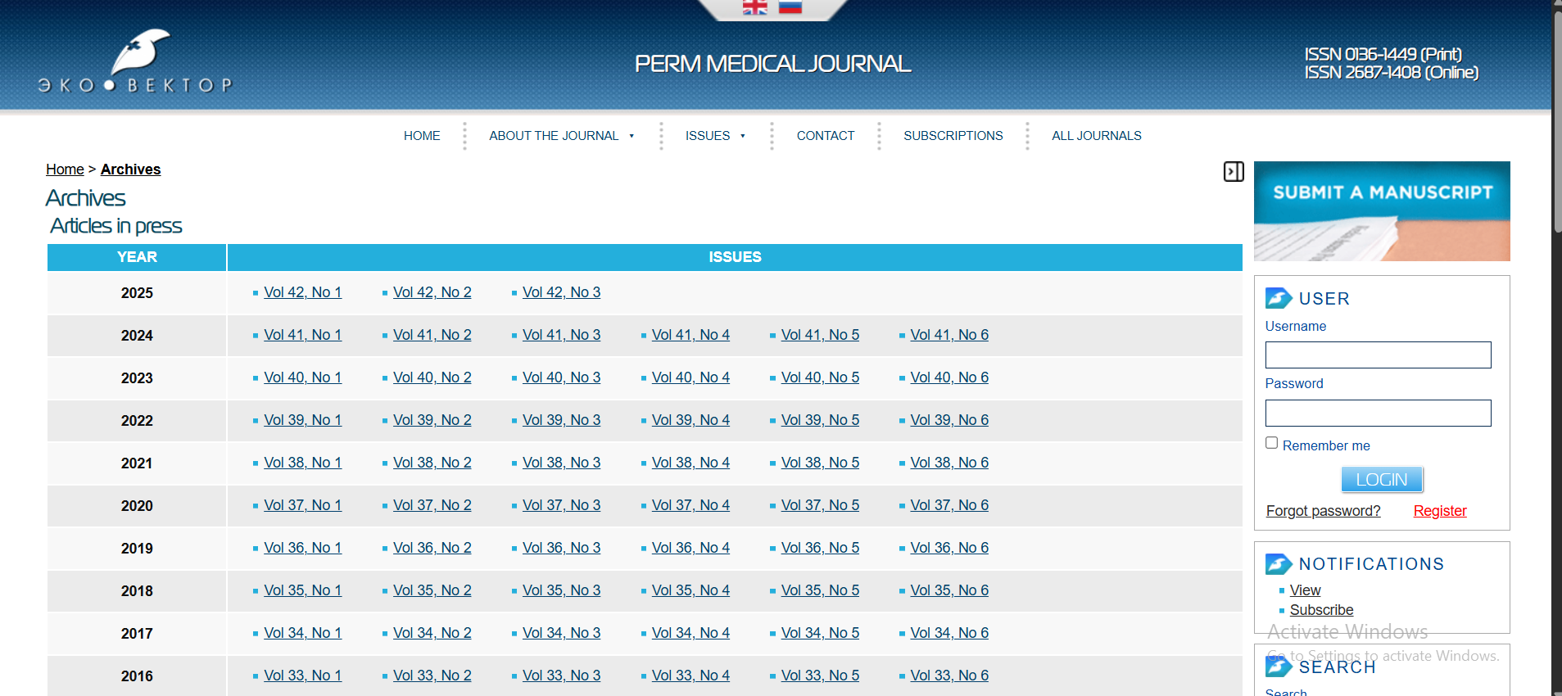
ISSN
Source Title
Current issue
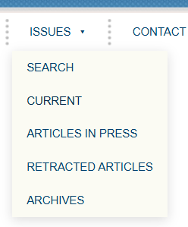

2. Capture the metadata as shown below.
Issue
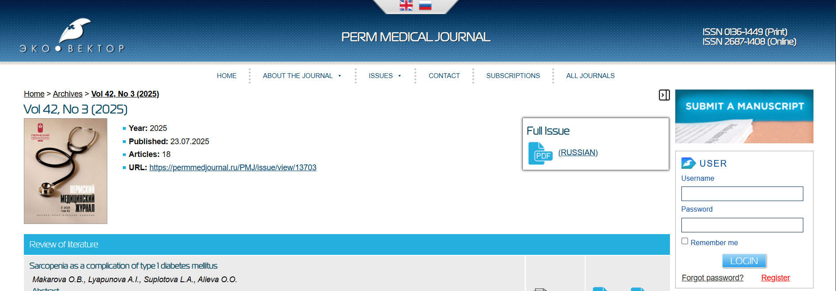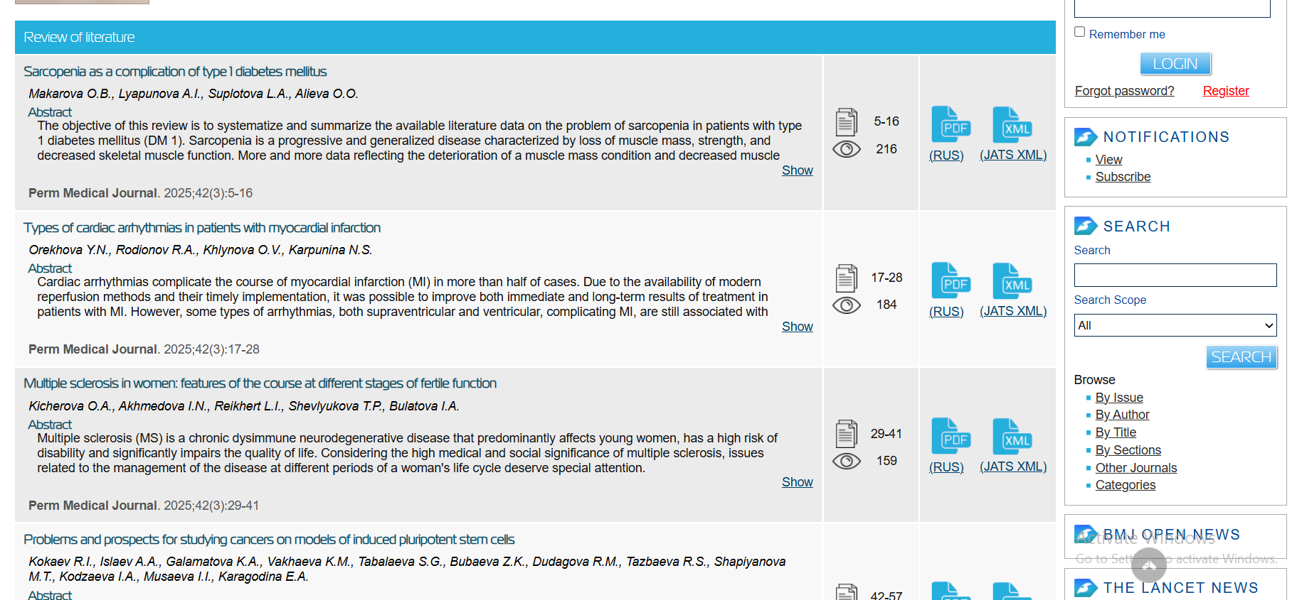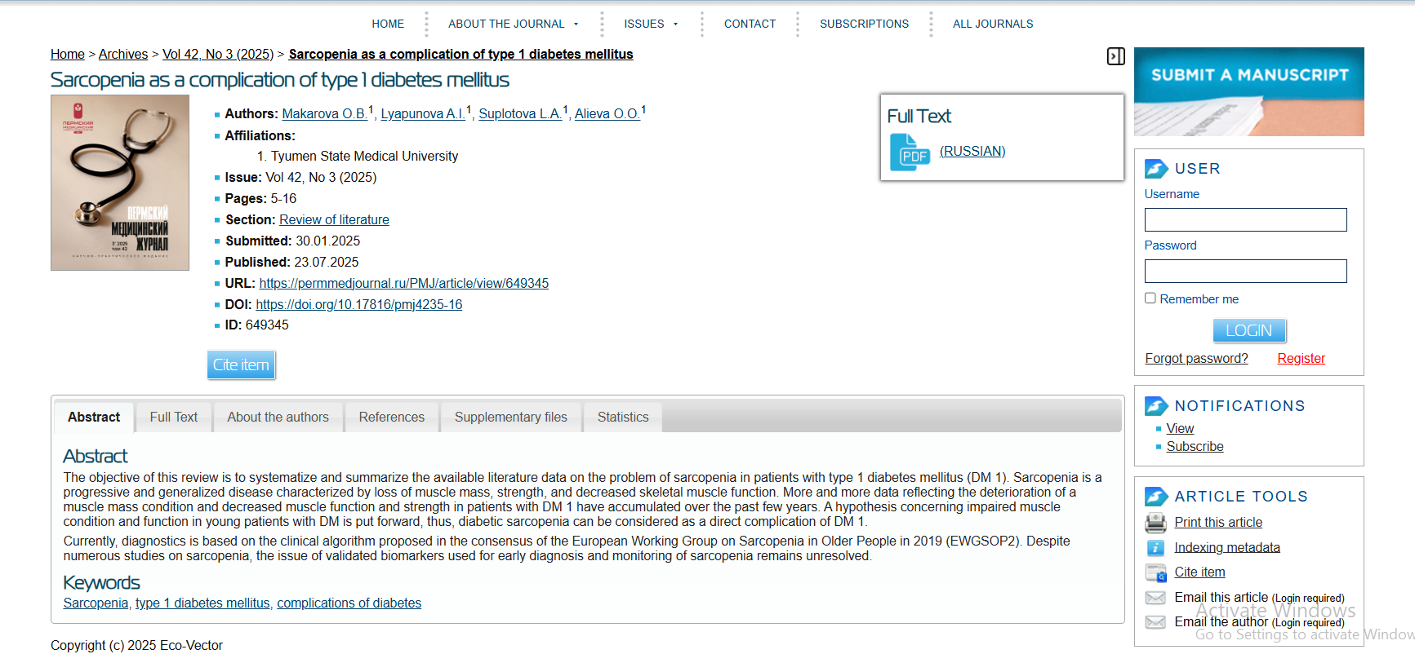
Year
volume
Page Range
Article Type
Doi
Click to download the PDF
Article Tittle

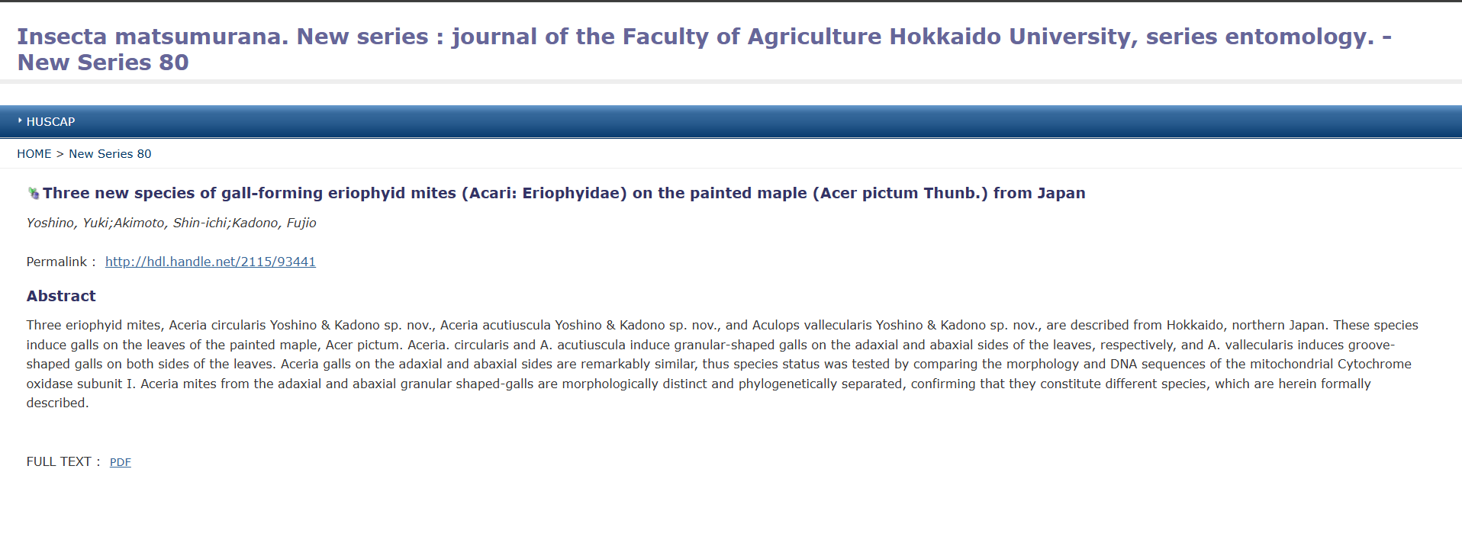
Abstract

