**Sharof Rashidov nomidagi Samarqand davlat universiteti matematika fakulteti 4-03-guruh talabasi Esanov Otabekning Matematik modellashtirish fanidan**

**Mustaqil ishi**

**Mavzu: Impulsning saqlanish qonuni asosida matematik modellar tuzish**

**O’qituvchi:** *Mahmudov Jamol*

**Tayyorladi:** *Esanov Otabek*

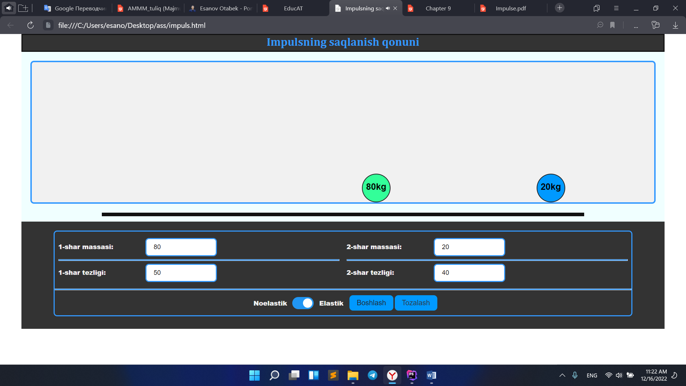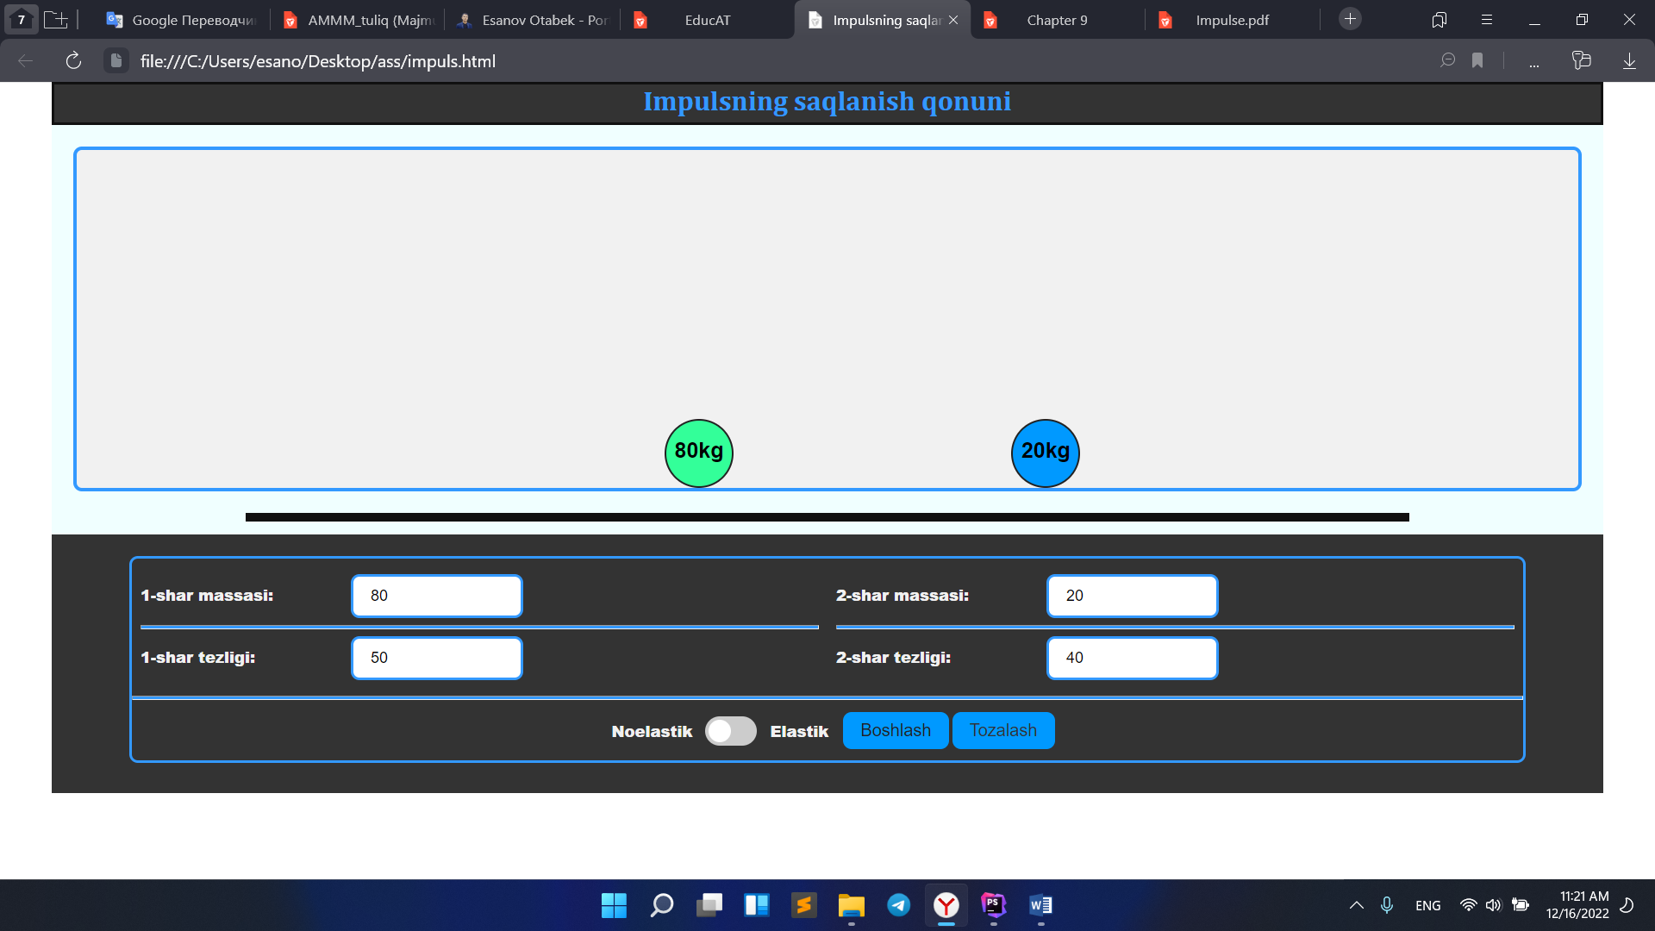

**JavaScript kodi**

function writer(n) {  
 var massa =Number(***document***.getElementById('massa_'+n).value);  
 ***document***.getElementById("m_"+n).innerText = massa + "kg";  
}  
  
var ***id***=null;  
function start(){  
 var circle_1 = ***document***.getElementById('circle_1');  
 var circle_2 = ***document***.getElementById('circle_2');  
 circle_1.style.left = "200px";  
 circle_2.style.right = "1470px";  
  
 clearInterval(***id***);  
  
  
 var massa_1 = Number(***document***.getElementById('massa_1').value);  
 var massa_2 = Number(***document***.getElementById('massa_2').value);  
 var speed_1 = Number(***document***.getElementById('speed_1').value);  
 var speed_2 = -Number(***document***.getElementById('speed_2').value);  
 var checked = ***document***.getElementById('isElastik').checked;  
  
 var start1_pos = 200;  
 var start2_pos = 1470;  
  
 var impuls = massa_1 * speed_1 + massa_2 * speed_2;  
 var speed=0;  
 var speed0=0;  
  
 if(!checked){  
 speed = impuls/(massa_1 + massa_2);  
 speed0 = speed;  
 }  
 else{  
 speed = (impuls - massa_2 * (speed_1 - speed_2)) / (massa_1 + massa_2);  
 speed0 = speed + (speed_1 - speed_2);  
 }  
 var xs = false;  
 ***id*** = setInterval(function () {  
 // console.log(start1_pos+80);  
 // console.log(start2_pos);  
 start1_pos += speed_1/100;  
 start2_pos += speed_2/100;  
 start1_pos = ***Math***.round(start1_pos*100)/100;  
 start2_pos = ***Math***.round(start2_pos*100)/100;  
  
 circle_1.style.left = start1_pos + "px";  
 circle_2.style.left = start2_pos + "px";  
 if (!xs && ***Math***.abs(***Math***.round(start1_pos)+80 - ***Math***.round(start2_pos))<=1){  
 xs = true;  
 taskSolvedCongratulations()  
  
 speed_1 = speed;  
 speed_2 = speed0;  
 }  
  
 if (start2_pos+80 > 1750 || start1_pos <= 0){  
 clearInterval(***id***);  
 }  
 },1);  
  
 if (start2_pos >= 1700){  
 speed_2 = 0;  
 }  
 if(start1_pos <= 0){  
 speed_1 = 0;  
 }  
}  
  
function stop(){  
 clearInterval(***id***);  
 var circle_1 = ***document***.getElementById('circle_1');  
 var circle_2 = ***document***.getElementById('circle_2');  
 circle_1.style.left = "200px";  
 circle_2.style.left = "1470px";  
}  
  
  
function taskSolvedCongratulations() {  
 const duration = 800;  
 const animationEnd = Date.now() + duration;  
 const defaults = {startVelocity: 30, spread: 360, ticks: 60, zIndex: 0};  
  
 function randomInRange(min, max) {  
 return ***Math***.random() * (max - min) + min;  
 }  
  
 const interval = setInterval(function () {  
 const timeLeft = animationEnd - Date.now();  
  
 if (timeLeft <= 0) {  
 return clearInterval(interval);  
 }  
  
 const particleCount = 50 * (timeLeft / duration);  
 // since particles fall down, start a bit higher than random  
  
 confetti(***Object***.assign({}, defaults, {  
 particleCount,  
 origin: {x: randomInRange(0.1, 0.3), y: ***Math***.random() - 0.2}  
 }));  
  
 confetti(***Object***.assign({}, defaults, {  
 particleCount,  
 origin: {x: randomInRange(0.7, 0.9), y: ***Math***.random() - 0.2}  
 }));  
  
 confetti(***Object***.assign({}, defaults, {  
 particleCount,  
 origin: {x: randomInRange(0.5, 0.7), y: ***Math***.random() - 0.2}  
 }));  
 }, 250);  
  
 let audio = ***document***.getElementById('congratulationsSound')  
  
 if (audio.paused) {  
 audio.play();  
 }else{  
 audio.currentTime = 0  
 }  
}

***HTML KODI***

<!DOCTYPE html>  
<html lang="en">  
<head>  
 <meta charset="UTF-8">  
 <title>Impulsning saqlanish qonuni</title>  
 <meta name="viewport" content="width=device-width, initial-scale=1.0">  
 <link rel="stylesheet" href="style.css">  
</head>  
<body>  
  
<div class="content">  
 <div class="head">  
 <h2 class="title">Impulsning saqlanish qonuni</h2>  
  
 </div>  
  
 <div class="body">  
 <div class="border">  
 <div id="circle_1" class="circle">  
 <p id="m_1">0</p>  
 </div>  
  
 <div id="circle_2" class="circle">  
 <p id="m_2">0</p>  
 </div>  
 </div>  
 <div class="line"></div>  
 </div>  
  
 <div class="foot">  
 <div class="row">  
 <div class="col">  
 <label for="massa_1">1-shar massasi: </label>  
 <input type="number" id="massa_1" placeholder="M1" min="0" max="100" onkeyup="writer(1)">  
  
 <hr>  
  
 <label for="speed_1">1-shar tezligi: </label>  
 <input type="number" id="speed_1" placeholder="V1">  
  
 </div>  
  
 <div class="col">  
 <label for="massa_2">2-shar massasi: </label>  
 <input type="number" id="massa_2" placeholder="M2" min="0" max="100" onkeyup="writer(2)">  
  
 <hr>  
  
 <label for="speed_2">2-shar tezligi: </label>  
 <input type="number" id="speed_2" placeholder="V2">  
  
 </div>  
 <hr>  
 <div class="btn_center">  
 <p class="ass">Noelastik</p>  
 <label class="switch" >  
 <input type="checkbox" id="isElastik">  
 <span class="slider round"></span>  
 </label>  
 <p class="ass">Elastik</p>  
 <button class="btn_ok" onClick="start()">Boshlash</button>  
 <button class="btn_ok" onclick="stop()">Tozalash</button>  
 </div>  
  
 </div>  
 </div>  
</div>  
  
<script src="https://cdn.jsdelivr.net/npm/canvas-confetti@1.4.0/dist/confetti.browser.min.js"></script>  
<audio src="https://robocontest.uz/assets/sounds/fireworks.mp3" id="congratulationsSound"></audio>  
<script src="app.js"></script>  
  
</body>  
</html>