HTTP Request and Response – codeforces.com

Website: <https://www.codeforces.com>

Explanation:

1. The general section shows a summary of the HTTP request and response details. It includes:

Request URL: The full address of the resource being requested.

Request Method: The type of HTTP method used (like GET or POST). The GET method is an HTTP request method used to retrieve data from a server.

Status Code: The server’s response code (e.g., 200 OK, 404 NOT FOUND). 200 OK is a standard success status code in HTTP.

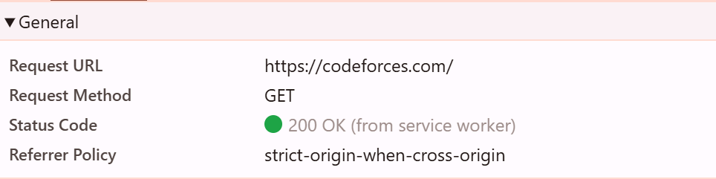

2.Request headers help the server:

Optimize content (based on device, browser, or platform).

Log useful analytics.

| **Header** | **Description** |
| --- | --- |
| **sec-ch-ua** | A **Client Hint** header indicating the browser and its version. Helps servers optimize responses based on browser type.  **Example**: "Chromium";v="136", "Google Chrome";v="136" |
| **sec-ch-ua-mobile** | Indicates if the client is a **mobile device**.  **Value**: ?0 means it is **not** a mobile device. |
| **sec-ch-ua-platform** | Shows the **operating system** the browser is running on.  **Value**: "Windows" |

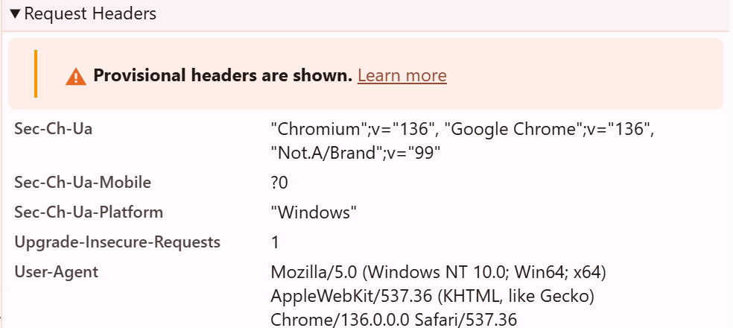

3.Response headers help the browser:

Handle content properly (type, compression)

Manage caching

| Header | Description |
| --- | --- |
| **alt-svc** | Tells the browser that the server supports **HTTP/3** on port 443, and to cache this info for 1 day (ma=86400). |
| **cache-control** | Controls caching behavior. Here, it says: **don’t cache** the content (no-store, no-cache, etc.). |
| **content-encoding**: br | The content is compressed using **Brotli** encoding for faster loading. |
| **content-type**: text/html;charset=UTF-8 | The response is an **HTML page** using UTF-8 character encoding. |
| **date** | The date and time the response was sent (in GMT). |

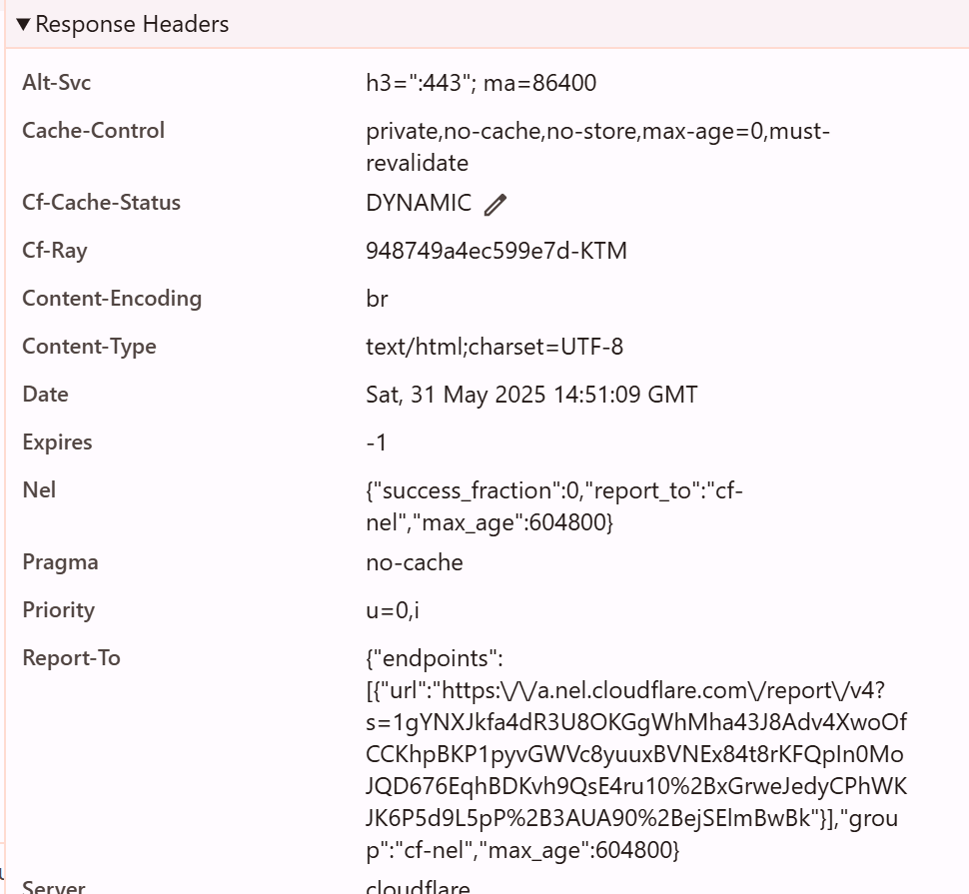

1. Response Section contains:

The HTML source code of the main page (containing the site’s structure, links, text, etc.

Embedded scripts or references to other resources (JS, CSS)

This is the body/content of the HTTP response — what your browser renders or uses

