RoboFusion Techathon 2026

Round 1 Submission

Smart Campus Safety & Response Grid

An IoT-Based Multi-Sensor Risk Assessment and Emergency Response System

Team Name
GenZ Ignite

Team Members
Mst. Esat Jahan Akhi
Md. Muniruzzaman Bony

University
University of Frontier Technology,Bangladesh

Submission
System Documentation

July 2026

Executive Summary
The Smart Campus Safety & Response Grid is an IoT-based safety monitoring system designed to detect environmental hazards and provide real-time risk assessment.

The system collects sensor data from an ESP32-based zone node (simulated using Wokwi), securely transmits the readings to a FastAPI backend through REST APIs, stores the information in PostgreSQL, evaluates the situation using a weighted Risk Fusion Engine, and displays the results on a React dashboard.

The Risk Fusion Engine converts each sensor value into a normalized risk score, applies weighted fusion, and executes emergency override rules for critical conditions such as flame detection, combined smoke and gas emergencies, and severe flooding.

The developed prototype successfully demonstrates end-to-end communication from the IoT sensing layer to the visualization dashboard, providing a scalable architecture for future smart campus deployments.

Problem Statement
Educational institutions require continuous monitoring of environmental conditions to ensure student and staff safety.

Traditional monitoring approaches are largely manual and often fail to provide timely warnings for emergencies such as fire, gas leakage, flooding, abnormal vibration, or overcrowding.

The absence of centralized monitoring and intelligent risk assessment may delay emergency response and increase potential damage.

An integrated IoT platform capable of continuously collecting sensor data, evaluating risk, and presenting real-time information is therefore required.

Proposed Solution
The proposed Smart Campus Safety & Response Grid integrates IoT sensing, backend processing, database storage, and web visualization into a unified platform.

Environmental sensor readings are generated using an ESP32 node simulated in Wokwi. These readings are transmitted through HTTPS REST APIs to a FastAPI backend.

The backend stores sensor data in PostgreSQL and evaluates the overall safety condition using a weighted Risk Fusion Engine.

Finally, the processed information is presented through a React dashboard that provides real-time visualization of sensor values, calculated risk scores, and historical records.

The modular architecture allows easy migration from simulation to physical ESP32 hardware.

System Architecture
ESP32 (Wokwi Simulation)
│
▼
HTTPS REST API
│
▼
FastAPI Backend
│
▼
PostgreSQL Database
│
▼
Risk Fusion Engine
│
▼
React Dashboard

Circuit & Sensors
The Zone Node is implemented using an ESP32 microcontroller simulated in Wokwi.

The node collects environmental information from multiple virtual sensors representing temperature, humidity, smoke, gas, water level, vibration, flame, occupancy, and battery voltage.

After collecting the measurements, the ESP32 transmits the sensor readings to the backend through HTTPS POST requests.

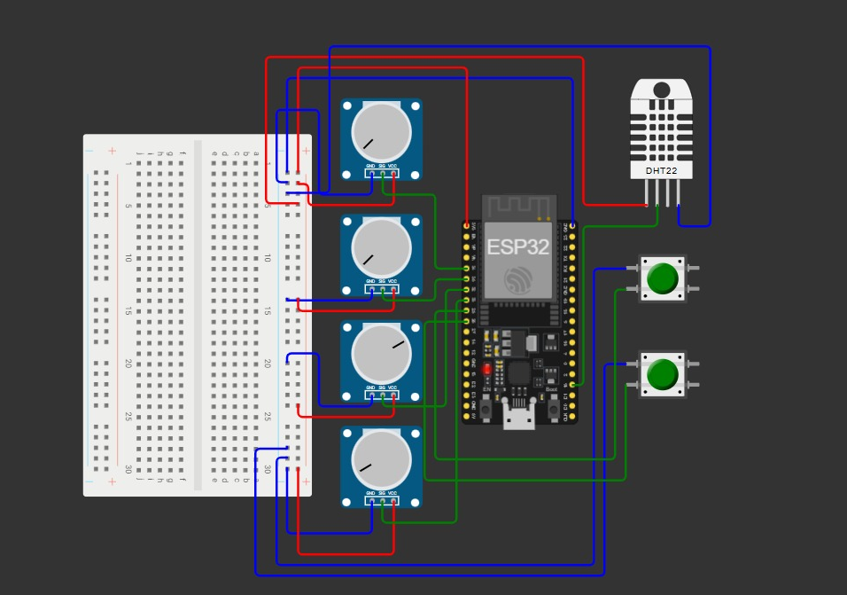
Figure 1: Wokwi Circuit

Backend Architecture
The backend is developed using FastAPI.

The backend performs request validation, stores sensor readings in PostgreSQL, executes the Risk Fusion Engine, generates risk assessments, and exposes REST APIs for frontend visualization.

The modular backend consists of routers, services, database models, schemas, and utility components.

Database
PostgreSQL is used as the primary database.

The database stores sensor readings, generated risk assessments, and zone information.

SQLAlchemy ORM is used to simplify database interaction while reducing SQL injection risks.

The database design allows efficient retrieval of historical sensor records for visualization and analysis.
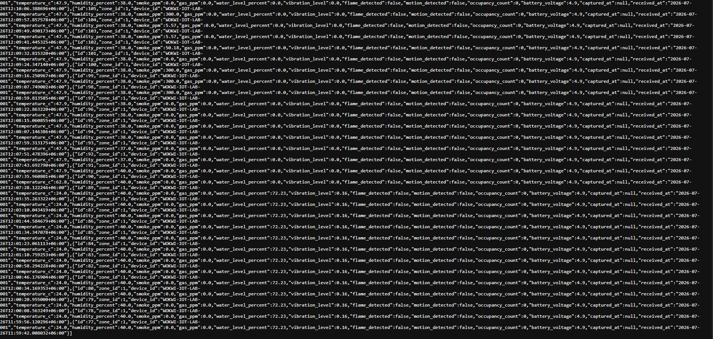
Figure2:Database Record

REST APIs
The backend exposes REST APIs for receiving sensor readings and retrieving calculated risk assessments.

Implemented APIs include:

• /api/v1/zones
• /api/v1/sensor-readings
• /api/v1/risk/preview
• /api/v1/risk-assessments
• /api/v1/zones/{id}/risk-assessments
• /api/v1/zones/{id}/latest-risk

FastAPI automatically generates interactive Swagger documentation for testing and verification.

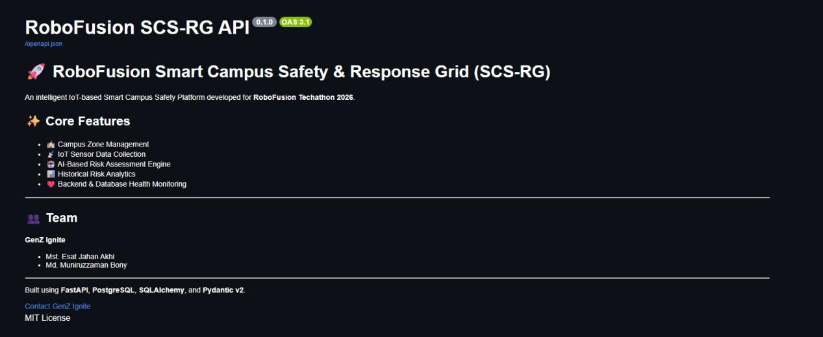
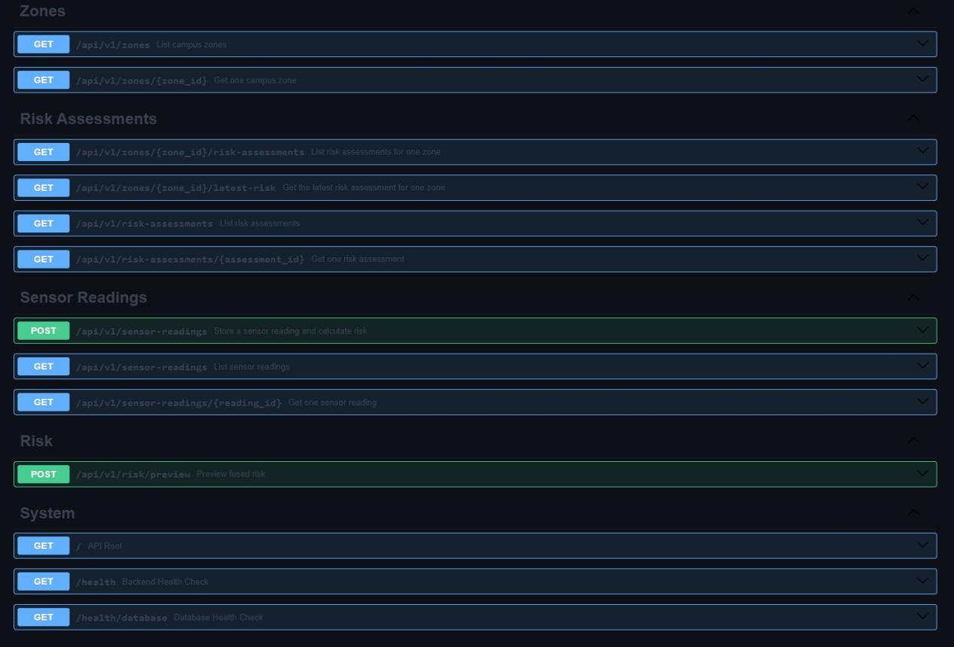
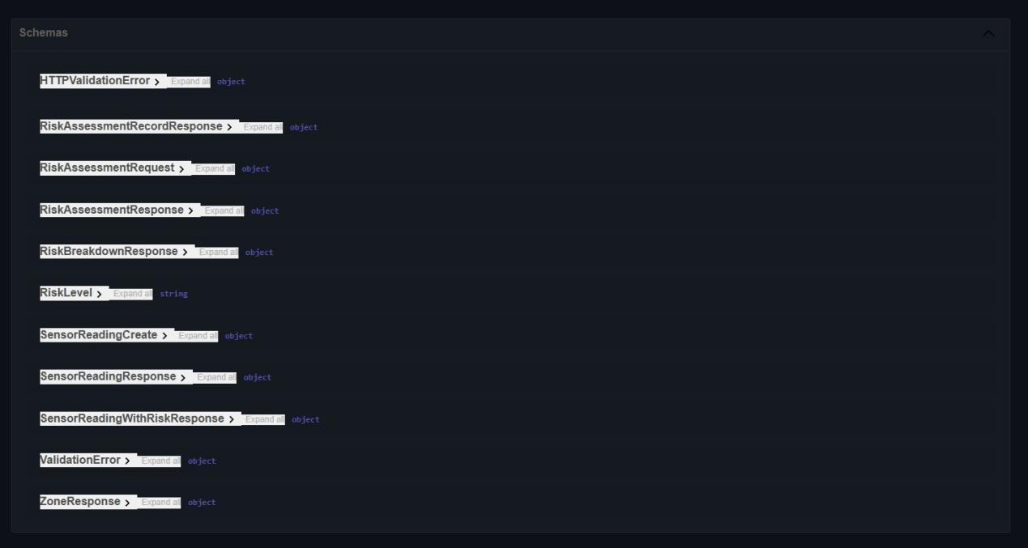
Figure2:Swagger_api

Risk Fusion Engine
The Risk Fusion Engine is responsible for evaluating the overall safety condition of a monitored zone. It converts each sensor reading into a normalized risk value ranging from 0 to 100, applies predefined weights to each sensor category, and calculates a single weighted risk score. Finally, emergency override rules are evaluated to ensure that critical hazards are never underestimated.
Sensor Thresholds
Each sensor has a predefined Safe Limit and Critical Limit. Sensor readings are normalized into a risk value between 0 and 100 based on these thresholds.
Sensor | Safe Limit | Critical Limit | Risk Direction
Temperature | 30 °C | 60 °C | Increasing
Humidity | 70 % | 100 % | Increasing
Smoke | 30 ppm | 300 ppm | Increasing
Gas | 50 ppm | 500 ppm | Increasing
Water Level | 10 % | 100 % | Increasing
Vibration | 0.2 | 3.0 | Increasing
Flame | Not Detected | Detected | Binary
Occupancy | 20 Persons | 100 Persons | Increasing
Battery Voltage | 4.5 V | 3.3 V | Decreasing
For the flame sensor, the risk is assigned directly:
- Flame Detected → Risk Score = 100
- Flame Not Detected → Risk Score = 0
Risk Weights
After normalization, every sensor contributes to the final risk score according to the following weights.
Risk Category | Weight | Contribution
Temperature | 0.15 | 15 %
Humidity | 0.05 | 5 %
Smoke | 0.18 | 18 %
Gas | 0.17 | 17 %
Water | 0.12 | 12 %
Vibration | 0.10 | 10 %
Flame | 0.13 | 13 %
Occupancy | 0.05 | 5 %
Battery | 0.05 | 5 %
Total | 1.00 | 100 %
The higher weights assigned to Smoke and Gas reflect their importance in identifying fire and toxic gas emergencies.
Weighted Risk Calculation
The weighted base risk score is calculated using the following equation:
$$R_{base}=0.15R_{temperature}+0.05R_{humidity}+0.18R_{smoke}+0.17R_{gas}+0.12R_{water}+0.10R_{vibration}+0.13R_{flame}+0.05R_{occupancy}+0.05R_{battery}$$

Since all weights sum to 1.00, the weighted score remains within the range of 0–100 before emergency override rules are applied.
Emergency Override Rules
Although the weighted score provides the overall safety condition, several emergency situations require immediate action. Therefore, three emergency override rules are implemented.

Override Rule 1 – Flame Emergency
If the flame sensor detects fire, the final risk score is immediately increased to at least 90, regardless of the weighted score.
Condition
- Flame Detected = True
Action
Final Score = max(Weighted Score, 90)
Reason Generated
- Flame sensor triggered.

Override Rule 2 – Combined Smoke and Gas Emergency
When both smoke and gas risks reach extremely high levels, the system assumes a possible fire or toxic gas emergency.
Conditions
- Smoke Risk ≥ 80
- Gas Risk ≥ 80
Action
Final Score = max(Weighted Score, 85)
Reason Generated
- Combined smoke and gas emergency condition detected.

Override Rule 3 – Severe Flooding
When the normalized water-level risk reaches 90 or higher, the system classifies the situation as a severe flooding event.
Condition
- Water Risk ≥ 90
Action
Final Score = max(Weighted Score, 80)
Reason Generated
- Severe flooding condition detected.
Final Risk Score
After evaluating the weighted score and all emergency override rules, the final score is restricted to the range of 0–100 and rounded to two decimal places.
$${\text{R}}_{\text{final}}\text{=}\text{Clamp}\text{(}{\text{R}}_{\text{adjusted}}\text{,0,100)}$$
Risk Level Classification
The final numeric score is converted into one of four operational risk levels.
Final Score | Risk Level | Description
Less than 25 | LOW | Normal operating condition
25 – 49.99 | MEDIUM | Attention recommended
50 – 74.99 | HIGH | Immediate monitoring required
75 – 100 | CRITICAL | Emergency condition

The backend uses the following classification logic:
- Score ≥ 75 → CRITICAL
- Score ≥ 50 → HIGH
- Score ≥ 25 → MEDIUM
- Otherwise → LOW
Results
The complete system was validated using Wokwi simulation.

Sensor readings were successfully transmitted to the backend using HTTPS.

The backend stored the data in PostgreSQL, generated risk assessments, and displayed the results through the React dashboard.

Both LOW and CRITICAL operating conditions were successfully demonstrated.

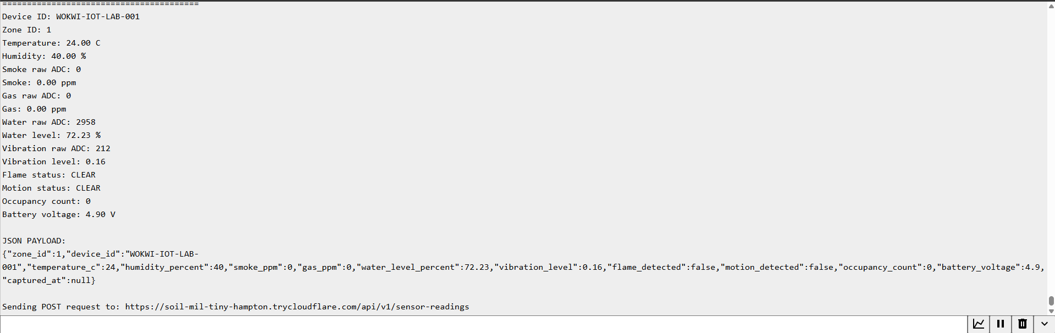
Figure3:LOW Serial
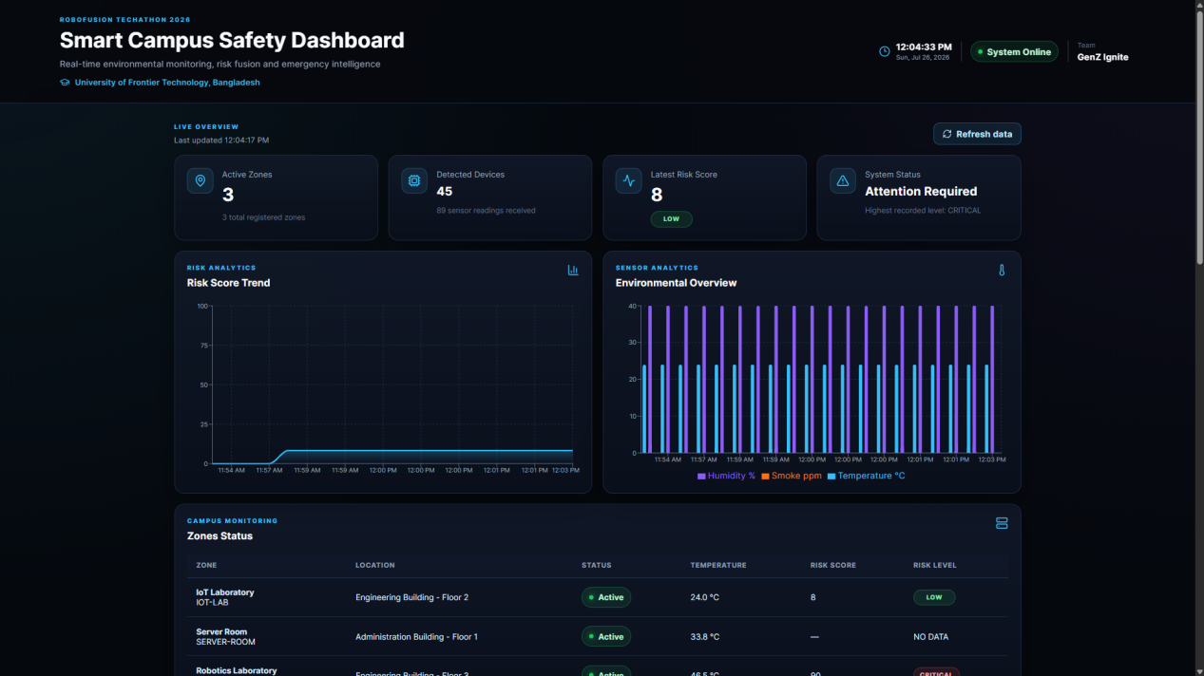
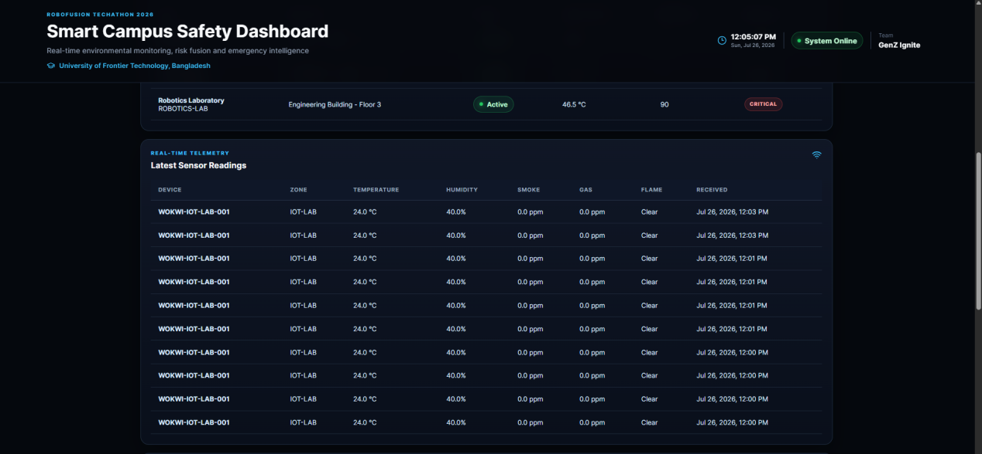
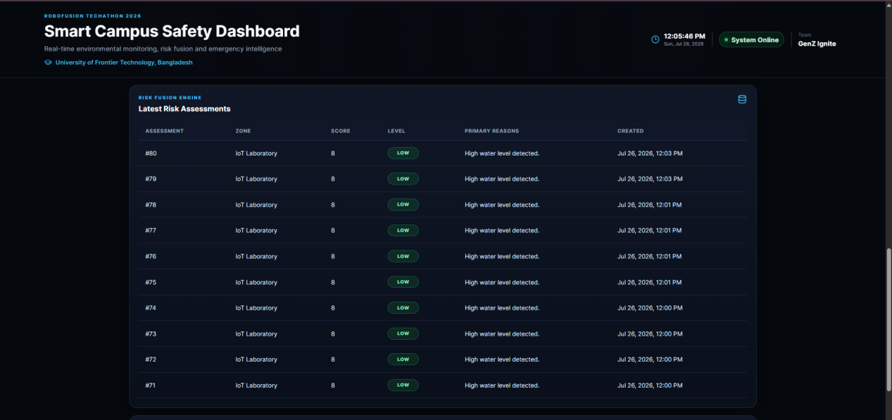
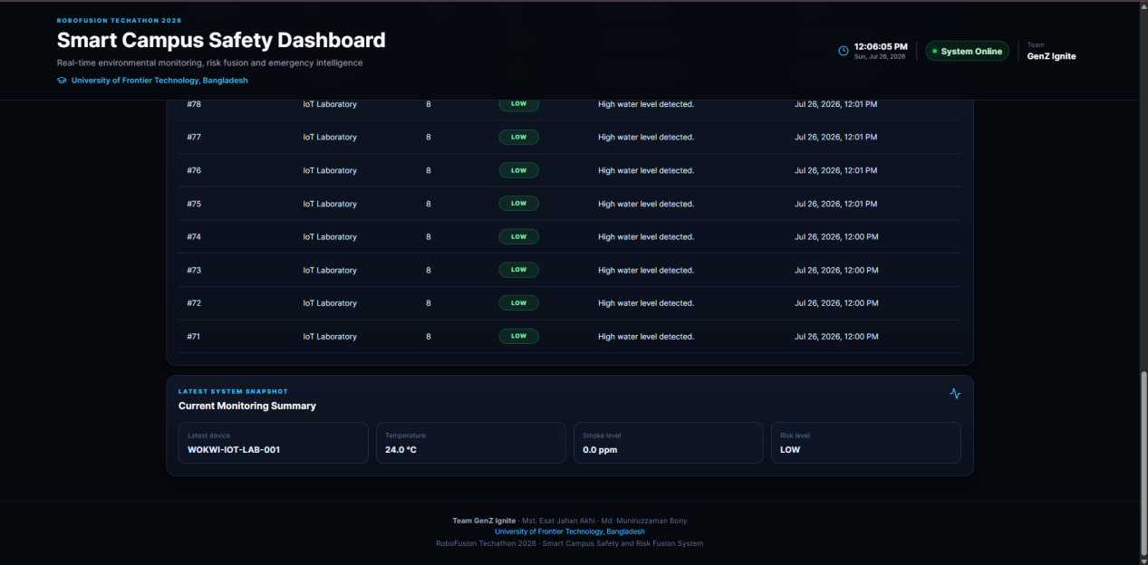
Figure4:LOW Dashboard

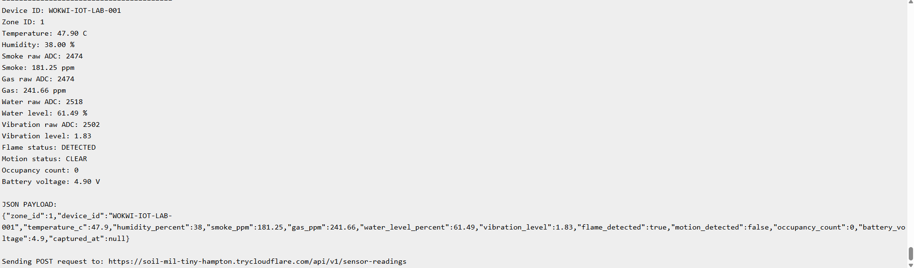
Figure5;Critical Serial
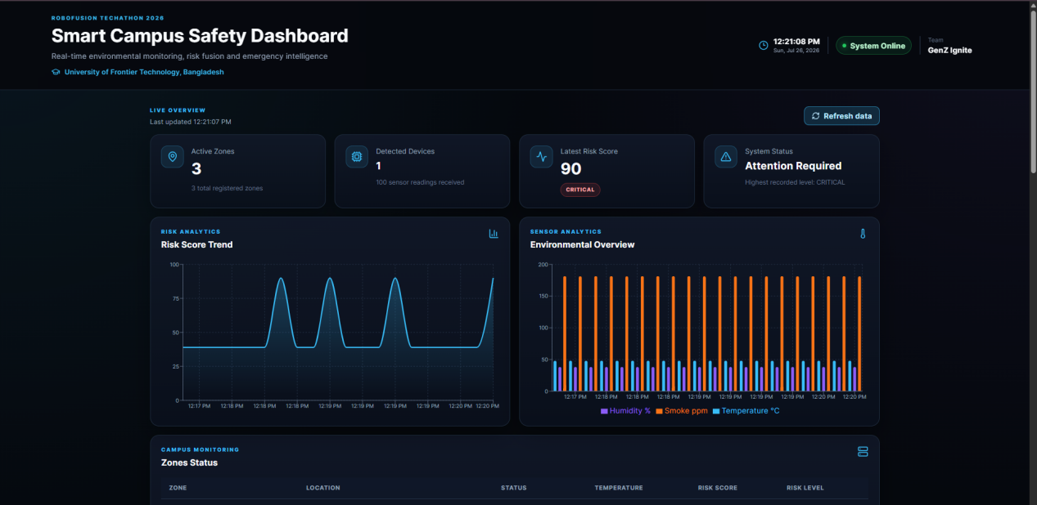
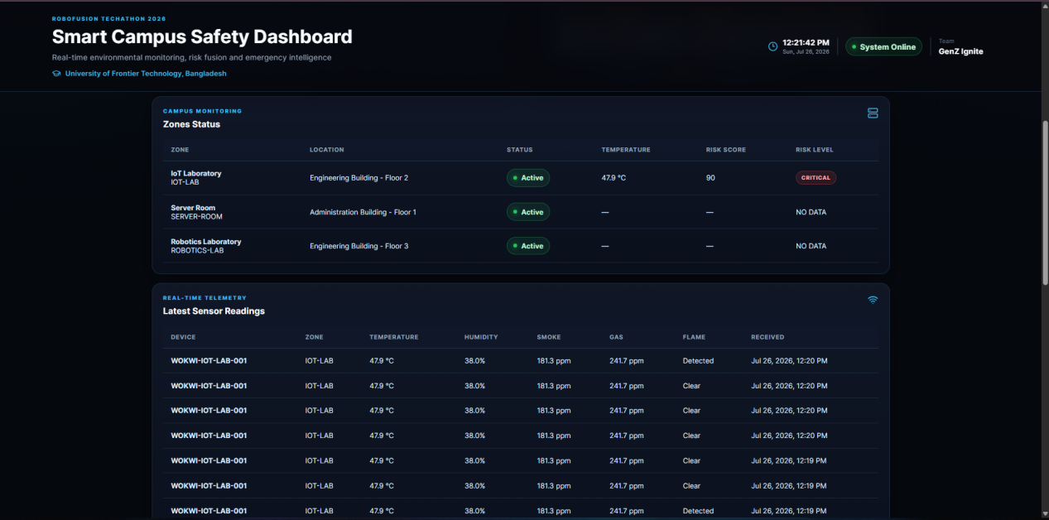
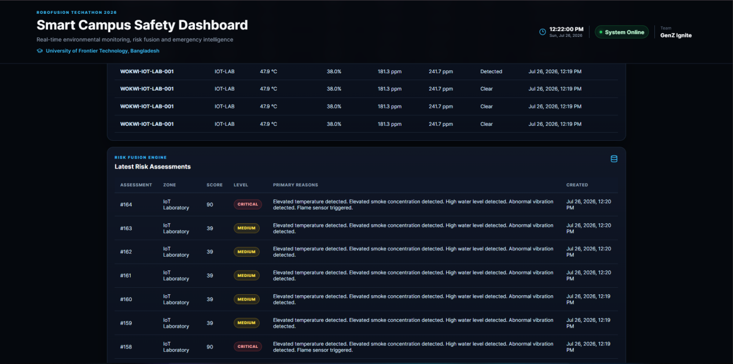
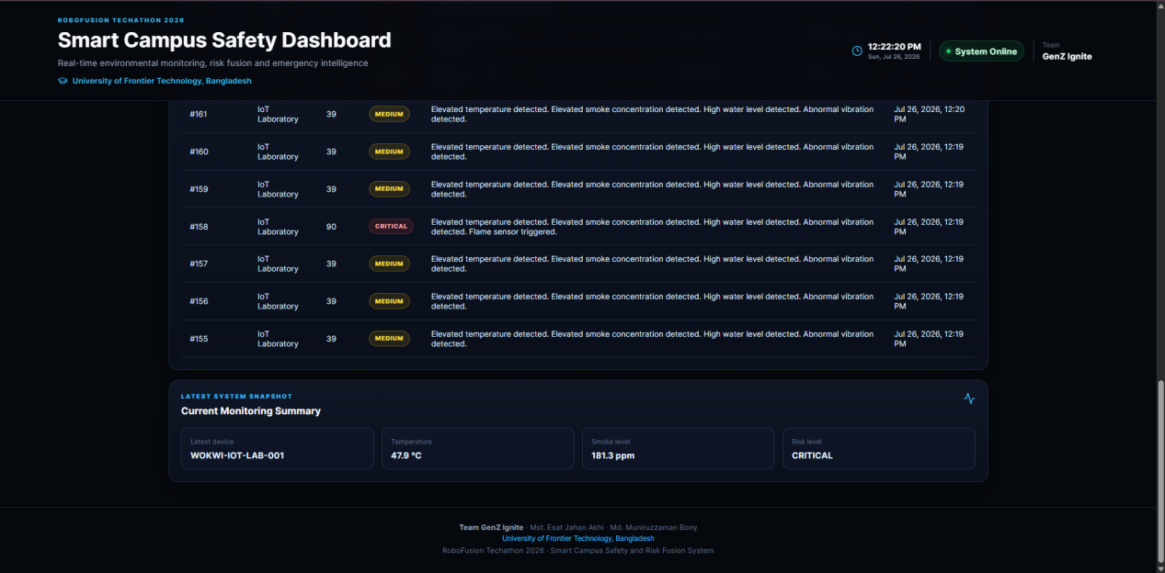
Figure6:Critical Dashboard

Security
The system incorporates several software engineering best practices.

- HTTPS communication through Cloudflare Tunnel
- Request validation using Pydantic
- SQLAlchemy ORM
- Environment variable configuration
- Health monitoring endpoints
- Modular backend architecture

Limitations
The current prototype uses Wokwi simulation instead of physical hardware.

Cloudflare Quick Tunnel provides temporary public URLs.

The current implementation focuses on a single simulated zone and does not include authentication or notification services.

These limitations do not affect the demonstration of the proposed architecture.

Future Improvements
Future enhancements include:

- Physical ESP32 deployment
- Multiple campus zones
- MQTT communication
- LoRa connectivity
- SMS and Email alerts
- AI-based anomaly detection
- Mobile application
- Cloud deployment

Conclusion
The Smart Campus Safety & Response Grid successfully demonstrates an end-to-end IoT safety monitoring platform.

The system integrates ESP32 simulation, FastAPI, PostgreSQL, a weighted Risk Fusion Engine, and a React dashboard into a unified architecture capable of real-time environmental monitoring and intelligent risk assessment.

The modular design allows straightforward migration from simulation to real hardware, making the proposed solution suitable for future smart campus deployments.

