Deliverable 1: Basic Project Design: hardware design, back-end and front-end architecture.

Work Package 1.1: Hardware Schematic and Hardware specification: micro-controller, fingerprint sensor, real time clock (RTC), etc.

1. **Micro-controller: ESP32 DevKit V1**

Characteristics:

* Processor: Dual-core Tensilica LX6 microprocessor, up to 240 MHz
* Memory:
  + RAM: 520 KB SRAM
  + Flash: Varies (commonly 4MB)
* Connectivity:
  + Wi-Fi: 802.11 b/g/n (STA, AP and dual mode)
  + Bluetooth: Bluetooth v4.2 BR/EDR and BLE
* GPIO Pins:
  + Digital I/O: 34 GPIO pins (various multifunction)
  + Analog Inputs: 18 (ADC1: GPIO32-39, ADC2: GPIO0, 2, 4, 12-15, 25-27, 34-39)
* Communication Interfaces:
  + UART: 3 (UART0, UART1, UART2)
  + SPI: 4
  + I2C: 2 (HSI and HSI2)
  + PWM: Multiple channels
* Power Supply:
  + Input Voltage: 5V via USB or VIN pin
  + Operating Voltage: 3.3V (logic level)

Functionality in Project:

* Acts as the central controller managing data acquisition from the fingerprint sensor, LCD display, RTC module, and communication with the remote server via Wi-Fi.
* Handles user authentication and data storage operations.

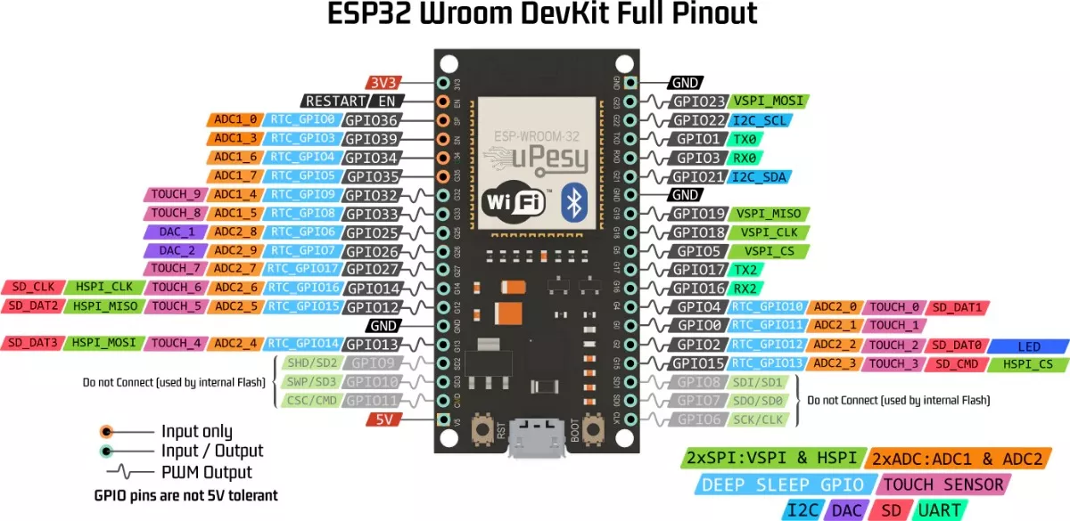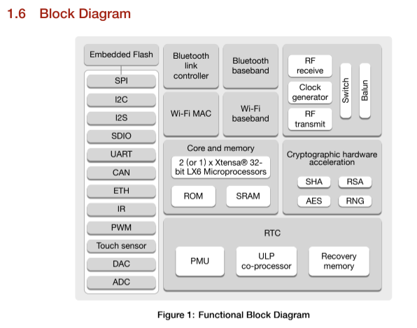

1. **Fingerprint Sensor: R305**

Key Specifications:

* Interface: UART (Serial Communication)
* Operating Voltage: 3.3V to 6V (compatible with ESP32’s 3.3V logic)
* Resolution: 500 DPI (dots per inch)
* Precision :
  + FAR (False Acceptance Rate): < 0.001%.
  + FRR (False Rejection Rate): < 0.1%.
* Fingerprint Capacity: Up to 1000 fingerprints
* Capture Time: ~0.3 seconds
* Storage: Onboard memory for fingerprint templates
* LED Indicators: Status LEDs for operations (enrollment, verification)

Functionality in Project:

* Captures and reads users’ fingerprint data for authentication.
* Sends fingerprint data to the ESP32 for processing and verification against stored templates.

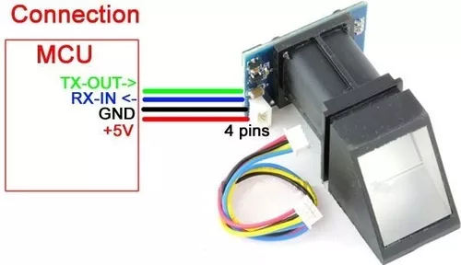

1. **Display LCD: 16x2 I2C**

Characteristics:

* Type: Character LCD, 16 columns x 2 rows
* Interface: I2C via PCF8574 I/O expander
* Operating Voltage: 5V (logic levels are typically 5V compatible, but can work with 3.3V with proper configuration)
* Backlight: LED backlight (typically controlled via I2C)
* Contrast Control: Potentiometer or via I2C commands
* PINS:
  + SDA Pin: Data line
  + SCL Pin: Clock line
* Address: Common default is 0x27 or 0x3F

Functionality in Project:

* Displays system status, prompts, and other information.
* Provides real-time feedback to users during the authentication process.

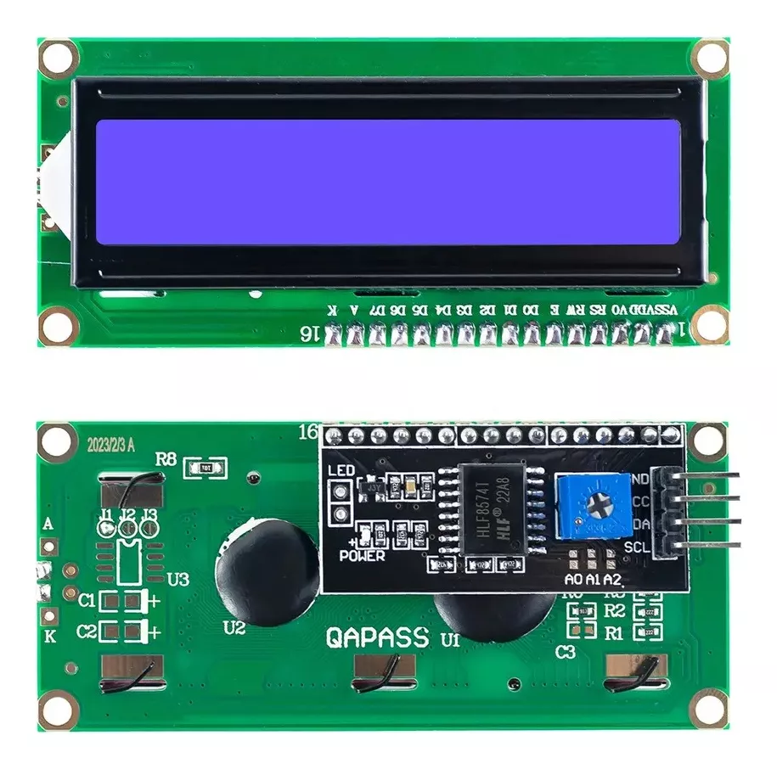

1. **RTC Module: DS3231**

Although the ESP32 microcontroller already has an integrated RTC, it may experience synchronization problems due to the lack of an internal battery as a power source. This is the main reason why we decided to use the **DS3231** module. It is a low-cost, highly accurate I2C real-time clock with an integrated temperature-compensated crystal oscillator (TCXO) and crystal. The device incorporates a **battery input** and maintains accurate timekeeping even when the main power to the device is interrupted.

Characteristics:

* Interface: I2C
* Operating Voltage: 3.3V to 5V
* Accuracy: ±2 minutes per year
* Battery backup (for timekeeping when power is off)
* Timekeeping: Supports seconds, minutes, hours, day, date, month, and year.
* PINS:
  + SDA Pin: Data line
  + SCL Pin: Clock line
* Address: Typically 0x68

Functionality in Project:

* Keeps accurate real-time data for logging entry and exit times.
* Ensures time stamps are maintained even during power outages via the backup battery.

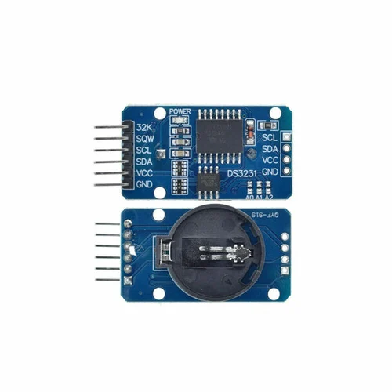

**Power Supply: USB Current Adaptor**

Characteristics:

* Output Voltage: 5V DC
* Current Rating: Minimum 2A
* Connector: USB Type-A or Micro/USB

Functionality in Project:

* Provides stable power to the ESP32 and connected peripherals.
* Ensures reliable operation of the system by maintaining adequate power supply.

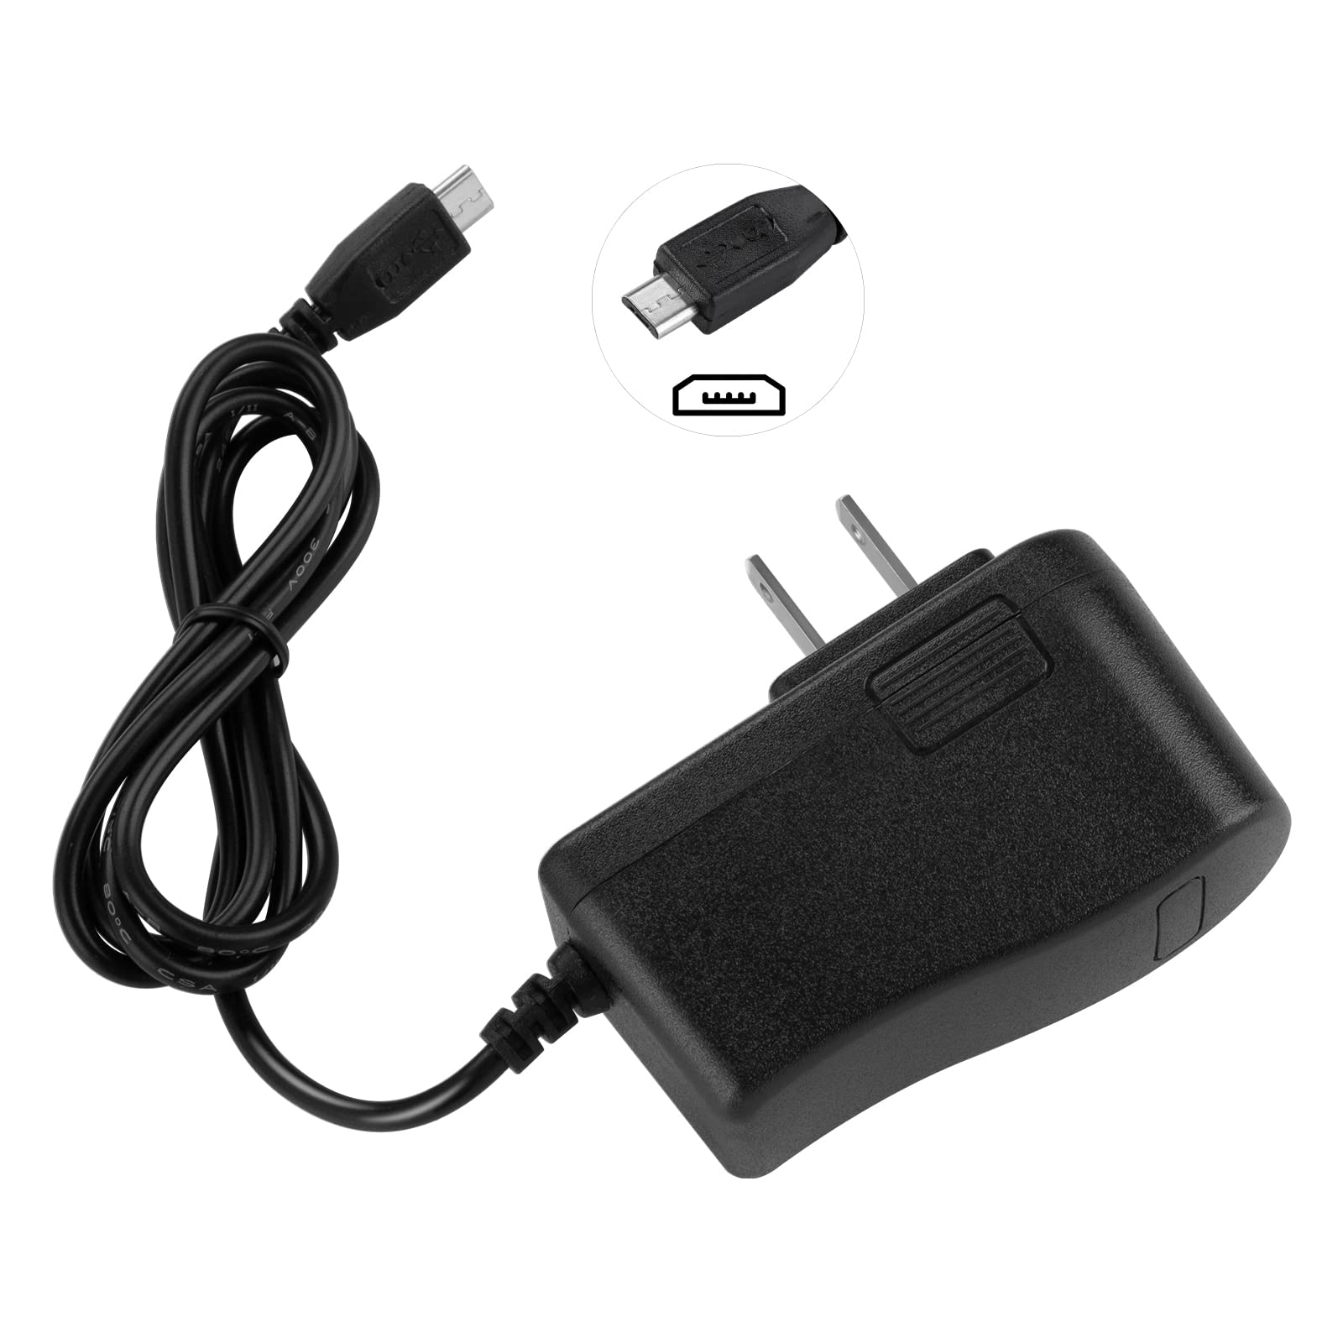

**Hardware Schematics**

The system will have the following connections as shown in the figure:

1. **ESP32:**
   * Power from USB.
   * I2C bus for LCD and RTC:
     + SDA (GPIO21), SCL (GPIO22).
   * UART for fingerprint sensor:
     + TX (GPIO1), RX (GPIO3).
2. **Fingerprint Sensor (R305):**
   * VCC → ESP32 3.3V or 5V.
   * GND → ESP32 GND.
   * TX → ESP32 RX (GPIO16).
   * RX → ESP32 TX (GPIO17).
3. **LCD 16x2:**
   * VCC → ESP32 5V.
   * GND → ESP32 GND.
   * SDA → ESP32 GPIO21.
   * SCL → ESP32 GPIO22.
4. **RTC DS3231:**
   * VCC → ESP32 3.3V or 5V.
   * GND → ESP32 GND.
   * SDA → ESP32 GPIO21.
   * SCL → ESP32 GPIO22.