**Project “FirstRPG” 1-Page GDD**

*First try into RPGs*

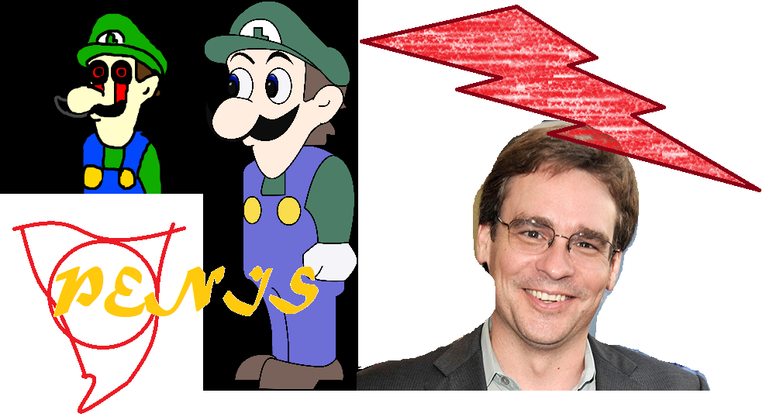

**Genre:** Action RPG, 3rd person fixed camera  
**Target Audience:** ADULTS MEMEs

**Controls:** Mouse-keyboard and controller

**Thematic Setting:** Krazy LSD induced

**Tech Stack:** Unity + C# + Blender + Gimp + Audacity

**Platform(s):** Steam, PC, Android

**Game Moment:** Combat, mood setting

**Game Summary:**

**Core Player Experience:** Funny Sexual Adult Adventure

**Central Theme:**

**Design Pillar:**

**Anticipated Remarkability:**

**Anticipated Steam Early Access Launch date:**

**Feature Development Priorities:**

**Comparative Products:**