**150160032 Jenni Singleton**

**COM1008 Responsive Web Design Plan**

**General ethos**

For a site aimed at children, I chose to keep the design simple, focusing on eye-catching colours. The simplistic layout keeps navigation easy, while the colour scheme is intended to draw attention without being straining.

**Site map**

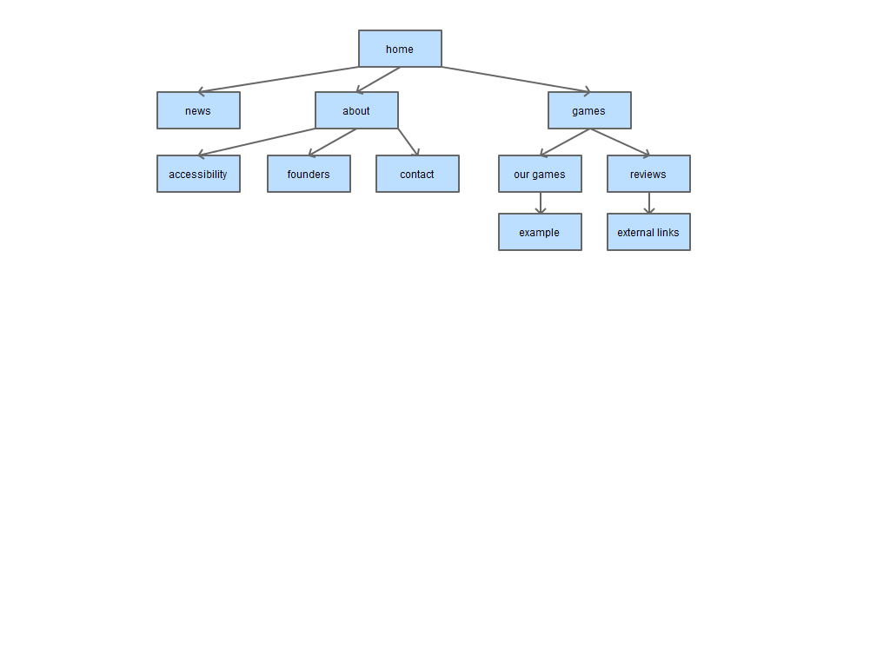

Figure . Site map

The structure has three main categories which contain logically linked content. The company’s contact information and website accessibility statement, as well as biographies of the company’s founders, fall under information about the company. “Games” includes both games made by the company and reviews/recommendations of other puzzle games. While the “news” category could include content relating to either games or the company itself, the amount of content would be sufficient to merit its own section.

**Accessibility**

The World Wide Web Consortium (W3C) suggest four principles for accessible web design[1]: perceivable, operable, understandable and robust.

**Perceivable**

The colour scheme has a high level of contrast between background and text, which makes it easier to read, especially for people with visual impairments. Colour is used for aesthetic appeal rather than to convey information, meaning that it can be changed without compromising the content of the site. Images that are important will be supplied with a descriptive tag so that they can be interpreted by screen reader software, whereas purely decorative images will not, as this creates unnecessary clutter.

**Operable**

The site will not contain flashing images, which may cause seizures. The majority of the content should be accessible via a keyboard and without time limits, however this may cause issues for the game element. Links are clearly labelled to provide easy navigation for users with varying levels of English.

**Understandable**

The site content will be written in clear and simple language to make it easy to understand, particularly for younger users or those with learning disabilities.

**Robust**

The site uses HTML 5 semantic elements to categorise content. This allows assistive technologies such as screen readers to better process the site.

**Design mock-ups**

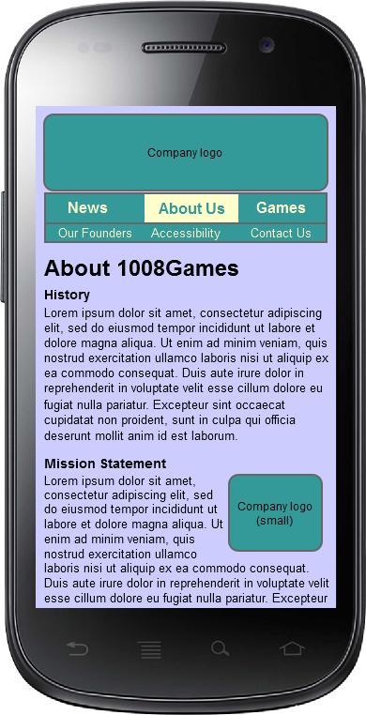

Figure . Mobile

The design uses one breakpoint, at 700 pixels wide. At this width, the horizontal navigation bar becomes too spread out, and so the menu is moved to a vertical display on the left of the screen. This is also a possible transition point from a portrait display, which favours vertically arranged page elements, to landscape, for which a horizontal design is better suited.

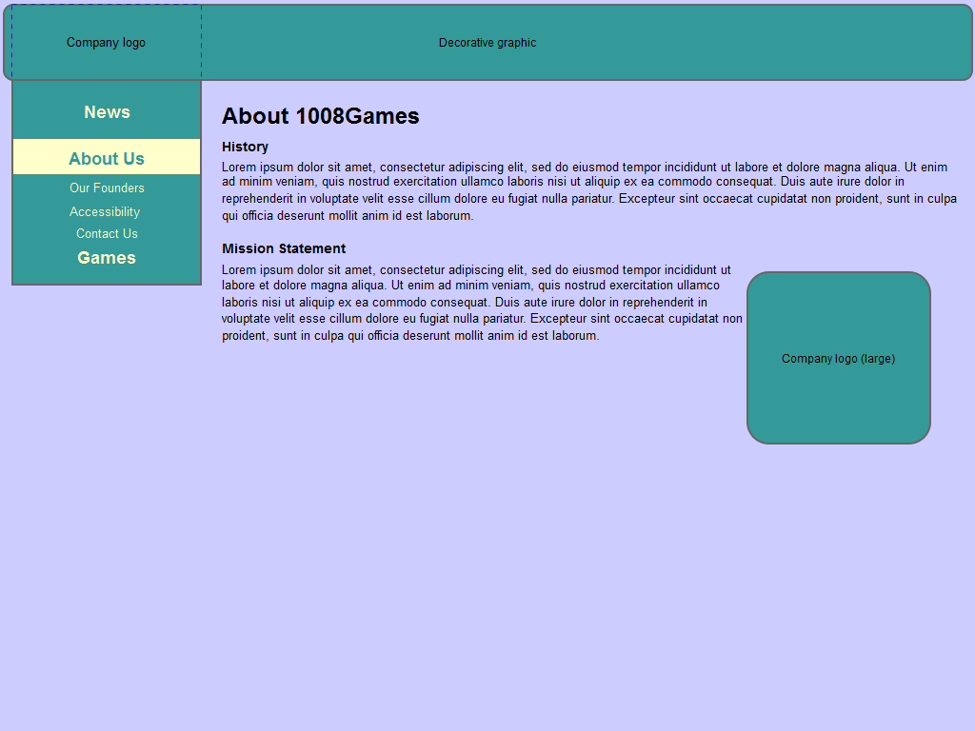

Figure . Desktop

**Menu system**

The site utilises a “do nothing approach”[2] to the menu system. This simplistic method uses padding to make links more easily operable on touchscreen devices without relying on functions that may not be available on all devices, or which some users may choose to deactivate.

**Puzzle game design**

I am choosing to implement the pair matching puzzle. To enable the game to work on the mobile version of the site, the images used will need to be scalable to different screen sizes. This means that they should be simple, without fine details that would be lost on a smaller display. While the visual nature of the game means that, unfortunately, it will not be accessible to all users, considerations can still be made such as differentiating the images by shape as well as colour so that people with colour blindness can play.

**References**

[1] Web Content Accessibility Guidelines (WCAG) 2.0, <https://www.w3.org/TR/WCAG20/>, accessed 28/11/16.

[2] Adventures in Response Navigation, <http://responsivenavigation.net/index.html>, accessed 28/11/16.