How International Travel Has Been Affected By COVID-19

Taeyoung Eun (301365637)

Kenta Horie (301374650)

CMPT 353 D100 (Steven Bergner)

**Introduction**

COVID-19 affected everyone around the world in different ways. It has critically damaged various businesses and industries. The travel industry is one of the biggest victims of the COVID-19 pandemic because of the harsh travel restrictions introduced by the virus. The fear of catching COVID-19 has prevented or deterred international travel for many people leaving the travel industry with significantly less travellers. We will take a closer look at its impact by investigating how many fewer people traveled to Canada due to COVID-19. We will analyse whether or not the government set deterrents had an effect on the number of travelers, and how many more people will travel as the COVID-19 pandemic situation improves.

**Experimental Setup / Hypothesis**

We acquired our dataset regarding travel from the Statistics Canada website. It included how many people travelled to Canada every month, how they travelled, and their origin (United States, Canada, other). We had data about people travelling to Canada from the US, returning Canadians, and people coming into Canada from other countries. We also used a COVID-19 intervention timeline from Canadian Institute of Health Information to closely investigate the major deterrents of international travelers: The travel restrictions. The timeline also had useful information regarding health workforce, covid-19 vaccines, and important public announcements. We converted the dataset from Statistics Canada from pdf to a csv file, and the COVID-19 intervention timeline was provided as a csv. We used an external application called Able2Extract to convert the information within the pdf file from Statistics Canada to a csv.

We changed the index and various fields of the pdf file, so that it can be readable by pandas in python and to be further cleaned and analyzed. The csv files were re-organized and separated to different files. Fields such as dates had to be changed to the number of days from the start of the recording because dates directly could not be used for the machine learning techniques used.

The data set for this project has been separated into two: one with pre-covid 19 data (2019, 2020, 2021), and one without. (2020 May - 2021). People could find the 2019 data will be the “normal values,” and therefore valuable to add to the dataset. However, it can also have a terrible effect in the dataset because it is like including a year’s worth of outlier values. We divided the data to: Canadians travelling to Canada, people travelling from the United states, anyone travelling from anywhere other than those two countries, and all the travelers together.

We hypothesized that the dataset without pre-covid 19 data will perform much better in the statistical test because the data from 2019 are so different from every single year. We also predict that having the pre-covid 19 data will cause the machine learning techniques to create extremely high values that will not make logical sense. In comparison, not accounting for the pre-covid 19 data will create a prediction of steady but slow growth which will be a more believable prediction. Overall, we predict a steady increase in the number of travelers.

**Results & Discussions**

From figure 1, you can see just how much effect COVID-19 had on travel. The number of people travelling sharply drops from January of 2020, and it stays at an incredibly low number for a very long time. You can see that it sees eventual climb in 2021, mainly due to climbing vaccination rates and loosening of the travel restrictions.

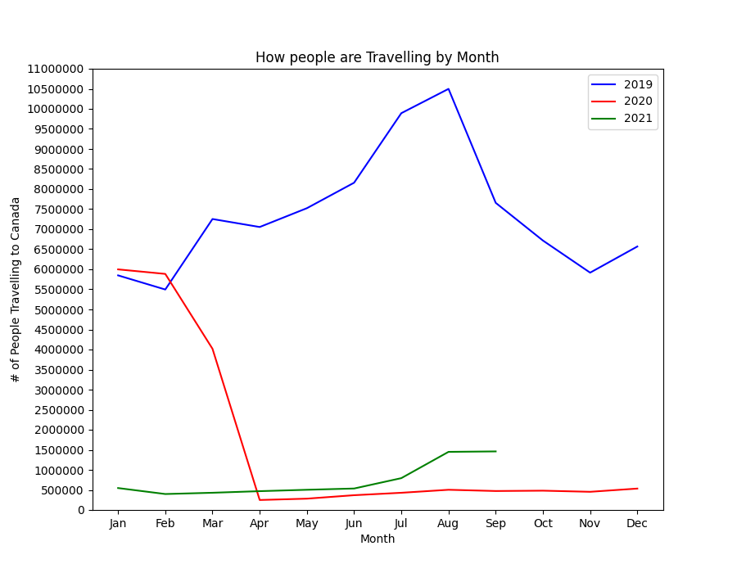

Figure 1. Graph of how number of people travelling to Canada

Fortunately, in figure 2, we can see that the situation is improving for the travel industry. The number of travelers has been increasing, and it has picked up a strong momentum in April 2021. It is reasonable to assume that authorization and distribution of covid-19 vaccines had a great effect on this increase. However, we must take into account that 2019 and 2020 were extremely different years in comparison. There is still a long way to go until the travel industry fully recovers.

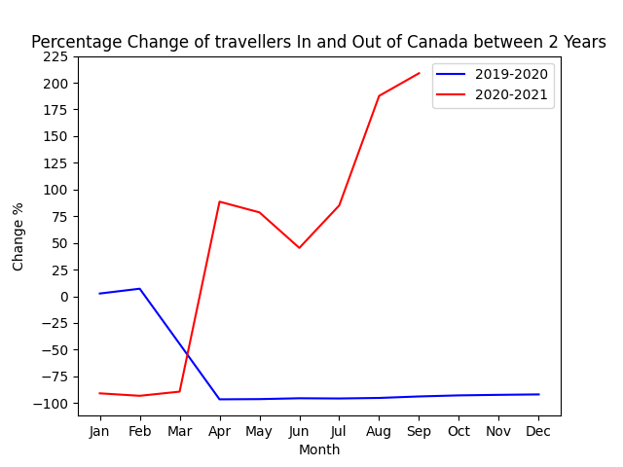

Figure 2. The graph of percentage change of travelers to Canada between 2 years

For predictions, we used linear regression to predict the number of travellers from the end of 2021 to the end of 2022. Figure 3 shows how crazy the predictions made when using linear regression were when we did not include the pre-covid 19 information. The predictions start with extreme drop then an extremely fast climb. We believe that linear regression did not handle the comparatively explosive increase in travellers starting in July 2021 poorly as it was making predictions; to the model, it was an extreme change which it could not adequately account for. The relatively similar values throughout the dataset had unfortunate effects on the predictions. However, it is interesting that the predictions are expecting a very steep increase in travelers after the drop.

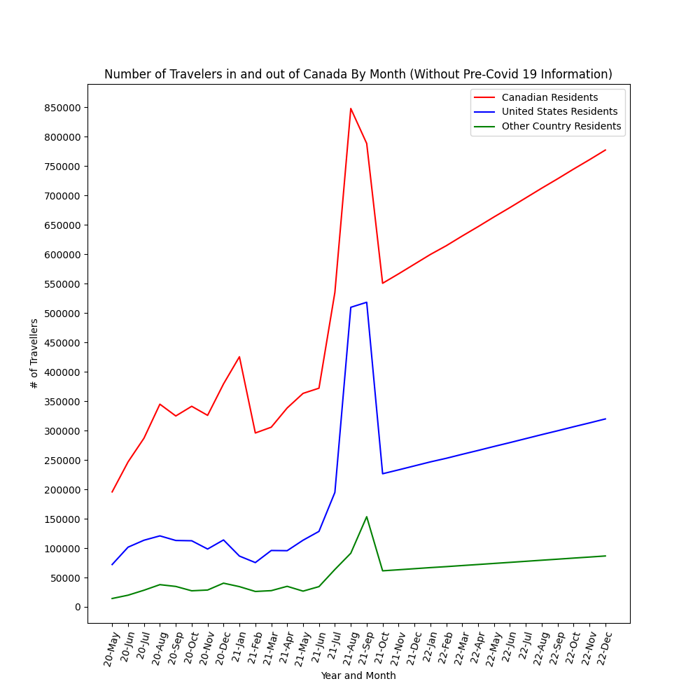

Figure 3. Graph of number of people travelling to Canada, and predictions (starting on 21 Oct) without pre-covid 19 information

Looking at the figure 4 below, the dataset with the pre covid 19 data shows a much more reasonable trend. Even when we predict the rates of travel for 2022 using linear regression, the dataset with pre covid 19 makes fewer radical predictions. It shows a steady increase in travellers, which is what we predict. The extra variance from the 2019 dataset likely contributed to predictions making more sense. Big variance and jumps between data points are the major reasons why the predictions continue to follow a trend of growth.

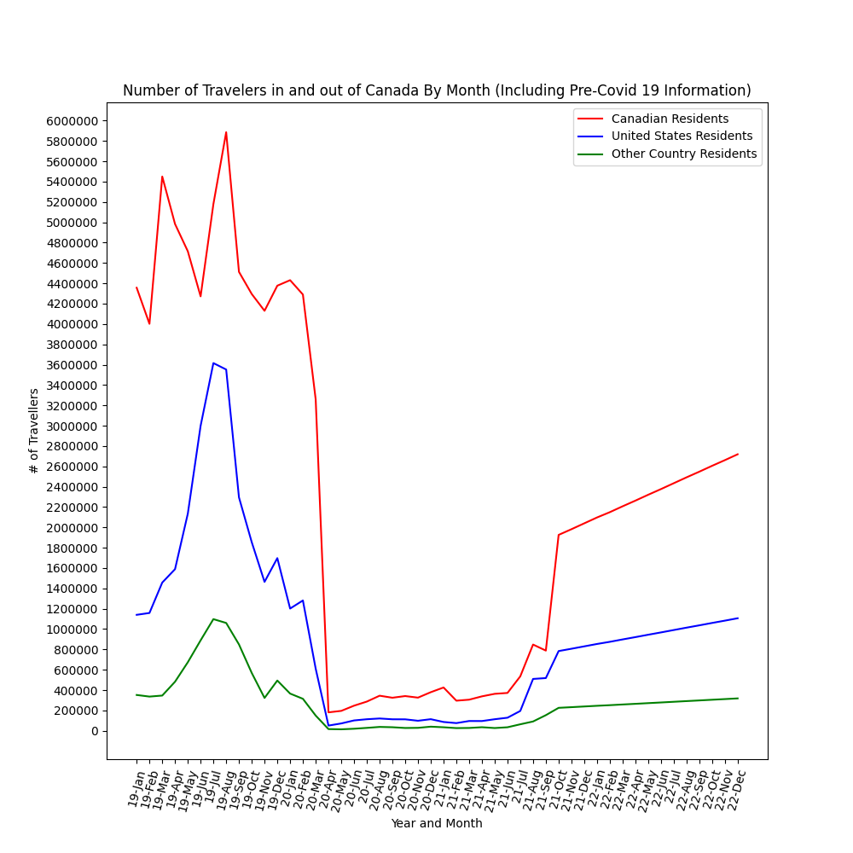

Figure 4. Graph of number of people travelling to Canada, and predictions (starting on 21 Oct) with pre-covid 19 information

To see if these predictions seemed reasonable, we performed a normal test on the datasets. When performing the normal test with the new predicted values, it shows mixed results. looking at the normal test results shows that both datasets have their pros and cons for using them. However, it is very interesting that some of the predictions made from data without pre-covid 19 information pass as normal predictions despite a huge drop at the start of predictions.

| Country | 2019 – 2021  p-value | 2020 - 2021  p-value | 2019 - 2022 real + prediction p-value | 2020 -2022 real + prediction p-value |
| --- | --- | --- | --- | --- |
| Canada | 3.6504 * 10 ^  -13 | 0.0012 | 0.0020 | 0.0017 |
| US | 0.0144 | 3.2345 * 10 ^ -5 | 0.0001 | 0.0514 |
| Other | 0.0092 | 2.0041 * 10 ^ -6 | 5.0063 * 10 ^ -5 | 0.0141 |
| Total | 0.0051 | 0.0002 | 0.1744 | 0.1488 |

Figure 5. Table of p-values from normal tests.

Upon closer inspection of the list of interventions, (figure 6), you can reasonably assume that other than the initial travel warnings and travel restrictions from January and April, new restrictions did not have much of an effect decreasing travel. Additionally, it is more likely that the desire to travel has strongly died down because of the fear of catching covid-19. Similarly, the increase in the number of travelers starting june of 2021 can be linked to the increasing vaccination rates of Canada, and how people began to fear covid-19 less. Even though July is when the travel restrictions loosened, and the number of travelers greatly increased, we cannot say in full confidence that the loosened restrictions was the cause of people beginning to travel more.The change in the number of travelers is a combination of many factors, but we believe that the travel restrictions did have a strong correlation with the decreasing number of travelers.

Travel Restrictions Concerning People Travelling In and Out of Canada

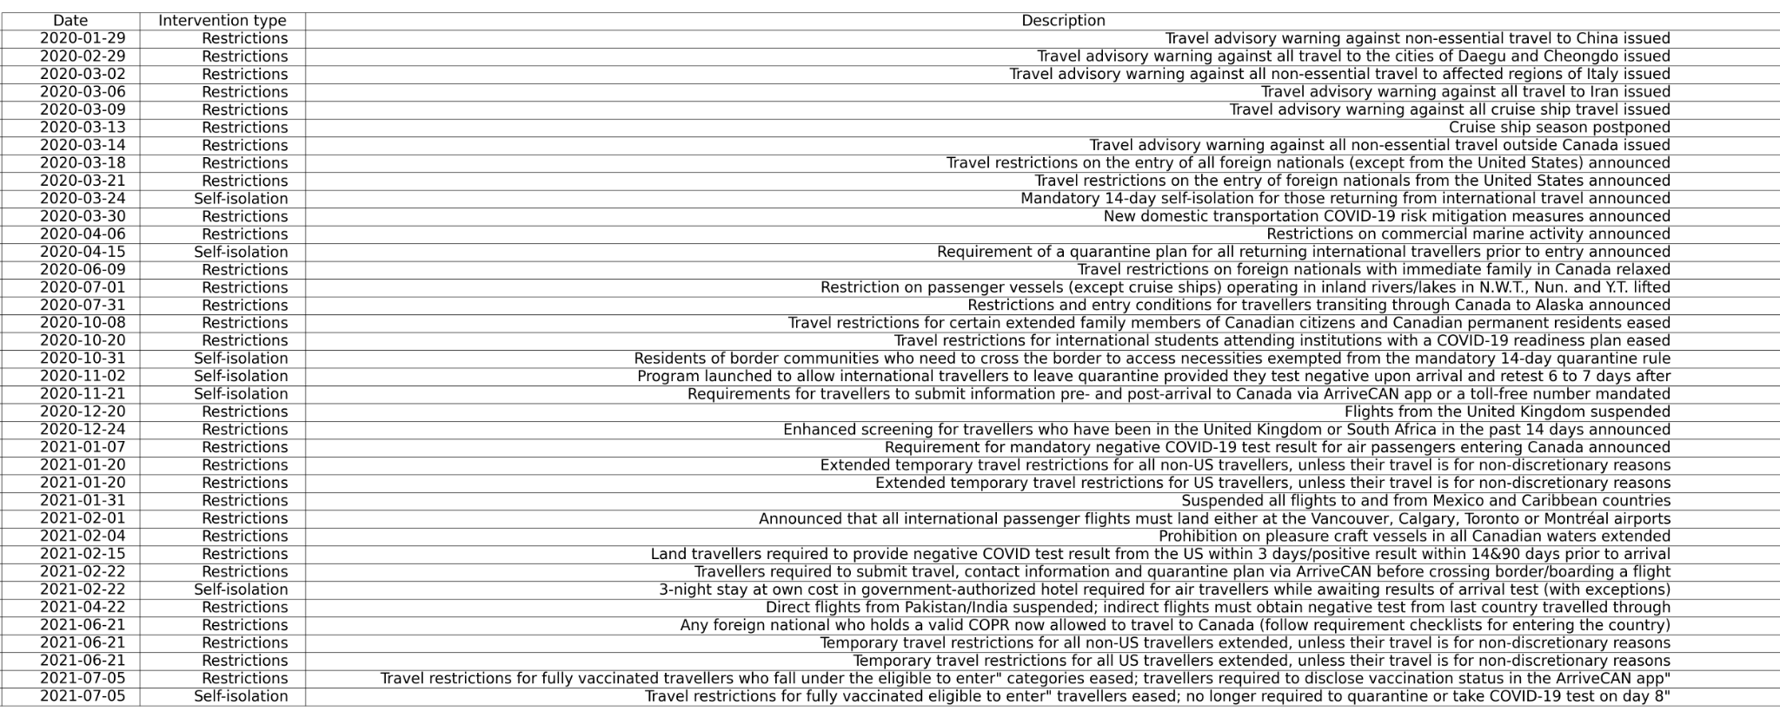

Figure 6. The Table of Travel restrictions concerning people travelling In and Out of Canada

There were several restrictions made in between 2020 April and 2021 March, which had little to no effect on the number of travellers. We can conclude that at these points, almost all non-essential travelers have chosen not to travel to Canada. Since all the non essential travellers have been exhausted, the increased restrictions would have no effect because the majority of the restrictions specifically targeted non-essential travellers.

Overall, we predict that there will be an increase in the number of travellers in the future. We think that the increase in vaccine rates and overall decrease of fear towards covid-19 will increase the number of travelers. However, there could be sudden decreases in the number of travelers , for variants of covid-19 may create more fear and force the governments to place more restrictions again. From this experiment, we gained confidence to say that we can be more optimistic about the resurgence of the travel industry.

**Conclusion**

This experiment taught us how devastating covid-19 was to the travel industry. It showed how many less people traveled to Canada compared to previous years. We gained insight on what restrictions and events had more effect on travel than others. Finally, it gave further support to our prediction that the traveling industry will slowly return to normal.

Although this experiment was an insightful experience, there were definitely many limitations, and we would've made many changes given more time. The datasets of predicted travellers from both the dataset with pre covid-19 information and without pre covid-19 information both show optimism and growth concerning the number of travellers. This trend is what we were looking for, and we aimed to see how much growth the traveling industry was going to get in the future. However, as obviously shown by figure 3, one of the predictions was extremely off the mark when it came to prediction. If we had time, we would have tried different machine learning methods for prediction to get more accurate values.

Our dataset regarding travel gave us data about every month, but we believe that predictions would’ve been much better if we found a data set which gave us information regarding everyday. Additionally, we found detailed information regarding covid-19 vaccinations. We wished that we had allotted more time to incorporate this information in our project.

Regardless of the many downfalls, We believe that we learned a lot. This project was a great opportunity to hone and show our skills. Not only gave us insight on covid-19’s effect on the travel industry, it also showed us that we can apply the skills that we learned from CMPT 353 in real life settings.

**Experience Summary**

Tony

I focused on managing the project and using the extracted data to do operations required for our analysis. First, I researched a topic which my partner and I agreed on. Then I formulated a list of tasks which needed to be accomplished to help organize ourselves while working on the project. I created a girlabs environment and outlined our code with the tasks to avoid any confusion between us and the work. After receiving CSV files with the data, I reformed some of them usingPandas dataframes and Microsoft excel.

I used the pandas dataframes to store our information in our code. I restructured, extracted, cleaned and removed parts of data to be usable for our tasks using pandas dataframes. I used the data frames and various machine learning methods to get the necessary data for our project such as the p-value using the normal test and the predictions using linear regression.

After acquiring all the required data, graphs and tables, I wrote this final project report using the acquired information and presentation tools.

Kenta

My main task for this project was to extract the info from a pdf and clean it to data that can be manipulated and then displayed in a more digestible format. In terms of extracting raw data, as mentioned in the set up, I used a third party application that can read PDF text and turn them into a csv. Albeit the conversion was not perfect so I needed to manually tweak certain labelling schemes so it can be properly read in Pandas. Since the sample we used was fairly small, this task was accomplished by this method, however for next time, I should investigate in a more streamlined format that doesn't involve too much manual changes so it can be applied to large amounts of data.

Once I got the CSV I needed to further manipulate the raw data to something that can be more usable for the sake of our analysis. So, I simply used Pandas and all of its functions that I learned throughout the course to clean up the data and format them into something that can be further manipulated or graphed.

With all of the Data frames created we needed a way to display it so it can be easily analysed. I used pyplot to graph the Data frames and saved it as a png so it can be used on this report. I also found that by pandas.plotting, I can also plot out tables which can be used in conjunction with the graph. I did attempt to incorporate both on a single diagram, however, the diagram was going to be cluttered and hard to read thus the decision was made to have them as two separate images.

**References**

https://www150.statcan.gc.ca/n1/pub/66-001-p/2021009/tbl/tbl-1-eng.htm

https://www.cihi.ca/en/covid-19-intervention-timeline-in-canada