Negotiation User Guide

T. Baarslag, W. Pasman, K. Hindriks, D. Tykhonov, W. Visser
26 October 2010

Introduction
For the second half of the course AI Techniques (IN4010TU) you have to implement an agent that will negotiate on your behalf. This document describes how you can install the required environment, work with the provided agents, and write, compile, and run such an agent yourself.

Contents
Negotiation User Guide 1
Introduction 1
Contents 2
1. Theory Crash Course 3
Actions 3
Negotiation Protocol 3
Time available for a Session 3
Negotiation Objects 4
Utility of a Bid 4
Optimality of a Bid 5
2. Installing the Environment 6
System Requirements 6
Installation 6
Progress & Error Messages 6
Bug reporting 6
3. Profile Creation 7
4. Running Negotiations 11
Using an Automatic Agent 11
Using the UIAgent 12
Negotiation Results 13
5. Writing a Negotiation Agent 16
Init 17
ReceiveMessage 17
ChooseAction 17
Compiling an Agent 18
6. Data structures 20
Domain 20
ValueDiscrete (implements Value) 20
IssueDiscrete (implements Issue) 20
UtilitySpace 21
Bid 21
EvaluatorDiscrete (implements Evaluator) 22
7. Conclusions 23
References 23

1. Theory Crash Course
This section gives a crash course on some essential theory needed to understand the negotiaton system. The negotiation objects that are used in a negotiation and utility values are discussed.

Actions
In negotiation, the two parties take turns in doing the next negotiation action. The possible actions are:

Accept | This action indicates that agent (which usually has the value 'this') accepts the opponent's last bid
Offer | This action indicates that the agent proposes a new bid
EndNegotiation | This action indicates that the agent terminates the entire negotiation, resulting in the lowest possible score of zero for both agents

Negotiation Protocol
The negotiation protocol determines the overall order of actions during a negotiation. Agents are obliged to stick to this protocol, and deviations from the protocol are caught and penalized. This section discusses the details of the protocol for this assignment.
Agent A and B take turns in the negotiation. One of the two agents is picked at random to start. When it is the turn of agent X (X being A or B), that agent is informed about the action taken by the opponent. If the action was an Offer, agent X is subsequently asked to determine its next action and the turn taking goes to the next round. If it is not an Offer, the negotiation has finished. The turn taking stops and the final score (utility of the last bid) is determined for each of the agents, as follows:
- the action of agent X is an Accept. This action is possible only if the opponent actually did a bid. The last bid of the opponent is taken, and the utility of that bid is determined in the utility spaces of agent A and B. The opponent is informed of this accept via the ReceiveMessage method (but now without the subsequent chooseAction).
- the action returned is an EndNegotiation. The score of both agents is set to 0.
So far for the protocol. If an agent does not follow this protocol, for instance by sending another action that is not one of the above or by crashing, that agent will get a utility of 0, and the opponent will be given the utility of his last bid (or 1 if he did not yet do a bid). If the agent deviates grossly from the protocol in such a way that it endangers the negotiaton simulator itself, it may be disqualified entirely.

Time available for a Session
Normally, each negotiation session is allowed to last at most 180 seconds. If no agreement has been reached before this time, the negotiation will be terminated by killing the negotiation agents, and the utility of both parties will be 0. Only if (at least) one of the agents is a GUI agent requiring user input, the deadline is set to 1800 seconds. Notice that manipulation of the available time (by delaying the response of your agent) can be an important factor influencing the negotiation results, and one improvement for the example agent (SimpleAgent) would be to be more careful about this.

Negotiation Objects
The central datastructures in the negotiation are the bid and the utilityspace. Both work in a domain. Figure 1 shows an overview of the Domain and utility space datastructures and their relations.
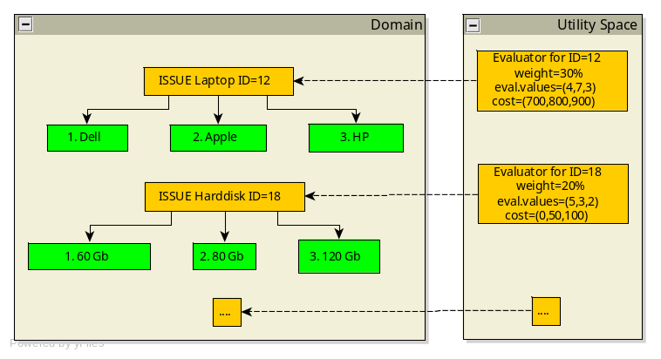
Figure 1. Overview of the datastructures and relations.

The domain describes which issues are the subject of the negotiation. To give a concrete example of a domain, in the laptop domain the domain is a list of issues, where the issues are laptop, harddisk and monitor. Issues are being referred to via the issue ID, a unique number for each issue. The domain description also describes the possible values that all the issues can take. In the laptop domain, all issues can have only discrete values, e.g. the harddisk issue can have only the values 60 Gb, 80 Gb and 120 Gb. These issues are an instance of IssueDiscrete. There are other types of Issue but discussion of them falls out of the scope of this short discussion.
Issues are an instantiation of a more general Objective class. The objective class itself is not relevant except that some functions return an Objective, and the returned object then has to be cast to an Issue or IssueDiscrete as needed.
The utilityspace provides all the information enabling the computation of the utility of some bid. It is implemented as a list of evaluators, one evaluator for every issue in the domain. Because the issues in the laptop domain are all discrete issues, the evaluators are all EvaluatorDiscrete objects.
The Evaluator object contains a weight, and for each value that the issue can have it gives an evaluation-value and a cost value.
The weight indicates the relative importance of an issue. The sum of the weights of all issues is 1.0.
The evaluation-value gives the evaluation, or utility, associated with each value that an issue can take. For instance, for the harddisk issue above, the evaluation values could be 2 for the 60 Gb, 4 for the 80 Gb and 10 for the 12 0Gb, etc.
The exact formula for computation of the utilities is given in equation .
The bid is a set of values for each of the issues in the domain.

Utility of a Bid
A bid is a set of chosen values 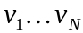 for each of the N issues. Each of these values has been assigned an evaluation value eval(v_{i}) in the utility space, and also there are fixed costs cost(v_{i}) associated with each value. The utility is the weighted sum of the normalized evaluation values, under the assumption that the cost is below the maximum cost of 1200. If the maximum cost is exceeded, the utility is zero.

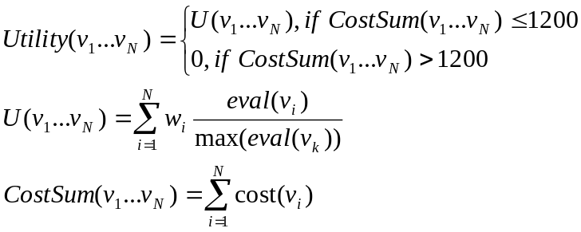 ()

Optimality of a Bid
For a single agent, the optimal bid is of course one with a maximum utility. But a more general notion of optimality of a negotiation involves the utility of both agents. Figure 2 shows the utilities of all bids for the two parties in the negotiation.
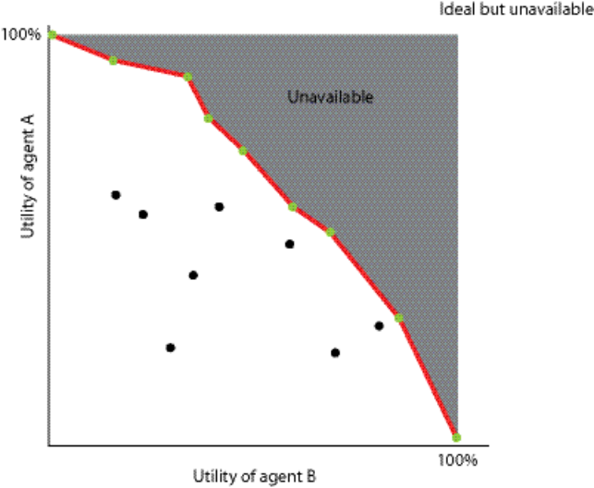
Figure 2. Utility plot. Each point indicates the utility for both agents of a particular bid. The red line is the Pareto optimal frontier.
There are multiple ways to define a more global "optimum". One approach to optimality is that a bid is not optimal for both parties if there is another bid that has the higher utility for one party, and at least equal utility for the other party. Thus, only bids in Figure 2 for which there is no other bid at the top right is optimal. This type of optimality is called Pareto optimality. The collection of Pareto optimal points is called the Pareto optimal frontier. Another approach is the Nash optimality. A Nash solution is a bid for which the product of the utilities of both agents is maximal.

2. Installing the Environment

System Requirements
You can run the negotiation environment on any system running Java version 5 or 6. You can download Java from the internet (www.sun.com/java) [sun07].

Installation
To install the environment, the file negotiator.zip can be downloaded from Blackboard. Unzip the file at a convenient location on your machine. This will result in a package containing the following files:

- assignment.pdf, containing the assignment
- userguide.pdf, containing this document
- negosimulator.jar, the negotiation simulator
- a templates folder, containing various domain spaces, all with a few sample utility spaces (xml files)
- The SimpleAgent.java and SimpleAgent.class file

Progress & Error Messages
When you run the negosimulator (by double-clicking the application), progress messages and error messages are printed mainly to the standard output. On Mac OSX you can view these messages by opening the console window (double-click on Systemdisk/Applications/Utilities/Console.app). On Windows this is not directly possible. Console output can be read only if you start the application from the console window by hand, as follows. Go to the directory with the negosimulator and enter
java -jar negosimulator.jar
This will start the simulator, and all system.out messages will appear in the console window.

Bug reporting
The negotiation environment has been tested extensively on Mac OSX 10.9 and on Windows XP, Windows 7. It should run on any machine running Java 1.5.0 or higher. This includes Solaris, Linux, and more recent versions of Mac OSX and Microsoft Windows. There are still a number of known bugs in the negotiation environment, and possibly new bugs will be discovered during the course. If you find a bug, please report this to ai@mmi.tudelft.nl or W.Pasman@tudelft.nl.

3. Profile Creation
The profile describes your personal preferences for a negotiation in a given domain. The profile is used to convert any bid in that domain to a value indicating how you would rate that bid. This is also called your utility of that bid. A profile is also called a utility space. Your utility space has a major impact on your final rating in the course, because it will be used to judge how well you completed the negotiations that you will perform. This section discusses how to edit your utility space.

Step 1: Start the Negosimulator
Start the negosimulator by double-clicking the negosimulator.jar file in the negotiator package. The negosimulator screen is displayed in Figure 3. The Domains and Preference Profiles tab contains a repository of domains and preference profiles (under the corresponding domain). Domains and preference profiles can be added or deleted with the green + and red – buttons. The agents tab contains a repository of agents. Agents can also be added or deleted with the green + and red – buttons.

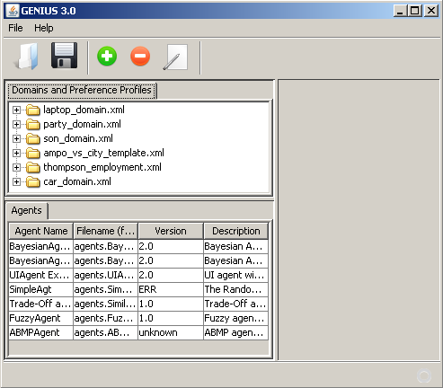
Figure 3. The negosimulator right after start-up.

Step 2: Load the Domain
Load the domain specification that you want to work with, by double-clicking one of the domains in the Domains and Preference Profiles tab, for instance laptop_domain.xml. After loading the laptop domain the simulator will look like Figure 4. The left column shows the laptop domain, with the issues "Laptop", "Harddisk", and "External Monitor". The center column shows the type of the issue. The right column shows the values that are available for the issue.
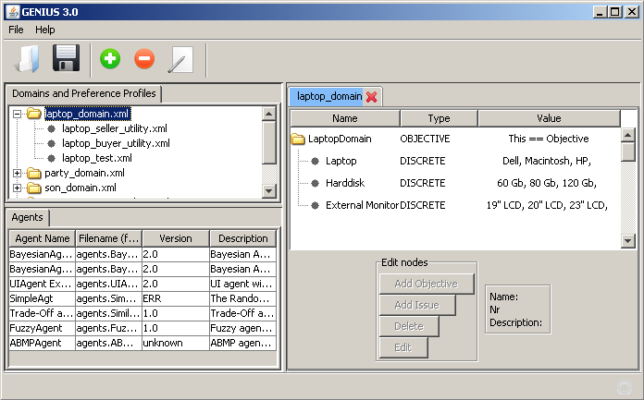
Figure 4. The negosimulator after loading the laptop domain.

Step 3: Create a Preference Profile
We need to extend the domain that has now been loaded into an empty utility space for that domain. In the Domains and Preference Profiles tab, select the domain for which you want to create a new preference profile. Then select File > New > Preferences Profile. After this, the editor should look like Figure 5. New as compared to Figure 4 is the "Weight" column, showing the importance associated with this issue. Notice the numbers and check boxes at the far right. If you do not see them in your window, you may need to resize the window and the headers.

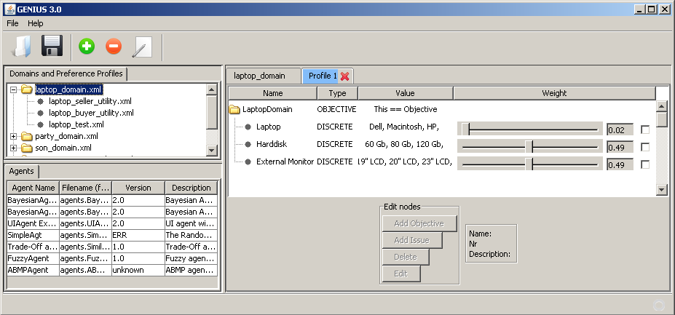
Figure 5. The negosimulator after creating a new utility space.
Now you are ready to start customizing your utility space to reflect your personal preferences. The next two steps will deal with this.

Step 4: Set the Evaluation Values
In this step the utility values for each value will be set for each of the issues. Select one of the issues by clicking on the name of the issue (do not select the "LaptopDomain" which is not an issue). The selected name will turn blue and a large yellow area will appear. Then click the "Edit" button. The editor for discrete issues will pop up (see Figure 6).

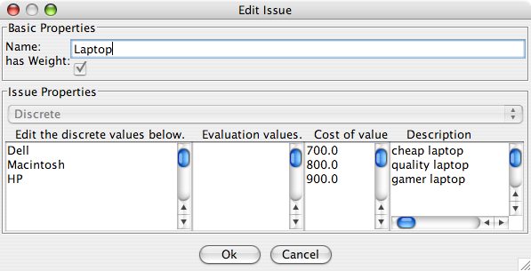
Figure 6. The discrete-issue editor.
Now you can edit the column Evaluation values by clicking in the blank column under "Evaluation values". You can enter the evaluation values, one per line, matching the values on your hand-written profile. Only integer numbers larger than 0 are allowed. To introduce a strong preference of one issue over other issues, just make the number very large. The window will look like Figure 7 after editing.
Do not edit the first column. Doing so will change the domain, resulting in a utility space that does not fit the laptop domain. The other columns should not be edited either for the same reasons. The editor will not allow editing of these values anyway, but you can also edit the xml files by hand in which case you have to be careful not to touch those fields.
When adjusting the evaluation values, keep in mind that the utility of a bid will be zero if the cost constraint is violated (see Equation ).

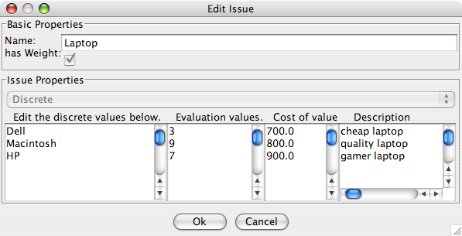
Figure 7. The discrete-issue editor after entering the evaluation values.
If you are satisfied with the evaluation values, press the Ok button. If you entered an illegal value, a warning will appear and the evaluation values will not be changed. Repeat step 4 for the other issues, until all evaluation values of all issues have been set.

Step 5: Set the Issue Weights
As a final step to tune your utility space, you can adjust the relative weights of the issues, by using the sliders next to that issue. You can lock the weight value of an issue by clicking the checkbox next to the slider. The sum of the weights is automatically kept at 1, causing all unlocked sliders to change when you drag one of them.

Step 6. Save your Utility Space
Once you have set all sliders and have filled out the evaluations for the options under each issue, select File > Save or click the save button, and save your file. It is possible to save incomplete utility spaces as well, for later completion. Use an appropriate filename that refers to the domain it is related to, and makes clear it is a utility space file, e.g. laptop_buyer_utility.xml. The preference profile is automatically added to the repository under the domain.

4. Running Negotiations
To run a negotiation session, select File > New > Negotiation Session. The Session tab pops up (Figure 8).

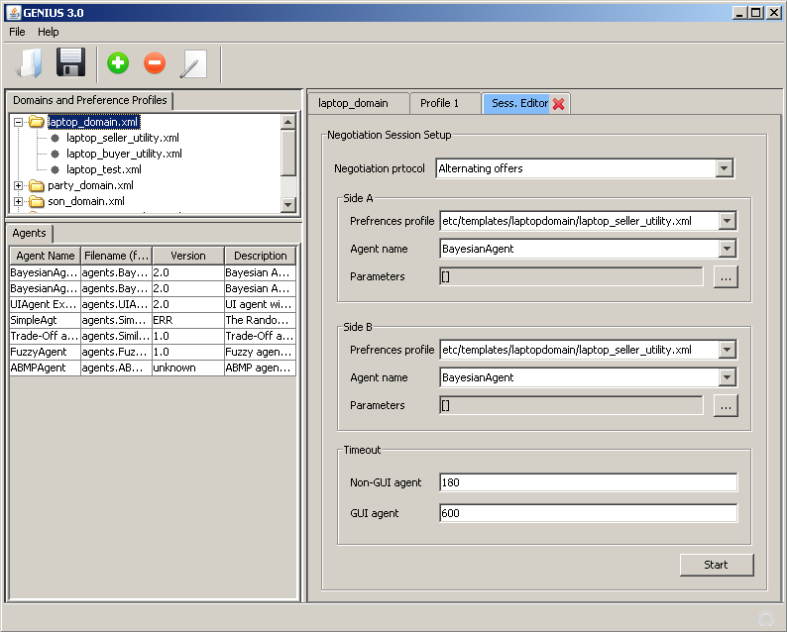
Figure 8. The negotiation set-up screen.
You need to set up the following items:
- The negotiation protocol. Only the Alternating offers is possible at this time. You can also use “Alternating Offers with separate deadlines (deprecated)” protocol for backwards compatibility with agents written for older versions of Genius.
- Agent A/B preferences profile: the xml file containing the utility space of agent A/B. Usually this is a file with a name like laptop_A/B_utility.xml.
- Agent A/B name: the name of the negotiation agent that party A/B in the negotiation wants to use. You can use the provided agents, or use your own agent placed in the directory containing the negotiator.jar file. UIAgent allows you to manually control party A/B in the negotiation. SimpleAgent is an agent that automatically handles the negotiation for party A/B.
After these fields have been set appropriately, you can press the Start button to run the negotiation sessions.

Using an Automatic Agent
If you selected an automatic negotiation agent, for instance SimpleAgent, there will not appear any window while that agent has the turn. The agent should pose its bid within a reasonable time. After the agent made its bid, the other agent is given the turn. If both agents are automatic, no windows will appear at all during the entire negotiation, and only the output windows will show the ongoing negotiation results.

Using the UIAgent
If you selected the UIAgent for Agent A/B, the window as shown in Figure9 will pop up every time input from negotiation agent A/B is needed.

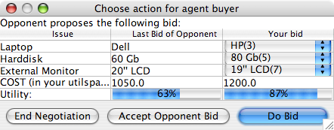
Figure 9. The GUI of UIAgent.
This GUI has three main components: the text field at the top level, the table showing the last bid and a possible next bid, and a row of buttons at the bottom.
The text field shows some text about the current negotiation state.
The table has three columns:
- The left column shows the names of the issues in the domain
- The center column shows the evaluation values for the issues as proposed in the last bid of the opponent (or "-" if this is the first round)
- The right column shows the current picked values for the issues. You can edit the current pick by clicking on the fields, which will open the combo boxes in the fields (Figure 90).

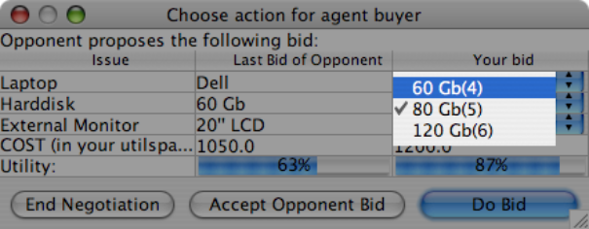
Figure 90. Combo box opens after clicking on a field, allowing change of the picked values for the next bid.
The last two rows of the table show the cost and utility of the last opponent's bid and your current bid. The cost field will turn red if you exceed the maximum cost of 1200. The utility is shown as a percentage, and also as a bar of matching size. These values are computed according to your utility space, as that determines your score, and also because you have no access to the opponent's utility space. The lower three buttons allow you to submit the next bid as set in the right column, or to accept the opponent's last bid.

Using the Extended UIAgent
The extended UIAgent is similar to the UIAgent. It additionally shows a table and a plot of the utilities of all bids made in the session (Figure 11).
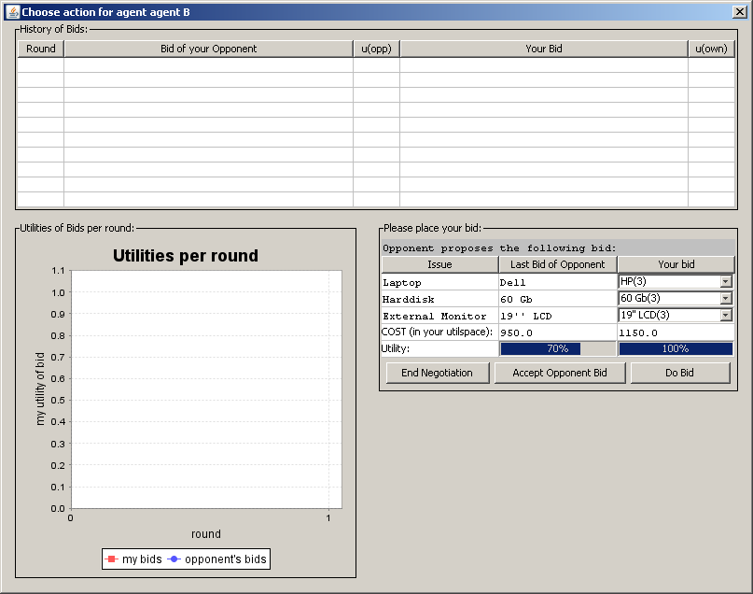
Figure 11. The GUI of UIAgent Extended.

Negotiation Results
There are two types of results: the utility plot and the utility of the last bid for each round. Both are shown in the Progress tab, as displayed in Figure 12.

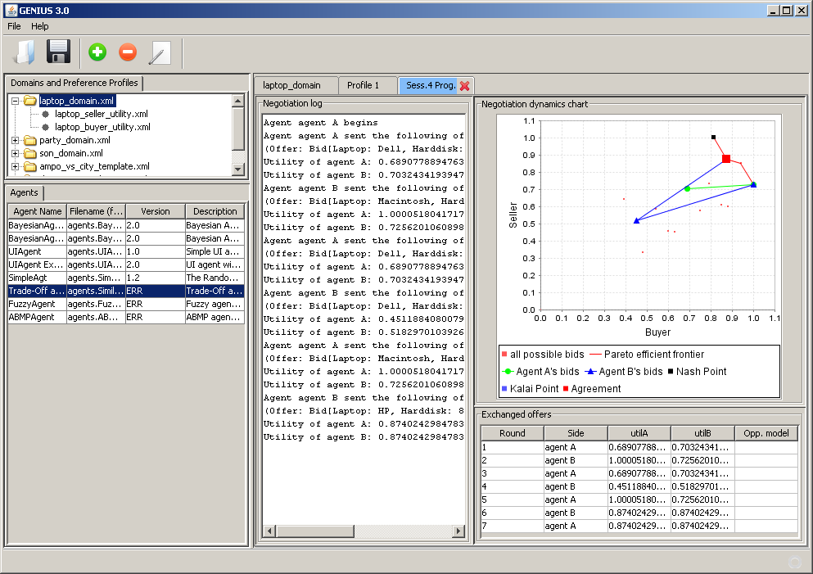
Figure 12. Progress tab. The utility plot also shows the Pareto Frontier (the red line), and the bidding sequence of agent A and agent B (the green and the blue lines).

The Utility Plot
A utility plot will be provided during each negotiation. The plot shows points corresponding to all possible bids, the Pareto Frontier, Nash and Kalai points, all bids made by both agents and the final agreement.

Exchanged Offers
The results of the negotiation are shown in the Exchanghed Offers part. This shows four columns: the session number, the final utility for agent A and B, and the Protol ErrorRemarks column. The utilities are the utilities of the final, accepted bid, as measured in the utility spaces of agent A and B (see the section Utility of a Bid).

Running a Tournament
Besides running a single negotiation session, it is also possible to run a tournament. In a tournament, a negotiation session is held for every possible combination of chosen agents and preference profiles for each side. To do this, select File > New > Tournament. The Tournament tab will appear as displayed in Figure 13.
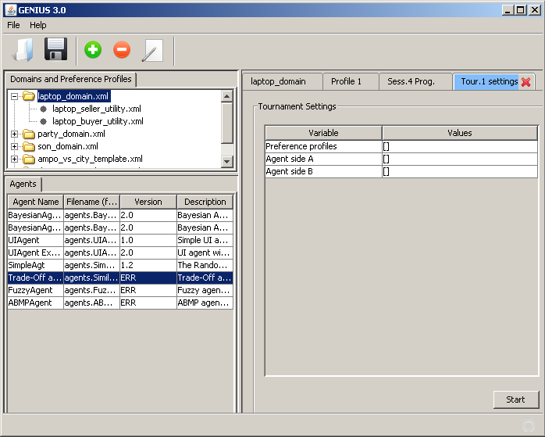
Figure 13. Tournament tab.
Double-click Preference profiles and select at least two profiles from the window that pops up (Figure 14). For every chosen domain, at least two profiles should be chosen. For example, choose laptop_seller_utility.xml and laptop_buyer_utility.xml.

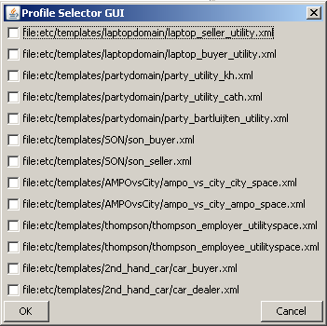
Figure 14. Profile Selector.
Next, double-click Agent side A and select one or more agents from the window that pops up. Do the same for Agent side B and press the Start button. A Progress tab will appear as dispayed in Figure 15. This tab contains the same information as a Progress tab for a single negotiation session, but additionally it has a tournament overview. If you click on a session in this overview, the details of that session will be diplayed.

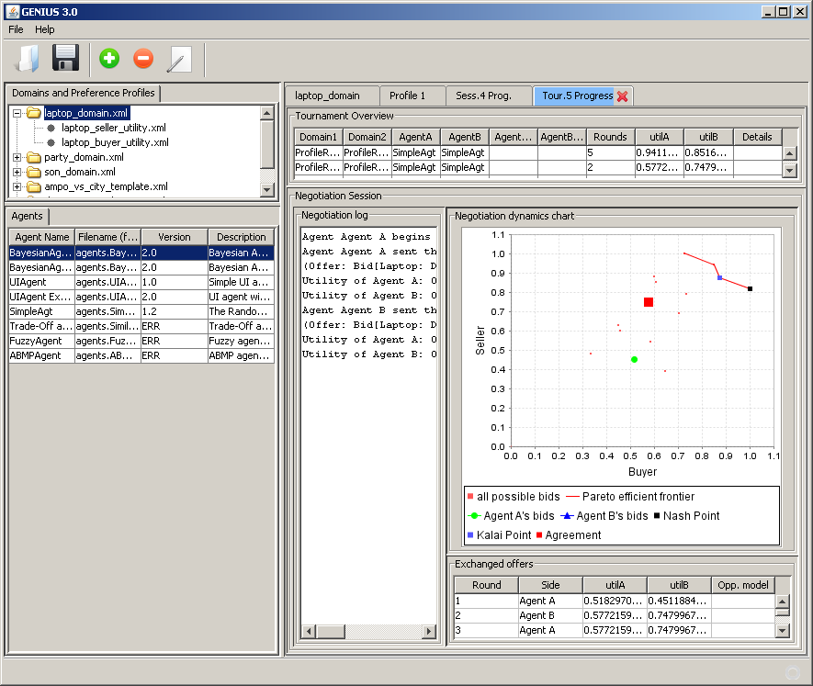
Figure 15. Progress tab for a tournament.

5. Writing a Negotiation Agent
This section discusses how you create an automatic negotiation agent. To explain this, the SimpleAgent.java code as provided in the installation package will be discussed.
It is assumed that you are familiar with programming in Java. In case you need more information about JAVA programming, please use the following link: http://java.sun.com/docs/books/tutorial/index.html. The Java API definitions can be found on http://java.sun.com/j2se/1.5.0/docs/api/index.html.
In the first place, a negotiation agent has to extend the negotiator.agents.Agent class. Table 1 shows the fields and methods of this class.

Table 1. Methods and fields of the Agent class
UtilitySpace utilitySpace
the current utility space. This usually is an instance of the UtilitySpace that you specified in the negotiation set-up screen (Figure 8)
public Timeline timeline
Use timeline for everything time-related, such as getTime().See the Timeline class for more details.
public void sleep(double fraction)
Let the agent wait. Example:
sleep(0.1) will let the agent sleep for 10% of the negotiation time (as defined by the Timeline).
Date startTime
Deprecated. Please use timeline.
the start time for the current negotiation session
Integer totalTime
Deprecated. Please use timeline.
the total available time (seconds) to complete the current negotiation session
public double getUtility(Bid bid)
A convenience method to get the utility of a bid. This method will take discount factors into account, using the status of the current timeline.
void init()
Informs the agent about beginning of a new negotiation session
void ReceiveMessage(Action opponentAction)
Informs the agent which action the opponent did
Action chooseAction()
This function should return the action your agent wants to make next.
This function is called immediately after a ReceiveMessage, and only if the opponent made an Offer or if this is the first round in the session.
String getName()
returns the name of the agent
Integer sessionTotalNumber
Informs you about the total number of sessions with the same opponent and using the same utility spaces.
Integer sessionNumber
A unique number identifying the current negotiation session in the sessionTotalNumber.

By extending Agent, your agent can access the fields as it likes.
To implement your agent, you have to override two or three three classes:

- public void ReceiveMessage(Action opponentAction)
- public Action chooseAction()
- public void init ()

Init
An important consideration for the implementation is that an agent may participate in multiple negotiation sessions with the same opponent. This enables the agent to learn from the previous sessions. For this reason, the negotiation environment calls the method init before starting the new session.

ReceiveMessage
The ReceiveMessage(Action opponentAction) informs you that the opponent just did opponentAction. The opponentAction may be null if you are the first to place a bid, or an Offer containing the bid of the opponent. It may also be an Accept or EndNegotiation action.
The chooseAction() asks you to return an Action to make the next step in the negotiation.

In the SimpleAgent code, the following code is available for ReceiveMessage (Figure 10). This will be the typical code for automatic negotiation agents.

public void ReceiveMessage(Action opponentAction)
{ actionOfPartner = opponentAction; }
Figure 10. Example code for ReceiveMessage

ChooseAction
Figure 11 shows the example code for the chooseAction method. For safety, all code was wrapped in a try-catch block, because if our code would accidentally contain a bug we still want to return a good action (failure to do so is a protocol error – see Negotiation Protocol – and results in a score of 0 for us!).
The sample code works as follows. If we are the first to place a bid, we place a random bid with sufficient utility (see the .java file for the details on that). Else, we determine the probability to accept the bid, depending on the utility of the offered bid and the remaining time. Finally, we randomly accept or pose a new random bid.

public Action chooseAction()
{
Action action = null;
try {
if(actionOfPartner==null)
action = chooseRandomBidAction();
if(actionOfPartner instanceof Offer)
{
Bid partnerBid = ((Offer)actionOfPartner).getBid();
double offeredutil=
utilitySpace.getUtility(partnerBid);
// get current time
double time = timeline.getTime();
double P=Paccept(offeredutil,time);
if (P>Math.random()) action = new Accept(this);
else action = chooseRandomBidAction();
}
Thread.sleep(1000); // just for fun
} catch (Exception e) {
System.out.println("Exception in
ChooseAction:"+e.getMessage());
action=new Accept(this);
}
return action;
}
Figure 11. Example code for chooseAction
The Paccept function is a probabilistic acceptance function where P equals

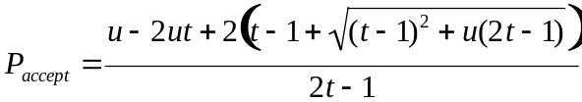 ()

Where u is the utility of the bid made by the opponent (as measured in our utility space), and t is the current time as a fraction of the total available time.
Figure 12 shows how this function behaves depending on the utility and remaining time. It can take quite some time to figure out a formula that suits the requirements, but it is at the heart of the example agent.
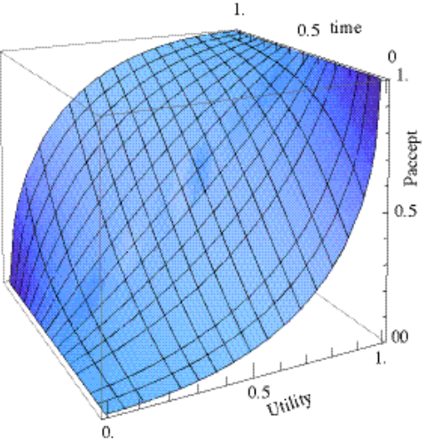
Figure 12. Paccept value as function of the utility and time (as a fraction of the total available time)
The UtilitySpace and its functions should be considered as 'given',
You may want to override the init function, to catch the sessionNumber and sessionTotalNumber. See the SimpleAgent.java example file.
Automatic agents have to negotiate on their own, and are not allowed to communicate with a human user Therefore, do not override the isUIAgent() function in automatic negotiation agents.

Compiling an Agent
To compile the agent, you put YourAgent.java code in the directory containing the negotiator.jar file, and use the command line

javac -cp negosimulator.jar YourAgent.java

After compilation, the resulting YourAgent.class file can be loaded into the negotiator simulator by typing "YourAgent" (fill in your actual agent name) in the negotiation set-up screen (Figure 8). Make sure your agent can be found in the same directory structure as is indicated by its package header.

6. Data structures
This section discusses the datastructures that are relevant when writing a negotiation agent. Only the functions that fetch information out of the available datastructures will be discussed, as modification of these datastructures is strongly discouraged in this context.
The following sections discuss the methods of the relevant objects in more detail. For a number of data structures the constructor is not given, as the readily provided objects should be used.

Domain
Objective getObjective(int ID)
ID is the ID of the objective
returns the objective with the given ID.
Bid getRandomBid()
returns a bid with randomly set values. The bid may have utility 0.
ArrayList<Issue> getIssues()
get all issues as an arraylist.

ValueDiscrete (implements Value)
ISSUETYPE getType()
returns ISSUETYPE.DISCRETE.
String getValue()
returns the String associated with this Value

IssueDiscrete (implements Issue)
int getNumber()
returns the issueID of this issue.
String getName()
returns the name of the issue
int getNumberOfValues()
returns the number of values available for this issue.
String getDescription()
returns the description for this issue.
ValueDiscrete getValue(int n)
returns the n^{th} value of this issue. n can be 0..getNumberOfValues()-1.
String getStringValue(int n)
returns the n^{th} value of this issue as a String.
int getValueIndex(String s)
returns the index number n for which getStringValue(n)=s.
ArrayList<ValueDiscrete> getValues()
returns an ordered list with all values associated with this issue.

UtilitySpace
Evaluator getEvaluator(int index)
index is the IDnumber of the issue.
returns an evaluator for the objective or issue.
double getUtility(Bid bid) throws Exception
computes the utility of a given bid in your utility space, without regard to any discount factors. This is in fact the weighted sum of getEvaluation().
Can throw an exception if there is a problem with the computations, for instance if the utility space contains illegal weights or evaluators.
public double getUtilityWithDiscount(Bid bid, Timeline timeline)
Let d in (0, 1) be the discount factor. (If d <= 0 or d >= 1, we assume that d = 1.)
Let t in [0, 1] be the current time, as defined by the Timeline.
We compute the discounted utility discountedUtility as follows:

discountedUtility = originalUtility * d^t.
double getEvaluation(int pIssueIndex, Bid bid)
throws Exception
Computes the utility of one of the issues (pIssueIndex) in a bid. This just translates to a call to EvaluatorDiscrete.getEvaluation.
boolean constraintsViolated(Bid bid)
Check that the constraints are not violated in this bid. Returns true if the bid violates the constraints. In the current negotiator system, the only, hard coded constraint is that getCost(bid)≤1200. This constraint is used with every utility space.
Bid getMaxUtilityBid() throws Exception
returns a bid with the maximum utility value attainable in this utility space.
Throws an exception if there is no bid at all in this utility space
double getWeight(int issueID)
returns the weight of the issue with given issueID
Objective getIssue(int index)
does exactly the same as Domain.getIssue
Domain getDomain()
returns the domain
Double getCost(Bid bid) throws Exception
returns the cost of the given bid. throws if cost can not be computed for some reason.

Bid
fDomain
variable holding the domain
Bid(Domain domainP, HashMap<Integer,Value> bidP)
throws Exception
constructor for a Bid.
The bidP is a hashmap that maps issue IDs to Values (which are Strings).
Will throw exception if not all issues in the domain are assigned a value.
Value getValue(int issueNr) throws Exception
returns the picked value for a given issue ID number.
void setValue(int issueId, Value pValue)
sets the value for issue with issueId to pValue.
boolean equals(Bid pBid)
returns true if bids are equal
HashMap<Integer, Value> getValues()
returns the entire set of bid values

EvaluatorDiscrete (implements Evaluator)
double getWeight()
returns the weight for this evaluator, a value in [0,1].
Integer getValue(ValueDiscrete alternativeP)
returns the non-normalized evaluation-value
may return null if the alternativeP is not a value, or when the value has not been set.
Integer getEvalMax() throws Exception
returns the largest evaluation value available.
Throws if there are no evaluation values available.
Double getEvaluation(UtilitySpace uspace, Bid ID,
int index) throws Exception
returns the normalized evaluation value ( in equation )
Double getEvaluation(ValueDiscrete v) throws Exception
returns the normalized evaluation value of value v
(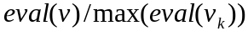 in equation )
Double normalize(Integer EvalValue) throws Exception
EvalValue is the evaluation value to be normalized
returns 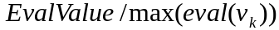
throws if the EvalValue is null, or if the normalization fails.
Double getCost(Value value)
value is the value of which the cost is needed
returns the cost for given value, or null if no cost available for value.
double getMaxCost()
returns the maximum of the costs for this evaluator.
Double getCost(UtilitySpace uspace, Bid bid, int id)
throws Exception
Returns the cost of issue with given id. May throw if the bid is incomplete or utilityspace has problems
Value getMaxValue()
returns the first value that has the maximum evaluation-value.
Value getMinValue()
returns the value that has the smallest evaluation-value

Timeline
public double getTime()
Get the time, running from t = 0 (start) to t = 1 (deadline). The time is normalized, so agents need not be concerned with the actual internal clock. Please use Agent.sleep(double) for pausing the agent.

7. Conclusions
Any comments and suggestions on the negotiation system and manuals can be mailed to ai@mmi.tudelft.nl.

References
[sun07] Sun Developer Network, JDK 6 Update 3. http://java.sun.com/javase/downloads/index.jsp

