# **ACKNOWLEDGEMENT FORM**

**I,** AHMED OLANREWAJU SODIQ ……………………………………………………………………………………………

**Last Name Middle Name First Name**

of…Softworks Software & Infrastructure Services ASH191754C …..…………………………………………………………………………………

**Company Department Staff Number**

hereby acknowledge that I have read the Corporate Communication Policy and have been given the opportunity to seek for clarifications in order to fully understand its contents and provisions. I therefore hereby willingly agree to abide by the contents and provisions of the handbook.

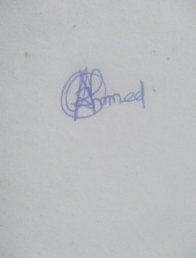

Signature:

Date: 11/17/2020

* This form must be completed and sent to HR department one week after receiving a copy of the staff handbook either by mail or hard copy.