**NAME: OGUNTOLU IRETIOLA D.**

**MATRIC NO: NCSF/15/0055 COURSE CODE: COM 213**

**SOURCE CODE**

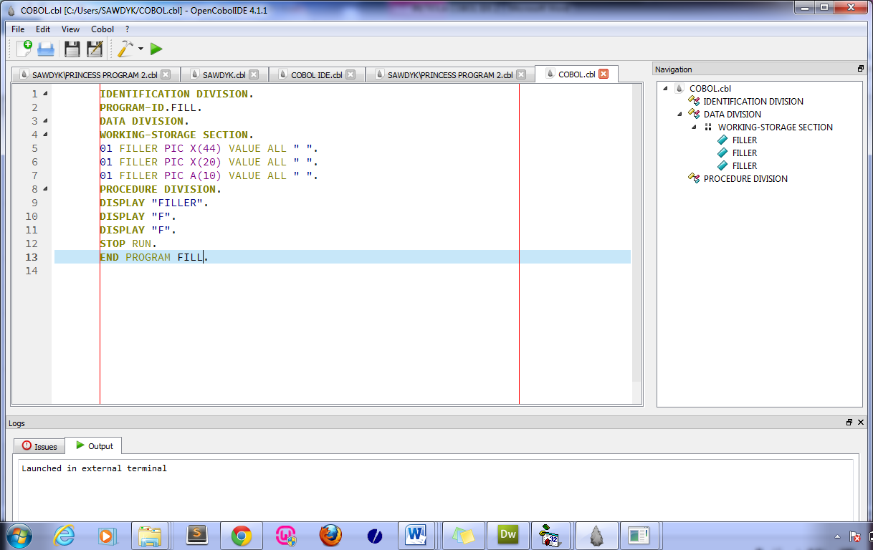

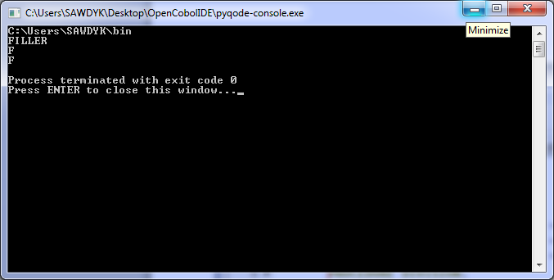**OUTPUT**