**NAME:** OGUNTOLU IRETIOLA DEBORAH

**DEPT:** COMPUTER SCIENCE

**COURSE CODE:** COM216 **LEVEL:** ND2

**COURSE TITLE:** COMPUTER TROUBLE SHOOTING 1 (PRACTICAL 1)

**Question: Differentiate between primary and secondary storage**

**PRIMARY STORAGE**

Primary storage, also known as main storage or [memory](http://searchmobilecomputing.techtarget.com/definition/memory), is the area in a computer in which [data](http://searchdatamanagement.techtarget.com/definition/data) is stored for quick access by the computer's [processor](http://searchcio-midmarket.techtarget.com/definition/processor). The terms random access memory ([RAM](http://searchmobilecomputing.techtarget.com/definition/RAM)) and [memory](http://searchmobilecomputing.techtarget.com/definition/memory) are often as synonyms for primary or main [storage](http://searchstorage.techtarget.com/definition/storage). Primary storage is [volatile](http://whatis.techtarget.com/definition/volatile) and can be contrasted with [non-volatile](http://searchstorage.techtarget.com/definition/nonvolatile-storage) [secondary storage](http://searchstorage.techtarget.com/definition/secondary-auxiliary-storage), also known as auxiliary storage.

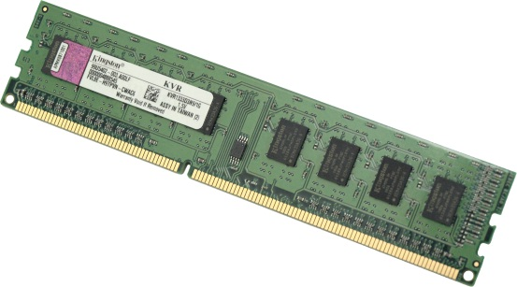

Random Access Memory (RAM)

**SECONDARY STORAGE**

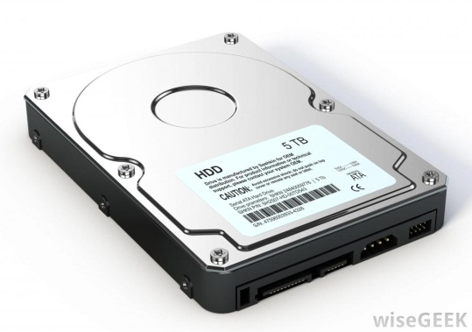Secondary storage, sometimes called auxiliary storage or external storage, is [non-volatile storage](http://searchstorage.techtarget.com/definition/nonvolatile-storage) that is not under the direct control of a computer's central processing unit ([CPU](http://whatis.techtarget.com/definition/CPU-central-processing-unit)) or does not directly interact with an application. Secondary storage, sometimes called auxiliary storage or external storage, is [non-volatile storage](http://searchstorage.techtarget.com/definition/nonvolatile-storage) that is not under the direct control of a computer's central processing unit ([CPU](http://whatis.techtarget.com/definition/CPU-central-processing-unit)) or does not directly interact with an application.

Hard Drive

**NAME:** OGUNTOLU IRETIOLA DEBORAH

**DEPT:** COMPUTER SCIENCE

**COURSE CODE:** COM216 **LEVEL:** ND2

**COURSE TITLE:** COMPUTER TROUBLE SHOOTING 1 (PRACTICAL 2)

**Question: Differentiate between SATA and IDE hardware with image**

**SATA HARDWARE**

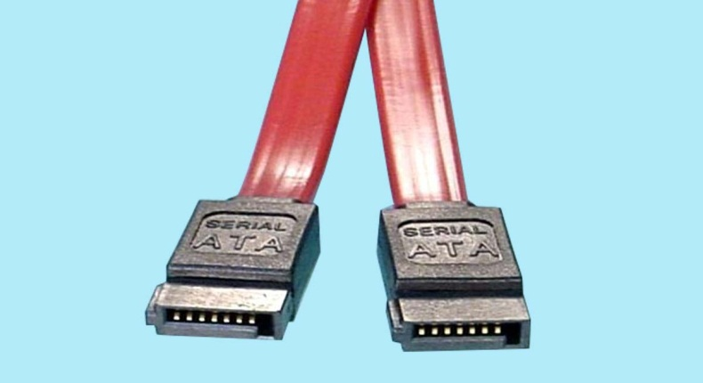Serial ATA (SATA, abbreviated from Serial AT Attachment) is a [computer bus](https://en.wikipedia.org/wiki/Computer_bus) interface that connects [host bus adapters](https://en.wikipedia.org/wiki/Host_adapter) to [mass storage devices](https://en.wikipedia.org/wiki/Mass_storage_device) such as [hard disk drives](https://en.wikipedia.org/wiki/Hard_disk_drive), [optical drives](https://en.wikipedia.org/wiki/Optical_drive), and [solid-state drives](https://en.wikipedia.org/wiki/Solid-state_drive). Serial ATA succeeded the older [Parallel ATA](https://en.wikipedia.org/wiki/Parallel_ATA) (PATA) standard, offering several advantages over the older interface: reduced cable size and cost (seven conductors instead of 40 or 80), native [hot swapping](https://en.wikipedia.org/wiki/Hot_swapping), faster [data transfer](https://en.wikipedia.org/wiki/Data_transfer) through higher signaling rates, and more efficient transfer through an (optional) [I/O](https://en.wikipedia.org/wiki/I/O) queuing protocol.

**IDE HARDWARE**

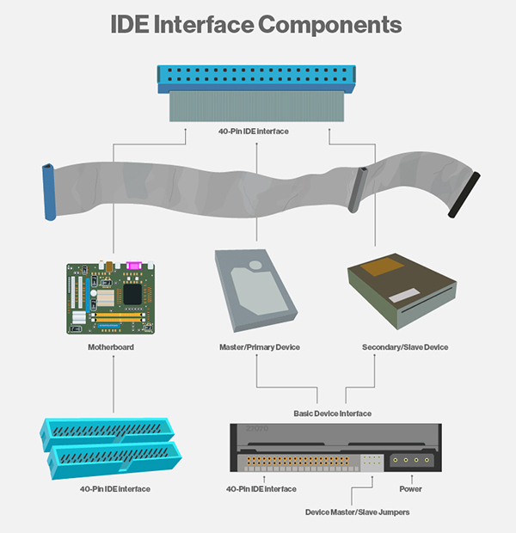IDE (Integrated Drive Electronics) is a standard electronic [interface](http://searchcio-midmarket.techtarget.com/definition/interface) used between a computer [motherboard's](http://searchcio-midmarket.techtarget.com/definition/motherboard) data paths or [bus](http://searchstorage.techtarget.com/definition/bus) and the computer's disk [storage](http://searchstorage.techtarget.com/definition/storage) devices. The IDE [interface](http://whatis.techtarget.com/definition/interface) is based on the IBM PC Industry Standard Architecture ([ISA](http://searchwinit.techtarget.com/definition/ISA)) 16-bit bus standard, but it is also used in computers that use other bus standards. IDE was adopted as a standard by the American National Standards Institute ([ANSI](http://searchdatacenter.techtarget.com/definition/ANSI)) in November 1990.

**NAME:** OGUNTOLU IRETIOLA DEBORAH

**DEPT:** COMPUTER SCIENCE

**COURSE CODE:** COM216 **LEVEL:** ND2

**COURSE TITLE:** COMPUTER TROUBLE SHOOTING 1 (PRACTICAL 3)

**Question: Differentiate between Open motherboard and Close motherboard**

**NAME:** OGUNTOLU IRETIOLA DEBORAH

**DEPT:** COMPUTER SCIENCE

**COURSE CODE:** COM216 **LEVEL:** ND2

**COURSE TITLE:** COMPUTER TROUBLE SHOOTING 1 (PRACTICAL 4)

**Question: Differentiate between clone systems and branded systems**

**BRANDED SYSTEMS**

Branded computers are manufactured by big companies like Packard Bell, Acer, Dell, Compaq, IBM, Gateway and others. These big names have built their reputation over the years. Therefore they do take quality seriously, since their reputation is at stake. Branded computers save time to the user, instead of having to assemble his own personal computer, which can be a difficult task to a non-technical person. When you buy a branded computer you are covered with a guarantee and there are less chance that something will go wrong, than if you had to assemble the computers yourself. The difference between branded and assembled computers is that while branded computers are built in mass productions plants, assembled computers are built by a technical person or by the computer owner.

When one buys a branded computer, he has a quality assurance that the computer components have been tested thoroughly. A branded company is expected to make use of quality parts and not cheap ones. This means that the computer owner gets good quality for a reasonable price. Branded computers are expected to give stable performance since all parts are manufactured by the same company, while in assembled computers one can experience hardware conflicts and other technical problems. The buyer also enjoys experienced technical support from the mother company, while if you buy an assembled computer you are at the mercy of the after sales service of the shop keeper. Another advantage of a branded computer is that it looks unique in design and professional. Branded computers contain original software such as operating system and common applications. Even extended warranties are available. Branded computers come with PC restore CD.

**CLONING**

In [computing](https://en.wikipedia.org/wiki/Computing), a **clone** is a [hardware](https://en.wikipedia.org/wiki/Computer_hardware) or [software](https://en.wikipedia.org/wiki/Software) system that is designed to function in the same way as another system. Specific subsets of clones are **Remakes** (or **Remades**), which are revivals of old, obsolete, or discontinued products.

A clone is an identical copy of something and is a term that first became familiar to the public from the biosciences. In the computer industry, the term became widely used in referring to imitations of the IBM PC by Compaq, Dell, and others. Clones of the PC allowed users to purchase a comparable personal computer at a much lower price than that offered by IBM and helped make PCs affordable for more people. While the term has fallen mostly into commercial disuse, the term clone for PCs still applies to a PC made to entry-level or above standard (at the time it was made) which bears no commercial branding (e.g., [Acer](https://en.wikipedia.org/wiki/Acer_Inc.), [IBM](https://en.wikipedia.org/wiki/IBM), [HP](https://en.wikipedia.org/wiki/Hewlett-Packard), [Dell](https://en.wikipedia.org/wiki/Dell)). This includes, but is not limited to, PCs assembled by home users or Corporate IT Departments.

**NAME:** OGUNTOLU IRETIOLA DEBORAH

**DEPT:** COMPUTER SCIENCE

**COURSE CODE:** COM216 **LEVEL:** ND2

**COURSE TITLE:** COMPUTER TROUBLE SHOOTING 1 (PRACTICAL 5)

**Question: Explain what you understand by POST (Power On Self-Test)**

**POST (Power On Self-Test)**

When power is turned on, POST (Power-On Self-Test) is the diagnostic testing sequence that a computer's [basic input/output system](http://whatis.techtarget.com/definition/BIOS-basic-input-output-system) (or "starting program") runs to determine if the computer keyboard, [random access memory](http://searchmobilecomputing.techtarget.com/definition/RAM), disk drives, and other hardware are working correctly.

If the necessary hardware is detected and found to be operating properly, the computer begins to [boot](http://searchwinit.techtarget.com/definition/boot). If the hardware is not detected or is found not to be operating properly, the BIOS issue an error message which may be text on the display screen and/or a series of coded beeps, depending on the nature of the problem. Since POST runs before the computer's video card is activated, it may not be possible to progress to the display screen. The pattern of beeps may be a variable numbers of short beeps or a mixture of long and short beeps, depending on what type of BIOS is installed.

The patterns of beeps contain messages about the nature of the problem detected. For example, if the keyboard is not detected, a particular pattern of beeps will inform you of that fact. An error found in the POST is usually fatal (that is, it causes current program to stop running) and will halt the boot process, since the hardware checked is absolutely essential for the computer's functions.

