

SMARTSKEP SOLUTION LIMITED
[Grab your reader’s attention with a great quote from the document or use this space to emphasize a key point. To place this text box anywhere on the page, just drag it.]

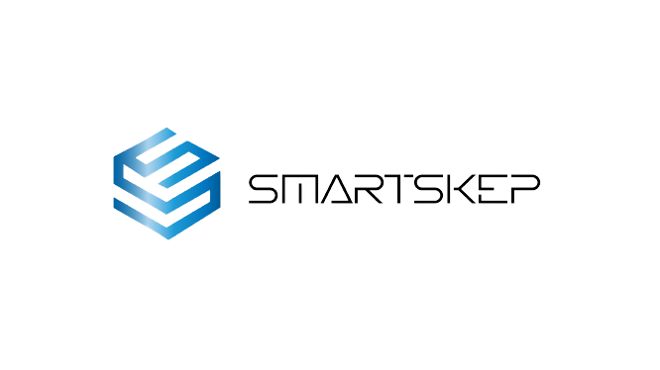
Smartskep is a premier software development firm that specialises in developing unique, custom software solutions to complicated business issues. We were founded in 2017 and have established ourselves as a trusted partner for organisations looking to harness technology for growth and efficiency.
Introduction
Company Principles:
About Us
Excellence: We are devoted to providing high-quality software solutions founded on knowledge and precision.
"Our mission at Propylene is to create exceptional software that transforms businesses." We are motivated by a desire for coding excellence and a desire to provide solutions that enable our clients to prosper in the digital era."
Innovation: Our enthusiasm for innovation motivates us to constantly investigate new technology and innovative methods to solve complicated problems.
We operate with honesty, openness, and a strong sense of ethical responsibility.
Collaboration is key to our success, promoting synergy among team members, clients, and partners.
Our services are tailored to a wide range of sectors, including startups aiming to launch revolutionary apps, existing businesses in need of software modernization, and organisations wishing to optimise their operations with specialised software solutions.

- Software Development : We create and construct customised software programmes that meet the specific needs of our clients, simplifying operations and improving user experiences.
- web and mobile applications: Our team develops flexible web and mobile applications that mix functionality and aesthetics to attract people across many platforms.
- Software Consulting: We provide skilled consulting services to customers to help them through the software development lifecycle, from concept to execution.
- Legacy System Modernization: We help businesses modernize their outdated software systems, ensuring they remain competitive in today's rapidly evolving tech landscape.
Our Services

Our Team
Emma Chidi
Database Administrator

Efe Otome
Database Administrator

Shalem Offiong
Designer
Ola Ojedapo
Senior FrontEnd Dev

Ese Okpako
Senior Backend Dev
Our Clients
https://nikdelan.com/

https://havillahcareers.co.uk/Public/LandingPortal/system-pages/index.php

http://shsclinic.ng/patient/views/index.php


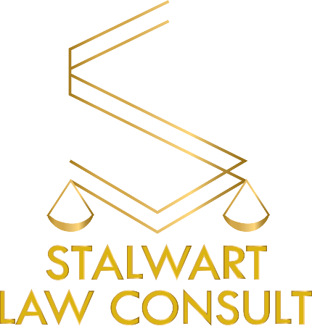



SAVEASE was established to create simple solutions to complex savings problem. http://savease.ng/





Plot 8, Rumuapu, Rukpokwu, PORT HARCOURT, RIVERS STATE
+234(0)9012757248
info@smartskep.com
https://Smartskep.com

Contact Us

