SOFTWARE REQUIREMENTS
SPECIFICATION
for
Relex Ride (E-Bus Ticketing System)
Version 1.0
Prepared by :
1. Md. Md Younus Nobi Sohan(2111458642)
2. Md Esfer Abdus Sami (2112321642)
3. Entiser Hossain (2021789642)

Submitted to :
Professor Dr. Md. Sazzad Hossain
July 19, 2025
Contents
1 Introduction 4
1.1 Purpose 4
1.2 Intended Audience and Reading Suggestions 4
1.3 Project Scope 5
1.4 Definitions, Acronyms, and Abbreviations 6
2 Overall Description 6
2.1 Product Perspective 6
2.2 Product Functions 6
2.3 User Classes and Characteristics 7
2.4 Operating Environment 7
2.5 Design 7
2.6 User Documentation 7
3 System Features 8
3.1 User Authentication: 8
3.2 Profile Management: 8
3.3 Trip Management: 8
3.4 Payment: 8
3.5 Notification: 8
3.6 Jet Setter Features: 8
3.7 Loan Management: 8
3.8 Transaction History: 9
3.9 Digital Wallet: 9
4 Other Nonfunctional Requirements 9
4.1 Performance: 9
4.2 Security: 9
4.3 Usability: 9
4.4 Concurrency: 9
4.5 Reliability: 10
4.6 Scalability: 10
5 External Interface Requirements 10
5.1 User Interfaces 10
5.2 Hardware Interfaces 12
5.3 Software Interfaces 12
6 System Architecture Overview 12
6.1 Use Case Diagram 12
6.2 Class Diagram 13
6.3 Sequence Diagram 14
7 Use Case Descriptions 15
7.1 User Authentication 15
7.2 Trip Management 16
7.3 Transaction History 16
7.4 Digital Wallet 17
7.5 Jet Setter Scheme Management 17
8 Limitations 18
9 Future Enhancements 18

Introduction

Purpose
Our project's aim is to develop a user-centric Flutter mobile application for the Android platform that simplifies the process of purchasing e-bus tickets and enhances the overall commuter experience. By integrating advanced technologies and user-friendly features, we intend to revolutionize the way consumers interact with and utilize e-bus transportation services. Through this application, we aim to achieve the following objectives:
Facilitate easy access to e-bus transportation services, reducing the hassle of booking tickets and planning travel arrangements.
- Enhance user reliability and punctuality by providing proactive push notifications for scheduled trip times and boarding procedures.
- Streamline the ticketing process by offering digital ticketing options, which will eliminate the need for paper tickets and increase user convenience.
- Deliver exceptional customer service and support through dedicated app channels, addressing inquiries, feedback, and assistance requests promptly and efficiently.
- Build trust and confidence in the application by ensuring the security and privacy of users' payment information with secure payment processing features.
- Offer an emergency loan option for premium users to further improve convenience.
Our overarching goal is to elevate the e-bus commuter experience and set new standards in the transportation sector, providing users with a seamless and pleasant journey from start to finish.

Intended Audience and Reading Suggestions
This document is intended for the development team, project stakeholders, testers, academic advisors, and future maintainers of the system. It provides a comprehensive overview of the system's architecture, user requirements, system features, and technical constraints, which will serve as a blueprint during development and maintenance phases.

Project Scope
The Relex Ride mobile application is designed for Android platforms using Flutter and backed by a Flask-powered server. The app facilitates trip booking, user authentication, profile management, and secure payments. Premium features include subscription schemes, emergency loans, and digital wallet functionality. The app is scalable, secure, and user-friendly.

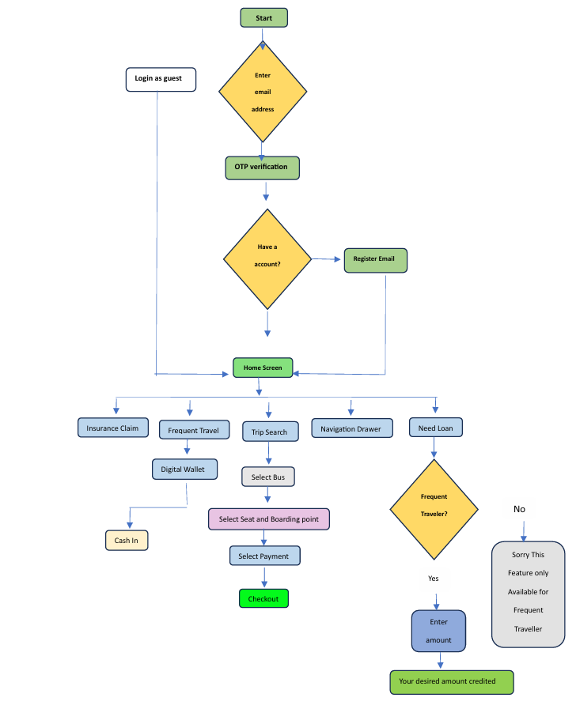

Definitions, Acronyms, and Abbreviations
- UI: User Interface
- UX: User Experience
- API: Application Programming Interface
- SQLite: Structured Query Language Lite (Lightweight Database)
- OTP: One-Time Password
- 2FA: Two-Factor Authentication

Overall Description

Product Perspective
The application is a standalone product intended to replace traditional ticket booking methods with a more digital, user-friendly alternative. It includes a frontend mobile application and a backend server with API support.

Product Functions

The main functions of the application include:
- Registering and authenticating users
- Managing user profiles and roles
- Allowing users to search for bus trips based on filters
- Enabling seat selection and reservation
- Processing digital payments and storing transaction records
- Providing real-time notifications
- Supporting premium features such as subscription plans, digital wallets, and loan applications

User Classes and Characteristics
There are three primary user classes:

- Free Users: These users can register, search for trips, and make bookings.
- Gold Jet Setters: In addition to Free User functionalities, they have access to subscription schemes and digital wallet features.
- Platinum Jet Setters: They enjoy all features including emergency loan options and donation capabilities.

Operating Environment
- Android operating system (version 8.0 and above)
- Flutter framework for mobile frontend development
- Python Flask for backend server development
- SQLite for local database management
- Android Studio and PyCharm as development environments

Design
- The app is designed exclusively for Android in its initial phase.
- Limited to SQLite for local data storage due to resource constraints.
- Booking is limited to a maximum of four seats per transaction to prevent misuse.
- The backend is hosted locally or on low-cost cloud infrastructure.

User Documentation
A detailed user manual will be provided within the app, including step-by-step guides for trip booking, managing wallet balances, and applying for premium features.

System Features

User Authentication:
- Validate user details (e.g., email, password) during registration.
- Store user details in the database upon registration.
- Verify user credentials during login.
- Initiate a user session upon successful login.

Profile Management:
- Allow users to input and save profile details.
- Ensure users can update their profiles at any time.

Trip Management:
- Provide search filters for trips.
- Display trip details based on user search criteria.
- Show available seats for selected trips.
- Reserve selected seats for users.
- Generate and display tickets after seat selection.

Payment:
- Handle payment processing for selected seats.
- Confirm booking after successful payment.

Notification:
- Fetch and display notifications to users.

Jet Setter Features:
- Display available subscription schemes.
- Allow users to select their subscription scheme.

Loan Management:
- Display loan options to eligible users.
- Process loan applications.

Transaction History:
- Fetch and display user transaction history.

Digital Wallet:
- Process addition of money to the digital wallet.
- Handle donation transactions made by users.

Other Nonfunctional Requirements

Performance:

- Registration process should be complete within 3 seconds.
- Login process should complete within 2 seconds.
- Search results should load within 2 seconds.
- Ticket view should load within 1 second.
- Transactions should be processed quickly (within a few seconds).

Security:
- Ensure data security and integrity for all transactions.
- Secure payment processing.
- Secure handling of user credentials and personal information.
- Ensure secure processing of loan approvals and donations.

Usability:
- Profile updates should reflect immediately.
- Notifications should be displayed in real-time.
- Scheme selection should be confirmed immediately.
- Deposit transactions should reflect immediately.

Concurrency:
- Support concurrent logins from multiple users.
- Ensure real-time updates for seat selection and availability.

Reliability:
- System should be highly available and handle peak loads without performance degradation.
- Ensure data consistency across different system modules (e.g., profile management, trip management).

Scalability:
- System should be scalable to handle increasing numbers of users and transactions without compromising performance.

External Interface Requirements

User Interfaces
The app features a home screen, login/register screen, trip search page, booking interface, wallet dashboard, and profile management section. UI is built using Flutter widgets ensuring responsiveness and accessibility.

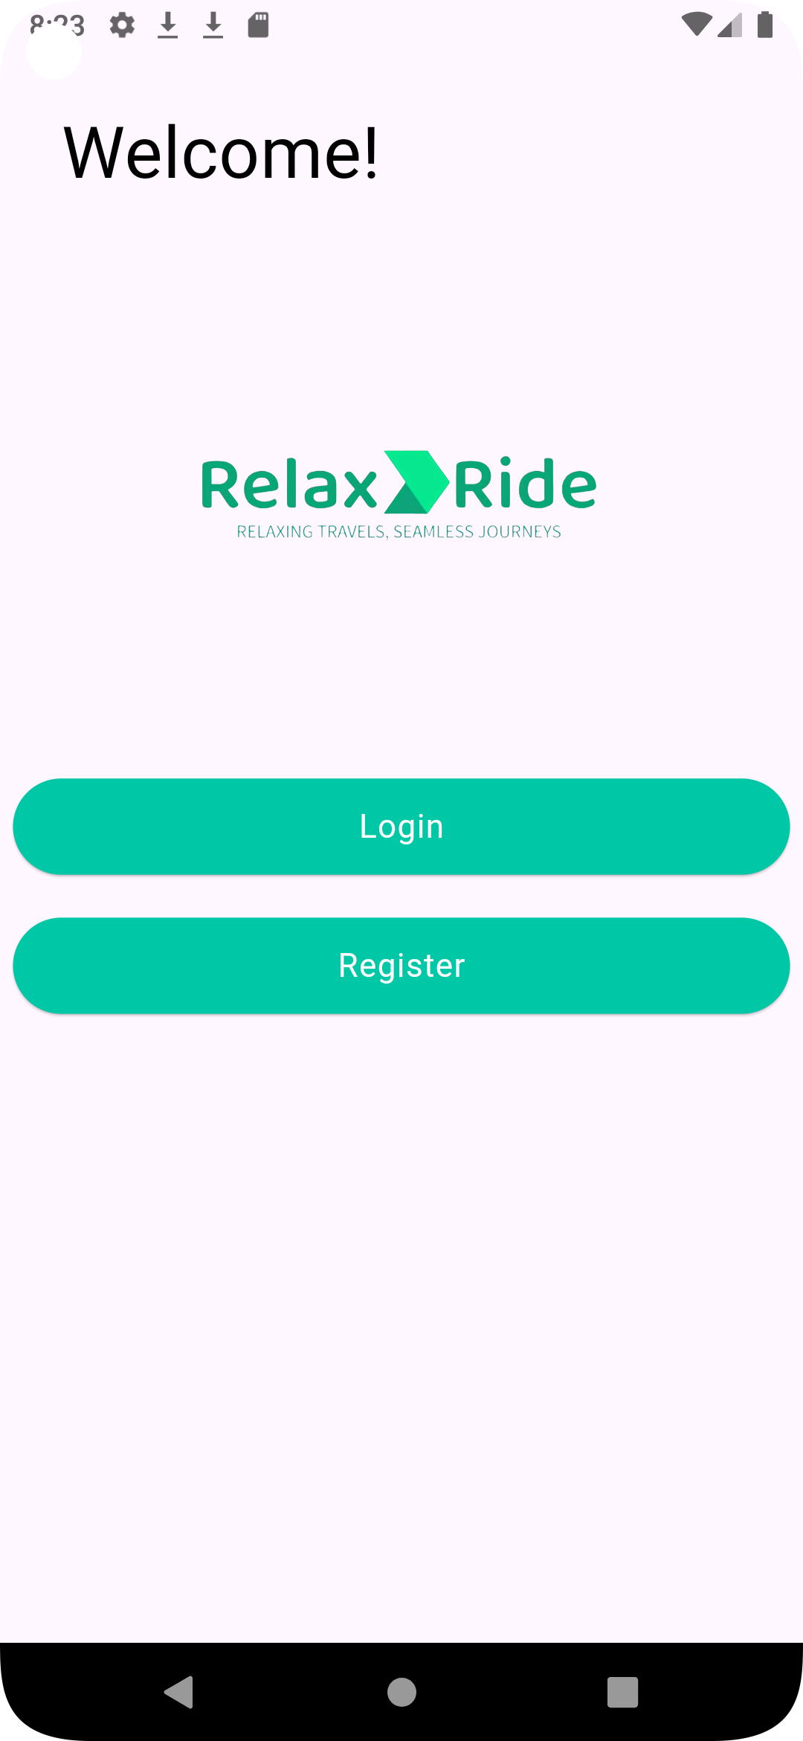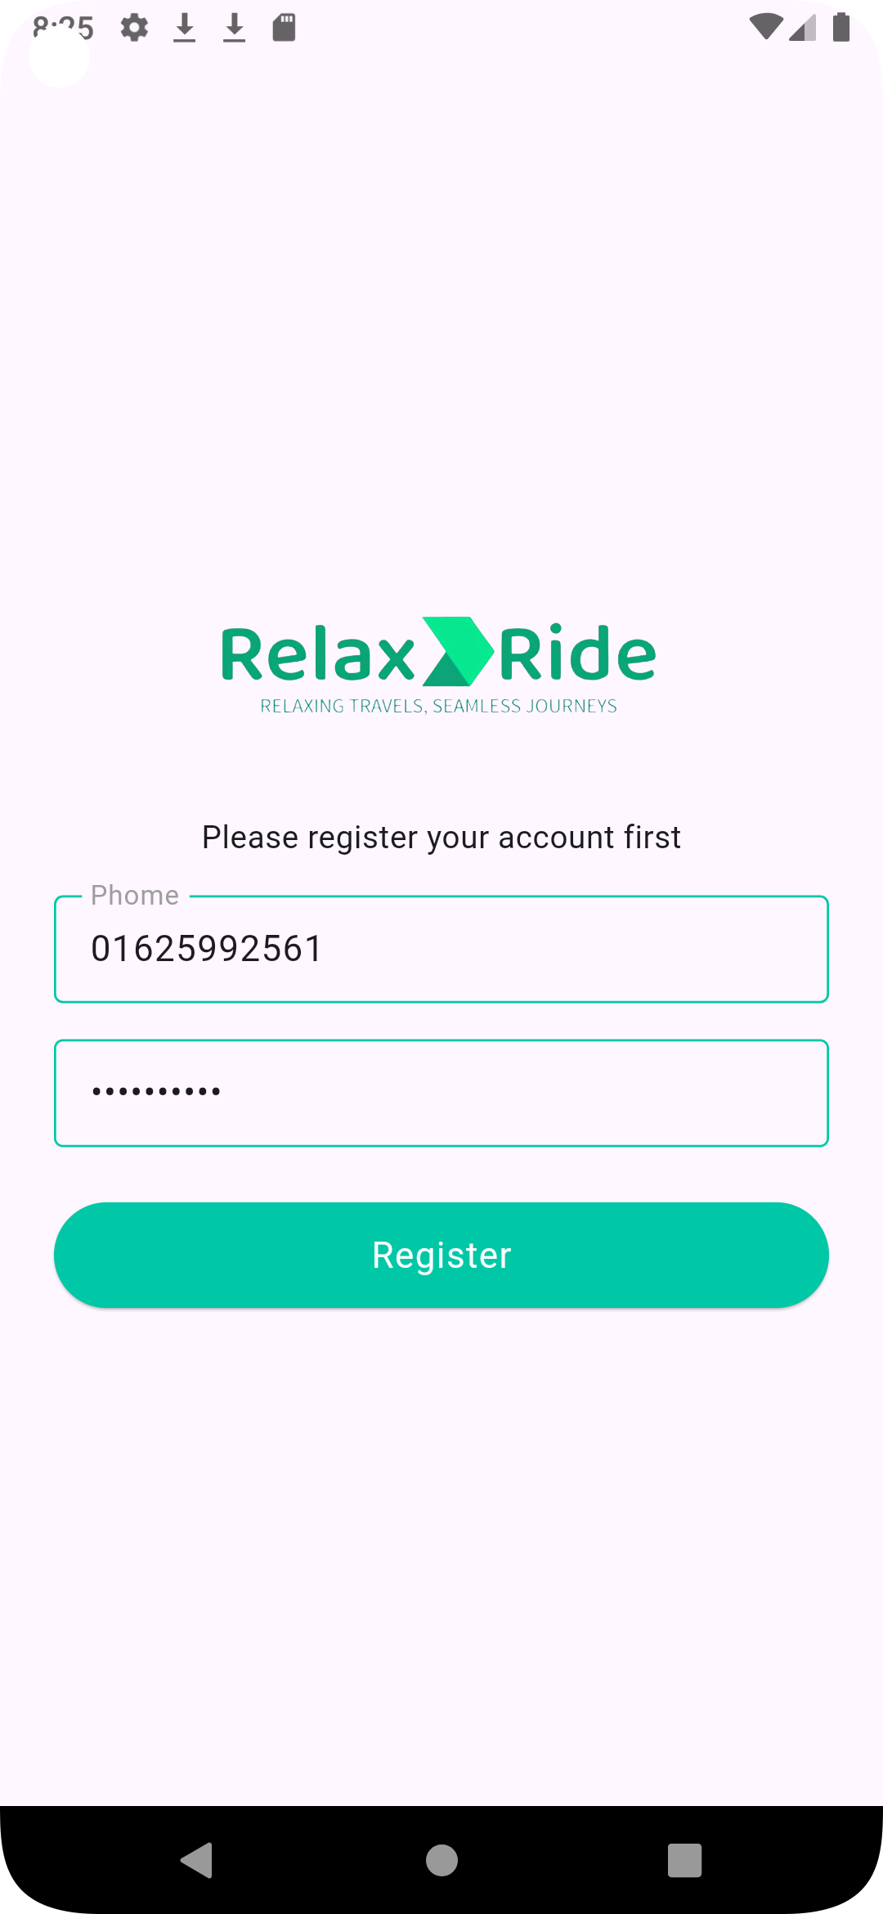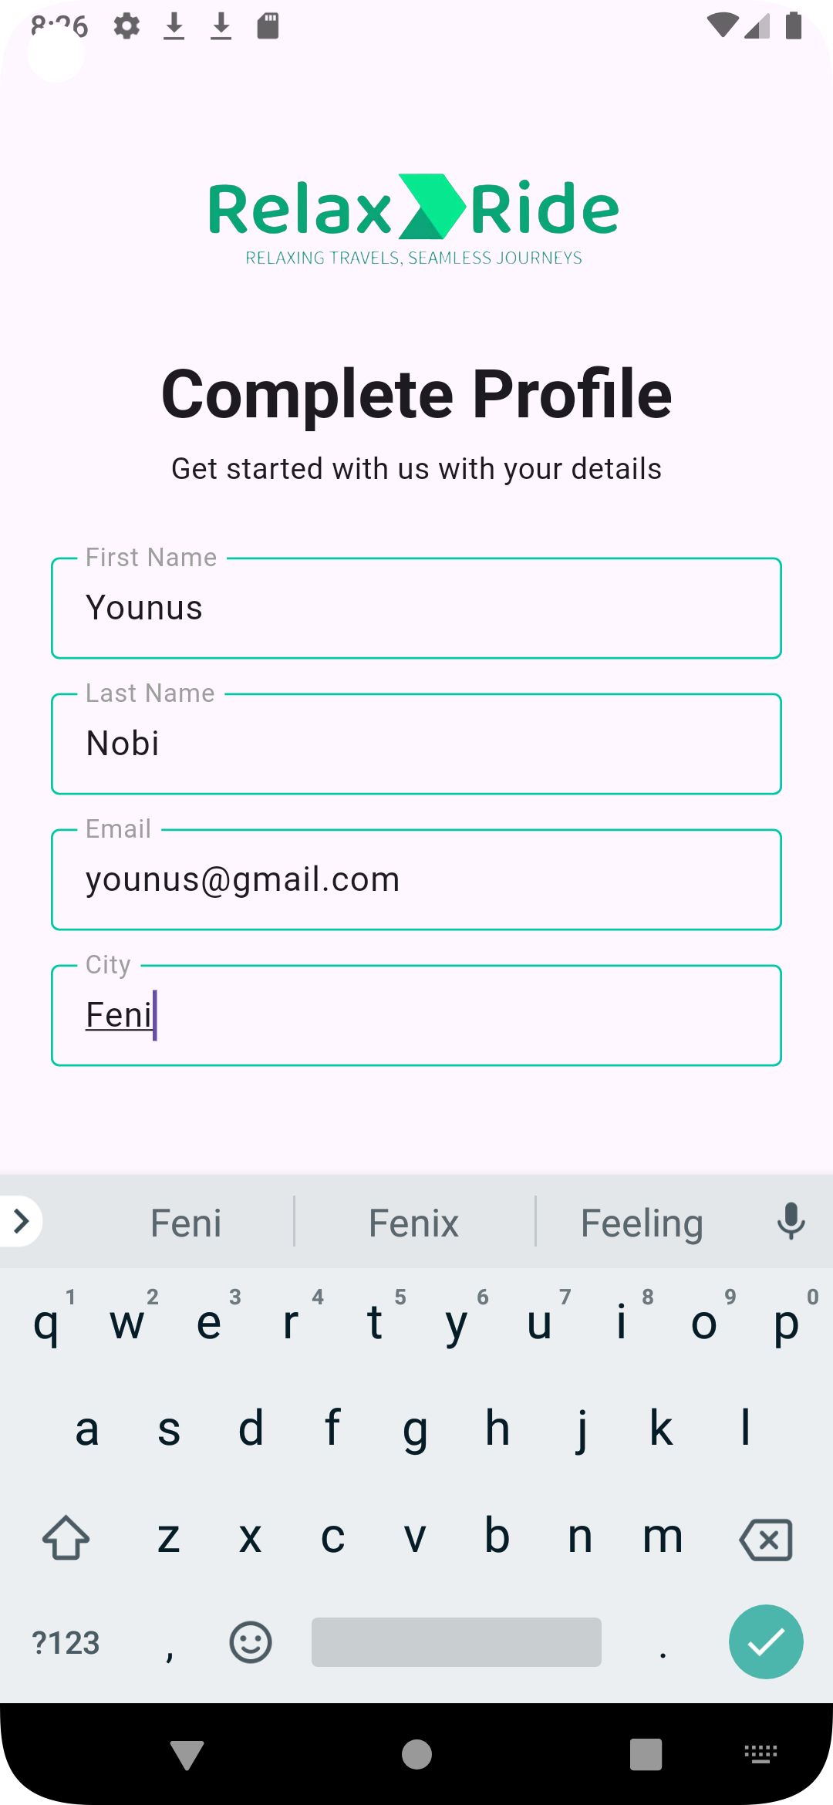
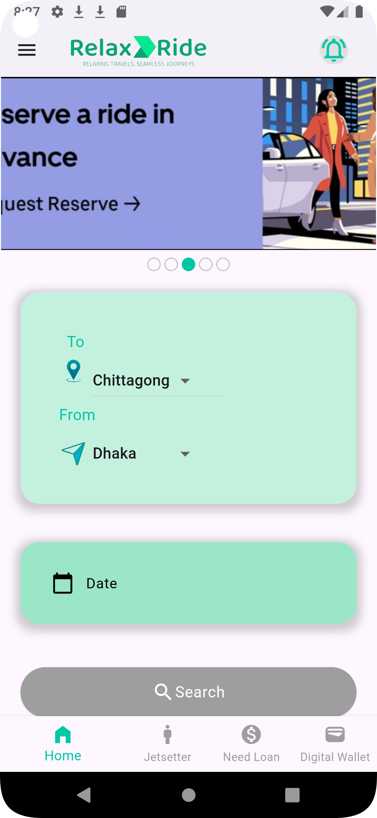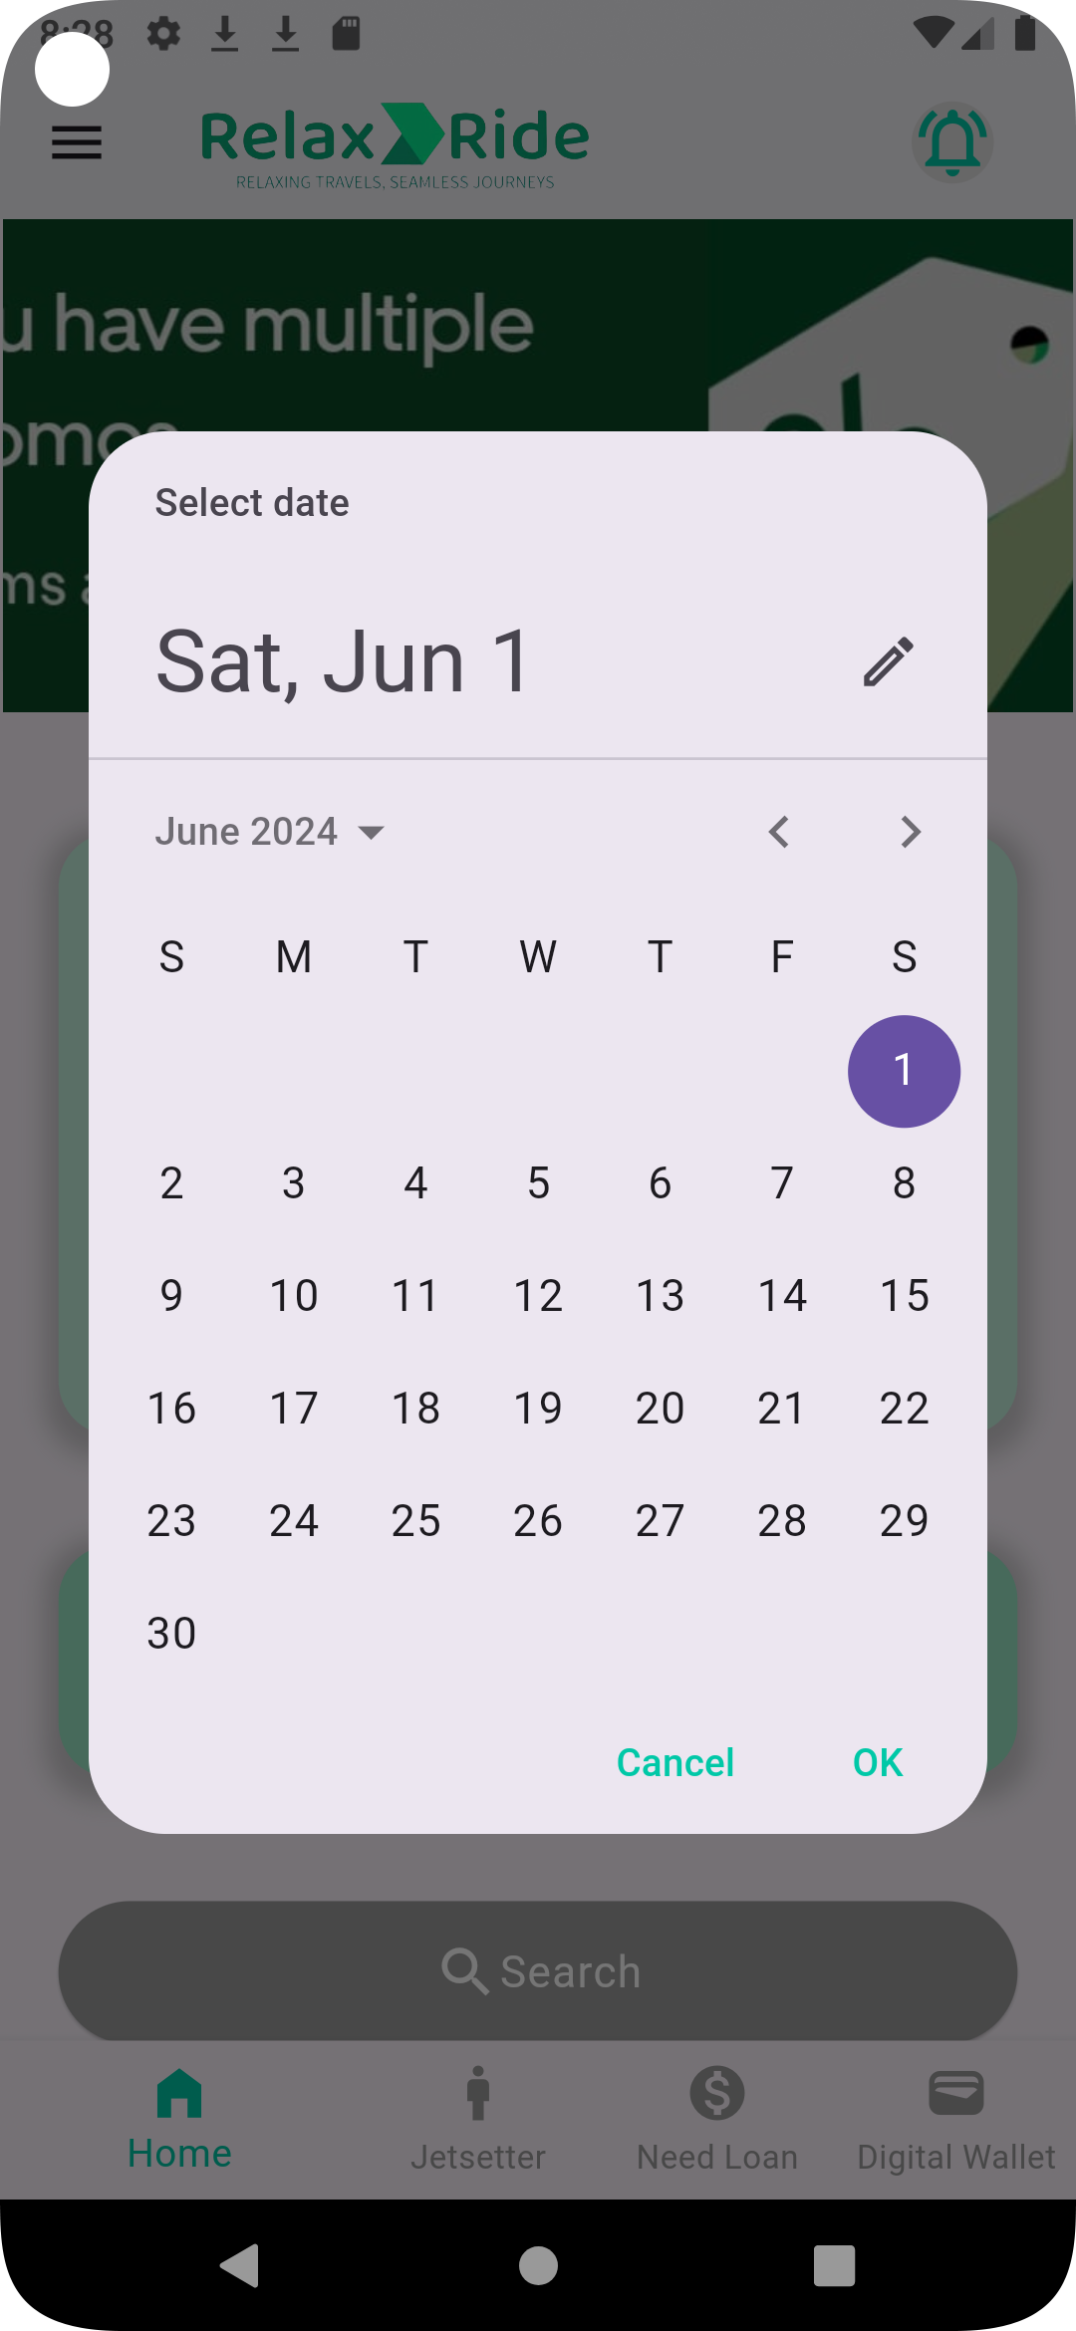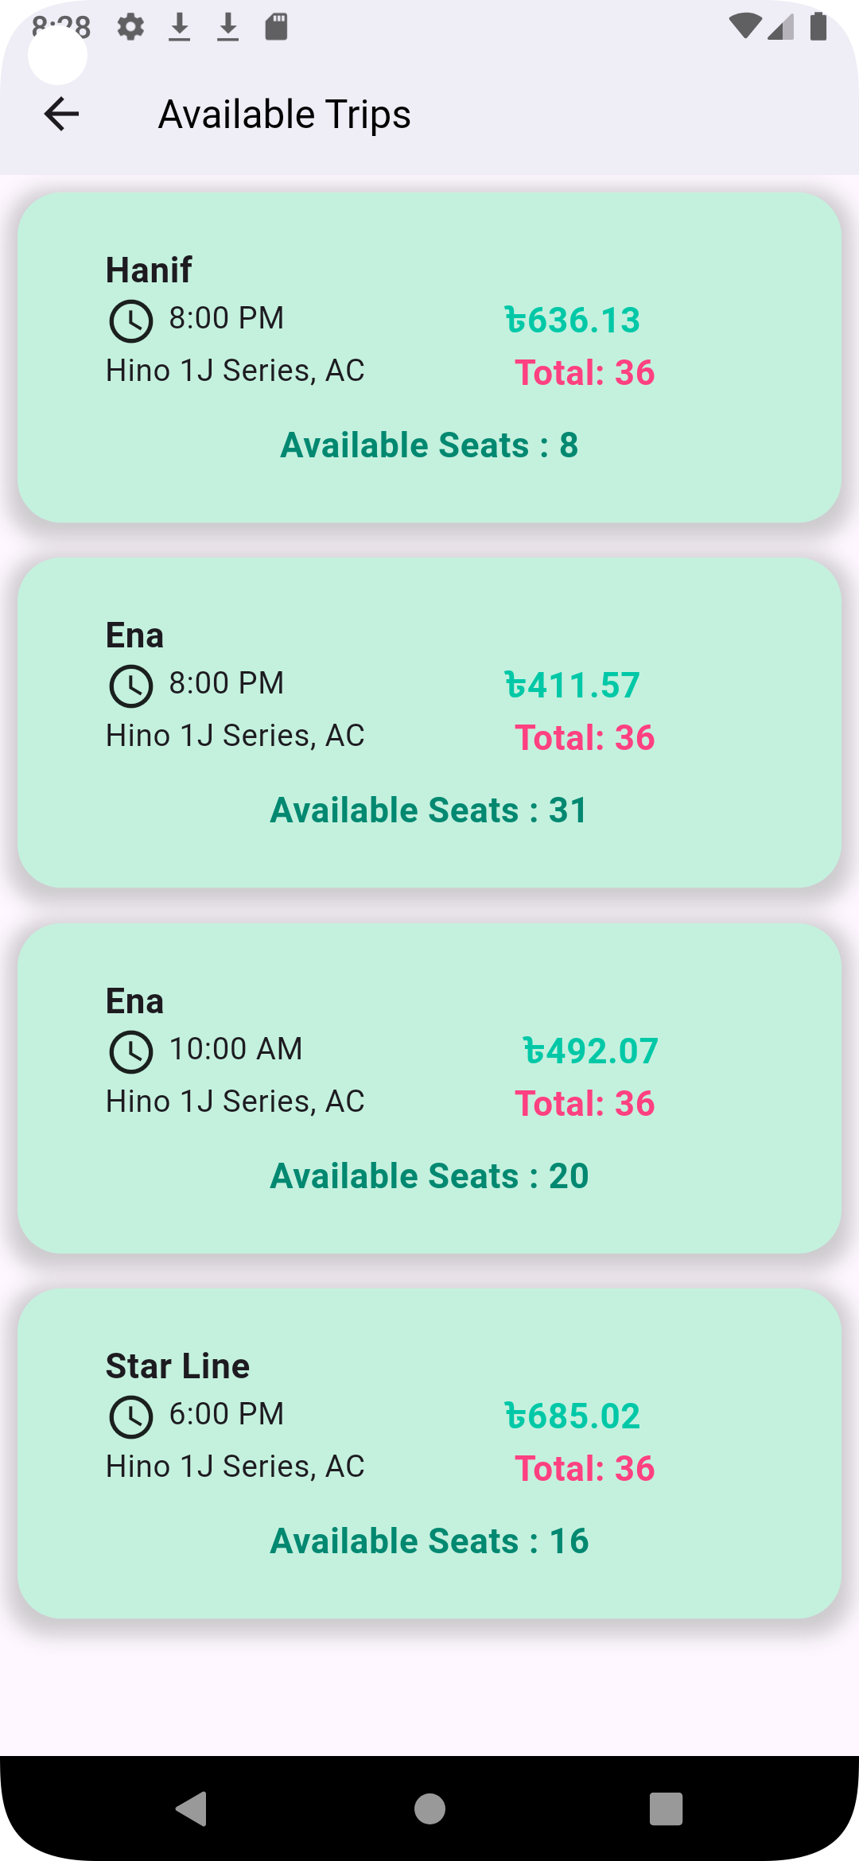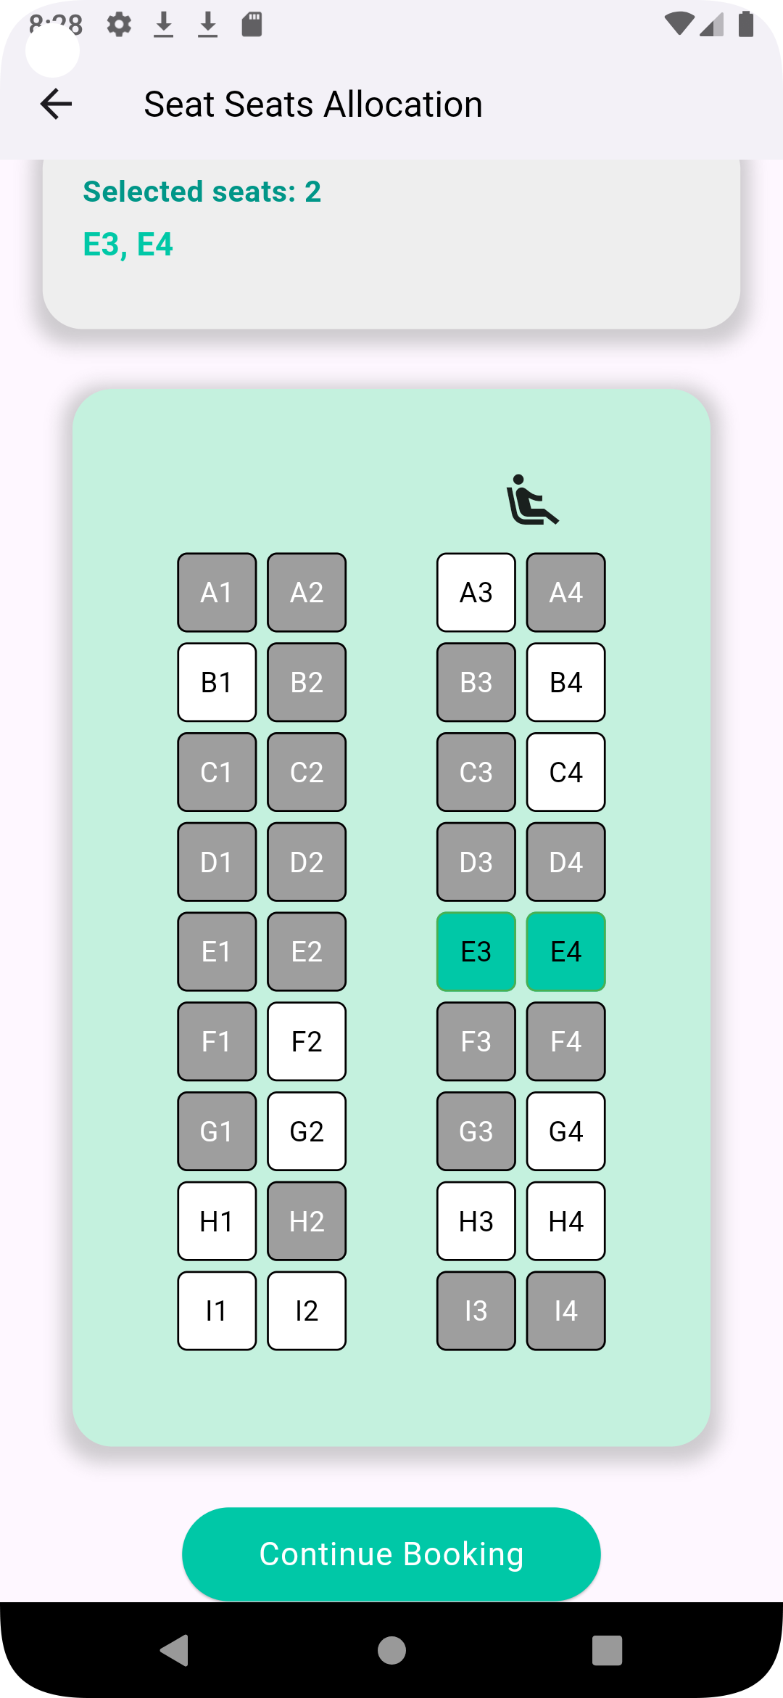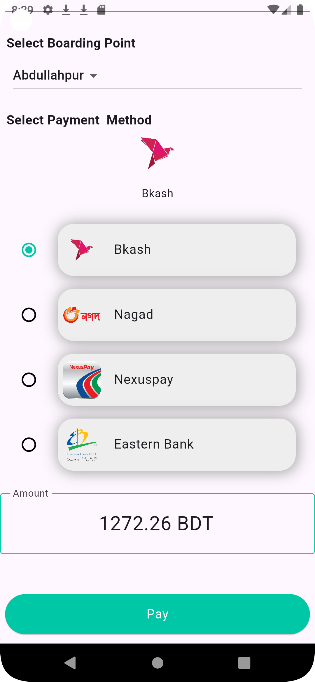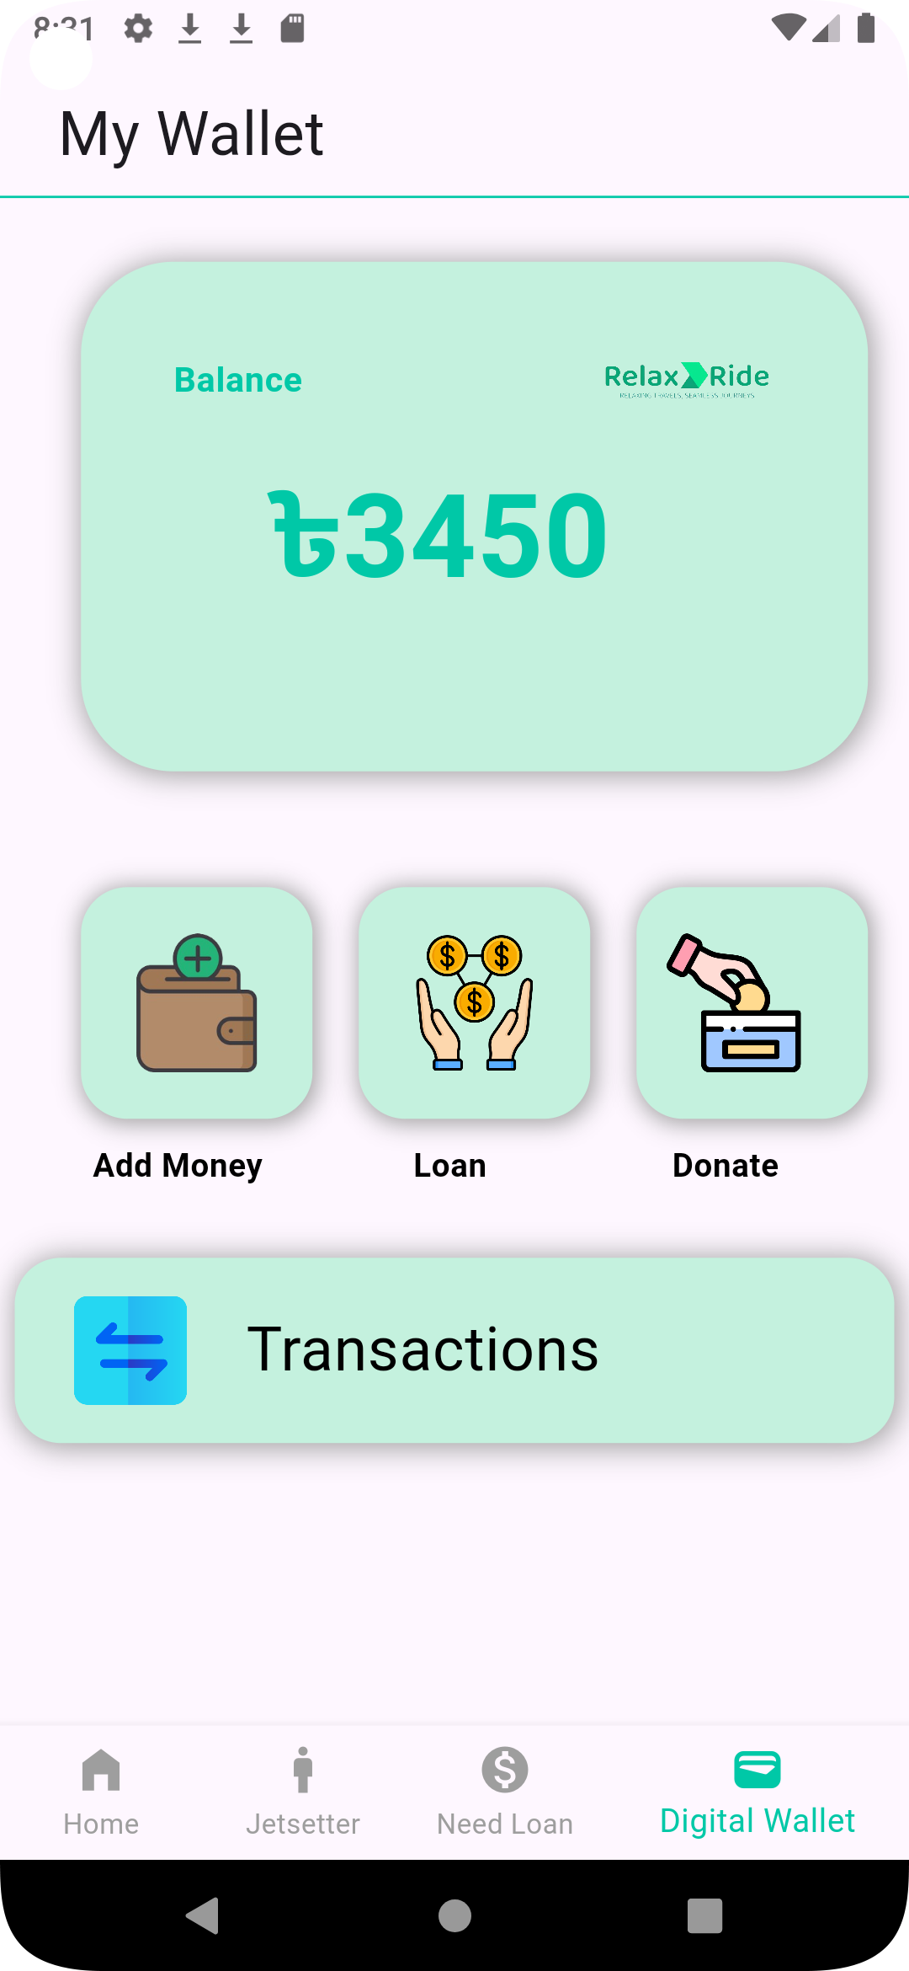

Hardware Interfaces
Requires an Android device with internet access. Minimum RAM of 2GB is recommended for smooth operation.

Software Interfaces
- RESTful APIs for communication between frontend and backend.
- SQLite for data storage.
- Payment gateway API (e.g., Stripe) for processing transactions.

System Architecture Overview
The application follows a client-server architecture. The frontend is developed using Flutter and communicates with the backend Flask server via RESTful APIs. SQLite is used for local data persistence, and GetX is used for state management within the Flutter app.

Use Case Diagram
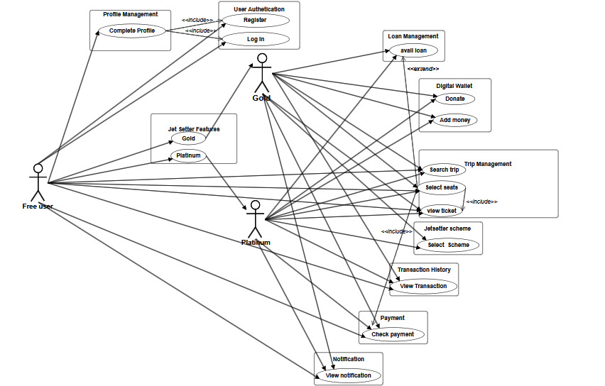

Class Diagram

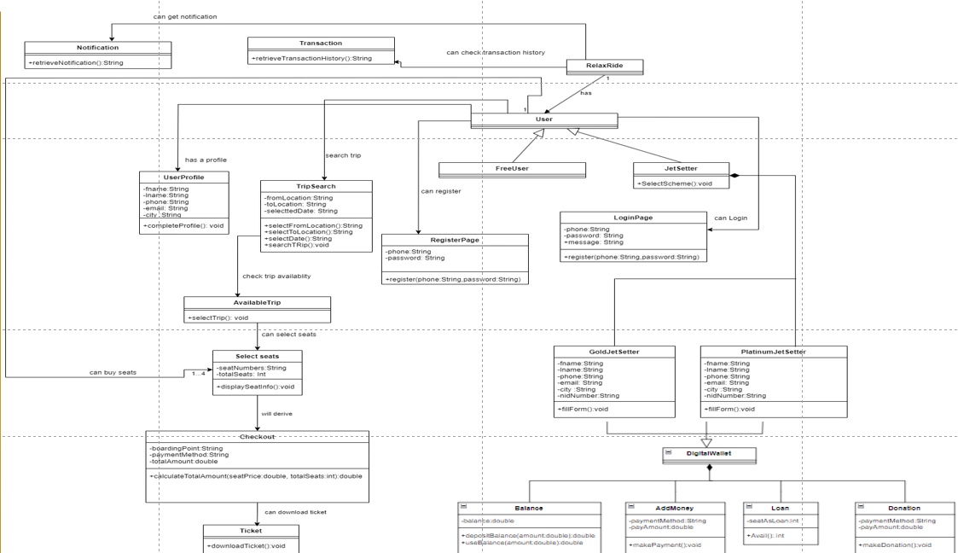

Sequence Diagram
Authentication System:
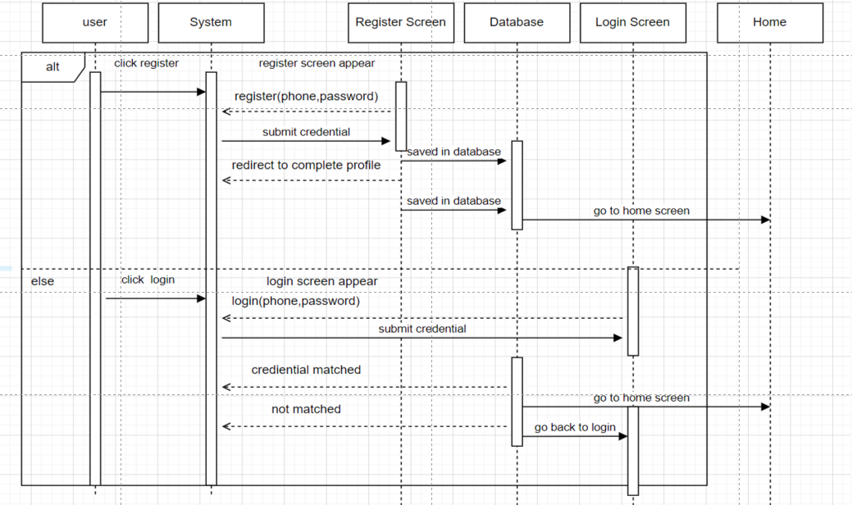
Trip Booking:
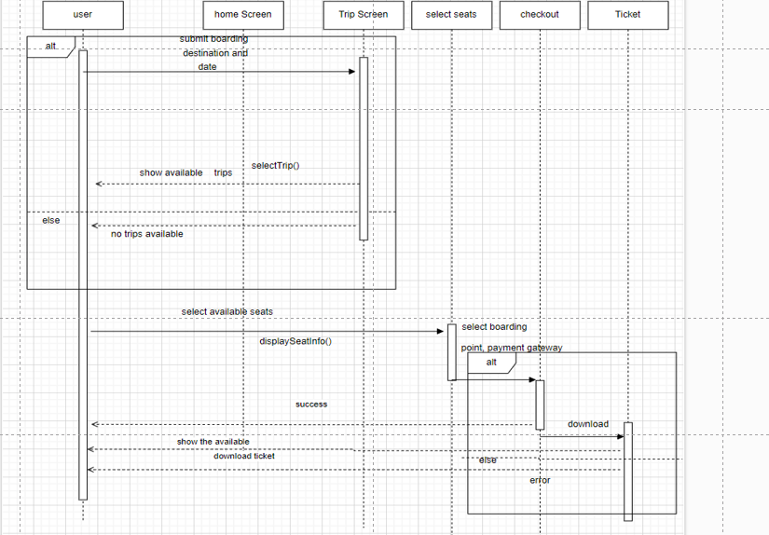
Premium feature

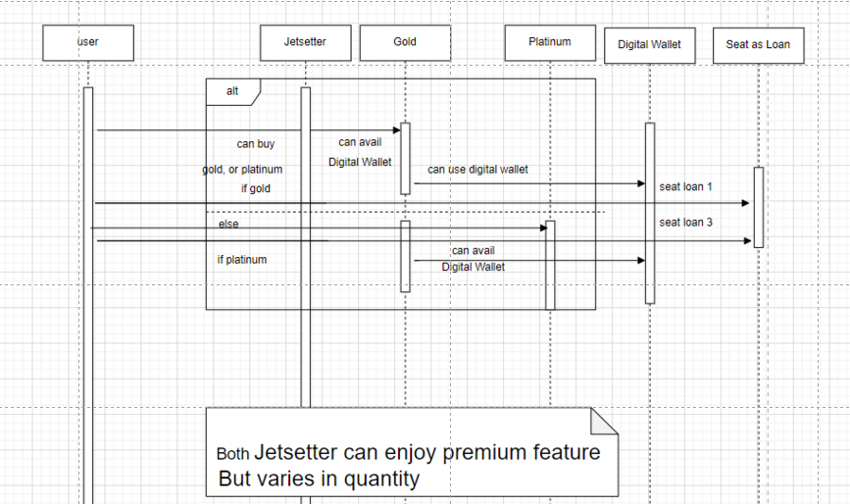

Use Case Descriptions

User Authentication

Use Case: Register
Actors: User
Scenario: User enters details and submits registration form. System validates and creates the account.
Exceptions: Email already registered, missing/invalid fields.
Preconditions: User is not logged in.
Postconditions: User accounts are created.

Use Case: Login
Actors: User
Scenario: User enters credentials and submits. System verifies and logs in the user.
Exceptions: Incorrect credentials, account locked.
Preconditions: User has a registered account.
Postconditions: User is logged in.

Use Case: Complete Profile
Actors: Free Users, Gold Jet Setters, Platinum Jet Setters
Scenario: User updates profile information. System saves updates.
Exceptions: Missing/invalid fields.
Preconditions: User is logged in.
Postconditions: Profile is updated.

Trip Management

Use Case: Search Trip
Actors: User
Scenario: User enters search criteria. System displays matching trips.
Exceptions: No matching trips found.
Preconditions: User is logged in.
Postconditions: Display list of available trips.

Use Case: Select Seats
Actors: User
Scenario: User selects trip and seats. System reserves seats.
Exceptions: Seats unavailable.
Preconditions: User has searched for a trip.
Postconditions: Seats are reserved.

Transaction History
Use Case: View Transactions
Actors: User
Scenario: User views transaction history. System displays it.
Exceptions: Transaction history retrieval error.
Preconditions: User is logged in.
Postconditions: Transaction history is displayed.

Digital Wallet

Use Case: Add Money
Actors: Gold Jet Setters, Platinum Jet Setters
Scenario: User enters amount and submits. System processes transaction
and updates wallet balance.
Exceptions: Transaction declined.
Preconditions: User is logged in.
Postconditions: Money added to digital wallet.

Use Case: Make Donation
Actors: Gold Jet Setters, Platinum Jet Setters
Scenario: User enters donation amount and submits. System processes donation and updates wallet balance.
Exceptions: Donation declined.
Preconditions: User has sufficient balance.
Postconditions: Donation processed.

Jet Setter Scheme Management

Use Case: Get Jet Setter Scheme
Actors: Gold Jet Setters, Platinum Jet Setters
Scenario:
- User navigates to the Jet Setter Scheme page.
- System displays available schemes.
- User selects a scheme and submits the selection.
- The system saves the selected scheme.
- The user receives a confirmation message.
Exceptions: Scheme selection error.
Preconditions: The user is logged in as a Gold or Platinum Jet Setter.
Postconditions: The Jet Setter scheme is selected.

Limitations
Despite the system's robust design, some limitations include:

1. Initial Backend Constraints: The use of Firebase in the initial phase led to scalability issues due to the limitations of the free tier version. This necessitated a transition to a Flask-based backend, which, although more flexible, required additional development time and resources.

2. Seat Booking Limit: The restriction on booking a maximum of four seats was implemented to prevent black market activities. However, this limitation may inconvenience larger groups wanting to travel together.

3. Device Compatibility: While the app was developed and tested primarily using *Android Studio*, ensuring optimal performance across various devices and operating systems posed challenges, potentially affecting user experience on less common devices.

Future Enhancements
To address these limitations and further enhance the application, the following improvements are proposed:

1. Backend Optimization: Continued optimization of the Flask backend to enhance scalability and performance. This includes exploring cloud-based solutions to handle increased user loads efficiently.

2. Enhanced Booking Flexibility: Reassessing the seat booking limit to accommodate larger groups while maintaining measures to prevent misuse. Implementing a more dynamic booking system could allow for exceptions under certain conditions.

3. Cross-Platform Testing and Support: Expanding testing to a wider range of devices and operating systems to ensure consistent performance. This may include leveraging cross-platform development tools and conducting user feedback sessions to identify and resolve device-specific issues.

4. User Feedback Integration: Regularly incorporating user feedback to improve existing features and introduce new functionalities. This iterative approach will help in aligning the app with user expectations and industry standards.

5. Advanced Security Measures: Implementing advanced security protocols to protect user data, such as two-factor authentication and end-to-end encryption for sensitive transactions.

By addressing these limitations and implementing the suggested improvements, the e-bus ticketing mobile application can achieve greater user satisfaction, enhanced functionality, and robust security, positioning it as a reliable solution in the transportation industry.

