If using windows 10, 8.1,8,7 you need

1. Visual Code
2. Docker (Always broken)
3. Dotnet 2.5
4. MSSQL plug in Visual Code
5. Visual studio

Go to user\not working\webapiassinment\webapiassinment\webapi\api

Right click open git console and write dotnet run.

Then go back a folder and go to sql folder and right click open with visual code.

Then got to test and do the same.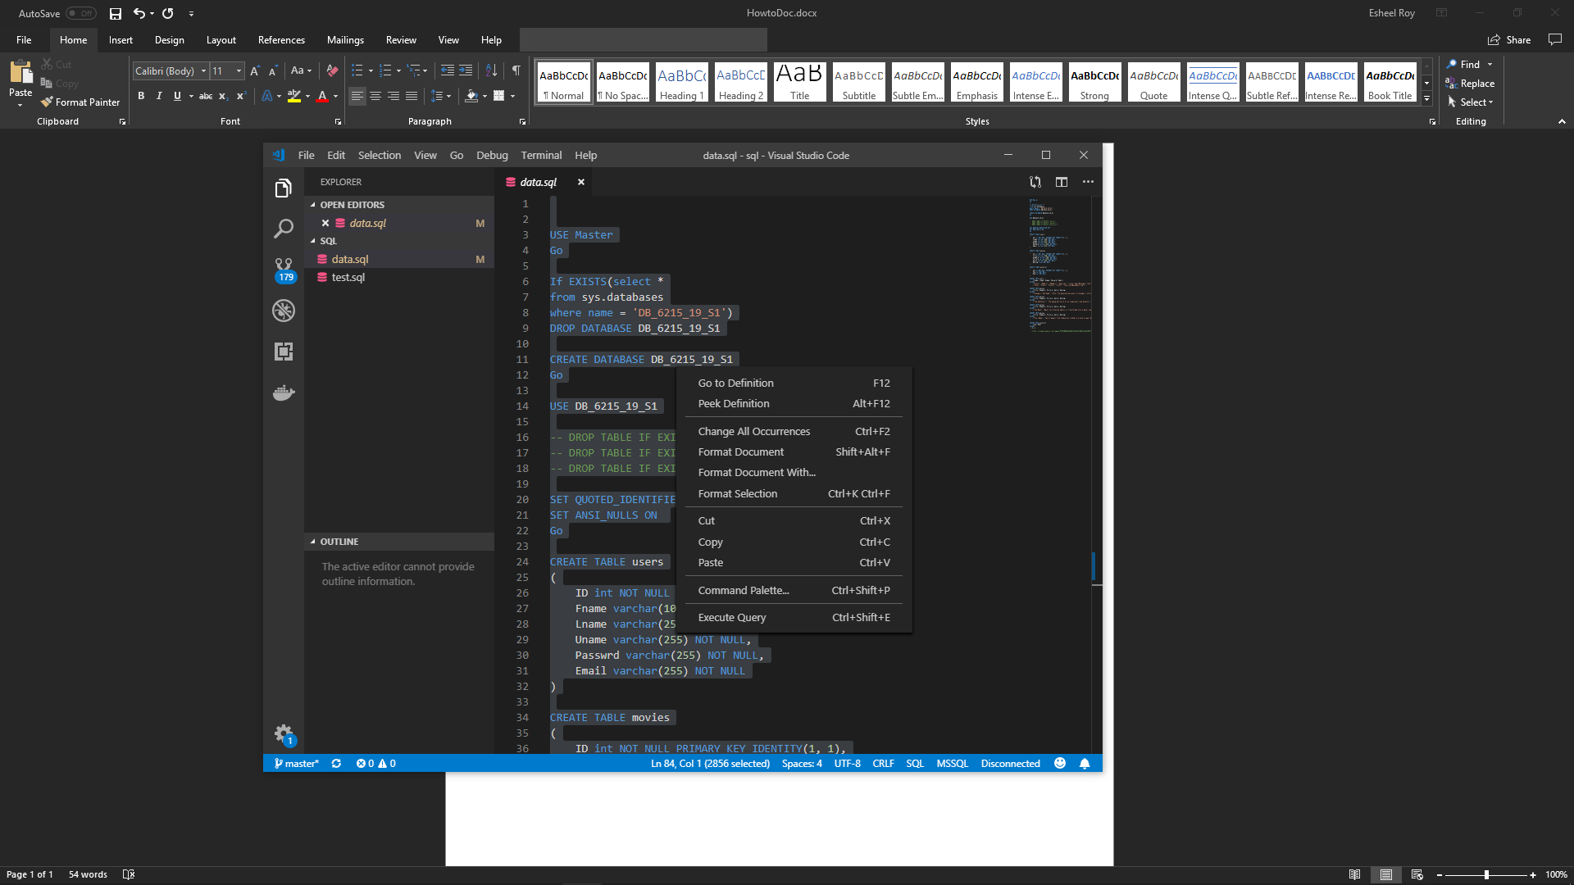

If you find an error you will have to restart Docker (Windows problem only). Remember restart Docker not Docker Container

Go to [http://localhost:5000/api/](http://localhost:5000/api/MoviesControler) if you want to see MoviesControler, UserControler and WishlistControler just add them after api/