

Bahria University Islamabad Campus E-8
Department of Computer Science

PROGRAMMING for ARTIFICIAL INTELLIGENCE TEAM PROJECT
Data Description

Members:
- Syed Salman Ali Shah
01-136242-044
- Esha Sajjad Mirza
01-136252-016
- Qurat-ul-Ain
01-136242-03

HOSPITAL BED MANAGEMENT SYSTEM - DATA DESCRIPTION
ABSTRACT
This project implements a comprehensive Hospital Bed Management System using Python to analyze healthcare datasets from Kaggle. The system processes patient records, staff information, bed inventory, and service metrics to identify resource utilization patterns, patient flow bottlenecks, and operational inefficiencies. Through data cleaning, exploratory analysis, and visualization, we provide actionable insights for hospital administration to optimize bed occupancy, improve patient satisfaction, and enhance operational efficiency.

TABLE OF CONTENTS
- Abstract
- Dataset Description
  - 2.1 Dataset Source
  - 2.2 Dataset Composition
  - 2.3 Dataset Relationships
  - 2.4 Dataset Size & Statistics
- Technical Implementation
  - 3.1 Python Libraries & Tools
  - 3.2 Data Quality & Cleaning Process
- References & Resources
- Project Application
- Analysis Potential

1. DATASET SOURCE
- Platform: Kaggle (Hospital Management Datasets) & (Hospital Bed Capacity and ICU load Dataset)
- Collection Method: Synthetic/Real hospital administrative data
- Purpose: Educational/Research - Hospital resource management analysis
- License: CC0 Public Domain for educational use
2. DATASET COMPOSITION
Four interconnected CSV files representing different aspects of hospital operations:
2.1 services.csv - Weekly Service Metrics
Purpose: Track weekly service performance and resource utilization

Column | Data Type | Description | Example Values
week | Integer | Week number (1-52) | 15, 32, 48
month | Integer | Month number | 9, 3,
service | String | Medical department/service | "Emergency", "ICU"
available_beds | Integer | Beds available in the service | 25, 10, 15
patients_request | Integer | Patients requesting admission | 45, 22, 18
patients_admitted | Integer | Patients actually admitted | 40, 20, 15
patients_refused | Integer | Patients turned away | 5, 2, 3
patient_satisfaction | Integer (0-100) | Average satisfaction score | 85, 92, 78
staff_morale | Integer (0-100) | Staff satisfaction/well-being score | 75, 88, 65
event | String | Special events affecting operations | "Donation", "Strike", "None"

Key Metrics:
- Capacity Utilization: patients_admitted vs available_beds
- Refusal Rate: patients_refused / patients_request
- Service Quality: patient_satisfaction and staff_morale

2.2 patients.csv - Individual Patient Records
Purpose: Detailed patient treatment history and outcomes
Column | Data Type | Description | Example Values
patient_id | String/Integer | Unique patient identifier | "PAT-927fa9"
name | String | Patient name (anonymized) | "John Doe"
age | Integer | Patient age in years | 35, 67, 12
arrival_date | Date | Admission date | "2023-05-15", "2024-01-22"
departure_date | Date | Discharge/transfer date | "2023-05-20", "2024-01-25"
service | String | Treating department | "Emergency", "Surgery", "ICU"
satisfaction | Integer (0-100) | Individual satisfaction rating | 90, 75, 95

Derivable Metrics:
- Length of Stay: departure_date - arrival_date
- Service Popularity: Distribution across services
- Age Distribution: Patient demographics

2.3 staff.csv - Hospital Staff Information
Purpose: Staff allocation and role distribution across services

Column | Data Type | Description | Example Values
staff_id | String/Integer | Unique staff identifier | "STF-9385xa"
staff_name | String | Staff member name | "Smith", "Johnson"
role | String | Professional role | "Doctor", "Nurse", "Technician"
service | String | Assigned department | "ICU", "Radiology", "OPD"

Key Analysis:
- Staff-to-Service Mapping: Resource allocation
- Role Distribution: Workforce composition
- Department Staffing: Service-wise human resources
2.4 beds.csv - Bed Inventory & Utilization
Purpose: Real-time bed availability and ICU capacity tracking

Column | Data Type | Description | Example Values
Department | String | Hospital department | "Cardiology", "ICU", "General Ward"
Total_Beds | Integer | Total beds in department | 30, 15, 50
Free_Beds | Integer | Available beds | 5, 2, 10
Total_ICU_Beds | Integer | ICU beds in department | 5, 10, 0
Free_ICU_Beds | Integer | Available ICU beds | 1, 3, 0
Total_Amount_of_Beds | Integer | Total beds + Total ICU beds | 35, 25, 50
Staff_On_Duty | Integer | Current working staff | 8, 12, 15
Occupied_Beds | Integer | Currently occupied beds | 25, 13, 40
Occupied_ICU_Beds | Integer | Currently occupied ICU beds | 4, 7, 0
Critical Calculations:
- Occupancy Rate: Occupied_Beds / Total_Beds
- ICU Utilization: Occupied_ICU_Beds / Total_ICU_Beds
- Staff-to-Bed Ratio: Staff_On_Duty / Total_Beds

3. DATASET SIZE & STATISTICS
Dataset | Approx Records | File Size | Time Coverage | Update Frequency
services.csv | 52-104 rows | 5-15 KB | 1-2 years weekly | Weekly
patients.csv | 1,000-5,000 rows | 100-500 KB | Individual admissions | Daily
staff.csv | 50-200 rows | 2-10 KB | Current staff | Monthly
beds.csv | 10-50 rows | 1-5 KB | Real-time snapshot | Daily

Total Data Volume: Approximately 0.1-0.5 MB across all files

4. DATASET RELATIONSHIPS
services.csv (Weekly aggregates)
↑
patients.csv (Individual records) → service field links to services
↑
staff.csv (Human resources) → service field links to services
↑
beds.csv (Physical resources) → Department field links to services

Key Relationships:
- Patients ↔ Services: Which services treat which patients
- Staff ↔ Services: Which staff work in which services
- Beds ↔ Services: Which departments have which bed capacities
- Weekly ↔ Daily: Aggregate vs individual patient data

5. PYTHON LIBRARIES & TOOLS
5.1 Core Libraries
Library | Version | Purpose | Specific Usage in Project
Pandas | 2.0+ | Data manipulation & analysis | Data loading, cleaning, transformation, grouping
NumPy | 1.24+ | Numerical computing | Statistical calculations, array operations
Matplotlib | 3.7+ | Basic plotting | Histograms, bar charts, line plots
Seaborn | 0.12+ | Statistical visualization | Enhanced plots, distribution charts
Jupyter | Latest | Interactive computing | Notebook development & presentation

5.2 Supporting Tools
- Google Colab: Cloud-based Python environment for execution
- VS Code with Anaconda: Local development environment
- Git/GitHub: Version control and collaboration
- datetime module: Date parsing and manipulation
5.3 Library Implementation Examples
# Pandas for data loading and cleaning
patients = pd.read_csv('data/patients.csv')
patients_clean = patients.fillna('Unknown').drop_duplicates()

# NumPy for statistical analysis
avg_age = np.mean(patients['age'])
std_age = np.std(patients['age'])

# Matplotlib/Seaborn for visualization
plt.figure(figsize=(10,6))
sns.histplot(patients['age'], bins=20, kde=True)
plt.title('Patient Age Distribution')
plt.savefig('outputs/patient_age.png')

6. DATA QUALITY & CLEANING PROCESS
6.1 Initial Data Quality Assessment (check for common data values)
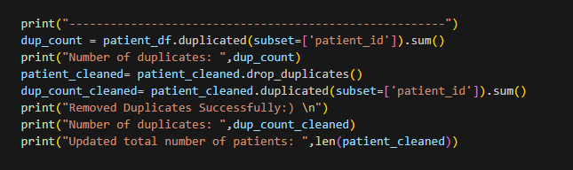
6.2 Cleaning Pipeline Implementation
Step 1: Handle Missing Values
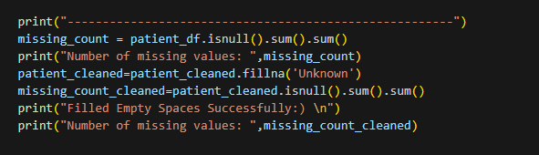
Step 2: Remove Duplicates
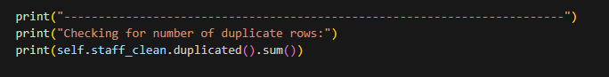
Step 3: Validate and Fix Data Types
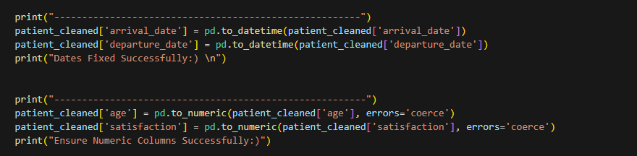
Step 4: Value Range Validation
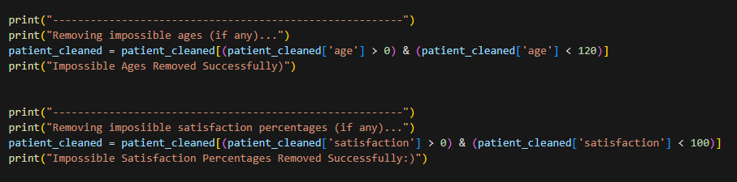
Step 5: Standardize Categorical Data
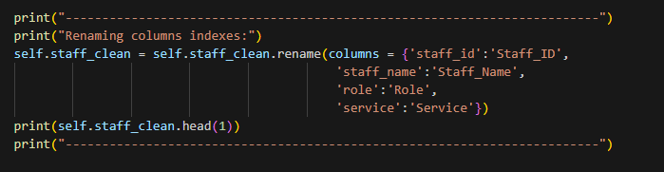
6.3 Complete Cleaning Function
Example:
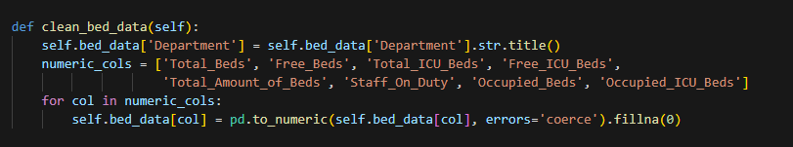

7. REFERENCES
7.1 Primary Dataset Sources
- Hospital Management Datasets on Kaggle:
  - https://www.kaggle.com/datasets/jaderz/hospital-beds-management?select=patients.csv
  - https://www.kaggle.com/datasets/jaderz/hospital-beds-management?select=services_weekly.csv
  - https://www.kaggle.com/datasets/jaderz/hospital-beds-management?select=staff.csv
- Hospital Bed Capacity and ICU Load Dataset:
  - https://www.kaggle.com/datasets/endernel/capacity-of-hospitals-bed?select=Hospital_Bed_Capacity_New.csv
7.2 Related Healthcare Datasets
- UCI Machine Learning Repository: Healthcare datasets
- MIMIC-III: Critical care database (requires credentials)
- Government Health Portals: Public health statistics
7.3 Citation Format
Data Source: Kaggle Hospital Management Datasets, Hospital Bed Capacity and ICU Load Dataset
URL:
- https://www.kaggle.com/datasets/jaderz/hospital-beds-management
- https://www.kaggle.com/datasets/endernel/capacity-of-hospitals-bed
Accessed: [30-11-25]
License: CC0 Public Domain
Usage: Educational analysis and project development

8. PROJECT APPLICATION
This dataset is used to build a Hospital Bed Management System that:
- Analyzes current resource utilization across departments
- Identifies bottlenecks in patient admission and flow
- Optimizes bed and staff allocation based on demand patterns
- Improves patient satisfaction through data-driven service improvements
- Provides actionable insights for hospital administration decision-making
- Generates visual reports for stakeholders and management
Key Analysis Areas:
- Operational Efficiency: Bed utilization, staff allocation, service demand
- Patient Experience: Satisfaction analysis, wait times, service quality
- Resource Management: ICU capacity, seasonal trends, staffing levels
- Predictive Insights: Demand forecasting, resource planning

9. Analysis Potential
9.1 Operational Efficiency
- Bed Utilization: Identify over/under-utilized departments
- Staff Allocation: Optimize staff distribution based on patient load
- Service Demand: Predict busy periods and plan resources
9.2 Patient Experience
- Satisfaction Analysis: Factors affecting patient satisfaction
- Wait Times: Admission vs refusal rates
- Service Quality: Correlation between staff morale and patient satisfaction
9.3 Resource Management
- ICU Capacity: Critical care resource optimization
- Seasonal Trends: Monthly/weekly variations in demand
- Staffing Levels: Appropriate staff-to-patient ratios

END OF DATA DESCRIPTION DOCUMENT

