Assignment 1 : Simple SQL Query with a single table with where clause

1. Write a query to get a Product list (id, name, unit price) where current products cost
less than $20.

SELECT ProductID, ProductName, UnitPrice
FROM Products
WHERE ((UnitPrice)<20)

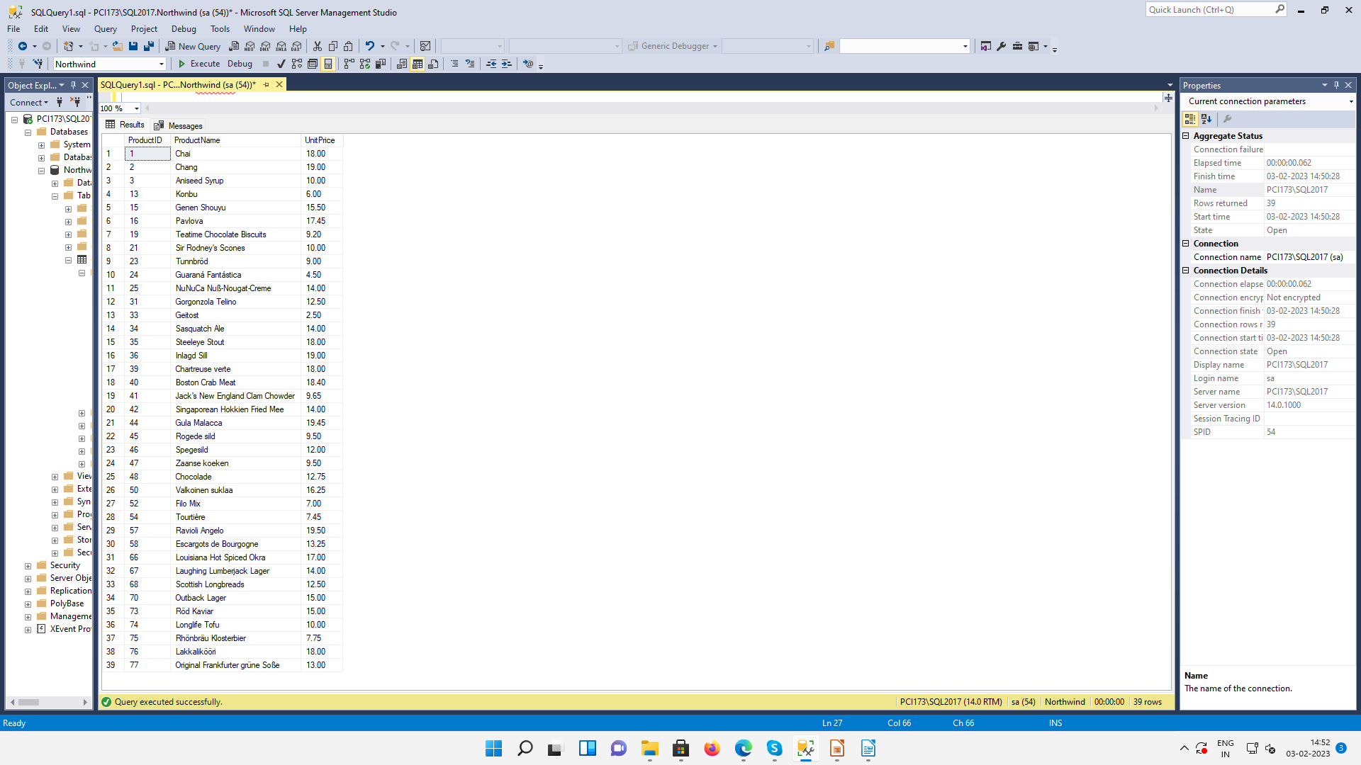
2. Write a query to get Product list (id, name, unit price) where products cost between
$15 and $25

SELECT ProductID, ProductName, UnitPrice
FROM Products
WHERE ((UnitPrice)>=15 AND (UnitPrice)<=25)

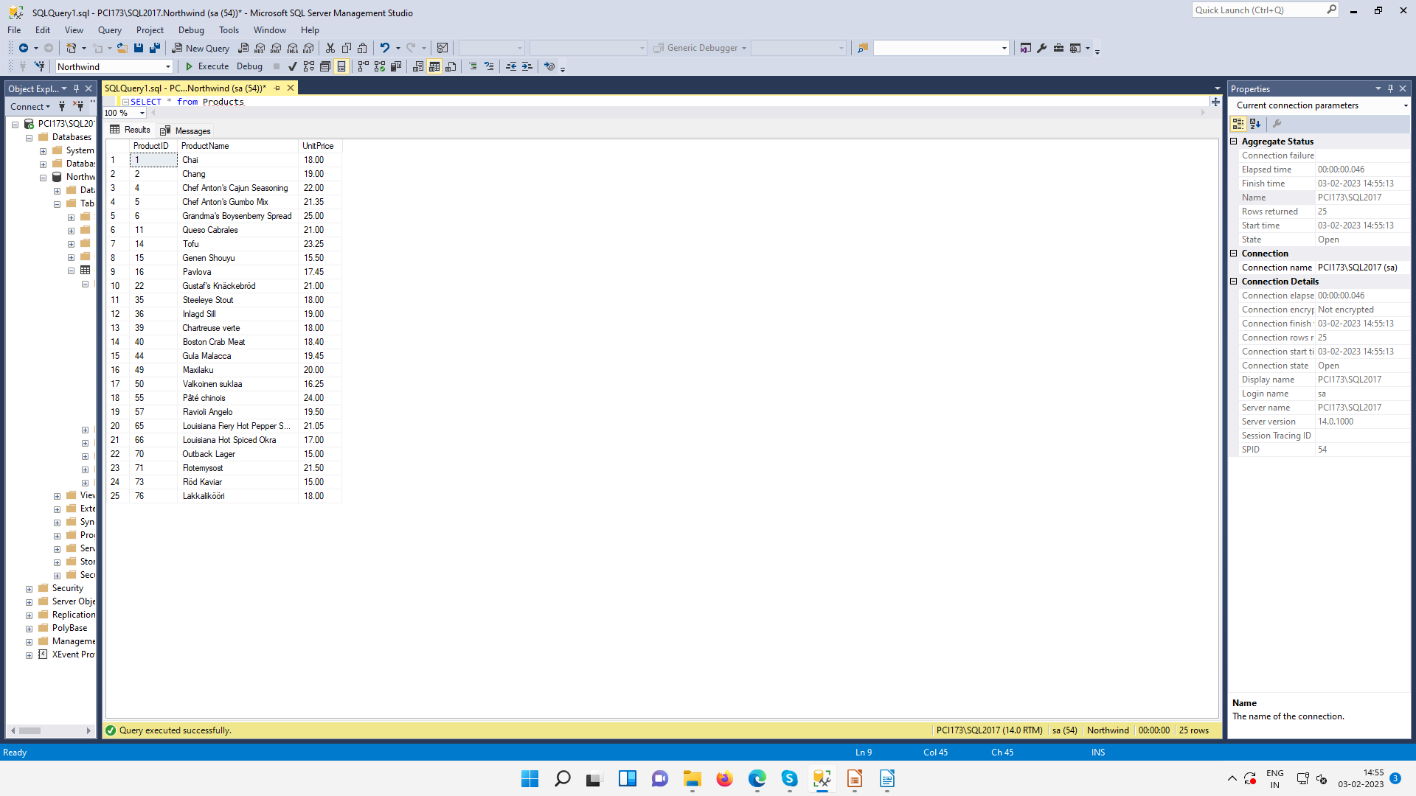
3. Write a query to get Product list (name, unit price) of above average price.

SELECT DISTINCT ProductName, UnitPrice
FROM Products
WHERE UnitPrice > (SELECT avg(UnitPrice) FROM Products)

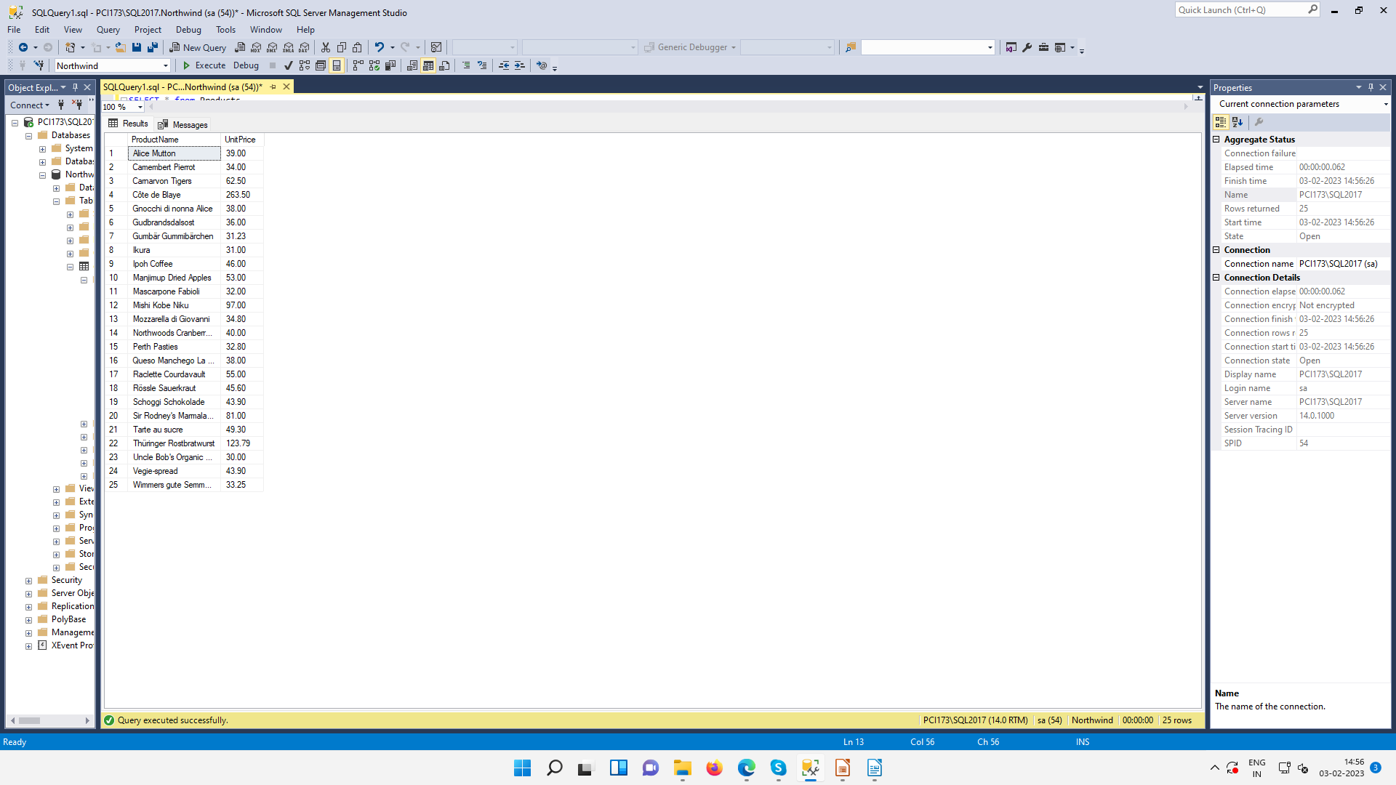
4. Write a query to get Product list (name, unit price) of ten most expensive products

SELECT DISTINCT ProductName as Ten_Most_Expensive_Products, UnitPrice
FROM Products AS a
WHERE 10 >= (SELECT COUNT(DISTINCT UnitPrice)
FROM Products AS b
WHERE b.UnitPrice >= a.UnitPrice)
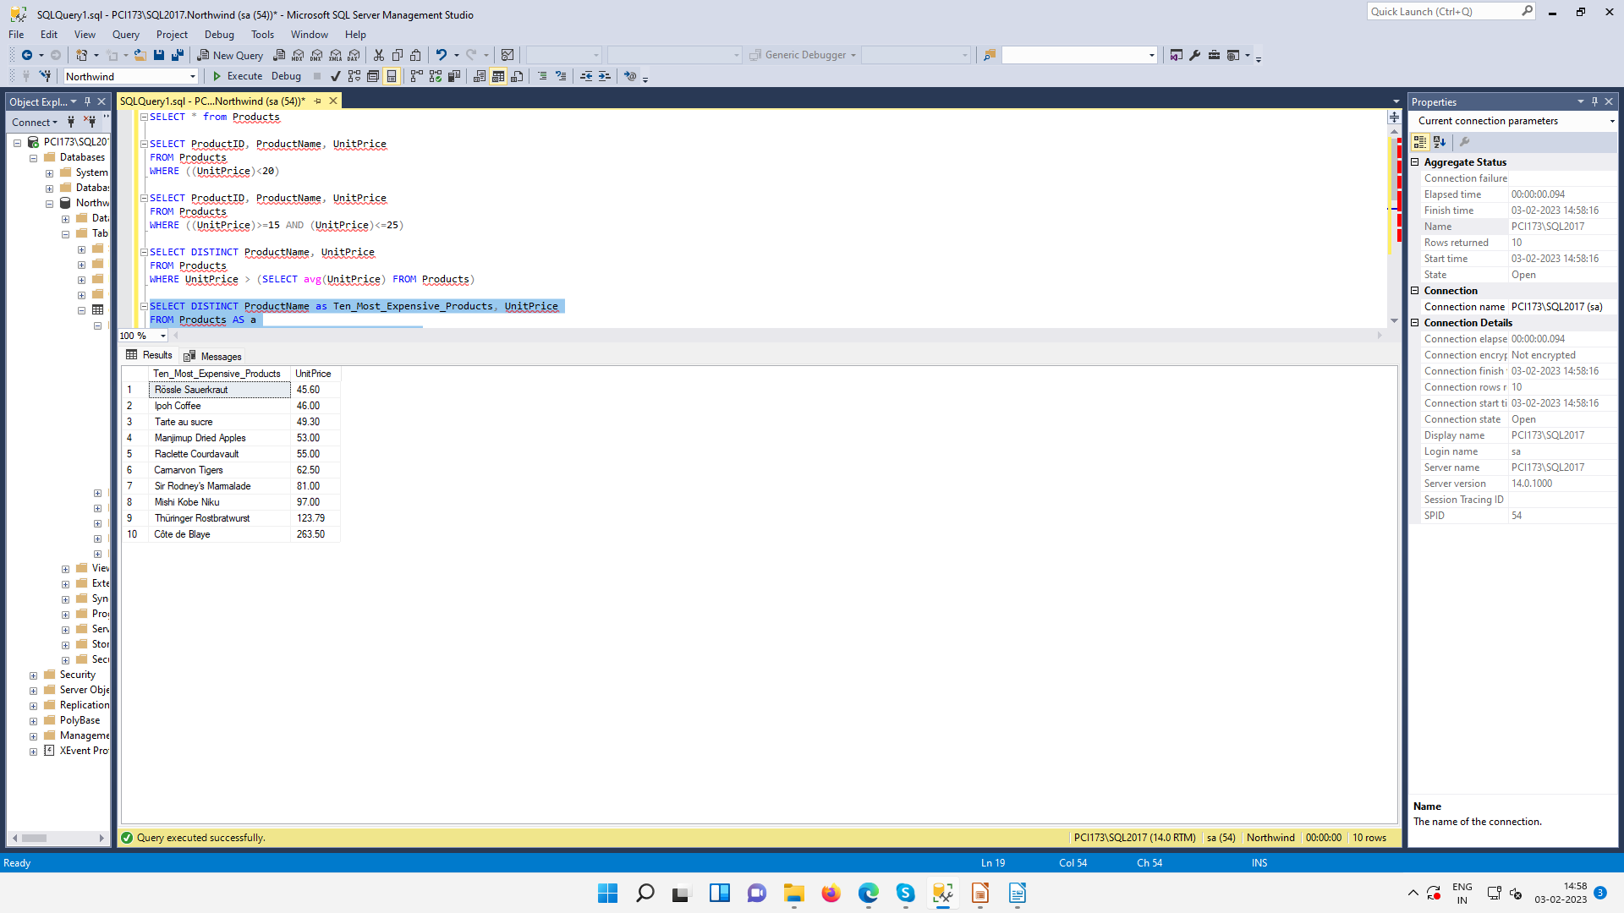
5. Write a query to count current and discontinued products

SELECT Count(ProductName)
FROM Products
GROUP BY Discontinued

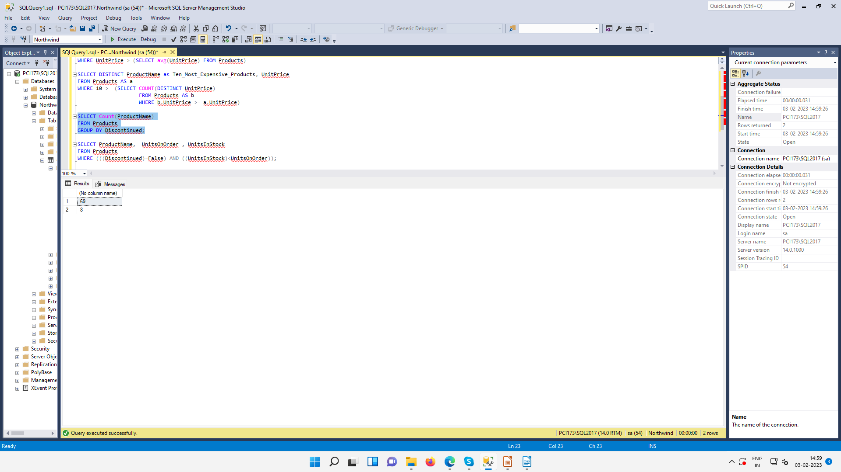
6. Write a query to get Product list (name, units on order , units in stock) of stock is less
than the quantity on order

SELECT ProductName, UnitsOnOrder , UnitsInStock
FROM Products
WHERE ((UnitsInStock)<(UnitsOnOrder))

