Assignment 3 : Retrieve data using Group By clause

1. write a SQL query to find Employees who have the biggest salary in their Department

select top 1 * from employee ORDER BY salary DESC;
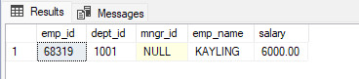

2. write a SQL query to find Departments that have less than 3 people in it

SELECT department.dept_name,employee.dept_id,count(emp_name),SUM(salary)
FROM employee
INNER JOIN department
ON employee.dept_id =department.dept_id
GROUP BY department.dept_name,employee.dept_id
HAVING COUNT(*) > 3;

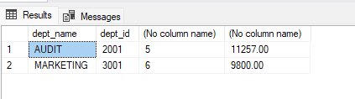

3. write a SQL query to find All Department along with the number of people there

SELECT department.dept_name,employee.dept_id,count(emp_name) as "number of people"
FROM employee
INNER JOIN department
ON employee.dept_id =department.dept_id
GROUP BY department.dept_name,employee.dept_id
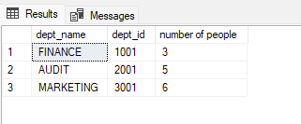

4. write a SQL query to find All Department along with the total salary there

SELECT department.dept_name,employee.dept_id,count(emp_name)as "number of people",SUM(salary) "total of salary"
FROM employee
INNER JOIN department
ON employee.dept_id =department.dept_id
GROUP BY department.dept_name,employee.dept_id

