Assignment 4 : Create Stored procedure in Northwind database to insert or update a
record in a table

1. Create a stored procedure in the Northwind database that will calculate the average
value of Freight for a specified customer.Then, a business rule will be added that will
be triggered before every Update and Insert command in the Orders controller,and
will use the stored procedure to verify that the Freight does not exceed the average
freight. If it does, a message will be displayed and the command will be cancelled.

alter Procedure spCalculateAvgFreight
@CustomerID nchar(10),
@AvgFreight money out
as
Begin
Select @AvgFreight = avg(Freight)
From Orders
Where CustomerID = @CustomerID
End
alter Trigger check_freight
ON Orders
Instead of Insert
as
Begin
Declare @Avg money
Exec spCalculateAvgFreight 'VINET', @Avg out
Declare @Freight money
Select @Freight = Freight from inserted
if(@Freight > @Avg)
Begin
Print 'Command is cancelled'
Return
End
End
INSERT INTO "Orders"
("CustomerID","EmployeeID","OrderDate","RequiredDate",
"ShippedDate","ShipVia","Freight","ShipName","ShipAddress",
"ShipCity","ShipRegion","ShipPostalCode","ShipCountry")
VALUES (N'TOMSP',6,'7/5/1996','8/16/1996','7/10/1996',1,200.61,
N'Toms Spezialitäten',N'Luisenstr. 48',N'Münster',
NULL,N'44087',N'Germany')

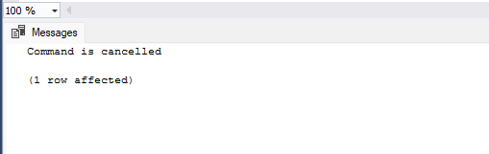

2. write a SQL query to Create Stored procedure in the Northwind database to retrieve
Employee Sales by Country

create procedure query2
as
begin
select EmployeeID ,shipcountry ,count(shipcountry) from orders
group by EmployeeID,shipcountry
order by EmployeeID
end
execute query2
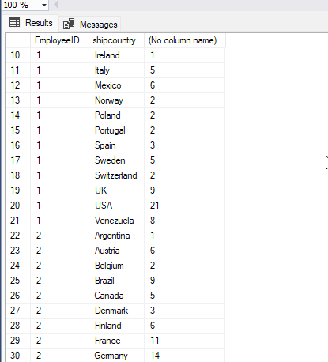

alter Procedure Employee_SalesById
@shipcontry nvarchar(15)
As
BEGIN
SELECT Employees.LastName, Employees.FirstName, Orders.ShippedDate, Orders.OrderID,
"Order Subtotals".Subtotal AS SaleAmount
FROM Employees INNER JOIN(Orders INNER JOIN "Order Subtotals" ON Orders.OrderID =
"Order Subtotals".OrderID)
ON Employees.EmployeeID = Orders.EmployeeID
Where Orders.shipcountry = @shipcontry
END
execute Employee_SalesById 'USA'

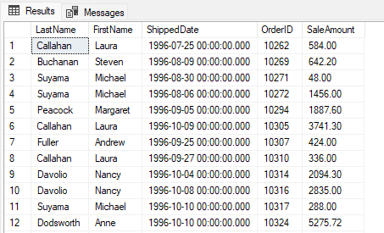

3. write a SQL query to Create Stored procedure in the Northwind database to retrieve
Sales by Year

create procedure query3
as
begin
select YEAR(ShippedDate),COUNT(OrderID) as "total no of sales" from Orders
group by YEAR(ShippedDate)
order by YEAR(ShippedDate)
end
execute query3
create procedure [dbo].[Sales_by_Year]
@Beginning_Date DateTime, @Ending_Date DateTime AS
SELECT Orders.ShippedDate, Orders.OrderID, "Order Subtotals".Subtotal,
DATENAME(yy,ShippedDate) AS Year
FROM Orders INNER JOIN "Order Subtotals" ON Orders.OrderID = "Order Subtotals".OrderID
WHERE Orders.ShippedDate Between @Beginning_Date And @Ending_Date
GO
execute [Sales_by_Year] '1998','1999'

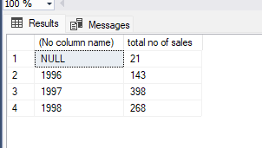

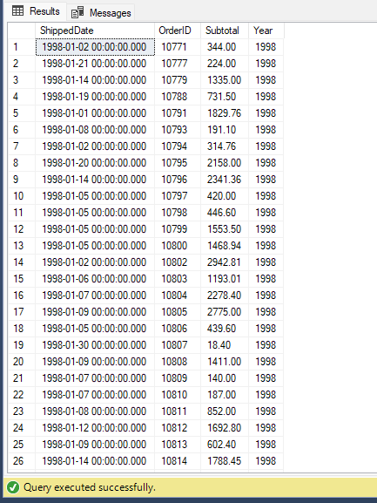

4. write a SQL query to Create Stored procedure in the Northwind database to retrieve
Sales By Category

create procedure query4
as
begin
select distinct c.CategoryID,count(c.CategoryName) as "number of orders",c.CategoryName
from orders o
inner join "order details" od on od.orderid=o.OrderID
inner JOIN Products p on p.productID=od.productid
inner join Categories c on p.CategoryID= c.CategoryIDgroup by c.CategoryID ,c.CategoryName
end
execute query4
create procedure query51
@CategoryName nvarchar(15)
as
begin
SELECT ProductName,
TotalPurchase=ROUND(SUM(CONVERT(decimal(14,2), OD.Quantity * (1-OD.Discount)
* OD.UnitPrice)), 0)
FROM [Order Details] OD, Orders O, Products P, Categories C
WHERE OD.OrderID = O.OrderID
AND OD.ProductID = P.ProductID
AND P.CategoryID = C.CategoryID
AND C.CategoryName = @CategoryName
--AND SUBSTRING(CONVERT(nvarchar(22), O.OrderDate, 111), 1, 4) = @OrdYear
GROUP BY ProductName
ORDER BY ProductName
end
execute query51 'Confections'

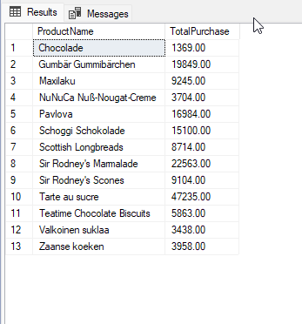

5. write a SQL query to Create Stored procedure in the Northwind database to retrieve
Ten Most Expensive Products

alter procedure query5
as
begin
select top 10 ProductName, UnitPrice from Products order by UnitPrice desc
end
execute query5

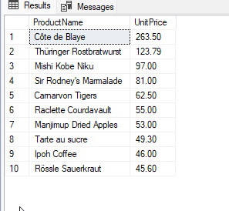

6. write a SQL query to Create Stored procedure in the Northwind database to insert
Customer Order Details

create procedure query6
@OID int,
@pid int ,
@UnitPrice money ,
@Quantity smallint ,
@Discount real
as
begin
insert into [Order Details] values (
@OID ,
@pid ,
@UnitPrice ,
@Quantity ,
@Discount )
end
execute query6 10248,14, 18.60, 9 ,0

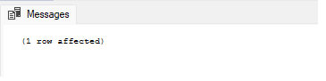

7. write a SQL query to Create Stored procedure in the Northwind database to update
Customer Order Details

create procedure query7
@changeid int,
@OID int,
@pid int ,
@UnitPrice money ,
@Quantity smallint ,
@Discount real
as
begin
UPDATE [Order Details]
SET OrderID = @OID, ProductID = @pid, UnitPrice = @UnitPrice, Quantity = @Quantity,
Discount = @Discount
WHERE OrderID = @changeid
end
execute query7 11074,10288,14, 18.60, 9 ,0

