Project Title

Software Requirement Specifications
Bachelor of Science in Software Engineering
By

 | Name | Registration # | Mobile # | E-Mail
1 | Ayesha Ishfaq | Fa-22/BSSE/166 | 0324-8529491 | Fa-22-bsse-166@lgu.edu.pk
2 | Esha Farrukh | Fa-22/ BSSE/172 | 0300-1717607 | Fa-22-bsse-172@lgu.edu.pk

Supervised by Co-Supervised by

___________________ ___________________
Teacher Name Teacher Name



Department of Software Engineering
Lahore Garrison University
Lahore
Table of Contents
1. Introduction 5
1.1 Purpose 5
1.2 Document Conventions 5
1.3 Intended Audience and Reading Suggestions 6
1.4 Product Scope 6
2. Overall Description 6
2.1 Product Perspective 6
2.2 Product Functions 7
2.3 User Classes and Characteristics 9
2.3.1 General Users (Developers, Tech Students, Researchers) 9
2.3.2 Licensed Therapists 10
2.3.3 System Administrators 10
2.4 Operating Environment 11
2.5 Design and Implementation Constraints 12
2.6 User Documentation 12
2.7 Assumptions and Dependencies 12
3. External Interface Requirements 13
3.1 User Interfaces 13
3.2 Hardware Interfaces 13
3.3 Software Interfaces 14
3.4 Communications Interfaces 16
4. System Features 17
4.1 AI Emotional Support Chat 17
4.1.1 Description and Priority 17
4.1.2 Stimulus/Response Sequences 17
4.1.3 Functional Requirements 18
4.2 Therapist Booking & Video Sessions 18
4.2.1 Description and Priority 18
4.2.2 Stimulus/Response Sequences 18
4.2.3 Functional Requirements 18
4.3 Mood Tracking & Analytics 19
4.3.1 Description and Priority 19
4.3.2 Stimulus/Response Sequences 19
4.3.3 Functional Requirements 19
4.4 User Authentication & Privacy Controls 19
4.4.1 Description and Priority 19
4.4.2 Stimulus/Response Sequences 19
4.4.3 Functional Requirements 20
4.5 Notification & Alerts System 20
4.5.1 Description and Priority 20
4.5.2 Stimulus/Response Sequences 20
4.5.3 Functional Requirements 20
4.6 User Profile Management 20
4.6.1 Description and Priority 21
4.6.2 Stimulus/Response Sequences 21
4.6.3 Functional Requirements 21
4.7 Therapist Dashboard (Web) 21
4.7.1 Description and Priority 21
4.7.2 Stimulus/Response Sequences 21
4.7.3 Functional Requirements 21
4.8 Admin Panel 21
4.8.1 Description and Priority 22
4.8.2 Stimulus/Response Sequences 22
4.8.3 Functional Requirements 22
4.9 Settings & Customization 22
4.9.1 Description and Priority 22
4.9.2 Stimulus/Response Sequences 22
4.9.3 Functional Requirements 22
5. Other Nonfunctional Requirements 22
5.1 Performance Requirements 22
5.2 Safety Requirements 23
5.3 Security Requirements 23
5.4 Software Quality Attributes 24
5.5 Business Rules 26
5.6 Detailed Subsystem Design 27
5.6.1 Chat & AI Processing Subsystem 27
5.6.2 Mood Logging & Analytics Subsystem 30
5.6.3 Therapist Booking & Session Subsystem 31
5.6.4 Authentication & User Management Subsystem 32
5.6.5 Notification Subsystem 32
5.6.6 Database Management Subsystem 33
5.6.7 System Architecture Subsystem 34
5.6.8 Application Frontend Subsystem (Flutter) 35
References 35

1. Introduction

1.1 Purpose
The purpose of the Software Requirements Specification (SRS) document is to define the functional and non-functional requirements of MoodGenie, an AI-powered mental wellness application designed for software developers, research scholars, and tech students. The SRS outlines the complete scope of core features, including AI emotional support, therapist booking, real-time video and text sessions, mood tracking, analytics, consent management, and privacy controls that will be implemented in the MoodGenie Minimum Viable Product (MVP) [[1][2], [3], [4].
The specification follows the IEEE 830-1998 standard for software requirements documentation and serves as a contract between stakeholders and the development team. Project managers, supervisors, and evaluators can rely on the SRS to understand scope and constraints, while developers and testers can use the same document as a baseline for design, implementation, and verification activities [5].

1.2 Document Conventions
The SRS follows a structured format based on the IEEE 830-1998 guideline [5]. Requirements are written in clear, measurable, and verifiable language. The following conventions are applied:
- FR-x → Functional Requirement
- NFR-x → Non-Functional Requirement
- H / M / L → Priority level (High, Medium, Low)
- Bold text → Section headings and requirement identifiers
- Italic text → Emphasis, technical terms, or role names
- Monospaced text → API endpoints, code snippets, command examples
Each requirement has an explicit identifier and priority; no implicit inheritance of priority from higher-level sections is assumed. References are numbered in square brackets such as [1], [2], [3]and will be managed using Mendeley in the final formatted document.

1.3 Intended Audience and Reading Suggestions
The SRS targets several stakeholder groups:
- Software developers and backend engineers who will implement mobile, web, and backend modules.
- Mobile developers and Flutter engineers who will build the Android and iOS clients.
- UI/UX designers responsible for creating mental-health-friendly, developer-oriented interfaces.
- Testers and QA engineers who will derive unit, integration, and system-level test cases.
- Project supervisors, reviewers, and examiners who will evaluate technical correctness and completeness.
- Future maintainers and researchers who may extend MoodGenie with additional AI models, languages, or integrations.
A recommended reading order:
- Sections 1 and 2 for a high-level understanding of context, scope, and user groups [1], [2], [3].
- Section 3 for external interfaces, platforms, and integration points.
- Section 4 for detailed system features and functional requirements.
- Section 5 for non-functional requirements, quality attributes, and business rules.
- Subsection 5.6 for subsystem-level design, architectural diagrams, and relationships to other documents.

1.4 Product Scope
MoodGenie is a cross-platform mental wellness application that targets software developers, tech students, and research scholars who frequently experience stress, burnout, and imposter syndrome due to demanding workloads and cognitively intensive environments [1], [2], [3]. The application provides:
- An empathetic, non-diagnostic AI chat assistant available 24/7 for emotional support, coping strategies, and guided self-care.
- Secure booking and encrypted video or text sessions with licensed therapists, subject to user consent.
- Daily mood logging with labels, scores, and notes, plus weekly and monthly analytics that summarize emotional trends.
- Consent-based sharing of aggregated mood reports and summaries with therapists, without exposing raw chat transcripts by default.
- Strong privacy controls that allow users to manage retention, delete selected data, and limit therapist access to only what is required for care [4], [6].
The overall objective is to provide an affordable, accessible, and privacy-first hybrid mental health solution that combines AI-driven support with professional human care. MoodGenie aligns with Sustainable Development Goal SDG-3 – Good Health and Well-Being, by promoting early support, reducing barriers to help-seeking, and leveraging digital technology to scale mental health support for the tech community [1], [7].

2. Overall Description

2.1 Product Perspective
MoodGenie is a new, self-contained digital mental wellness product created for the tech community. No legacy institutional system requires replacement; the application introduces an integrated model that unifies AI emotional support, therapist interaction, and mood analytics in a single platform[1], [2], [3], [4]. The system operates as a mobile-first solution built in Flutter, with a Node.js and Express backend, Firebase services, and external AI providers such as OpenAI and HuggingFace [8], [9], [10], [11], [12], [13], [14].
From a systems viewpoint, the solution contains three major logical layers:
- Client layer
Flutter mobile application for Android and iOS, along with a planned web dashboard for therapists and administrators.
- Application layer
Node.js / Express server handling business logic, AI orchestration, risk detection, report generation, booking workflows, and WebRTC signaling.
- Data and services layer
Firebase Authentication, Firestore database, Firebase Cloud Messaging, external AI APIs, and WebRTC infrastructure (STUN/TURN).
A high-level architecture diagram in the design section will show mobile clients communicating with the backend over HTTPS, while the backend connects securely to Firebase, OpenAI, HuggingFace, and WebRTC services [8], [9], [10], [11], [12], [13], [14].

2.2 Product Functions
MoodGenie offers a set of core functions aimed at improving emotional well-being for software developers, tech students, and research scholars [1], [2], [3]:
- AI emotional support chat
  - Empathetic conversation, mood check-ins, journaling prompts, and self-care tips.
  - Non-diagnostic language with crisis-escalation behavior for high-risk content.
- Therapist access and booking
  - Search and filter therapist profiles.
  - View availability and book text or video sessions.
  - Manage bookings (reschedule, cancel) and receive confirmations.
- Secure text and video sessions
  - Encrypted WebRTC sessions with camera and microphone access under user control [11].
  - Optional text-only sessions for low-bandwidth scenarios.
- Mood tracking and analytics
  - Daily mood logs with score, label, emoji, and optional notes.
  - Weekly and monthly charts summarizing stress trends and emotional patterns.
  - Consent-based sharing of aggregated reports with therapists.
- User account, privacy, and consent management
  - Role-based access: user, therapist, admin.
  - Consent toggles for data sharing and report access.
  - Data deletion requests covering chats, mood logs, and associated records.
- Notification and reminder system
  - Push notifications for mood check-ins, upcoming sessions, and crisis alerts.
- Therapist and admin dashboards
  - Therapist interface for managing sessions, notes, and consent-based analytics.
  - Admin interface for therapist verification, incident logs, and high-level metrics.
Functional breakdown aligns with the scope defined in the project proposal and covers the features required in the FYP MVP.

2.3 User Classes and Characteristics
The application targets three primary user classes with distinct goals, permissions, and interaction patterns [1], [2], [3].

2.3.1 General Users (Developers, Tech Students, Researchers)
General users represent the largest group and include individuals from software engineering, computer science, IT, and research backgrounds. Key characteristics:
- Medium to high technical literacy.
- Frequent usage, often daily or several times per week.
- Strong concern for privacy, data control, and stigma-free emotional support [1], [2].
Typical goals:
- Quick emotional check-ins with minimal friction.
- Access to self-help tips and coping strategies tailored to deadlines, debugging frustration, imposter syndrome, or academic pressure.
- Affordable therapist sessions when needed.
Main interaction points:
- AI chat, mood logging, analytics, therapist browsing and booking, notifications, and profile / consent settings.

2.3.2 Licensed Therapists
Licensed therapists are mental health professionals registered with relevant authorities. Characteristics:
- Clinical training and experience in counseling, psychology, or psychiatry.
- Medium technical literacy and preference for simple, reliable interfaces.
- Intermittent usage, often aligned with scheduled sessions.
Primary responsibilities and needs:
- Review consent-based mood trends and reports before or after sessions.
- Conduct secure text or video sessions.
- Add structured session notes and update availability.
Therapists access a web dashboard or tablet-friendly interface with strong authentication and role-based restrictions.

2.3.3 System Administrators
System administrators manage platform configuration, therapist verification, and security oversight. Characteristics:
- High technical knowledge and familiarity with cloud platforms and monitoring tools.
- Low frequency of use, limited to configuration, monitoring, and incident response.
Key actions:
- Approve or reject therapist registration based on license information.
- Review system-level metrics and aggregated, anonymized usage data.
- Oversee audit logs, security alerts, and misuse reports.

2.4 Operating Environment
MoodGenie runs in a mobile-first, cloud-connected environment. Supported environments include:
- Mobile clients
  - Android version 10 or higher with at least 2–3 GB RAM.
  - iOS version 13 or higher on iPhone or iPad devices.
- Web environments
  - Modern browsers such as Chrome, Firefox, Edge, or Safari for therapist and admin dashboards.
- Backend environment
  - Node.js (v18 or later) with the Express framework running on a cloud platform.
  - Firebase services for Authentication, Firestore, and Cloud Messaging [8].
  - External AI and NLP services accessed through secure HTTPS endpoints [9], [10].
- Communication and media
  - WebRTC for audio and video sessions, including STUN/TURN servers for NAT traversal and improved connectivity behind firewalls [11].
Reliable internet connectivity is required for AI chat, therapist sessions, and real-time synchronization, whereas offline mode offers read-only access to recent mood logs and cached content.

2.5 Design and Implementation Constraints
Several constraints shape design and implementation decisions:
- Technology stack constraints
  - Mobile development relies on Flutter and Dart, so UI components and state management must remain compatible with Flutter libraries [14].
  - Backend logic uses Node.js and Express, which limits server-side implementation to JavaScript or TypeScript [12], [13].
  - Data storage and authentication depend on Firebase, so modeling must respect Firestore’s document-oriented structure, indexing limits, and Firebase security rules [8].
- Regulatory and ethical constraints
  - Handling of mental-health-related information must follow privacy and confidentiality principles inspired by GDPR and tele-mental-health guidelines [2], [6].
  - AI chat must avoid diagnostic statements and cannot replace professional medical advice [4].
- Operational constraints
  - FYP time frame and budget require efficient use of free tiers (Firebase, OpenAI trial credits, WebRTC test infrastructure).
  - Mobile clients must perform adequately on mid-range devices with limited memory and battery capacity.
  - WebRTC performance depends on network quality; design includes fallbacks such as text-only sessions.

2.6 User Documentation
Users receive in-app and web-based documentation tailored to each role:
- Interactive onboarding screens explaining core features, privacy policies, and consent options for general users.
- An in-app help center with FAQs, step-by-step guides, and screenshots covering mood logging, AI chat, therapist booking, and data deletion.
- A concise therapist manual describing account setup, dashboard usage, session workflows, and consent boundaries.
- Administrator notes documenting therapist verification procedures, access control policies, monitoring responsibilities, and incident-handling steps.
Documentation is provided in English, optimized for mobile and web viewing, and updated alongside major feature releases.

2.7 Assumptions and Dependencies
Development and deployment rely on several assumptions and external dependencies:
- Stable availability of Flutter SDK, Node.js, Firebase, OpenAI APIs, HuggingFace models, and WebRTC libraries throughout the project timeline [8], [9], [10], [11], [12], [13], [14].
- Users possess smartphones or laptops that meet minimum hardware and OS requirements and have regular access to the internet.
- Licensed therapists have reliable connectivity and familiarity with basic web tools for scheduling and video calls.
- University policies permit use of external cloud services for academic prototypes, with appropriate API key management and ethical approval where needed.
- Pricing and rate limits for external APIs remain within student budget constraints; major pricing changes may require reduced AI usage or alternative open-source models.
Any major deviation in these assumptions, such as deprecation of a cloud service, significant pricing increases, or new regulatory restrictions, may require revision of requirements or replacement of dependent components.

3. External Interface Requirements

3.1 User Interfaces
User interaction with MoodGenie takes place through three main interfaces: a mobile application interface for end users, a therapist dashboard, and an admin panel.
Mobile application (end users)
The mobile app follows Material Design 3 principles to provide a clean, consistent, and predictable layout across Android and iOS devices [15], [16], [17]. Screens use a bottom navigation bar for quick access to:
- Home dashboard
- AI chat
- Mood history and analytics
- Profile and settings
A floating action button on the home screen offers a one-tap mood check-in flow that can be completed in under ten seconds, supporting evidence that lower interaction friction improves adherence for mental health apps [18], [19]. The AI chat screen uses a familiar messaging pattern with user and assistant bubbles, timestamps, and quick-reply chips for common actions (for example, “breathing exercise”, “journal prompt”).
The mood analytics screen presents weekly and monthly charts summarizing mood scores and labels. Charts prioritize readability and avoid visual clutter, aligning with usability recommendations for mobile mental health technologies . Therapist booking screens use card-based layouts for therapist profiles, followed by a calendar view for slot selection and a clear confirmation dialog that summarizes therapist name, time, session mode (video or text), and expected fee.[18], [19]
Therapist dashboard
Therapists interact with a browser-based dashboard optimized for desktop and tablet devices. A left-side navigation menu provides entry points for:
- Appointment calendar
- Consent-based client reports
- Session notes
- Availability management
Calendar views present upcoming appointments in daily, weekly, or monthly formats. Client detail pages show aggregated mood trends, recent reports, and previous session summaries, always respecting user consent settings. Interaction design for the dashboard aims to reduce cognitive load so that therapists can focus on clinical decision making rather than navigation.
Admin panel
Administrators access a lightweight web interface focused on configuration and oversight. Key screens include:
- Therapist verification queue (license review and approval)
- Role and access management
- Platform usage metrics (aggregated and anonymized)
- Audit log inspection for security events
Color usage and layout emphasize clarity and risk visibility, especially for actions such as blocking an account or flagging an incident.

3.2 Hardware Interfaces
MoodGenie relies on standard, widely available hardware rather than specialized devices.
Mobile devices
Primary usage occurs on smartphones and tablets running Android 8.0 or above and iOS 13 or above with at least 2–3 GB of RAM. Interaction occurs via capacitive touchscreens and standard device buttons. Optional use of the vibration motor provides subtle feedback for critical notifications such as upcoming therapy sessions, subject to user settings.
Camera and microphone
Encrypted video sessions require access to front-facing cameras and microphones on user and therapist devices. Access is mediated by operating system permission dialogs and can be revoked at any time by the user. Guidance from tele-mental-health and telepsychiatry best practices highlights the importance of secure video and audio handling for client confidentiality [20], [21], [22], [23].
Desktop and laptop hardware
Therapists and administrators commonly use laptops or desktop machines with modern browsers (Chrome, Edge, Firefox, or Safari). Browsers manage access to webcams, microphones, and speakers under OS control, so no direct hardware drivers are accessed by application code.
Networking hardware
All clients depend on standard networking equipment such as Wi-Fi routers and cellular base stations. No direct configuration of routers or modems is required; the application only needs stable IP connectivity. Guidance from agencies such as CISA recommends secure configuration of video conferencing environments, which informs suggested deployment and usage practices [22].

3.3 Software Interfaces
MoodGenie integrates several software components and external services.
Mobile operating systems and Flutter framework
The mobile client uses the Flutter framework and Dart runtime to render UI and manage app logic on Android and iOS [10,11]. Interaction with OS-level services covers:
- Secure storage for tokens and preferences
- Push notification channels
- Camera and microphone permissions
- Network connectivity monitoring
Flutter widgets and Material components follow official guidelines for layout, typography, and interaction patterns [1–3,10].
Backend server (Node.js and Express)
Server-side logic runs on Node.js with Express as the primary web framework [12], [13]. The backend exposes RESTful JSON APIs over HTTPS for:
- Chat handling and AI orchestration (POST /chat)
- Therapist listing and availability (GET /therapists, GET /therapists/:id/availability)
- Appointment management (POST /appointments, PATCH /appointments/:id/cancel)
- Report retrieval and PDF generation (GET /reports, POST /generateReport)
- WebRTC signaling (POST /webrtc/signaling)
Each protected endpoint verifies Firebase ID tokens, enforces role-based access, and returns structured JSON responses for the Flutter and web clients.
Firebase services
Firebase provides several backend-as-a-service components [8], [24], [25]:
- Authentication: user, therapist, and admin sign-in flows with email, password, and OAuth options.
- Cloud Firestore: storage of user profiles, mood logs, therapist records, appointments, reports, and audit logs.
- Firebase Cloud Messaging (FCM): push notifications for mood reminders, booking confirmations, and crisis-related alerts.
Official Firestore and FCM documentation guides how data models and messaging payloads are designed.
AI and NLP services
AI capabilities rely on external providers:
- OpenAI API for empathetic conversational responses, working with prompts that embed mood context and safety instructions [9].
- Hugging Face Inference API or equivalent for sentiment and risk classification based on user messages [10].
Requests to AI services use JSON payloads over HTTPS, with API keys stored only on the server side. Sensitive identifiers are avoided or pseudonymized in prompts, following digital mental health privacy recommendations [18], [20].
WebRTC stack
Secure real-time communication uses WebRTC libraries on both mobile and web platforms [26], [27], [28], [29]. WebRTC provides:
- Peer-to-peer media channels for audio and video
- ICE candidate gathering
- Secure transport using DTLS-SRTP
Signaling messages (SDP offers, answers, and ICE candidates) travel through the backend signaling endpoint. Telemedicine-focused WebRTC guidance helps shape configuration choices, especially around STUN/TURN usage and quality expectations in healthcare contexts [26], [27], [28].
Payment gateway (future phase)
In a later phase, Stripe or local gateways such as JazzCash or Easypaisa can be integrated for session payments using their REST APIs and client SDKs. Payment APIs are accessed via HTTPS, and no card data is stored in project infrastructure.
Design, development, and deployment tools
Figma or similar tools support interface design, while Visual Paradigm or equivalent tools support diagram creation [30], [31]. GitHub and GitHub Actions handle version control and continuous integration. Deployment may use Firebase Hosting, Render, Railway, or similar Node.js-compatible platforms, depending on available university infrastructure.

3.4 Communications Interfaces
Communication requirements focus on reliability, low latency for live sessions, and strong security for sensitive data.
Network protocols and encryption
All client–server and server–cloud traffic uses HTTPS with TLS 1.2 or higher. WebRTC audio and video streams use DTLS-SRTP for end-to-end encryption at the media level [11]. Tele-mental-health best practices stress the importance of encrypted communication channels for preserving confidentiality [20], [21], [22], [23].
Message formats
JSON serves as the standard format for requests and responses:
- Chat messages and AI responses
- Sentiment and risk analysis results
- Mood log submissions
- Appointment data and session metadata
- Notification payloads
Standardized structures make it easier to test, debug, and extend the system over time.
Real-time features and synchronization
Cloud Firestore listeners provide near real-time updates for mood logs, appointment status, and therapist availability where live updates improve user experience [25]. WebRTC signaling relies on timely exchange of SDP and ICE messages via HTTP or WebSocket, depending on chosen implementation, to establish stable media sessions [27], [28], [29].
Push notifications
Firebase Cloud Messaging delivers push notifications to Android and iOS clients [24]. Notification types include:
- Daily mood reminders
- Upcoming session reminders and follow-ups
- Crisis-related instructions or support prompts
- System announcements such as report readiness
Payloads contain only non-sensitive identifiers, and detailed content loads from Firestore after authentication.
Bandwidth and connectivity considerations
AI chat, mood logging, and analytics views are optimized for moderate bandwidth scenarios. Video sessions require higher throughput, with recommended minimum speeds around 1–2 Mbps for stable 720p quality, reflecting common guidance for telehealth video [27], [28]. Fallback options such as switching from video to text-only sessions can help maintain support under poor network conditions.
Security and privacy in communication
Authentication tokens, API keys, and any other secrets are never transmitted in clear text. All endpoints validate tokens and enforce authorization rules before returning data. Tele-mental-health guidance from professional organizations and cybersecurity agencies informs encryption choices, logging policies, and safe video usage [20], [21], [22], [23].

4. System Features

4.1 AI Emotional Support Chat

4.1.1 Description and Priority
The AI emotional support chat provides 24/7 non-diagnostic, empathetic conversation for developers, tech students, and researchers who experience stress, burnout, or anxiety. The feature offers mood check-ins, grounding exercises, coping tips, and gentle guidance, and routes high-risk content to crisis responses and therapist escalation.
- Priority: High – core value proposition.

4.1.2 Stimulus/Response Sequences
- Standard conversation
  - User opens chat screen and sends a message about stress or mood.
  - System authenticates the user silently in the background.
  - Backend runs rule-based keyword checks and sentiment/risk analysis.
  - For low or medium risk, backend calls the OpenAI API with a structured prompt and returns an empathetic, concise reply.
  - Chat screen shows the AI response and suggests optional actions (log mood, book therapist, view coping strategy).
- High-risk message detected
  - User sends a message indicating self-harm, suicidal intent, or extreme distress.
  - Backend detects high risk through keyword rules and sentiment thresholds.
  - Backend generates a crisis-oriented response that includes helpline information, an SOS action, and guidance to contact emergency services.
  - Interface highlights urgent options and offers to open the therapist booking flow.
  - Backend records an incident entry in audit logs without storing unnecessary sensitive content.
- AI or network failure
  - User sends a message while internet connection is unstable or AI provider is unavailable.
  - Backend detects error or timeout.
  - Chat screen shows a human-friendly error message and offers offline self-help tips or saved content.

4.1.3 Functional Requirements
- FR-AI-1
System shall allow an authenticated user to send text messages to the AI chat endpoint.
- FR-AI-2
System shall perform rule-based keyword checks and sentiment/risk analysis for each incoming message before generating a response.
- FR-AI-3
System shall classify each message into at least three risk levels: low, medium, and high.
- FR-AI-4
For low and medium risk, system shall call the configured LLM provider with a safety-focused prompt including context, consent flags, and mood summary.
- FR-AI-5
For high risk, system shall return a crisis-oriented response that includes:
  - clear recommendation to contact emergency services,
  - a list of relevant helplines based on region configuration,
  - an option to open therapist booking,
  - a visible SOS action inside the app.
- FR-AI-6
System shall enforce non-diagnostic language in AI responses by using prompt constraints and post-processing filters.
- FR-AI-7
System shall respect consent settings when handling chat history:
  - store full transcripts only if the user opted in,
  - otherwise store minimal summaries or risk flags.
- FR-AI-8
System shall link AI chat with mood tracking by offering one-tap mood logging based on current conversation.
- FR-AI-9
System shall log high-risk events in an audit log with timestamp, user ID, risk level, and action taken, without storing raw sensitive text beyond what is needed for safety review.
- FR-AI-10
System shall return a clear, human-readable error message when AI providers or network connectivity fail.

4.2 Therapist Booking and Video/Text Sessions

4.2.1 Description and Priority
The booking and session feature allows users to discover licensed therapists, view availability, schedule paid sessions, and conduct secure text or video consultations. Encrypted WebRTC video provides real-time communication aligned with tele-mental-health best practices for privacy and safety.
- Priority: High – essential for hybrid care model.

4.2.2 Stimulus/Response Sequences
- Booking a therapist session
  - User opens therapist list, filters by specialty or fee, and selects a profile.
  - User views therapist bio, specialties, ratings (if enabled), and available slots.
  - User selects date, time, and mode (text or video) and proceeds to payment.
  - Backend validates payment (sandbox in FYP) and creates an appointment record with status booked.
  - Both user and therapist receive confirmation and optional calendar reminder.
- Starting a video session
  - At session time, user and therapist navigate to the appointment detail screen and tap “Join session”.
  - Client apps contact the signaling endpoint to exchange SDP and ICE candidates.
  - WebRTC connection establishes audio/video streams.
  - User can mute microphone, disable camera, or end session at any time.
- Cancellation flow
  - User or therapist opens appointment details and chooses “Cancel session”.
  - Backend checks cancellation window rules and updates appointment status to cancelled.
  - Notifications inform both parties of the change.

4.2.3 Functional Requirements
- FR-BOOK-1
System shall display a searchable, filterable list of verified therapists with specialties, session fee, and basic bio.
- FR-BOOK-2
System shall show available appointment slots for each therapist based on stored availability and existing bookings.
- FR-BOOK-3
System shall allow users to book an appointment by selecting a therapist, time slot, and session mode (video or text).
- FR-BOOK-4
System shall integrate with a payment flow or sandbox to mark appointments as paid or unpaid.
- FR-BOOK-5
System shall create an appointment record including user ID, therapist ID, time, mode, and payment status.
- FR-BOOK-6
System shall allow users to cancel appointments before a configurable cut-off time, updating status to cancelled.
- FR-BOOK-7
System shall provide a join-session action at the scheduled time that initiates WebRTC signaling for both participants.
- FR-BOOK-8
System shall support secure audio/video communication using WebRTC with encryption and appropriate STUN/TURN configuration.
- FR-BOOK-9
System shall allow therapists to add structured session notes after a session, subject to user consent.
- FR-BOOK-10
System shall notify therapists and users about new bookings, cancellations, and upcoming sessions through push notifications.

4.3 Mood Tracking and Analytics

4.3.1 Description and Priority
Mood tracking enables users to log daily emotional states and view trends over time. Analytics provide weekly and monthly summaries including average mood, peaks, dips, and stress patterns.
- Priority: High – core measurement and feedback loop.

4.3.2 Stimulus/Response Sequences
- Daily mood entry
  - User taps quick mood button from home.
  - User selects mood score (1–10), mood label, emoji, and optional notes or activities.
  - System stores entry under the user’s mood log collection and updates cached values.
- Weekly / monthly review
  - User opens mood history screen and selects a period (week or month).
  - System queries relevant mood logs and computes average mood, trend direction, and event counts (for example, number of low-mood days).
  - Charts and summary text appear, with optional recommendations such as “consider scheduling a check-in with a therapist”.
- Report export
  - User requests a PDF report for a selected period.
  - Backend generates a PDF including charts and summary text, stores metadata in the reports collection, and returns a downloadable link.

4.3.3 Functional Requirements
- FR-MOOD-1
System shall allow users to create daily mood entries with score, label, emoji, and optional notes.
- FR-MOOD-2
System shall store mood entries in a user-scoped collection with timestamps.
- FR-MOOD-3
System shall provide weekly and monthly summaries that include metrics such as average mood score and number of low-mood days.
- FR-MOOD-4
System shall visualize mood history using line charts, bar charts, or similar visualizations appropriate for mobile devices.
- FR-MOOD-5
System shall generate structured reports for weekly or monthly periods and store them in a reports collection.
- FR-MOOD-6
System shall allow users to export or download reports in PDF format.
- FR-MOOD-7
System shall support consent-based access for therapists to view aggregated mood reports.
- FR-MOOD-8
System shall cache recent mood data locally for offline viewing of the last 7–14 days.

4.4 Authentication, Privacy, and Consent Management

4.4.1 Description and Priority
Authentication and privacy controls secure user data and enforce role-based access. Consent management determines which data a therapist can see and how long sensitive information remains stored.
- Priority: High – required for safety, ethics, and compliance.

4.4.2 Stimulus/Response Sequences
- Sign-up and onboarding
  - New user registers using email/password or Google sign-in.
  - Onboarding screens present disclaimers, privacy policy, and consent options for data sharing with therapists and for chat history retention.
- Protected action
  - Authenticated user attempts to book a session or view reports.
  - System verifies Firebase ID token and associated role.
  - Access is granted or denied based on security rules and consent configuration.
- Consent update
  - User navigates to privacy settings and modifies consent for mood sharing or chat storage.
  - System updates flags in the user profile and adjusts access rules for therapists and admins.
- Data deletion request
  - User requests data deletion or account closure.
  - System triggers a deletion flow that removes chat history (where applicable), mood logs, personal profile, and related records according to retention policies.

4.4.3 Functional Requirements
- FR-AUTH-1
System shall support sign-up and login via Firebase Authentication using email/password and Google sign-in.
- FR-AUTH-2
System shall assign each account a role: user, therapist, or admin.
- FR-AUTH-3
System shall verify ID tokens on every protected API endpoint and reject requests with invalid or expired tokens.
- FR-AUTH-4
System shall provide consent toggles for:
  - sharing mood analytics with therapists,
  - storing chat transcripts,
  - using anonymized data for research (optional future extension).
- FR-AUTH-5
System shall enforce role-based access control in Firestore security rules and backend logic.
- FR-AUTH-6
System shall provide a user-initiated data deletion flow that removes or anonymizes personal data and associated records, subject to technical and ethical constraints.
- FR-AUTH-7
System shall log security-sensitive events (login attempts, role changes, high-risk flags, deletion requests) in an audit log.

4.5 Notifications and Alerts

4.5.1 Description and Priority
Notifications keep users informed about mood reminders, upcoming sessions, report availability, and crisis-related prompts.
- Priority: Medium to High – improves engagement and safety.

4.5.2 Stimulus/Response Sequences
- Daily mood reminder
  - Scheduler triggers a reminder at user-configured times.
  - FCM delivers a notification titled, for example, “How are you feeling today?”.
  - User taps notification and lands on the mood logging screen.
- Booking confirmations and reminders
  - When a booking is created or cancelled, backend sends notification payloads to user and therapist.
  - Before session time, reminder notifications are sent with appointment details.
- Crisis alerts and follow-ups
  - High-risk chat event generates an in-app alert and optional push notification encouraging immediate support.

4.5.3 Functional Requirements
- FR-NOTIF-1
System shall send daily mood reminders through push notifications based on user preferences.
- FR-NOTIF-2
System shall send booking confirmations, cancellations, and reminder notifications for appointments.
- FR-NOTIF-3
System shall route high-risk events to in-app alerts and optional push notifications that respect safety guidelines.
- FR-NOTIF-4
System shall allow users to enable or disable individual notification types in settings.

4.6 User Profile Management

4.6.1 Description and Priority
Profile management handles demographic details, professional or academic context, and wellness goals. Those attributes support personalization while remaining optional.
- Priority: Medium.

4.6.2 Stimulus/Response Sequences
- Profile setup
  - User opens profile screen and fills in fields such as name, age range, domain (student, developer, researcher), and personal goals.
  - System validates input and updates the user document.
- Profile update
  - User modifies goals or preferences over time.
  - System updates stored information and uses new values for personalization logic.

4.6.3 Functional Requirements
- FR-PROFILE-1
System shall allow users to view and edit profile information such as name, basic demographics, and tech domain.
- FR-PROFILE-2
System shall store profile data in a user document in Firestore with timestamps.
- FR-PROFILE-3
System shall use selected goals and domain tags to tailor AI prompts and recommendations where appropriate.

4.7 Therapist Dashboard (Web)

4.7.1 Description and Priority
Therapist dashboard enables licensed professionals to manage availability, review consent-based mood reports, conduct sessions, and maintain notes.
- Priority: High for hybrid care; may be phased in by FYP milestones.

4.7.2 Stimulus/Response Sequences
- Schedule management
  - Therapist logs in via web dashboard.
  - Therapist defines recurring availability slots and special constraints.
  - System displays updated availability to users in real time.
- Session preparation
  - Therapist opens client detail view for upcoming appointment.
  - System displays mood trends and previous reports based on user consent.
- Notes after session
  - Therapist records structured notes.
  - System stores notes in a protected collection only accessible to therapist and admin roles under strict rules.

4.7.3 Functional Requirements
- FR-THER-1
System shall allow therapists to log in via web interface with role verification.
- FR-THER-2
System shall allow therapists to manage availability slots that users can book.
- FR-THER-3
System shall display consent-based mood summaries and reports for each client.
- FR-THER-4
System shall allow therapists to record and update session notes linked to appointments.

4.8 Admin Panel

4.8.1 Description and Priority
Admin panel supports platform governance, therapist verification, role assignment, and incident monitoring.
- Priority: Medium to High – required for safe operation.

4.8.2 Stimulus/Response Sequences
- Therapist verification
  - Admin reviews pending therapist applications containing license details.
  - Admin approves or rejects applications.
  - System updates therapist records and enables or disables access.
- Incident review
  - Admin opens audit log screen and filters for high-risk events or security alerts.
  - Admin reviews entries and records any follow-up actions taken.

4.8.3 Functional Requirements
- FR-ADMIN-1
System shall provide an admin role with access to a web panel.
- FR-ADMIN-2
System shall allow admins to verify, approve, or block therapist accounts.
- FR-ADMIN-3
System shall display aggregated metrics such as number of active users, appointments, and high-risk events.
- FR-ADMIN-4
System shall expose audit logs for security-relevant actions and high-risk flags.

4.9 Settings and Personalization

4.9.1 Description and Priority
Settings area allows users to configure notification preferences, language (future extension), privacy options, theme, and other personalization choices.
- Priority: Medium.

4.9.2 Stimulus/Response Sequences
- Adjusting preferences
  - User opens settings from profile menu.
  - User modifies notification, privacy, and theme options.
  - System stores updated preferences and applies changes immediately where applicable.

4.9.3 Functional Requirements
- FR-SET-1
System shall provide a settings screen where users can configure notification preferences and privacy options.
- FR-SET-2
System shall persist user settings in a profile or preferences document.
- FR-SET-3
System shall apply updated preferences without requiring the user to re-authenticate, unless security-sensitive options are changed.

5. Other Nonfunctional Requirements

5.1 Performance Requirements
MoodGenie aims to feel responsive and reliable on common student and developer devices. Target values below serve as design goals during implementation and testing.
- AI chat responses should reach the user within 3–5 seconds under normal network conditions after a message is sent.
- Mood logging actions (saving a daily mood entry) should complete within 2 seconds, including write to Firestore and UI update.
- Mood analytics screens (weekly and monthly charts) should load summary data and render within 4–6 seconds for typical log volumes.
- Login and initial dashboard loading should complete within 3 seconds on a moderate connection.
- Video sessions using WebRTC should aim for 720p quality with end-to-end latency below 200 ms on a stable connection of at least 2 Mbps.
- API endpoints on the backend should handle typical FYP-scale loads (dozens of concurrent users) and remain extensible for future scaling.
- Local caching should allow viewing of the latest 7–14 days of mood data without network access and should load in under 2 seconds.
Performance targets will be evaluated using emulator tests, physical devices, and basic load testing tools, within the limits of available hardware and university infrastructure.

5.2 Safety Requirements
Safety is central for a mental health–oriented application, particularly where users share distressing thoughts or emotions.
Key safety requirements:
- AI responses must avoid harmful, shaming, or triggering language and must not provide medical diagnoses, prescribe medication, or advise users to stop any treatment.
- High-risk content such as suicidal ideation, explicit self-harm intent, or severe panic must trigger a predefined crisis response that prioritizes immediate safety.
- Crisis responses should include clear guidance to contact local emergency services, helpline suggestions (configurable per region), and an option to contact a therapist where feasible.
- High-risk events must be recorded in audit logs with minimal identifying data, sufficient only for internal review and quality improvement.
- Video sessions must end cleanly on connection loss, without leaving orphan media streams or exposing private audio/video to unintended parties.
- Account deletion or data deletion should be blocked while a session is actively in progress, to avoid inconsistent states and potential data corruption.
- Actions that remove data, such as deleting chat history or mood logs, should require confirmation steps to reduce accidental loss.
- Therapist guidance and content within the platform should follow ethical standards for remote mental health support.
Safety logic for AI responses combines prompt design, rule-based filters, risk models, and post-processing safeguards.

5.3 Security Requirements
Security requirements protect both personal data and system integrity.
Authentication and access control
- Firebase Authentication must guard all user, therapist, and admin accounts.
- ID tokens must be verified on every protected backend endpoint before processing.
- Role-based access control must distinguish user, therapist, and admin privileges and prevent privilege escalation.
- Accounts should enter a temporary lock state after several failed login attempts, with user-friendly error messages and recovery options.
Data protection
- All traffic between clients, backend, Firebase, and AI services must use HTTPS with TLS 1.2 or higher.
- Firestore and related storage must rely on encryption at rest provided by the cloud provider.
- WebRTC media streams must use secure transport (DTLS-SRTP).
- Sensitive personal identifiers should be minimized in logs and prompts, following data minimization principles.
Privacy and retention
- Users must have the ability to request deletion of their data, including mood logs and chat content where retention is not legally required.
- Chat transcripts should only be stored when users explicitly opt in; otherwise, summarised or anonymised signals may be stored for safety and analytics.
- Retention periods for stored data should remain short by default (for example, 90 days), with clear communication to users.
API and infrastructure security
- API keys and secrets must never reside in client code or public repositories; secrets belong in environment variables or managed secret storage.
- Rate limiting on chat and other endpoints must reduce the risk of abuse and denial-of-service behaviour.
- Administrative operations such as therapist verification, role changes, and configuration updates must require admin credentials and should be logged.
Regular review of security rules, access logs, and dependency updates is recommended as part of long-term maintenance beyond the FYP phase.

5.4 Software Quality Attributes
Several quality attributes define expectations for MoodGenie beyond basic functionality.
Usability
- Interface should be understandable without a long tutorial, especially for stressed users who may have limited cognitive energy.
- Core actions such as mood logging, opening AI chat, and booking a session should be reachable within two or three taps.
- Fonts, colors, and spacing should support readability and avoid visual overload.
- Dark mode support is recommended to reduce eye strain for developers who frequently work at night.
Reliability and availability
- App should handle intermittent connectivity by queueing non-critical actions and re-sending when network access returns.
- Common failure modes (network timeouts, AI provider errors, Firestore unavailability) should show clear fallback messages instead of crashing the app.
- Critical data operations, such as saving mood logs and appointments, should either fully succeed or fail with feedback; partial, silent failures should be avoided.
Maintainability
- Codebase should follow modular architecture: separation between presentation, domain, and data layers on the Flutter side, and clear controllers/services on the Node.js side.
- Naming conventions and folder structures should be documented for future contributors.
- Unit tests for core logic should support safe refactoring.
Portability and scalability
- Flutter should allow deployment on both Android and iOS from a single codebase.
- Backend should remain deployable on multiple hosting providers that support Node.js and HTTPS, such as Firebase Hosting with Cloud Functions, Render, or Railway.
- Firestore and stateless backend design should allow horizontal scaling in future if user volume increases.
Testability
- API endpoints should be testable with tools such as Postman or automated integration tests.
- Mood calculations and report generation functions should have deterministic outputs for given input sets, simplifying unit testing.
- AI-dependent flows should expose clear seams where mocked responses can replace real API calls during tests.

5.5 Business Rules
- Only registered users can access the AI companion, mood tracking, and therapist booking features.
- Therapists must verify their identity and professional license before account approval.
- Therapists may access a user’s mood analytics only when the user provides explicit, time-bound consent.
- Admin users can manage therapist verification requests but cannot view user chats or mood logs.
- AI-generated responses must follow safe-content guidelines; the AI must not provide harmful clinical advice.
- Users must complete authentication before performing sensitive actions such as video calls, chat access, or report exports.
- Users can delete their chat history, but this action must require confirmation to prevent accidental deletion.
- Therapist sessions must be booked in available time slots only, and overlapping appointments are not allowed.
- The system must prevent therapists from initiating a session without the user’s approval.
- All financial payments (if added in future versions) must follow secure payment standards and must be logged for auditing.
- Crisis or high-risk messages must automatically trigger a predefined safety response and cannot be skipped by the AI module.
- Mood logs must be timestamped and cannot be modified after submission; only new entries may be added.
- Recommendations generated by the system must be non-clinical and must not replace professional diagnosis.
- Users must agree to the privacy policy before account creation, and withdrawal of consent will disable all system features.
- Role-based access control must ensure that each user only accesses features appropriate to their role (User, Therapist, Admin).

5.6 Detailed Subsystem Design
This section provides a detailed description of the major subsystems of the MoodGenie application. Each subsystem is broken down into its core responsibilities, internal components, and interactions with other parts of the system. The diagrams included within this section illustrate the system’s structure, behavior, and data flow across different stages of operation. The subsystem descriptions align with the system architecture defined earlier in this SRS.

5.6.1 Chat & AI Processing Subsystem
This subsystem manages all interactions between the user and the AI assistant. It receives user messages, performs safety checks, communicates with external AI models (OpenAI and HuggingFace), and stores chat logs depending on the user’s consent settings.
Responsibilities
- Receive chat input from the Flutter client
- Verify Firebase authentication token
- Execute rule-based filters and sentiment/risk detection
- Generate an AI response using OpenAI
- Store conversation logs (if consented)
- Return processed responses to the client
Sequence Diagram – AI Chat Flow
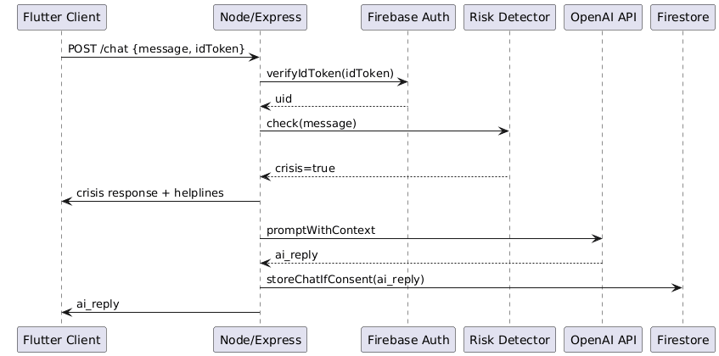
Activity Diagram – Chat Processing
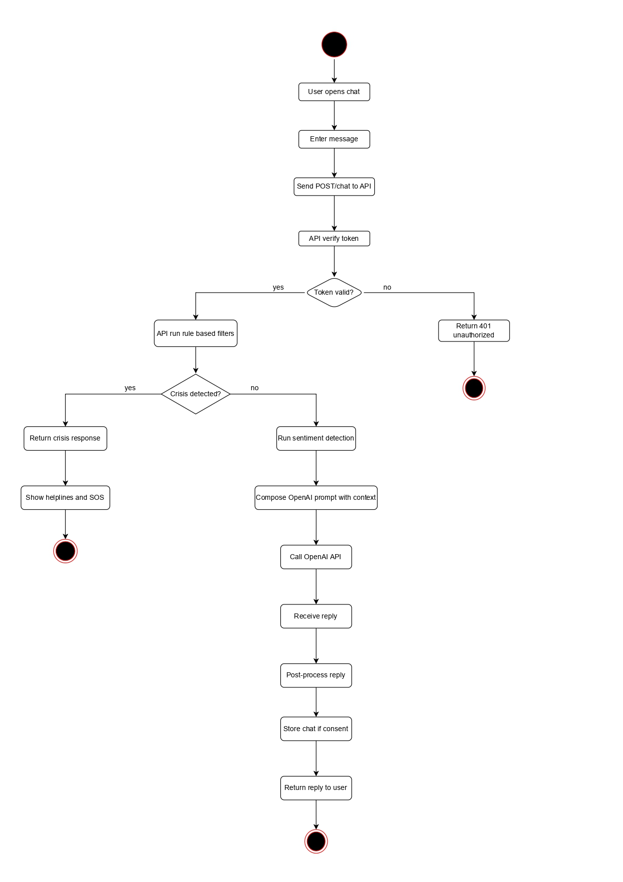
Class Diagram – Chat & Message Models
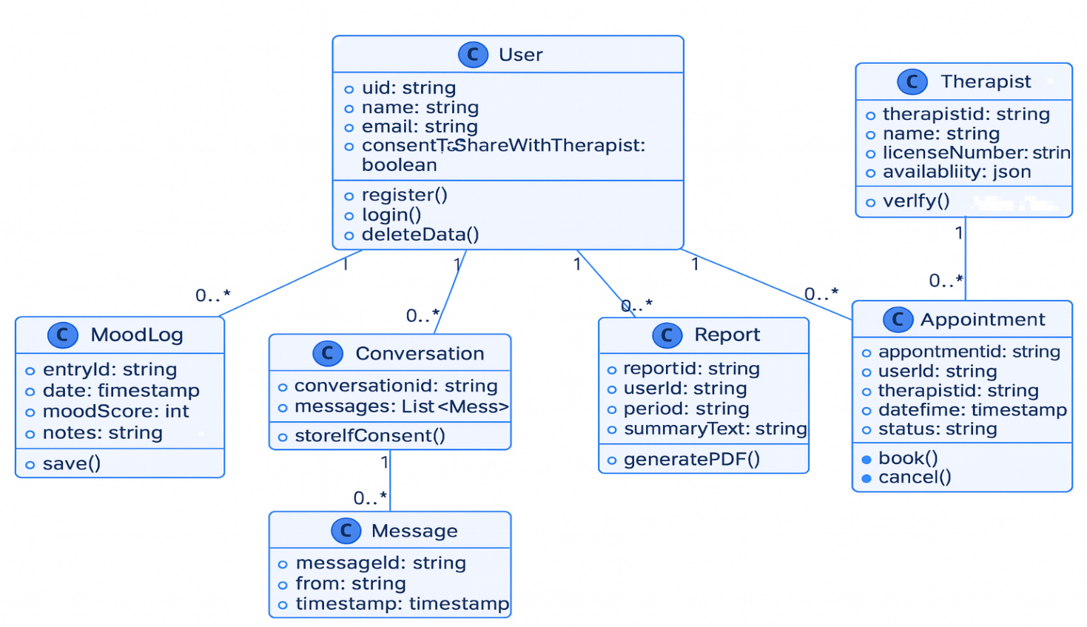

5.6.2 Mood Logging & Analytics Subsystem
This subsystem handles the collection, storage, and processing of mood logs submitted by users. It also generates weekly and monthly analytical summaries through scheduled backend tasks.
Responsibilities
- Receive daily mood entries from user
- Save mood logs in Firestore subcollections
- Aggregate historical data for trends
- Generate insight reports (PDF/JSON)
- Support therapist access based on user consent
DFD Level 1 – Mood Logging Flow
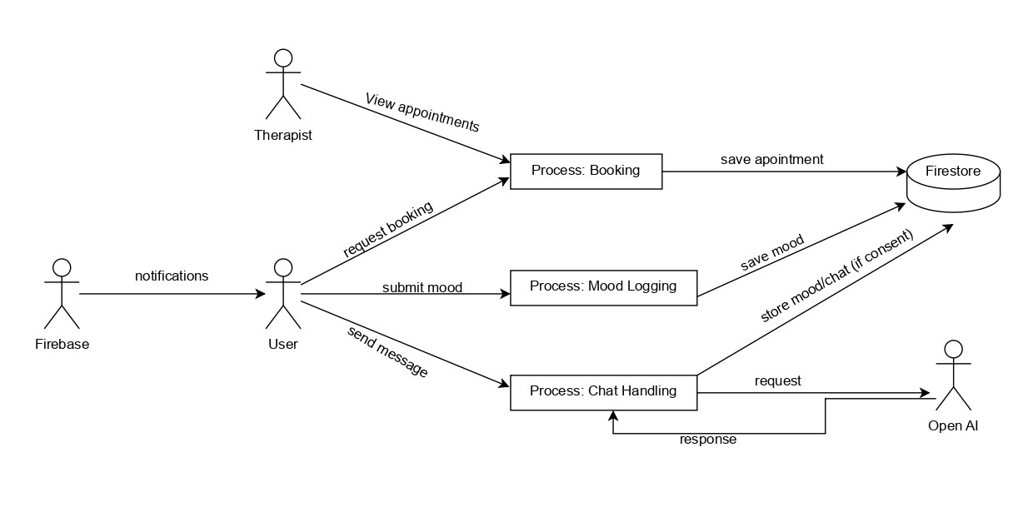

5.6.3 Therapist Booking & Session Subsystem
This subsystem manages therapist availability, appointment scheduling, payment verification, and WebRTC signaling for secure video or text sessions.
Responsibilities
- Fetch therapist availability
- Handle booking requests and cancellations
- Manage payment verification
- Support WebRTC signaling (ICE, SDP exchange)
- Maintain session states and therapist notes
State Machine – Session Lifecycle
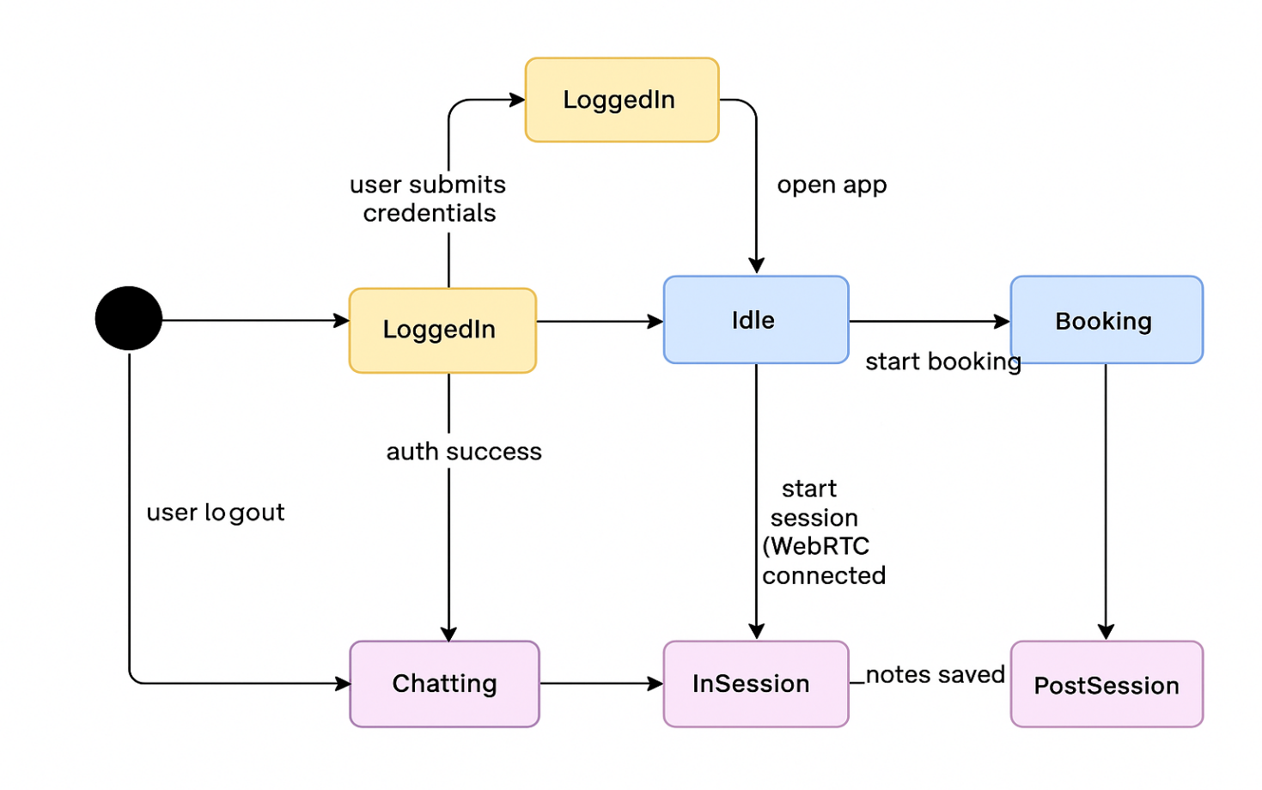

5.6.4 Authentication & User Management Subsystem
Handles user account creation, authentication, profile management, and data-access permissions.
Responsibilities
- Firebase Authentication for signup/login
- Manage sessions and access tokens
- Control consent settings
- Manage profile attributes and preferences

5.6.5 Notification Subsystem
This subsystem delivers reminders, therapist notifications, and system alerts through Firebase Cloud Messaging (FCM).
Responsibilities
- Register device tokens
- Deliver periodic reminders (mood check-ins, session alerts)
- Push appointment confirmations/cancellations
- Push crisis alerts if flagged

5.6.6 Database Management Subsystem
This subsystem defines how structured and unstructured data is stored across Firestore collections and subcollections, ensuring consistency, privacy, and secure access.
Responsibilities
- Define Firestore collections (users, therapists, appointments, reports, moods)
- Manage NoSQL document structure
- Enforce access rules via Firebase Security Rules
- Handle backup, retrieval, and deletion
Database Diagram – Firestore Collections
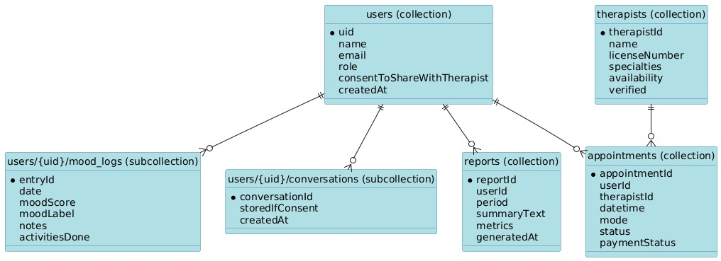
ER Diagram – Full System Entities
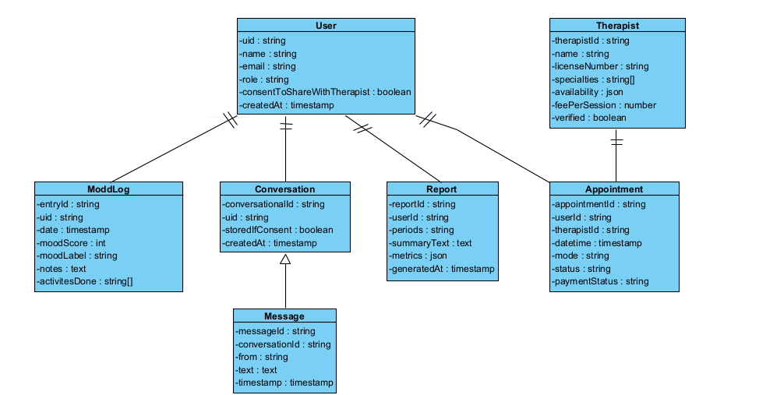

5.6.7 System Architecture Subsystem
This subsystem outlines the complete structural layout of MoodGenie including all external services like Firebase, OpenAI, HuggingFace, and payment gateways.
Responsibilities
- Define boundaries between client, backend, cloud services
- Manage communication protocols (HTTPS, WebRTC)
- Handle API routing using Express.js
- Manage external integrations
Architectural Diagram – High-Level System Structure
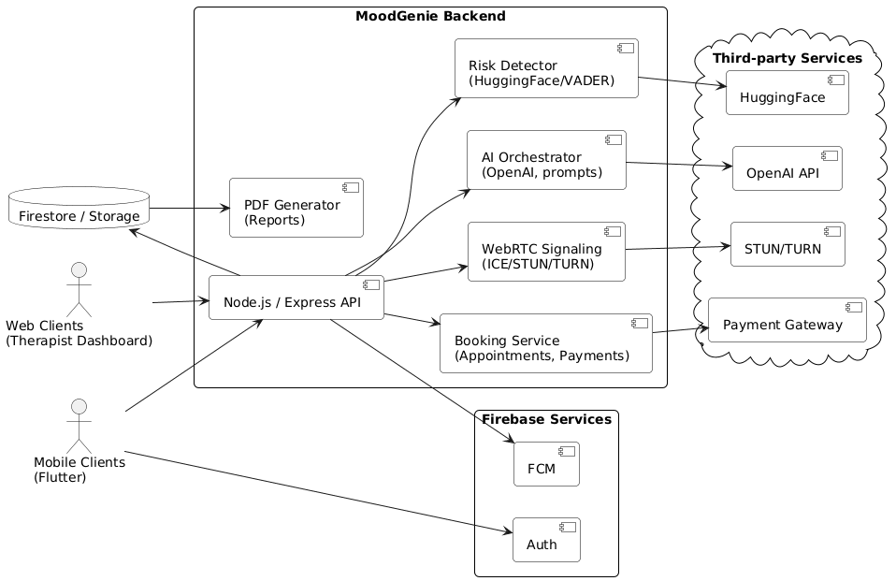
Component Diagram – Backend & External Systems
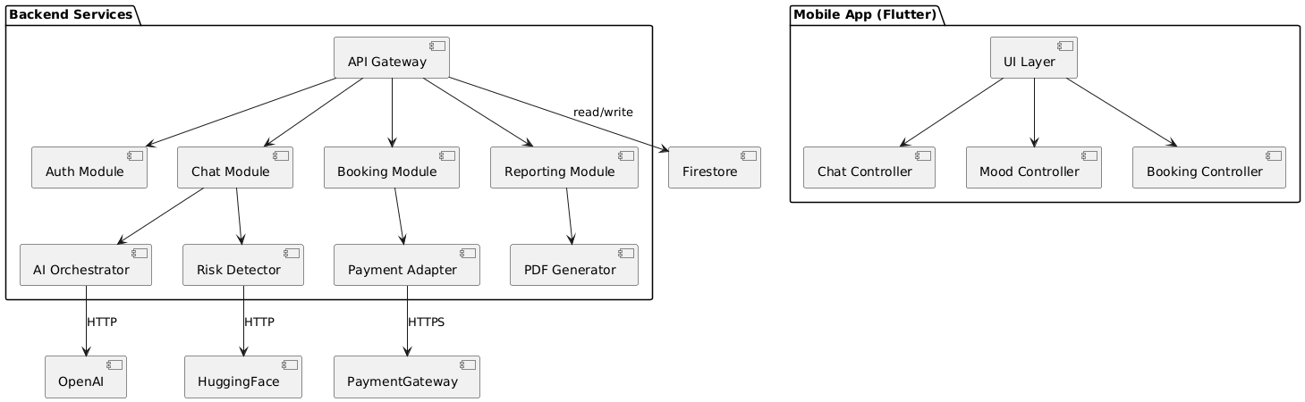

5.6.8 Application Frontend Subsystem (Flutter)
Defines the UI/UX layers of the mobile client (Android/iOS) including screens, navigation, state management, and API communication.
Responsibilities
- Render UI screens (chat, mood logs, booking, reports)
- Manage state using provider/bloc (your choice)
- Interact with backend APIs
- Validate user input
- Provide accessibility-friendly UI

References
[1] World Health Organization, “World Mental Health Report: Transforming mental health for all,” Geneva, 2022.
[2] A. Javed, “Reducing the stigma of mental health disorders with a focus on low- and middle-income countries,” Asian J Psychiatr, vol. 58, p. 102601, 2021.
[3] N. Topooco, “Digital interventions to address mental health needs in colleges: Perspectives of student stakeholders,” Internet Interv, vol. 28, 2022.
[4] K. K. ; D. A. ; V. M. Fitzpatrick, “Delivering cognitive behavior therapy to young adults with symptoms of depression and anxiety using a fully automated conversational agent (Woebot): A randomized controlled trial,” JMIR Ment Health, vol. 4, no. 2, 2017.
[5] IEEE, “IEEE Recommended Practice for Software Requirements Specifications,” New York (optional), 1998.
[6] J. A. Conrad, “Digitization and its discontents: The promise and limitations of digital mental health interventions,” J Contemp Psychother, vol. 54, pp. 209–215, 2024.
[7] United Nations, “Sustainable Development Goal 3: Ensure healthy lives and promote well-being for all at all ages.”
[8] Firebase, “Firebase Realtime Database / Firestore Documentation.”
[9] OpenAI, “OpenAI Platform.”
[10] Hugging Face, “Inference API Documentation.”
[11] WebRTC Project, “WebRTC Overview and Documentation.”
[12] Express, “Express – Node.js web application framework.”
[13] Node.js Foundation, “Node.js.”
[14] Flutter, “Flutter SDK | App Development Toolkit.”
[15] Google, “Material Design Guidelines – Overview.”
[16] Android Developers, “Material Design for Android – Look and Feel.”
[17] GeeksforGeeks, “Introduction to Material Design in Android.”
[18] Y. ; W. J. D. ; G. F. ; N. T. Inal, “Usability Evaluations of Mobile Mental Health Technologies: Systematic Review,” J Med Internet Res, vol. 22, no. 1, 2025.
[19] A. ; H. R. ; T. I. ; T. S. ; M. A. Almuqrin, “Smartphone apps for mental health: systematic review of the literature and five recommendations for clinical translation,” BMJ Open, vol. 15, no. 2, 2025.
[20] American Psychiatric Association, “Security Issues – Telepsychiatry Toolkit.”
[21] East Coast Telepsychiatry, “The Role of Confidentiality in Telepsychiatry: Ensuring Your Privacy During Online Consultations,” 2025.
[22] Cybersecurity and Infrastructure Security Agency (CISA), “Guidance for Securing Video Conferencing.”
[23] American Telemedicine Association, “Best Practices in Synchronous Videoconferencing-Based Telemental Health.”
[24] Google, “Firebase Cloud Messaging – Overview.”
[25] Google, “Cloud Firestore Documentation.”
[26] Google, “Receive Messages Using Firebase Cloud Messaging.”
[27] Sheerbit, “WebRTC Softphones in Healthcare: Secure Real-Time Communication for Telemedicine.”
[28] Relevant Software, “WebRTC Telemedicine & WebRTC Services for Modern Healthcare.”
[29] T. Levent-Levi, “WebRTC in Telehealth: More Than Just HIPAA Compliance.”
[30] Figma, “Figma – Collaborative Interface Design Tool.”
[31] Visual Paradigm and Canva, “Diagramming and design support tools.”

