Game Design Document

Fill up the Following document

1. Write the title of your project.

Haunted Mansion

1. What is the goal of the game?

Enjoyment and to overcome the fear of Ghost ☺

1. Write a brief story of your game?

One fine day Sofy was playing in the garden and suddenly there were thunderstorms and lightning in the sky and soon it started raining. She was running towards a tree so she can survive in current situation. After some moments, raining stopped. There was a Big Mansion behind the tree, Sofy was curious to go inside, first she hesitated but finally she walked in. But less did she know she was trapped in house and there were some weird creatures passing here and there with some grumpy sounds.

Again raining started and now there is only One way out, to fight with those weird creatures. In addition, Sofy have the fear of ghosts, it’s the right time she can overcome it. Will you help Sofy?

1. Which are the playing characters of this game?

* Playing characters are the ones which respond to the user based on the input from the user
* Cars, monkeys, dinos, wizards etc, are the playing characters in the game.

|  |  |  |
| --- | --- | --- |
| Number | Character Name | What can this character do? |
| 1 | Sofy | She can kill ghost with the help of cross |
| 2 | Cross | Will kill the ghost |
| 3 |  |  |
| 4 |  |  |
| 5 |  |  |
| 6 |  |  |
| 7 |  |  |
| 8 |  |  |

1. Which are the Non Playing Characters of this game?

* Non Playing characters are the ones which don't have an action or behaviour when the user interacts with the game.
* Hurdles, stones, bananas, coins, etc are non playing characters in the game.

|  |  |  |
| --- | --- | --- |
| Number | Character Name | What can this character do? |
| 1 | Mr. Bindra | Can kill Sofy |
| 2 | Rima | Can injure Sofy |
| 3 | Rohan | Can injure Sofy |
| 4 | Mrs. Maria | Can kill Sofy |
| 5 |  |  |
| 6 |  |  |
| 7 |  |  |
| 8 |  |  |

Draw your imagination of this game. What does this game look like?

* Draw the game either on your computer or on paper,
* Add images of scenes of the game to show each of the playing and non-playing characters at least once.

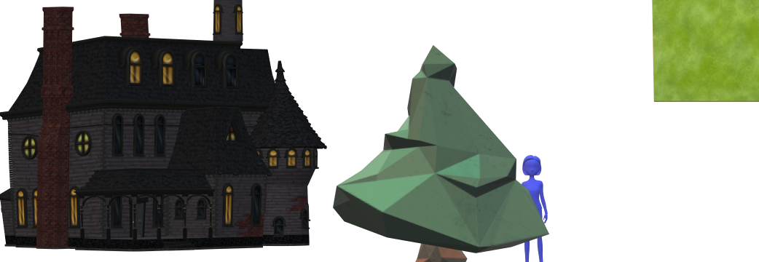

Exterior of the game (according to the story)

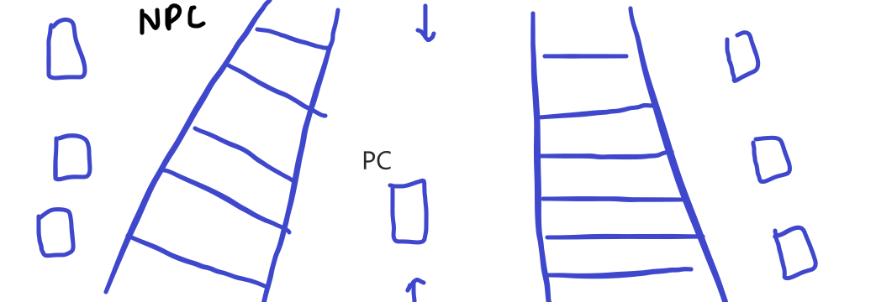

NPC will appear randomly with spooky sounds

How do you plan to make your game engaging?

When the player will kill 1 ghost the velocity of ghost will increase and by adding interesting images

And by adding horror sounds to the game