**National University of Computer and Emerging Sciences**



**Lab Manual 13**

*for*

# Data Structures Lab

|  |  |
| --- | --- |
| Course Instructor | Mr. Uzair Naqvi |
| Lab Instructor | Mr. Durraiz Waseem |
| Section(s) | 3H & 3J |
| Semester | Fall 2024 |

# Department of Computer Science

FAST-NU, Lahore, Pakistan

**Objectives:** Graphs and its applications (BFS/ DFS)

**Problem 1:**

Write a program to represent an undirected graph using, Adjacency Matrix and Adjacency List.

**Problem 2:**

Create a program to count the number of connected components in the undirected graph below using Depth-First Search (DFS):

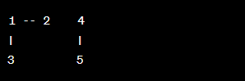

**Problem 3:**

Consider the directed acyclic graph (DAG) below:

Write a program to perform topological sorting using Depth-First Search (DFS). Print the topological order.

**Problem 4:**

Given the following undirected graph represented using an adjacency list:

Write a program to implement a class for graph with methods to add an edge, perform Breadth-First Search, and print the connected components. Test the class with a sample graph also print the BFS traversal.

**Problem 5:**

You are given the following undirected graph representing a subway system:

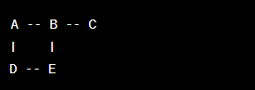

Write a program to find the number of stations you need to pass through to travel from station A to station C using Breadth-First Search (BFS).