Summary

- Sales are highest for:
  - Budget older families
  - Mainstream young couples / singles
  - Mainstream retirees
- Most of our customers are from:
  - Mainstream young couples / singles
  - Mainstream retirees
- Mainstream young couples / singles are more likely to pay more per unit. Also more likely to purchase Tyrrells chips and / or chips of size 270 g.
- Sales increase a lot before Christmas.

Trial Store | Control Store
77 | 233
86 | 155
88 | 237

- Store 86 the number of customers increased significantly higher throughout the trial period, but this trend wasn’t reflected in sales trends. We must check whether there was some sales, or other special offers at the store that might have caused this.
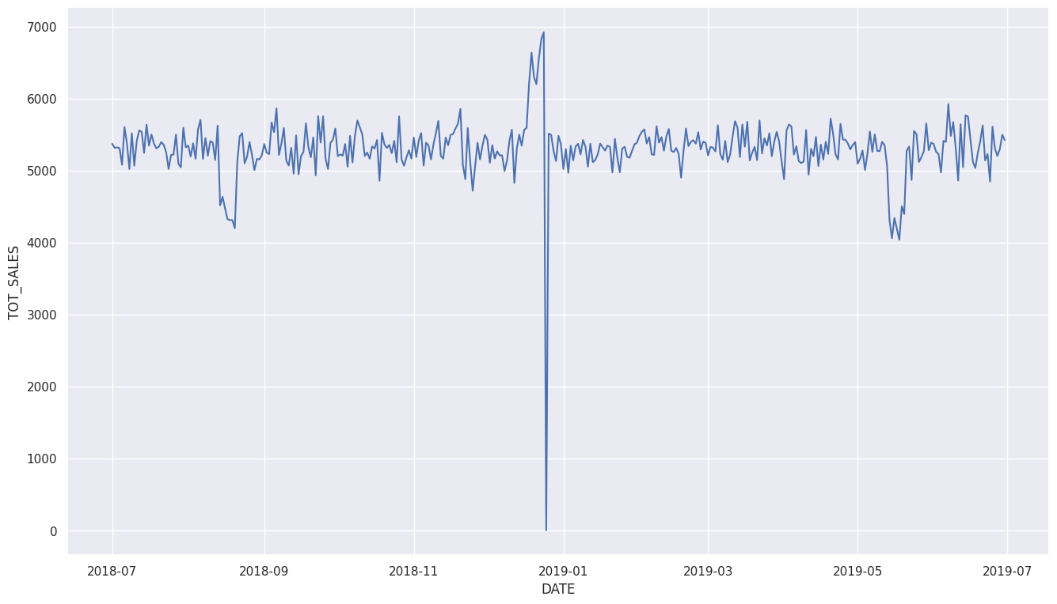
Store was closed on Christmas 2018

Customer segments
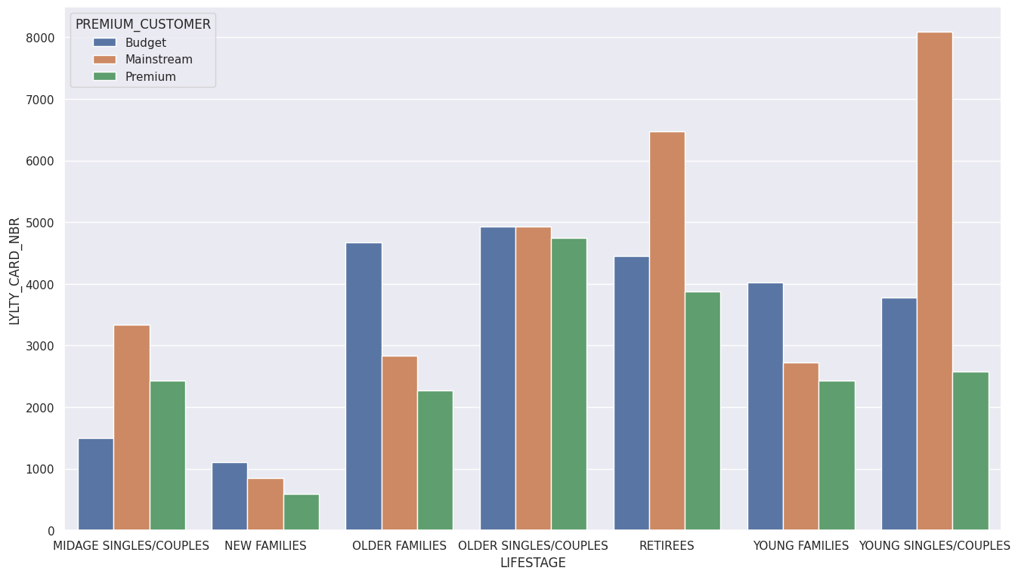

Most bought pack size
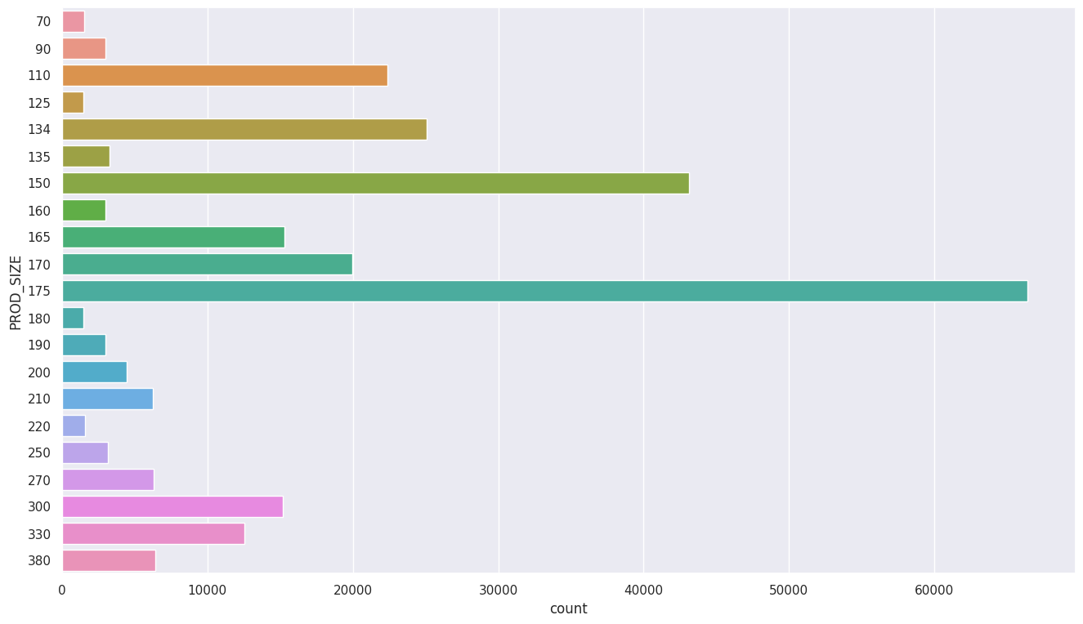

Sales Distribution
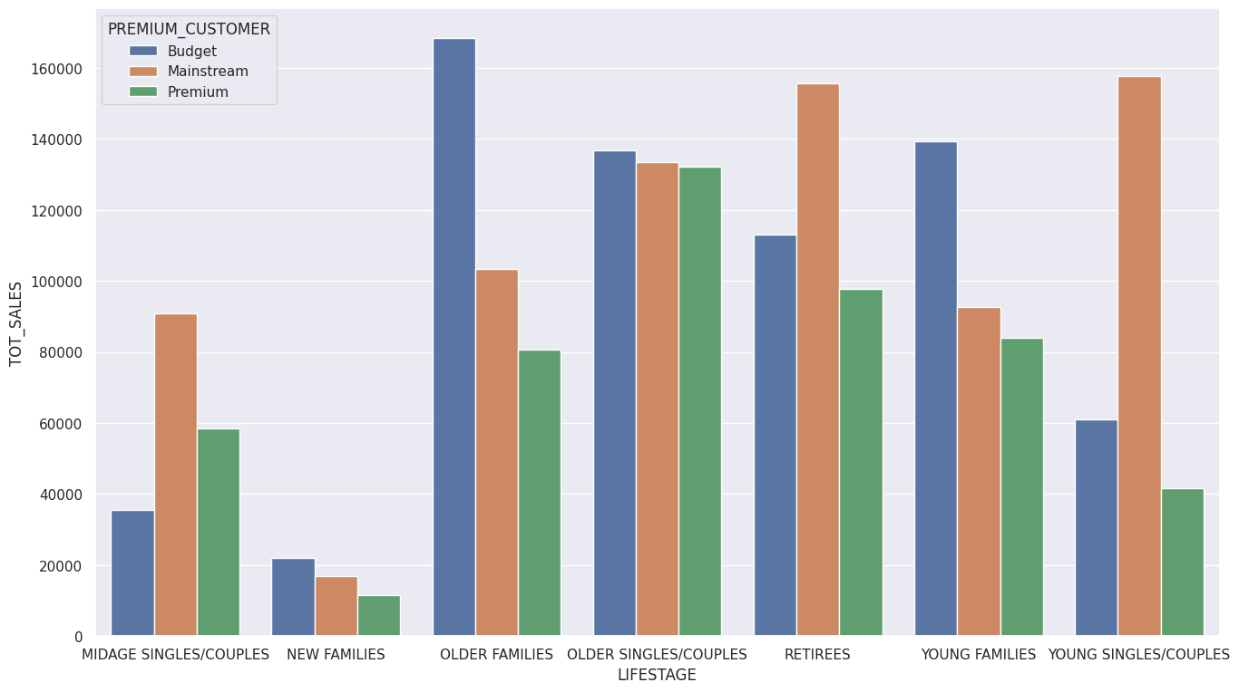

Quantity purchased

