IMAGE TRACE

Project Guide and System Methodology

STATUS  Completed local application | OWNER  Eshaan Sarkhawas | LAST UPDATED  September 10, 2026
Authors | Eshaan Sarkhawas and Codex
Related source | github.com/EshaanS013/image-trace
Public demonstration | image-trace-demo.polite-tulip-8246.chatgpt.site
Scope | Architecture, workflows, methodology, responsible uses, verification, operation, and limitations

1 Abstract
IMAGE TRACE is a complete local-first application for controlled analysis of image collections. It preserves accepted originals, records acquisition hashes and custody events, extracts hostile-input-safe metadata, reconstructs qualified chronology and routes, applies transparent versioned rules, records human review, and generates analysis-bound PDF reports with separate SHA-256 manifests.
The central design choice is to keep evidence processing on the analyst's computer. The public website is a demonstration surface built from synthetic screenshots; it does not accept evidence. The operational application uses a React and TypeScript client, a FastAPI and SQLAlchemy service, SQLite in WAL mode, and controlled filesystem storage. This guide explains the system, the methodology behind its results, how to run it, and the limits that govern responsible interpretation.

2 Purpose and Responsible Uses
The project helps an analyst answer a narrow question: what do the available metadata and image characteristics indicate about time, location, reported source device, byte integrity, and items that deserve qualified review? It organizes evidence and calculations so that another reviewer can reconstruct how each displayed result was obtained.
Suitable uses | Uses outside the product scope
Computer engineering coursework and demonstrations | Stalking, covert surveillance, or locating people without consent
Consented metadata inspection and evidence organization | A definitive claim that an image is authentic, false, or manipulated
Internal audit preparation and repeatable case review | Court certification or legal conclusions
Synthetic training fixtures and software testing | Device attribution based only on make and model metadata

Every output must be read as evidence about recorded bytes and metadata, not as proof of the event depicted. Missing GPS is an absence statement. An editing-software tag establishes only that the tag value is present. A derived route describes selected coordinates and timestamps, not observed physical travel.Interpretation rule.

3 Goals and Non Goals
Goals | Non goals
Preserve each accepted original without recompression, rotation, or metadata stripping | Replace a certified forensic imaging process
Make each hash, timestamp choice, rule, threshold, and review transition inspectable | Infer guilt, intent, authorship, or image truth
Support a complete local case-to-report workflow without a paid service | Provide multi-tenant cloud evidence storage
Use synthetic or consented evidence and privacy-safe map defaults | Silently contact external mapping or metadata services
Keep historical analysis runs and review events immutable | Rewrite old findings when a rule or threshold changes

4 System Architecture
The browser client communicates only with the versioned REST API. FastAPI route handlers validate request contracts and delegate behavior to domain services. Records and audit history live in SQLite; original bytes, derivatives, reports, and exports use separate controlled storage roots. The frontend never receives an absolute local storage path.
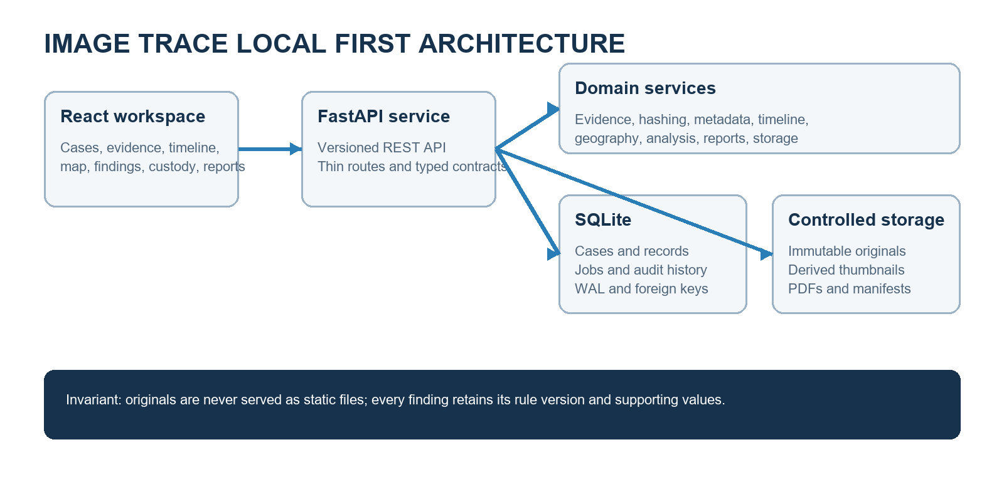
Figure 1 Local system architecture and evidence boundaries

Core components
Component | Responsibility | Primary state | Failure behavior
React workspace | Case navigation, evidence inspection, timeline, map, findings, custody, and reports | TanStack Query cache and view state | Shows typed loading and error states without exposing paths
FastAPI boundary | Versioned HTTP contracts, identifier validation, pagination, and safe errors | Request and response models | Rejects invalid input and suppresses stack traces
Evidence services | Validation, immutable copy, hash, metadata, thumbnail, and custody registration | SQLite plus controlled storage | One invalid file can fail without aborting a valid batch
Analysis services | Immutable runs, rule evaluation, geography, and finding support | Versioned run configuration | Failed runs retain status and safe summaries
Report service | HTML preview, PDF creation, final hash, manifest, and custody event | Reports storage and generated report record | No report is presented as complete until finalization and hashing succeed

5 Data Flow from Evidence to Report
1. The analyst creates a case with its name, number, description, analyst, and status.
2. The upload boundary checks the submitted basename, supported extension, declared MIME type, image signature, full decode, byte size, pixel count, and controlled path containment.
3. Accepted bytes are copied in chunks to a pending file, flushed, atomically renamed into a UUID-based evidence directory, and hashed with SHA-256 in chunks.
4. The application records the evidence row, acquisition hash, normalized and raw metadata, initial custody event, and durable job state. A WebP thumbnail is generated as a derivative; the original is not altered.
5. Timeline logic selects the strongest available time source and preserves its raw value, source, timezone status, confidence, and selection reason.
6. Analysis creates an immutable run with application, analyzer, rule-set, build, threshold, and configuration details. Findings copy their rule version and supporting inputs.
7. Analyst review appends disposition events. It never deletes the automated result or its historical context.
8. Report generation renders one completed analysis run, finalizes the PDF, hashes that final byte sequence, and writes a separate manifest that lists the report and evidence hashes.

6 Evidence Intake and Integrity Methodology
Validation does not trust a filename alone. The server compares extension, declared MIME type, decoded image format, and actual image parsing. It applies configurable defaults of 100 MiB per file, 200 files per batch, and 100 megapixels per image. JPEG, PNG, WebP, and TIFF are supported in the default build; HEIC remains disabled unless a safe parser is installed.
Storage keys use generated case and evidence identifiers. Submitted filenames remain escaped metadata and do not control disk paths. Root-containment checks reject traversal and symlink escape. Originals, derivatives, reports, and exports use separate roots. The frontend static server never exposes the originals directory.
SHA-256 is calculated while streaming chunks, which avoids reading an entire file merely to hash it. The acquisition hash identifies the exact accepted byte sequence. A later verification pass calculates a current hash and compares it with the acquisition value. Equality establishes byte identity with the recorded copy; it does not establish the truth, date, authorship, or authenticity of image content.
Integrity state | Meaning | Required analyst response
Verified | Current bytes match the acquisition SHA-256 | No integrity action required; continue contextual review
Mismatch | Current SHA-256 differs from the acquisition value | Review storage history and custody events before relying on the current file
Unknown | No completed comparison is available | Run verification when byte identity matters to the decision

7 Metadata Extraction and Normalization
The metadata service treats all tags as untrusted input. It bounds and escapes stored values, retains a raw JSON representation for reconstruction, and writes normalized fields for repeatable filtering and analysis. Extraction warnings remain attached to the evidence record when a value is present but cannot be normalized safely.
Metadata group | Raw value retained | Normalized use
Capture time | DateTimeOriginal, DateTimeDigitized, GPS date and time | Qualified timeline timestamp and source confidence
Location | Latitude, longitude, altitude components | Coordinate display, distance, and route calculations
Camera | Make, model, lens, serial when present | Reported camera grouping and adjacent-source change checks
Exposure | Focal length, ISO, aperture, shutter speed | Inspection context only in the MVP
Software | Exact software tag | Configured editor-pattern observation without a manipulation claim
Dimensions | Width, height, orientation | Inventory display and image validation

8 Timestamp Methodology
Timestamp selection follows a fixed priority: EXIF DateTimeOriginal, EXIF DateTimeDigitized, GPS date and time, source filesystem modification time, and filename ordering. The last two are explicitly labelled fallbacks. The record also explains why a higher-priority value could not be used.
A timestamp with an explicit offset can be normalized to UTC. A timezone-naive EXIF wall-clock value remains local or unknown. The application does not silently label it UTC. An analyst may apply a case-level timezone assumption; that assumption is recorded in analysis configuration and remains visible in the derived timestamp.
Source | Default confidence | Timezone handling
EXIF DateTimeOriginal | High when parseable | Known offset is normalized; otherwise local or unknown
EXIF DateTimeDigitized | Medium to high | Same explicit-offset rule
GPS date and time | Medium to high | Handled as UTC when the complete GPS value is valid
Filesystem modified time | Low fallback | Uses documented source timezone context
Filename ordering | Lowest fallback | Orders items but does not invent a capture instant

9 Geography and Route Methodology
GPS rational values are converted to decimal latitude and longitude only when their components and hemisphere references are usable. The offline coordinate canvas is the default display. No basemap request is needed, so coordinates and filenames are not sent to an external tile provider.
For two usable points, the geo service calculates great-circle distance with the Haversine formula and an Earth radius of 6,371.0088 km. Derived speed equals that distance divided by positive elapsed time. The application skips speed when either coordinate is unusable, the interval is zero or negative, or timestamps cannot be compared because timezone context is unknown.
A speed result is a consistency indicator. It reflects the selected metadata values and threshold; it is not an observation that a person or device travelled that route.

10 Explainable Analysis Rules
Each analysis run stores its analyzer version, rule-set version, application version, build commit, complete configuration, and configuration hash. Rerunning analysis creates new findings. Historical runs and review events remain unchanged.
Rule | Default level | Trigger and required support
INTEGRITY_HASH_MISMATCH | High | Verification hash differs from acquisition hash; show both hashes and verification time
TIMESTAMP_SOURCE_FALLBACK | Info | Timeline used filesystem or filename fallback; show source and selection reason
TIMESTAMP_DISCREPANCY | Review | Parseable embedded wall-clock sources differ by more than 300 seconds by default; show raw and normalized values, difference, and timezone status
EDITING_SOFTWARE_PRESENT | Review | Software tag matches a configured editor pattern; show exact tag and matching pattern without claiming manipulation
IMPLAUSIBLE_TRAVEL | Review | Derived speed exceeds 1,000 km/h by default; show evidence pair, distance, interval, speed, threshold, and timestamp confidence
MISSING_GPS | Info | No usable coordinates exist; state absence only
CAMERA_SOURCE_CHANGE | Info | Adjacent evidence reports a changed make and model grouping; show previous and current values

11 Human Review and Audit History
Findings begin as automated observations. An analyst can acknowledge, resolve, or exclude a finding and must provide a note for the consequential transition. The application appends a review event containing the actor, prior status, new status, note, and timestamp. This preserves the distinction between machine output and human disposition.
Evidence notes and review state are separate from the stored original. Editing a note never edits image bytes or raw metadata. Chain-of-custody events record acquisition, verification, report generation, and other case actions without exposing local paths in the API.

12 Reporting and Provenance
A report references one specific completed analysis run, so its findings and configuration remain reconstructable. The report includes case context, methodology, limits, evidence and hash information, analysis versions, and review dispositions. The application finalizes the PDF before calculating its SHA-256 value.
The separate manifest avoids a circular hash problem: a PDF cannot contain its own final hash without changing the bytes being hashed. The manifest therefore records the fixed report hash and relevant evidence hashes after finalization. The generated report record also stores the application version and build commit.

13 API and Data Contracts
The REST surface is versioned under /api/v1 and documented through FastAPI OpenAPI at /api/docs. Routes use typed Pydantic contracts, validated identifiers, stable error objects, and polling-friendly job resources. The API does not return absolute storage paths or stack traces.
Resource group | Representative operations | Primary records
Cases | Create, list, inspect, update, archive, reopen | cases
Evidence | Batch upload, list, inspect, thumbnail, download, verify, review, note | evidence_files, image_metadata, evidence_notes
Analysis | Create runs, inspect runs, timeline, map data, findings, dispositions | analysis_runs, findings, finding_review_events
Audit and jobs | Custody history, job status, cancellation | chain_of_custody_events, jobs
Reports | Create, list, preview, download, manifest | generated_reports

14 Consistency Failure and Recovery
Scenario | Expected behavior | Reason
One file in a batch is malformed | Reject that file with a safe reason and continue valid items | A single parser failure must not discard successful evidence intake
Registration transaction fails | Do not leave a committed evidence row without its acquisition hash and initial custody event | These records form one consistency boundary
Analysis is rerun | Create a new run and new findings | Historical results remain reconstructable
Configuration changes during a run | Use the configuration snapshot stored on that run | Mid-run behavior cannot silently change
Report creation fails before finalization | Keep the job failed or partial and do not publish a completed report record | The report hash and manifest must describe fixed bytes

15 Security Privacy and Threat Model
• Trust boundaries exist at file upload, metadata parsing, API input, controlled storage, report rendering, and optional external map access.
• Pillow decompression-bomb safeguards, byte and pixel limits, full decode, and supported-format checks constrain parser resource use.
• Generated UUID directories, root-containment checks, filename sanitization, and separated storage roots reduce traversal, overwrite, and accidental serving risk.
• Metadata is escaped in the UI and report. Embedded external URLs are never followed automatically during analysis.
• The offline coordinate canvas is the privacy-preserving map default. An online tile provider would require explicit enablement and a privacy notice.
• Uploaded evidence, generated derivatives, runtime databases, reports, logs, and caches are excluded from Git. Only safe synthetic fixtures belong in public source control.
Residual risk remains because image parsers handle complex untrusted formats, local users may have filesystem access outside the application, and metadata itself may contain sensitive location or device details. The project should therefore run on a maintained operating system with access limited to the analyst and with case storage protected by normal endpoint security and backups.

16 User Workflows
Workspace | What the analyst does | Decision supported
Case registry | Create, reopen, archive, and locate investigations | Which case context is active
Evidence | Search, filter, select, and inspect hashes, metadata, notes, and status | Which file and source values need review
Timeline | Examine timestamp order, source, confidence, and intervals | Whether chronology is sufficiently supported
Map | Inspect coordinates, route segments, distance, and derived speed | Whether location inputs create an explainable inconsistency
Findings | Read rule support and record an auditable disposition | Which automated observations remain unresolved
Custody | Review append-only case and evidence events | How evidence and reports moved through the application
Reports | Generate, preview, and download the PDF and manifest | What fixed analysis state is being communicated

17 Product Demonstration
The following screens were captured from the running application with the committed 20-image synthetic fixture. The fixture contains no person and asserts no real-world event. It includes images with and without GPS, two declared camera groups, timestamp and software-tag examples, a deliberately rapid synthetic transition, and duplicate examples.

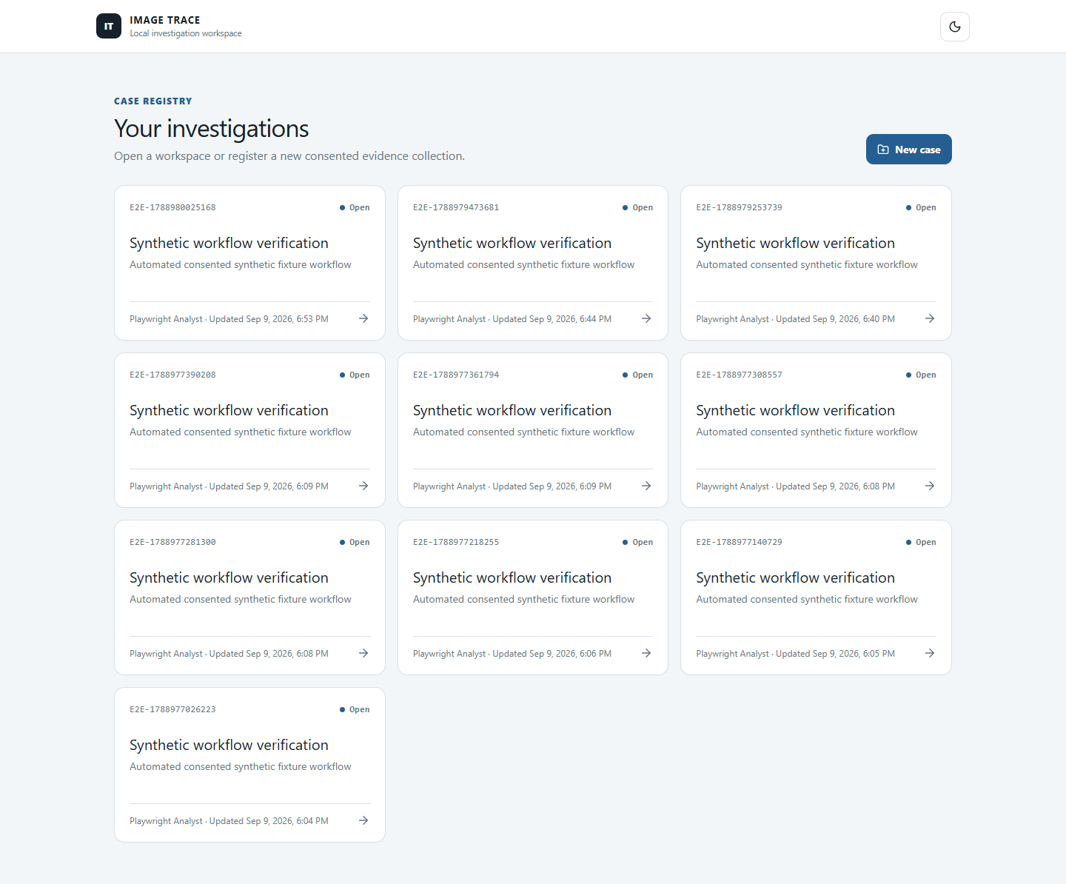
Figure 2 Case registry in dark mode

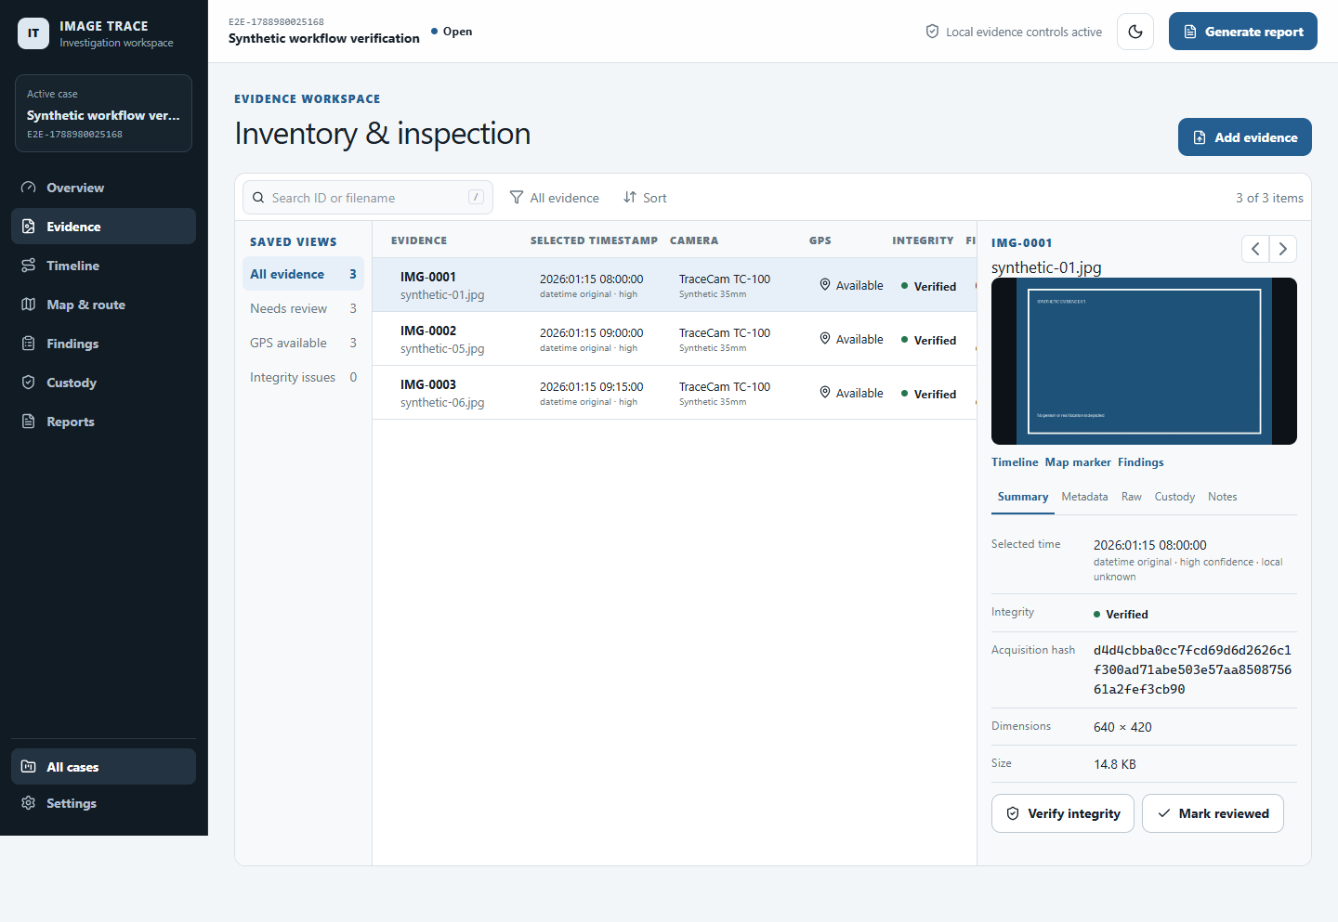
Figure 3 Evidence inventory and persistent inspector

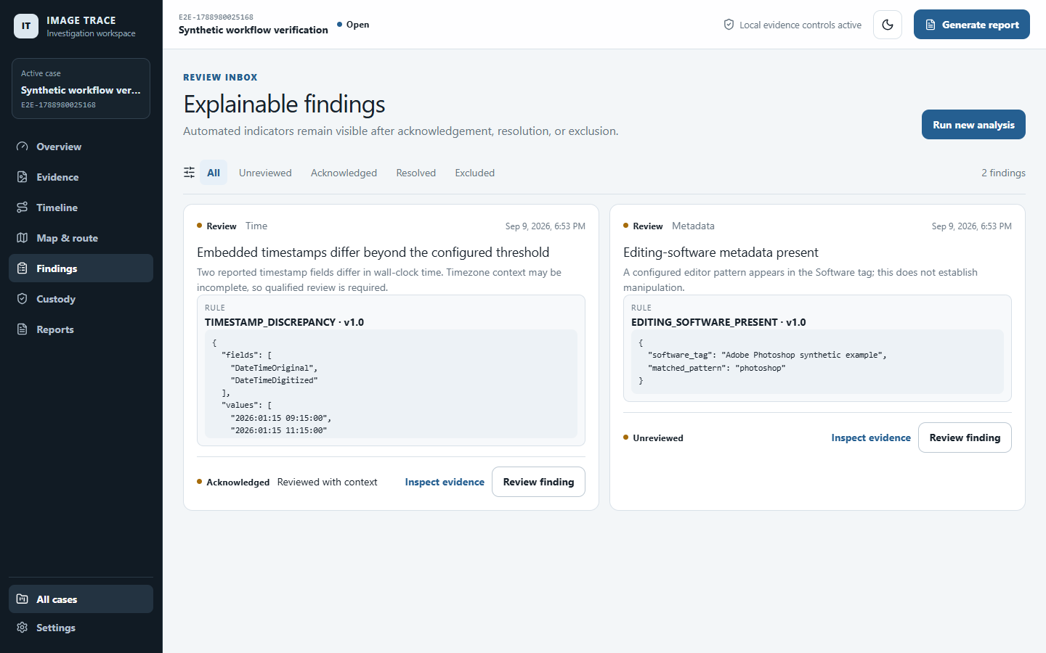
Figure 4 Explainable findings and human review

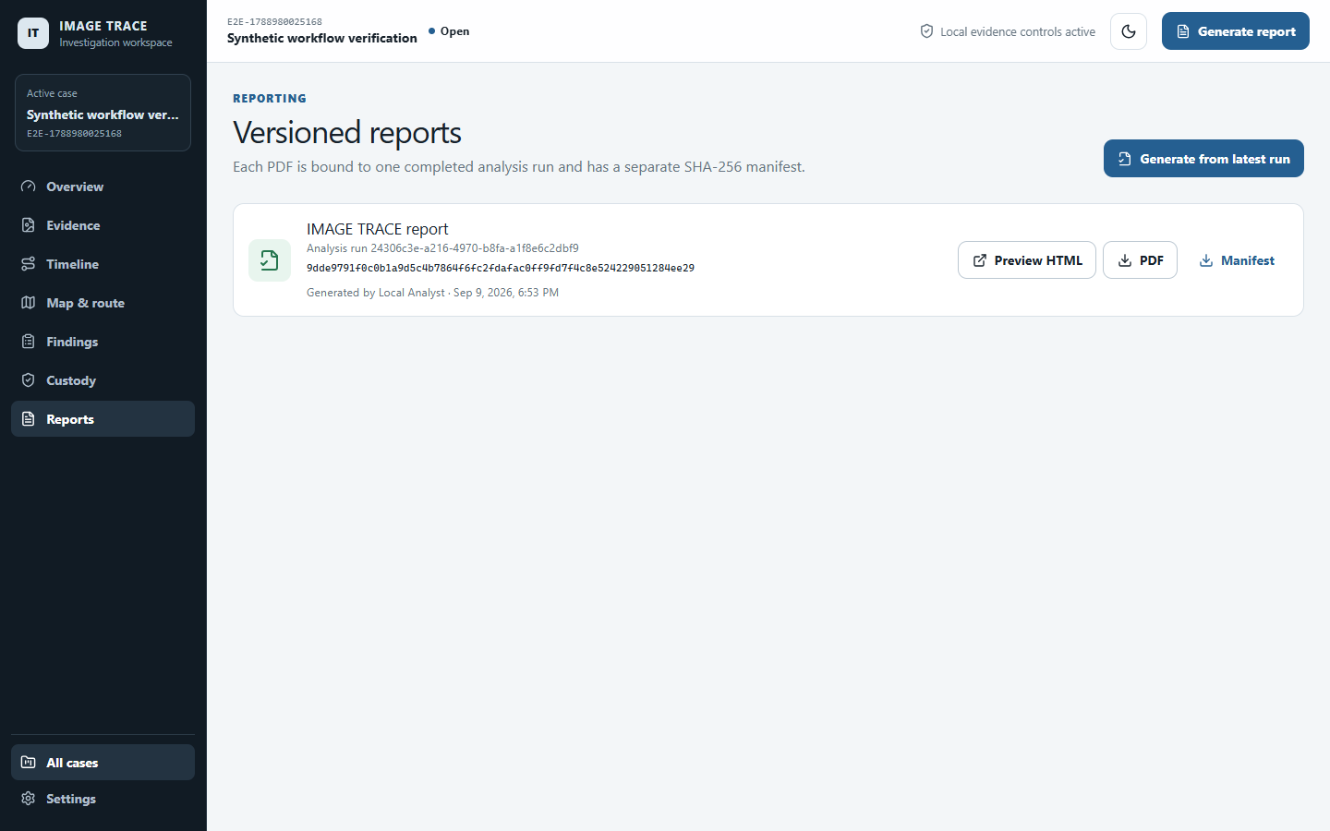
Figure 5 Versioned report generation and downloads

18 Installation and Operation
Prerequisites are Python 3.12 or newer, Node.js 22 or newer, npm 10 or newer, and Chrome for the local Playwright workflow. On Windows, WeasyPrint can use an installed GTK runtime; when it is unavailable, the application uses its complete paginated ReportLab renderer.

Windows PowerShell
cd apps/backend
python -m venv .venv
.\.venv\Scripts\python.exe -m pip install -e \".[dev]\"
.\.venv\Scripts\python.exe -m alembic upgrade head
cd ../frontend
npm ci
cd ../..
.\scripts\dev.ps1
Open http://127.0.0.1:5173 for the application and http://127.0.0.1:8000/api/docs for the API reference. The public demonstration site is intentionally read-only and contains synthetic screenshots only.

19 Repository Structure
Path | Purpose
apps/frontend | React, TypeScript, Vite, routes, shared state, components, and UI tests
apps/backend | FastAPI service, SQLAlchemy models, Alembic migration, domain services, report template, and tests
fixtures/synthetic-case | Deterministic public sample images and fixture manifest
storage | Runtime roots for originals, derivatives, reports, and exports; generated content is ignored
docs | Architecture, API, data model, methodology, threat model, limitations, testing, and demo script
scripts | Fixture generation, local launch, and demo asset tooling
tests/e2e | Playwright principal workflow and demo capture

20 Verification Results
The completed local verification suite covers the case-to-report vertical slice and the controlled integrity mismatch path. It also checks light and dark theme behavior, the responsive investigation surfaces, dependency consistency, and the final report layout.
Check | Result | Coverage
Backend tests | 5 passed | Hashes, time, geography, intake, findings, review history, mismatch, reports, and HTTP workflow
Frontend tests | 3 passed | Case listing, essential navigation, and theme behavior
Playwright | 2 passed | Principal workflow and reproducible demo capture
Static analysis | Passed | Ruff and mypy for backend; lint and TypeScript checks for frontend
Production build | Passed | Vite production bundle
Dependency checks | Passed | Both npm audits reported zero vulnerabilities; pip check was clean
Report visual QA | Passed | Two generated PDF pages rendered and inspected

21 Known Limitations
• Metadata may be absent, incorrect, stale, rewritten by normal software, or stripped during transfer.
• SHA-256 equality proves only byte identity with the recorded acquisition copy.
• Camera grouping uses reported make and model metadata and is not device-level source attribution.
• Timezone-naive timestamps cannot be compared safely across places without a documented assumption.
• Coordinates may be inaccurate; route and speed results are derived from selected metadata.
• HEIC support depends on a separately installed safe parser and is not enabled by default.
• The in-process local job runner is appropriate for the MVP, not for a multi-user distributed deployment.
• The public demonstration site does not process evidence. The full application runs locally by design.

22 Future Development
Priority | Possible extension | Required safeguard
Near term | Improved metadata-based camera grouping and duplicate review | Keep supporting values visible and avoid device attribution claims
Near term | Packaging and signed desktop distribution | Preserve controlled storage and reproducible builds
Later | Optional local tile packages | No implicit external coordinate transmission
Experimental | Controlled PRNU research module | Separate experimental labelling and detailed reliability limitations for resizing, denoising, HDR, recompression, screenshots, editing, and social media processing

23 Completion and Next Steps
The complete MVP exists as a committed local Git repository and runs through the documented PowerShell or Unix-like commands. The public website demonstrates the interface and methodology without accepting evidence. The source repository URL is https://github.com/EshaanS013/image-trace.
To use the project, run the database migration, start the backend and frontend, create a case, upload only synthetic or consented images, review the extracted values and qualified findings, and generate a report from the completed analysis run. Retain the PDF with its separate SHA-256 manifest when transferring the result.

Use footnotes for definitions, assumptions, or terms that need precision without interrupting the main narrative.

