What is Muse data?

MUSE stands for Multi-Unit Spectroscopic Explorer. It's an instrument on the Very Large Telescope (VLT) in Chile, operated by ESO (European Southern Observatory).
it's an Integral Field Unit (IFU)
A normal camera takes a 2D image. A normal spectrograph takes a spectrum (light split by wavelength) of one point. MUSE does both simultaneously — it takes a spectrum at every single pixel across a large field of view (1 arcminute × 1 arcminute). So instead of a single image or a single spectrum, you get a 3D data cube:
- X position
- Y position
- Wavelength (i.e., the spectrum at each position)
This is incredibly powerful because you can extract images at any wavelength or extract a spectrum from any location in the field.
Key MUSE specs:
- Wavelength range: 4000–9000 Å (optical light)
- ~3000 resolution elements across the field
- Each element gives ~100k pixels worth of spectral information
- This matches exactly what your project description says!

What is fits file format?
FITS stands for Flexible Image Transport System. It is the standard file format used in astronomy , almost all astronomical data, including MUSE data cubes, is stored as .fits files.
A FITS file can contain:
- Images (2D arrays of pixel values)
- Data cubes (3D arrays — like MUSE data: x, y, wavelength)
- Tables (catalogues of stars, measurements, etc.)
- Headers — metadata stored as plain text, containing information like the telescope used, observation date, coordinates, exposure time, wavelength calibration, etc.
For my project, the MUSE data cube will likely be a FITS file with shape something like (wavelength channels × y pixels × x pixels)

Research Paper-1(The Th 28 Jet)

What is this paper about?
Th 28 (also called Sz 102 or Krautter's Star) is a Classical T Tauri Star — a young star still in its pre-main-sequence phase, located in the Lupus 3 cloud about 160 parsecs away. It drives a bipolar jet (gas shooting out in two opposite directions), called HH 228.
Why are jets interesting? Jets from young stars are linked to how stars form — they remove mass and angular momentum from the star-disk system. Understanding jets helps us understand how stars like our Sun were born.

What did the researchers do with MUSE data?
They pointed MUSE at Th 28 and used its IFU capability to study the jet in detail:
- Spectro-imaging — They extracted images of the jet in specific emission lines (like Hα, [S II], [O III], [N II]) and at specific velocity ranges. This lets them see which parts of the jet are moving towards us (blue-shifted) vs. away (red-shifted).
- Position-Velocity (PV) diagrams — Slices through the data cube showing how velocity changes with position along the jet.
- Knot identification — They found 6 new knots (clumps of shocked gas) in the jet that hadn't been seen before, including some only visible after applying a Lucy-Richardson deconvolution to improve spatial resolution.
- Jet width measurement — By fitting Gaussian profiles across the jet, they measured how wide it is and its opening angle.
- Precession detection — Most importantly, they found the jet wiggles with point symmetry on both sides of the star. This is a signature of jet precession — the jet axis is slowly rotating like a spinning top.

What are they searching for?
The core scientific question is: why does the jet precess? Their answer: probably a brown dwarf companion (a failed star, ~70 Jupiter masses) orbiting Th 28 at a very close separation of ~0.3 AU, causing the inner disk to precess, which makes the jet precess. This has a period of about 8 years.
This connects back to the bigger question of jet launching — how exactly do young stars produce these jets, and what does the jet's shape tell us about the star-disk system?
Richardson–Lucy deconvolution is a method used to make blurry images clearer. It works by using the known blur pattern of the instrument (the PSF) and repeatedly adjusting the image to guess what the original, sharp image looked like. Each step improves the estimate a little more. This technique is common in astronomy because it helps reveal fine details that were hidden by atmospheric blur or telescope optics.

Research Paper - 2(AION-1 (Parker et al. 2025)

AION-1 is a foundation model (think: a large AI model like GPT, but for astronomy data) that can process 39 different types of astronomical data — images from multiple telescopes, spectra, and scalar measurements — all in a single unified model.

AION-1 addresses a major limitation in modern astronomy: the absence of a unified framework capable of jointly modelling heterogeneous data modalities. Traditional analyses rely on separate, instrument-specific models, preventing consistent cross-modal reasoning. AION-1 overcomes this by introducing an omnimodal architecture that integrates images, spectra, and scalar measurements within a single system.

1.1 Architecture and Methodology
AION-1 employs a two-stage design tailored to the diversity and noise characteristics of real astronomical observations.
- Universal Tokenization: All input modalities—2D images, 1D spectra, and scalar values—are transformed into a common discrete token space.
  - Images: Encoded using a ResNet-based MagViT autoencoder with Finite Scale Quantization (FSQ).
  - Spectra: Processed through a ConvNeXt-V2 backbone using Look-up-Free Quantization (LFQ).
  - Scalars: Normalized via CDF-mapping to a standard normal distribution before FSQ quantization.

- Multimodal Masked Modeling: A transformer encoder–decoder is trained with a masked-token objective, enabling the model to learn both intra-modal and cross-modal relationships. By reconstructing masked tokens from partially observed inputs, AION-1 develops a unified physical understanding across all data types.

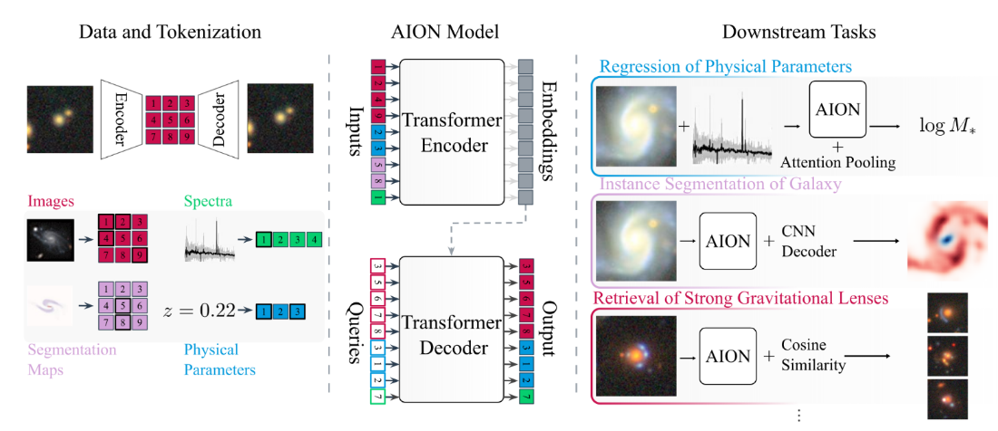

Three Model variants of AION-1

Model Variant | Parameters | Encoder Blocks | Decoder Blocks | MLP Dimension
AION-B | 300M | 12 | 12 | 3072
AION-L | 800M | 24 | 24 | 4096
AION-XL | 3.1B | 24 | 24 | 16384

What is precessing??

What is red and blue shift?? And how is it used to identify objects from image(via wavelength)

What is flux?

Emission lines in MUSE FITS data
When working with MUSE data cubes, you are not just looking at a single image — you have a full spectrum at every pixel. This means you can isolate specific emission lines: narrow wavelength channels where particular atoms or ions emit light. Each emission line traces different physical conditions (temperature, ionisation, density) in the gas being observed. This is exactly what the Th 28 paper does — extracting images in Hα, [S II], [O III], and [N II] to map different zones of the jet.

What is an emission line?
When an electron in an atom drops from a higher energy level to a lower one, it releases a photon at a very specific wavelength. This produces a bright “spike” in the spectrum at that exact wavelength — an emission line. Because each element and ionisation state has a unique set of energy levels, each emission line acts like a fingerprint for that species. In a MUSE data cube you can collapse the cube along the wavelength axis at just that channel to produce an image showing where that specific gas is located in the field.

False colour and the Hubble SHO palette
Because most emission lines fall outside the range of what our eyes see as “normal” colour, astronomers assign false colours to them for visualisation. The most common convention is the Hubble SHO palette: [S II] → red, Hα → green, [O III] → blue. This is counter-intuitive (Hα is physically red at 656 nm) but it separates the three lines clearly and produces the distinctive colour scheme seen in images like the Pillars of Creation. In HaRGB imaging (more common in amateur work) Hα maps to red, matching its true wavelength.

Key emission lines used in MUSE work
The table below summarises the eight most important emission lines for MUSE observations. All wavelengths are in the optical range (400–700 nm), which matches the MUSE wavelength coverage of 480–930 nm (and 465–930 nm in wide field mode).
Line | Wavelength | False colour | What it traces
Hα (H-alpha) | 656.3 nm | Red / green (SHO) | Ionised hydrogen in HII regions, stellar jets, supernova remnants. The strongest and most important line in optical nebula work. Used extensively in the Th 28 jet paper.
[O III] (O-three) | 500.7 nm | Cyan / blue (SHO) | Highly ionised, hot gas. Prominent in planetary nebulae and the outer shells of jets. A forbidden transition — only occurs at low enough gas density.
[S II] (S-two) | 671.6 + 673.1 nm | Deep red / magenta (SHO) | Lower-ionisation gas at jet edges and shock fronts. Excellent for tracing filamentary structure in jets. Key line in the Th 28 paper for identifying knots.
[N II] (N-two) | 654.8 + 658.3 nm | Orange-red | Low-ionisation zones bordering HII regions. Only 2 nm from Hα — a separate filter is needed. Also key to the BPT diagram for classifying galaxies.
Hβ (H-beta) | 486.1 nm | Blue | About 4x fainter than Hα. Used with Hα to measure dust extinction via the Balmer decrement (expected ratio Hα/Hβ = 2.86 when no dust). Also used in galaxy spectroscopy.
[O II] (O-two) | 372.7 nm | UV / violet | Star formation rate tracer in distant galaxies. Lower ionisation than [O III]. Critical in redshift surveys because it is bright in high-z galaxies.
[O I] (O-one) | 630.0 nm | Amber / orange | Neutral or very low-ionisation gas at nebula edges and in shocks. A key diagnostic on the BPT diagram. Traces the outermost, coolest zones.

How to extract an emission line image from a MUSE cube
In Python using astropy and numpy, the basic workflow is:
1. Open the FITS cube: the data array has shape (wavelength, y, x).
2. Read the WCS from the header to convert wavelength channel index to nanometres (using CRVAL3, CDELT3, CRPIX3 keywords).
3. Find the channel indices corresponding to the emission line wavelength (e.g. 656.3 nm for Hα).
4. Collapse (sum or median) the cube over those channels to produce a 2D image: data[channel_min:channel_max, :, :].sum(axis=0)
5. Subtract a continuum estimate (from adjacent wavelength channels either side of the line) to isolate the emission from the background star/galaxy light.
The resulting 2D array is your emission line map — it shows the spatial distribution of that particular gas species across the field of view. This is exactly what the Th 28 paper does to isolate the jet structure in each line.

Connection to velocity / redshift
Because we know the rest wavelength of each emission line precisely, any shift in the observed wavelength tells us the radial velocity of the gas via the Doppler formula: v = c × (λobserved − λrest) / λrest. Gas moving towards us (blue-shifted) appears at a shorter wavelength; gas moving away (red-shifted) appears at a longer wavelength. This is why the Th 28 paper can produce Position-Velocity diagrams — by looking at the cube at slightly different wavelengths around Hα, they see the jet gas at different velocities and map how the flow speed changes along the jet axis.

Emission Line Maps of the HH 399 Jet System
Continuum-subtracted emission line maps were extracted from the MUSE data cube for four diagnostic lines: Hα λ6563, [N II] λ6583, [S II] λλ6716,6731, and [O III] λ5007. The resulting maps reveal the spatial distribution of ionised gas across the field of view and allow the morphology of the HH 399 jet system to be examined in multiple gas tracers simultaneously.
Hα λ6563
The Hα emission line map reveals a prominent, curved jet structure extending from a bright compact source located at approximately pixel coordinates (210, 75), which corresponds to the position of the driving protostar Th 28. The jet is clearly visible as a bright arc sweeping from the source position toward the south and east, with the emission brightest at the base near the source and gradually decreasing along the jet axis. A secondary fainter arc-like structure is also visible to the upper left of the driving source at approximately (130, 150), consistent with the counter-jet or a bow shock from a previous ejection episode. The continuum subtraction successfully removes the smooth background emission from the central star, leaving the jet emission clearly isolated against a low, approximately uniform background. Hα is a recombination line and traces all ionised hydrogen along the line of sight, making it the most sensitive tracer of the total column of ionised gas in the jet. The broad, diffuse emission surrounding the jet axis in the raw map, which is significantly reduced after continuum subtraction, confirms that the extended emission in Hα is predominantly continuum in origin, with the jet itself occupying a relatively narrow spatial extent.
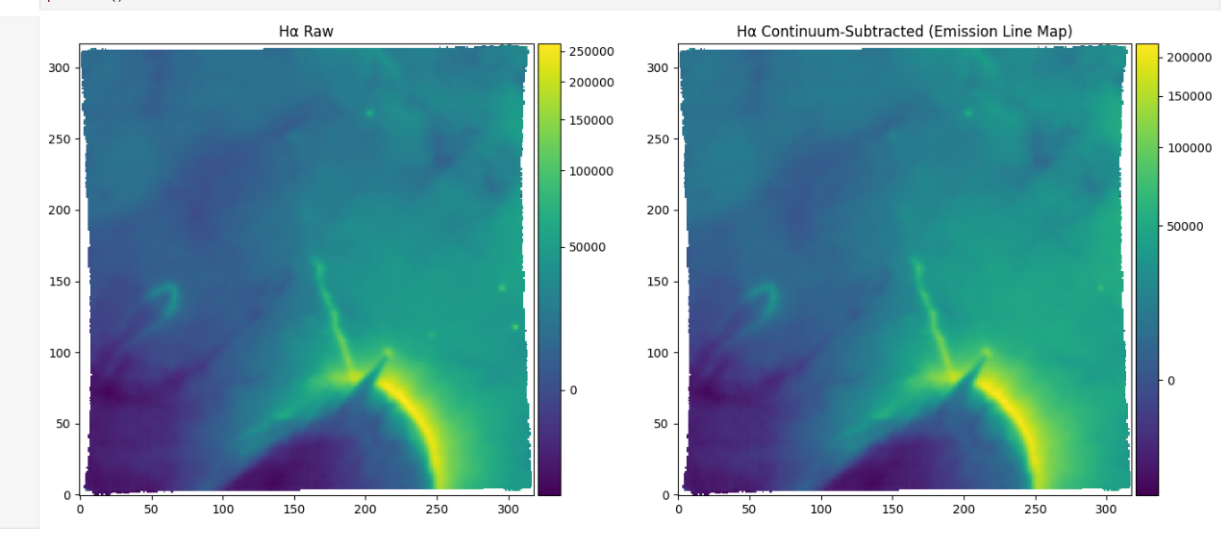

[S II] λλ6716,6731
The [S II] doublet map shows a strikingly similar morphology to Hα, with the same curved arc and driving source position clearly recovered. However, several important differences are apparent. The background in the continuum-subtracted [S II] map is significantly cleaner than in Hα, with point sources corresponding to foreground or background stars almost entirely removed by the continuum subtraction, demonstrating the effectiveness of the technique for stellar contamination. The jet arc itself appears sharper and more collimated in [S II] than in Hα, with the emission more tightly concentrated along the jet axis rather than the broader, more diffuse distribution seen in Hα. This morphological difference is physically meaningful: [S II] is a forbidden line that is collisionally excited in post-shock gas and traces regions of moderate density and temperature behind shock fronts, whereas Hα traces all recombining hydrogen including lower-excitation regions. The enhanced collimation of [S II] emission therefore indicates that the brightest shocked regions are more spatially confined than the total ionised gas distribution. The peak [S II] flux is lower than Hα by approximately a factor of three, consistent with typical [S II]/Hα ratios observed in HH jet shocks. The bow shock arc morphology is particularly well defined in this line, supporting a jet-driven bow shock interpretation for the curved emission feature.
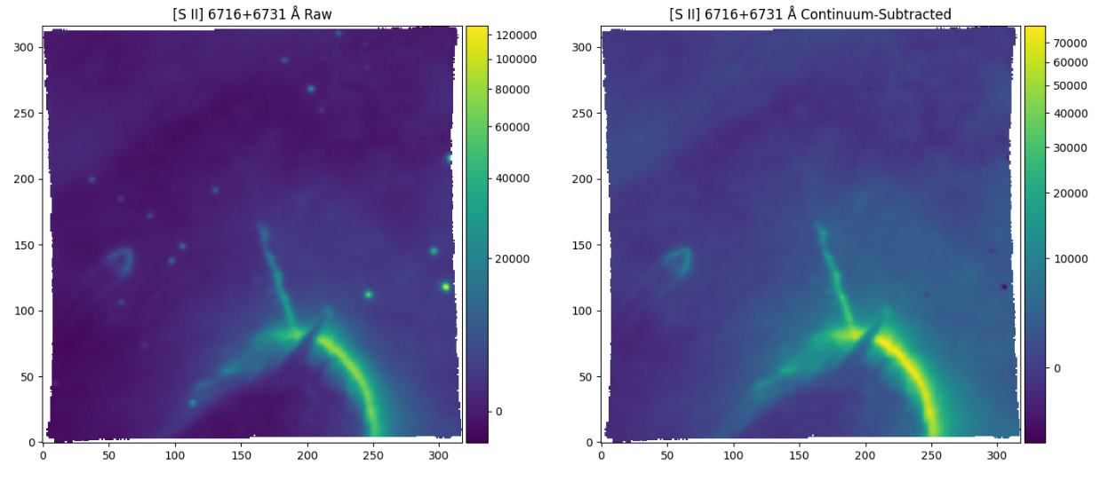

[N II] λ6583
The [N II] map recovers the same jet structure as Hα and [S II], with the curved arc and central source both clearly detected. The [N II] emission is somewhat fainter than both Hα and [S II], which is consistent with the relatively low nitrogen abundance and the moderate shock velocities typical of T Tauri jets, where nitrogen is not expected to be highly ionised. The continuum-subtracted map shows some residual large-scale structure across the field, manifesting as a broad positive and negative pattern in the background away from the jet. This is attributable to the proximity of [N II] λ6583 to Hα λ6563, which required the blue continuum reference window to be placed further from the line than standard, at 6530–6545 Å, to avoid sampling the wing of the Hα line. Any spatial variation in the Hα line profile or line-to-continuum ratio across the field could introduce low-level residuals into the [N II] continuum estimate. Despite this, the jet structure itself is robustly detected above the residual background, and the morphology is consistent with that seen in Hα and [S II]. The [N II]/Hα ratio, which can be estimated spatially from these maps, is a useful diagnostic of the shock ionisation conditions and will be discussed further in the context of jet excitation.

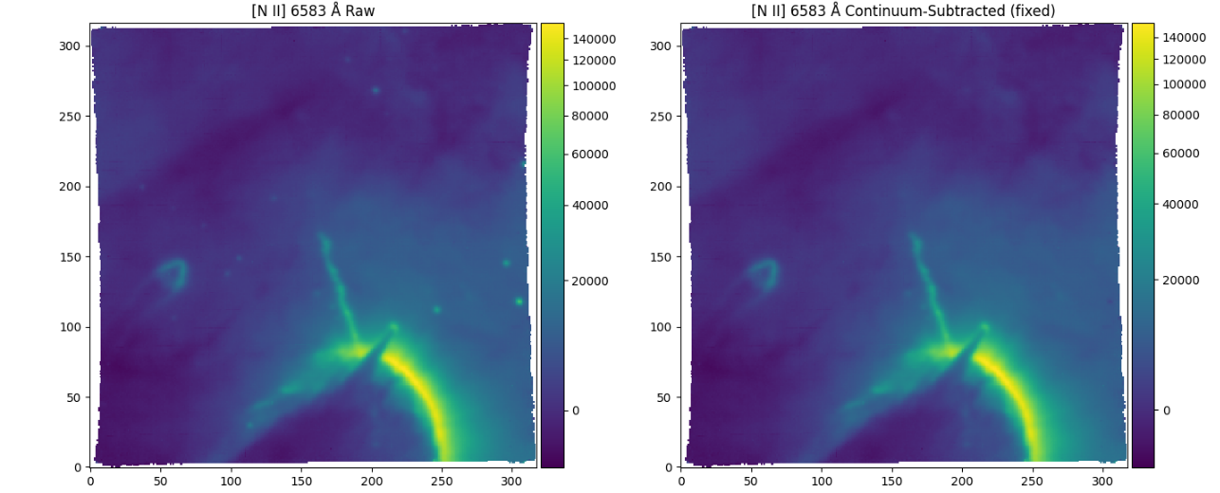

Comparison Across Lines
Taken together, the three emission line maps paint a consistent picture of the HH 399 jet system. All three lines recover the same large-scale morphology: a curved bow shock arc driven by a collimated jet from the Th 28 protostar, with a fainter counter-jet structure to the upper left of the source. The relative brightness of the lines follows the pattern expected for a partially ionised, shock-excited jet: Hα is brightest as it traces all recombining hydrogen, [S II] is the cleanest shock tracer and shows the most collimated emission, and [N II] is the faintest of the three. The fact that the jet is detected robustly in all three lines, with consistent morphology, confirms that the emission is real and not an artefact of the data reduction or continuum subtraction. Quantitative comparison of line ratios between these maps will allow the physical conditions in the jet — including electron density, temperature, and ionisation fraction — to be constrained spatially along the jet axis, which is the subject of subsequent analysis.

