Mini Project Report
on
PREPMATE - AI Based Study Assistant
Submitted by

Bhavya S Shaji (20223037)
Eshani S Nair (20223047)
Ganga K Girish (20223050)
Haifa Shameem (20223055)
Joseph Alen Napier (20223059)
In partial fulfilment of the requirements for the award of degree of Bachelor of Technology in Computer Science and Engineering.


DIVISION OF COMPUTER SCIENCE AND ENGINEERING
SCHOOL OF ENGINEERING COCHIN UNIVERSITY OF SCIENCE AND
TECHNOLOGY
APRIL 2026

DIVISION OF COMPUTER SCIENCE AND ENGINEERING SCHOOL OF ENGINEERING
COCHIN UNIVERSITY OF SCIENCE AND TECHNOLOGY



CERTIFICATE
Certified that this is a Mini Project Report titled PREPMATE – AI-BASED STUDY ASSISTANT
Submitted by
Bhavya S Shaji (20223037)
Eshani S Nair (20223047)
Ganga K Girish (20223050)
Haifa Shameem (20223055)
Joseph Alen Napier (20223059)

of VI Semester, Computer Science and Engineering in the year 2025 in partial fulfillment requirements for the award of degree of Bachelor of Technology in Computer Science and Engineering of Cochin University of Science and Technology.

Mr.Pramod Pavithran
Head of Division
Dr. Sudheep Elayidom
Project Coordinator
Dr.Sheena Mathew
Project Guide

ACKNOWLEDGEMENT
First and foremost, we offer our deepest gratitude and humble prayers to the Almighty, whose grace and blessings have been our guiding light through- out this project. We express our heartfelt appreciation to our esteemed guide, Dr. Sheena Mathew, for her invaluable guidance, unwavering patience, and continued support. Her insightful feedback and encouragement were instrumental in shaping the successful implementation of this project. We also extend our sincere thanks to Mr. Pramod Pavithran, Head of the Department and Dr. Sudheep Elayidom, the Project Coordinator, for their constant support and constructive guidance during every phase of our work. We remain truly grateful to our friends and classmates for their helpful suggestions, cooperation, and motivation throughout the development process. Their involvement played a vital role in refining our ideas and execution. Last but not least, we would like to express our profound gratitude to our families for their endless encouragement, understanding, and moral support. Their presence behind us made this accomplishment possible.

Bhavya S Shaji (20223037)
Eshani S Nair (20223047)
Ganga K Girish (20223050)
Haifa Shameem (20223055)
Joseph Alen Napier (20223059)

DECLARATION

We, Eshani S Nair, Haifa Shameem, Ganga K Girish, Bhavya S Shaji, and Joseph Alen Napier hereby declare that the project titled “PREPMATE–AI Based Study Assistant” is a bona fide work carried out by us during the year 2025, under the guidance of Dr. Sheena Mathew, Associate Professor, School of Engineering, CUSAT. We further declare that this project has not been submitted, either in part or full, for the award of any degree, diploma, associateship, fellowship, or any other academic recognition in any university or institution.

ABSTRACT

PrepMate: AI-Based Study Assistant is an intelligent learning support system designed to help students efficiently organize and understand study materials. The system processes educational documents and generates concise study aids that improve revision and knowledge retention.

The application utilizes Natural Language Processing (NLP) techniques to analyze and process the content of study materials. Through NLP-based text preprocessing, summarization, and concept extraction, the system identifies important information from the provided documents and converts them into useful learning resources such as summaries and flashcards.

To enhance the quality and readability of the generated content, the system integrates a local Large Language Model using Ollama with the phi3:mini model. This model assists in refining the extracted information and generating clearer explanations for students while maintaining offline functionality and data privacy.

Additionally, PostgreSQL is used as the database management system to store user data, processed study materials, and generated outputs. This allows efficient data management and retrieval within the system.

List of Figures

4.1 System Architecture of NLP Study Assistant ............. 15
4.2 NLP Pipeline Flow Diagram ............................... 16
4.3 Data Flow Diagram (DFD) ................................ 17
4.4 Use Case Diagram ....................................... 18
5.1 Login Page ............................................ 26
5.2 Dashboard Page ........................................ 27
5.3 PDF Upload UI ......................................... 28

List of Tables

4.1 User Table Schema ..................................... 19
7.1 Testing Results ...................................... 49
Contents

Acknowledgement | i
Declaration | ii
Abstract | iii
List of Figures | iv
List of Tables | v
1 Introduction | 1
1.1 Methodology . . . . . . . . . . . . . . . . . . . . . . . . . . . | 1
1.2 Features . . . . . . . . . . . . . . . . . . . . . . . . . . . . . . | 3
1.3 Significance of Work . . . . . . . . . . . . . . . . . . . . . . . | 3
2 Literature Review | 5
2.1 Natural Language Processing in Education. . . . . . . | 5
2.2 Text Processing Techniques . . . . . . . . . . . . . . . . . . . . . . . . . . | 6
2.3 Keyword Extraction Methods. . . . . . . | 6
2.4 Automatic Text Summarization . . . . . . . . . . . | 7
3 System Study | 9
3.1 Existing System . . . . . . . . . . . . . . . . . . . . . . . . . | 9
3.2 Proposed System . . . . . . . . . . . . . . . . . . . . . . . . . | 9
3.3 Software Requirements Specification . . . . . . . . . . . . . . | 10
3.3.1 Overall Description . . . . . . . . . . . . . . . . . . . | 10
3.4 Software Requirements Specification . . . . . . . . . . . . . . | 12
3.4.1 External Interfaces . . . . . . . . . . . . . . . . . . . . | 12

    - Functional Requirements 13
    - Non-Functional Requirements 14
- System Design 15
  - Data Flow Diagram (DFD) 16
  - Use Case Diagram 17
  - Database Design 18
  - Model and Dataset 19
  - Input-Output Design 20
  - Modular Design 23
- System Implementation 25
  - Modular Implementation 26
    - Frontend Development 26
    - Backend Development 32
    - Database Integration 33
    - AI Model Integration 33
    - AI-Driven Features 36
    - Data Storage and Retrieval 37
- Technologies, Stacks and Tools Used 38
  - Development Environment 38
  - Frontend Technologies 38
  - Backend and Data Management 42
  - AI Integration Features 43
  - Libraries and Dependencies 44
  - Testing Tools 45
  - Version Control and Project Management 46
  - Deployment 46
  - Security Measures 46
- Testing 48
  - Unit Testing 48
  - Integration Testing 49
  - Performance Testing 50
  - Usability Testing 51
- Future Scope 53
- Conclusion 54
References 55

Chapter 1
Introduction
In the modern digital age, students increasingly depend on electronic study materials such as PDF documents, lecture notes, and online resources. Although access to information has become more convenient, managing and extracting meaningful insights from large volumes of textual data remains a major challenge. Students often spend a significant amount of time reading lengthy documents, identifying important concepts, and preparing notes for revision. This process is not only time-consuming but also inefficient, as important information may be overlooked.
To overcome these challenges, the project titled “AI-Based Smart Study Assistant using Natural Language Processing (NLP)” aims to automate the analysis of study materials and assist students in effective learning. Natural Language Processing, a branch of Artificial Intelligence, enables computers to understand and process human language in a meaningful way. By applying NLP techniques, the system can transform unstructured text into structured information, allowing users to quickly grasp the core ideas of the content.
The proposed system is designed to process study materials in formats such as PDF and Word documents, extract relevant text, and analyze it using advanced NLP techniques. It identifies important keywords and generates concise summaries, thereby helping students focus on essential topics. The use of techniques such as tokenization, stopword removal, lemmatization, and TF-IDF ensures that the system accurately captures the significance of words and sentences within the document. Overall, the system acts as an intelligent assistant that enhances learning efficiency and reduces the effort required for manual analysis of study materials.

  - Methodology

The methodology adopted in this project follows a systematic approach to process and analyze study materials using Natural Language Processing techniques. The process begins with the collection of input data, where users upload study materials in the form of PDF or DOCX files. These files contain raw and unstructured text, which needs to be extracted and processed for further analysis. Text extraction is carried out using specialized libraries, where PDF files are handled using PyPDF2 and Word documents are processed using python-docx. The extracted content is then stored as plain text for subsequent steps.
Once the text is extracted, it undergoes a preprocessing phase, which is a crucial step in the NLP pipeline. During preprocessing, the text is cleaned and transformed into a structured format. This involves breaking the text into sentences and words through tokenization, removing common stopwords that do not contribute significant meaning, and applying lemmatization to convert words into their base forms. This step ensures that only meaningful and relevant words are retained for analysis.
Following preprocessing, the cleaned text is converted into numerical representations using the TF-IDF (Term Frequency–Inverse Document Frequency) technique. This method assigns importance scores to words based on their frequency within the document and their relevance across the entire text. Words that appear frequently but are also contextually important receive higher scores, making it easier to identify key concepts.
Based on these scores, the system performs keyword extraction by selecting the top-ranked words that represent the main topics of the document. In addition to this, the system also performs extractive summarization by assigning scores to sentences and selecting the most important ones. The final output consists of a list of keywords and a concise summary, which helps users quickly understand the content without reading the entire document. This structured methodology ensures efficient processing and accurate extraction of meaningful information.

  - Features
The proposed AI-Based Smart Study Assistant offers several features that enhance the learning experience and simplify the process of studying large volumes of text. One of the key features of the system is its ability to support multiple file formats, allowing users to upload study materials in both PDF and Word document formats. This flexibility ensures that users can work with a wide range of educational resources without compatibility issues.
Another important feature of the system is automatic keyword extraction. By analyzing the text using TF-IDF, the system identifies the most significant words that represent the core concepts of the document. These keywords help students quickly understand the main topics and focus their attention on important areas of study. In addition to keyword extraction, the system also provides automatic summary generation. It selects the most relevant sentences from the document and presents them as a concise summary, enabling users to grasp the overall content in a short amount of time.
The system also incorporates efficient text preprocessing techniques such as tokenization, stopword removal, and lemmatization, which improve the accuracy of analysis by eliminating irrelevant data. Furthermore, the system is designed with a user-friendly interface that makes it easy to upload files and view results. The processing is fast and efficient, ensuring that users receive outputs without delay.
Overall, the combination of these features makes the system a powerful tool for students, as it reduces manual effort, saves time, and improves the efficiency of studying. It provides a smart and automated solution for handling large amounts of textual information, thereby supporting better learning outcomes.

  - Significance of Work

The proposed AI-Based Smart Study Assistant plays an important role in improving the efficiency of studying by addressing the challenges of handling large volumes of digital learning material. Students often find it difficult to identify important topics from textbooks and previous year question papers, which makes exam preparation time-consuming and less effective. This system simplifies the process by automatically extracting key topics and generating summaries, allowing students to focus only on the most relevant content. As a result, it saves time, reduces manual effort, and minimizes the chances of missing important information.
In addition, the use of Natural Language Processing techniques ensures accurate analysis and meaningful output, making the study process more structured and reliable. The system also supports smart and exam-oriented learning by highlighting frequently asked topics and adapting study recommendations based on the time remaining before exams. Overall, this project contributes to modern digital education by providing an intelligent, scalable, and user-friendly solution that enhances learning outcomes.

Chapter 2
Literature Review

The rapid growth of digital learning resources has led to an increased need for intelligent systems that can efficiently process and analyze large volumes of textual data. Students today rely heavily on electronic study materials such as PDFs, e-books, lecture notes, and online content. However, extracting meaningful insights from these resources remains a challenging and time-consuming task. To address this issue, various research efforts have focused on the application of Natural Language Processing (NLP) techniques for text analysis, keyword extraction, and automatic summarization.
This chapter presents a review of existing research and technologies relevant to the development of the proposed AI-Based Smart Study Assistant. It highlights different approaches used in text processing, summarizes key contributions from previous studies, and identifies the research gaps that motivate the current project.

  - Natural Language Processing in Education

Natural Language Processing has gained significant importance in the field of education, particularly in developing intelligent tutoring systems, automated grading systems, and content summarization tools. NLP enables machines to understand human language and extract useful information from unstructured text. In educational applications, NLP is used to analyze textbooks, generate summaries, and assist students in understanding complex concepts.
Several studies have demonstrated the effectiveness of NLP in improving learning outcomes. For instance, NLP-based systems can identify key concepts in study materials and present them in a simplified manner, helping students grasp essential ideas quickly. Additionally, NLP techniques are used in chatbots and virtual assistants that provide instant support to learners.
Despite these advancements, many existing systems lack the ability to integrate multiple features such as keyword extraction, summarization, and exam-focused topic identification in a single platform. This limitation highlights the need for a comprehensive system that combines these functionalities.

  - Text Preprocessing Techniques

Text preprocessing is a fundamental step in NLP that involves cleaning and transforming raw text into a structured format suitable for analysis. Various preprocessing techniques such as tokenization, stopword removal, stemming, and lemmatization have been widely used in research.
Tokenization involves breaking down text into smaller units such as words or sentences, which allows for easier analysis. Stopword removal eliminates commonly used words that do not contribute significant meaning, such as “the,” “is,” and “and.” Stemming and lemmatization reduce words to their base or root forms, improving the consistency of text data.
Research studies have shown that effective preprocessing significantly enhances the performance of NLP models. However, improper preprocessing can lead to loss of important information. Therefore, selecting appropriate preprocessing techniques is crucial for achieving accurate results in text analysis.
  - Keyword Extraction Methods
Keyword extraction is an important task in text analysis, as it helps identify the most relevant words that represent the core content of a document. Various methods have been proposed for keyword extraction, including statistical approaches, linguistic approaches, and machine learning-based techniques.
One of the most widely used statistical methods is TF-IDF (Term Frequency–Inverse Document Frequency). This method assigns weights to words based on their frequency within a document and their importance across multiple documents. Words with high TF-IDF scores are considered more significant.
Other approaches such as RAKE (Rapid Automatic Keyword Extraction) and TextRank have also been used for keyword extraction. While these methods provide good results, they may require additional tuning and computational resources. TF-IDF remains a popular choice due to its simplicity, efficiency, and effectiveness in identifying important terms.

  - Automatic Text Summarisation

Automatic text summarization is another key area of research in NLP. It involves generating a concise summary of a document while preserving its main ideas. Summarization techniques are broadly classified into two types: extractive and abstractive summarization.
Extractive summarization selects important sentences directly from the original text based on certain criteria such as sentence importance and relevance. Abstractive summarization, on the other hand, generates new sentences that capture the meaning of the text, similar to how humans summarize content.
Most existing systems use extractive summarization due to its simplicity and lower computational requirements. Techniques such as sentence scoring, frequency-based methods, and graph-based approaches are commonly used. However, extractive summaries may lack coherence in some cases, which is a limitation of this approach.

Chapter 3
System Study

The system study involves analyzing the current methods used by students for studying and identifying their limitations. It also includes understanding the requirements of the proposed system and defining how the new system will overcome existing problems. This phase is essential to ensure that the developed system is efficient, user-friendly, and meets the needs of students.

  - Existing System
In the existing system, students primarily depend on manual methods such as reading textbooks, highlighting important points, and referring to previous year question papers. While these methods are widely used, they are not efficient when dealing with large volumes of study material.
Students often struggle to identify important topics, as there is no automated way to analyze question patterns or extract key concepts. Preparing summaries and notes manually requires significant time and effort. Additionally, there is no proper system that helps students prioritize topics based on exam relevance or time constraints.

  - Proposed System
The proposed system, AI-Based Smart Study Assistant, is designed to overcome the limitations of the existing system by using Natural Language Processing techniques. It automates the process of analyzing study materials and provides intelligent outputs such as keyword extraction, summarization, and topic highlighting.
The system allows users to upload textbooks and previous year question papers. It processes the content, identifies important topics, and highlights them based on frequency and relevance. Additionally, the system provides features such as quiz generation and time-based study recommendations.

  - Software Requirements Specification

The Smart Study Assistant is a web-based application designed to help students prepare efficiently for examinations by analyzing study materials and previous year question papers. The system uses Natural Language Processing (NLP) techniques to identify important topics, generate quizzes, and provide personalized study recommendations based on the time remaining for exams. The main objective of the system is to reduce the effort required by students to manually analyze large volumes of content and to improve their study efficiency.
This Software Requirements Specification (SRS) document outlines the functional and non-functional requirements of the system. It serves as a guideline for developers to understand the system’s features, constraints, and overall behavior. The document ensures that all stakeholders have a clear understanding of the system before implementation, thereby reducing errors and improving development quality.

    - Overall Description

The Smart Study Assistant operates as a web application consisting of frontend, backend, database, and NLP modules. Users interact with the system through a browser interface where they can register, log in, and upload study materials such as textbooks and question papers. The backend processes these inputs and communicates with the NLP module to analyze the content and extract meaningful insights such as important topics and keywords.
The system is designed for students with basic computer knowledge and aims to provide a simple, user-friendly interface. It performs multiple functions including topic extraction, quiz generation, and time-based study planning. The system operates under certain constraints such as dependency on internet connectivity and the accuracy limitations of NLP algorithms. Overall, it provides an intelligent and structured approach to exam preparation by integrating multiple technologies into a single platform.
    - External Interfaces
The Smart Study Assistant system provides a web-based user interface that is designed to be simple, interactive, and user-friendly. The interface allows users to perform actions such as registration, login, uploading study materials, viewing extracted topics, and attempting quizzes. It is developed using HTML, CSS, and JavaScript to ensure responsiveness across different devices including desktops and mobile phones. The system does not require any specialized hardware and can run on standard devices with basic specifications such as a computer or smartphone with internet access.
On the software side, the system interacts with various components including the Django backend, which handles request processing and application logic, and the SQLite database, which stores user information and uploaded files. Additionally, NLP libraries such as NLTK and Scikit-learn are integrated for text processing and analysis. Communication between the frontend and backend is carried out using HTTP/HTTPS protocols, ensuring secure and efficient data transfer. Session management techniques are used to maintain user state during interaction with the system.

Functional Requirements
The Smart Study Assistant system provides several core functionalities that enable effective exam preparation. The system allows users to register and log in securely, maintaining user sessions for continuous interaction. It enables users to upload study materials such as PDF and document files, which are then processed to extract textual content. The system uses Natural Language Processing techniques to preprocess the text, remove unnecessary words, and identify important topics based on frequency and relevance.
Furthermore, the system highlights key topics and displays them to the user in an organized manner. It also generates quizzes based on these topics, allowing users to test their understanding through timed assessments. In addition, the system includes a study planning feature where users can input their exam date, and the system calculates the remaining time and suggests topics accordingly. A dashboard is provided to display all relevant information, including uploaded files, extracted topics, quiz results, and study recommendations, ensuring a comprehensive and interactive user experience.

Non-Functional Requirements
The Smart Study Assistant system is designed to meet several quality attributes to ensure effective performance and user satisfaction. The system should provide fast processing of uploaded files and deliver results within a reasonable time, even when handling multiple users. Security is a key requirement, and the system ensures that user data is protected through password encryption, secure authentication mechanisms, and protection against common web vulnerabilities such as SQL injection and cross-site attacks.
In terms of usability, the system is designed with a simple and intuitive interface that can be easily used by students with basic technical knowledge. Reliability is ensured by implementing proper error handling and maintaining system stability during operation. The system is also designed to be scalable, allowing it to handle an increasing number of users and data in the future. Additionally, maintainability is considered by structuring the code in a modular and organized manner, making it easier for developers to update and enhance the system over time.

Chapter 4
System Design

System design is a crucial phase in software development that focuses on defining the overall architecture, components, modules, and data flow of the system. It provides a structured approach to transforming the requirements identified in earlier phases into a working model. The main objective of system design is to ensure that the system is efficient, scalable, and capable of meeting user requirements effectively. A well-designed system improves performance, simplifies implementation, and enhances maintainability.
In this project, the system design of the AI-Based Smart Study Assistant is developed to integrate multiple modules such as authentication, file handling, Natural Language Processing, analysis, and output generation. The design ensures smooth interaction between these modules while maintaining data consistency and security. The architecture follows a layered approach, where the frontend handles user interaction, the backend manages application logic, and the NLP engine processes textual data. The database is used to store user information, uploaded documents, and analysis results.
The design also includes various diagrams such as system architecture, data flow diagrams, use case diagrams, and database design, which collectively represent the working of the system. These diagrams help in understanding how data moves through the system, how different components interact, and how user actions are processed. Overall, the system design provides a clear blueprint for implementing the Smart Study Assistant in an organized and efficient manner.

System Architecture – Description
The system architecture defines the overall structure of the Smart Study Assistant and how different components interact with each other. It follows a layered architecture consisting of the frontend, backend, database, and NLP engine. The frontend provides the user interface for interaction, while the backend handles application logic and processes user requests. The database is responsible for storing user data, uploaded files, and analysis results. The NLP engine performs text processing tasks such as keyword extraction and summarization. This structured architecture ensures scalability, maintainability, and efficient communication between components.

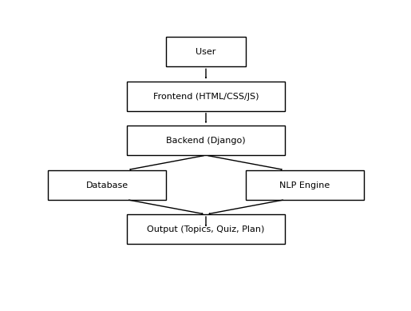

Figure 4.1: System Architecture

Main Components:
The system is divided into multiple modules, each responsible for a specific functionality. The authentication module manages user registration and login securely. The file upload module allows users to upload textbooks and previous year question papers. The NLP processing module extracts and preprocesses text using techniques such as tokenization and TF-IDF. The analysis module identifies important topics and generates summaries. Additionally, the quiz module generates time-based quizzes, and the study planner suggests topics based on the time remaining before exams. This modular design improves system organization and simplifies development.

Data Flow Diagram (DFD)
The Data Flow Diagram illustrates how data moves through the system from input to output. At the initial stage, the user provides input in the form of login credentials and uploaded files. The data is then processed through different modules, including authentication, file handling, and NLP processing. The analysis module extracts meaningful information such as keywords and topics. Finally, the processed data is presented to the user in the form of summaries, quizzes, and study plans. The DFD helps in understanding the internal workflow and data interactions within the system.
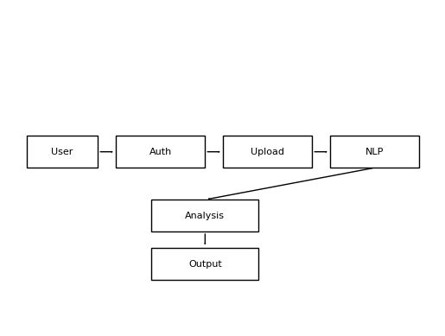
Figure 4.2: Dataflow Diagram

Use Case Diagram
The use case diagram represents the interactions between the user and the system. It highlights the various functionalities that the system provides, such as registration, login, file upload, viewing topics, taking quizzes, and receiving study plans. Each use case describes a specific action performed by the user. This diagram helps in identifying system functionalities from the user's perspective and ensures that all required features are implemented.

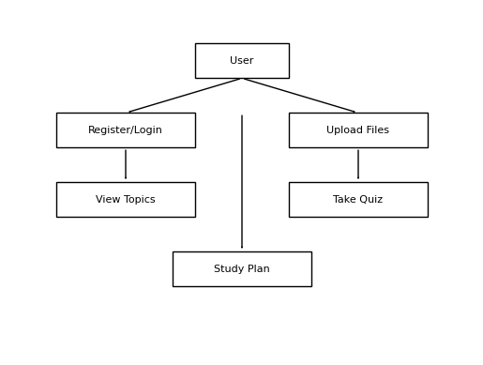

Figure 4.3: Use Case Diagram of the System

Database Design
The database design defines how data is structured and stored within the system. It consists of entities such as users, documents, analysis results, and quizzes. Relationships are established between these entities to maintain data integrity and consistency. For example, each user can upload multiple documents, and each document can have associated analysis results. The ER diagram provides a clear representation of these relationships and ensures efficient data management.

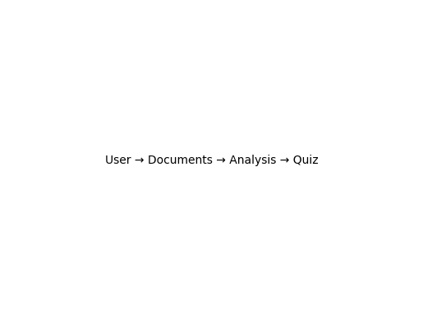

User Schema
The User Schema defines the structure of the user data stored in the database. It is used to manage user information required for authentication and interaction with the Smart Study Assistant system. The schema ensures that all necessary details such as login credentials and user-specific data are stored securely and efficiently.
The user table contains fields such as a unique user ID, email, and password. The user ID acts as the primary key and uniquely identifies each user in the system. The email field is used as the username for login purposes and is enforced to be unique to prevent duplicate accounts. The password is stored in an encrypted (hashed) format to ensure security. Additional fields such as date of registration and last login time can also be included to track user activity.

Field Name | Data Type | Description
user_id | Integer (Primary Key) | Unique user identifier
email | String (Unique) | User email for login
password | String | Encrypted password
date_joined | DateTime | Registration date
last_login | DateTime | Last login time

Table 4.1: User Schema: Properties, Descriptions, and Data Types

Model and Dataset
The model design of the system focuses on how the Natural Language Processing techniques are implemented to analyze the study material. The system uses an extractive approach where text is processed using techniques such as tokenization, stopword removal, and TF-IDF vectorization. The TF-IDF model helps in identifying important words by assigning weights based on their frequency and importance in the document. These weighted terms are then used for keyword extraction and topic identification. Additionally, sentence scoring techniques are applied to generate summaries by selecting the most relevant sentences. This model ensures efficient and accurate extraction of meaningful information from large textual data.

Input-Output Design
The input and output design of the Smart Study Assistant system focuses on ensuring smooth interaction between the user and the application. The input design includes all the data that users provide to the system through various interfaces. Users input their details during registration and login, including email and password for authentication. The system also accepts study materials such as PDF and document files uploaded by the user, along with additional inputs like exam date for generating time-based study plans. Proper validation is applied to ensure that only valid and correctly formatted data is accepted, thereby reducing errors and improving system reliability.
The output design defines how the processed information is presented to the user in a clear and understandable format. After analyzing the uploaded content, the system displays important topics, keywords, and summaries in an organized manner on the dashboard. It also generates quizzes based on these topics and presents them with a timer for user interaction. Additionally, the system provides study recommendations based on the time remaining for exams. All outputs are displayed through a user-friendly interface with proper formatting, ensuring readability and ease of understanding.

User Registration
During the registration process, users are required to provide their email, password, and name. Upon successful submission and validation of these details, the system securely stores the information and redirects the user to their personalized dashboard. This registration process initiates the user’s journey within the application and enables access to all other modules.

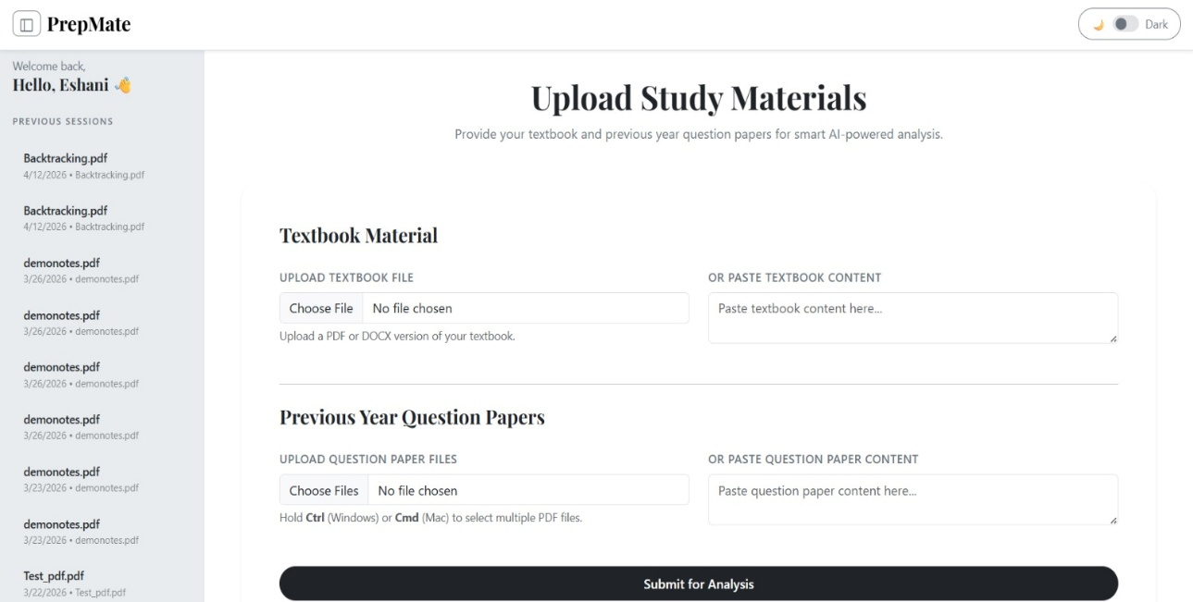

Figure : Data Upload Block

PDF Upload
The PDF/Document Upload Module allows users to upload study materials and previous year question papers in formats such as PDF and DOC. It validates file types and securely stores the uploaded files for further processing.

Text Extraction Module
The Text Extraction Module processes the uploaded files and extracts textual content from them using file-handling libraries. This extracted text is then passed to the NLP module for analysis

NLP Processing Module
The NLP Processing Module analyzes the extracted text using techniques such as tokenization, stopword removal, and TF-IDF. It identifies important keywords and topics based on frequency and relevance.

Modular Design
T The Smart Study Assistant system is developed using a modular design approach, where the entire system is divided into smaller, independent modules based on functionality. Each module is responsible for a specific task, such as user authentication, file handling, NLP processing, quiz generation, and frontend interaction. This separation of concerns makes the system easier to develop, test, and maintain, as changes in one module do not significantly affect other modules.
The authentication module manages user registration, login, and session handling. The database module is responsible for storing and retrieving user data, uploaded files, and processed results. The NLP module processes textual data to extract important topics and generate insights. The backend module handles the core logic, connects all modules, and processes user requests, while the frontend module provides the user interface for interaction. This modular structure improves scalability, allows parallel development by different team members, and ensures better organization and efficiency of the overall system.

Chapter 5
System Implementation

The system implementation phase involves the actual development of the Smart Study Assistant based on the design and requirements specified in earlier stages. In this phase, all modules of the system, including user authentication, file upload, text processing, NLP analysis, quiz generation, and study recommendation, are developed and integrated to form a complete working application. The implementation is carried out using a combination of frontend, backend, database, and NLP technologies to ensure smooth functionality and efficient performance.
The backend is implemented using the Django framework, which handles server-side logic, user authentication, and database interactions. The frontend is developed using HTML, CSS, and JavaScript to provide an interactive and user-friendly interface. The NLP module is integrated into the backend to process textual data and extract meaningful insights such as important topics and keywords. Each module is tested individually and then integrated to ensure proper communication between components. The implementation phase ensures that the system meets all functional requirements and is ready for testing and deployment.

Modular Implementation
The Smart Study Assistant system is implemented using a modular approach, where each functionality such as user authentication, file upload, text extraction, NLP processing, quiz generation, and study planning is developed as a separate module. Each module performs a specific task independently and is later integrated with others to form the complete system. This approach simplifies development, testing, and maintenance while ensuring flexibility and scalability. All modules are tested individually before integration to ensure smooth interaction and efficient system performance.

Frontend Development


Figure 5.1: Home page of Web App

The frontend of the Smart Study Assistant system is designed to provide an intuitive and user-friendly interface for seamless interaction. It is developed using HTML, CSS, and JavaScript, ensuring a responsive and visually appealing layout. The interface allows users to easily navigate through different functionalities such as uploading study materials, viewing previous sessions, and accessing analysis results.

User Registration (Account Creation)

The frontend provides a registration page where new users can create an account by entering details such as email and password. The form includes input validation to ensure correct data format and password strength. Once the user submits the form, the data is sent to the backend for processing. After successful registration, the user is either redirected to the login page or automatically logged into the system.

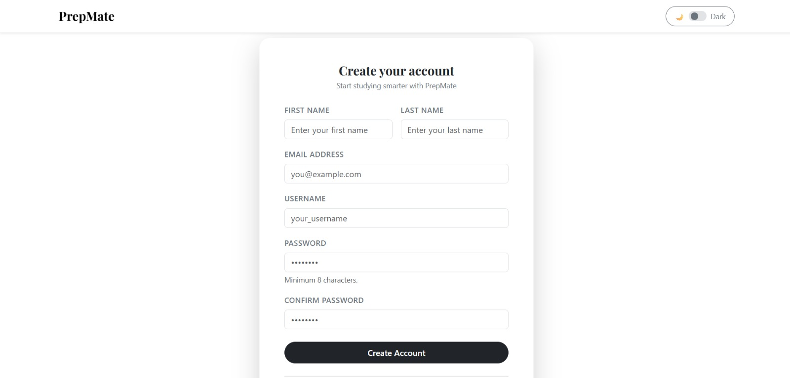

Figure 5.4: Creating an account

User Login

For existing users, a login page is provided where they can enter their registered credentials. The frontend sends this information to the backend for authentication. If the credentials are valid, the user is successfully logged in and redirected to the dashboard. In case of incorrect details, appropriate error messages are displayed to help the user retry.

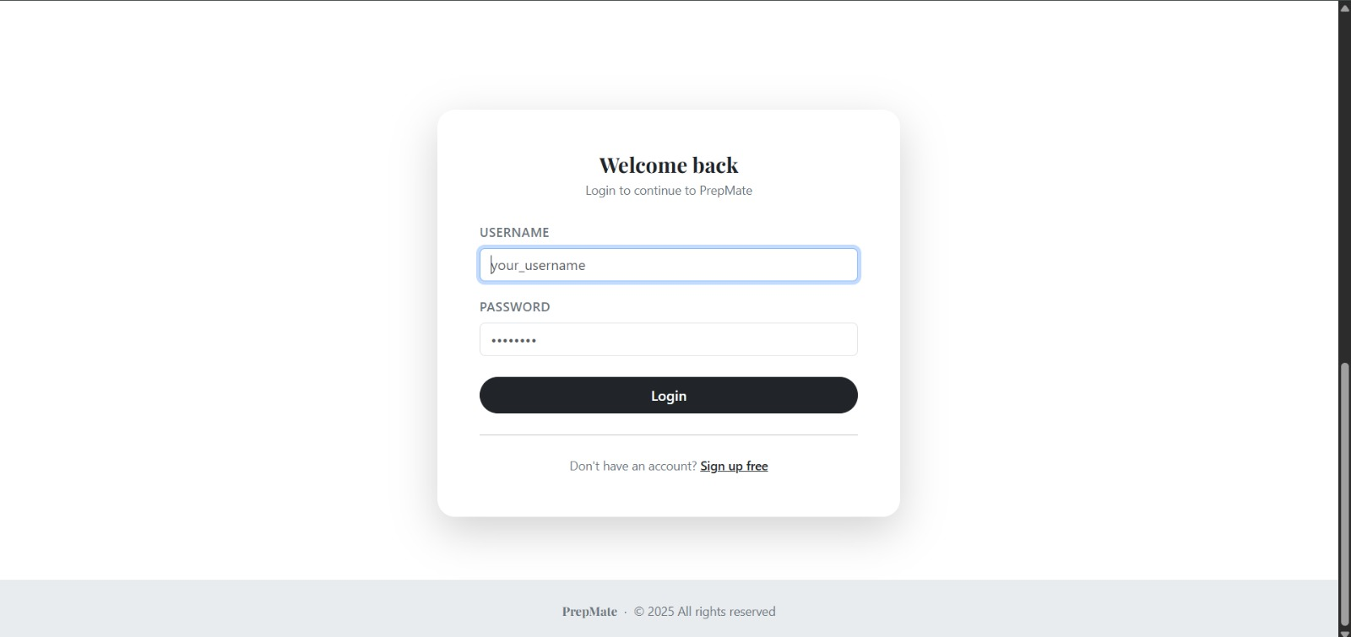
Figure 5.4: user Login

Session Handling and Redirection

The system uses session management to track whether a user is logged in. If a user revisits the application and is already authenticated, the frontend automatically redirects them to the dashboard without requiring login again. This improves user experience and reduces repeated actions.

Dashboard Interface
Once logged in, the user is directed to the dashboard, which acts as the main interface of the application. The dashboard provides access to all core features such as uploading study materials, viewing previously uploaded files, and accessing analysis results. It is designed with a clean layout and easy navigation to ensure efficient interaction.

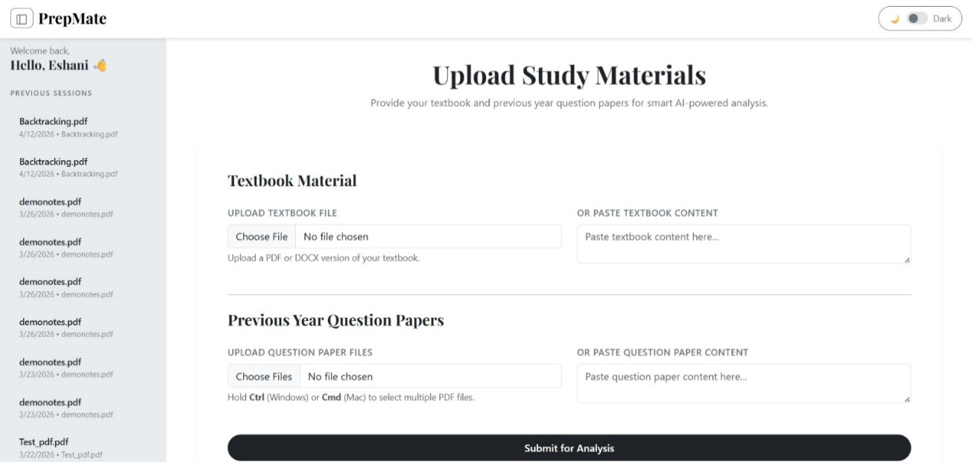
Figure 5.5: Dashboard

Core Features Interface

The Core Features interface presents the primary functionalities of the Smart Study Assistant in a clean, card-based layout, enabling users to quickly understand and access different tools available within the system. Each feature—such as PDF Analysis, timed quizzes, flashcards, and the Pomodoro timer—is represented with an icon, title, and brief description to ensure clarity and ease of navigation. The design focuses on simplicity and user engagement, allowing users to interact with each module seamlessly while maintaining a visually appealing and organized structure that enhances the overall user experience.

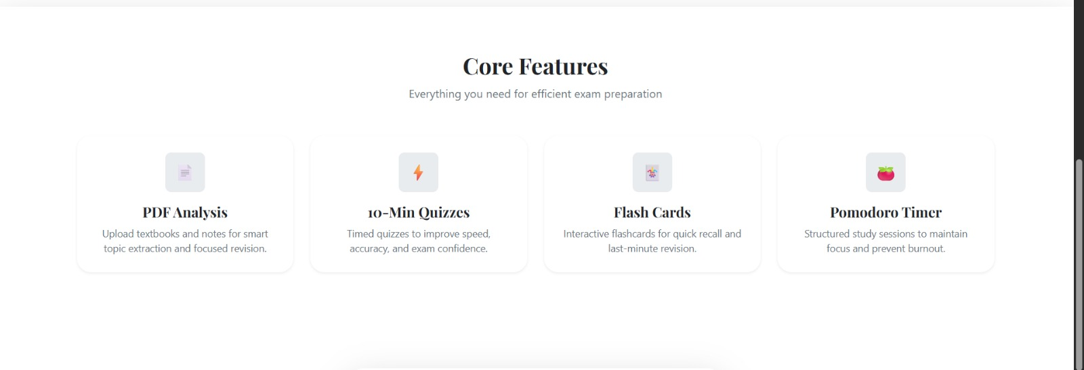
Figure 5.6: Feature Page
- PDF Analysis
This feature allows users to upload textbooks and notes, which are then analyzed using NLP techniques to extract important topics and keywords for focused revision.

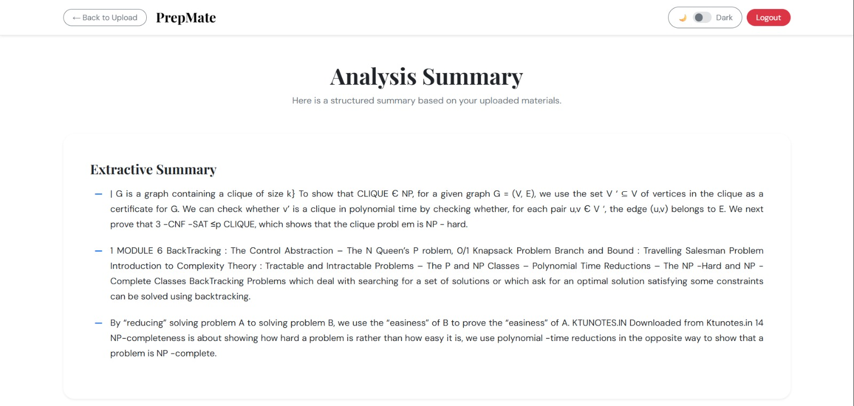

- Quizzes
Provides short, timed quizzes to help users improve speed, accuracy, and confidence while preparing for exams.

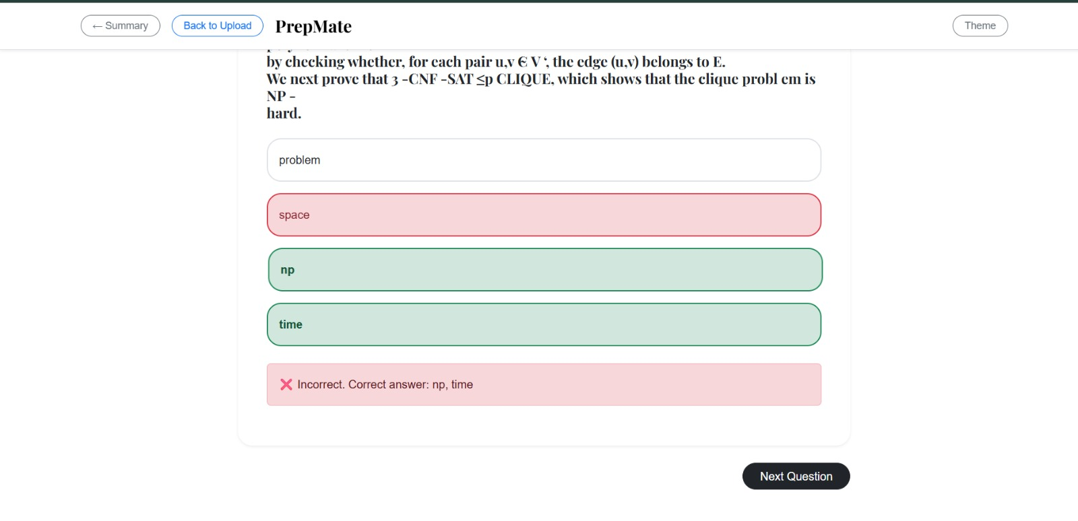
- Flash Cards
Offers interactive flashcards for quick revision and better memory retention of key concepts.

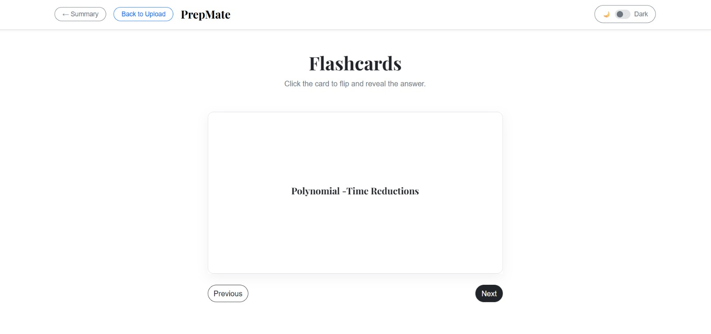

- Pomodoro Timer
Helps users manage study time effectively by dividing sessions into focused intervals, reducing fatigue and improving productivity.



Backend Development

The backend of the AI-Powered Study Assistant is responsible for handling application logic, user authentication, file processing, and integration of NLP functionalities. It is implemented using Python, which provides a flexible and efficient environment for managing server-side operations. The backend acts as an intermediary between the frontend and the database, ensuring smooth data flow and secure handling of user information. It manages functionalities such as user registration, login, session handling, and storage of uploaded files and generated outputs. Proper validation and error-handling mechanisms are incorporated to maintain system reliability and data integrity.
A core component of the backend is the NLP module, which processes uploaded PDF and Word documents to extract meaningful insights. The process begins with file reading using libraries like PyPDF2 and python-docx, followed by text preprocessing using spaCy and NLTK for tokenization, stopword removal, and lemmatization. The cleaned text is then converted into numerical form using TF-IDF vectorization through scikit-learn, enabling the system to identify important keywords and concepts. Based on these scores, the system performs keyword extraction and generates concise summaries using extractive summarization techniques. This integration of NLP within the backend enables intelligent analysis of study materials, forming the foundation for advanced features such as quizzes and personalized study recommendations.

Database Integration (PostgreSQL)
The system integrates a PostgreSQL database to efficiently manage and store application data. PostgreSQL is used to handle structured data such as user information, authentication details, uploaded files, quiz results, and analysis outputs. The backend communicates with the database through an ORM (Object Relational Mapping) layer, enabling seamless interaction without writing complex SQL queries. It ensures data consistency, reliability, and security through features like constraints, indexing, and transaction management. Additionally, PostgreSQL supports scalability and efficient querying, making it suitable for handling large volumes of study materials and user activities within the system.

AI Model Integration

The Smart Study Assistant integrates Artificial Intelligence through a Natural Language Processing (NLP) module embedded within the backend. This integration enables the system to process unstructured text from uploaded PDFs and Word documents and convert it into meaningful insights. The AI pipeline begins with text extraction, followed by preprocessing steps such as tokenization, stopword removal, and lemmatization using libraries like spaCy and NLTK. The processed text is then converted into numerical form using TF-IDF vectorization with the help of scikit-learn, which helps in identifying the importance of words and sentences. This seamless integration allows the system to automatically analyze large volumes of study material efficiently.

AI-Driven Features

The system provides several AI-driven features to enhance the learning experience. It performs keyword extraction to identify and highlight important topics, helping students focus on key concepts. It also generates concise summaries using extractive summarization techniques, reducing lengthy content into manageable information. Additionally, the system supports quiz generation based on extracted topics and offers time-based study recommendations according to the user’s exam schedule. These intelligent features make the system more interactive, efficient, and personalized, improving overall study effectiveness.

Data Storage and Retrieval
The application utilizes several MongoDB collections, including notes, ai outputs, and audio transcripts, to manage the data efficiently. Each document within these collections stores raw user input (such as handwritten notes, audio files, or PDFs), the corresponding AI-generated output (e.g., transcriptions, summaries, or extracted information), and associated meta- data (such as user ID, timestamps, and input type). To ensure quick and efficient data retrieval, indexing is performed on key fields like user id, input type, and timestamp. This indexing strategy enables the system to filter and search large datasets rapidly, ensuring that user queries and data retrieval processes are handled seamlessly. Furthermore, MongoDB’s flexible schema allows the system to scale efficiently as new data types and features are integrated into the application.

Chapter 6
Technologies, Stacks and Tools Used

The development of the Smart Study Assistant system involves the integration of multiple technologies across different layers such as frontend, backend, database, and Natural Language Processing. Each technology is carefully selected to ensure scalability, efficiency, and ease of development. The system follows a full-stack development approach where the frontend handles user interaction, the backend processes logic, and the database stores user and application data. Additionally, NLP libraries are used to extract meaningful insights from textual data.

Development Environment
The development environment refers to the setup of hardware and software tools used to build and test the Smart Study Assistant system. The project was developed on a standard computing system with sufficient processing power and memory to handle web development and NLP tasks. The software environment includes an operating system, code editor, programming language, and necessary libraries.
The backend development was carried out using Python and the Django framework, while the frontend was built using HTML, CSS, and JavaScript. The system was tested locally using Django’s development server. Additionally, version control tools were used to manage the project efficiently and ensure smooth collaboration among team members.

Frontend Technologies
The frontend of the Smart Study Assistant system is responsible for providing an interactive and user-friendly interface for users to interact with the application. It is developed using HTML, CSS, and JavaScript, which together form the foundation of modern web development. The frontend handles user inputs such as login credentials, file uploads, and navigation between different pages like dashboard and results.
HTML is used to structure the content of the web pages, CSS is used to enhance the visual appearance, and JavaScript is used to add interactivity and dynamic behavior. The frontend is designed to be simple, responsive, and easy to use, ensuring that users can efficiently access all features of the system without confusion.

Web Application Frontend
The frontend of the Smart Study Assistant system represents the client-side interface through which users interact with the application. It is developed using HTML, CSS, and JavaScript, providing a simple and user-friendly interface. The frontend allows users to perform actions such as registration, login, uploading study materials, and viewing analysis results.
The frontend communicates with the backend using HTTP requests. Django templates are used to dynamically display data such as extracted keywords, summaries, and quiz questions. The design focuses on usability, responsiveness, and smooth navigation.

Frontend Responsibilities
- Display web pages (login, register, dashboard)
- Accept user input (forms, file upload)
- Send requests to backend
- Show processed results (keywords, summaries)

Backend and Data Management
To facilitate seamless interaction and ensure consistent data synchroniza- tion across both the mobile and web platforms, the system integrates tailored backend architectures optimized for performance, scalability, and maintain- ability. Each backend setup is aligned with the specific operational require- ments of its platform, allowing for efficient data handling and feature expan- sion.

Web Application Backend
The backend is responsible for processing user requests, managing data, and controlling the application logic. It is implemented using Django, a Python-based web framework. The backend handles authentication, file uploads, database operations, and integration with the NLP module.
When a user performs an action such as uploading a file, the backend processes the request, interacts with the database, and sends the data to the NLP module for analysis. After processing, the backend returns the results to the frontend for display.

Backend Responsibilities
- Handle user authentication (login/register)
- Process requests and responses
- Manage database (users, files)
- Call NLP module for analysis
- Send results to frontend

.

AI Integration Features

The AI component of the system is implemented using Natural Language Processing techniques. It is integrated into the backend and is responsible for analyzing textual data from uploaded study materials. The NLP module processes the text using techniques such as tokenization, stopword removal, and TF-IDF vectorization.
The integration is done in such a way that once a file is uploaded, the backend extracts the text and sends it to the NLP module. The module then generates outputs such as keywords, summaries, and quiz questions. These results are sent back to the backend and displayed on the frontend.

AI/NLP Responsibilities
- Text preprocessing
- Keyword extraction
- Topic identification
- Text summarization
- Quiz generation

Libraries and Dependencies
Libraries and dependencies are external modules and packages used to extend the functionality of the system without writing code from scratch. In the Smart Study Assistant system, various Python libraries and Django dependencies are used for web development, database management, and Natural Language Processing. These libraries improve development efficiency, reduce complexity, and ensure reliable performance.

Web Application Libraries
The web application made use of a variety of libraries to improve func- tionality and simplify tasks. The backend relies on Django and its built-in modules for handling authentication, request processing, and database operations. Python standard libraries are also used to support file handling and system operations.
Natural Language Processing is implemented using powerful Python libraries that help in text analysis and extraction of meaningful information. Additionally, file handling libraries such as PyPDF2 and python-docx are used to extract text from uploaded PDF and Word documents. These libraries enable the system to process various input formats, making it flexible and user-friendly. All required dependencies are installed using package management tools such as pip and are maintained in a requirements file to ensure consistency across different development environments.
Dependencies Installation
pip install django
pip install nltk
pip install scikit-learn
pip install PyPDF2
pip install python-docx

Testing Tools
Testing tools are used to ensure the Smart Study Assistant system works correctly, efficiently, and without errors. For backend testing, Django’s built-in testing framework and Python’s unittest module are used to verify functionalities such as authentication and database operations.
Frontend testing is performed using browsers like Google Chrome, where developer tools help debug UI and check responsiveness. For integration testing, Postman is used to test communication between frontend and backend by sending HTTP requests and validating responses.
Performance testing is carried out using Apache JMeter to evaluate system behavior under load. Additionally, Git is used for version control and managing code changes. These tools collectively ensure the system is reliable, efficient, and user-friendly.

Version Control and Project Management
Version control and project management tools are essential for organizing development and enabling collaboration among team members. In this project, Git is used as the version control system to track code changes, maintain different versions, and prevent data loss. It allows multiple developers to work on different modules simultaneously and merge their contributions efficiently. Platforms like GitHub are used to host the repository, manage code, and facilitate collaboration.
For project management, tasks are divided among team members based on modules such as authentication, backend, frontend, database, and NLP. Simple tools like task lists, timelines, and regular updates help in tracking progress and ensuring timely completion of the project. These practices improve coordination, maintain code quality, and ensure systematic development of the system.

Deployment
Deployment is the process of making the Smart Study Assistant system available for users to access over the internet. After development and testing, the application is hosted on a server where it can run continuously. The Django backend is deployed using a web server, while the frontend is served through the same application. The database is configured to store user data and application content securely.
Platforms such as cloud hosting services can be used to deploy the project, allowing users to access it through a web browser from anywhere. Proper configuration of environment settings, static files, and security measures ensures smooth and secure operation. Deployment makes the system accessible, scalable, and ready for real-world use.

Security Measures
Security measures are implemented in the Smart Study Assistant system to protect user data and ensure safe operation of the application. Django provides built-in security features such as password hashing, user authentication, and protection against common attacks like Cross-Site Scripting (XSS) and Cross-Site Request Forgery (CSRF). Sensitive information such as user passwords is securely stored using encryption techniques.
Input validation is applied to prevent malicious data from being submitted through forms, and file uploads are restricted to safe formats. Session management ensures that only authenticated users can access protected pages. Additionally, proper configuration of settings and environment variables helps secure the application during deployment. These measures collectively ensure data integrity, confidentiality, and secure user interaction.

Chapter 7
Testing

Testing was conducted to validate the functionality, performance, and us- ability of the SMNS – Smart Multi-Note System. A layered testing methodol- ogy was adopted, starting with individual module testing through unit tests, followed by integration testing to ensure smooth interaction between modules, and concluding with performance and usability evaluations under real-world usage scenarios.

Unit Testing
Unit testing involves testing individual components or modules of the system independently to ensure that each unit functions correctly. In this project, each module such as authentication, file upload, and NLP processing is tested separately. This helps in identifying bugs at an early stage and ensures that each function performs as expected before integration.

Module | Test Case | Input | Expected Output | Result
Authentication | Register user | Valid details | User created | Pass
Authentiation | Login | Correct credentials | Dashboard access | Pass
File Upload | Upload file | PDF file | File stored | Pass
NLP Module | Keyword extraction | Sample text | Keywords list | Pass
NLP Module | Summarization | Paragraph | Short summary | Pass

Integration Testing
Integration testing verifies the interaction between different modules of the system. After individual modules are tested, they are combined to ensure that data flows correctly between them. For example, after login, the user should be able to upload files, and the uploaded data should be processed by the NLP module and displayed correctly in the output.

Test Scenario | Modules Involved | Expected Behavior | Result
Login → Dashboard | Authentication + UI | Redirect to dashboard | Pass
Upload → Processing | File Upload + NLP | File processed correctly | Pass
NLP → Output | NLP + Output Module | Keywords & summary displayed | Pass
Full Flow | All modules | End-to-end execution | Pass

Performance Testing
Performance testing evaluates how efficiently the system performs under different conditions. The system is tested with multiple users and large file uploads to measure response time and processing speed. The goal is to ensure that the system remains stable and responsive even under moderate load conditions.

Test Case | Condition | Expected Result | Observed Result
File upload | Small file | Fast upload | Fast
File upload | Large file | Slight delay | Acceptable
NLP processing | Long text | Moderate time | Efficient
Multiple users | Concurrent access | No crash | Stable

Usability Testing
Usability testing focuses on evaluating how user-friendly and intuitive the system is. The interface is tested to ensure that users can easily navigate through the system, perform actions like login, upload files, and view results without confusion. Feedback from users is considered to improve the design and usability of the system.

Feature | User Action | Expected Outcome | Result
Login Page | Enter credentials | Easy login | Pass
Navigation | Move between pages | Smooth transition | Pass
File Upload | Upload document | Simple process | Pass
Output Display | View results | Clear information | Pass

Future Scope

The Smart Study Assistant system can be further enhanced by incorporating advanced features and technologies. One major improvement would be the integration of machine learning models for more accurate topic prediction and personalized study recommendations. Additionally, support for multiple languages can be added to make the system accessible to a wider range of users. The system can also be extended to include voice-based interaction, allowing users to interact with the application using speech.
Another potential enhancement is the integration of cloud storage and deployment, enabling users to access their study materials from anywhere. Features such as real-time collaboration, mobile application support, and adaptive learning techniques can further improve the system. With continuous improvements, the system has the potential to evolve into a comprehensive AI-powered learning platform.

Conclusion

The Smart Study Assistant system was successfully designed and implemented to assist students in improving their study process through intelligent analysis of study materials. The system integrates multiple modules including authentication, file upload, Natural Language Processing, and output generation to provide meaningful insights such as keywords, summaries, quizzes, and study plans. The use of NLP techniques enables efficient extraction of important information from large volumes of text, making learning more focused and effective.
The system has been tested using various testing techniques, ensuring its reliability, efficiency, and usability. It provides a user-friendly interface and delivers accurate results within acceptable time limits. Overall, the project demonstrates how modern technologies such as Django and NLP can be effectively combined to develop a practical and useful educational tool.

References
- Speech and Language Processing – Daniel Jurafsky and James H. Martin
- NLTK Documentation – https://www.nltk.org
- Scikit-learn Documentation – https://scikit-learn.org
- Django Documentation – https://docs.djangoproject.com
- Introduction to Information Retrieval – Christopher D. Manning
- Research papers on NLP and text summarization (IEEE / Google Scholar)
- Online tutorials and documentation for Python and web development

