**Student ID:** 985712____________________________________________

**Full Names:** Eshan Kuthu______________________________________

Web Application Programming

(CS472)

(September 2017)

Instructor: Obinna A. Kalu

W1D6 – Exam 1

1. The exam duration is 2 hours.
2. The exam is a computer-based exam.
3. You are expected to use a CS lab or your own computer to answer both the Coding questions and the theory/non-coding/knowledge-based questions. You may use the Internet and/or the lecture slides for reference purposes to lookup APIs or code syntax.
4. Make sure to switch-off your cell-phones or simply turn the ringer off.
5. You may use blank sheet(s) of paper for your scratch work, if needed.
6. Exams are copyrighted materials and must not be copied, reproduced or distributed.
7. All answers to the theory/non-coding/knowledge-based questions should be typed-in, on this document, following the questions.
8. All answers to the Coding questions may be typed-in as source code files, using a Code Editor or IDE. But be sure to copy your finished code for each coding question from your Code Editor and paste it to this document as your answer.
9. Finally, compress/zip your entire code folder into one zip file and upload/submit it to Sakai, along with your typed/pasted answers in this document.

--------------------------------------------------------------------------------------------------------------------

(CS472 - WAP)

(September 2017)

W1D6 – Examination 1

**Part I – Science of Consciousness (SCI):** (3 points)

From Maharishi’s teachings, we learnt about the principles of the Science of Consciousness which are the fundamental laws of nature that uphold all progress and growth in life. In the last 1 week, you have learnt about several concepts and principles in the Web Application Programming (WAP) course. In the table below, three (3) Web programming topics are given, on the first column. For each of these, write-down in the 2nd column, a related principle from the Science of Consciousness which you are familiar with, and in the 3rd column, write 1 or 2 sentences to show how the Web Programming topic relates to your chosen SCI principle.

**Note**: To get the full credit, make sure your sentence(s) provide(s) a reasonable, clear connection between your stated SCI principle and the given WAP topic. You may use a relevant analogy from Maharishi’s teachings, to help illustrate your point.

|  |  |  |
| --- | --- | --- |
| **Topic from Web Application Programming** | **SCI principle** | **Connection sentence(s)** |
| The Internet, the World-Wide Web and HTML | Life is Found in every layers. | Different technologies are built on top of another technology. |
| Regular Expressions (Regex) | Do less and accomplish more. | Server first and the client gets immediate response. |
| Cascading Style Sheets (CSS) | The nature of life is to grow. | Css gives different visual style to HTML element and change the apprearance. |

**Part II – Theory (Short answers, True/False, Multiple-choice questions):** (37 points)

1. (7 points) Answer the following questions with True or False. For each answer, give a rationale (i.e. If True state how, if False state why. No rationale, earns you just half of the points if your True/False answer is correct, and zero point if your True/False answer is incorrect).
   1. (3 points) In order to create a sub-form inside a bigger Web-form, an HTML <form> element can be contained or nested inside another HTML <form> on a web page.

False, because **Hypertext Transport Protocol command cannot be nested.**

* 1. (2 points) The HTML <table> element can be used to create complex Web page layouts.

False, because there are lots of drawbacks like its hard to read, it is not good for search engine, loads slowely,etc.

* 1. (2 points) Based on the HTML markup and CSS styling presented in the figure P2 – 1 – III below, the <div> with class named, mainmenu, will be **positioned** on the webpage at 200pixels from the left margin and 100pixels from the top margin.

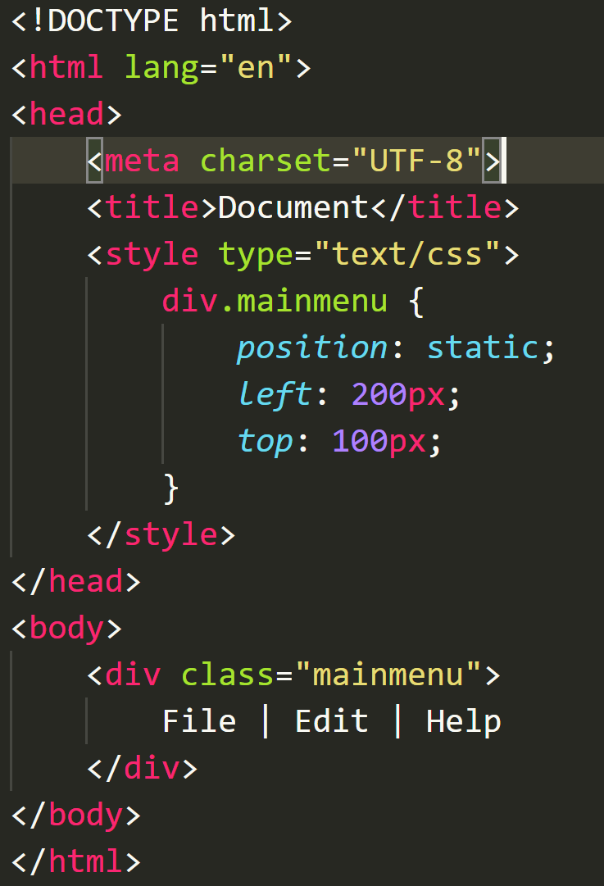

Figure P2 – 1 - III

False, with static it is placed as they should appear with flow. For that in context of browser we should use position : fixed.

1. (23 points) Give short answers to the following questions.
   1. (4 points) What is the difference between the 2 CSS selectors given below?

**A.**

div > p {

…

}

**B.**

div p {

…

}

**Answer 2 - I:**

1. It applies for given property to P if it is direct child of div.
2. It applies for give property to P if it is inside of of div.

* 1. (4 points) What is the difference between the 2 CSS properties settings,

**visibility: hidden** versus **display: none**?

Display none will render page as element does not exists, it will leave no space.

Visiblity:hidden will hide the element and it will take space of that.

* 1. (3 points) What is the original purpose/function of the CSS *float* property?

By default block element cannot be line up beside each other.So css float property allows to achieve table like column and place element without using table.

* 1. (4 points) What do we mean by a **Semantically correct HTML markup** (You may give an example to illustrate your answer).

Semantically correct HTML markup means HTML which clearly describes its meaning to both the browser and developer.

For example.

A section is a thematic grouping of content, typically with a heading

A header element use as a container for introduction content.

A footer element use as a container that is placed bottom of the page like copyright etc.

<!DOCTYPE html>

<html>

<body>

<header>

<h1>My description</h1>

<p>This is my breif decription:</p>

</header>

<section>

<h1>Name</h1>

<p>My name is eshan.</p>

</section>

<section>

<h1>Address</h1>

<p>I live in kathmandu Nepal</p>

</section> <footer>

<p>@ Eshan kuthu </p>

</footer>

</body>

</html>

* 1. (4 points) Write a relative URL that would take you from <http://mumstudents.org/cs472/~98009999/test/index.html> to: <http://mumstudents.org/cs472/register.html>.

<form action=”../../register.htlm”>

…

</form>

* 1. (4 points) Write a regular expression (regex) that matches any string that starts with the word, HTML followed by at least one numeric character.

HTML\d{1,}

1. (7 points) The following questions involve multiple choices; choose the correct option by putting a green highlight over, either Option A or Option B or Option C.
   1. (2 points) For an HTTP Request received by a web server and processed without any error, the HTTP Response code sent back is:

**Option A**.

404

**Option B**.

200

**Option C**.

500

* 1. (3 points) Which is the incorrect HTML markup for implementing Radio buttons on a Web Form:

**Option A**.

<label><input type=**"radio"** name=**"prefcar"** value=**"Toyota"** checked=**"checked"**/>

**Toyota**</label>

<label><input type=**"radio"** name=**" prefcar"** value=**"Chevrolet"** /> **Chevrolet**</label>

**Option B**.

<label><input type=**"radio"** name=**"toyota"** value=**"Toyota"**checked=**"checked"**/>

**Toyota**</label>

<label><input type=**"radio"** name=**"chevrolet"** value=**"Chevrolet"** /> **Chevrolet**</label>

* 1. (2 points) Which is the incorrect regular expression for matching US Social Security numbers formatted as XXX-XX-XXXX (where X is number)?

**Option A**.

^\d{3}-\d{2}-\d{4}$

**Option B**.

\d{3}-\d{2}-\d{4}

**Option C**.

\d{3}\-\d{2}\-\d{4}

**Part III – Skill (Web Coding):** (60 points)

1. (10 points) Create a web page (filename: index.html) that displays the content as shown in the browser screenshot given below.

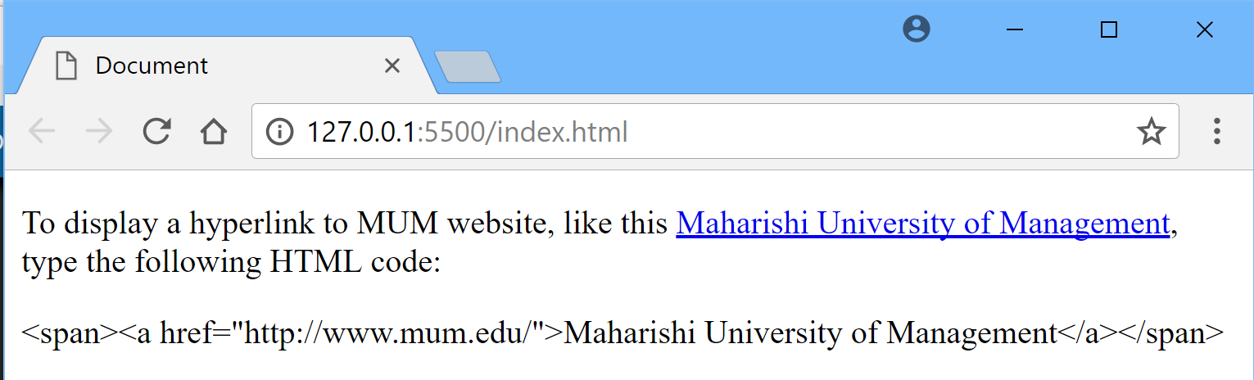

**Answer 1:**

<!DOCTYPE html>

<html>

<head>

<meta charset="UTF-8">

<title>Document</title>

</head>

<body>

<p>To display a hyperlink to MUM website , like this <a href=”http://www.mum.edu> Maharishi University of Management</a> type the following html code</p>

&lt;span&gt;&lt;a href=&quot;http://www.mum.edu/&quot;&gt;Maharishi University of Management&lt;/a&gt;&lt;/span&gt;

</body>

</html>

1. (10 points) Answer the following questions:
   1. (5 points) Write an appropriate Regular Expression to match valid United States telephone numbers, formatted as shown in the figure below, including the country code, +1.

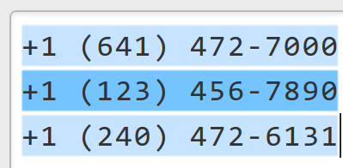

**Answer 2a:**

**<!DOCTYPE html>**

**<html>**

**<head> <meta charset="UTF-8">**

**<title>United States telephone numbers</title>**

**</head>**

**<body>**

**<form action="" >**

**<label>Phone Number</label>**

**<input type="text" name="phone" placeholder="Enter Phone Number" pattern="\+1\s\(\d{3}\)\s\d{3}-\d{4}" title="Invalid Social Security pattern"></br>**

**<button type="submit">Submit</button>**

**<button type="reset">Reset</button>**

**</form>**

**</body>**

**</html>**

* 1. (5 points) Consider the HTML markup for a Web Form shown below.

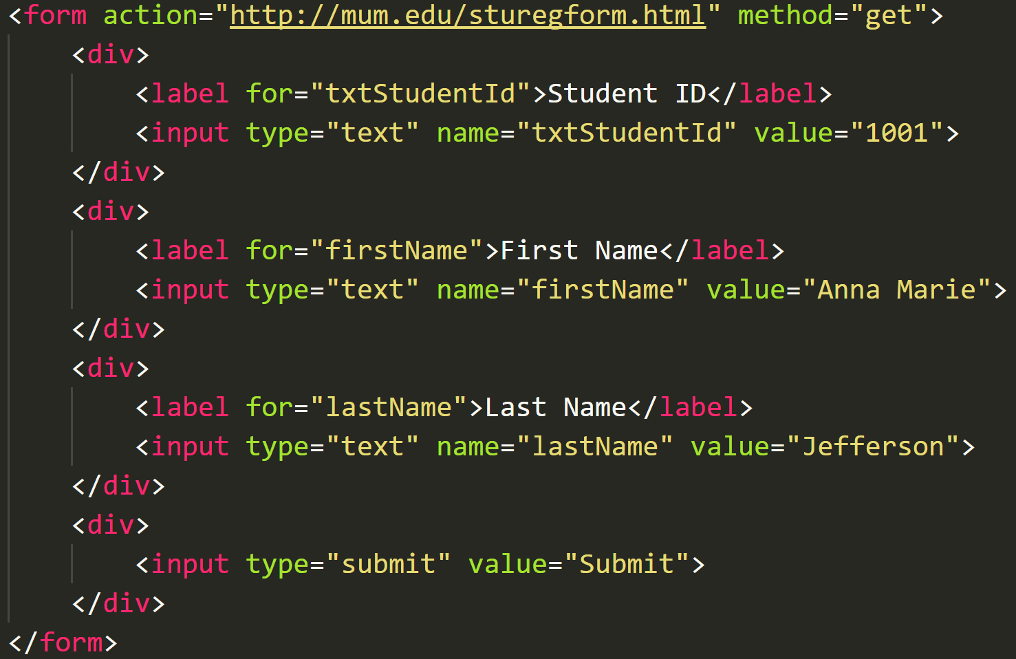

Write-out the full destination URL (including the query string/parameters) generated by the browser, when the form is submitted to the web server.

**Answer 2b:**

**https://www.mum.edu/studregform.htlm?txtStudentID=1001&firstName=Anna+Marie&lastName=Jefferson**

1. (10 points) Answer the following questions:
   1. Consider the HTML markup displayed below, along with the browser output (also displayed below), which is a paragraph content with the text, “Lorem Ipsum”, colored, red.

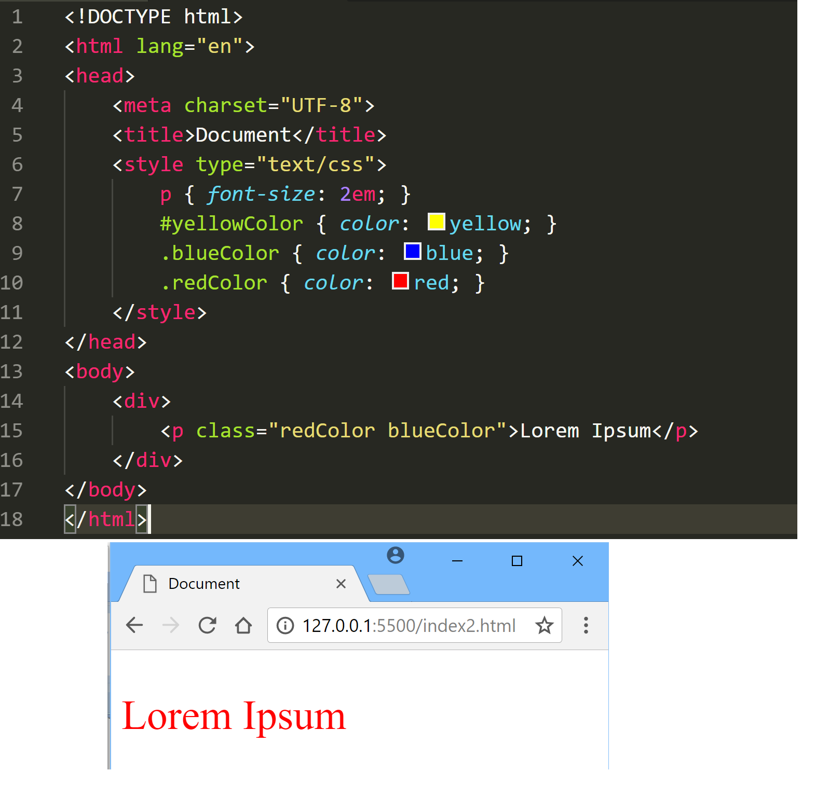

**Task 1** - (5 points): Re-create the HTML markup, and include/make appropriate modification to the embedded CSS styling such that the paragraph content with the text, “Lorem Ipsum”, is displayed in blue.

**Answer 3a – Task 1:**

In Zip Folder

**Task 2** - (5 points): Re-create the HTML markup again, and include/make another (different) appropriate modification to the embedded CSS styling such that the paragraph content with the text, “Lorem Ipsum”, is displayed in blue.

**Answer 3a – Task 2:**

In Zip Folder

1. (10 points) Write HTML markup and appropriate CSS styling, to display a web page with a list of Numbers displayed in reverse order and using roman numerals, as shown in the figure below:

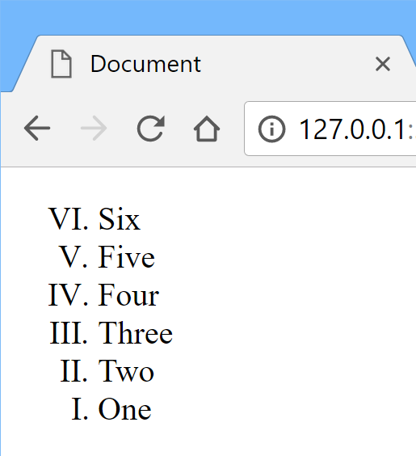

**Answer 4:**

<!DOCTYPE html>

<html>

<head> <meta charset="UTF-8">

<title>Document</title>

<style>

#roman ol {

transform: rotate(180deg);

}

#roman ol>li{

transform: rotate(-180deg) translateX(40px);

}

</style>

</head>

<body>

<div id="roman">

<ol type="I">

<li>One</li>

<li>Two</li>

<li>Three</li>

<li>Four</li>

<li>Five</li>

<li>Six</li>

</ol>

</div>

</body>

</html>

1. (20 points) Using an appropriate Web layout technique, write HTML markup and CSS styling to produce the page layout, as shown in the figure below. *(Please note: The aim is to produce the given page layout structure. So, feel free to use any colors and text content of your choosing*):

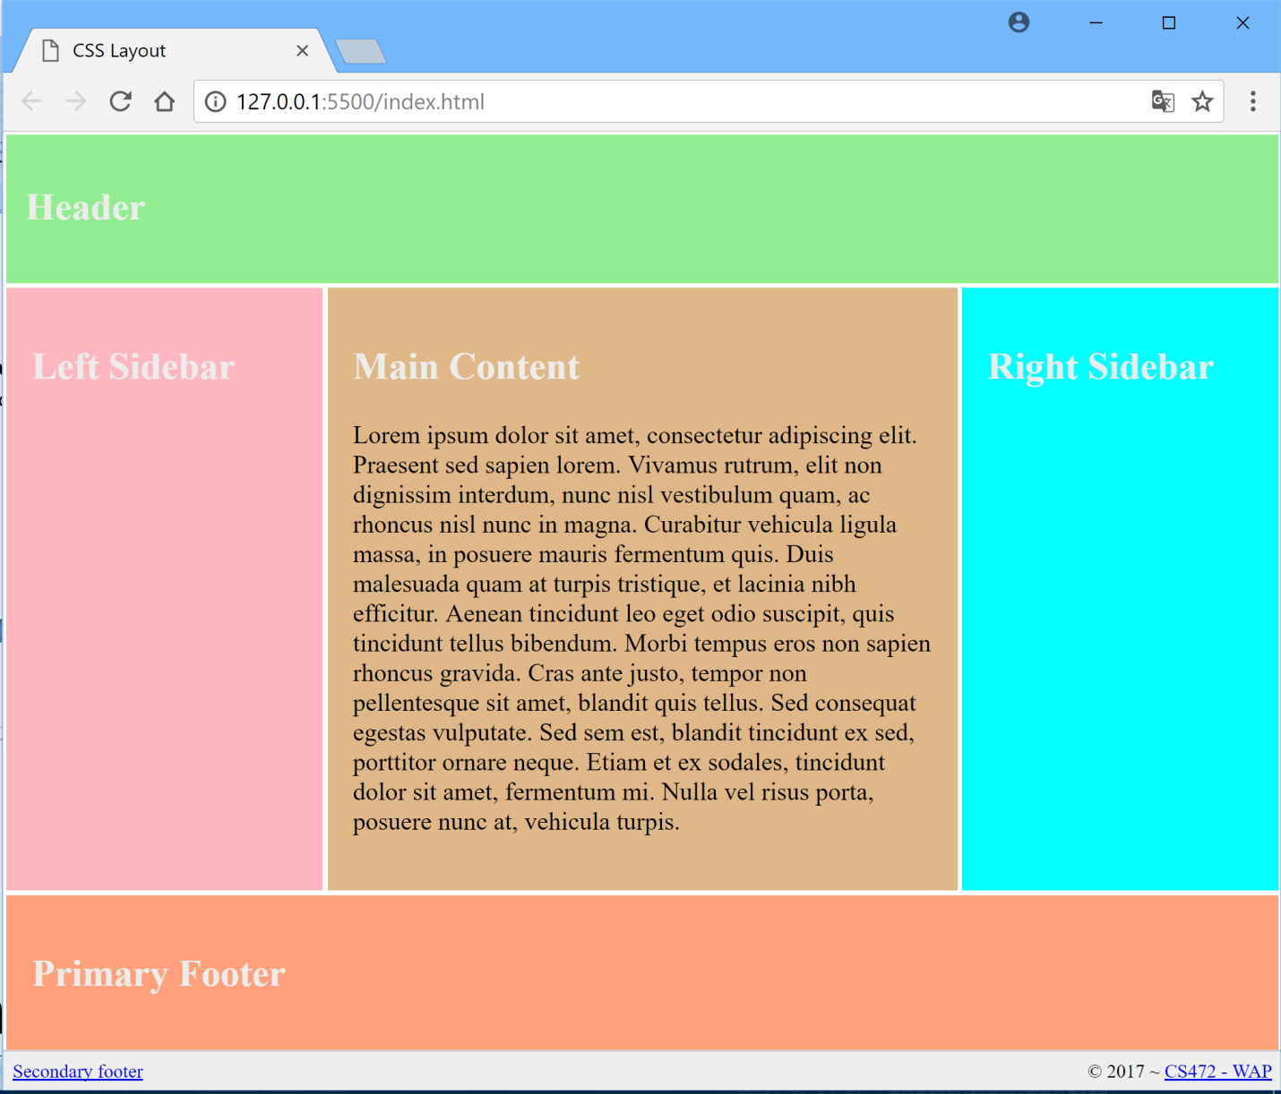

<!DOCTYPE html>

<html>

<head>

<meta charset="utf-8">

<title>CSS layout</title>

<link rel="stylesheet" href="style.css">

</head>

<body>

<div class="main">

<div class="header">

<h2>Header</h2>

</div>

<div class="sidebar-left">Left Sidebar</div>

<div class="main-content">

<h2>Main Content</h2>

<p>Welcome to my home on the web. I am a Nepal based Software Developer, Seo Expert and Internet Marketer.

</p>

</div>

<div class="sidebar-right">Right Sidebar</div>

<div class="footer">Footer</div>

<div style="float: left; padding-left: .5em;">

<a href="" target="_blank">Seconday Footer</a>

</div>

<div style="float: right; padding-right: .5em;">

<a href="">CS472-WAP</a>

</div>

</div>

</body>

</html>

body {

background: white;

padding: 10px;

}

.main {

display: grid;

grid-template-columns: 150px auto 150px;

grid-template-rows: auto;

grid-template-areas: "header header header"

"left main-content right"

"footer footer footer";

grid-gap: 3px;

height: 96vh;

}

.header, .sidebar-left, .sidebar-right, .main-content, .footer {

background-color: lightblue;

padding: 1em;

}

.header {

grid-area: header;

background-color: green;

vertical-align: text-top;

}

.sidebar-left { grid-area: left;

background-color: orange;

}

.main-content {

grid-area: main-content;

vertical-align: text-top;

}

.sidebar-right { grid-area: right; background-color: orange; }

.footer {

grid-area: footer;

background-color: green;

}

**//-- The End --//**