**NAME :** ESHAN SINGH

**ROLL NO :** TEAD21228

**SUBJECT :** SL-III

**CLASS :** TE

**BRANCH :** AI&DS

**EXPERIMENT NO :12**

**TITLE :**

**Write a simple program in SCALA using Apache Spark framework**

**THEORY:**

**What is Scala?**

Scala is an acronym for “Scalable Language”. It is a general-purpose programming language designed for the programmers who want to write programs in a concise, elegant, and type-safe way. Scala enables programmers to be more productive. Scala is developed as an object-oriented and functional programming language.

If you write a code in Scala, you will see that the style is similar to a scripting language. Even though Scala is a new language, it has gained enough users and has a wide community support. It is one of the most user-friendly languages.

**Scala is pure Object-Oriented programming language**

Scala is an object-oriented programming language. Everything in Scala is an object and any operations you perform is a method call. Scala, allow you to add new operations to existing classes with the help of implicit classes. One of the advantages of Scala is that it makes it very easy to interact with Java code. You can also write a Java code inside Scala class. The Scala supports advanced component architectures through classes and traits

**Scala is a functional language**

Scala is a programming language that has implemented major functional programming concepts. In Functional programming, every computation is treated as a mathematical function which avoids states and mutable data. The functional programming exhibits following characteristics:

● Power and flexibility

● Simplicity

● Suitable for parallel processing

**Installing Scala**

Scala can be installed in any Unix or windows based system. Below are the steps to install for Ubuntu (14.04) for scala version 2.11.7. I am showing the steps for installing Scala (2.11.7) with Java version 7. It is necessary to install Java before installing Scala. You can also install latest version of Scala(2.12.1) as well.

**Step 0:** Open the terminal

**Step 1:** Install Java $ sudo apt-add-repository ppa:webupd8team/java $ sudo apt-get update $ sudo apt-get install oracle-java7-installer If you are asked to accept Java license terms, click on “Yes” and proceed. Once finished, let us check whether Java has installed successfully or not. To check the Java version and installation, you can type: $ java -version

**Step 2:** Once Java is installed, we need to install Scala

$ cd ~/Downloads

$ wget <http://www.scala-lang.org/files/archive/scala-2.11.7.deb>

$ sudo dpkg -i scala-2.11.7.deb

$ scala –version

**Scala Basics Terms**

**Object:** An entity that has state and behavior is known as an object. For example: table, person, car etc.

**Class:** A class can be defined as a blueprint or a template for creating different objects which defines its properties and behavior.

**Method:** It is a behavior of a class. A class can contain one or more than one method. For example: deposit can be considered a method of bank class.

**Closure:** Closure is any function that closes over the environment in which it’s defined. A closure returns value depends on the value of one or more variables which is declared outside this closure.

**Traits:** Traits are used to define object types by specifying the signature of the supported methods. It is like interface in java

**Procedure & Code:-**

SIMPLE SCALA PROGRAM:-

/ SCALA PROGRAM TO PRINT HELLO, WORLD!

// BY USING OBJECT-ORIENTED APPROACH

OBJECT HELLOWORLD

{

DEF MAIN(ARGS: ARRAY[STRING])

{

PRINTLN("HELLO, WORLD!")

}

}

**Compile a Scala Program**

To run any Scala program, you first need to compile it. “Scalac” is the compiler which takes source program as an argument and generates object files as output.

Let’s start compiling your “HelloWorld” program using the following steps:

1. For compiling it, you first need to paste this program into a text file then you need to save this program as HelloWorld.scala

2. Now you need change your working directory to the directory where your program is saved

3. After changing the directory you can compile the program by issuing the command. scalac HelloWorld.scala

4. After compiling, you will get Helloworld.class as an output in the same directory. If you can see the file, you have successfully compiled the above program.

Running Scala Program

After compiling, you can now run the program using following command:

scala HelloWorld

**CODE & OUTPUT:**



Let’s make a new Dataset from the text of the README file in the Spark source directory:

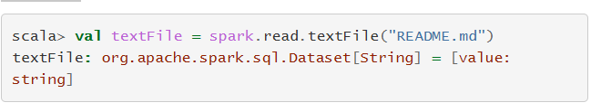

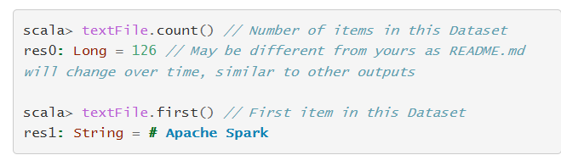

We can chain together transformations and actions:

