

**Project Phase 1A**

Course Name: CSE231

Section: 03

Group No. : 08

Date : 14/03/2017

**Submitted by:**

|  |  |
| --- | --- |
| **NAME** | **ID** |
| SAYEF SARKAR EASHAN | 1513253042 |
| JABID HASSAN PAPPU | 1511885642 |
| SHARIF AHAMED | 1510656042 |

**Specification:**

**Input:**We are using 4 bit binary input as W,X,Y,Z. The value of W,X,Y,Z will be decimal equivalent of 0 to 16.We will use 0(0 0 0 0) for ‘H’,1(0 0 0 1) for E,2(0 0 1 0) for L,3(0 0 1 1) for L,4(0 1 0 0) for O.5(0 1 0 1) for C.6(0 1 1 0) for S,7(0 1 1 1) for E,8(1 0 0 0) for 2,9 (1 0 0 1) for 3,10(1 0 1 0) for 1,11(1 0 1 1) for -,12(1 1 0 0) for 3,13(1 1 0 1) for -,14(1 1 1 0) for 8.

**Output:**We will use 7 segment display that’s why we need 7 output as a,b,c,d,e,f,g.

**Truth Table:**

|  |  |  |  |  |  |  |  |  |  |  |  |  |
| --- | --- | --- | --- | --- | --- | --- | --- | --- | --- | --- | --- | --- |
| **Index** |  | **W** | **X** | **Y** | **Z** | **a** | **b** | **c** | **d** | **e** | **f** | **g** |
| **0** | **H** | **0** | **0** | **0** | **0** | **0** | **1** | **1** | **0** | **1** | **1** | **1** |
| **1** | **E** | **0** | **0** | **0** | **1** | **1** | **0** | **0** | **1** | **1** | **1** | **1** |
| **2** | **L** | **0** | **0** | **1** | **0** | **0** | **0** | **0** | **1** | **1** | **1** | **0** |
| **3** | **L** | **0** | **0** | **1** | **1** | **0** | **0** | **0** | **1** | **1** | **1** | **0** |
| **4** | **O** | **0** | **1** | **0** | **0** | **1** | **1** | **1** | **1** | **1** | **1** | **0** |
| **5** | **C** | **0** | **1** | **0** | **1** | **1** | **0** | **0** | **1** | **1** | **1** | **0** |
| **6** | **S** | **0** | **1** | **1** | **0** | **1** | **0** | **1** | **1** | **0** | **1** | **1** |
| **7** | **E** | **0** | **1** | **1** | **1** | **1** | **0** | **0** | **1** | **1** | **1** | **1** |
| **8** | **2** | **1** | **0** | **0** | **0** | **1** | **1** | **0** | **1** | **1** | **0** | **1** |
| **9** | **3** | **1** | **0** | **0** | **1** | **1** | **1** | **1** | **1** | **0** | **0** | **1** |
| **10** | **1** | **1** | **0** | **1** | **0** | **0** | **1** | **1** | **0** | **0** | **0** | **0** |
| **11** | **-** | **1** | **0** | **1** | **1** | **0** | **0** | **0** | **0** | **0** | **0** | **1** |
| **12** | **3** | **1** | **1** | **0** | **0** | **1** | **1** | **1** | **1** | **0** | **0** | **1** |
| **13** | **-** | **1** | **1** | **0** | **1** | **0** | **0** | **0** | **0** | **0** | **0** | **1** |
| **14** | **8** | **1** | **1** | **1** | **0** | **1** | **1** | **1** | **1** | **1** | **1** | **1** |

**K-Map:**

|  |  |  |  |
| --- | --- | --- | --- |
| **0** | **1** | **0** | **0** |
| **1** | **1** | **1** | **1** |
| **1** | **0** | **X** | **1** |
| **1** | **1** | **0** | **0** |

**a = W’X+XZ’+WY’Z’+X’Y’Z**

|  |  |  |  |
| --- | --- | --- | --- |
| **1** | **0** | **0** | **0** |
| **1** | **0** | **0** | **0** |
| **1** | **0** | **X** | **1** |
| **1** | **1** | **0** | **1** |

**b = Y’Z’+WZ’+WX’Y’**

|  |  |  |  |
| --- | --- | --- | --- |
| **1** | **0** | **0** | **0** |
| **1** | **0** | **0** | **1** |
| **1** | **0** | **X** | **1** |
| **0** | **1** | **0** | **1** |

**c = XZ’+W’Y’Z’+WYZ’+WX’Y’Z**

|  |  |  |  |
| --- | --- | --- | --- |
| **0** | **1** | **1** | **1** |
| **1** | **1** | **1** | **1** |
| **1** | **0** | **X** | **1** |
| **1** | **1** | **0** | **0** |

**d = W’X+WY+W’Z+X’Y+WY’Z’+WX’Y’**

|  |  |  |  |
| --- | --- | --- | --- |
| **1** | **1** | **1** | **1** |
| **1** | **1** | **1** | **0** |
| **0** | **0** | **X** | **1** |
| **1** | **0** | **0** | **0** |

**e = W’Y’+W’X’+W’Z+X’Y’Z+WXY**

|  |  |  |  |
| --- | --- | --- | --- |
| **1** | **1** | **1** | **1** |
| **1** | **1** | **1** | **1** |
| **0** | **0** | **X** | **1** |
| **0** | **0** | **0** | **0** |

**f = W’+ XYZ’**

|  |  |  |  |
| --- | --- | --- | --- |
| **1** | **1** | **0** | **0** |
| **0** | **0** | **1** | **1** |
| **1** | **1** | **X** | **1** |
| **1** | **1** | **1** | **0** |

**g = X’Y’+XY+WY’+WZ**

**Universal gate:**

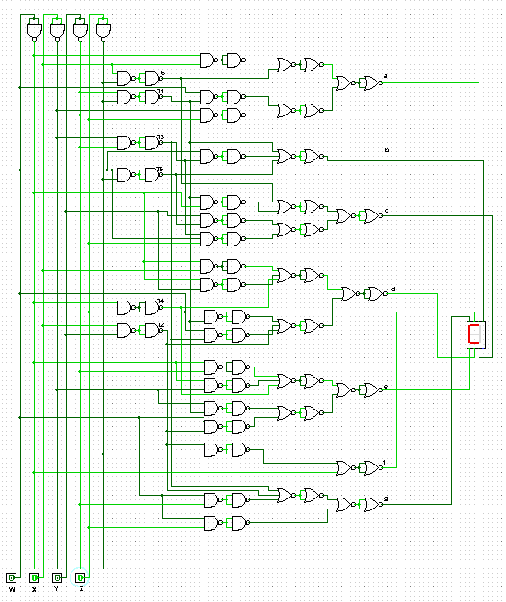

**Decoder:**

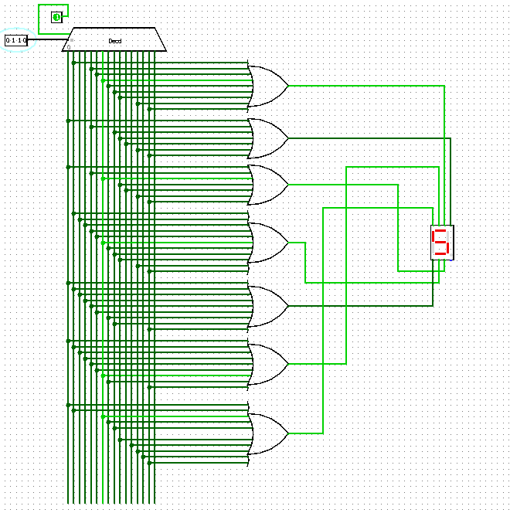

**Multiplexer:**

