

**Digital Logic Design**

**Project**

Course :CSE231

Section: 03

Group :08

|  |  |
| --- | --- |
| **Name** | **ID** |
| Sayef Sarkar Eashan | 1513253042 |
| Sharif Ahamed | 1510656042 |
| Jabid Hasan Pappu | 1511885642 |

**Introduction:**

The purpose of our project is to design a circuit which will display “HELLOCSE231-3-8” via a 7 segment display. This project has two parts.

1. Combinational Part
2. Sequential Part.

In the combinational part, we have designed a combinational circuit using 8:1 multiplexers. We used multiplexers because it is easy to implement and to minimize the circuit. In this part, we have shown that string in the 7 segment display by changing inputs manually.

And, in the sequential part we have designed a sequential circuit using basic logic gates and Flip-Flops . We used 2 JK Flip-Flops and 2 T Flip-Flops. Because of using the combination of JK and T Flip-Flops ,we found the most simplified circuit. In the end of this part ,we were able to generate the string in the 7 segment display by changing the clock pulse.

**Project Phase 1A**

**Combinational Part :**

**Specification:**

**Input:**We are using 4 bit binary input as W,X,Y,Z. The value of W,X,Y,Z will be decimal equivalent of 0 to 16.We will use 0(0 0 0 0) for ‘H’,1(0 0 0 1) for E,2(0 0 1 0) for L,3(0 0 1 1) for L,4(0 1 0 0) for O.5(0 1 0 1) for C.6(0 1 1 0) for S,7(0 1 1 1) for E,8(1 0 0 0) for 2,9 (1 0 0 1) for 3,10(1 0 1 0) for 1,11(1 0 1 1) for -,12(1 1 0 0) for 3,13(1 1 0 1) for -,14(1 1 1 0) for 8.

**Output:**We will use 7 segment display that’s why we need 7 output as a,b,c,d,e,f,g.

**Truth Table:**

|  |  |  |  |  |  |  |  |  |  |  |  |  |
| --- | --- | --- | --- | --- | --- | --- | --- | --- | --- | --- | --- | --- |
| **Index** |  | **W** | **X** | **Y** | **Z** | **a** | **b** | **C** | **d** | **e** | **f** | **g** |
| **0** | **H** | **0** | **0** | **0** | **0** | **0** | **1** | **1** | **0** | **1** | **1** | **1** |
| **1** | **E** | **0** | **0** | **0** | **1** | **1** | **0** | **0** | **1** | **1** | **1** | **1** |
| **2** | **L** | **0** | **0** | **1** | **0** | **0** | **0** | **0** | **1** | **1** | **1** | **0** |
| **3** | **L** | **0** | **0** | **1** | **1** | **0** | **0** | **0** | **1** | **1** | **1** | **0** |
| **4** | **O** | **0** | **1** | **0** | **0** | **1** | **1** | **1** | **1** | **1** | **1** | **0** |
| **5** | **C** | **0** | **1** | **0** | **1** | **1** | **0** | **0** | **1** | **1** | **1** | **0** |
| **6** | **S** | **0** | **1** | **1** | **0** | **1** | **0** | **1** | **1** | **0** | **1** | **1** |
| **7** | **E** | **0** | **1** | **1** | **1** | **1** | **0** | **0** | **1** | **1** | **1** | **1** |
| **8** | **2** | **1** | **0** | **0** | **0** | **1** | **1** | **0** | **1** | **1** | **0** | **1** |
| **9** | **3** | **1** | **0** | **0** | **1** | **1** | **1** | **1** | **1** | **0** | **0** | **1** |
| **10** | **1** | **1** | **0** | **1** | **0** | **0** | **1** | **1** | **0** | **0** | **0** | **0** |
| **11** | **-** | **1** | **0** | **1** | **1** | **0** | **0** | **0** | **0** | **0** | **0** | **1** |
| **12** | **3** | **1** | **1** | **0** | **0** | **1** | **1** | **1** | **1** | **0** | **0** | **1** |
| **13** | **-** | **1** | **1** | **0** | **1** | **0** | **0** | **0** | **0** | **0** | **0** | **1** |
| **14** | **8** | **1** | **1** | **1** | **0** | **1** | **1** | **1** | **1** | **1** | **1** | **1** |

**K-Map:**

|  |  |  |  |
| --- | --- | --- | --- |
| **0** | **1** | **0** | **0** |
| **1** | **1** | **1** | **1** |
| **1** | **0** | **X** | **1** |
| **1** | **1** | **0** | **0** |

**a = W’X+XZ’+WY’Z’+X’Y’Z**

|  |  |  |  |
| --- | --- | --- | --- |
| **1** | **0** | **0** | **0** |
| **1** | **0** | **0** | **0** |
| **1** | **0** | **X** | **1** |
| **1** | **1** | **0** | **1** |

**b = Y’Z’+WZ’+WX’Y’**

|  |  |  |  |
| --- | --- | --- | --- |
| **1** | **0** | **0** | **0** |
| **1** | **0** | **0** | **1** |
| **1** | **0** | **X** | **1** |
| **0** | **1** | **0** | **1** |

**c = XZ’+W’Y’Z’+WYZ’+WX’Y’Z**

|  |  |  |  |
| --- | --- | --- | --- |
| **0** | **1** | **1** | **1** |
| **1** | **1** | **1** | **1** |
| **1** | **0** | **X** | **1** |
| **1** | **1** | **0** | **0** |

**d = W’X+WY+W’Z+X’Y+WY’Z’+WX’Y’**

|  |  |  |  |
| --- | --- | --- | --- |
| **1** | **1** | **1** | **1** |
| **1** | **1** | **1** | **0** |
| **0** | **0** | **X** | **1** |
| **1** | **0** | **0** | **0** |

**e = W’Y’+W’X’+W’Z+X’Y’Z+WXY**

|  |  |  |  |
| --- | --- | --- | --- |
| **1** | **1** | **1** | **1** |
| **1** | **1** | **1** | **1** |
| **0** | **0** | **X** | **1** |
| **0** | **0** | **0** | **0** |

**f = W’+ XYZ’**

|  |  |  |  |
| --- | --- | --- | --- |
| **1** | **1** | **0** | **0** |
| **0** | **0** | **1** | **1** |
| **1** | **1** | **X** | **1** |
| **1** | **1** | **1** | **0** |

**g = X’Y’+XY+WY’+WZ**

|  |  |  |  |  |  |  |  |  |  |  |  |  |
| --- | --- | --- | --- | --- | --- | --- | --- | --- | --- | --- | --- | --- |
| **INDEX** |  | **W** | **X** | **Y** | **Z** | **a** | **b** | **c** | **d** | **e** | **f** | **g** |
| **0** | **H** | **0** | **0** | **0** | **0** | **I0=Z** | **I0=Z’** | **I0=Z’** | **I0=Z** | **I0=1** | **I0=1** | **I0=1** |
| **1** | **E** | **0** | **0** | **0** | **1** |
| **2** | **L** | **0** | **0** | **1** | **0** | **I1=0** | **I1=0** | **I1=0** | **I1=1** | **I1=1** | **I1=1** | **I1=0** |
| **3** | **L** | **0** | **0** | **1** | **1** |
| **4** | **O** | **0** | **1** | **0** | **0** | **I2=1** | **I2=Z’** | **I2=Z’** | **I2=1** | **I2=1** | **I2=1** | **I2=0** |
| **5** | **C** | **0** | **1** | **0** | **1** |
| **6** | **S** | **0** | **1** | **1** | **0** | **I3=1** | **I3=0** | **I3=Z’** | **I3=1** | **I3=Z** | **I3=1** | **I3=1** |
| **7** | **E** | **0** | **1** | **1** | **1** |
| **8** | **2** | **1** | **0** | **0** | **0** | **I4=1** | **I4=1** | **I4=Z** | **I4=1** | **I4=Z’** | **I4=0** | **I4=1** |
| **9** | **3** | **1** | **0** | **0** | **1** |
| **10** | **1** | **1** | **0** | **1** | **0** | **I5=0** | **I5=Z’** | **I5=Z’** | **I5=0** | **I5=0** | **I5=0** | **I5=Z** |
| **11** | **-** | **1** | **0** | **1** | **1** |
| **12** | **3** | **1** | **1** | **0** | **0** | **I6=Z’** | **I6=Z’** | **I6=Z’** | **I6=Z’** | **I6=0** | **I6=0** | **I6=1** |
| **13** | **-** | **1** | **1** | **0** | **1** |
| **14** | **8** | **1** | **1** | **1** | **0** | **I7=Z’** | **I7=Z’** | **I7=Z’** | **I7=Z’** | **I7=Z’** | **I7=Z’** | **I7=Z’** |
| **15** | **X** | **X** | **X** | **X** | **X** |

**Universal gate:**

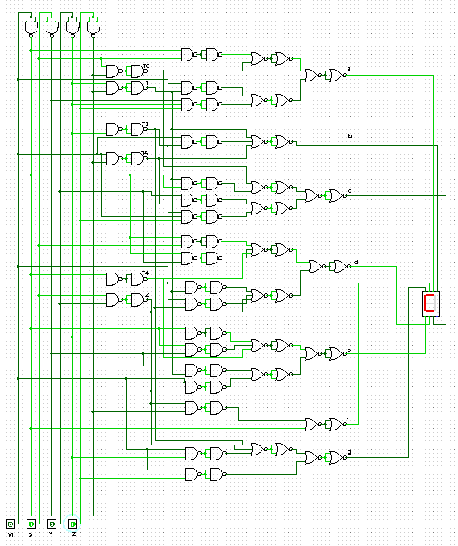

**Decoder:**

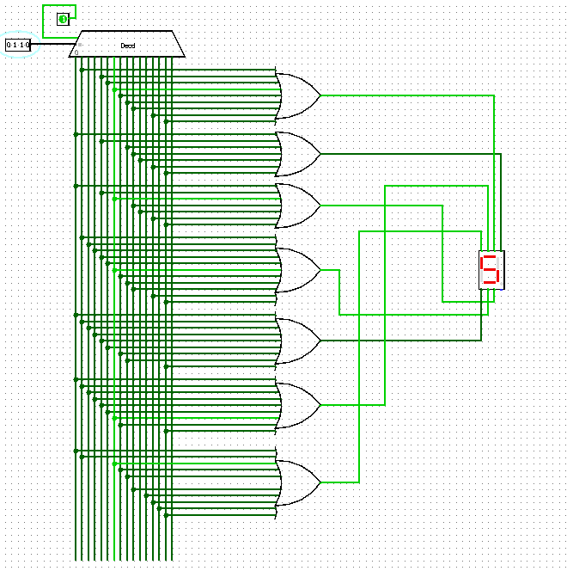

**Multiplexer:**

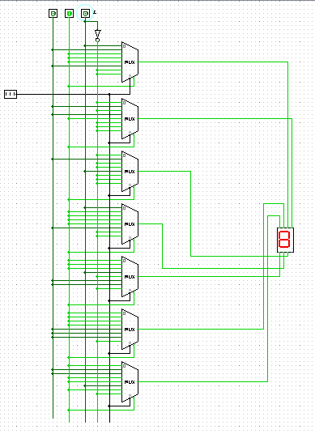

**Project Phase 2**

**Sequential Part :**

**Specification** : There are total 15 states .These states are H,E,L,L,O,C,S,E,2,3,1,-,3,-,8.

Assign binary for these values are 0(0 0 0 0) for ‘H’,1(0 0 0 1) for E,2(0 0 1 0) for L,3(0 0 1 1) for L,4(0 1 0 0) for O.5(0 1 0 1) for C.6(0 1 1 0) for S,7(0 1 1 1) for E,8(1 0 0 0) for 2,9 (1 0 0 1) for 3,10(1 0 1 0) for 1,11(1 0 1 1) for -,12(1 1 0 0) for 3,13(1 1 0 1) for -,14(1 1 1 0) for 8.

**State Diagram** :

**State Table :**

|  |  |  |  |  |  |  |  |  |  |  |  |  |  |  |  |
| --- | --- | --- | --- | --- | --- | --- | --- | --- | --- | --- | --- | --- | --- | --- | --- |
|  | | Present State | | | | Next State | | | | Flip-Flop | | | | | |
| Index |  | W | X | Y | Z | Wt+1 | Xt+1 | Yt+1 | Zt+1 | JW | KW | TX | TY | JZ | kZ |
| 0 | H | 0 | 0 | 0 | 0 | 0 | 0 | 0 | 1 | 0 | X | 0 | 0 | 1 | X |
| 1 | E | 0 | 0 | 0 | 1 | 0 | 0 | 1 | 0 | 0 | X | 0 | 1 | X | 1 |
| 2 | L | 0 | 0 | 1 | 0 | 0 | 0 | 1 | 1 | 0 | X | 0 | 0 | 1 | X |
| 3 | L | 0 | 0 | 1 | 1 | 0 | 1 | 0 | 0 | 0 | X | 1 | 1 | X | 1 |
| 4 | O | 0 | 1 | 0 | 0 | 0 | 1 | 0 | 1 | 0 | X | 0 | 0 | 1 | X |
| 5 | C | 0 | 1 | 0 | 1 | 0 | 1 | 1 | 0 | 0 | X | 0 | 1 | X | 1 |
| 6 | S | 0 | 1 | 1 | 0 | 0 | 1 | 1 | 1 | 0 | X | 0 | 0 | 1 | X |
| 7 | E | 0 | 1 | 1 | 1 | 1 | 0 | 0 | 0 | 1 | X | 1 | 1 | X | 1 |
| 8 | 2 | 1 | 0 | 0 | 0 | 1 | 0 | 0 | 1 | X | 0 | 0 | 0 | 1 | X |
| 9 | 3 | 1 | 0 | 0 | 1 | 1 | 0 | 1 | 0 | X | 0 | 0 | 1 | X | 1 |
| 10 | 1 | 1 | 0 | 1 | 0 | 1 | 0 | 1 | 1 | X | 0 | 0 | 0 | 1 | X |
| 11 | - | 1 | 0 | 1 | 1 | 1 | 1 | 0 | 0 | X | 0 | 1 | 1 | X | 1 |
| 12 | 3 | 1 | 1 | 0 | 0 | 1 | 1 | 0 | 1 | X | 0 | 0 | 0 | 1 | X |
| 13 | - | 1 | 1 | 0 | 1 | 1 | 1 | 1 | 0 | X | 0 | 0 | 1 | X | 1 |
| 14 | 8 | 1 | 1 | 1 | 0 | 0 | 0 | 0 | 0 | X | 1 | 1 | 1 | 0 | X |
| 15 | X | X | X | X | X | X | X | X | X | X | X | X | X | X | X |

K-Map:

|  |  |  |  |
| --- | --- | --- | --- |
| 0 | 0 | 0 | 0 |
| 0 | 0 | 1 | 0 |
| X | X | X | X |
| X | X | X | X |

JW = YZ

|  |  |  |  |
| --- | --- | --- | --- |
| X | X | X | X |
| X | X | X | X |
| 0 | 0 | X | 1 |
| 0 | 0 | 0 | 0 |

KW = XY

|  |  |  |  |
| --- | --- | --- | --- |
| 0 | 0 | 1 | 0 |
| 0 | 0 | 1 | 0 |
| 0 | 0 | X | 1 |
| 0 | 0 | 1 | 0 |

Tx = YZ + WXY

|  |  |  |  |
| --- | --- | --- | --- |
| 0 | 1 | 1 | 0 |
| 0 | 1` | 1 | 0 |
| 0 | 1 | X | 1 |
| 0 | 1 | 1 | 0 |

Ty = Z + WXY

|  |  |  |  |
| --- | --- | --- | --- |
| 1 | X | X | 1 |
| 1 | X | X | 1 |
| - 1 | X | X | 0 |
| 1 | X | X | 1 |

Jz = W’ + X’ + Y’

|  |  |  |  |
| --- | --- | --- | --- |
| X | 1 | 1 | X |
| X | 1 | 1 | X |
| X | 1 | X | X |
| X | 1 | 1 | X |

Kz = 1

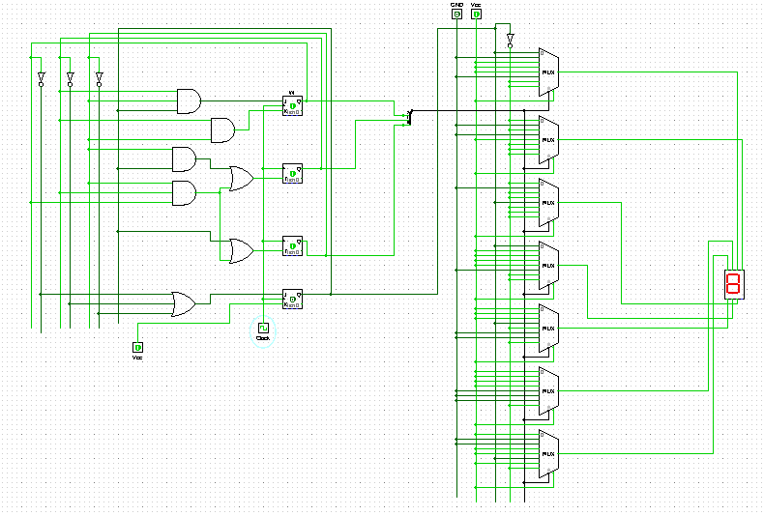

**Discussion** :

Our main objective is to print “HELLOCSE231-3-8”. There are two parts in the project. One is combinational part and the other one is sequential part.

For sequential circuit input ‘W’ we used JK Flip-Flop. For input ‘X’ we used T Flip-Flop. For input ‘Y’ we used T Flip-Flop. For input ‘Z’ we used JK Flip-Flop. Because by using these Flip-Flops we found the most simplified circuit. Then we added the sequential part with the combinational part.

Output of the Flip-Flops will be the input of the main combinational circuit. This will be changed by the clock pulse added with the Flip-Flops. For every clock pulse the sequential circuit will count the decimal 0-15.

Sequential circuit is working as we wanted. Then it is giving the output perfectly. After triggering the clock sequential circuit gives the next output which is the input of the main combinational circuit. After connecting the sequential part our main objective to display in the seven-segment is working fine with the every clock pulse.