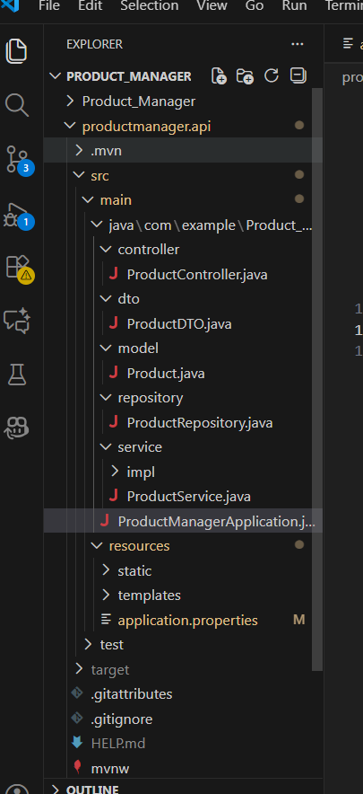
ProductController.java
package com.example.Product_Manager.controller;
import com.example.Product_Manager.dto.ProductDTO;
import com.example.Product_Manager.model.Product;
import com.example.Product_Manager.service.ProductService;
import jakarta.validation.Valid;
import org.springframework.beans.factory.annotation.Autowired;
import org.springframework.http.HttpStatus;
import org.springframework.http.ResponseEntity;
import org.springframework.web.bind.annotation.*;

import java.util.List;

@RestController
@RequestMapping("/products")
public class ProductController {

@Autowired
private ProductService productService;

@PostMapping
public ResponseEntity<Product> addProduct(@Valid @RequestBody ProductDTO productDTO) {
Product newProduct = productService.addProduct(productDTO);
return new ResponseEntity<>(newProduct, HttpStatus.CREATED);
}

@GetMapping
public ResponseEntity<List<Product>> getAllProducts() {
List<Product> products = productService.getAllProducts();
return ResponseEntity.ok(products);
}

@GetMapping("/category/{category}")
public ResponseEntity<List<Product>> getProductsByCategory(@PathVariable String category) {
List<Product> products = productService.searchProducts(category);
if (products.isEmpty()) {
return ResponseEntity.notFound().build();
}
return ResponseEntity.ok(products);
}

@DeleteMapping("/{name}")
public ResponseEntity<Void> deleteProductByName(@PathVariable String name) {
productService.deleteProductByName(name);
return ResponseEntity.noContent().build();
}
}

ProductDTO.java
package com.example.Product_Manager.dto;
import jakarta.validation.constraints.Min;
import jakarta.validation.constraints.NotBlank;
import jakarta.validation.constraints.NotNull;

public class ProductDTO {

@NotBlank(message = "Product name is required.")
private String productName;

@NotBlank(message = "Category is required.")
private String category;

@NotNull(message = "Price is required.")
@Min(value = 1, message = "Price must be a positive value.")
private Double price;

@NotNull(message = "Quantity is required.")
@Min(value = 1, message = "Quantity must be a positive value.")
private Integer quantity;

public String getProductName() {
return productName;
}
public void setProductName(String productName) {
this.productName = productName;
}
public String getCategory() {
return category;
}
public void setCategory(String category) {
this.category = category;
}
public Double getPrice() {
return price;
}
public void setPrice(Double price) {
this.price = price;
}
public Integer getQuantity() {
return quantity;
}
public void setQuantity(Integer quantity) {
this.quantity = quantity;
}
}
Product.java
package com.example.Product_Manager.model;

import jakarta.persistence.*;

@Entity
@Table(name = "product")
public class Product {

@Id
@GeneratedValue(strategy = GenerationType.IDENTITY)
private Long id;

private String productName;
private String category;
private Double price;
private Integer quantity;

public Product() {}

public Long getId() {
return id;
}
public void setId(Long id) {
this.id = id;
}
public String getProductName() {
return productName;
}
public void setProductName(String productName) {
this.productName = productName;
}
public String getCategory() {
return category;
}
public void setCategory(String category) {
this.category = category;
}
public Double getPrice() {
return price;
}
public void setPrice(Double price) {
this.price = price;
}
public Integer getQuantity() {
return quantity;
}
public void setQuantity(Integer quantity) {
this.quantity = quantity;
}
}
ProductRepository.java
package com.example.Product_Manager.repository;
import com.example.Product_Manager.model.Product;
import org.springframework.data.jpa.repository.JpaRepository;
import org.springframework.stereotype.Repository;
import org.springframework.transaction.annotation.Transactional;

import java.util.List;
import java.util.Optional;

@Repository
public interface ProductRepository extends JpaRepository<Product, Long> {

List<Product> findByCategoryIgnoreCase(String category);

Optional<Product> findByProductNameIgnoreCase(String productName);

@Transactional
void deleteByProductNameIgnoreCase(String productName);
}

ProductService.java
package com.example.Product_Manager.service;

import com.example.Product_Manager.dto.ProductDTO;
import com.example.Product_Manager.model.Product;
import java.util.List;

public interface ProductService {

Product addProduct(ProductDTO productDTO);

List<Product> getAllProducts();

List<Product> searchProducts(String category);

void deleteProductByName(String name);
}
ProductManagerApplication.java
package com.example.Product_Manager;
import org.springframework.boot.SpringApplication;
import org.springframework.boot.autoconfigure.SpringBootApplication;

@SpringBootApplication
public class ProductManagerApplication {

public static void main(String[] args) {
SpringApplication.run(ProductManagerApplication.class, args);
}

}
Applicationproperties.java
spring.application.name=Product_Manager
server.port=8081

spring.datasource.url=jdbc:mysql://localhost:3306/product_db?createDatabaseIfNotExist=true&useSSL=false&serverTimezone=UTC
spring.datasource.username=root
spring.datasource.password= Eshanv8@2001
spring.datasource.driver-class-name=com.mysql.cj.jdbc.Driver

spring.jpa.hibernate.ddl-auto=update
spring.jpa.show-sql=true
spring.jpa.properties.hibernate.dialect=org.hibernate.dialect.MySQLDialect

Database
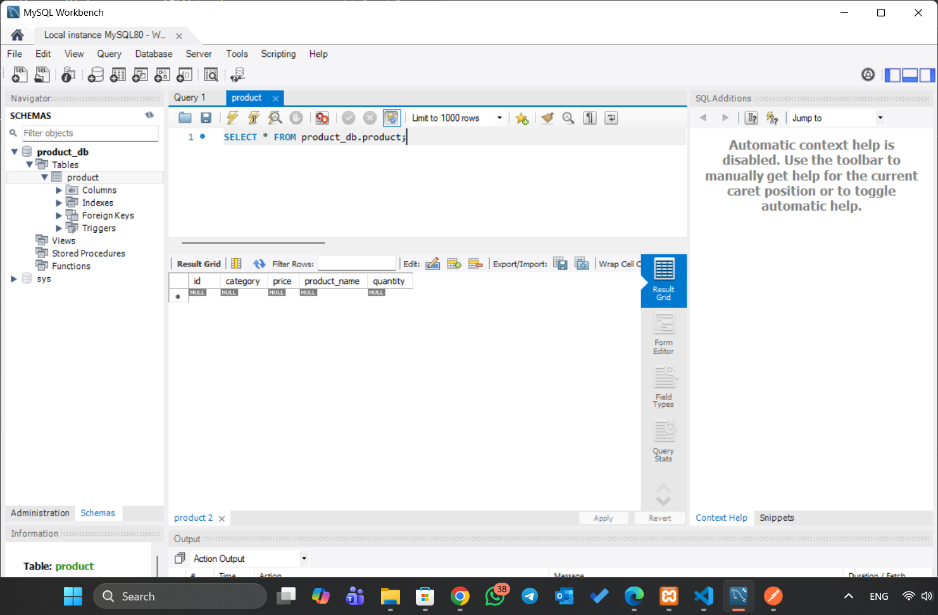

Data send through Postman
