**Books Wish List**

In this task you are asked to implement a single page app that manages a user's book wish-list.

The page should look like in the following image:

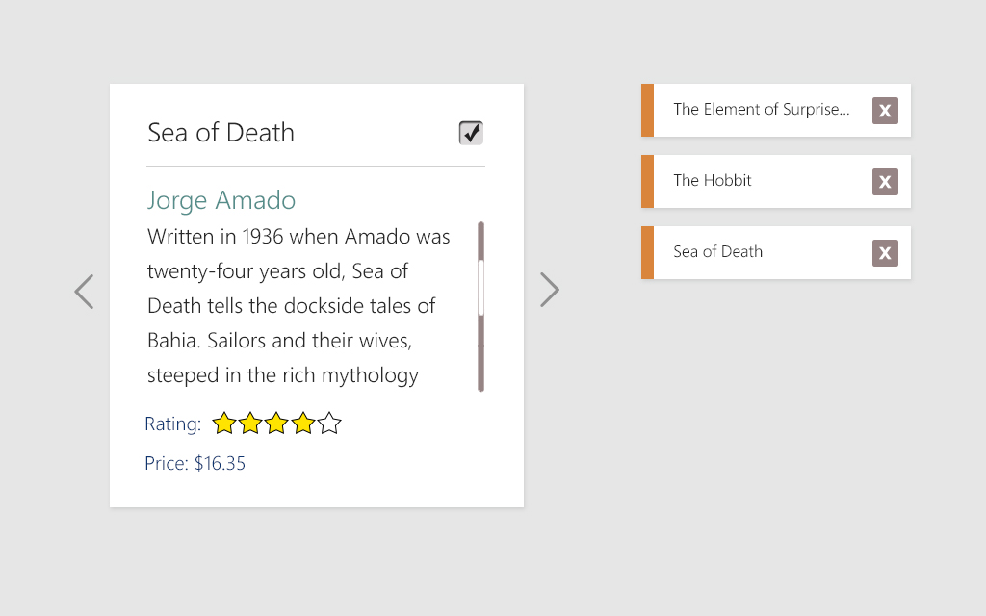

On the left, books data is presented.

The book data is a json file that can be received through an API.  
Your application should work correctly with each one of the following .jsons:

<http://s3.amazonaws.com/sundaysky-mock/books/listOfBooks.json>

<http://s3.amazonaws.com/sundaysky-mock/books/noListOfBooks.json>

<http://s3.amazonaws.com/sundaysky-mock/books/smallListOfBooks.json>

**Start by saving the book data in your app. Don't get stuck on retrieving it. Only after everything works, if you wish, use ajax to retrieve the data.**

The user can page through book data using the right and left arrows, which are displayed only when relevant (i.e. if this is the first item of the list, the left arrow is not displayed)

In the book data area, there's a checkbox, once checked – the book is added to the wish list on the right

A book can be removed from the wish list by either unchecking the checkbox or by clicking the 'X' on the item in the wish list

Rating should be presented by stars and should be rounded to the closest integer for display purposes

**Bonus tasks**

1. Add a sorting control   
   The user can sort his wish list by either one of the following parameters:
   1. Book title
   2. Book price
   3. Book rating
2. Show the total price of the books in your wish list (always shown, dynamically updated)

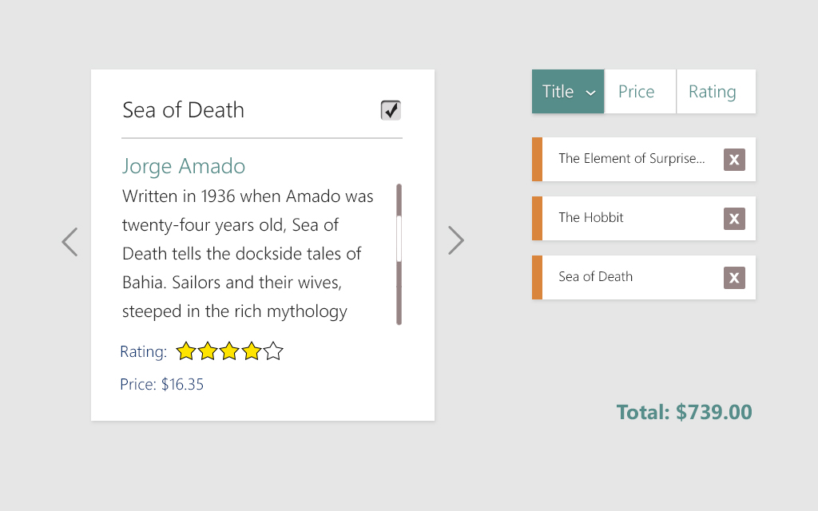

**General instructions**

You'll have exactly 3 hours to work on it, and at the end of these 3 hours you are requested to submit the exam by sending a zip with all of your files.

The application must run, so plan your time wisely so that at the end of those 3 hours you'll have something runnable.

The exercise focuses on Front End capabilities. You are not required to set up a server.

It should be written in javascript, you are allowed to use any framework or library you wish.

You'll be evaluated by the following criteria in order of precedence:

* Functionality
* Code cleanness (Arrangement of files, objects and functions, naming etc.)
* Styling (according to the given design)