RV UNIVERSITY
School of Business
Bengaluru – 560059



Human Resource Management
SB3080
Faculty: Guduru Shravani

Date : 14 April 2026
Group 4:
Amrithaa M
Ananya R
Akanksha
Akil Pranav G
Thanmayee S
Anagha Anish
ACKNOWLEDGEMENT

We would like to express our sincere gratitude to our faculty, Guduru Shravani, for providing us with the opportunity to work on this report on Performance Management - Meaning, Objectives, and Appraisal Process. Her guidance, support, and valuable insights have helped us understand the topic in depth and complete this work successfully.

We would also like to thank RV University School of Business for providing a learning environment that encourages practical knowledge and application of concepts. The resources and academic support provided by the institution played a crucial role in the completion of this report.

We extend our heartfelt thanks to all our group members - Amrithaa M, Ananya R, Esheshwari Kumari, Akanksha, Akil Pranav G, Thanmayee S, and Anagha Anish - for their cooperation, teamwork, and dedication. Their contributions and collaborative efforts made this report more effective and meaningful.
We would also like to acknowledge the various online resources, books, and study materials that helped us gather relevant information and enhance our understanding of the subject.
Finally, We are grateful for the opportunity to work on this project, which has significantly improved our knowledge of performance management and its importance in modern organizations.

Index
 | Content | Page No.
01. | Introduction | 04
02. | Meaning of Performance Management | 05
03. | Key Concepts of Performance Management | 06
04. | Nature of Performance Management | 07
05. | Features of Performance Management | 08
06. | Objectives of Performance Management | 09
07. | Importance of Performance Management | 10
08. | Performance Appraisal – Meaning | 11
09. | Difference between Performance Management & Appraisal | 12
10. | Appraisal Process | 13
11. | Problems in Performance Appraisal | 14
12. | Conclusion | 15
13. | References | 16

INTRODUCTION

Performance Management is a systematic and continuous process that focuses on improving the performance of employees in an organization. It ensures that employees’ activities and outputs are aligned with the organization’s goals and objectives. In today’s competitive environment, organizations must focus not only on achieving targets but also on developing their human resources.
Performance Management plays a crucial role in enhancing productivity, improving employee engagement, and ensuring organizational success. It involves setting clear expectations, monitoring performance, providing feedback, and taking corrective actions when required. It is not a one-time activity but an ongoing process that helps both employees and organizations grow together.
In addition, performance management helps create a culture of accountability and transparency within the organization. When employees clearly understand expectations and receive regular feedback, they are more motivated and productive. It also strengthens communication between employees and managers.
For example, companies like Google use continuous performance management systems where employees receive regular feedback instead of annual reviews. This helps improve performance consistently and encourages innovation.

MEANING OF PERFORMANCE MANAGEMENT

Performance Management refers to a continuous and systematic process of planning, monitoring, evaluating, and improving employee performance to achieve organizational goals effectively. It ensures that employees understand their roles clearly and are aligned with the strategic objectives of the organization.
It is not limited to performance evaluation but also focuses on developing employee skills, enhancing productivity, and improving overall organizational effectiveness. The process involves setting clear goals, measuring performance regularly, and providing constructive feedback to employees.
Performance Management also promotes accountability and transparency, as employees are aware of expectations and are evaluated fairly. It creates a performance-driven culture where continuous learning and improvement are encouraged.
For example, companies like Infosys implement structured performance management systems that include goal setting, regular reviews, and employee development programs to enhance performance.

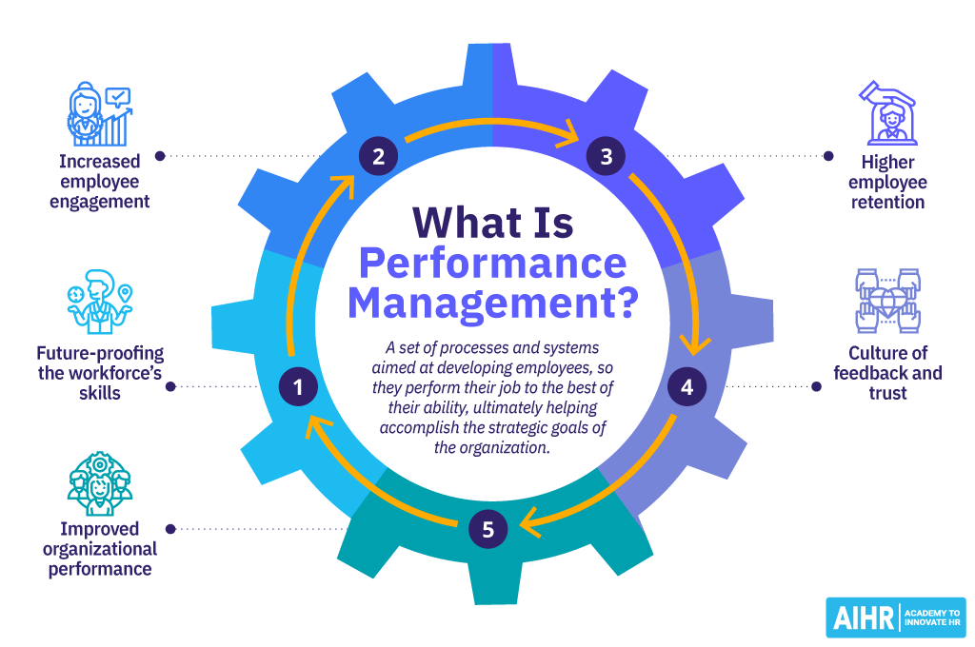
KEY CONCEPTS OF PERFORMANCE MANAGEMENT

The key concepts of performance management include continuous improvement, goal alignment, performance measurement, and feedback. It is an ongoing process that ensures employees consistently improve their performance over time.
Goal alignment is a critical concept, where individual goals are linked with organizational objectives. This ensures that every employee contributes directly to the success of the organization.
Another important concept is regular feedback and communication. Continuous interaction between managers and employees helps identify performance gaps and take corrective actions.
Performance management also emphasizes employee development by identifying training needs and providing growth opportunities. It focuses not only on evaluating performance but also on improving it.
For instance, Amazon uses performance metrics and continuous feedback systems to align employee performance with business goals.

NATURE OF PERFORMANCE MANAGEMENT

Performance Management is continuous, systematic, and goal-oriented in nature. It is not a one-time activity but an ongoing process that takes place throughout the employee lifecycle.
It is future-oriented, focusing on improving employee performance and preparing them for future roles and responsibilities. It also adapts to changes in the organizational environment, making it dynamic in nature.
The process is structured and involves clear steps such as planning, monitoring, reviewing, and improving performance. It also promotes collaboration and communication between employees and management.

For example, Microsoft adopted continuous performance management practices to encourage teamwork and innovation instead of focusing only on annual reviews.

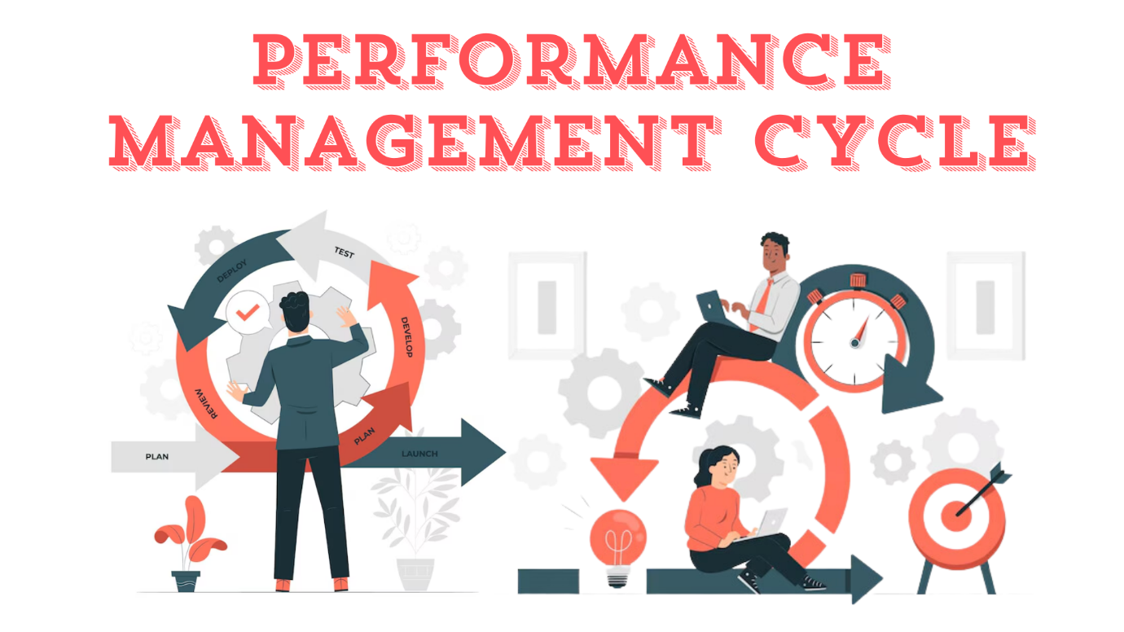

FEATURES OF PERFORMANCE MANAGEMENT

Key features include regular performance reviews, continuous feedback, employee involvement, and transparency. It promotes open communication and ensures employees actively participate in the process.
It also focuses on employee development and growth, not just evaluation.
For example, Adobe introduced a “check-in” system instead of annual appraisals, where employees receive continuous feedback and guidance.

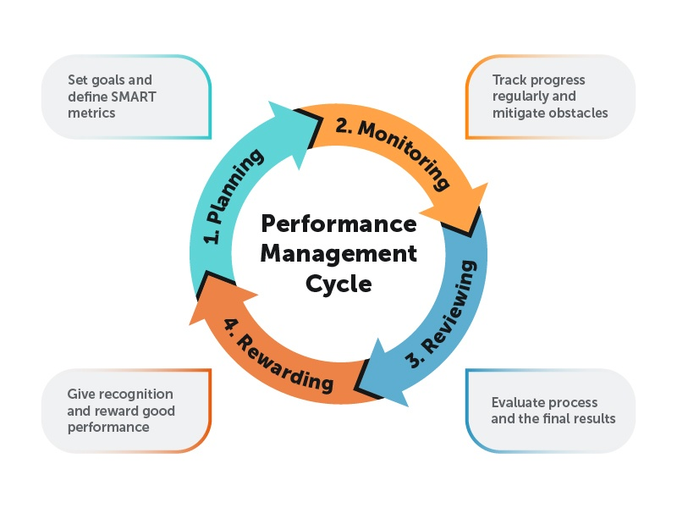

OBJECTIVES OF PERFORMANCE MANAGEMENT

The primary objective is to improve employee performance and productivity. It also aims to align individual goals with organizational goals.
Other objectives include employee development, motivation, improved communication, and better decision-making.
For example, Tata Consultancy Services uses performance management to identify training needs and develop future leaders.

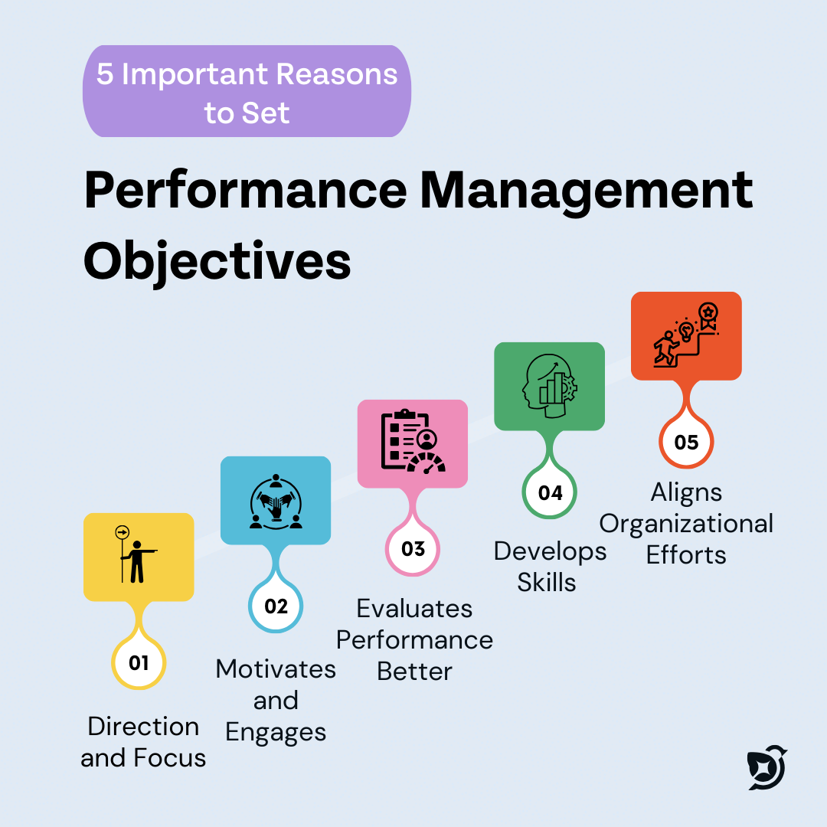

IMPORTANCE OF PERFORMANCE MANAGEMENT

Performance Management plays a vital role in enhancing organizational efficiency and effectiveness. It helps organizations achieve their strategic goals by ensuring that employees perform at their best.
It improves productivity by setting clear expectations and monitoring performance regularly. It also enhances employee motivation by recognizing achievements and providing growth opportunities.
Performance Management helps identify training and development needs, enabling employees to improve their skills. It also reduces employee turnover by increasing job satisfaction and engagement.

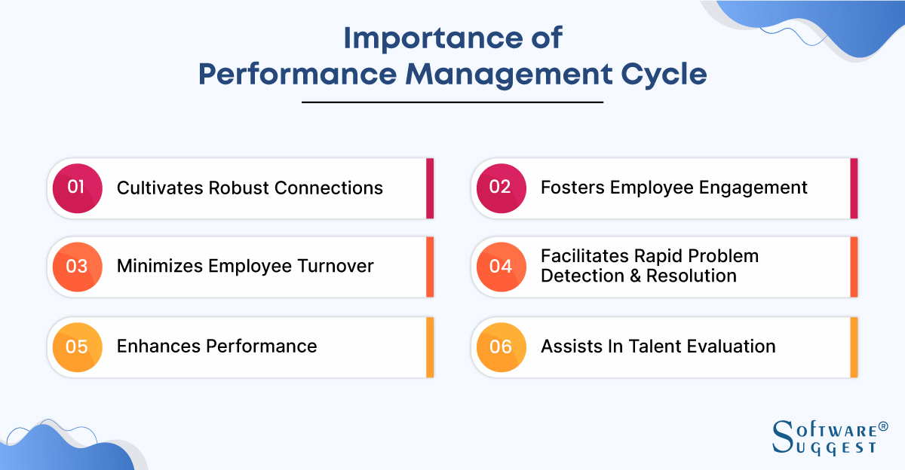
For example, Accenture uses continuous feedback and performance systems to improve employee engagement and organizational performance.

PERFORMANCE APPRAISAL – MEANING

Performance Appraisal is the systematic process of evaluating an employee’s performance over a specific period, usually annually or semi-annually. It helps in assessing how effectively employees have performed their assigned roles and responsibilities.
It is a formal method used by organizations to measure employee performance against predetermined standards. The results of performance appraisal are used for important decisions such as promotions, salary increments, training needs, and career development.
Performance appraisal not only evaluates past performance but also provides feedback to employees for future improvement. It helps identify strengths and weaknesses, enabling employees to enhance their skills and productivity. Additionally, it promotes accountability and encourages employees to perform better.
For example, companies like Wipro conduct structured performance appraisals to evaluate employee contributions and provide opportunities for growth and development.

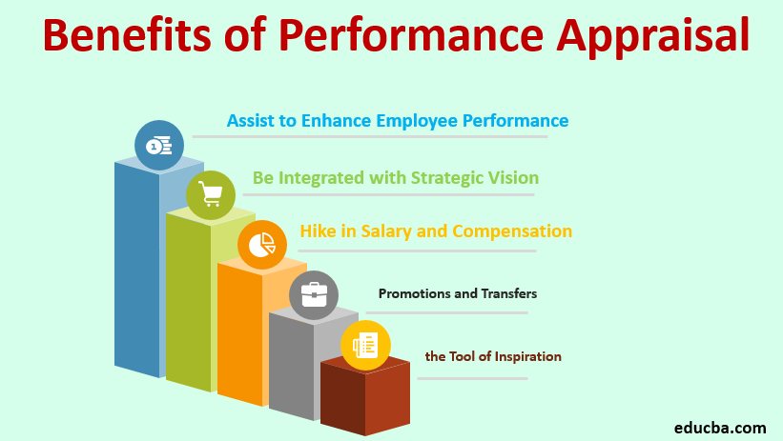

DIFFERENCE BETWEEN PERFORMANCE MANAGEMENT & PERFORMANCE APPRAISAL

Basis | Performance Management | Performance Appraisal
Meaning | Continuous process of managing and improving employee performance | Periodic evaluation of employee performance
Nature | Ongoing and continuous | Occasional (annual or semi-annual)
Focus | Development and improvement | Evaluation and assessment
Scope | Broad (includes planning, monitoring, feedback, development) | Narrow (mainly evaluation)
Objective | Improve future performance and growth | Assess past performance
Approach | Proactive and strategic | Reactive and judgmental
Time Orientation | Future-oriented | Past-oriented
Feedback | Continuous feedback | Limited feedback (during appraisal time)
Role | Involves managers and employees continuously | Mostly handled by managers during evaluation
Example | Continuous feedback system in Deloitte | Annual appraisal system in many traditional organizations

APPRAISAL PROCESS

The first step is setting performance standards, where clear and measurable goals are defined. These standards serve as a benchmark for evaluating performance.
The second step is communicating expectations to employees. It ensures that employees understand what is expected from them and how their performance will be evaluated.
The third step is measuring actual performance using various tools such as reports, observations, and performance metrics. This helps in assessing how well employees are performing their duties.
The fourth step is comparing actual performance with the set standards. This comparison helps identify gaps between expected and actual performance.
The fifth step is providing feedback to employees. Feedback should be constructive, highlighting both strengths and areas for improvement.
The final step is taking corrective actions, such as training, counseling, or rewards. This ensures continuous improvement in employee performance.
For example, IBM follows a structured appraisal process where employees are evaluated based on predefined goals and receive feedback for improvement.

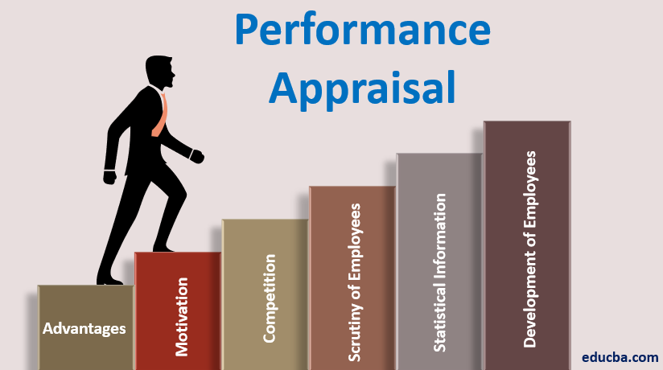
PROBLEMS IN PERFORMANCE APPRAISAL

Performance appraisal systems may face several challenges that affect their effectiveness. One of the major problems is bias and favoritism, where managers may evaluate employees based on personal preferences rather than actual performance.
Another common issue is the halo effect, where one positive trait influences the overall evaluation. Similarly, leniency or strictness bias occurs when managers rate all employees either too high or too low.
Lack of clear performance standards can also create confusion and lead to unfair evaluations. Poor communication and lack of feedback reduce the effectiveness of the appraisal process.
Additionally, employees may feel demotivated if the appraisal system is not transparent or fair. This can lead to dissatisfaction and reduced productivity.
To overcome these issues, organizations must ensure objective evaluation methods, proper training for managers, and transparent appraisal systems.

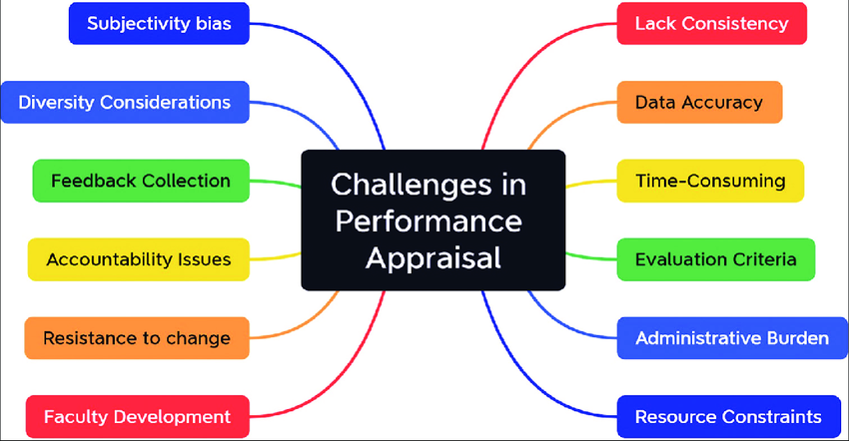

CONCLUSION

Performance Management is a critical function in modern organizations as it helps improve employee performance, enhance productivity, and achieve organizational goals. It is a continuous process that focuses on development, growth, and alignment of individual and organizational objectives.
A well-structured performance appraisal system ensures fair evaluation, identifies strengths and weaknesses, and supports employee development. It also helps organizations make informed decisions regarding promotions, rewards, and training.
In today’s dynamic and competitive environment, organizations cannot succeed without effectively managing their human resources. Performance Management not only measures performance but also creates a culture of continuous improvement and accountability.
Ultimately, organizations do not achieve success through strategies alone, but through their people and Performance Management is the bridge that transforms employee potential into organizational success.

REFERENCES

- https://www.tutorialspoint.com/human_resource_management/performance_management.htm

- https://www.managementstudyguide.com/performance-management.htm

- https://www.geeksforgeeks.org/performance-management-system/

- https://www.investopedia.com/terms/p/performance-management.asp

- https://www.aihr.com/blog/performance-management/

- https://www.keka.com/performance-management

- https://www.simplilearn.com/tutorials/hr-tutorial/performance-management

- https://corporatefinanceinstitute.com/resources/management/performance-management/

- https://www.indeed.com/career-advice/career-development/performance-management

- https://www.spiceworks.com/hr/performance-management/articles/what-is-performance-management/

- https://www.analyticsinhr.com/blog/performance-management/

- https://www.hrhelpboard.com/performance-management.htm

Thank You

