Calculator.html

<!DOCTYPE html>
<html lang="en">
<head>
<meta charset="UTF-8">
<meta name="viewport" content="width=device-width, initial-scale=1.0">
<title>ProCalc - Scientific Edition</title>
<script src="https://cdn.tailwindcss.com"></script>
<link href="https://cdnjs.cloudflare.com/ajax/libs/font-awesome/6.0.0/css/all.min.css" rel="stylesheet">
<style>
@import url('https://fonts.googleapis.com/css2?family=JetBrains+Mono:wght@400;700&family=Poppins:wght@300;400;600&display=swap');

body {
font-family: 'Poppins', sans-serif;
background: linear-gradient(135deg, #0f172a 0%, #1e293b 100%);
min-height: 100vh;
display: flex;
align-items: center;
justify-content: center;
margin: 0;
color: white;
}

.calc-container {
background: rgba(255, 255, 255, 0.05);
backdrop-filter: blur(20px);
border: 1px solid rgba(255, 255, 255, 0.1);
border-radius: 2rem;
padding: 2rem;
box-shadow: 0 25px 50px -12px rgba(0, 0, 0, 0.5);
width: 100%;
max-width: 400px;
}

.display-screen {
background: rgba(0, 0, 0, 0.2);
border-radius: 1rem;
padding: 1.5rem;
margin-bottom: 1.5rem;
text-align: right;
min-height: 100px;
display: flex;
flex-direction: column;
justify-content: flex-end;
word-wrap: break-word;
word-break: break-all;
border: 1px solid rgba(255, 255, 255, 0.05);
}

#history {
font-family: 'JetBrains Mono', monospace;
font-size: 0.875rem;
color: #94a3b8;
margin-bottom: 0.5rem;
height: 1.25rem;
}

#current-val {
font-family: 'JetBrains Mono', monospace;
font-size: 2rem;
font-weight: 700;
color: #f8fafc;
}

.btn-grid {
display: grid;
grid-template-columns: repeat(4, 1fr);
gap: 0.75rem;
}

.calc-btn {
height: 3.5rem;
border-radius: 1rem;
display: flex;
align-items: center;
justify-content: center;
font-weight: 600;
font-size: 1.125rem;
transition: all 0.2s cubic-bezier(0.4, 0, 0.2, 1);
cursor: pointer;
user-select: none;
}

.btn-num { background: rgba(255, 255, 255, 0.08); color: #e2e8f0; }
.btn-num:hover { background: rgba(255, 255, 255, 0.15); transform: translateY(-2px); }

.btn-op { background: rgba(99, 102, 241, 0.15); color: #818cf8; }
.btn-op:hover { background: rgba(99, 102, 241, 0.25); color: #a5b4fc; transform: translateY(-2px); }

.btn-sci { background: rgba(255, 255, 255, 0.03); color: #94a3b8; font-size: 0.9rem; }
.btn-sci:hover { background: rgba(255, 255, 255, 0.1); color: #cbd5e1; transform: translateY(-2px); }

.btn-clear { background: rgba(239, 68, 68, 0.15); color: #f87171; }
.btn-clear:hover { background: rgba(239, 68, 68, 0.25); transform: translateY(-2px); }

.btn-equal {
background: linear-gradient(135deg, #6366f1 0%, #4f46e5 100%);
color: white;
grid-column: span 2;
box-shadow: 0 4px 15px rgba(99, 102, 241, 0.3);
}
.btn-equal:hover { transform: translateY(-2px); box-shadow: 0 6px 20px rgba(99, 102, 241, 0.4); filter: brightness(1.1); }

.active-btn { transform: scale(0.95) !important; filter: brightness(1.2); }
</style>
</head>
<body>

<div class="calc-container">
<!-- Logo/Header -->
<div class="flex items-center justify-between mb-6 opacity-60">
<span class="text-xs font-bold tracking-widest uppercase">Scientific</span>
<i class="fas fa-microchip"></i>
</div>

<!-- Display -->
<div class="display-screen">
<div id="history"></div>
<div id="current-val">0</div>
</div>

<!-- Buttons -->
<div class="btn-grid">
<!-- Row 1: Scientific Basics -->
<div class="calc-btn btn-sci" onclick="scientific('sin')">sin</div>
<div class="calc-btn btn-sci" onclick="scientific('cos')">cos</div>
<div class="calc-btn btn-sci" onclick="scientific('tan')">tan</div>
<div class="calc-btn btn-clear" onclick="clearAll()">AC</div>

<!-- Row 2: Powers/Roots -->
<div class="calc-btn btn-sci" onclick="scientific('sqrt')">√</div>
<div class="calc-btn btn-sci" onclick="appendValue('**')">xʸ</div>
<div class="calc-btn btn-sci" onclick="scientific('log')">log</div>
<div class="calc-btn btn-op" onclick="deleteLast()"><i class="fas fa-backspace"></i></div>

<!-- Row 3: Standard -->
<div class="calc-btn btn-num" onclick="appendValue('7')">7</div>
<div class="calc-btn btn-num" onclick="appendValue('8')">8</div>
<div class="calc-btn btn-num" onclick="appendValue('9')">9</div>
<div class="calc-btn btn-op" onclick="appendValue('/')">÷</div>

<!-- Row 4 -->
<div class="calc-btn btn-num" onclick="appendValue('4')">4</div>
<div class="calc-btn btn-num" onclick="appendValue('5')">5</div>
<div class="calc-btn btn-num" onclick="appendValue('6')">6</div>
<div class="calc-btn btn-op" onclick="appendValue('*')">×</div>

<!-- Row 5 -->
<div class="calc-btn btn-num" onclick="appendValue('1')">1</div>
<div class="calc-btn btn-num" onclick="appendValue('2')">2</div>
<div class="calc-btn btn-num" onclick="appendValue('3')">3</div>
<div class="calc-btn btn-op" onclick="appendValue('-')">−</div>

<!-- Row 6 -->
<div class="calc-btn btn-num" onclick="appendValue('0')">0</div>
<div class="calc-btn btn-num" onclick="appendValue('.')">.</div>
<div class="calc-btn btn-op" onclick="appendValue('+')">+</div>
<div class="calc-btn btn-sci" onclick="scientific('pi')">π</div>

<!-- Final Row -->
<div class="calc-btn btn-sci" onclick="appendValue('(')">(</div>
<div class="calc-btn btn-sci" onclick="appendValue(')')">)</div>
<div class="calc-btn btn-equal" onclick="calculate()">=</div>
</div>
</div>

<script>
const currentDisplay = document.getElementById('current-val');
const historyDisplay = document.getElementById('history');
let currentInput = '0';
let shouldReset = false;

function updateDisplay() {
currentDisplay.innerText = currentInput;
}

function appendValue(val) {
if (currentInput === '0' || shouldReset) {
if (val === '.') {
currentInput = '0.';
} else if (['+', '-', '*', '/', '**'].includes(val)) {
currentInput += val;
} else {
currentInput = val;
}
shouldReset = false;
} else {
currentInput += val;
}
updateDisplay();
}

function clearAll() {
currentInput = '0';
historyDisplay.innerText = '';
shouldReset = false;
updateDisplay();
}

function deleteLast() {
if (currentInput.length > 1) {
currentInput = currentInput.slice(0, -1);
} else {
currentInput = '0';
}
updateDisplay();
}

function calculate() {
try {
// Pre-process for UI power display if needed, but here we use **
let expression = currentInput;
historyDisplay.innerText = expression + ' =';

// eval is safe for a local calculator with restricted input
let result = eval(expression);

// Handle floating point precision
if (!Number.isInteger(result)) {
result = parseFloat(result.toFixed(8));
}

currentInput = result.toString();
shouldReset = true;
updateDisplay();
} catch (error) {
currentInput = "Error";
updateDisplay();
setTimeout(clearAll, 1500);
}
}

function scientific(func) {
let val = parseFloat(currentInput);
let res = 0;

switch(func) {
case 'sin': res = Math.sin(val * Math.PI / 180); break;
case 'cos': res = Math.cos(val * Math.PI / 180); break;
case 'tan': res = Math.tan(val * Math.PI / 180); break;
case 'sqrt': res = Math.sqrt(val); break;
case 'log': res = Math.log10(val); break;
case 'pi':
if (currentInput === '0') currentInput = Math.PI.toString();
else currentInput += '*' + Math.PI.toFixed(8);
updateDisplay();
return;
}

if (!Number.isInteger(res)) res = parseFloat(res.toFixed(8));
currentInput = res.toString();
shouldReset = true;
updateDisplay();
}

// Add keyboard support
window.addEventListener('keydown', (e) => {
if (e.key >= '0' && e.key <= '9') appendValue(e.key);
if (e.key === '.') appendValue('.');
if (e.key === '+') appendValue('+');
if (e.key === '-') appendValue('-');
if (e.key === '*') appendValue('*');
if (e.key === '/') appendValue('/');
if (e.key === 'Enter') calculate();
if (e.key === 'Backspace') deleteLast();
if (e.key === 'Escape') clearAll();
});
</script>
</body>
</html>

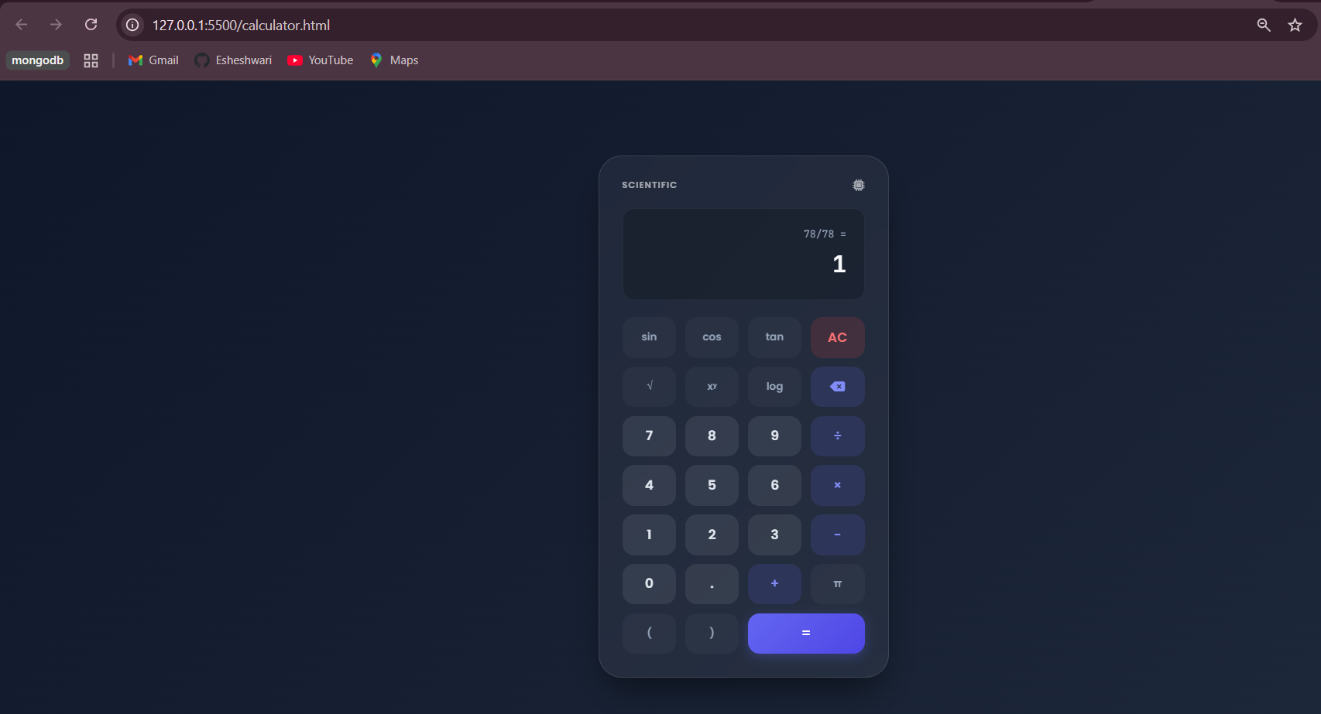

Metrofare.html
<!DOCTYPE html>
<html lang="en">
<head>
<meta charset="UTF-8">
<meta name="viewport" content="width=device-width, initial-scale=1.0">
<title>MetroPass - Smart Fare Calculator</title>
<script src="https://cdn.tailwindcss.com"></script>
<link href="https://cdnjs.cloudflare.com/ajax/libs/font-awesome/6.0.0/css/all.min.css" rel="stylesheet">
<style>
@import url('https://fonts.googleapis.com/css2?family=Inter:wght@300;400;500;600;700&display=swap');

body {
font-family: 'Inter', sans-serif;
background: #f0f2f5;
min-height: 100vh;
display: flex;
align-items: center;
justify-content: center;
padding: 20px;
}

.card {
background: white;
border-radius: 24px;
box-shadow: 0 10px 40px rgba(0, 0, 0, 0.08);
width: 100%;
max-width: 450px;
overflow: hidden;
}

.header {
background: linear-gradient(135deg, #2563eb 0%, #1e40af 100%);
padding: 40px 30px;
text-align: center;
color: white;
}

.input-group {
margin-bottom: 20px;
}

.gender-btn {
transition: all 0.3s cubic-bezier(0.4, 0, 0.2, 1);
border: 2px solid #e5e7eb;
}

.gender-btn.active {
border-color: #2563eb;
background-color: #eff6ff;
color: #2563eb;
}

.result-box {
background: #f8fafc;
border-radius: 16px;
padding: 24px;
margin-top: 24px;
border: 1px dashed #cbd5e1;
display: none;
}

.rules-box {
background: #fefce8;
border: 1px solid #fef08a;
border-radius: 16px;
padding: 16px;
margin-bottom: 24px;
}

.animate-pop {
animation: pop 0.4s ease-out forwards;
}

@keyframes pop {
0% { transform: scale(0.95); opacity: 0; }
100% { transform: scale(1); opacity: 1; }
}

.fare-badge {
display: inline-block;
padding: 4px 12px;
border-radius: 999px;
font-size: 0.75rem;
font-weight: 600;
margin-top: 8px;
}
</style>
</head>
<body>

<div class="card">
<div class="header">
<div class="flex justify-center mb-4">
<div class="bg-white/20 p-3 rounded-full">
<i class="fas fa-subway text-3xl"></i>
</div>
</div>
<h1 class="text-2xl font-bold">MetroPass</h1>
<p class="opacity-80 text-sm">Automated Fare Calculator</p>
</div>

<div class="p-8">
<!-- Fare Rules Info Box -->
<div class="rules-box mb-6">
<h3 class="text-xs font-bold text-yellow-800 uppercase tracking-wider mb-2 flex items-center gap-2">
<i class="fas fa-tag"></i> Discount Rules
</h3>
<ul class="text-[13px] text-yellow-900 space-y-1 opacity-90">
<li>• <strong>Females:</strong> 50% Off</li>
<li>• <strong>Under 5 Years:</strong> FREE</li>
<li>• <strong>Up to 8 Years:</strong> 50% Off (Half Ticket)</li>
<li>• <strong>Over 65 Years:</strong> Pay only 30% (70% Off)</li>
<li class="pt-1 text-[11px] italic text-yellow-700 underline">Max discount applies for multiple categories.</li>
</ul>
</div>

<!-- Base Fare Input -->
<div class="input-group">
<label class="block text-sm font-semibold text-gray-700 mb-2">Standard Ticket Fare ($)</label>
<div class="relative">
<span class="absolute left-4 top-1/2 -translate-y-1/2 text-gray-400">$</span>
<input type="number" id="baseFare" placeholder="Enter amount"
class="w-full pl-8 pr-4 py-3 bg-gray-50 border border-gray-200 rounded-xl focus:ring-2 focus:ring-blue-500 focus:outline-none transition" value="10">
</div>
</div>

<!-- Gender Selection -->
<div class="input-group">
<label class="block text-sm font-semibold text-gray-700 mb-2">Select Gender</label>
<div class="grid grid-cols-2 gap-4">
<button onclick="setGender('male')" id="btn-male" class="gender-btn flex items-center justify-center gap-2 py-3 rounded-xl font-medium text-gray-600">
<i class="fas fa-mars"></i> Male
</button>
<button onclick="setGender('female')" id="btn-female" class="gender-btn flex items-center justify-center gap-2 py-3 rounded-xl font-medium text-gray-600">
<i class="fas fa-venus"></i> Female
</button>
</div>
</div>

<!-- Age Input -->
<div class="input-group">
<label class="block text-sm font-semibold text-gray-700 mb-2">Passenger Age</label>
<input type="number" id="age" placeholder="e.g. 25"
class="w-full px-4 py-3 bg-gray-50 border border-gray-200 rounded-xl focus:ring-2 focus:ring-blue-500 focus:outline-none transition">
</div>

<!-- Action Button -->
<button onclick="calculateFare()" class="w-full bg-blue-600 hover:bg-blue-700 text-white font-bold py-4 rounded-xl shadow-lg shadow-blue-200 transition transform active:scale-[0.98]">
Calculate Fare
</button>

<!-- Result Area -->
<div id="resultArea" class="result-box animate-pop">
<div class="flex justify-between items-start">
<div>
<p class="text-sm text-gray-500 font-medium">Final Ticket Price</p>
<h2 id="finalPrice" class="text-4xl font-bold text-gray-900 mt-1">$0.00</h2>
<div id="appliedDiscount" class="fare-badge bg-green-100 text-green-700"></div>
</div>
<div class="text-right">
<p class="text-xs text-gray-400 uppercase tracking-wider font-bold">Status</p>
<p id="ticketStatus" class="font-semibold text-blue-600">Valid Entry</p>
</div>
</div>

<hr class="my-4 border-gray-200">

<div class="flex items-center text-xs text-gray-500 gap-2">
<i class="fas fa-info-circle"></i>
<span>Best possible discount applied automatically.</span>
</div>
</div>
</div>
</div>

<script>
let selectedGender = null;

function setGender(gender) {
selectedGender = gender;
document.getElementById('btn-male').classList.remove('active');
document.getElementById('btn-female').classList.remove('active');
document.getElementById('btn-' + gender).classList.add('active');
}

function calculateFare() {
const baseFare = parseFloat(document.getElementById('baseFare').value);
const age = parseInt(document.getElementById('age').value);
const resultArea = document.getElementById('resultArea');
const finalPriceEl = document.getElementById('finalPrice');
const discountEl = document.getElementById('appliedDiscount');
const statusEl = document.getElementById('ticketStatus');

// Validation
if (isNaN(baseFare) || baseFare <= 0) {
alert("Please enter a valid ticket fare.");
return;
}
if (isNaN(age) || age < 0) {
alert("Please enter a valid age.");
return;
}
if (!selectedGender) {
alert("Please select a gender.");
return;
}

let discounts = []; // Store decimal multipliers (0.5 means 50% discount)

// Rule 1: Females get 50% off
if (selectedGender === 'female') {
discounts.push(0.50);
}

// Rule 2: Kids under 5 are free (100% off)
if (age < 5) {
discounts.push(1.00);
}
// Rule 3: Kids up to 8 have half ticket (50% off)
else if (age <= 8) {
discounts.push(0.50);
}

// Rule 4: Over 65 pay only 30% (meaning 70% off)
if (age > 65) {
discounts.push(0.70);
}

// Case for no discounts
if (discounts.length === 0) {
discounts.push(0);
}

// Max discount will apply
const maxDiscount = Math.max(...discounts);
const finalPrice = baseFare * (1 - maxDiscount);

// UI Update
resultArea.style.display = 'block';
finalPriceEl.innerText = `$${finalPrice.toFixed(2)}`;

if (maxDiscount === 1) {
discountEl.innerText = "FREE ENTRY (100% OFF)";
discountEl.className = "fare-badge bg-blue-100 text-blue-700";
statusEl.innerText = "Complimentary";
} else if (maxDiscount > 0) {
discountEl.innerText = `${(maxDiscount * 100).toFixed(0)}% DISCOUNT APPLIED`;
discountEl.className = "fare-badge bg-green-100 text-green-700";
statusEl.innerText = "Discounted Pass";
} else {
discountEl.innerText = "STANDARD FARE";
discountEl.className = "fare-badge bg-gray-100 text-gray-700";
statusEl.innerText = "Regular Pass";
}
}
</script>
</body>
</html>
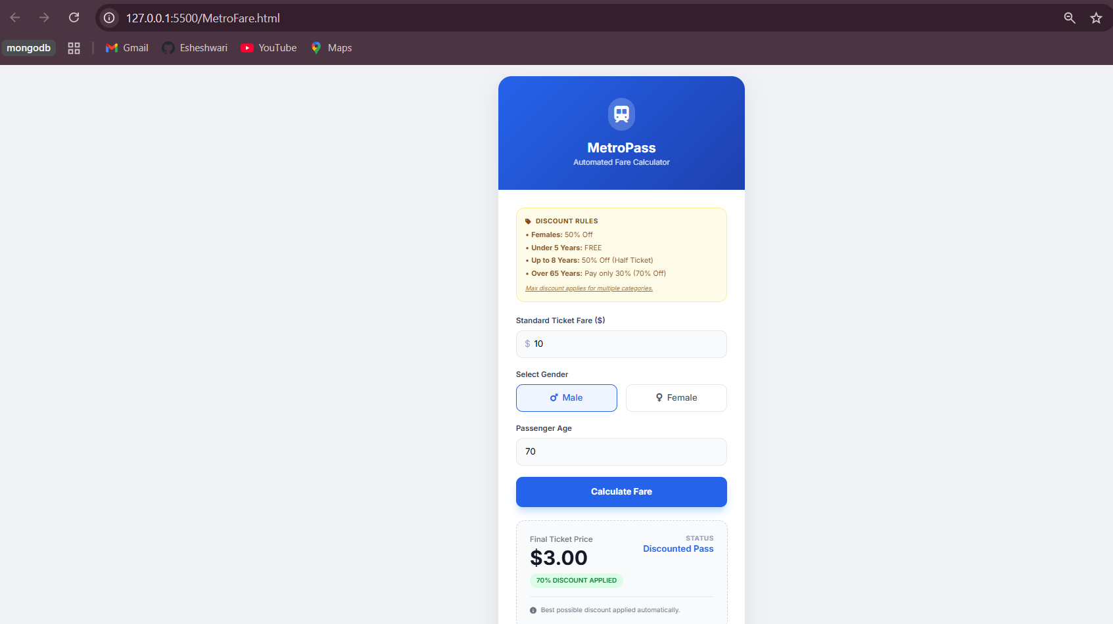
Shopping.html
<!DOCTYPE html>
<html lang="en">
<head>
<meta charset="UTF-8">
<meta name="viewport" content="width=device-width, initial-scale=1.0">
<title>ShopSmart - 1+1 Deals & More</title>
<script src="https://cdn.tailwindcss.com"></script>
<link href="https://cdnjs.cloudflare.com/ajax/libs/font-awesome/6.0.0/css/all.min.css" rel="stylesheet">
<style>
@import url('https://fonts.googleapis.com/css2?family=Poppins:wght@300;400;600;700&display=swap');

body {
font-family: 'Poppins', sans-serif;
background-color: #f3f4f6;
}

.product-card {
transition: transform 0.3s ease, box-shadow 0.3s ease;
}

.product-card:hover {
transform: translateY(-5px);
box-shadow: 0 10px 20px rgba(0,0,0,0.1);
}

/* Toast Animation */
@keyframes slideIn {
from { transform: translateX(100%); opacity: 0; }
to { transform: translateX(0); opacity: 1; }
}

.toast {
animation: slideIn 0.5s ease forwards;
}

.badge-sale {
background: linear-gradient(45deg, #ff416c, #ff4b2b);
}

/* Side Drawer Transition */
.drawer-transition {
transition: transform 0.3s ease-in-out;
}

.overlay {
background: rgba(0, 0, 0, 0.5);
backdrop-filter: blur(4px);
transition: opacity 0.3s ease;
}
</style>
</head>
<body class="flex flex-col min-h-screen relative overflow-x-hidden">

<!-- Navigation -->
<nav class="bg-white shadow-md sticky top-0 z-50">
<div class="container mx-auto px-4 py-3 flex justify-between items-center">
<div class="flex items-center space-x-2">
<i class="fas fa-shopping-bag text-indigo-600 text-2xl"></i>
<h1 class="text-xl font-bold text-gray-800 tracking-wide">ShopSmart</h1>
</div>

<div class="flex items-center space-x-6">
<!-- Wishlist Icon -->
<div class="relative cursor-pointer hover:text-indigo-600 transition" onclick="toggleWishlistModal(true)">
<i class="fas fa-heart text-xl text-gray-600"></i>
<span id="wishlist-count" class="absolute -top-2 -right-2 bg-pink-500 text-white text-xs font-bold w-5 h-5 flex items-center justify-center rounded-full">0</span>
</div>

<!-- Cart Icon -->
<div class="relative cursor-pointer hover:text-indigo-600 transition" onclick="toggleCartDrawer(true)">
<i class="fas fa-shopping-cart text-xl text-gray-600"></i>
<span id="cart-count" class="absolute -top-2 -right-2 bg-indigo-600 text-white text-xs font-bold w-5 h-5 flex items-center justify-center rounded-full">0</span>
</div>
</div>
</div>
</nav>

<!-- Main Content -->
<main class="container mx-auto px-4 py-8 flex-grow">

<!-- Header -->
<div class="mb-8 text-center">
<h2 class="text-3xl font-bold text-gray-800">Featured Collections</h2>
<p class="text-gray-500 mt-2">Grab the best 1+1 Deals on Food & Fashion</p>
</div>

<!-- Product Grid -->
<div id="product-grid" class="grid grid-cols-1 sm:grid-cols-2 lg:grid-cols-3 xl:grid-cols-4 gap-6">
<!-- Products will be injected here by JS -->
</div>

</main>

<!-- Footer -->
<footer class="bg-gray-800 text-white py-6 mt-auto">
<div class="container mx-auto text-center">
<p>&copy; 2024 ShopSmart. All specific buttons included.</p>
</div>
</footer>

<!-- CART SIDE DRAWER -->
<div id="cart-drawer-overlay" class="fixed inset-0 z-[60] overlay hidden opacity-0" onclick="toggleCartDrawer(false)"></div>
<div id="cart-drawer" class="fixed right-0 top-0 h-full w-full max-w-md bg-white z-[70] shadow-2xl drawer-transition translate-x-full flex flex-col">
<div class="p-6 border-b flex justify-between items-center bg-gray-50">
<h2 class="text-xl font-bold text-gray-800 flex items-center gap-2">
<i class="fas fa-shopping-cart text-indigo-600"></i> Your Bag
</h2>
<button onclick="toggleCartDrawer(false)" class="text-gray-400 hover:text-gray-600 p-2">
<i class="fas fa-times text-xl"></i>
</button>
</div>

<div id="cart-items-container" class="flex-grow overflow-y-auto p-6 space-y-4">
<!-- Cart items injected here -->
</div>

<div class="p-6 border-t bg-gray-50 space-y-4">
<div class="flex justify-between items-center text-lg font-bold">
<span>Total Amount:</span>
<span id="cart-total" class="text-indigo-600">$0.00</span>
</div>
<button onclick="checkout()" class="w-full bg-indigo-600 hover:bg-indigo-700 text-white py-4 rounded-xl font-bold shadow-lg transition transform active:scale-95 flex items-center justify-center gap-2">
Checkout Now <i class="fas fa-arrow-right"></i>
</button>
</div>
</div>

<!-- WISHLIST MODAL -->
<div id="wishlist-modal" class="fixed inset-0 z-[80] flex items-center justify-center hidden">
<div class="absolute inset-0 overlay" onclick="toggleWishlistModal(false)"></div>
<div class="bg-white rounded-3xl w-full max-w-lg mx-4 z-[90] shadow-2xl overflow-hidden animate-pop">
<div class="p-6 border-b flex justify-between items-center bg-pink-50">
<h2 class="text-xl font-bold text-pink-600 flex items-center gap-2">
<i class="fas fa-heart"></i> My Wishlist
</h2>
<button onclick="toggleWishlistModal(false)" class="text-gray-400 hover:text-gray-600">
<i class="fas fa-times text-xl"></i>
</button>
</div>
<div id="wishlist-container" class="max-h-[60vh] overflow-y-auto p-6 space-y-4">
<!-- Wishlist items injected here -->
</div>
<div class="p-6 border-t text-center">
<button onclick="toggleWishlistModal(false)" class="text-gray-600 font-medium hover:underline text-sm">Continue Shopping</button>
</div>
</div>
</div>

<!-- Toast Notification Container -->
<div id="toast-container" class="fixed top-20 right-5 z-[100] flex flex-col space-y-2 pointer-events-none"></div>

<!-- Javascript Logic -->
<script>
// --- Data ---
const products = [
{ id: 1, name: "Premium Burger Meal", category: "Food", price: 12.99, image: "https://images.unsplash.com/photo-1568901346375-23c9450c58cd?auto=format&fit=crop&w=500&q=80" },
{ id: 2, name: "Urban Denim Jacket", category: "Clothes", price: 49.99, image: "https://images.unsplash.com/photo-1523205565295-f8e91625443b?auto=format&fit=crop&w=500&q=80" },
{ id: 3, name: "Classic Sneakers", category: "Clothes", price: 79.99, image: "https://images.unsplash.com/photo-1549298916-b41d501d3772?auto=format&fit=crop&w=500&q=80" },
{ id: 4, name: "Fresh Organic Salad", category: "Food", price: 9.99, image: "https://images.unsplash.com/photo-1512621776951-a57141f2eefd?auto=format&fit=crop&w=500&q=80" },
{ id: 5, name: "Leather Handbag", category: "Accessories", price: 120.00, image: "https://images.unsplash.com/photo-1584917865442-de89df76afd3?auto=format&fit=crop&w=500&q=80" },
{ id: 6, name: "Pepperoni Pizza", category: "Food", price: 15.99, image: "https://images.unsplash.com/photo-1565299624946-b28f40a0ae38?auto=format&fit=crop&w=500&q=80" }
];

// --- State ---
let cart = {};
let wishlist = new Set();

// --- Core UI Functions ---
function renderProducts() {
const grid = document.getElementById('product-grid');
grid.innerHTML = products.map(product => {
const qty = cart[product.id] || 0;
return `
<div class="product-card bg-white rounded-xl shadow-sm overflow-hidden flex flex-col h-full border border-gray-100">
<div class="relative h-48 overflow-hidden">
<img src="${product.image}" alt="${product.name}" class="w-full h-full object-cover">
<span class="absolute top-2 left-2 bg-indigo-600 text-white text-xs font-bold px-2 py-1 rounded">
${product.category}
</span>
${qty > 0 ? `<span class="absolute top-2 right-2 bg-green-500 text-white text-xs font-bold px-2 py-1 rounded-full shadow-md">${qty} in Bag</span>` : ''}
</div>

<div class="p-4 flex-grow flex flex-col">
<h3 class="font-bold text-gray-800 text-lg mb-1">${product.name}</h3>
<p class="text-gray-600 font-semibold mb-4">$${product.price.toFixed(2)}</p>

<div class="mt-auto space-y-2">
<div class="flex items-center justify-between gap-2">
<button onclick="removeFromCart(${product.id})"
class="w-10 h-10 flex items-center justify-center rounded-lg bg-red-100 text-red-600 hover:bg-red-200 font-bold transition">
<i class="fas fa-minus"></i>
</button>
<button onclick="addToBag(${product.id})"
class="flex-grow h-10 bg-gray-900 text-white rounded-lg hover:bg-gray-800 transition font-medium text-sm flex items-center justify-center gap-2">
<i class="fas fa-shopping-bag"></i> Add
</button>
<button onclick="addToBag(${product.id})"
class="w-10 h-10 flex items-center justify-center rounded-lg bg-green-100 text-green-600 hover:bg-green-200 font-bold transition">
<i class="fas fa-plus"></i>
</button>
</div>
<div class="flex gap-2">
<button onclick="toggleWishlist(${product.id})"
class="flex-1 h-9 rounded-lg border border-gray-200 text-gray-600 hover:bg-gray-50 hover:text-pink-500 transition flex items-center justify-center gap-1 text-xs font-semibold ${wishlist.has(product.id) ? 'text-pink-500 border-pink-200 bg-pink-50' : ''}">
<i class="${wishlist.has(product.id) ? 'fas' : 'far'} fa-heart"></i> Wishlist
</button>
<button onclick="addOnePlusOne(${product.id})"
class="flex-1 h-9 rounded-lg badge-sale text-white hover:opacity-90 transition flex items-center justify-center gap-1 text-xs font-bold shadow-sm">
<i class="fas fa-tags"></i> 1+1 Sale
</button>
</div>
</div>
</div>
</div>
`;
}).join('');
}

function renderCartItems() {
const container = document.getElementById('cart-items-container');
const cartItems = Object.entries(cart).map(([id, qty]) => products.find(p => p.id == id));

if (cartItems.length === 0) {
container.innerHTML = `
<div class="h-full flex flex-col items-center justify-center text-center py-12">
<i class="fas fa-shopping-basket text-5xl text-gray-200 mb-4"></i>
<p class="text-gray-500 font-medium">Your bag is empty.</p>
<p class="text-gray-400 text-sm">Add some items to get started!</p>
</div>`;
document.getElementById('cart-total').innerText = "$0.00";
return;
}

let total = 0;
container.innerHTML = cartItems.map(p => {
const qty = cart[p.id];
const subtotal = p.price * qty;
total += subtotal;
return `
<div class="flex items-center gap-4 bg-gray-50 p-4 rounded-xl border border-gray-100 group">
<img src="${p.image}" class="w-16 h-16 object-cover rounded-lg shadow-sm" alt="${p.name}">
<div class="flex-grow">
<h4 class="font-bold text-gray-800 text-sm">${p.name}</h4>
<p class="text-gray-500 text-xs">$${p.price.toFixed(2)} x ${qty}</p>
<p class="text-indigo-600 font-bold text-sm">$${subtotal.toFixed(2)}</p>
</div>
<div class="flex flex-col gap-1">
<button onclick="addToBag(${p.id})" class="p-1 hover:text-indigo-600"><i class="fas fa-plus-circle"></i></button>
<button onclick="removeFromCart(${p.id})" class="p-1 hover:text-red-500"><i class="fas fa-minus-circle"></i></button>
</div>
</div>
`;
}).join('');
document.getElementById('cart-total').innerText = `$${total.toFixed(2)}`;
}

function renderWishlistItems() {
const container = document.getElementById('wishlist-container');
const wishlistItems = Array.from(wishlist).map(id => products.find(p => p.id == id));

if (wishlistItems.length === 0) {
container.innerHTML = `
<div class="py-12 text-center">
<i class="far fa-heart text-5xl text-gray-200 mb-4"></i>
<p class="text-gray-400">Your wishlist is lonely.</p>
</div>`;
return;
}

container.innerHTML = wishlistItems.map(p => `
<div class="flex items-center justify-between gap-4 p-3 bg-gray-50 rounded-xl border border-gray-100">
<div class="flex items-center gap-4">
<img src="${p.image}" class="w-12 h-12 object-cover rounded-lg shadow-sm">
<div>
<p class="font-bold text-gray-800 text-sm">${p.name}</p>
<p class="text-gray-500 text-xs">$${p.price.toFixed(2)}</p>
</div>
</div>
<div class="flex gap-2">
<button onclick="addToBag(${p.id}); toggleWishlistModal(false)" class="bg-indigo-600 text-white px-3 py-1.5 rounded-lg text-xs font-bold hover:bg-indigo-700">Add to Bag</button>
<button onclick="toggleWishlist(${p.id})" class="text-red-400 hover:text-red-600 p-2"><i class="fas fa-trash-alt"></i></button>
</div>
</div>
`).join('');
}

// --- Interactive Functions ---
function toggleCartDrawer(open) {
const drawer = document.getElementById('cart-drawer');
const overlay = document.getElementById('cart-drawer-overlay');
if (open) {
renderCartItems();
drawer.classList.remove('translate-x-full');
overlay.classList.remove('hidden');
setTimeout(() => overlay.classList.add('opacity-100'), 10);
} else {
drawer.classList.add('translate-x-full');
overlay.classList.remove('opacity-100');
setTimeout(() => overlay.classList.add('hidden'), 300);
}
}

function toggleWishlistModal(open) {
const modal = document.getElementById('wishlist-modal');
if (open) {
renderWishlistItems();
modal.classList.remove('hidden');
} else {
modal.classList.add('hidden');
}
}

function updateCartCount() {
const totalItems = Object.values(cart).reduce((a, b) => a + b, 0);
document.getElementById('cart-count').innerText = totalItems;
renderProducts();
if (!document.getElementById('cart-drawer').classList.contains('translate-x-full')) {
renderCartItems();
}
}

function addToBag(id) {
cart[id] = (cart[id] || 0) + 1;
updateCartCount();
const product = products.find(p => p.id === id);
showToast(`Added ${product.name} to bag!`, "success");
}

function addOnePlusOne(id) {
cart[id] = (cart[id] || 0) + 2;
updateCartCount();
const product = products.find(p => p.id === id);
showToast(`1+1 Applied: Added 2x ${product.name}`, "sale");
}

function removeFromCart(id) {
if (!cart[id]) return;
cart[id]--;
if (cart[id] === 0) delete cart[id];
updateCartCount();
showToast("Bag updated.", "info");
}

function toggleWishlist(id) {
const product = products.find(p => p.id === id);
if (wishlist.has(id)) {
wishlist.delete(id);
showToast(`Removed from wishlist`, "info");
} else {
wishlist.add(id);
showToast(`Saved to wishlist`, "love");
}
document.getElementById('wishlist-count').innerText = wishlist.size;
renderProducts();
renderWishlistItems();
}

function checkout() {
const totalItems = Object.values(cart).reduce((a, b) => a + b, 0);
if (totalItems === 0) {
showToast("Please add items to checkout.", "error");
return;
}
const total = document.getElementById('cart-total').innerText;

// Custom checkout summary instead of alert
const container = document.getElementById('cart-items-container');
container.innerHTML = `
<div class="h-full flex flex-col items-center justify-center text-center p-6 animate-pop">
<div class="bg-green-100 text-green-600 w-20 h-20 rounded-full flex items-center justify-center text-4xl mb-6">
<i class="fas fa-check"></i>
</div>
<h2 class="text-2xl font-bold text-gray-800 mb-2">Order Placed!</h2>
<p class="text-gray-500 mb-6">Your payment of <span class="font-bold text-indigo-600">${total}</span> has been processed successfully.</p>
<button onclick="clearCart(); toggleCartDrawer(false)" class="bg-gray-800 text-white px-8 py-3 rounded-xl font-bold">Done</button>
</div>
`;
// Hide footer of drawer during success
document.querySelector('#cart-drawer .border-t').style.display = 'none';
}

function clearCart() {
cart = {};
updateCartCount();
// Restore drawer footer
document.querySelector('#cart-drawer .border-t').style.display = 'block';
}

function showToast(message, type) {
const container = document.getElementById('toast-container');
const toast = document.createElement('div');
let bgClass = "bg-gray-800";
let icon = "fa-info-circle";
if (type === "success") { bgClass = "bg-green-600"; icon = "fa-check-circle"; }
if (type === "error") { bgClass = "bg-red-500"; icon = "fa-exclamation-circle"; }
if (type === "sale") { bgClass = "badge-sale"; icon = "fa-bolt"; }
if (type === "love") { bgClass = "bg-pink-500"; icon = "fa-heart"; }
toast.className = `toast ${bgClass} text-white px-6 py-3 rounded-lg shadow-lg flex items-center gap-3 transform transition-all mb-2`;
toast.innerHTML = `<i class="fas ${icon}"></i> <span class="font-medium text-sm">${message}</span>`;
container.appendChild(toast);
setTimeout(() => {
toast.style.opacity = '0';
toast.style.transform = 'translateY(-20px)';
setTimeout(() => toast.remove(), 300);
}, 3000);
}

renderProducts();
</script>
</body>
</html>
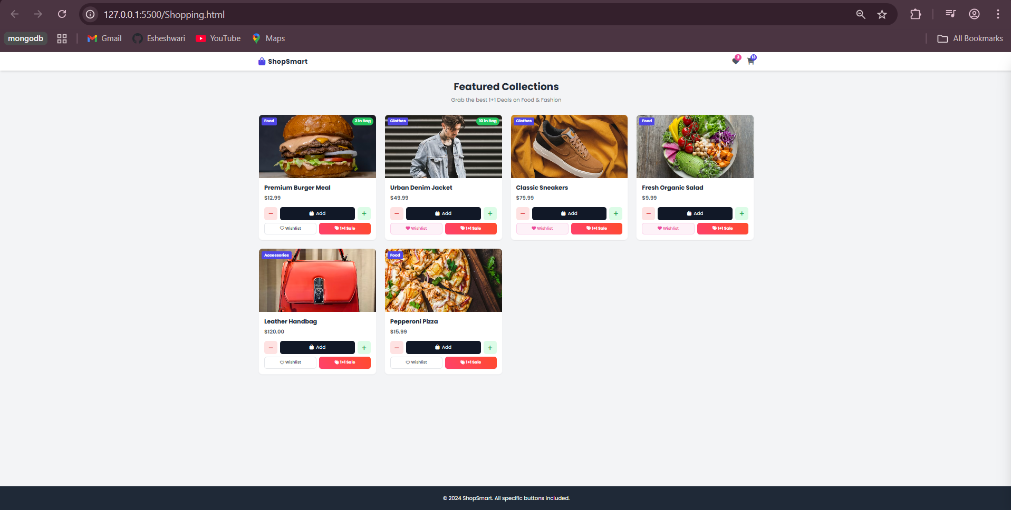
Question1.html
<!-- At a restaurant you ate: 1 Dal ₹ 100, 2 Roti ₹10
each, 1 Ice Cream ₹30, calculate and display the
final bill amount. -->

<!DOCTYPE html>
<html lang="en">
<head>
<meta charset="UTF-8" />
<meta name="viewport" content="width=device-width, initial-scale=1.0" />
<title>Restaurant Bill</title>
<style>
body {
font-family: Arial, sans-serif;
background: #f5f7fa;
display: flex;
justify-content: center;
align-items: center;
min-height: 100vh;
}
.card {
background: #fff;
padding: 24px;
width: 380px;
border-radius: 12px;
box-shadow: 0 10px 25px rgba(0,0,0,0.1);
}
h1 {
text-align: center;
margin-bottom: 16px;
}
.menu-item {
display: flex;
justify-content: space-between;
align-items: center;
margin-bottom: 12px;
}
.menu-item button {
padding: 6px 10px;
border: none;
background: #2563eb;
color: #fff;
border-radius: 6px;
cursor: pointer;
}
.menu-item button:hover {
background: #1d4ed8;
}
.bill {
margin-top: 20px;
border-top: 1px solid #e5e7eb;
padding-top: 12px;
}
.bill p {
display: flex;
justify-content: space-between;
margin: 6px 0;
}
.total {
font-weight: bold;
font-size: 18px;
}
.checkout {
margin-top: 16px;
width: 100%;
padding: 10px;
background: #16a34a;
color: #fff;
border: none;
border-radius: 8px;
font-size: 16px;
cursor: pointer;
}
.checkout:hover {
background: #15803d;
}
</style>
</head>
<body>
<div class="card">
<h1>Restaurant Menu</h1>

<div class="menu-item">
<span>Dal – ₹100</span>
<button onclick="addItem('Dal', 100)">Add</button>
</div>

<div class="menu-item">
<span>Roti – ₹10</span>
<button onclick="addItem('Roti', 10)">Add</button>
</div>

<div class="menu-item">
<span>Ice Cream – ₹30</span>
<button onclick="addItem('Ice Cream', 30)">Add</button>
</div>

<div class="bill" id="bill">
<h3>Bill Details</h3>
<div id="billItems"></div>
<p class="total"><span>Total</span><span>₹ <span id="total">0</span></span></p>
</div>

<button class="checkout" onclick="checkout()">Checkout</button>
</div>

<script>
const items = {};
let total = 0;

function addItem(name, price) {
if (!items[name]) {
items[name] = { price, qty: 1 };
} else {
items[name].qty += 1;
}
total += price;
renderBill();
}

function renderBill() {
const billItems = document.getElementById('billItems');
billItems.innerHTML = '';

for (let item in items) {
const p = document.createElement('p');
p.innerHTML = `<span>${item} x ${items[item].qty}</span><span>₹ ${items[item].price * items[item].qty}</span>`;
billItems.appendChild(p);
}

document.getElementById('total').innerText = total;
}

function checkout() {
if (total === 0) {
alert('Please add items to the cart first!');
} else {
alert(`Thank you! Your final bill amount is ₹${total}`);
}
}
</script>
</body>
</html>
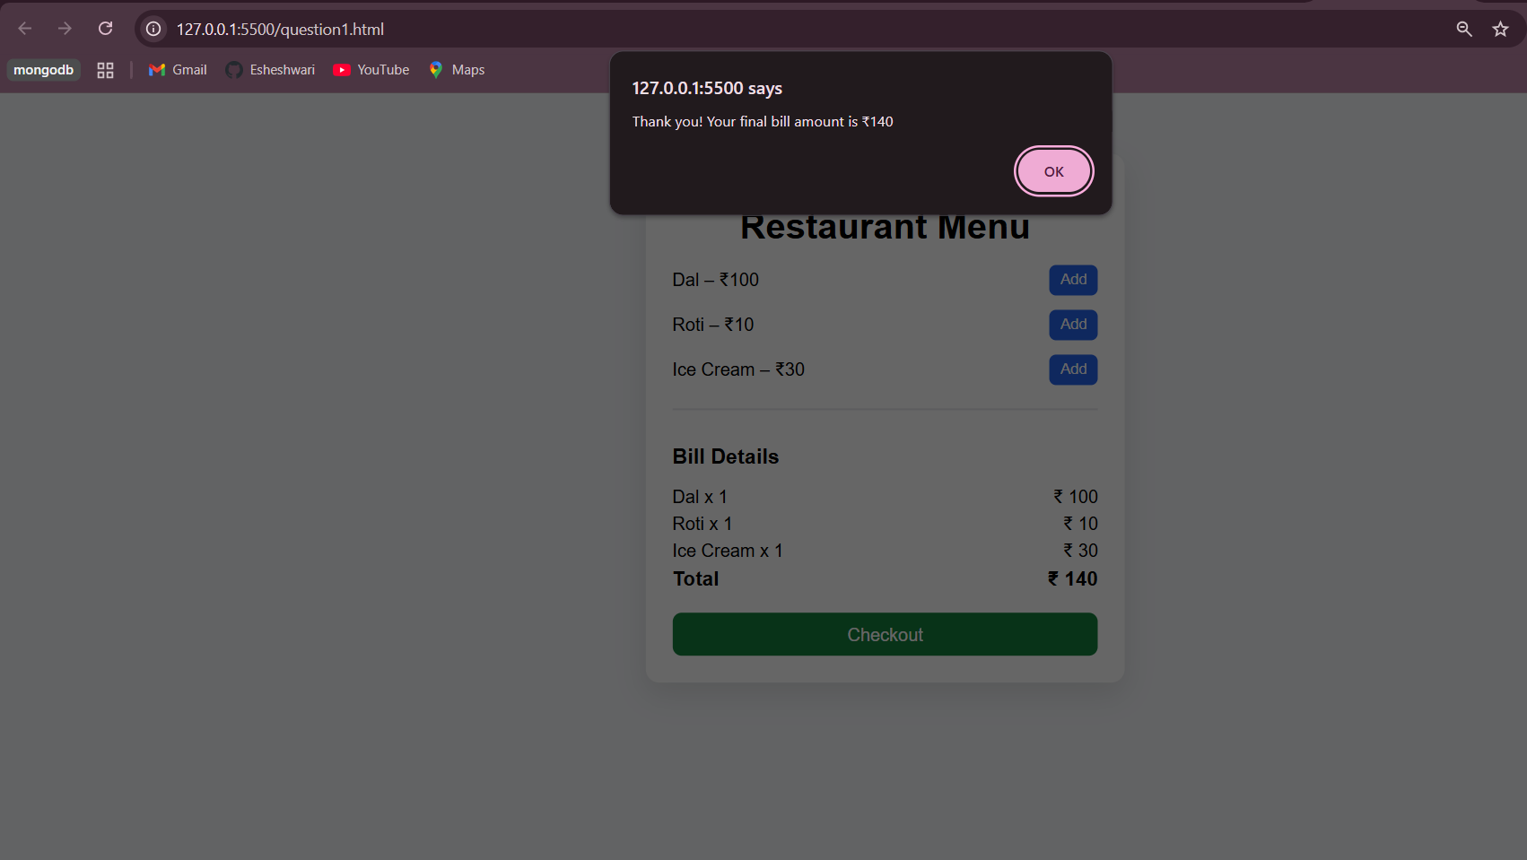
Question2.html
<!-- Calculate 18% GST on iPhone15 ₹79,990 and 2
Air pods Pro ₹24990 each. -->

<!DOCTYPE html>
<html lang="en">
<head>
<meta charset="UTF-8" />
<meta name="viewport" content="width=device-width, initial-scale=1.0" />
<title>GST Billing</title>
<style>
body {
font-family: Arial, sans-serif;
background: #f0f2f5;
display: flex;
justify-content: center;
align-items: center;
min-height: 100vh;
}
.card {
background: #fff;
padding: 24px;
width: 400px;
border-radius: 12px;
box-shadow: 0 10px 25px rgba(0,0,0,0.1);
}
h1 {
text-align: center;
margin-bottom: 16px;
}
.item {
display: flex;
justify-content: space-between;
align-items: center;
margin-bottom: 12px;
}
button {
padding: 6px 10px;
border: none;
background: #2563eb;
color: #fff;
border-radius: 6px;
cursor: pointer;
}
button:hover {
background: #1d4ed8;
}
.bill {
margin-top: 20px;
border-top: 1px solid #e5e7eb;
padding-top: 12px;
}
.bill p {
display: flex;
justify-content: space-between;
margin: 6px 0;
}
.total {
font-weight: bold;
font-size: 18px;
}
</style>
</head>
<body>
<div class="card">
<h1>Apple Store Billing</h1>

<div class="item">
<span>iPhone 15 – ₹79,990</span>
<div>
<button onclick="addItem('iPhone 15', 79990)">Add</button>
<button onclick="removeItem('iPhone 15', 79990)">Remove</button>
</div>
</div>

<div class="item">
<span>AirPods Pro – ₹24,990</span>
<div>
<button onclick="addItem('AirPods Pro', 24990)">Add</button>
<button onclick="removeItem('AirPods Pro', 24990)">Remove</button>
</div>
</div>

<div class="bill">
<h3>Bill Details</h3>
<div id="billItems"></div>
<p><span>Subtotal</span><span>₹ <span id="subtotal">0</span></span></p>
<p><span>GST (18%)</span><span>₹ <span id="gst">0</span></span></p>
<p class="total"><span>Grand Total</span><span>₹ <span id="total">0</span></span></p>
</div>
</div>

<script>
const items = {};
const GST_RATE = 0.18;

function addItem(name, price) {
if (!items[name]) {
items[name] = { price, qty: 1 };
} else {
items[name].qty += 1;
}
renderBill();
}

function removeItem(name, price) {
if (!items[name]) return;

items[name].qty -= 1;
if (items[name].qty === 0) {
delete items[name];
}
renderBill();
}

function renderBill() {
const billItems = document.getElementById('billItems');
billItems.innerHTML = '';

let subtotal = 0;

for (let item in items) {
const itemTotal = items[item].price * items[item].qty;
subtotal += itemTotal;

const p = document.createElement('p');
p.innerHTML = `<span>${item} x ${items[item].qty}</span><span>₹ ${itemTotal}</span>`;
billItems.appendChild(p);
}

const gst = subtotal * GST_RATE;
const total = subtotal + gst;

document.getElementById('subtotal').innerText = subtotal.toFixed(2);
document.getElementById('gst').innerText = gst.toFixed(2);
document.getElementById('total').innerText = total.toFixed(2);
}
</script>
</body>
</html>
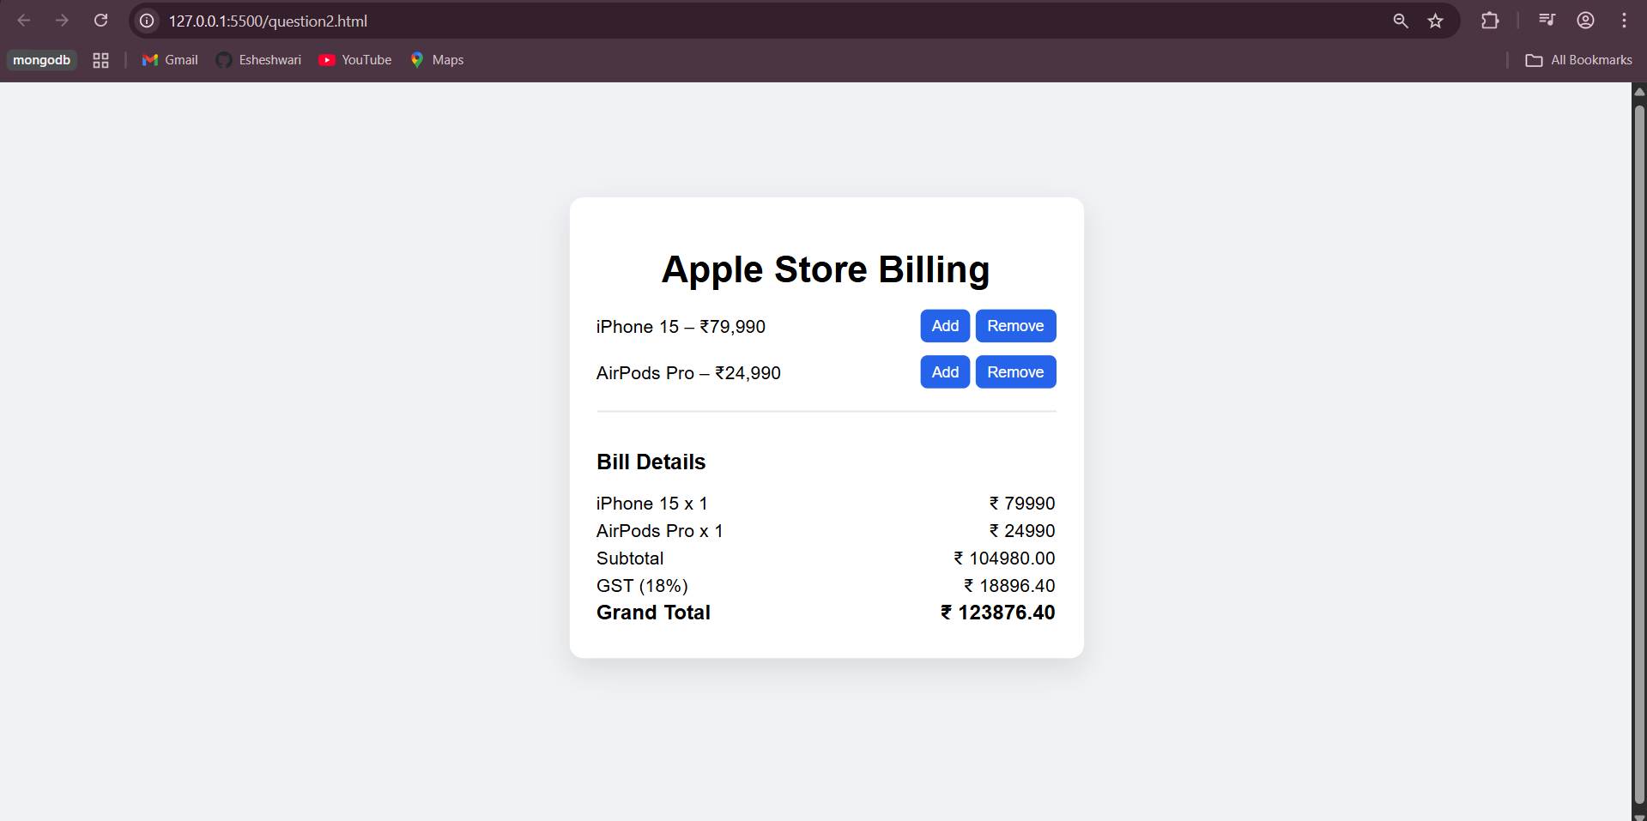

Question3.js
// Create string using all 3 methods

// Using Double Quotes (" " )
let str1 = "Hello World";
console.log(str1);

// Using Single Quotes (' ')
let str2 = 'JavaScript String';
console.log(str2);

// Using Template Literals (Backticks ` `)
let name = "Esha";
let str3 = `Welcome ${name}`;
console.log(str3);

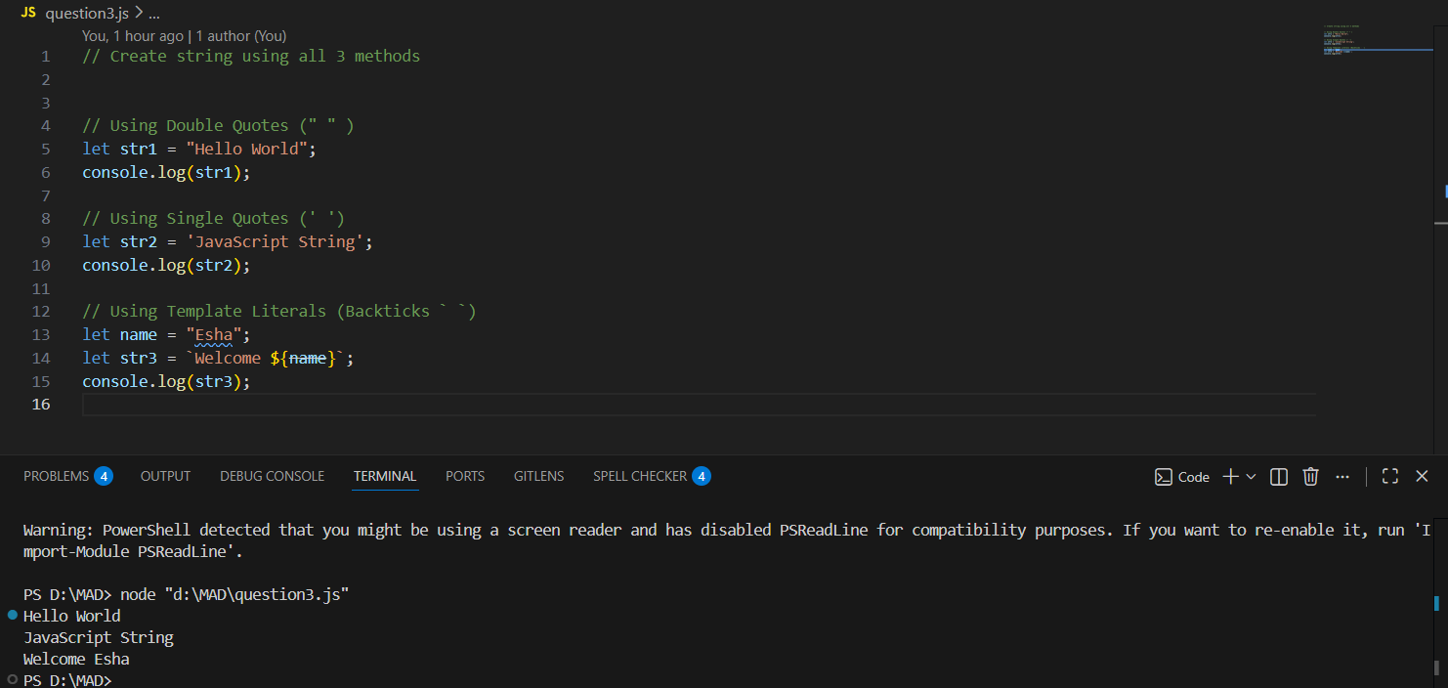

Question4.js
// Concatenate String with String

let str1 = "Hello";
let str2 = "World";

let result = str1 + " " + str2;
console.log(result);

// Concatenate String with Number
let name = "Total Items: ";
let count = 5;

let result1 = name + count;
console.log(result1);

// Using Template Literals
let price = 100;
let item = "Pen";

let result2 = `${item} costs ₹${price}`;
console.log(result2);

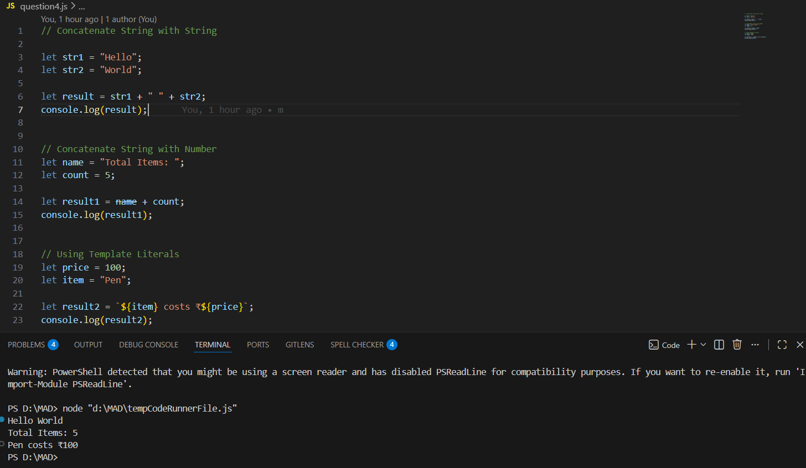

Question5.html
<!-- Create Order Summary String for our Myntra Cart. -->

<!DOCTYPE html>
<html lang="en">
<head>
<meta charset="UTF-8" />
<meta name="viewport" content="width=device-width, initial-scale=1.0" />
<title>Myntra Cart</title>
<style>
body {
font-family: Arial, sans-serif;
background: #f5f5f5;
display: flex;
justify-content: center;
align-items: center;
min-height: 100vh;
}
.card {
background: #fff;
width: 420px;
padding: 20px;
border-radius: 12px;
box-shadow: 0 10px 25px rgba(0,0,0,0.1);
}
h1 {
text-align: center;
margin-bottom: 16px;
}
.item {
display: flex;
justify-content: space-between;
align-items: center;
margin-bottom: 12px;
}
button {
padding: 6px 10px;
margin-left: 4px;
border: none;
border-radius: 6px;
background: #ff3f6c;
color: #fff;
cursor: pointer;
}
button.remove {
background: #6b7280;
}
.cart {
margin-top: 16px;
border-top: 1px solid #e5e7eb;
padding-top: 12px;
}
.cart p {
display: flex;
justify-content: space-between;
margin: 6px 0;
}
pre {
background: #f9fafb;
padding: 10px;
border-radius: 8px;
margin-top: 12px;
white-space: pre-wrap;
}
</style>
</head>
<body>
<div class="card">
<h1>Myntra Cart</h1>

<div class="item">
<span>T-Shirt – ₹799</span>
<div>
<button onclick="addItem('T-Shirt', 799)">Add</button>
<button class="remove" onclick="removeItem('T-Shirt', 799)">Remove</button>
</div>
</div>

<div class="item">
<span>Jeans – ₹1499</span>
<div>
<button onclick="addItem('Jeans', 1499)">Add</button>
<button class="remove" onclick="removeItem('Jeans', 1499)">Remove</button>
</div>
</div>

<div class="item">
<span>Shoes – ₹2999</span>
<div>
<button onclick="addItem('Shoes', 2999)">Add</button>
<button class="remove" onclick="removeItem('Shoes', 2999)">Remove</button>
</div>
</div>

<div class="cart">
<h3>Cart Summary</h3>
<div id="cartItems"></div>
<p><strong>Total Amount</strong><strong>₹ <span id="total">0</span></strong></p>

<h3>Order Summary String</h3>
<pre id="orderSummary">No items added</pre>
</div>
</div>

<script>
const cart = {};

function addItem(name, price) {
if (!cart[name]) {
cart[name] = { price, qty: 1 };
} else {
cart[name].qty++;
}
renderCart();
}

function removeItem(name) {
if (!cart[name]) return;

cart[name].qty--;
if (cart[name].qty === 0) {
delete cart[name];
}
renderCart();
}

function renderCart() {
const cartItems = document.getElementById('cartItems');
const orderSummary = document.getElementById('orderSummary');
cartItems.innerHTML = '';

let total = 0;
let summaryText = 'Order Summary:\n';

for (let item in cart) {
let itemTotal = cart[item].price * cart[item].qty;
total += itemTotal;

cartItems.innerHTML += `<p><span>${item} x ${cart[item].qty}</span><span>₹ ${itemTotal}</span></p>`;
summaryText += `${item} x ${cart[item].qty} = ₹${itemTotal}\n`;
}

if (total === 0) {
orderSummary.textContent = 'No items added';
} else {
summaryText += `Total Amount: ₹${total}`;
orderSummary.textContent = summaryText;
}

document.getElementById('total').innerText = total;
}
</script>
</body>
</html>
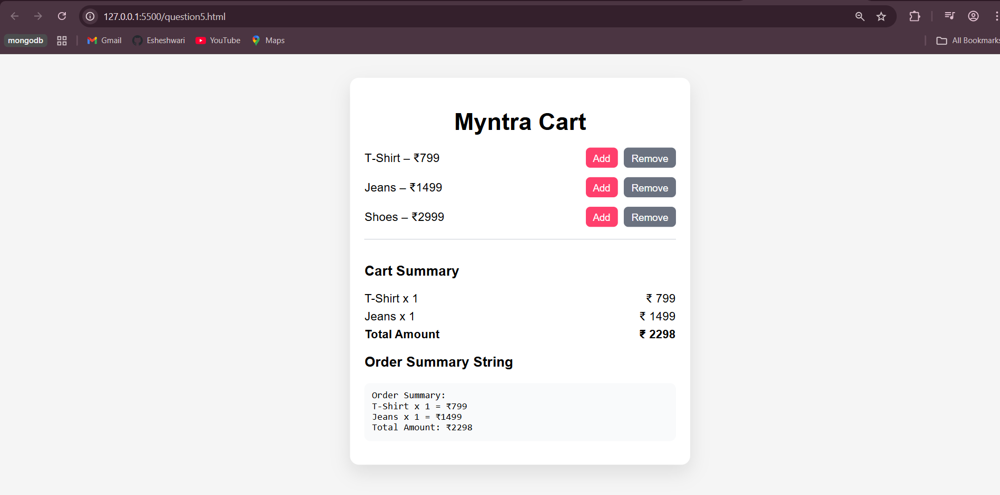

Question6.html
<!-- Display order summary in a popup -->
<!DOCTYPE html>
<html lang="en">
<head>
<meta charset="UTF-8" />
<meta name="viewport" content="width=device-width, initial-scale=1.0" />
<title>Myntra Cart</title>
<style>
body {
font-family: Arial, sans-serif;
background: #f5f5f5;
display: flex;
justify-content: center;
align-items: center;
min-height: 100vh;
}
.card {
background: #fff;
width: 420px;
padding: 20px;
border-radius: 12px;
box-shadow: 0 10px 25px rgba(0,0,0,0.1);
}
h1 {
text-align: center;
margin-bottom: 16px;
}
.item {
display: flex;
justify-content: space-between;
align-items: center;
margin-bottom: 12px;
}
button {
padding: 6px 10px;
margin-left: 4px;
border: none;
border-radius: 6px;
background: #ff3f6c;
color: #fff;
cursor: pointer;
}
button.remove {
background: #6b7280;
}
.cart {
margin-top: 16px;
border-top: 1px solid #e5e7eb;
padding-top: 12px;
}
.cart p {
display: flex;
justify-content: space-between;
margin: 6px 0;
}
pre {
background: #f9fafb;
padding: 10px;
border-radius: 8px;
margin-top: 12px;
white-space: pre-wrap;
}
</style>
</head>
<body>
<div class="card">
<h1>Myntra Cart</h1>

<div class="item">
<span>T-Shirt – ₹799</span>
<div>
<button onclick="addItem('T-Shirt', 799)">Add</button>
<button class="remove" onclick="removeItem('T-Shirt', 799)">Remove</button>
</div>
</div>

<div class="item">
<span>Jeans – ₹1499</span>
<div>
<button onclick="addItem('Jeans', 1499)">Add</button>
<button class="remove" onclick="removeItem('Jeans', 1499)">Remove</button>
</div>
</div>

<div class="item">
<span>Shoes – ₹2999</span>
<div>
<button onclick="addItem('Shoes', 2999)">Add</button>
<button class="remove" onclick="removeItem('Shoes', 2999)">Remove</button>
</div>
</div>

<div class="cart">
<h3>Cart Summary</h3>
<div id="cartItems"></div>
<p><strong>Total Amount</strong><strong>₹ <span id="total">0</span></strong></p>

<button onclick="showPopup()">View Order Summary</button>
<div id="popup" style="display:none; position:fixed; top:0; left:0; width:100%; height:100%; background:rgba(0,0,0,0.5); justify-content:center; align-items:center;">
<div style="background:#fff; padding:20px; border-radius:10px; width:300px;">
<h3>Order Summary</h3>
<pre id="orderSummary">No items added</pre>
<button onclick="closePopup()">Close</button>
</div>
</div>
</div>
</div>

<script>
const cart = {};

function addItem(name, price) {
if (!cart[name]) {
cart[name] = { price, qty: 1 };
} else {
cart[name].qty++;
}
renderCart();
}

function removeItem(name) {
if (!cart[name]) return;

cart[name].qty--;
if (cart[name].qty === 0) {
delete cart[name];
}
renderCart();
}

function showPopup() {
document.getElementById('popup').style.display = 'flex';
}

function closePopup() {
document.getElementById('popup').style.display = 'none';
}

function renderCart() {
const cartItems = document.getElementById('cartItems');
const orderSummary = document.getElementById('orderSummary');
cartItems.innerHTML = '';

let total = 0;
let summaryText = 'Order Summary:\n';

for (let item in cart) {
let itemTotal = cart[item].price * cart[item].qty;
total += itemTotal;

cartItems.innerHTML += `<p><span>${item} x ${cart[item].qty}</span><span>₹ ${itemTotal}</span></p>`;
summaryText += `${item} x ${cart[item].qty} = ₹${itemTotal}\n`;
}

if (total === 0) {
orderSummary.textContent = 'No items added';
} else {
summaryText += `Total Amount: ₹${total}`;
orderSummary.textContent = summaryText;
}

document.getElementById('total').innerText = total;
}
</script>
</body>
</html>
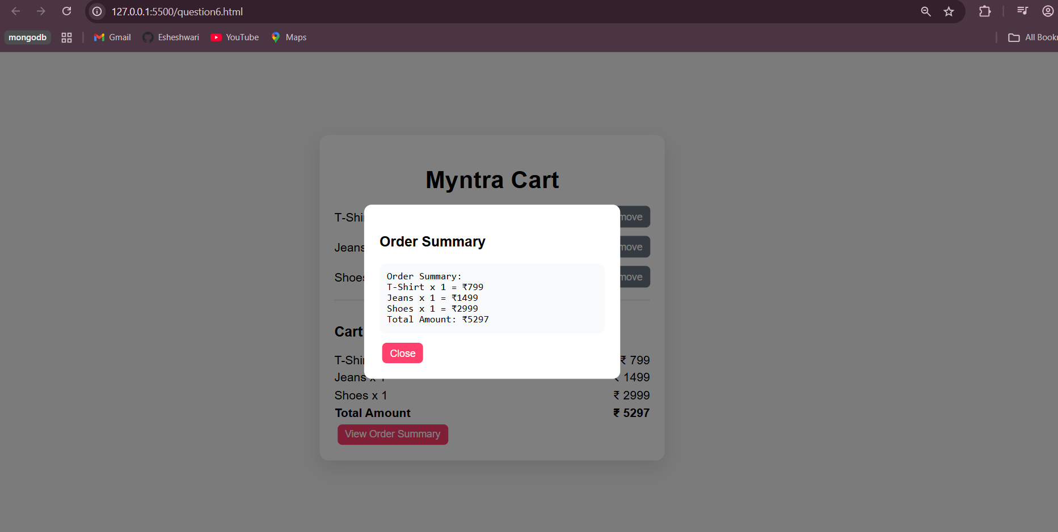

Question7-12.html
<!-- Create a button with text click

Create 2 buttons with class and id

Create a paragraph

Add colors to two buttons

Add proper html structure

Change page title

Try to copy the given design on the bottom

Add script element to page to show welcome alert

Add onclick alert on Add to Bag and
Wishlist
buttons -->

<!DOCTYPE html>
<html lang="en">
<head>
<meta charset="UTF-8">
<title>Buttons Practice Page</title>
<style>
body {
background-color: #000;
color: #fff;
font-family: Arial, sans-serif;
padding: 30px;
}

p {
margin-bottom: 20px;
}

/* Button styles */
.add-btn {
background-color: #9cff9c;
border: none;
padding: 10px 20px;
border-radius: 20px;
cursor: pointer;
font-weight: bold;
}

#wishlistBtn {
background-color: #fff;
color: #000;
border: 2px solid #000;
padding: 10px 20px;
border-radius: 20px;
cursor: pointer;
font-weight: bold;
margin-left: 10px;
}

.button-container {
background: #fff;
padding: 15px;
display: inline-block;
border-radius: 10px;
}
</style>
</head>
<body>

<!-- Paragraph -->
<p>This is a sample paragraph created as per the assignment.</p>

<!-- Buttons -->
<div class="button-container">
<button class="add-btn" id="addToBagBtn" onclick="addToBag()">Add to Bag</button>
<button class="wishlist" id="wishlistBtn" onclick="addToWishlist()">❤️ WISHLIST</button>
</div>

<!-- Script -->
<script>
// Welcome alert
alert("Welcome to the website!");

function addToBag() {
alert("Item added to bag!");
}

function addToWishlist() {
alert("Item added to wishlist!");
}
</script>

</body>
</html>
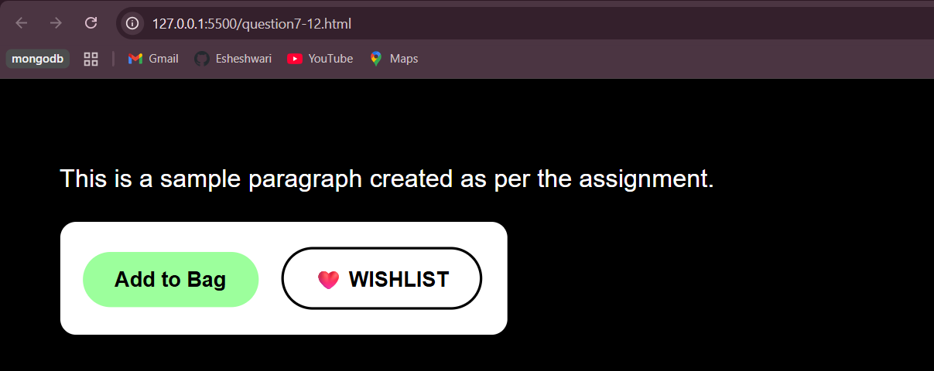

Question13-14.js
// Save your name in a variable inside script tag

// Display name from the variable on the page

let myName = "Esha";
console.log(myName);

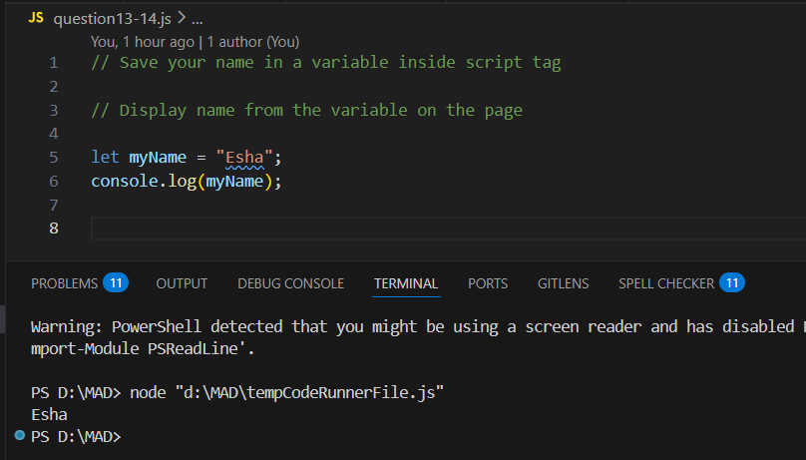
Question15-18.html
<!-- Calculate the cost of Myntra Bag and keep it in a
variable

Show it to console

Keep GST percentage as constant

Use eval method from math to convert string
calculation into result -->

<!DOCTYPE html>
<html lang="en">
<head>
<meta charset="UTF-8">
<meta name="viewport" content="width=device-width, initial-scale=1.0">
<title>Myntra Bag Cost Calculator</title>
<style>
/* Basic reset */
* { margin: 0; padding: 0; box-sizing: border-box; font-family: 'Arial', sans-serif; }

body {
background: #f8f4f0;
display: flex;
justify-content: center;
align-items: center;
min-height: 100vh;
}

.container {
background: #fff;
padding: 30px;
border-radius: 15px;
box-shadow: 0 8px 20px rgba(0,0,0,0.1);
width: 350px;
text-align: center;
}

h1 {
color: #ff3e6c;
margin-bottom: 20px;
}

.item {
display: flex;
justify-content: space-between;
align-items: center;
margin: 15px 0;
padding: 10px 15px;
background: #fafafa;
border-radius: 10px;
box-shadow: inset 0 0 5px rgba(0,0,0,0.05);
}

.item button {
padding: 5px 10px;
border: none;
border-radius: 8px;
cursor: pointer;
background: #ff3e6c;
color: #fff;
font-weight: bold;
transition: 0.3s;
}

.item button:hover {
background: #e6335b;
}

.wishlist {
background: #f0ad4e;
}

.wishlist:hover {
background: #e5943f;
}

.total-btn {
margin-top: 20px;
padding: 10px 20px;
background: #28a745;
color: white;
border: none;
border-radius: 12px;
font-size: 16px;
cursor: pointer;
transition: 0.3s;
}

.total-btn:hover {
background: #218838;
}
</style>
</head>
<body>
<div class="container">
<h1>Myntra Bag</h1>

<div class="item">
<span>Bag Price:</span>
<span>₹ <span id="bagPrice">2000</span></span>
</div>

<div class="item">
<span>Quantity:</span>
<button onclick="updateQuantity(-1)">-</button>
<span id="quantity">1</span>
<button onclick="updateQuantity(1)">+</button>
</div>

<div class="item">
<span>Wishlist:</span>
<button class="wishlist" onclick="toggleWishlist()">Add/Remove</button>
</div>

<button class="total-btn" onclick="calculateTotal()">Calculate Total</button>
</div>

<script>
// Price of bag
let bagCost = 2000;

// Quantity
let quantity = 1;

// GST as constant
const GST_PERCENTAGE = 18; // 18%

// Wishlist status
let inWishlist = false;

function updateQuantity(change) {
quantity += change;
if (quantity < 0) quantity = 0;
document.getElementById('quantity').textContent = quantity;
console.log("Quantity:", quantity);
}

function toggleWishlist() {
inWishlist = !inWishlist;
console.log("Wishlist status:", inWishlist ? "Added" : "Removed");
alert(inWishlist ? "Added to Wishlist" : "Removed from Wishlist");
}

function calculateTotal() {
// Using eval for calculation
let totalString = `${bagCost} * ${quantity} * (1 + ${GST_PERCENTAGE}/100)`;
let totalCost = eval(totalString); // eval converts string to calculation
console.log("Total Cost including GST:", totalCost.toFixed(2));
alert("Total Cost including GST: ₹" + totalCost.toFixed(2));
}
</script>
</body>
</html>

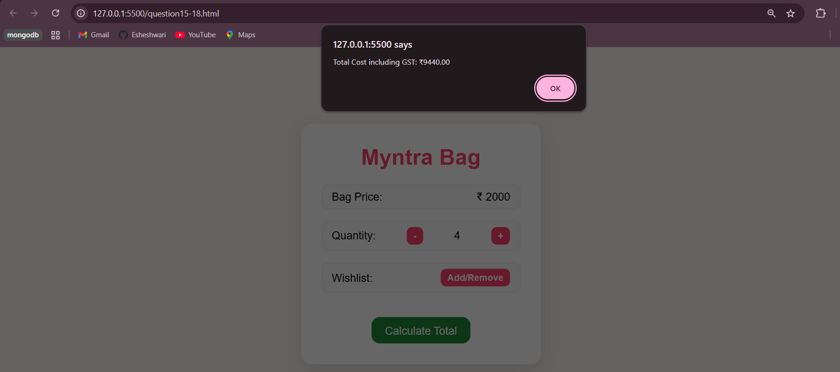

Question19-21.html
<!-- Create a method to check if a number is odd
or even.

Create a method to return larger of the two
numbers.

Create Method to convert Celsius to

Fahrenheit

F = (9/5) * C + 32 -->

<!DOCTYPE html>
<html lang="en">
<head>
<meta charset="UTF-8">
<meta name="viewport" content="width=device-width, initial-scale=1.0">
<title>Number & Temperature Utility</title>
<style>
body {
font-family: 'Arial', sans-serif;
background: #f0f4f8;
display: flex;
justify-content: center;
align-items: center;
min-height: 100vh;
}

.container {
background: #fff;
padding: 30px;
border-radius: 15px;
box-shadow: 0 10px 25px rgba(0,0,0,0.1);
width: 350px;
}

h1 {
text-align: center;
color: #ff3e6c;
margin-bottom: 20px;
}

.section {
margin-bottom: 25px;
}

input {
width: 100%;
padding: 10px;
margin-top: 5px;
margin-bottom: 10px;
border-radius: 8px;
border: 1px solid #ccc;
font-size: 16px;
}

button {
width: 100%;
padding: 10px;
background: #28a745;
color: #fff;
border: none;
border-radius: 10px;
font-size: 16px;
cursor: pointer;
transition: 0.3s;
}

button:hover {
background: #218838;
}

.output {
margin-top: 10px;
font-weight: bold;
text-align: center;
color: #333;
}
</style>
</head>
<body>
<div class="container">
<h1>Utility Tools</h1>

<!-- Odd/Even Checker -->
<div class="section">
<label>Enter a number to check Odd/Even:</label>
<input type="number" id="numInput" placeholder="Enter number">
<button onclick="checkOddEven()">Check Odd/Even</button>
<div class="output" id="oddEvenResult"></div>
</div>

<!-- Larger of Two Numbers -->
<div class="section">
<label>Enter two numbers to find larger:</label>
<input type="number" id="num1" placeholder="First number">
<input type="number" id="num2" placeholder="Second number">
<button onclick="findLarger()">Find Larger</button>
<div class="output" id="largerResult"></div>
</div>

<!-- Celsius to Fahrenheit -->
<div class="section">
<label>Enter Celsius to convert to Fahrenheit:</label>
<input type="number" id="celsiusInput" placeholder="Celsius value">
<button onclick="convertCelsius()">Convert</button>
<div class="output" id="fahrenheitResult"></div>
</div>
</div>

<script>
// Odd/Even checker
function checkOddEven() {
const num = Number(document.getElementById('numInput').value);
if(isNaN(num)) return alert("Please enter a valid number!");
const result = (num % 2 === 0) ? "Even" : "Odd";
document.getElementById('oddEvenResult').textContent = `${num} is ${result}`;
}

// Find larger of two numbers
function findLarger() {
const a = Number(document.getElementById('num1').value);
const b = Number(document.getElementById('num2').value);
if(isNaN(a) || isNaN(b)) return alert("Please enter both numbers!");
const larger = (a > b) ? a : b;
document.getElementById('largerResult').textContent = `Larger number is ${larger}`;
}

// Celsius to Fahrenheit
function convertCelsius() {
const c = Number(document.getElementById('celsiusInput').value);
if(isNaN(c)) return alert("Please enter a valid Celsius value!");
const f = (9/5) * c + 32;
document.getElementById('fahrenheitResult').textContent = `${c}°C = ${f.toFixed(2)}°F`;
}
</script>
</body>
</html>
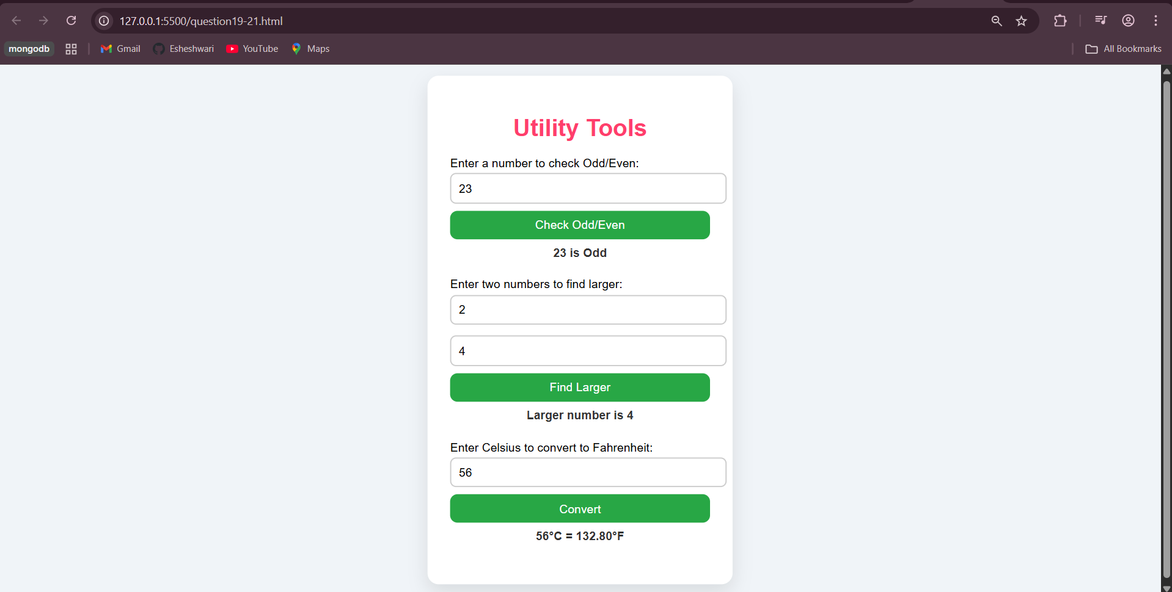
Question22-27.html
<!-- Create object to represent a product from Myntra

Create an Object with two references and log changes to
one object by changing the other one.

Use bracket notation to display delivery-time.

Given an object {message: 'good job', status: 'complete'},

use de-structuring to create two variables message and
status.

Add function isIdenticalProduct to compare two product
objects. -->

<!DOCTYPE html>
<html lang="en">
<head>
<meta charset="UTF-8">
<meta name="viewport" content="width=device-width, initial-scale=1.0">
<title>Myntra Product Demo</title>
<style>
body {
font-family: Arial, sans-serif;
background: #f0f4f8;
display: flex;
justify-content: center;
padding: 20px;
}
.container {
background: #fff;
padding: 25px;
border-radius: 15px;
box-shadow: 0 10px 25px rgba(0,0,0,0.1);
width: 450px;
}
h1 {
text-align: center;
color: #ff3e6c;
margin-bottom: 20px;
}
.section {
margin-bottom: 20px;
}
button {
padding: 8px 15px;
border: none;
border-radius: 8px;
cursor: pointer;
font-weight: bold;
margin-top: 5px;
}
.demoBtn { background: #28a745; color: white; }
.demoBtn:hover { background: #218838; }
.output {
margin-top: 10px;
font-weight: bold;
color: #333;
background: #f9f9f9;
padding: 8px;
border-radius: 8px;
min-height: 25px;
}
</style>
</head>
<body>

<div class="container">
<h1>Myntra Product Demo</h1>

<!-- Section 1: Display Products -->
<div class="section">
<button class="demoBtn" onclick="showProducts()">Show Products</button>
<div class="output" id="productsOutput"></div>
</div>

<!-- Section 2: Object References Demo -->
<div class="section">
<button class="demoBtn" onclick="demoReferences()">Demo Object References</button>
<div class="output" id="refOutput"></div>
</div>

<!-- Section 3: Bracket Notation Demo -->
<div class="section">
<button class="demoBtn" onclick="showDeliveryTime()">Show Delivery-Time</button>
<div class="output" id="deliveryOutput"></div>
</div>

<!-- Section 4: Destructuring Demo -->
<div class="section">
<button class="demoBtn" onclick="demoDestructuring()">Destructure Object</button>
<div class="output" id="destructureOutput"></div>
</div>

<!-- Section 5: Compare Products -->
<div class="section">
<button class="demoBtn" onclick="compareProducts()">Compare Two Products</button>
<div class="output" id="compareOutput"></div>
</div>
</div>

<script>
// -------------------------------
// 1️⃣ Create objects to represent Myntra products
// -------------------------------
let product1 = { name: "Stylish Bag", price: 1499, "delivery-time": "3-5 days" };
let product2 = { name: "Casual Backpack", price: 1299, "delivery-time": "4-6 days" };

let products = [product1, product2]; // Array of products

function showProducts() {
// Display all products
let output = products.map(p => `${p.name} - ₹${p.price}, Delivery: ${p["delivery-time"]}`).join("<br>");
document.getElementById('productsOutput').innerHTML = output;
}

// -------------------------------
// 2️⃣ Object with two references
// -------------------------------
let ref1 = product1; // Reference 1
let ref2 = ref1; // Reference 2 points to same object

function demoReferences() {
// Change price using ref2
ref2.price += 100;
// Log changes in ref1 (both are same object)
document.getElementById('refOutput').textContent =
`Price changed via ref2. ref1.price = ₹${ref1.price}, ref2.price = ₹${ref2.price}`;
console.log("ref1:", ref1, "ref2:", ref2);
}

// -------------------------------
// 3️⃣ Bracket notation to access delivery-time
// -------------------------------
function showDeliveryTime() {
let delivery = product1["delivery-time"]; // bracket notation
document.getElementById('deliveryOutput').textContent =
`Delivery time of ${product1.name}: ${delivery}`;
}

// -------------------------------
// 4️⃣ Destructuring an object
// -------------------------------
function demoDestructuring() {
let obj = {message: 'good job', status: 'complete'};
let {message, status} = obj; // destructuring
document.getElementById('destructureOutput').textContent =
`Message: ${message}, Status: ${status}`;
}

// -------------------------------
// 5️⃣ Compare two product objects
// -------------------------------
function isIdenticalProduct(p1, p2) {
// Compare using JSON.stringify
return JSON.stringify(p1) === JSON.stringify(p2);
}

function compareProducts() {
let identical = isIdenticalProduct(product1, product2);
document.getElementById('compareOutput').textContent =
identical ? "Products are identical ✅" : "Products are different ❌";
}
</script>

</body>
</html>

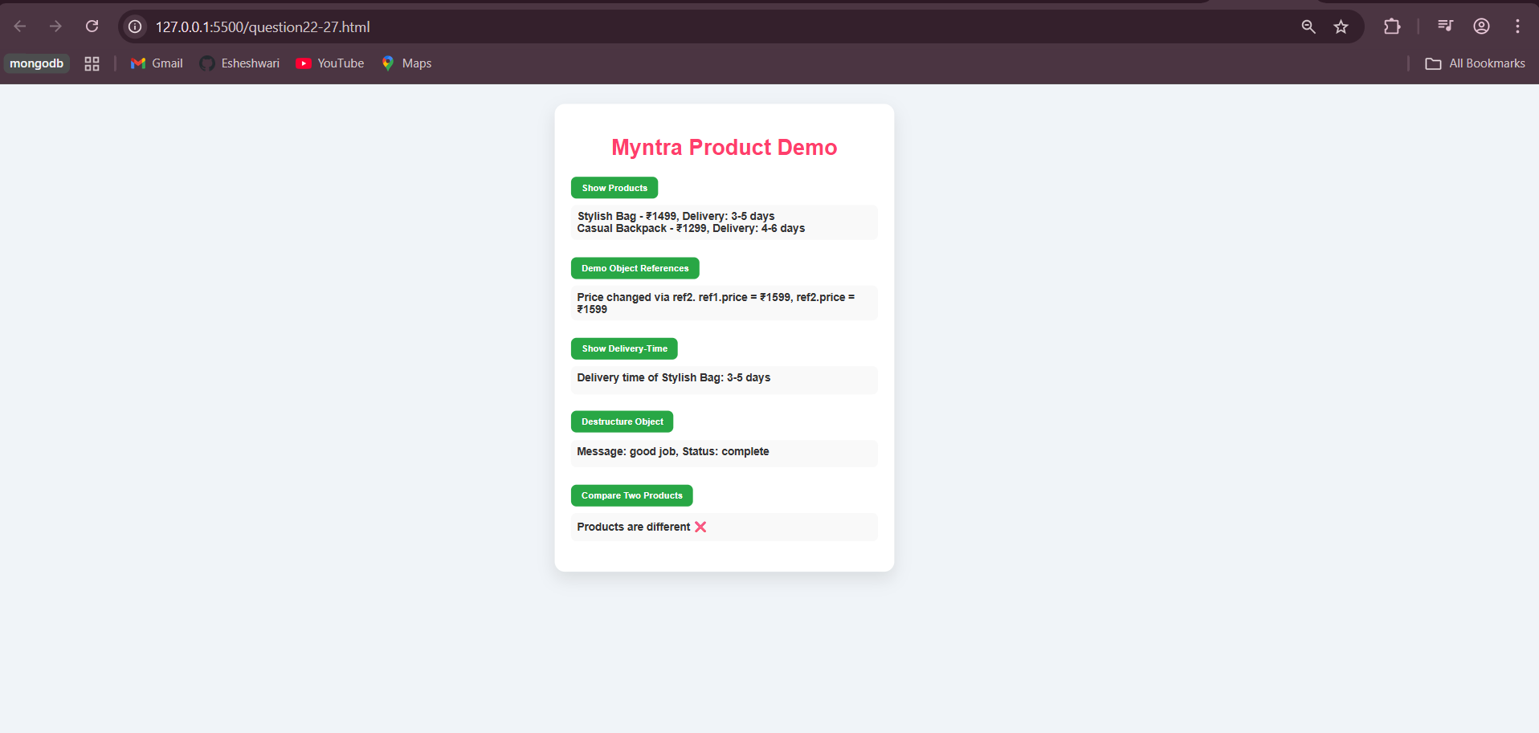

Question28-30.html
<!-- Display good morning, afternoon and night based on
current hour.

Add the name to the output too.

Create a Button which shows the number how many times

it has been pressed.

Also, it has different colors for when it has been pressed
odd or even times.

The click count should also survive browser refresh. -->

<!DOCTYPE html>
<html lang="en">
<head>
<meta charset="UTF-8">
<meta name="viewport" content="width=device-width, initial-scale=1.0">
<title>Greeting & Persistent Click Counter</title>
<style>
body {
font-family: 'Arial', sans-serif;
background: linear-gradient(135deg, #f8f4f0, #f0f4f8);
display: flex;
justify-content: center;
align-items: center;
min-height: 100vh;
padding: 20px;
}

.container {
background: #fff;
padding: 30px 25px;
border-radius: 20px;
box-shadow: 0 10px 30px rgba(0,0,0,0.15);
text-align: center;
width: 350px;
}

h1 {
color: #ff3e6c;
margin-bottom: 20px;
}

.greeting {
font-size: 20px;
margin-bottom: 25px;
color: #333;
min-height: 30px;
}

input {
padding: 10px;
width: 80%;
margin-bottom: 15px;
border-radius: 10px;
border: 1px solid #ccc;
font-size: 16px;
}

button {
padding: 12px 20px;
font-size: 16px;
font-weight: bold;
border-radius: 12px;
border: none;
cursor: pointer;
color: white;
transition: 0.3s;
margin: 5px 0;
}

#greetBtn {
background: #ff7f50;
}
#greetBtn:hover {
background: #ff6347;
}

#clickBtn {
width: 100%;
}

.counter {
margin-top: 15px;
font-size: 18px;
font-weight: bold;
color: #333;
}

</style>
</head>
<body>

<div class="container">
<h1>Greeting & Click Counter</h1>

<!-- User Name Input -->
<input type="text" id="userName" placeholder="Enter your name">

<!-- Button to Show Greeting -->
<button id="greetBtn" onclick="showGreeting()">Say Hello</button>
<div class="greeting" id="greetingOutput"></div>

<!-- Click Counter Button -->
<button id="clickBtn" onclick="handleClick()">Click Me!</button>
<div class="counter" id="clickCountOutput">Button clicked 0 times</div>
</div>

<script>
// -------------------------------
// Persistent click count using localStorage
// -------------------------------
let clickCount = localStorage.getItem("clickCount") ? parseInt(localStorage.getItem("clickCount")) : 0;

const clickBtn = document.getElementById("clickBtn");
const clickCountOutput = document.getElementById("clickCountOutput");

function updateButtonColor() {
// Odd = blue, Even = green
if(clickCount % 2 === 0) {
clickBtn.style.backgroundColor = "#28a745"; // green
} else {
clickBtn.style.backgroundColor = "#007bff"; // blue
}
clickBtn.style.color = "#fff";
}

function handleClick() {
clickCount++;
localStorage.setItem("clickCount", clickCount); // save count
clickCountOutput.textContent = `Button clicked ${clickCount} ${clickCount === 1 ? "time" : "times"}`;
updateButtonColor();
}

// Initialize button color and count on page load
window.onload = function() {
clickCountOutput.textContent = `Button clicked ${clickCount} ${clickCount === 1 ? "time" : "times"}`;
updateButtonColor();
}

// -------------------------------
// Display greeting based on current hour + name
// -------------------------------
function showGreeting() {
const name = document.getElementById("userName").value.trim();
if(!name) return alert("Please enter your name!");

const hour = new Date().getHours();
let greeting = "";

if(hour >= 5 && hour < 12) greeting = "Good Morning";
else if(hour >= 12 && hour < 17) greeting = "Good Afternoon";
else greeting = "Good Night";

document.getElementById("greetingOutput").textContent = `${greeting}, ${name}!`;
}
</script>

</body>
</html>

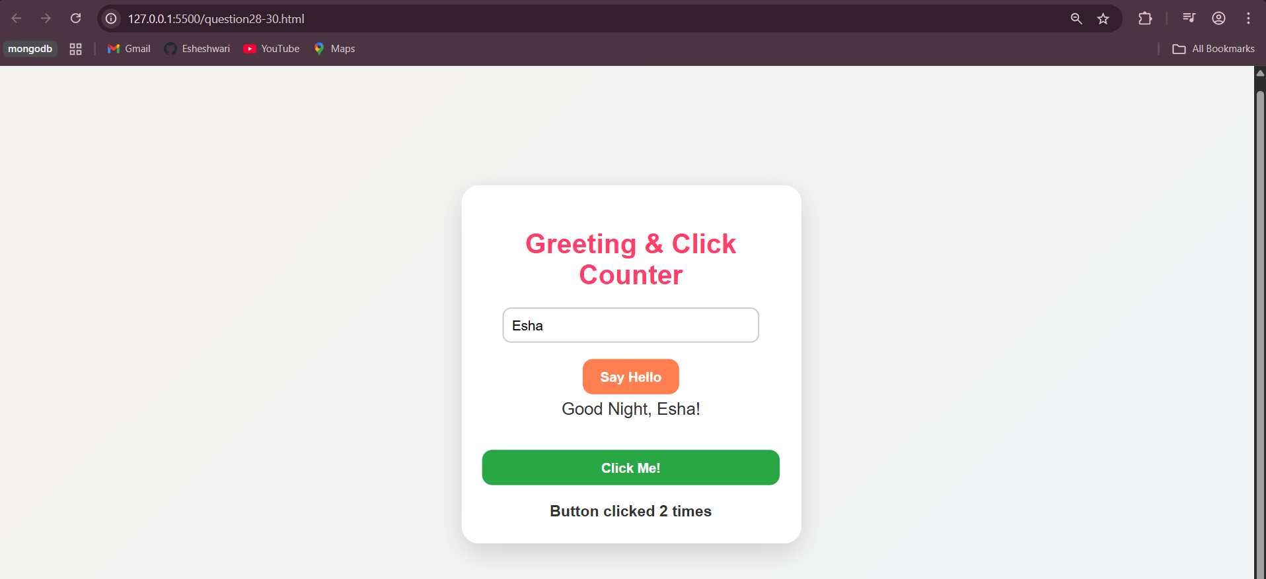
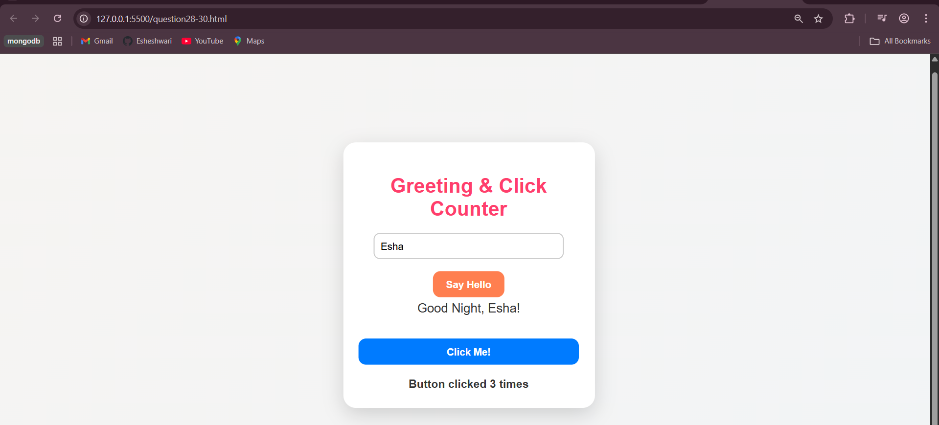
Question31-36.js
// While loop that exits after counting 5 prime numbers

function isPrime(num) {
if (num <= 1) return false;
for (let i = 2; i <= Math.sqrt(num); i++) {
if (num % i === 0) return false;
}
return true;
}

let count = 0;
let n = 2;

while (count < 5) {
if (isPrime(n)) {
console.log("Prime:", n);
count++;
}
n++;
}

// Same loop using break

count = 0;
n = 2;

while (true) {
if (isPrime(n)) {
console.log("Prime (break loop):", n);
count++;
}
if (count === 5) break;
n++;
}

// For loop printing numbers 1 to 10 in reverse

for (let i = 10; i >= 1; i--) {
console.log("Reverse:", i);
}

// Using continue, print only positive numbers

let mixedArray = [1, -6, 5, 7, -98];

for (let i = 0; i < mixedArray.length; i++) {
if (mixedArray[i] < 0) continue;
console.log("Positive number:", mixedArray[i]);
}
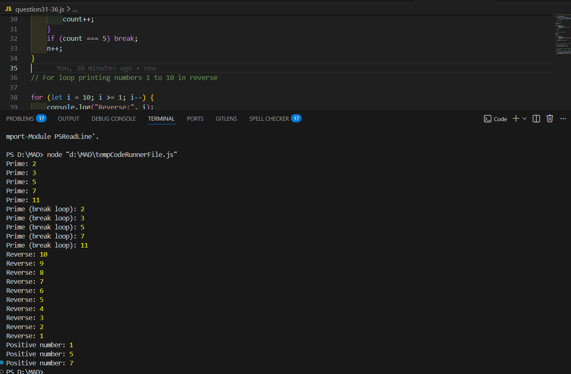
Question37-41.js
// While loop that exits after counting 5 prime numbers

// Function to check if a number is prime
function isPrime(num) {
if (num <= 1) return false;

for (let i = 2; i <= Math.sqrt(num); i++) {
if (num % i === 0) return false;
}
return true;
}

let count = 0;
let n = 2;

// Count first 5 prime numbers
while (count < 5) {
if (isPrime(n)) {
console.log("Prime:", n);
count++;
}
n++;
}

// Same logic using break

count = 0;
n = 2;

while (true) {
if (isPrime(n)) {
console.log("Prime (using break):", n);
count++;
}

if (count === 5) {
break; // exit loop after 5 primes
}
n++;
}

// For loop printing numbers 1 to 10 in reverse

for (let i = 10; i >= 1; i--) {
console.log("Reverse:", i);
}

// Using continue to print only positive numbers

let mixedArray = [1, -6, 5, 7, -98];

for (let i = 0; i < mixedArray.length; i++) {
if (mixedArray[i] < 0) continue; // skip negative numbers
console.log("Positive number:", mixedArray[i]);
}

