# Installing and running Expo-CLI

### Ethan Shimmel

## Requirements:

* Updated version of NPM

## Step 1:

You will first need to open up command prompt and go to a local folder. Do not use a One Drive folder because it will not work. I recommend using C:\Users\<Account Name>. This will allow you to add expo-cli to the node frame. Once you are there you will use the following command:

npm install -g expo-cli

A few errors might pop up and you should ignore them and move to the next steps.

## Step 2:

The next thing to do is create a new project for your app using the expo command. Since we do not have administrative privileges we will use npx. If you have administrative privileges you probably have access to the expo commands. Use the following command in the same folder:

npx expo init <Name of App>

In order to navigate to it use:

cd <Name of App>

## Step 3:

Next, we will start the server. We can test through a web version or you can download the Expo GO app from the app store. Once that is done you can use the following command:

npm start

You can also use expo if the expo command works on your computer but npm will do the job. Once it is done starting up you should see a screen like this:

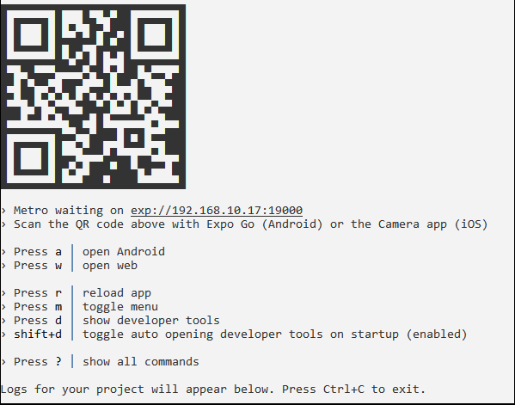

## Step 4:

The easiest and fastest way to test is scanning the QR code with your iPhone and use the Expo Go app to run it. It will load and if you have no errors it should pop up. When you are ready to change the program, you can open the App.js file in any text editor and work on your app. (You must be on the same internet as the computer, more info on that later if you are not)

Another way to run your app is by clicking “d” when inside the command prompt. It will bring up a webpage with developer tools. This page will have a lot of things on it for you to change. If you want to use the Expo Go app but are not on the same network you will have to use the bottom left **Connection** buttons. You will want to click **Tunnel** button to allow you to access the app through the app.

The third way to test your app is using their web browser tester. On the left-hand side there are a list of buttons that say “Run on…” They should look like this:

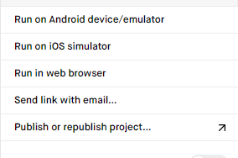

You want to click the **Run in web browser** button. This should open another page that allows you to see you page. I have noticed that the styling of the webpages is a little different than the phone but you can always test features this way without having a phone. I am sure they will fix that soon.