# MacOS Monterey Installation

### Ethan Shimmel

## Requirements:

* You will need a Mac that fits the requirements to update to macOS Monterey (Check apple site for more info)
* Logged in to the App Store/Apple ID

## Installation:

The first thing we will need to do is either find the software update through settings or download it from the app store. All you will need to do is to navigate to the App Store. Should be in the task bar at the bottom unless you changed it from the defaults. You will use the search bar to search for **macOS Monterey**. This should then download the installer for Monterey. Once done you should proceed to open it. It should launch with an installer page like this:

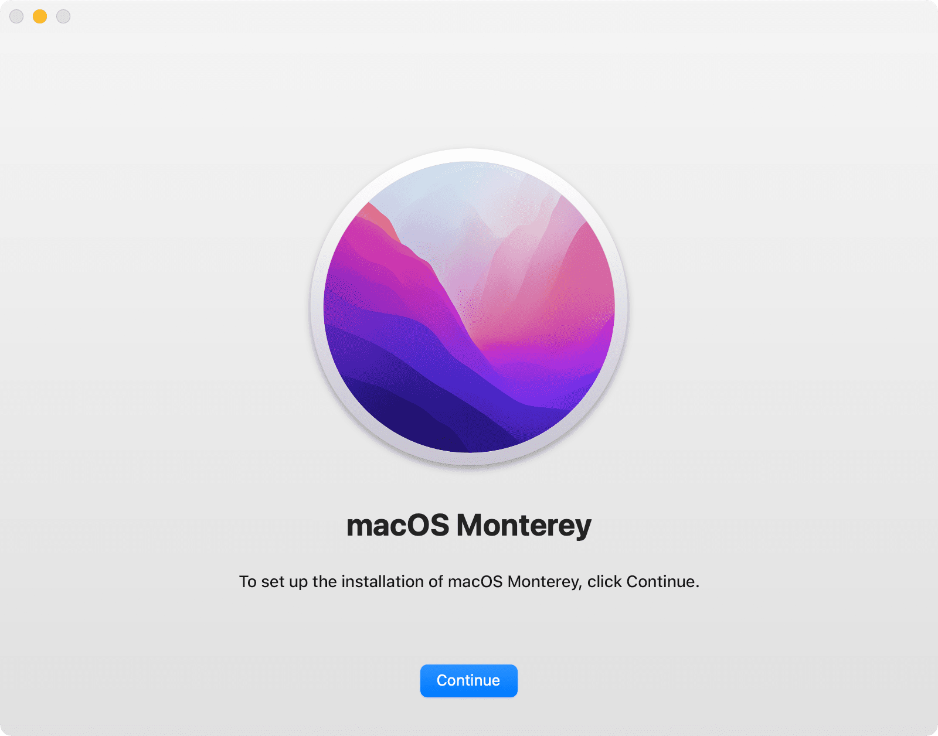

You will click continue and then proceed to the terms and agreements page. Take time to read through it if you would like and then **agree** to the terms. It will have a pop-up menu and click **agree** again. Once done it will ask for you to select a drive. You will need to select the main drive unless you have added on storage. The last thing needed to do is to click the **continue** and Monterey will proceed to install. Once it completes it will ask to restart. This will take a while depending on internet. Once you restart make sure your computer is plugged in and will not need to be turned off anytime soon. If the computer is turned off during installation the Mac will brick (More details on this below). Other than that, you should be set to go and just need to complete the user setup after installation.

## Debugging:

Once thing that might happen is your Mac will brick. This means the installation went wrong and your mac no longer launches macOS. It will probably launch a black screen. It could also launch to a page with error pictures that you can look up and follow the solutions. Here are a few fixes that I have found that will work. Most likely you will have to reinstall the old software version you had when you first got your Mac. In order to do this, you will need to restart your Mac by either shutting it off by the power button or through the software depending on your issue. Shut it off and when you turn the Mac back on click **Command + R**. This should pull up a page with a few options. We will be operating inside the Disk Utility to start. Once you are loaded into that you will need to find your main disk for your Mac. Usually named **Macintosh HD** but not always. Once you found it you will need to click on it and then click **erase** button placed in the toolbar at the top of the screen. Next you will be asked for the name and format. You should rename it with Macintosh HD and format with APFS (You can also use **MacOS Extended (Journaled)**). 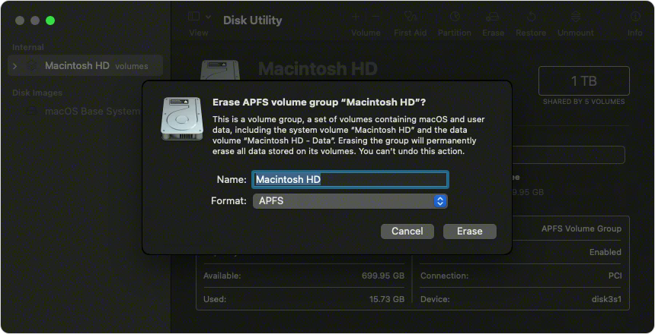Once finished click the **Erase** button and give it time to erase and reformat.

Th last thing to do in order to reinstall your old version is to exit disk utility and find **Reinstall macOS <name of version>** which will bring you through a new install. You will need to complete the install questions and accept the agreements. Once the install is complete you should try to reinstall macOS Monterey from the App store and let it load. If it seems to be stuck during installation it might not be so let it load for a while. It can look like it froze but it really didn’t.

The last error you might run into is the **“No packages were eligible to install”**. This error has a weird fix but it works. The first thing you will need to do is to unplug your internet or turn it off. After completing that you will then have to open a terminal. And from here you will have to manually update the date to the current date or any newer date (Something like this: date 0115124517). Once this has been done you should be able to close the terminal and click the restart button. After your computer restarts the software install should complete correctly.