# Creating the MacOS VM

### Ethan Shimmel

## Requirements:

* You will need to download VirtualBox
* Have the macOS Catalina ISO file

## Step 1:

You will need to create a new Virtual Machine. Click New in the top center of the VirtualBox application. Name it whatever you would like. I will be using Catalina for this tutorial. Then select Mac OS X for the type and Mac OS X (64-bit) for the version. Then hit next.

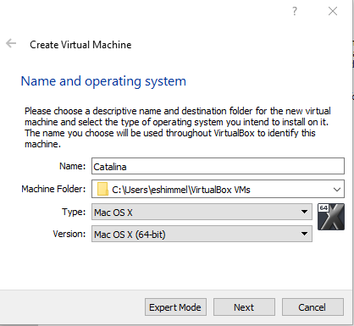

The next page will ask you to select the amount of RAM you want to give the VM. Next you will be asked whether to create a new virtual hard disk or import one. Select the “Create a virtual hard disk now”. Go through and create a 40GB hard disk. Once finished you will be finished with the creation.

## Step 2:

Start by selecting settings. Go to **Processor** tab of the **System** category. Select the processors tat you want to use. Next click on the **Motherboard** tab. Deselect the **Floppy** disk as a boot order. Make sure it is within the green line. After that go to the **Display** tab and max out the video memory to 128MB. The last thing you need to do is go to the **Storage** category. In their you will click the empty disk and in the right corner you will need to add your ISO file.

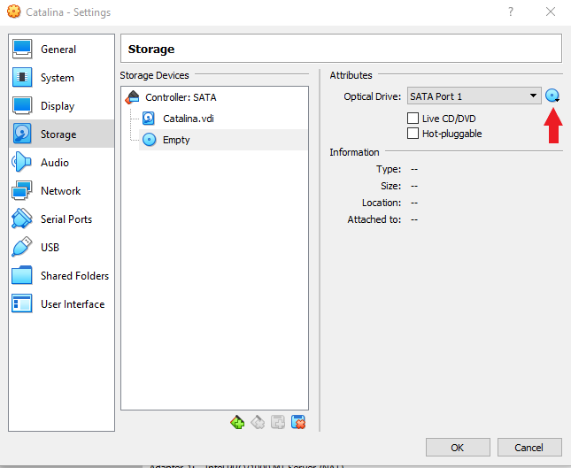

## Step 3:

Save the changes and close virtual box. Open up a command prompt. Type the following command:

cd "C:\Program Files\Oracle\VirtualBox\"

VBoxManage.exe modifyvm "VM Name" --cpuidset 00000001 000106e5 00100800 0098e3fd bfebfbff

VBoxManage setextradata "VM Name" "VBoxInternal/Devices/efi/0/Config/DmiSystemProduct" "iMac19,1"

VBoxManage setextradata "VM Name" "VBoxInternal/Devices/efi/0/Config/DmiSystemVersion" "1.0"

VBoxManage setextradata "VM Name" "VBoxInternal/Devices/efi/0/Config/DmiBoardProduct" "Mac-AA95B1DDAB278B95"

VBoxManage setextradata "VM Name" "VBoxInternal/Devices/smc/0/Config/DeviceKey" "ourhardworkbythesewordsguardedpleasedontsteal(c)AppleComputerInc"

VBoxManage setextradata "VM Name" "VBoxInternal/Devices/smc/0/Config/GetKeyFromRealSMC" 1

Make sure to change **VM Name** to the name of your virtual machine. If no errors pop up then you can reopen Virtual Box. When asked to select which file to boot from, select the iso file with macOS on. Give it a few minutes to boot. You should see lines of code running through. Once it is done it will ask for your language. Then it will bring up macOS Utilities.

## Step 4:

You will need to remove all data from the disk and install macOS all again. To do this you will first select **Disk Utility**. From here select the hard disk you created and click erase. Once done back out to the main page and select **Install macOS**. From here you will be asked to agree with apples terms of software license agreement. Then select the disk you just erased and allow macOS to install. Once it is done you should have macOS Catalina install. And you should have system that looks like the following:

