What is ServiceNow

# Overview

ServiceNow is a cloud-based software company founded by Fred Luddy in 2003 to simplify IT service delivery, making it intuitive and efficient for business users. The video covers the company's employees, customers, history, platform functionality, applications, and global presence, concluding with a concise definition of ServiceNow.

# Introduction to the video and the main question: What is ServiceNow?

The video aims to answer 'What is ServiceNow?' using a structured approach.

# History and milestones of ServiceNow.

Fred Luddy founded the company in 2003, initially named Glide Soft, which was rebranded to ServiceNow in 2006. The company went public in 2012 and was named the most innovative company by FORBES in 2018.

Bill McDermott became the CEO in 2019. The video transitions to the question of 'Why ServiceNow?

ServiceNow aims to provide a cloud-based IT department, simplifying interactions and making them more enjoyable.

# Overview of how ServiceNow works.

The NOW Platform is a cloud-based Application Platform as a Service (APaaS) that supports business IT needs with robust security, redundancy, and data backups.

The platform includes a comprehensive data model and the ability to create custom workflows and applications.

ServiceNow offers a wide range of pre-built applications categorized into IT, Employee, Customer, and Creator Workflows.

# Locations of ServiceNow’s offices and data centers.

ServiceNow is headquartered in Santa Clara, California, with offices worldwide. Its data centers are distributed globally to ensure redundancy and reliability.

ServiceNow Platform Overview

# Introduction to the ServiceNow platform user interface, covering its layout and common tools.

The ServiceNow user interface is a web-based tool essential for accessing the platform. This video covers the third lesson in the ServiceNow Fundamentals learning path.

The video will review common tools provided by the interface, including user menu, global search, chat, contextual help, system settings, application navigator, favourites, and history.

The presenter, Jeff, introduces himself and mentions the resources available in the video description. Viewers are encouraged to subscribe for notifications of new videos.

# Banner Frame: User Menu

Profile settings allow users to change personal information such as name, phone, date format, email, and time zone.

Impersonation feature is available for administrators or impersonators to view the system as another user, useful for troubleshooting.

System settings tool allows customization of the user interface, including general settings, theme, accessibility, menu settings, form settings, notifications, and developer settings.

# Application Navigator (Demo)

Further demonstration of the application navigator, including adding favorites and using the filter to find specific items.

Explanation of how the personal developer instance can be used to practice navigation and customization of the ServiceNow interface.

In-depth look at the three tabs: All Applications, Favorites, and History, and how to use them effectively.

The impersonation feature demonstrates how favorites and settings change when viewing as another user.

ServiceNow User Interface Overview

# Overview of the main screen elements of the ServiceNow user interface.

The lesson is divided into two main topics: an overview of the main screen elements and a deeper dive into the application navigator.

Three main screen elements: the banner frame at the top, the application navigator on the left, and the content frame in the remaining screen area.

Customization options and tools in the banner frame, including the user menu, global search, chat, contextual help, and system settings.

User menu options, including profile settings, impersonation, role elevation, and logout.

## Banner Frame: User Menu

Profile settings allow users to change personal information such as name, phone, date format, email, and timezone.

Impersonation feature is available for administrators or impersonators to view the system as another user, useful for troubleshooting.

Role elevation is a security mechanism for high-impact actions, requiring administrators to elevate their roles temporarily.

Logout option in the user menu to exit the ServiceNow instance.

## Banner Frame: System Settings

General settings include options to compress the UI, enable/disable keyboard shortcuts, and set the home page link

Theme settings allow users to change the color scheme of the interface, useful for distinguishing between different instances

Menu settings control the appearance of data lists and long text wrapping in columns.

Notification settings manage the types of notifications received and their delivery methods, while developer settings include options for application scopes and update sets.

## Main Screen Elements (Demo)

The application navigator is the main navigation tool on the left, with a filter at the top to find applications and modules quickly.

Three tabs in the application navigator: All Applications, Favorites, and History, allowing easy access to frequently used items and recently visited pages.

Applications and modules are organized hierarchically, with the ability to create separators for functional groupings.

ServiceNow Branding Overview

## Lesson 4 Overview and its importance.

Lesson 4 focuses on branding in ServiceNow and is brief but useful for understanding branding tasks.

The lesson includes a quick simulation to help viewers practice applying branding changes.

ServiceNow's guided setup wizards help in branding and customizing the platform's user interface.

The lesson also briefly discusses two other customization tools: ServiceNow Portal and UI Builder.

## Notes from Lesson 4 and their implications.

Branding in ServiceNow aims to make the user interface reflect your company's identity, increasing user comfort and adoption.

Guided setup wizards in ServiceNow help configure applications and modules, with some focused on branding.

There are two main guided setup categories: Service Management and IT Operations Management, each with specific setup tasks.

## Demonstration of applying branding in ServiceNow.

The presenter demonstrates logging into a personal developer instance to apply branding changes

The demonstration covers setting up overall instance branding to reflect the company's identity.

Guided setup is used to configure system settings and the welcome page to match company branding.

Details of configuring system settings and making branding changes, such as updating the header and browser tab title.

## Final configurations and summary of changes made.

Additional changes include updating the welcome page message, which is shown during user login.

The presenter marks the guided setup steps as complete, ensuring the changes are saved and implemented.

A summary of the lesson highlights the importance of branding in making the ServiceNow instance user-friendly.

ServiceNow Lists and Filters

## Introduction to ServiceNow lists and various types of lists available on the platform.

The video starts with an introduction to ServiceNow lists, including table lists, applicants, and incident lists. Jeff from It explains the importance of lists and their views in ServiceNow.

The List View UI is designed to present records from database tables, with tools for sorting, filtering, and analyzing data. Multiple ways to access lists are discussed, including using the application navigator and dot commands.

The List Control Menu allows users to choose from various saved list views, apply specific filters, and save custom views for easy access.

## Filtering and grouping data in ServiceNow lists.

Filter Conditions can be saved and applied to lists, allowing users to focus on records with specific attributes such as active status.

Grouping data by a single column, such as category, helps in organizing and viewing record counts per group. Users can easily remove groupings. Refreshing the list and adding it to favorites for quick access with applied settings.

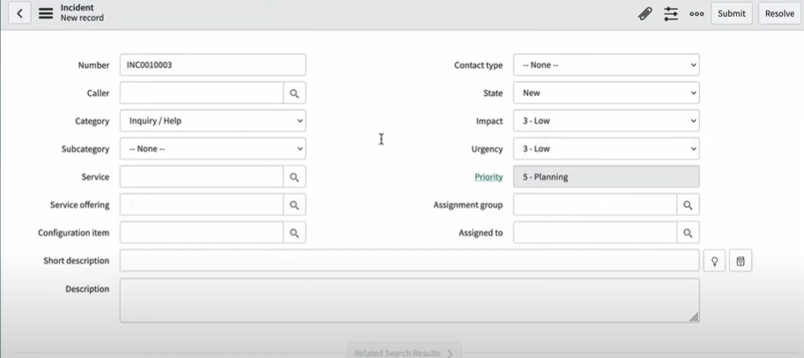

## Search tools and additional features in the List View interface.

The search tool allows users to find records by entering search terms for specific columns, with support for wildcard charactersThe Activity Stream Icon, available for tables that track activities, opens a sidebar with a chronological account of activities related to the list.

## Personalizing lists and managing list views.

The Personalized List Tool enables users to add, remove, and rearrange columns in the list view without affecting other users.

Additional list parameters can be customized, and changes are indicated by a dot on the gear icon. Users can reset to default settings if needed.

The Condition Builder is a powerful tool for applying filters with multiple columns, operators, and values. Saved filters can be reused.

## Column-specific search and use of breadcrumbs for filters.

The Column Search Row toggles search fields for each column, allowing for multi-column filtering with wildcard support.

Breadcrumbs in the list view indicate applied filters, helping users understand the current view context and easily modify filters.

Column labels and context menus offer additional options like sorting and configuring views, with some features reserved for specific roles.

## Advanced options and actions on selected rows.

Bar Chart and Pie Chart items allow for visual representation of data grouped by a specified column, accessible to users with the correct roles

List View provides extensive functionality through context menus, including row, column, and field-specific menus for various actions.

The Field Context Menu offers options like showing matching records or filtering out specific values, and copying URLs or system IDs for records.

Assigning tags to records helps in organizing and grouping related items for additional sorting, filtering, and notifications.

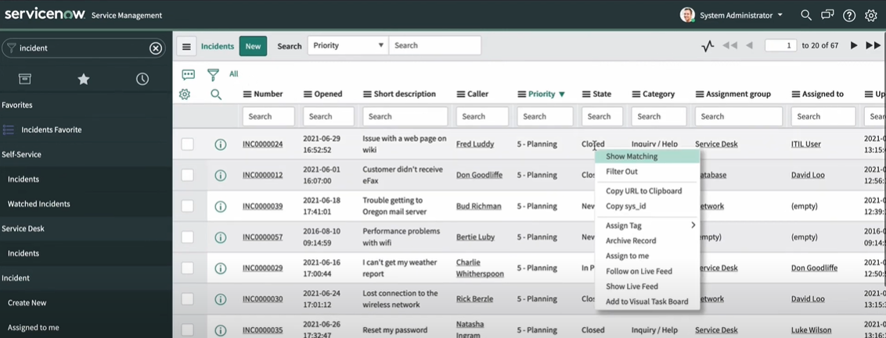

Forms in ServiceNow

* Forms are essential for viewing, changing, or adding data to records stored in ServiceNow's database.

It Demonstrates accessing a user record and creating a new record using forms. It Explains how forms are used to view or create records and mentions the variety of forms are available in ServiceNow.

## Types of form fields in ServiceNow.

##### String field

##### Choice field

##### Reference field

##### Boolean field

ServiceNow requires proactive saving of changes using submit, update, or save options.

Insert creates and saves a new record with copied values and closes the form, while insert & stay keeps the form open.

## Form sections in ServiceNow.

Forms are organized into sections to group fields and data, displayed in tabbed or collapsible formats.

Users can customize the display format through user preferences, affecting only the logged-in user's profile.

## Form views in ServiceNow.

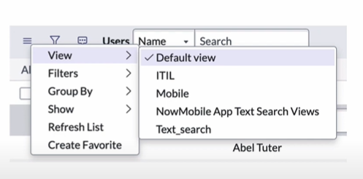

Different users may need different views of a record, which can be created and saved as form views.

Users can switch between form views using the view option in the context menu.

Demonstrates switching between different form views, like Business Card and Self-Service views.

Form views can be customized for different user types, with a default view set for each form.

Attachments can be added to records using the Manage Attachments button, useful for adding screenshots or documents.

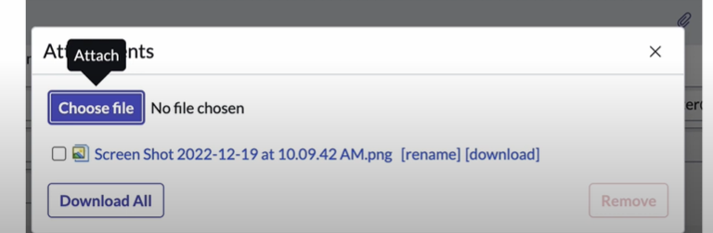

## Using form templates in ServiceNow.

Templates can be created by enabling the template bar and filling out the fields for automatic population.

Templates can set value of fields regardless of their visibility in the form view.

ServiceNow provides tools for creating and editing form views, accessible to users with certain roles.

Form Designer is a drag-and-drop tool for adding, moving, and removing fields and sections.

# A Hands-on ServiceNow Tool Demo

## OVERVIEW

The video provides a comprehensive hands-on demonstration of the ServiceNow platform. It begins with an introduction to ServiceNow and explains how to log into an instance. The speaker then covers the ServiceNow Next Experience UI and navigation bar, offering detailed insights into its components and functionalities.

We need to login into ServiceNow using a browser and entering the URL for the instance. For example chrome. Logging in requires a user account. Users are granted roles to manage their privileges.

## Navigating the ServiceNow interface using the navigation bar

Gives an Explanation of the navigation bar, starting with the User menu for configurations, notifications setup, and contextual help.

Description of the application scope picker, global search, and contextual app pill.

The star icon for creating favourites and the admin menu for specific tools.

## Overview of ServiceNow applications and their workflows.

ServiceNow divides its applications into four primary workflows: IT, Employee, Customer, and Creator.

Each workflow contains several applications tailored to specific needs, such as internal IT functions and customer support.

Further subdivision of workflows into groups of applications, showing the breadth and depth of ServiceNow's offerings.

## Introduction to form views in ServiceNow.

Forms display a single record from a table, showing details and allowing modifications.

Demonstration of accessing user records and displaying a form for a specific user.

Forms can display sections and related lists, such as roles and groups associated with a user.

## Knowledge Management in ServiceNow

Accessing the Knowledge home page, which contains libraries of important articles and documentation.

Knowledge bases are divided into categories, each containing specific articles.

Using the search function to find articles across all knowledge bases.

Details on viewing, flagging, commenting, and rating knowledge articles.

## Overview of the ServiceNow database.

Navigating to the System Definition application and viewing the Tables module, which lists all database tables.

Explanation that ServiceNow operates on a single, enterprise-wide database.

Permissions allow users to make changes to out-of-the-box tables or create new ones.

Introduction to the CMDB (Configuration Management Database), which tracks IT infrastructure and services.

# Introduction to Importing Data in ServiceNow

## Explanation of key terms used in the series.

Introduction to the terminology used in the series. When importing data, there are typically two data entities: the source data entity storing the data to be imported and the target data entity where the data will be loaded.

ServiceNow introduces an intermediary data entity called the staging table or import set table, which acts between the source and target entities.

Clarification that the staging table and import set table are the same. The term staging table simplifies the understanding of the process.

The staging table is automatically created by ServiceNow during the import process. It is not a table that needs to be created manually.

Source->Staging->Target

# Creating a Data Source in ServiceNow

The first step in building the import process is to inform the platform about the data source. This involves specifying the type of source, how to connect to it, the data to be imported, and the creation of a staging table.

## Creating a Data Source in ServiceNow and setting its parameters.

It explains that a Data Source is a record in ServiceNow storing parameters for understanding and connecting to the data source. It involves specifying the subset of data to import and naming the staging table.

This demonstrates navigating to the Data Source table using the application navigator. It shows the process of displaying records in the table, which is currently empty in the developer instance.

## Adding a new Data Source record with specific details.

The process of creating a new Data Source record starts by clicking the 'New' button. This involves filling out a form to add a record to the Data Source table.

Naming the Data Source and specifying details about the staging table. The video explains the importance of labels and actual table names in relational databases.

## Choosing the data source type and uploading the source file.

We select the file type for the data source, demonstrating with an Excel file. It explains setting up attributes based on the file type, such as sheet number and header row.

Attaching the source file to the Data Source record. It shows the process of uploading an Excel file and mentions the importance of having a header row in the spreadsheet.

Previewing the structure of the Excel data source, which includes columns for name, address, city, state, and zip code. It highlights how ServiceNow uses the header row to create fields in the staging table

Finalizing the Data Source setup by attaching the file and saving the record

# Understanding Import Sets in ServiceNow

## Running the import and verifying the staging table creation.

The presenter navigates back to the data source to run the import. They load all records from the data source, causing ServiceNow to create the staging table and load the data.

ServiceNow checks for the staging table, creates it, and loads the requested data. A confirmation message indicates the successful completion of the import, with five records processed.

Verification that the staging table was created and populated with five rows from the spreadsheet. The structure and layout of the staging table are shown.

## Connecting staging table records to import set runs and concluding the tutorial.

The presenter shows the linkage between staging table records and their respective import set runs. They demonstrate sorting records by the set attribute to view the grouping.

##### Summary of the steps covered:

Creating a data source record

Validating the data source connection

Creating and loading data into the staging table.

# ServiceNow Transform Maps & Field Maps

## Introduction to transform maps and field maps in ServiceNow.

Instructing ServiceNow on moving data from the staging table to the target table using transform maps and field maps.

Definition and explanation of field maps, which are used to map fields from the staging table to the target table one at a time.

## Explanation of transform maps and their purpose.

Transform maps group field maps together, representing the import as a whole

## Creating a transform map and field maps.

Creating a transform map by navigating to the transform map table and creating a new record.

## Using mapping assist to create field maps.

Mapping assist helps map fields from the source table (staging table) to the target table.It demonstrates mapping fields such as name, address, city, state, and zip code.

The concept of 'coalesce' is introduced, which is used for matching fields to avoid duplicate entries during import.

ServiceNow Incident Management Tutorial and Task Administration

# Detailed explanation of Incident, Problem, and Change Request tasks in ServiceNow.

Incident, Problem, and Change Request tasks extend the task table, inheriting its attributes and adding specific ones.

Task records are created when entries are added to tables extending the task table. Direct creation of task records in the task table is not possible.

Explanation of the importance of the task table and its extensions. Focus on the three most used tasks: incident, problem, and change request.

Task creation is managed through extended tables in the UI. The platform handles the creation of task records automatically.

# Explanation and demonstration of task assignment rules in ServiceNow.

Tasks are assigned to users or groups using the 'assigned to' and 'assignment group' fields. Users and groups must be populated in their respective tables.

Groups can contain multiple users and other groups. Tasks are typically assigned to groups first and then to individual users.

Assignment rules automate the assignment process by specifying conditions for task assignment. These rules are stored in the 'assignment rule' table.

Multiple assignment rules can exist for a task type, with execution order determining the rule check sequence. Rules are executed based on conditions met.

## Overview of Visual Task Boards and demonstration of their use.

Visual Task Boards offer a graphical drag-and-drop interface for viewing tasks. They help identify bottlenecks and organize work visually.

Components of Visual Task Boards include cards and lanes. Each card represents a task, and each lane represents a category or grouping.

Tools for managing, filtering, and assigning tasks. Quick panel allows filtering by user and assignment of users and labels via drag-and-drop.

ServiceNow Reporting Tutorial

# Step-by-step guide on creating a new report in ServiceNow.

Options for creating a report, including using the reports applications create new module, ServiceNow Studio, or an existing list View.

The other way is,

* Using ServiceNow Studio involves working within an application scope and creating a new report from there.

Creating a report from existing data by using the list view and column context menu.

What is Low Code No Code Development?

# The Low Code No Code Approach

Introduction of Low Code No Code as the hero that breaks down barriers between business and IT. It aims to empower business users to solve problems independently using intuitive tools, thus eliminating the skills gap and simplifying technical tasks.

Low Code No Code tools provide business users with the ability to manage servers, databases, workflows, and integrations without the need for extensive technical knowledge.

# Pros and Cons

The benefits of Low Code No Code development include improved agility, faster time to market, lower costs, and increased automation. However, it also comes with limitations such as reduced flexibility and the need to rely on pre-written code.

The underlying code still exists, and users must work within the constraints of the provided tools. Despite these limitations, the approach offers significant advantages in many scenarios.

Business users are encouraged to leverage Low Code No Code tools to innovate and improve their processes. They should seek opportunities to learn technical skills and collaborate with IT professionals to maximize their impact.