

ARTIFICIAL INTELLIGENCE

AND

MACHINE LEARNING

**Handwritten digit recognition**

By:

M S Eshwar(20csu057)

Sirun(20csu141)

Shiven Arora(20csu148)

Mehul Ratra(20csu151)

Department of Computer Science and Engineering

School of Engineering and Technology

The NorthCap University, Gurugram- 122001, India

Session 2022

**Introduction**

To make machines more intelligent, we are diving into machine learning and Deep learning techniques. A human learns to perform a task by performing it again and again, so that it memorizes how to perform a task. Machines do it by Deep learning, it uses different types of neural network architectures for problems like object recognition, image classification and object detection.

We are going to use MNIST dataset for the implementation of a handwritten digit recognition. To implement we use a neural network called Convolutional Neural Network. In the end we will use a Graphic user interface (GUI) where you can directly draw and recognize the digits. The MNIST dataset was complied with images of digits from various scanned documents and then normalized in size.

It can be used in pattern recognition applications. The applications of digit recognition include Band check processing, postal mail sorting, form data entry etc.5

**Problem statement**

In coming days, character recognition system might serve as a key factor to create a paperless environment by digitizing and processing existing paper documents.

We’re going to trace a character of digits, so if I write date, it should create a bounding box and within the bounding box it will represent what character it is e.g.: eight, seven etc

What we are going to learn:

1. How we can train our model
2. How we can implement the model in a real time scenario.

**Literature survey**

Research papers analysis

1. <https://ehtl.fa.us6.oraclecloud.com/hcmUI/CandidateExperience/en/job/10661/?utm_medium=jobshare&utm_source=linkedin&utm_medium=social>

In this paper, the variations of accuracies for handwritten digit were observed for 15 epochs by varying the hidden layers. The accuracy curves were generated for the six cases for the different parameter using CNN MNIST digit dataset, The six cases perform differently because of the various combinations of hidden layers. The layers were taken randomly in a periodic sequence so that each case behaves differently during the experiment. The maximum and minimum accuracies were observed for different hidden layers variation with a batch size of 100. Among all the observation, the maximum accuracy in the performance was found 99.21% for 15 epochs in case 2 (Conv1, pool1, Conv2, pool2 with 2 dropouts). In digit recognition, this type of higher accuracy will cooperate to speed up the performance of the machine more adequately. However, the minimum accuracy among all observation in the performance was found **97.07%** in case 6 (Conv1, pool1, Conv2, pool2 with 1 dropout). Moreover, among all the cases, the total highest test loss is approximately 0.049449 found in case 3 without dropout and the total lowest test loss is approximately 0.026303 found in case 2 with dropout. This low loss will provide CNN better performance to attain better image resolution and noise processing. In the future, we plan to observe the variation in the overall classification accuracy by varying the number of hidden layers and batch size.

2)<https://ieeexplore.ieee.org/stamp/stamp.jsp?tp=&arnumber=9641160&isnumber=9641065>

In this research, we have implemented three models for handwritten digit recognition using MNIST datasets, based on deep and machine learning algorithms. We compared them based on their characteristics to appraise the most accurate model among them. Support vector machines are one of the basic classifiers that’s why it’s faster than most algorithms and in this case, gives the maximum training accuracy rate but due to its simplicity, it’s not possible to classify complex and ambiguous images as accurately as achieved with MLP and CNN algorithms. We have found that CNN gave the most accurate results for handwritten digit recognition. So, this makes us conclude that CNN is best suitable for any type of prediction problem including image data as an input. Next, by comparing execution time of the algorithms we have concluded that increasing the number of epochs without changing the configuration of the algorithm is useless because of the limitation of a certain model and we have noticed that after a certain number of epochs the model starts overfitting the dataset and give us the biased prediction

3) blob:https://web.whatsapp.com/1ed8d9a5-8349-4c91-a387-7b2a03c08e42

The main objective of this investigation is to find a representation of isolated handwritten digits that allow their effective recognition. In this paper used different machine learning algorithm for recognition of handwritten numerals. In any recognition process, the important problem is to address the feature extraction and correct classification approaches. The proposed algorithm tries to address both the factors and well in terms of accuracy and time complexity. The overall highest accuracy **90.37%** is achieved in the recognition process by Multilayer Perceptron. This work is carried out as an initial attempt, and the aim of the paper is to facilitate for recognition of handwritten numeral without using any standard classification techniques

**Referenced Scholar articles:**

1. <https://ehtl.fa.us6.oraclecloud.com/hcmUI/CandidateExperience/en/job/10661/?utm_medium=jobshare&utm_source=linkedin&utm_medium=social>
2. Research on Mnist Handwritten Numbers Recognition based on CNN Yang Gong and Pan Zhang
3. A Survey of Handwritten Character Recognition with MNIST and EMNIST by Alejandro Baldominos, Yago Saez and Pedro Isasi

<https://www.mdpi.com/2076-3417/9/15/3169>

1. A review and an approach for object detection in images

January 2017

International Journal of Computational Vision and Robotics

<https://www.researchgate.net/publication/312037041_A_review_and_an_approach_for_object_detection_in_images>

1. Al-Mahmud, A. Tanvin and S. Rahman, "Handwritten English Character and Digit Recognition," 2021 International Conference on Electronics, Communications and Information Technology (ICECIT), 2021, pp. 1-4, doi: 10.1109/ICECIT54077.2021.9641160.

<https://ieeexplore.ieee.org/stamp/stamp.jsp?tp=&arnumber=9641160&isnumber=9641065>

1. E. R. G, S. M, A. R. G, S. D, T. Keerthi and R. S. R, "MNIST Handwritten Digit Recognition using Machine Learning," 2022 2nd International Conference on Advance Computing and Innovative Technologies in Engineering (ICACITE), 2022, pp. 768-772, doi: 10.1109/ICACITE53722.2022.9823806.

<https://ieeexplore.ieee.org/stamp/stamp.jsp?tp=&arnumber=9823806&isnumber=9823413>

1. <https://ijisrt.com/wp-content/uploads/2019/06/IJISRT19JU358.pdf>
2. <https://journalofbigdata.springeropen.com/articles/10.1186/s40537-021-00434-w>
3. Z. Kayumov and D. Tumakov, "Convolution Neural Network Learning Features for Handwritten Digit Recognition," 2020 IEEE East-West Design & Test Symposium (EWDTS), 2020, pp. 1-5, doi: 10.1109/EWDTS50664.2020.9224822.

<https://ieeexplore.ieee.org/stamp/stamp.jsp?tp=&arnumber=9224822&isnumber=9224633>

**Proposed methodology**

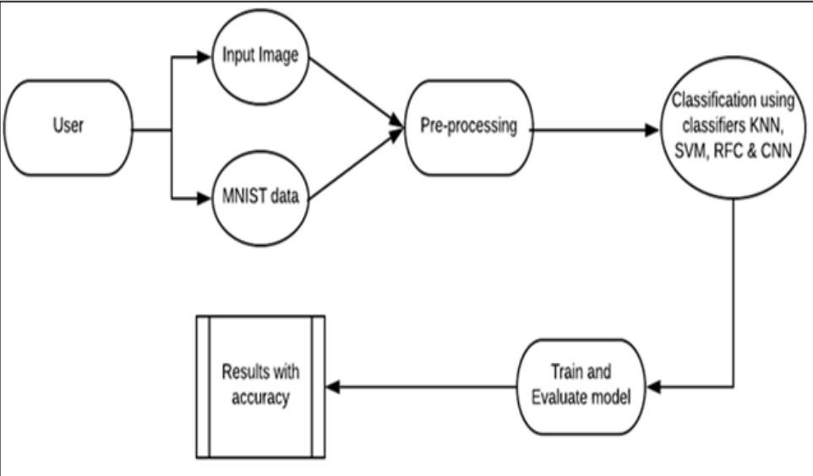

**CONVOLUTION NEURAL NETWORKS**

A convolutional neural network (CNN or ConvNet), is a network architecture for deep learning

which learns directly from data, eliminating the need for manual feature extraction.

Due to the selection of the data set, we decompose the picture into 28*28 blocks of the

same size. According to the original trained neural network, we input a complete picture

into the neural network. But for CNN, the pixel block is directly input this time. The

same neural network weight will be used for every small tile. If any small tile has any

abnormality, we think the tile is interested. In this neural network, there is no order in

which small tiles are disturbed, and the results are still saved in the order of input. Then

we will get a sequence. The part where the picture is stored is interesting. Since the

array is generally large, we will first down sample it to reduce the size of the array. Find

the max value in each grid square in our array. Finally, the column will be inputted into

the Fully Connected Network and the neural network will determine if the picture

matches.

**OPEN COMPUTER VISION**

OpenCV (Open-Source Computer Vision Library) is an open-source computer vision and machine learning software library. OpenCV was built to provide a common infrastructure for computer vision applications and to accelerate the use of machine perception in the commercial products.

**Experimental results**

**\*(Results screenshots)**

| |  | | --- | |  |
| --- | --- | --- |

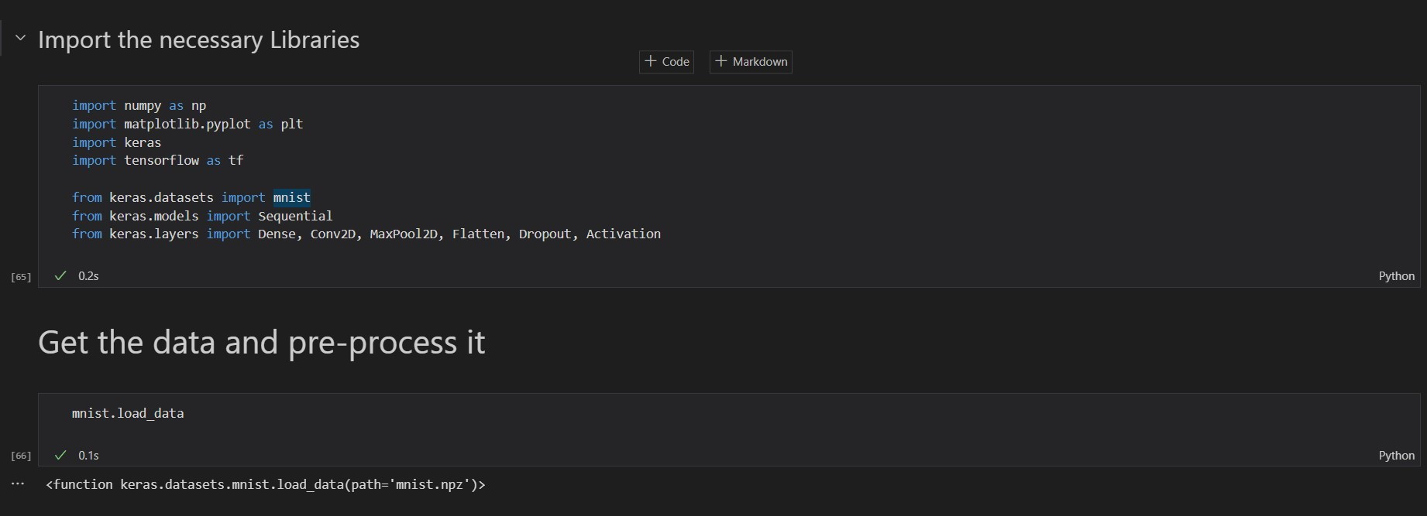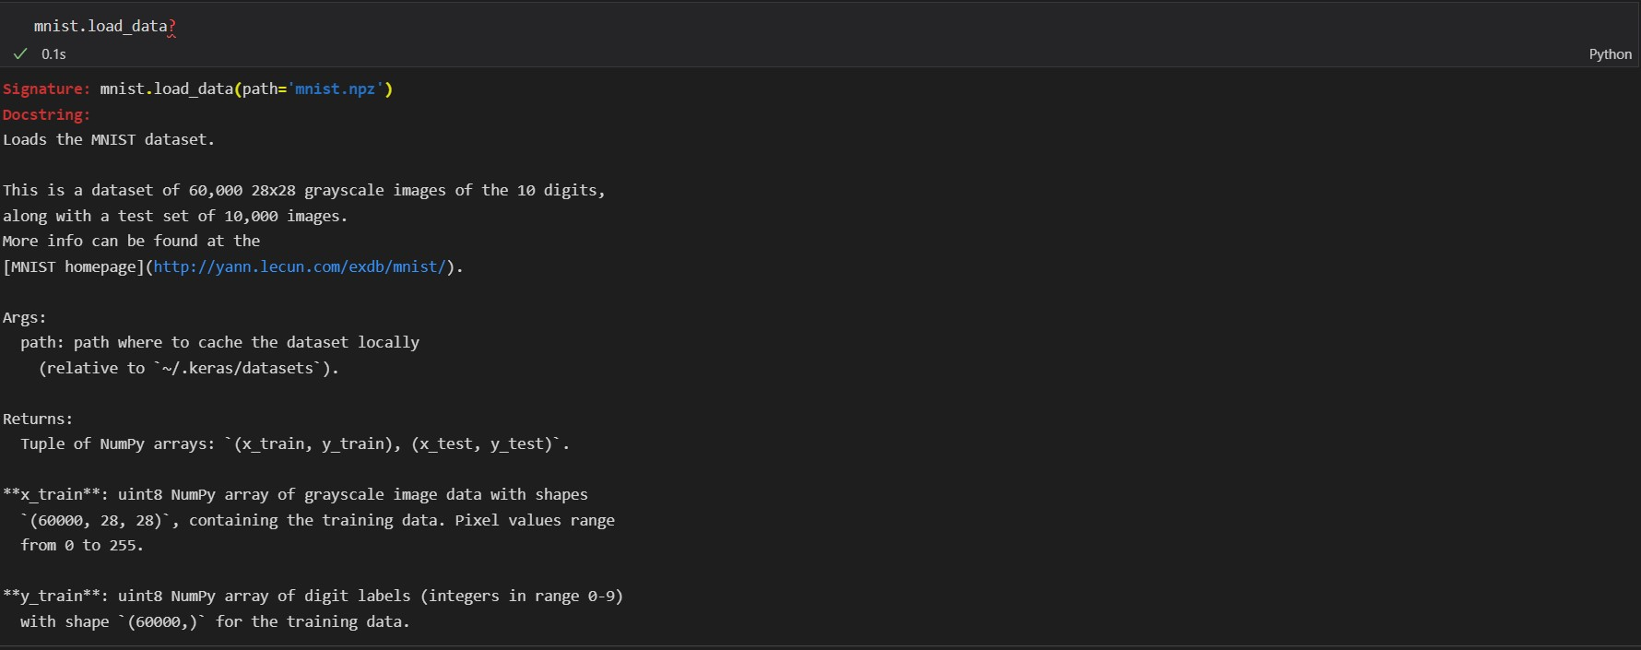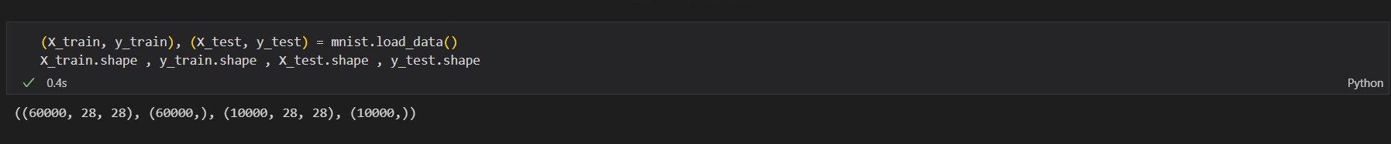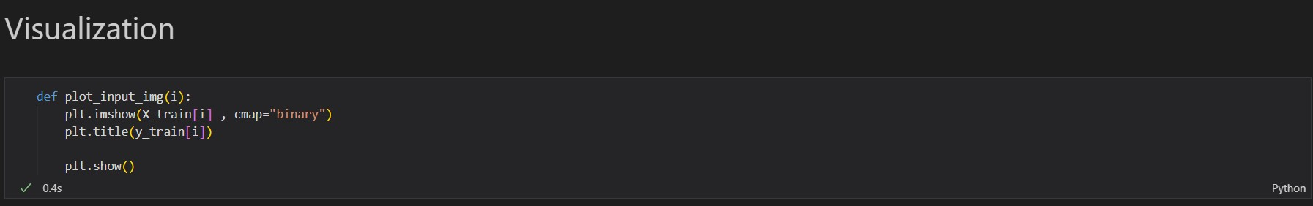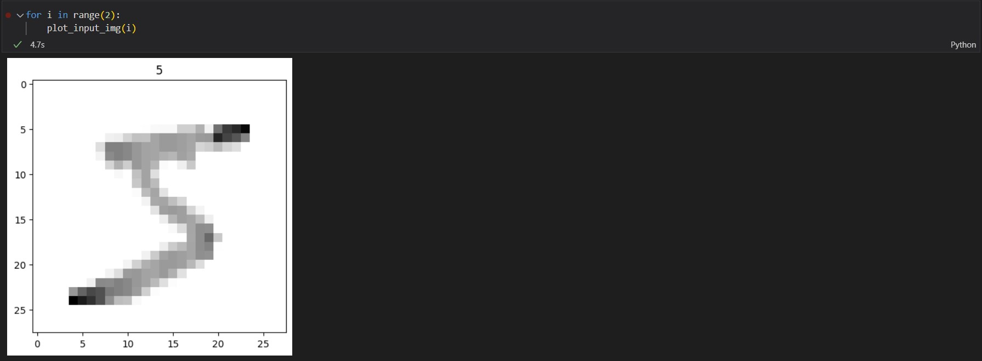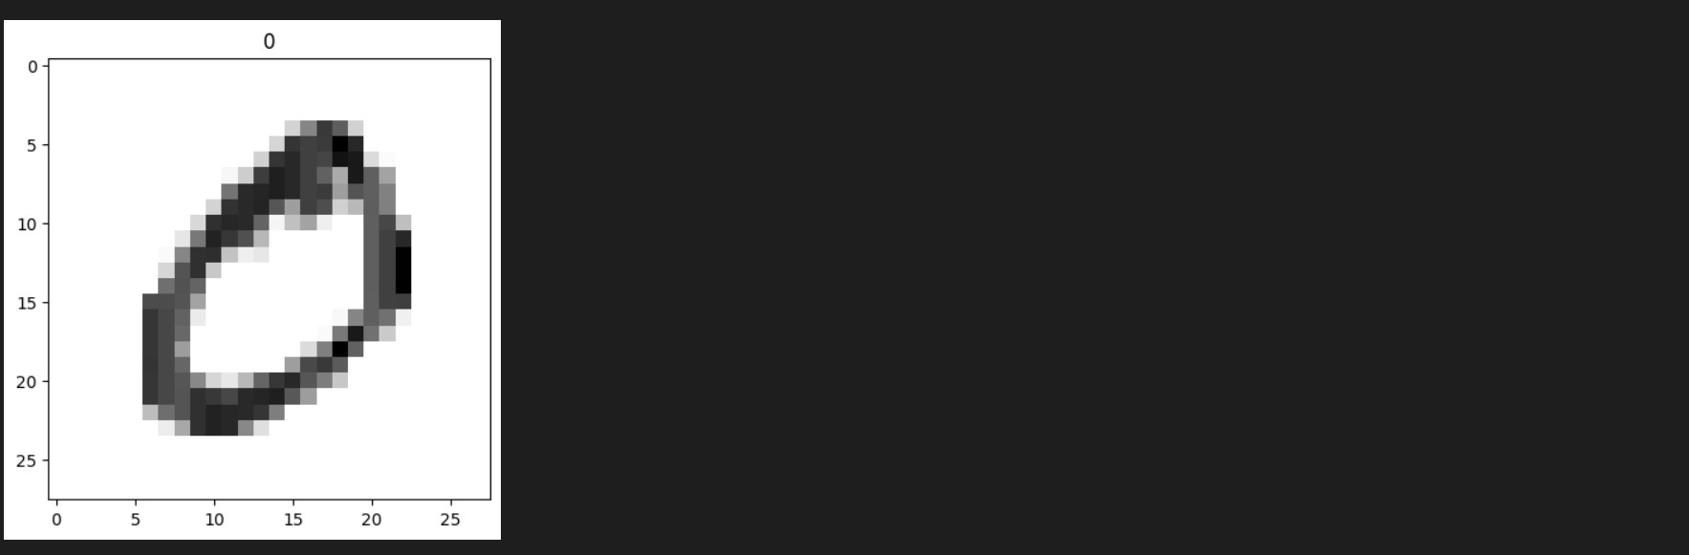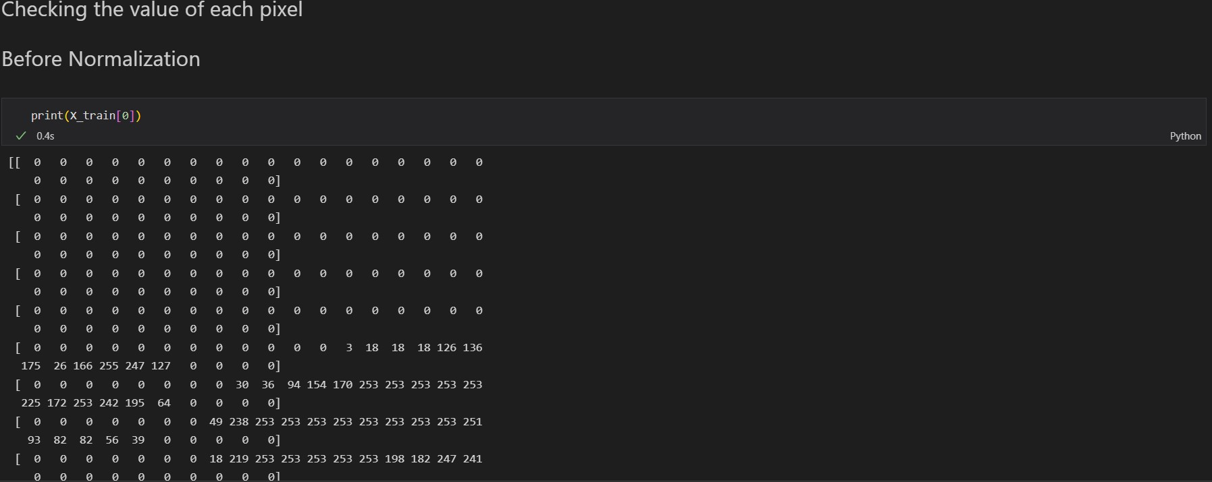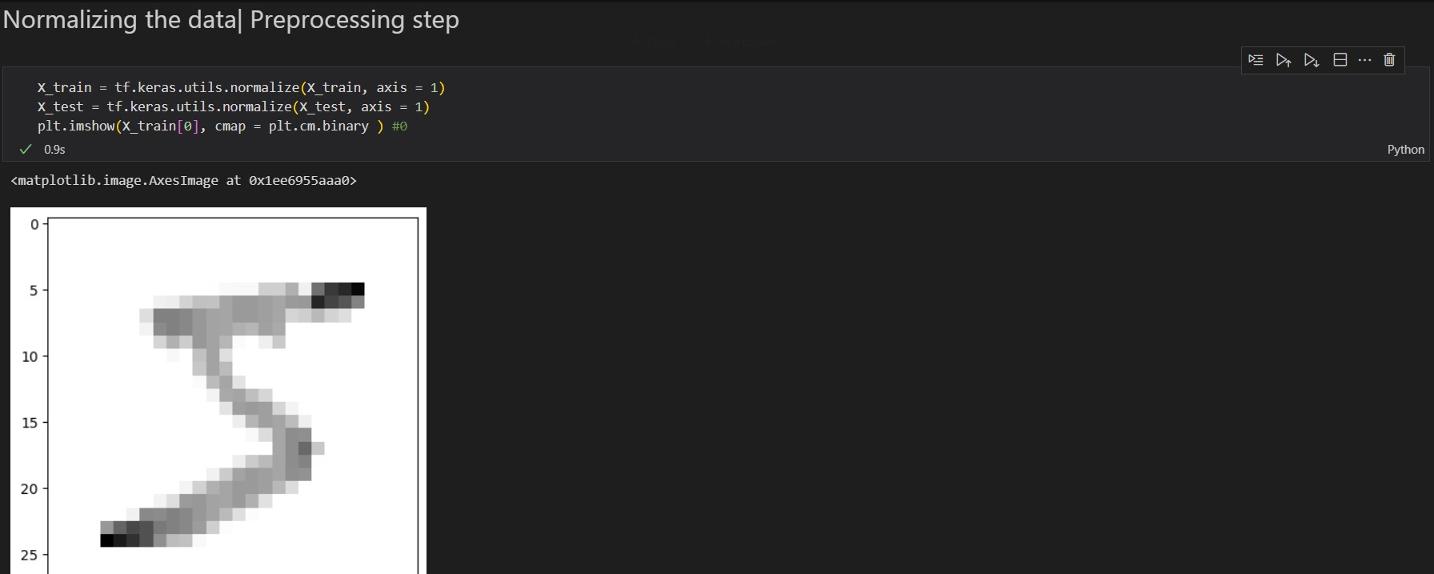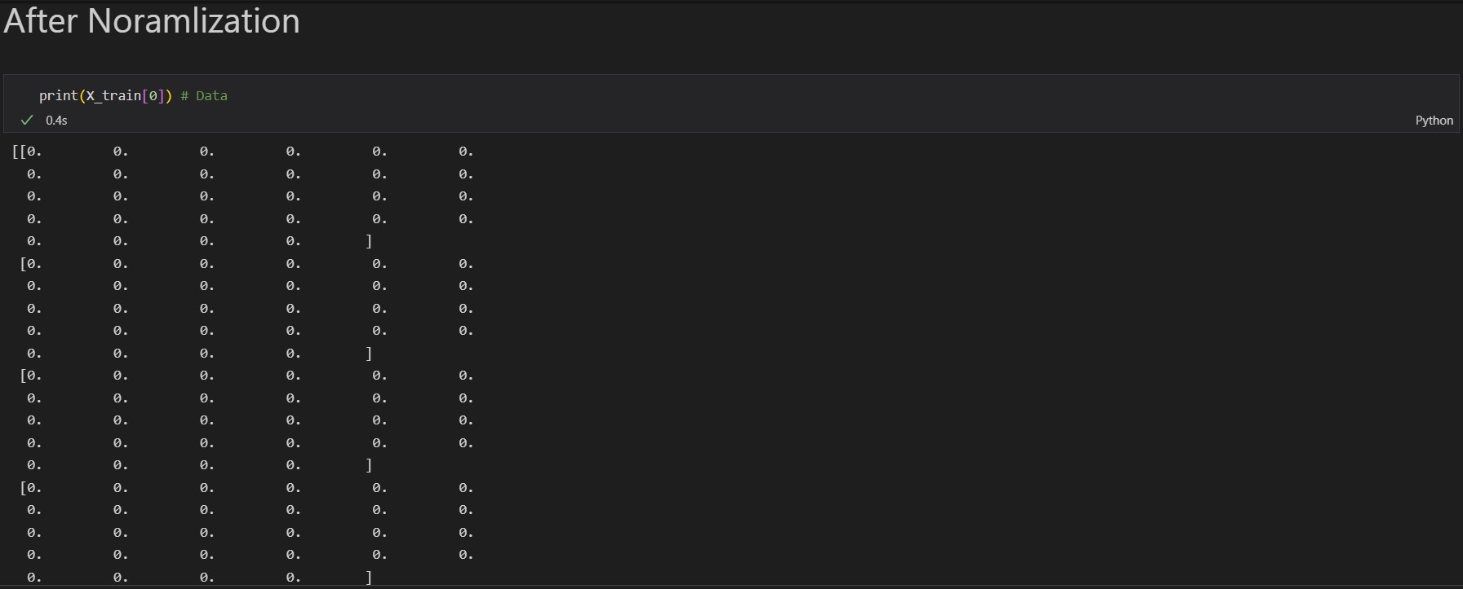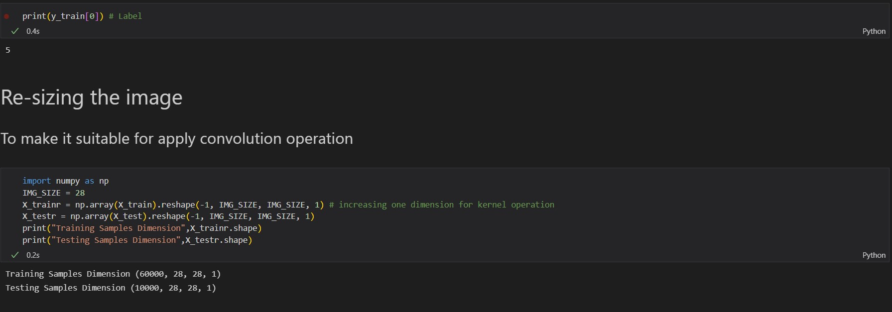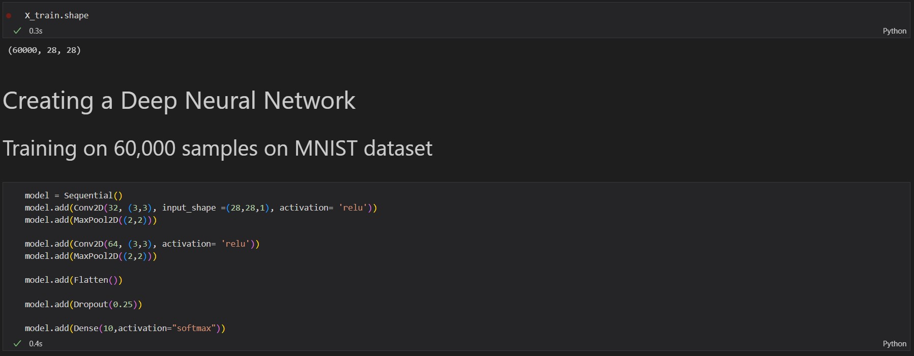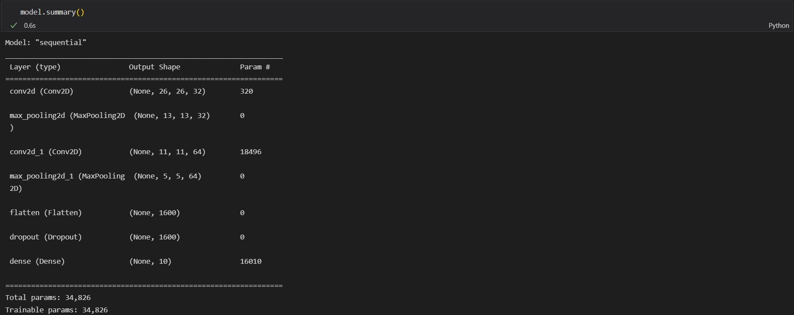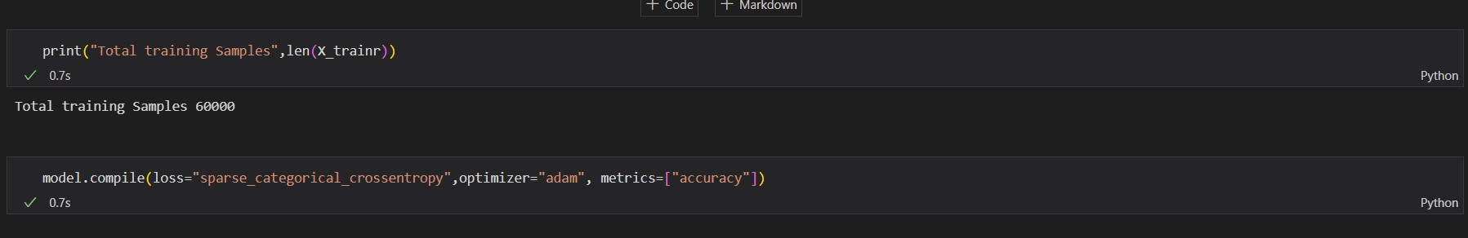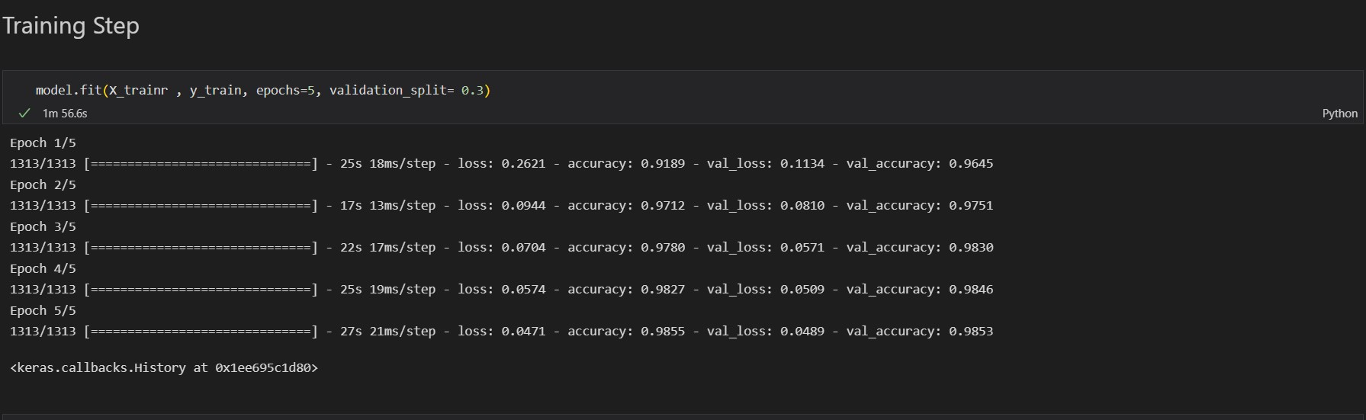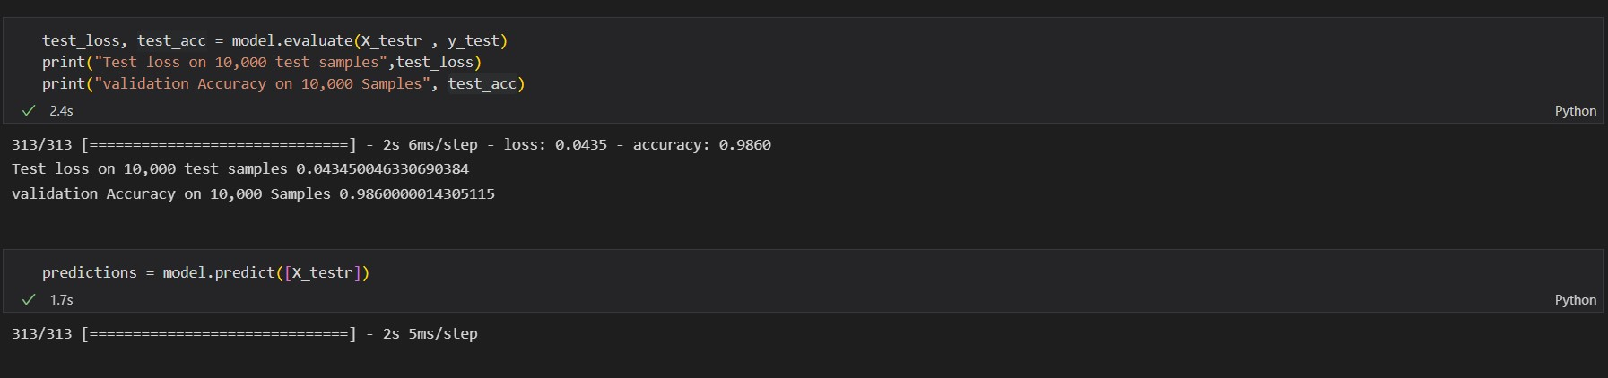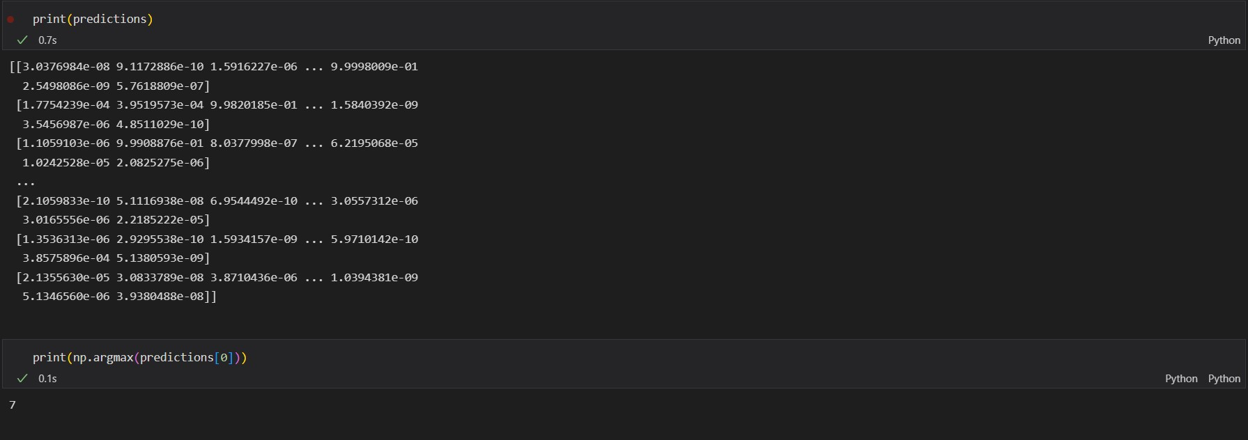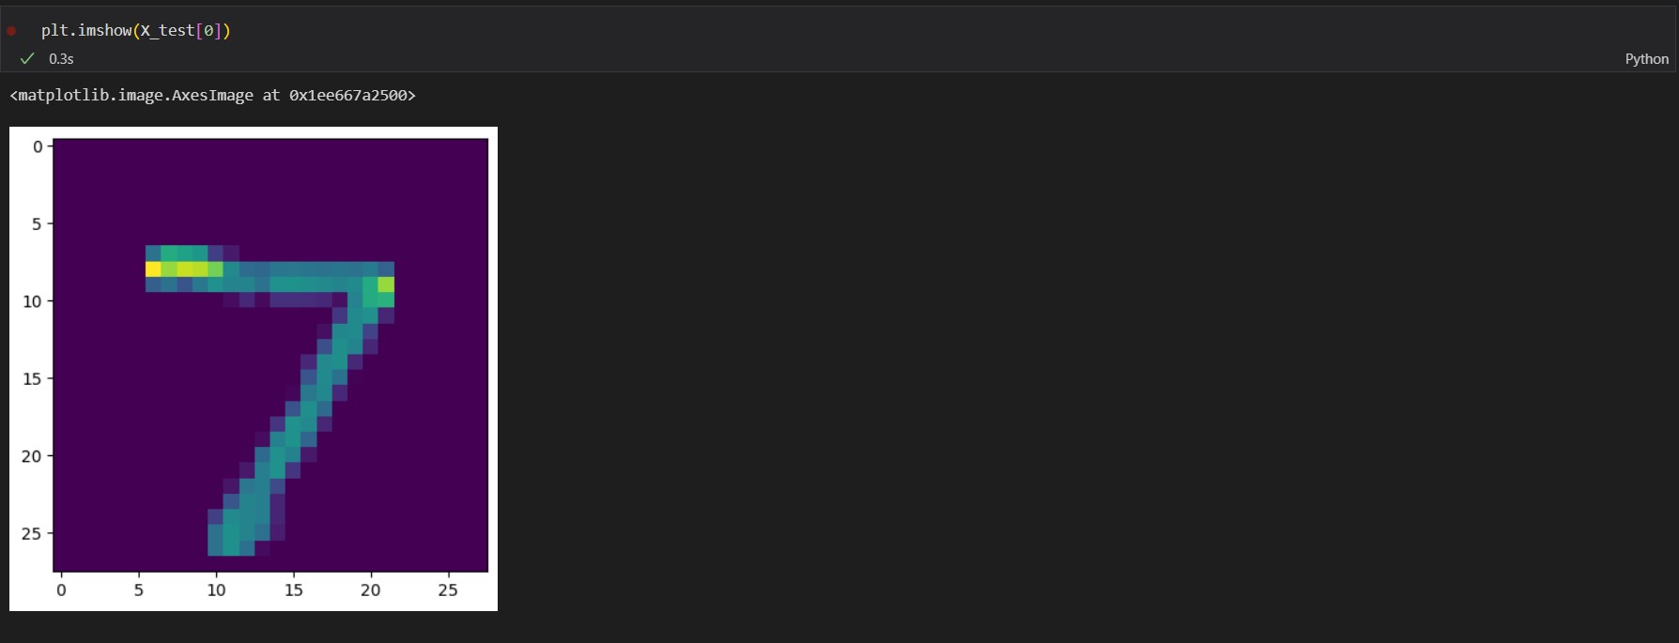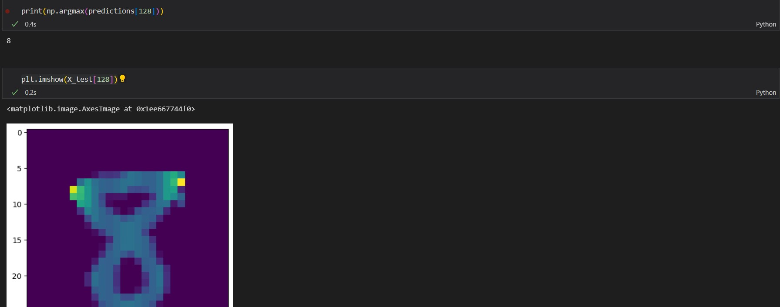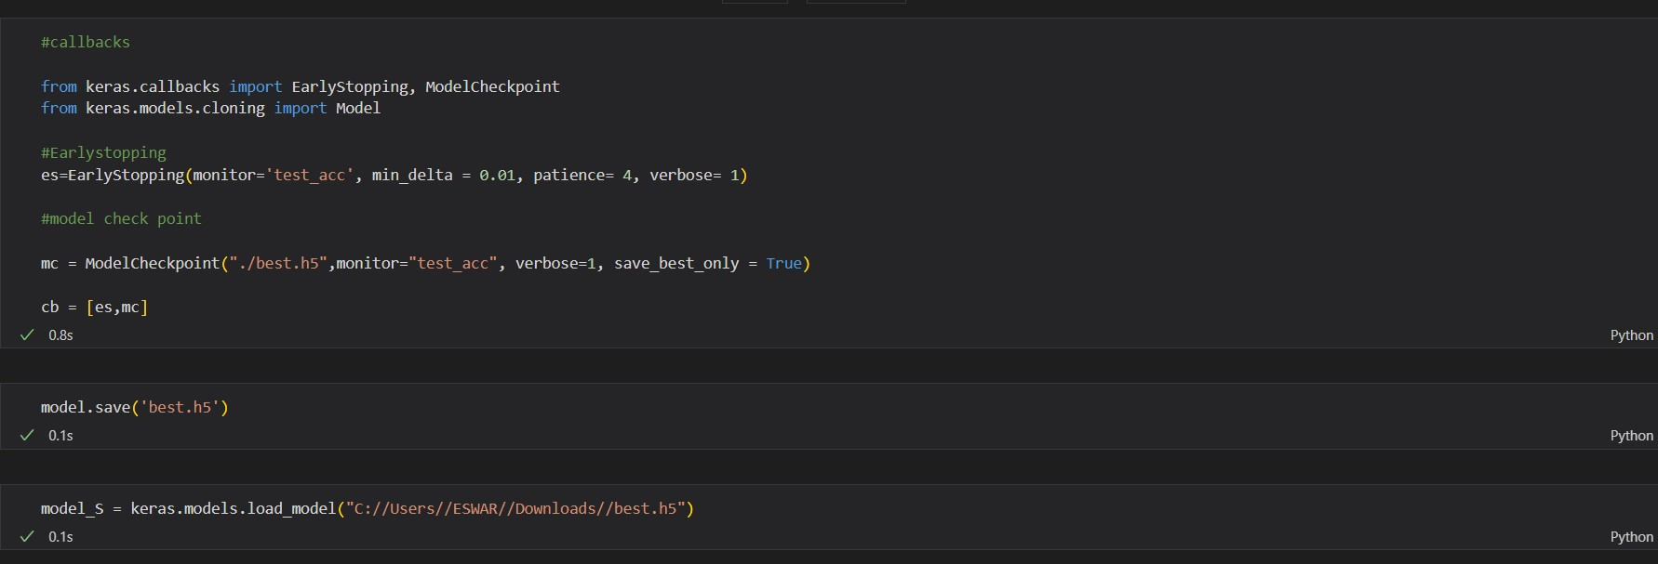

**Application**

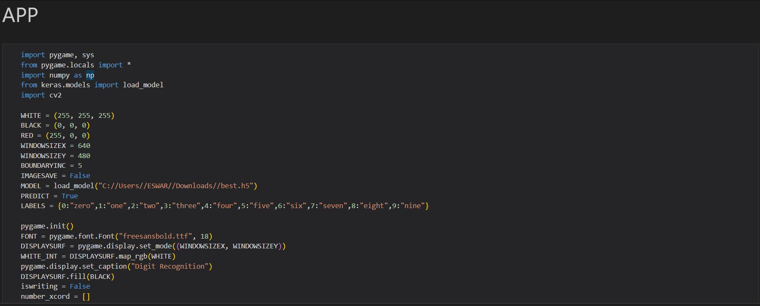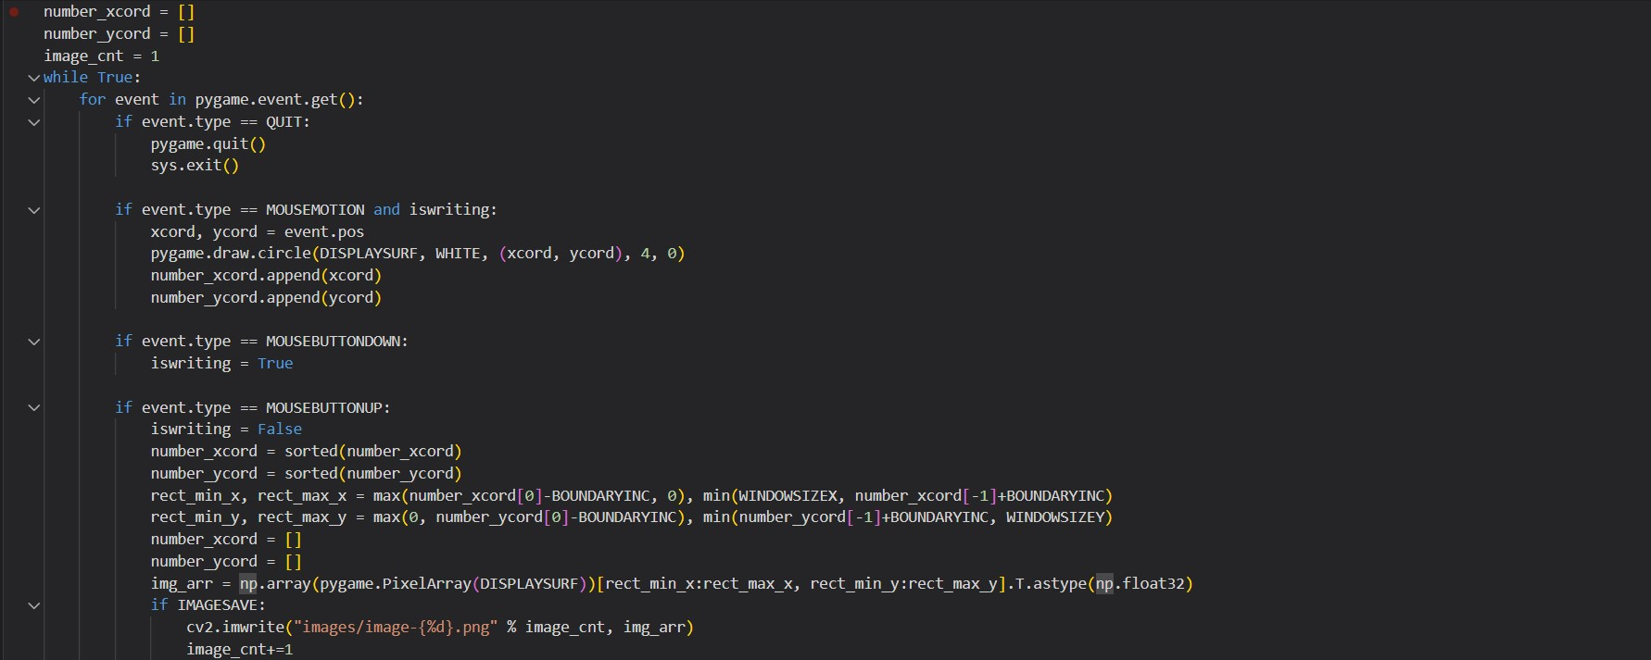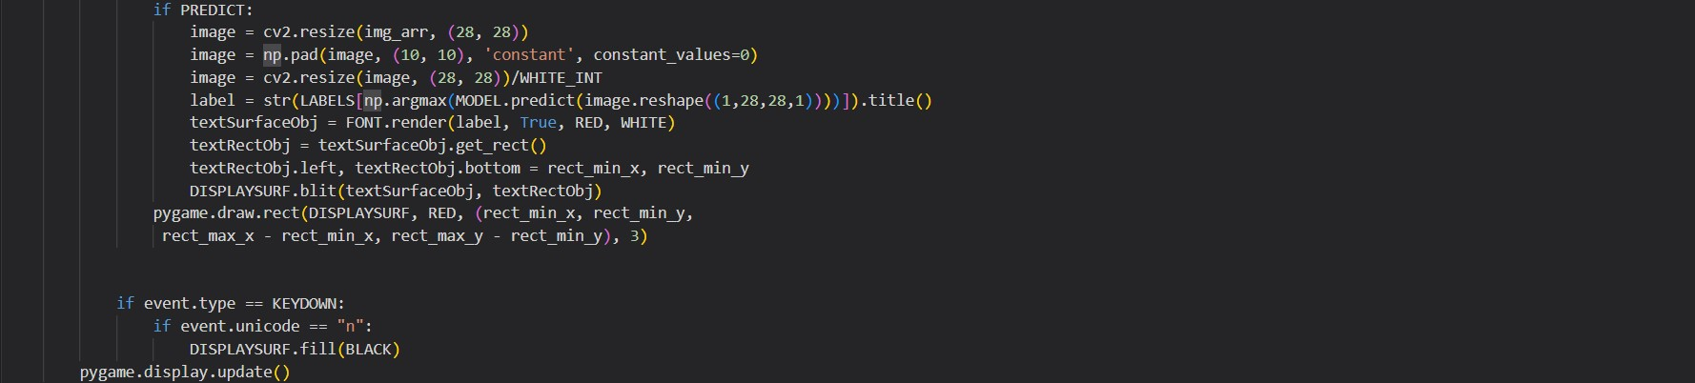

OUTPUT:

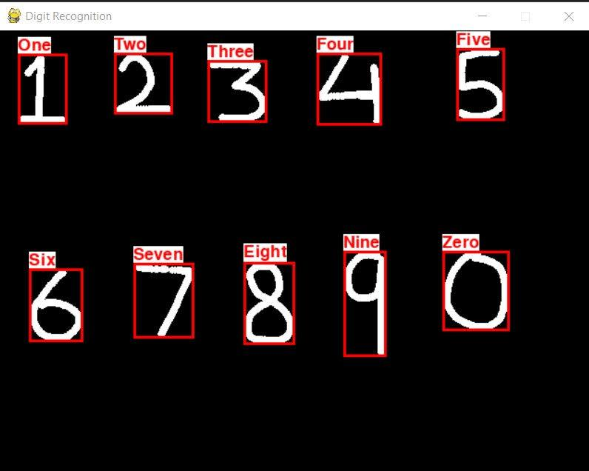

**Reference material**

1. [**https://hcis-journal.springeropen.com/articles/10.1186/s13673-020-00219-9**](https://hcis-journal.springeropen.com/articles/10.1186/s13673-020-00219-9)
2. <https://towardsdatascience.com>
3. [**https://machinelearningmastery.com/object-recognition-with-deep-learning/**](https://machinelearningmastery.com/object-recognition-with-deep-learning/)
4. [**https://hcis-journal.springeropen.com/articles/10.1186/s13673-020-00219-9**](https://hcis-journal.springeropen.com/articles/10.1186/s13673-020-00219-9)
5. [**https://www.kaggle.com/c/mnist-handwritten-digit-recognition/data**](https://www.kaggle.com/c/mnist-handwritten-digit-recognition/data)