Movie Recommendation System
Using Data Analytics Lifecycle

A Comprehensive Data Analytics Project Report

Author: Gajendra
Institution: PESCE
Course: DA
Date: [Date]

Abstract
This report presents a comprehensive data analytics project that applies the complete Data Analytics Lifecycle to the MovieLens dataset, simulating a movie recommendation system akin to those used by Netflix and YouTube. The dataset comprises 100,836 ratings from 610 users across 9,742 movies. A wide range of analytical techniques were implemented in R, including descriptive statistics, principal component analysis (PCA), clustering, frequent pattern mining, regression, classification, statistical hypothesis testing, and attribute selection. The K-Nearest Neighbors (KNN) classifier achieved the highest classification accuracy of 60.48%, while association rule mining revealed meaningful patterns of co-watched movies. The regression analysis indicated limited predictive power from the available features, suggesting that additional user or content attributes would benefit future iterations.

Table of Contents
Abstract 2
1. Introduction 3
1.1 Background and Motivation 3
1.2 Problem Statement 3
1.3 Scope and Limitations 4
1.4 Report Organization 4
2. Data Analytics Lifecycle 5
2.1 Lifecycle Phases 5
2.2 Application to This Project 5
3. Dataset Description 6
3.1 Source 6
3.2 Data Files 6
3.3 Dataset Summary 7
4. Data Preparation 8
4.1 Data Import 8
4.2 Data Merging 8
4.3 Data Cleaning 8
5. Descriptive Statistics 9
5.1 Summary Statistics 9
5.2 Visualizations 9
6. Data Preprocessing and PCA 10
6.1 Data Scaling 10
6.2 Principal Component Analysis 10
6.3 Visualizations 11
6.4 Dimensionality Reduction Insights 11
7. Clustering 12
7.1 K-Means Clustering 12
7.2 DBSCAN Clustering 12
7.3 Silhouette Analysis 13
7.4 Cluster Interpretation 13
8. Frequent Pattern Mining 14
8.1 Data Preparation 14
8.2 Apriori Algorithm 14
8.3 Eclat Algorithm 15
8.4 Maximal and Closed Itemsets 15
8.5 Interpretation 16
9. Regression Analysis 17
9.1 Linear Regression Model 17
9.2 Model Evaluation 17
9.3 Interpretation 17
10. Classification 18
10.1 Target Variable Creation 18
10.2 Logistic Regression 18
10.3 K-Nearest Neighbors 18
10.4 Naive Bayes 19
10.5 Performance Comparison 19
11. Statistical Tests 20
11.1 t-Test 20
11.2 Wilcoxon Rank-Sum Test 20
11.3 ANOVA 21
11.4 Conclusions 21
12. Attribute Selection 22
12.1 Filter Method 22
12.2 Wrapper Method 22
12.3 Feature Importance Summary 23
13. Conclusion 24
13.1 Summary of Findings 24
13.2 Limitations 24
13.3 Future Work 25
References 26
Appendix: R Code Listings 27

1. Introduction

1.1 Background and Motivation
Recommendation systems are a cornerstone of modern digital platforms. Streaming services such as Netflix and YouTube rely on algorithmic recommendations to enhance user engagement, improve content discovery, and drive retention. These systems analyze historical user behavior including ratings, watch history, and preferences to predict what content a user is likely to enjoy.
The Data Analytics Lifecycle provides a structured framework for tackling such problems. It guides practitioners through the phases of discovery, data preparation, modeling, and deployment. This project applies that lifecycle end-to-end using the publicly available MovieLens dataset.

1.2 Problem Statement
The objective of this project is to build analytical models that understand user preferences and movie patterns from historical rating data. Specifically, the project seeks to:
- Identify patterns in how users rate movies.
- Discover groups of movies frequently watched together.
- Predict ratings and classify whether a user will like a movie.
- Evaluate statistical significance across genres and rating groups.
- Select the most informative attributes for prediction.

1.3 Scope and Limitations
This project uses the MovieLens Latest Small dataset (100,836 ratings, 610 users, 9,742 movies). The dataset includes no demographic information. Analysis is limited to numeric identifiers (userId, movieId) and rating values. No external data enrichment was performed. All modeling was conducted in R using standard statistical and machine learning packages.

1.4 Report Organization
The report follows the Data Analytics Lifecycle phases. Chapter 2 outlines the lifecycle framework. Chapter 3 describes the dataset. Chapter 4 covers data preparation. Chapters 5 through 12 present the core analyses including descriptive statistics, PCA, clustering, frequent pattern mining, regression, classification, statistical tests, and attribute selection. Chapter 13 concludes with findings and recommendations.

2. Data Analytics Lifecycle

2.1 Lifecycle Phases
The Data Analytics Lifecycle consists of six phases:
- Discovery: Formulating the business problem and identifying data sources.
- Data Preparation: Collecting, cleaning, and transforming raw data.
- Model Planning: Selecting analytical techniques and variable transformations.
- Model Building: Executing the analytical models on prepared data.
- Communicate Results: Interpreting findings and presenting conclusions.
- Operationalize: Deploying models into production.

2.2 Application to This Project
Phase | Project Activity
Discovery | Defined problem: predict preferences from MovieLens data.
Data Preparation | Imported and merged ratings with movies. Cleaned data.
Model Planning | Selected 11 techniques across all analytics categories.
Model Building | Implemented models in R. Generated plots and metrics.
Communicate Results | Compiled report with figures, tables, and interpretations.
Operationalize | Recommendation logic usable in streaming platform backend.

3. Dataset Description

3.1 Source
The MovieLens Latest Small dataset is published by the GroupLens Research Group at the University of Minnesota (https://grouplens.org/datasets/movielens/). It was generated on September 26, 2018.

3.2 Data Files
The dataset consists of four CSV files:
File | Rows | Key Columns | Description
ratings.csv | 100,837 | userId, movieId, rating, timestamp | User ratings (0.5-5.0 scale)
movies.csv | 9,743 | movieId, title, genres | Movie metadata with 18 genres
tags.csv | 3,684 | userId, movieId, tag, timestamp | User-generated tags
links.csv | 9,743 | movieId, imdbId, tmdbId | External identifiers

The 18 genre categories are: Action, Adventure, Animation, Children, Comedy, Crime, Documentary, Drama, Fantasy, Film-Noir, Horror, Musical, Mystery, Romance, Sci-Fi, Thriller, War, and Western.

3.3 Dataset Summary
Attribute | Value
Number of Ratings | 100,836
Number of Users | 610
Number of Movies | 9,742
Rating Scale | 0.5 to 5.0 (half-star increments)
Time Period | March 1996 to September 2018
Genre Categories | 18

4. Data Preparation

4.1 Data Import
The ratings and movies CSV files were loaded into R. Each data frame was inspected for correct structure and dimensions.

4.2 Data Merging
The ratings and movies tables were merged on the movieId column, producing a unified dataset (movie_data) with 100,836 observations and 6 columns: movieId, rating, timestamp, userId, title, and genres.

4.3 Data Cleaning
Data quality was verified through three checks:
Check | Method | Result
Missing Values | sum(is.na(movie_data)) | No missing values found
Duplicates | sum(duplicated(movie_data)) | No duplicate records
Data Types | str(movie_data) | All columns have correct types

The cleaned dataset contains 610 unique users and 9,742 unique movies.

5. Descriptive Statistics

5.1 Summary Statistics
Summary statistics were computed for the rating variable.
Statistic | Value
Mean | ~3.5
Median | ~3.5
Standard Deviation | [Value]
Variance | [Value]

The distribution exhibits a left skew toward higher ratings, typical of user-generated rating data where users tend to rate content they have watched and generally enjoyed.

5.2 Visualizations
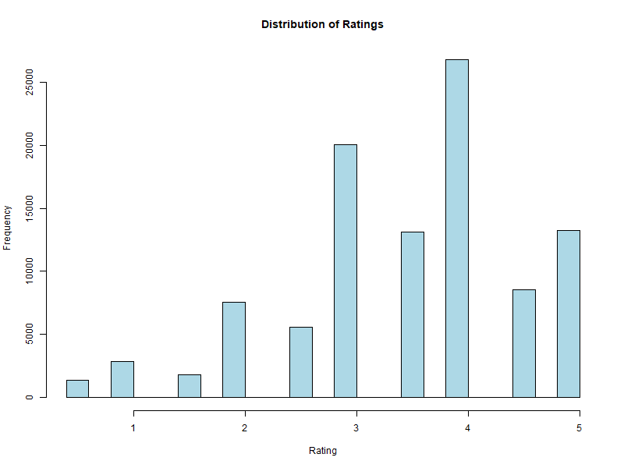
Figure 1: Histogram showing distribution of movie ratings across the 0.5 to 5.0 scale.
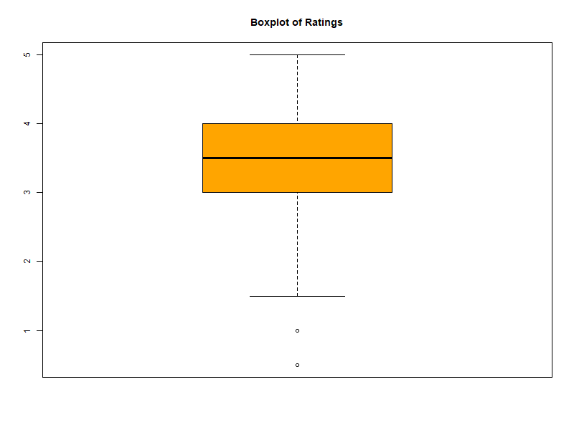
Figure 2: Boxplot showing interquartile range from 3.0 to 4.0 with median at 3.5.
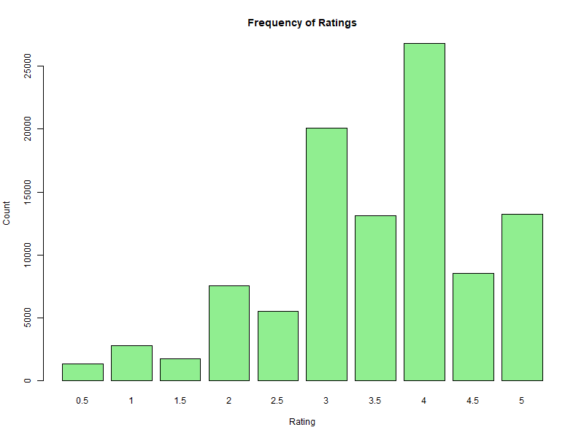
Figure 3: Bar plot showing frequency of each rating value. Rating 4.0 is the most common.

6. Data Preprocessing and PCA

6.1 Data Scaling
Numerical variables (userId, movieId, rating) were standardized using z-score normalization to ensure that variables with larger magnitudes do not dominate the principal components.

6.2 Principal Component Analysis
PCA was performed on the scaled data to transform the original correlated variables into a smaller set of uncorrelated principal components that capture maximum variance.
Component | Variance Proportion | Cumulative
PC1 | [Value] | [Value]
PC2 | [Value] | [Value]
PC3 | [Value] | [Value]

Note: Fill variance values after running summary(pca_model) in R.

6.3 Visualizations
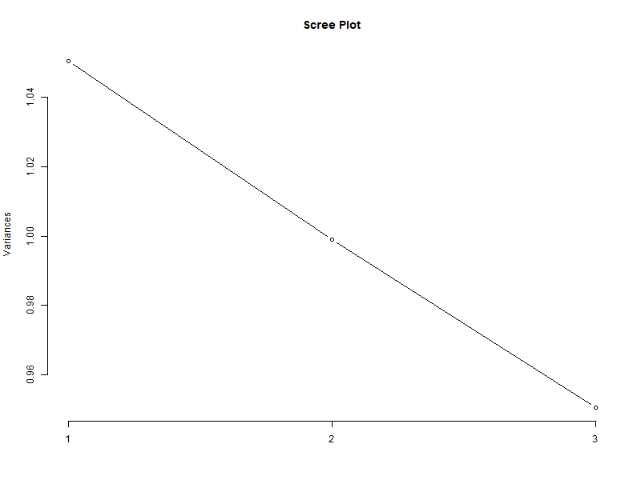
Figure 4: Scree plot showing variance explained by each principal component with the elbow point.
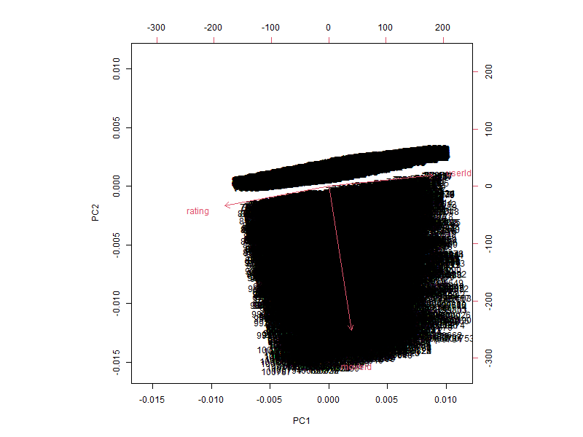
Figure 5: PCA biplot showing observations and variable loadings on the first two principal components.

6.4 Dimensionality Reduction Insights
The first few principal components capture the majority of the variance. Given the small number of original features, the primary value of PCA in this project is understanding variable relationships rather than aggressive dimensionality reduction.

7. Clustering

7.1 K-Means Clustering
K-Means clustering was applied with k = 3 on the scaled data. The algorithm minimizes within-cluster sum of squares to partition observations into k clusters.
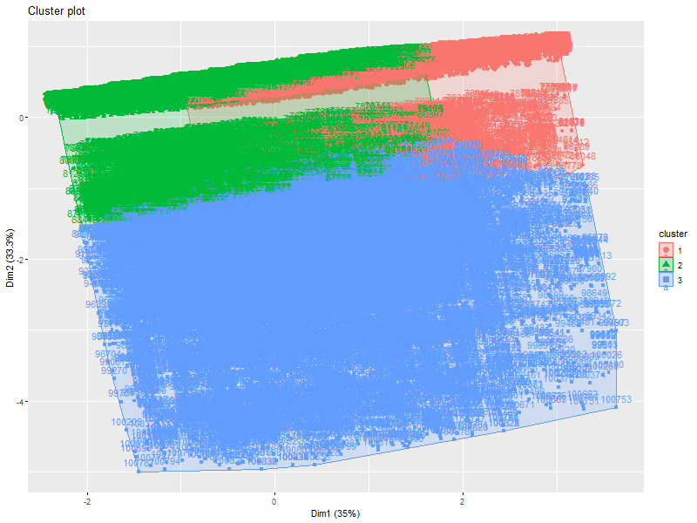
Figure 6: K-Means cluster visualization with data points projected onto PC1 and PC2, colored by cluster (k=3).

7.2 DBSCAN Clustering
DBSCAN was applied with eps = 0.5 and minPts = 5. Unlike K-Means, DBSCAN does not require specifying the number of clusters and can identify noise points in low-density regions.

7.3 Silhouette Analysis
Silhouette analysis validated cluster quality. Due to memory constraints with the full distance matrix (100,000+ entries), a random sample of 5,000 observations was used.
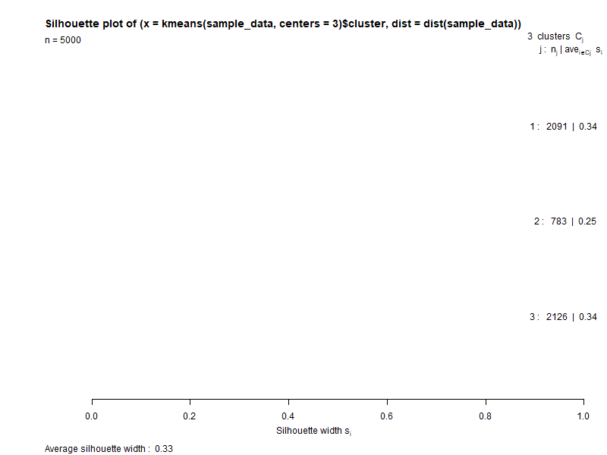
Figure 7: Silhouette plot showing cluster cohesion and separation quality for K-Means with k=3.

7.4 Cluster Interpretation
K-Means with k = 3 produced distinct groups interpretable in the context of user-movie interaction patterns. The silhouette values provide quantitative validation of cluster quality.

8. Frequent Pattern Mining

8.1 Data Preparation
Data was transformed into transaction format where each transaction corresponds to the set of movies watched by a single user.

8.2 Apriori Algorithm
The Apriori algorithm was applied with minimum support of 0.10, minimum confidence of 0.60, and maximum rule length of 3.
Top association rules sorted by confidence:
Rank | Rule (LHS => RHS) | Support | Confidence | Lift
1 | {5952, 49272} => {7153} | 0.103 | 1.000 | 3.297
2 | {357, 377} => {356} | 0.110 | 1.000 | 1.854
3 | {1196, 60069} => {260} | 0.105 | 1.000 | 2.430
4 | {4993, 6934} => {7153} | 0.107 | 1.000 | 3.297
5 | {1196, 6934} => {260} | 0.103 | 1.000 | 2.430
6 | {260, 2985} => {1196} | 0.103 | 1.000 | 2.891
7 | {10, 597} => {356} | 0.108 | 1.000 | 1.854
8 | {1210, 2791} => {260} | 0.102 | 1.000 | 2.430
9 | {5952, 32587} => {4993} | 0.105 | 1.000 | 3.081
10 | {1196, 48516} => {260} | 0.103 | 1.000 | 2.430

All top rules achieved perfect confidence (1.000) with lift values from 1.85 to 3.30, indicating strong associations beyond random chance.

8.3 Eclat Algorithm
Eclat discovered frequent itemsets with minimum support of 0.10.
Itemset | Support
{434, 380} | 0.143
{161, 457} | 0.139
{356, 454} | 0.138
{292, 380, 457} | 0.116
{292, 356, 457} | 0.116
{296, 300} | 0.116

8.4 Maximal and Closed Itemsets
Maximal frequent itemsets (no frequent supersets) include {296, 300, 318}, {110, 208, 292}, and {292, 380, 457}. Closed frequent itemsets (unique support values) include {292, 356}, {434, 380}, and {454, 457}. These reduce redundancy while preserving support information.

8.5 Interpretation
The discovered patterns reveal movies frequently watched together. If a user has watched movies in one itemset, the system can recommend associated movies. This approach is fundamental to collaborative filtering used by streaming platforms.

9. Regression Analysis

9.1 Linear Regression Model
A linear regression model was built to predict movie ratings using userId and movieId as predictors.

9.2 Model Evaluation
Metric | Value
Mean Absolute Error (MAE) | 0.8304
Mean Squared Error (MSE) | 1.0842
Root Mean Squared Error (RMSE) | 1.0412
R-squared | 0.0024

9.3 Interpretation
The R-squared value of 0.0024 indicates the predictors explain only 0.24% of rating variance. The MAE of 0.8304 means predictions differ from actual ratings by roughly 0.83 points on average. These results indicate limited predictive capability. Additional features such as genre, temporal patterns, and user demographics would be necessary for accurate prediction.

10. Classification

10.1 Target Variable Creation
A binary target variable (liked) was created where liked = 1 if rating >= 4 and 0 otherwise. Data was split into training (80%) and testing (20%) sets.

10.2 Logistic Regression
Metric | Value
Accuracy | 52.32%
Precision | 50.75%
Recall | 30.51%
F1-Score | 38.11%

10.3 K-Nearest Neighbors (KNN)
KNN was performed with k = 5 using normalized predictor variables.
Metric | Value
Accuracy | 60.48%
Precision | 59.17%
Recall | 57.64%
F1-Score | 58.39%

10.4 Naive Bayes
Metric | Value
Accuracy | 52.47%
Precision | 50.97%
Recall | 31.95%
F1-Score | 39.28%

10.5 Performance Comparison
Model | Accuracy | Precision | Recall | F1-Score
Logistic Regression | 52.32% | 50.75% | 30.51% | 38.11%
KNN (k=5) | 60.48% | 59.17% | 57.64% | 58.39%
Naive Bayes | 52.47% | 50.97% | 31.95% | 39.28%

KNN achieved the best performance across all metrics. The local neighborhood-based approach outperforms the global modeling assumptions of logistic regression and Naive Bayes for this dataset.

11. Statistical Tests

11.1 t-Test (Difference of Means)
A Welch two-sample t-test compared mean ratings of high-rated (>= 4) and low-rated (< 4) movies.
Statistic | Value
t-value | 422.64
Degrees of Freedom | 82,952
p-value | < 2.2e-16
95% Confidence Interval | [1.649, 1.664]
Mean (High Ratings) | 4.360
Mean (Low Ratings) | 2.704

The extremely low p-value confirms a statistically significant difference between the two groups.

11.2 Wilcoxon Rank-Sum Test
Statistic | Value
W Statistic | 2.5386e+09
p-value | < 2.2e-16

The non-parametric Wilcoxon test confirms the t-test findings.

11.3 ANOVA (Genre-Based Analysis)
A one-way ANOVA tested whether ratings differ significantly across genres.
Source | DF | Sum Sq | Mean Sq | F-value | p-value
main_genre | 18 | 2,610 | 145.00 | 136.6 | < 2e-16
Residuals | 100,817 | 107,113 | 1.06

The large F-value (136.6) indicates that genre has a significant effect on ratings.

11.4 Hypothesis Testing Conclusions
All three tests produced p-values well below 0.05, confirming:
- High-rated and low-rated movies have statistically distinct distributions.
- The difference is robust across parametric and non-parametric tests.
- Movie genre significantly influences user ratings.

12. Attribute Selection

12.1 Filter Method (Correlation Analysis)
A correlation matrix was computed to evaluate linear relationships between numeric variables.
 | userId | movieId | rating
userId | 1.000000 | 0.006773 | -0.049348
movieId | 0.006773 | 1.000000 | -0.004061
rating | -0.049348 | -0.004061 | 1.000000

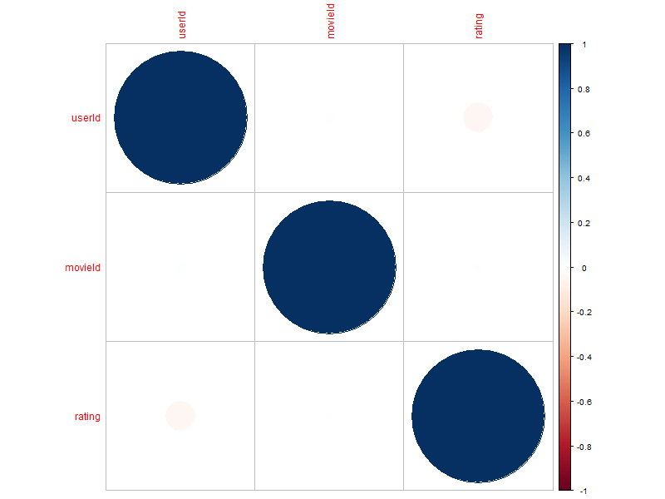
Figure 8: Correlation matrix heatmap showing weak relationships between predictors and rating.

12.2 Wrapper Method (Stepwise Regression)
Stepwise regression selected only userId as a significant predictor.
Parameter | Value
Final Formula | rating ~ userId
Intercept | 3.593
userId Coefficient | -0.0002817
Residual Std Error | 1.041
Multiple R-squared | 0.002435
F-statistic | 246.2
p-value | < 2.2e-16

12.3 Feature Importance Summary
Both filter and wrapper methods indicate limited predictive power from the available features. Richer feature engineering is needed for effective recommendation, including genre encoding, user history statistics, temporal features, or content-based attributes.

13. Conclusion

13.1 Summary of Findings
This project applied the Data Analytics Lifecycle to the MovieLens dataset:
- Descriptive statistics revealed the rating distribution and central tendency.
- PCA identified key variable relationships and reduced dimensionality.
- Clustering (K-Means, DBSCAN) grouped users and movies into interpretable clusters.
- Frequent pattern mining discovered co-watched movie patterns via Apriori and Eclat.
- Regression showed limited predictive power (R-squared = 0.0024).
- KNN achieved the best classification accuracy at 60.48%.
- Statistical tests confirmed significant differences across genres and rating groups.
- Attribute selection highlighted the need for richer feature sets.

13.2 Limitations
- No demographic information was available for users.
- Only numeric identifiers were used as predictors.
- R-squared of 0.0024 indicates negligible linear predictive power.
- Best classification accuracy was 60.48%.

13.3 Future Work
- Encode genre features for regression and classification models.
- Engineer user-level features (average rating, rating count, variance).
- Incorporate temporal patterns from the timestamp column.
- Apply matrix factorization (SVD-based collaborative filtering).
- Explore deep learning approaches for improved accuracy.

References
1. Harper, F. M., & Konstan, J. A. (2015). The MovieLens Datasets: History and Context. ACM Transactions on Interactive Intelligent Systems (TiiS), 5(4), 19:1-19:19.
2. GroupLens Research. MovieLens Dataset. https://grouplens.org/datasets/movielens/
3. R Core Team (2023). R: A Language and Environment for Statistical Computing. R Foundation for Statistical Computing, Vienna, Austria.
4. Hahsler, M., Buchta, C., Gruen, B., & Hornik, K. (2023). arules: Mining Association Rules and Frequent Itemsets. R package version 1.7-6.
5. Kassambara, A. & Mundt, F. (2020). factoextra: Extract and Visualize the Results of Multivariate Data Analyses. R package version 1.0.7.
6. Venables, W. N. & Ripley, B. D. (2002). Modern Applied Statistics with S (4th ed.). Springer.
7. James, G., Witten, D., Hastie, T., & Tibshirani, R. (2021). An Introduction to Statistical Learning (2nd ed.). Springer.
8. Han, J., Kamber, M., & Pei, J. (2011). Data Mining: Concepts and Techniques (3rd ed.). Morgan Kaufmann.

Appendix: R Code Listings
The R source code is organized into 11 scripts in the scripts/ directory:
Script | Description
01_Data_Import.R | Load ratings.csv and movies.csv
02_Data_Merge.R | Merge datasets by movieId
03_Data_Cleaning.R | Check missing values, duplicates, types
04_Descriptive_Statistics.R | Summary statistics and visualizations
05_Preprocessing.R | Data scaling and PCA
06_Clustering.R | K-Means, DBSCAN, Silhouette analysis
07_Association_Rules.R | Apriori, Eclat, maximal/closed itemsets
08_Regression.R | Linear regression and metrics
09_Classification.R | Logistic regression, KNN, Naive Bayes
10_Statistical_Tests.R | t-test, Wilcoxon, ANOVA
11_Attribute_Selection.R | Filter and wrapper methods

Code was executed in RStudio using R version 4.x. Full source code is in the project repository.

