The Prime Developer
Expertise Tab — Site Architecture & Content Specification
Interiors · Franchise · Collab · Invest

1. Overview
This document specifies every page under the Expertise tab of The Prime Developer's website, the content each page must hold, and the navigation flow that connects them. The Expertise tab has four sections: Interiors, Franchise, Collab, and Invest. Interiors is a product catalog with three finish tiers; the other three sections are informational pages that funnel into an inquiry form. A full exploded mind map follows in Section 2, and each section is then broken down page by page, field by field, with its own detailed flow diagram.
All four sections ultimately lead to a contact step. The recommendation throughout this document is to build one shared, reusable contact/quote form component with a hidden field identifying which section the visitor came from, rather than four separate forms. This keeps lead routing simple on the backend and avoids duplicating form logic across the site.

1.1 The four sections at a glance
Section | What it is | Primary user goal
Interiors | Product catalog of 33 interior finish options across 3 tiers, each with pricing, description, video, and a gallery. | Compare finishes, see real examples, request pricing or add a package to a purchase.
Franchise | Showcase of existing franchise tenants plus an open call for new franchise operators. | Learn who already operates here, or inquire about opening a new location.
Collab | Joint-venture partnership model where The Prime Developer co-owns and co-operates a business with a partner. | Understand the JV structure and propose a partnership.
Invest | Two investment tracks: planning-phase equity and stabilized property CAP / NNN investment. | Understand both paths and request investor information.

2. Full Site Mind Map — Exploded
Every node in the Expertise tab, from the top-level tab down to the final contact step, laid out by section. Purple nodes are informational or catalog pages, coral nodes are the two decision points in the flow (the interior typology detail page and the franchise property selector), teal nodes are supporting content (gallery, add-on path), and gray nodes are the contact/inquiry endpoints.
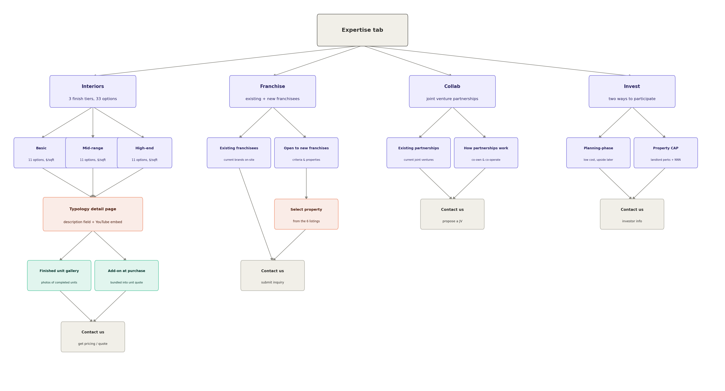
Figure 1 — Expertise tab, fully exploded across all four sections.

3. Interiors
Interiors is the most content-heavy section: a filterable catalog of 33 finish-out options split evenly across three tiers, each with its own detail page, and a path for a visitor to fold an interior package into a unit purchase.

3.1 Tier landing page (/expertise/interiors)
The landing page presents three tabs or a segmented control — Basic, Mid-range, High-end — each showing a grid of roughly 11 options. This is the entry point into the catalog.
Each option card in the grid displays:
- Thumbnail image of the finish
- Option name (e.g. “Polished concrete — warm gray”)
- Price per square foot for that finish
- Tier badge (Basic / Mid-range / High-end)
- Click-through to that option's typology detail page
Filtering and sorting: allow sort by price per sqft (low to high / high to low) and filter by material category (flooring, wall finish, ceiling, fixtures, etc.) if the 33 options span multiple categories. A persistent “View finished gallery” button sits at the top of the page, separate from any single option.

3.2 Typology detail page (one per option, 33 total)
Each of the 33 options needs its own detail page. Because hand-building 33 pages is not maintainable, this should be one dynamic template driven by a CMS entry per option, not 33 individually coded pages.
Fields per option (CMS schema):
- Option name and tier
- Price per square foot
- Hero image plus an image set for a small in-page carousel
- Description field — rich text, for material, finish, and application details
- YouTube video URL — rendered as an embedded player on the page
- Specification list (materials, brand/manufacturer if applicable, maintenance notes)
- Related gallery entries — finished units that used this specific option
- Call to action: “Add this to my unit quote”, which carries the option ID into the shared contact form

3.3 Finished unit gallery
A separate, filterable gallery of completed units, distinct from the per-option image sets. Each gallery entry represents an actual finished space and should carry:
- Property (one of the six: Centro Plaza, Prime Lewisville, Prime Leander, Spur Plaza, Regan Crossing, Rio Ranch)
- Unit number or type
- Finish tier and the specific typology options used
- Photo set
- Link back to the relevant typology detail page(s)
The gallery should be filterable by property and by tier, since a prospective tenant will most often be looking at a specific building.

3.4 Add-on at purchase
Interiors is not only a standalone browsing experience — it is also offered as an add-on during the unit purchasing or leasing flow. When a visitor is inquiring about or signing for a unit, they should be able to select a finish tier (and optionally specific typology options already viewed) and have that selection bundled into their unit quote automatically, rather than filling out a second, separate form.
This means the shared contact form needs a mode where it accepts pre-filled context: property, unit, and one or more interior option IDs, so a visitor arriving from a typology page's “Add to my unit quote” button lands on a form that already knows what they're asking about.
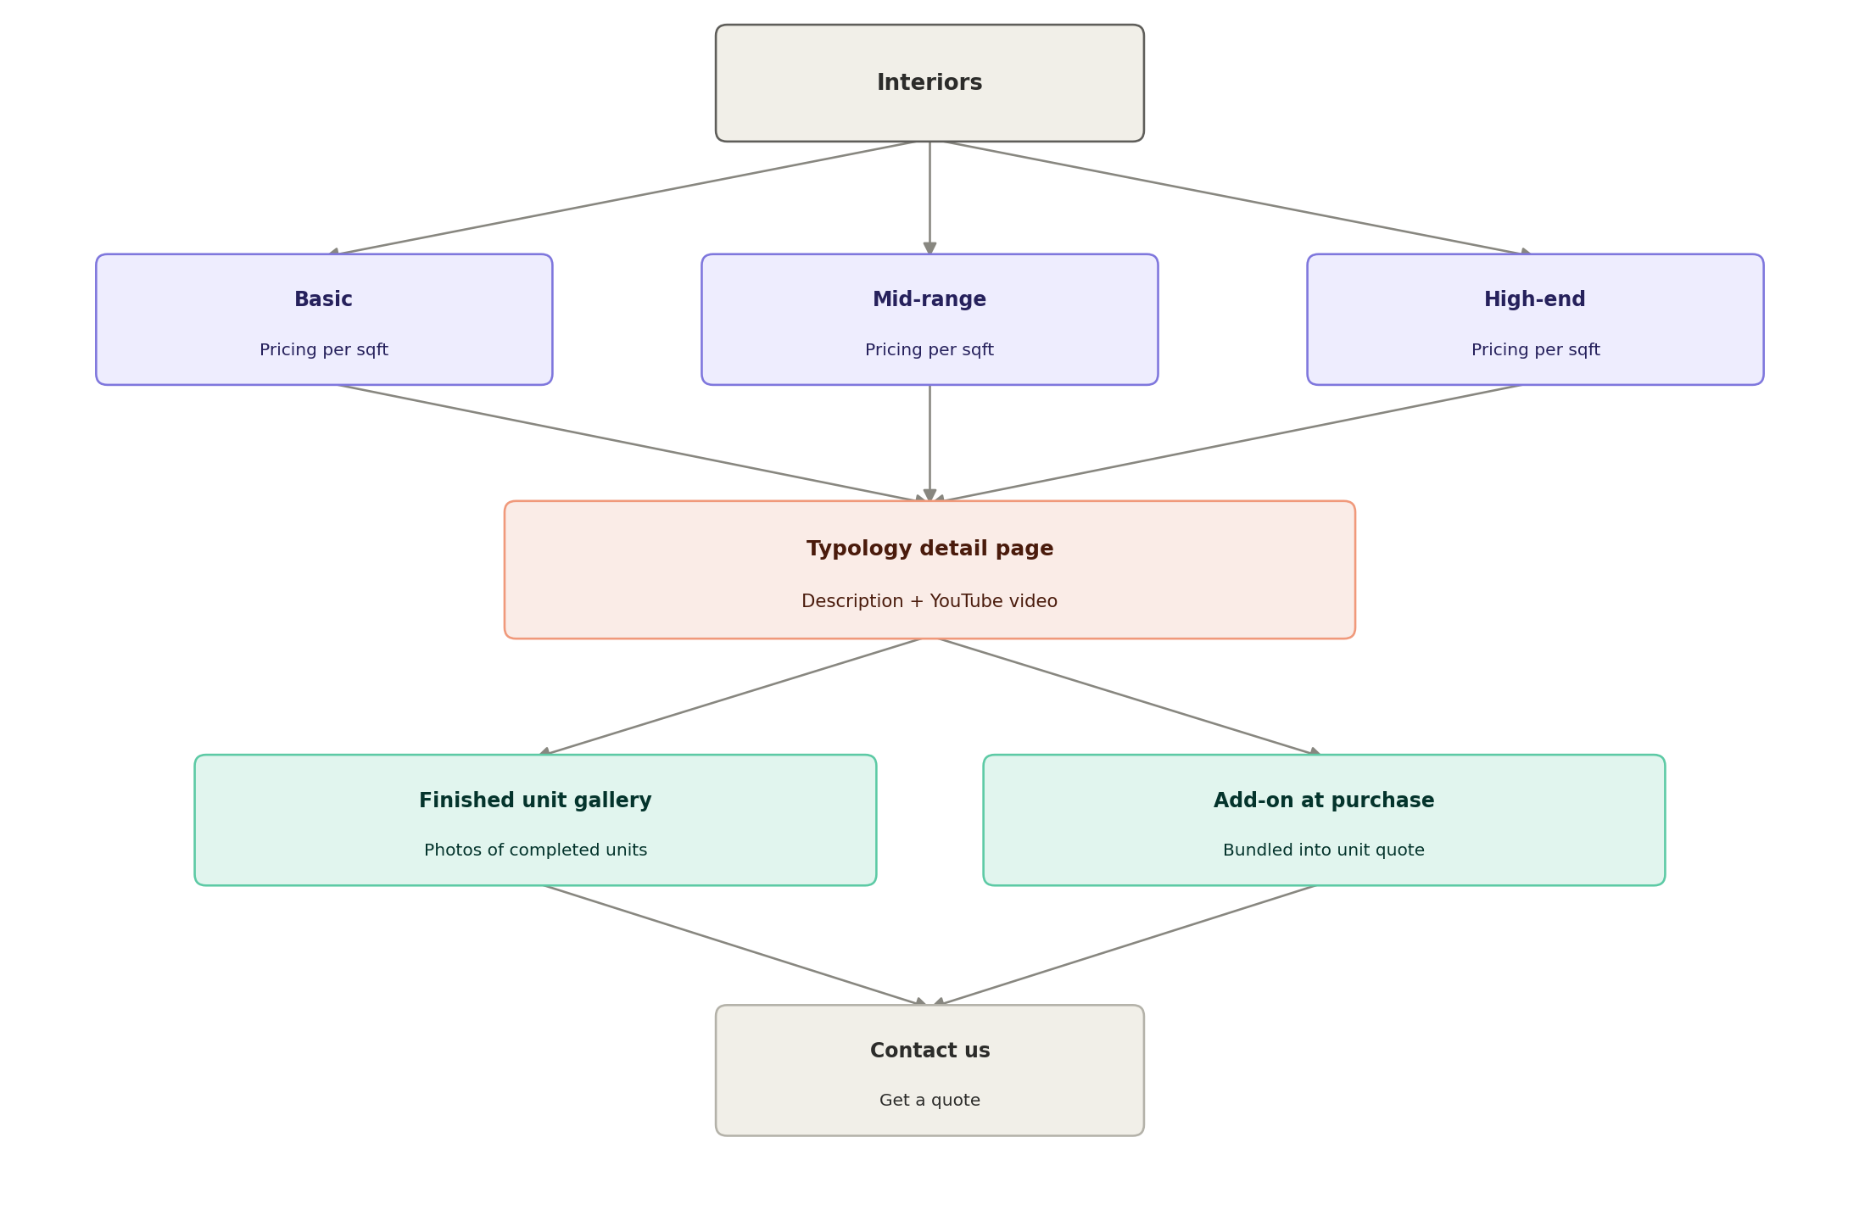
Figure 2 — Interiors section, page-level flow.

4. Franchise
Franchise establishes The Prime Developer as a developer-operator open to hosting franchise concepts, and separately signals that new franchise partners are welcome.

4.1 Existing franchisees
A showcase block listing the franchise brands currently operating across the six properties. Each entry should include:
- Brand name and logo
- Property and general location
- A short blurb or mini case study — how the space performs, what made the fit work
- Link to that property's page

4.2 Open to new franchises
A section explaining that The Prime Developer welcomes new franchise operators into its properties. Content here should cover:
- What kind of concepts fit (retail, food & beverage, service-based, etc.)
- Ideal footprint size range in square feet
- Why partner with The Prime Developer (portfolio strength, foot traffic, support during buildout)
- A property selector so the visitor can indicate which of the six properties interests them, or “no preference”

4.3 Contact / inquiry form
Fields: company or brand name, contact name and details, concept description, desired property (pre-filled if arriving from the property selector), square footage needed, target timeline, and a free-text message.
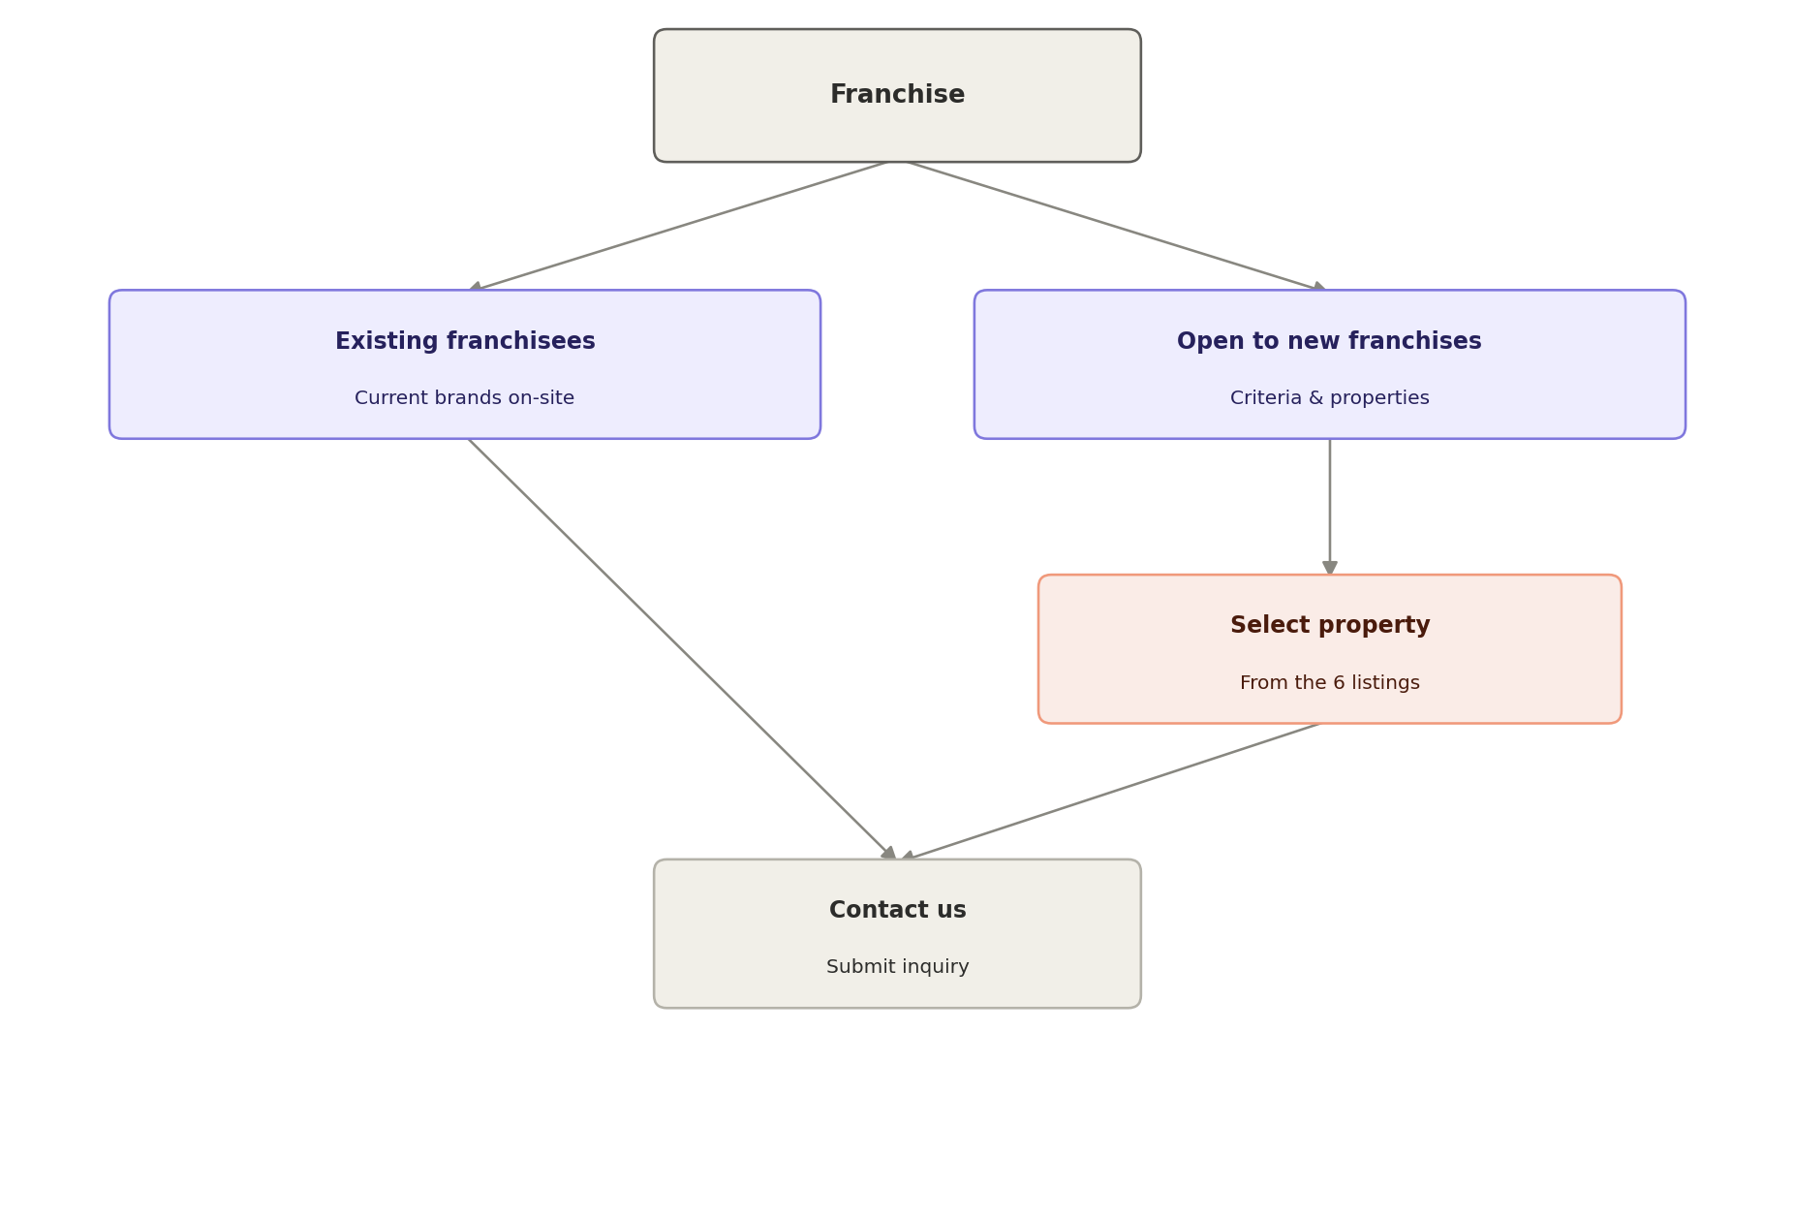
Figure 3 — Franchise section, page-level flow.

5. Collab
Collab is explicitly not a landlord-tenant relationship — it is a joint venture where The Prime Developer co-owns and co-operates the business alongside a partner, sharing both the risk and the upside. This distinction from Franchise should be stated plainly in the page copy, since visitors will otherwise conflate the two.

5.1 Existing partnerships
A showcase of current joint ventures, similar in structure to the Franchise showcase, but the copy should emphasize co-ownership rather than tenancy: partner name, concept, property, and a short summary of how the partnership is structured and performing.

5.2 How the partnership model works
An explainer section covering:
- What The Prime Developer contributes (space, capital, development expertise)
- What the operating partner contributes (concept, day-to-day operation, brand)
- How equity and decision-making are typically split
- The ideal partner profile — track record, concept stage, capital position

5.3 Contact / inquiry form
Fields: business concept description, operating experience/track record, capital available to contribute, desired property or “no preference”, timeline, and a free-text message.
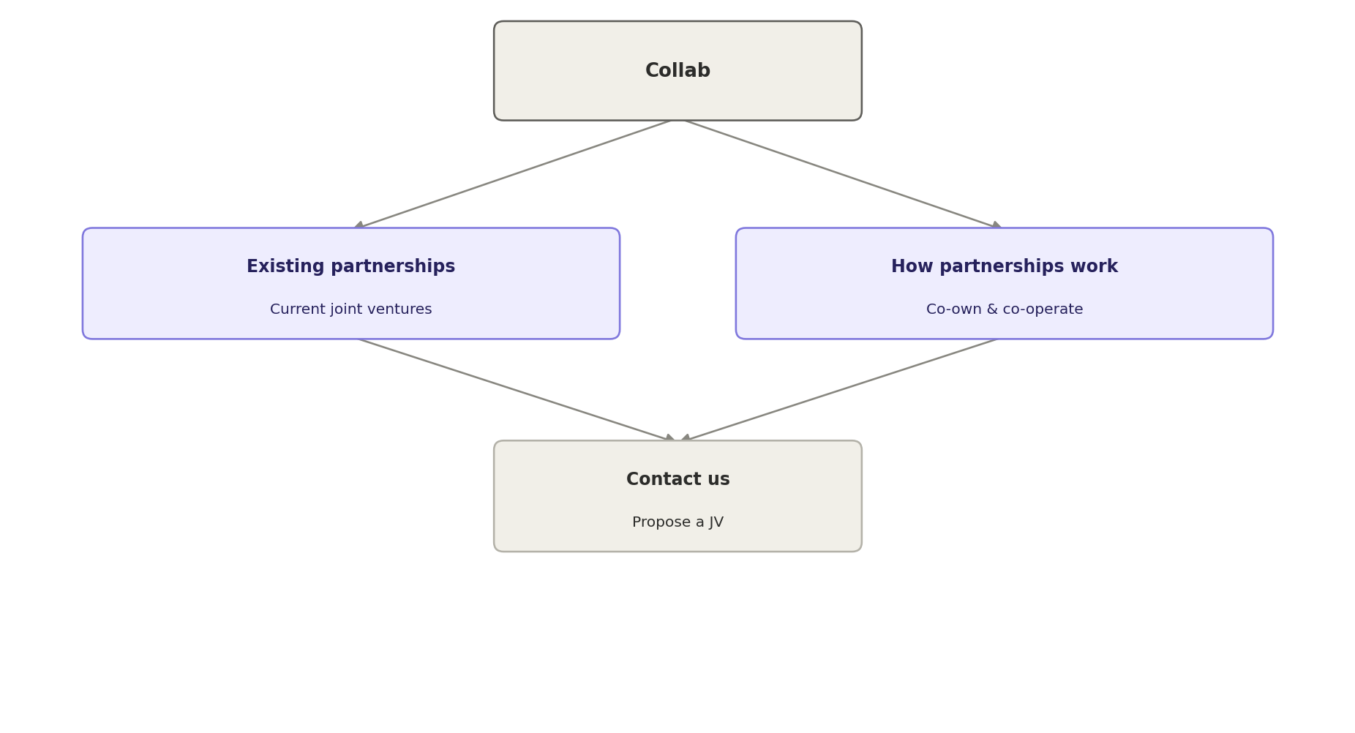
Figure 4 — Collab section, page-level flow.

6. Invest
Invest presents two distinct ways to put capital into The Prime Developer's portfolio. Because the two paths attract different investor profiles and different levels of risk tolerance, they should be explained as two separate, clearly labeled blocks rather than blended into one paragraph.

6.1 Planning-phase investment
Entry during a property's planning or pre-development stage, at a lower cost basis, with the upside realized as the project moves through development and stabilizes. Page content should cover the entry cost profile, the general timeline to realize returns, and the risk profile relative to investing in an already-stabilized property.

6.2 Property CAP / NNN investment
Entry into an already-stabilized, income-producing property, earning landlord-style returns through a triple-net (NNN) lease structure — tenants cover taxes, insurance, and maintenance, which keeps the investor's involvement largely passive. Page content should cover typical cap rate ranges, lease structure basics, and the passive-income positioning relative to the planning-phase path.

6.3 Contact / inquiry form
Fields: investor type (individual or entity), which track they're interested in (planning-phase, property CAP, or both), intended investment range, accreditation status, timeline, and a free-text message.
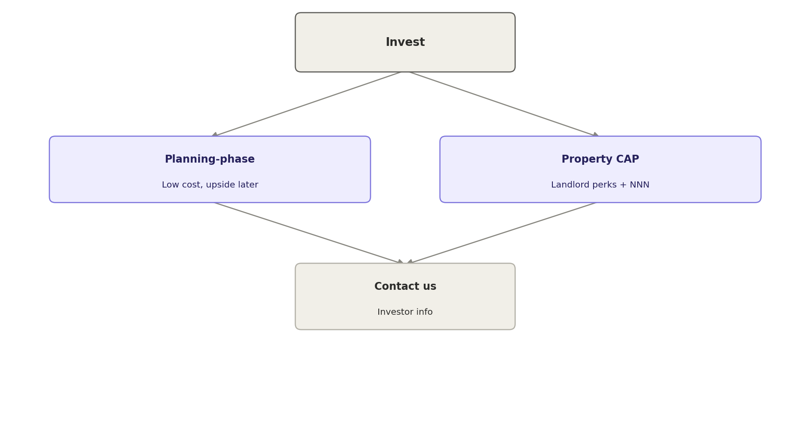
Figure 5 — Invest section, page-level flow.

7. Shared Contact / Quote Form
All four sections converge on a contact step. Rather than building four separate forms, use one shared form component with a hidden “source” field so submissions route and label correctly on the backend (e.g. to the leasing team for Interiors add-ons, to development for Franchise and Collab, to investor relations for Invest).
Source | Hidden context passed in | Suggested routing
Interiors | Option ID(s), tier, property/unit if mid-purchase | Leasing / interiors team
Franchise | Selected property, concept type | Development / leasing team
Collab | Concept type, capital available | Development / partnerships team
Invest | Investment track, amount range | Investor relations

8. Content Field Summary (Appendix)
A consolidated reference of every content field each page type needs in the CMS.
Page | Key fields
Interiors — tier grid | Tier, option name, thumbnail, price/sqft, category tag
Interiors — typology detail | Name, tier, price/sqft, hero image, image set, description (rich text), YouTube URL, spec list, related gallery entries
Interiors — gallery entry | Property, unit, tier, options used, photo set
Franchise — brand entry | Brand name, logo, property, blurb, link
Collab — partnership entry | Partner name, concept, property, structure summary
Invest — track content | Track name, description, entry profile, return profile
Shared contact form | Name, email, phone, message, source tag, context fields per section

