Examining BRIM Industry Examples
Objective
After completing this lesson, you will be able to examine SAP Billing Revenue Innovation Management (BRIM) industry examples.
SAP Billing Revenue Innovation Management (BRIM) Industry Examples
Through the following video, you delve into the application of BRIM (Billing and Revenue Innovation Management) across different industries. You identify potential customers of BRIM, highlighting the use of our solution in three distinct industries, and demonstrate how businesses implement BRIM to handle high volume events.
You’ll also be taken through how BRIM's solution components benefit both B2C and B2B businesses, particularly in sectors such as telecommunications, utilities, and high-volume transaction platforms.
This informative journey will provide you with valuable insights into the practical usage and benefits of BRIM.
Analyzing SAP CPQ for Quote Process Support in BRIM Context
Objectives
After completing this lesson, you will be able to:
- Create a Quote with Configurable Products for a Customer.
- Explain how SAP CPQ supports Quotation process with BRIM Integration.
Creating a Quote with Configurable Products for a Customer
Mark is a sales engineer with the O2C Cloud Company. His background is in Tech Sales, which enables him for the sales engineer role with the O2C Company. Let´s see which steps Mark needs to create a quote with configurable products for a customer.
- Creates Quotes.
- Sends quotes to customer.
- Changes Quotes (give discount) and change the amount.
- Change configuration according to customer needs, more volume, less, and another technical id.
- Creates customer confirmation letters.
What Is Quote-to-cash?
The Quote-to-cash (Q2C) process comprises activities that aim to convert sales opportunities into paying, long-lasting return customers.
The SAP CPQ–SAP Billing and Revenue Innovation Management integration covers the essential part of the Q2C process.
In our example, Mark from O2C configures a quote in SAP CPQ and negotiates legal terms with the customer until a final agreement is achieved and the customer has accepted the offer. After the customer accepts the quote, it’s transformed into a solution quotation in SAP S/4HANA. The confirmed solution quotation triggers order fulfillments, separated into physical, subscription, and service contracts.

Julia is a procurement specialist who works for CutAbove. She has 15 years’ experience under her belt in this role. However, this is the first time she has been responsible for purchasing cloud storage. Julia and Mark work together to ensure Julia purchases the correct cloud subscription service level and features for CutAbove. Let’s have a look at the service levels that Mark has offered Julia.
Cloud Selection Service Levels
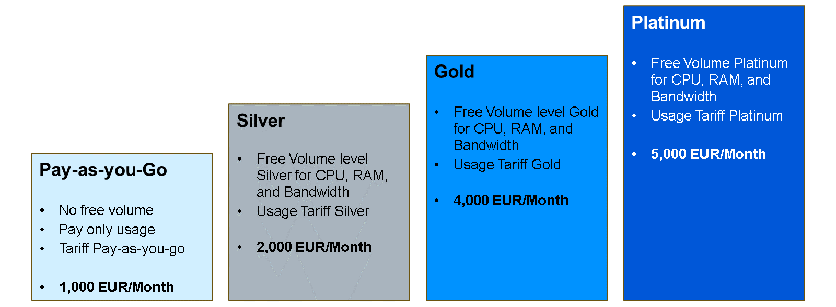
As you can see from the previous graphic, the O2C Company offers different cloud infrastructures to Julia from CutAbove. The product Cloud Selection Service is a subscription and is paid monthly.
The monthly fee depends on the selected service level agreement:
- Pay-as-you-Go
- Silver
- Gold
- Platinum
The product has a minimum duration for the subscription of 24 months.
Why Use SAP CPQ?
You may be wondering, "what does CPQ mean?". Well, SAP CPQ stands for Configure Price Quote.
Your next question is probably, "what does it do?". SAP CPQ is a B2B or B2C e-commerce platform that allows a company to sell complex products, solutions, and services to business and consumers.
SAP CPQ is a highly configurable system capable of tailoring application features that best fit the specific needs and expectations of businesses. For O2C Company, the goal is to implement an SAP CPQ solution that allows the company to:
- Efficiently manage product data and pricing.
- Standardize the product catalog and product list.
- Simplify selling of highly configurable and customizable products.
- Create consistent and professional-looking proposals.
- Automate quote approvals.
- Eliminate quote and order errors.
- Increase up-selling and cross-selling.
Now that O2C Company has CPQ up and running, they're eager to try it out. Here's their first chance. CutAbove would like to have an offer for more storage space. O2C Company can't wait to see how quickly, easily, and accurately they can generate a professional PDF quote to present to their client.
Quote-to-Cash Is a Cyclic Process
Through the following video, you discover how Q2C is a cyclic process.
Quote to Order
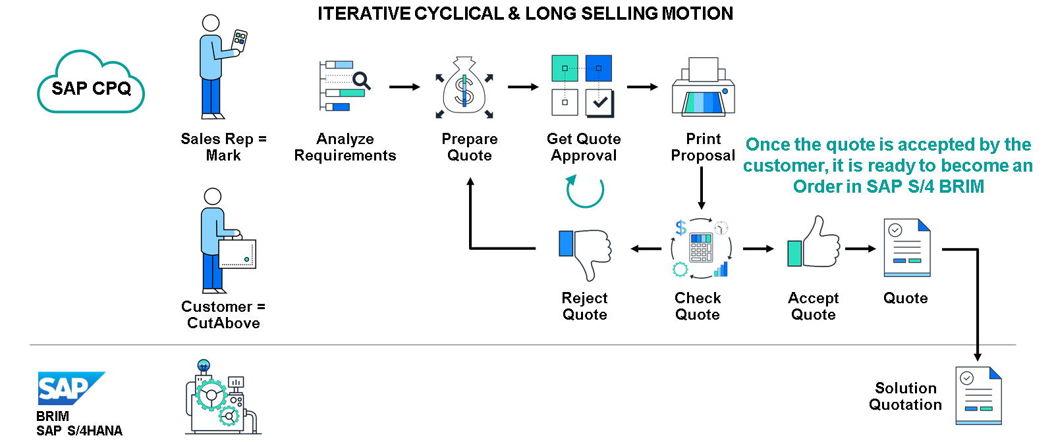
SAP CPQ can be integrated with SAP Billing and Revenue Innovation Management (BRIM) to provide a workflow for users to automatically create an SAP S/4HANA Solution Quotation whenever an SAP CPQ quote is sent to SAP Billing and Revenue Innovation Management. The follow-up documents are created inside SAP Billing and Revenue Innovation Management automatically. This integration only works with the Quote 2.0 engine in SAP CPQ.
The integration is triggered when the user finishes the quote process and sends the final quote to the back-end by choosing the Place Order button. This action would then create a Solution Quotation and its follow-up documents (for example Subscription Contract) in the BRIM system.
SAP CPQ and SAP Billing and Revenue Innovation Management are synchronized in terms of master data, business partners, and products (SAP S/4HANA) via SAP Cloud Integration. SAP Variant Configuration and Pricing is used as the default mechanism for configuring and Pricing subscription (SAP Billing and Revenue Innovation Management) products in SAP CPQ.
If the quote item is configurable, the quote data from SAP CPQ and the configuration data from SAP Variant Configuration and Pricing are combined and sent to SAP Billing and Revenue Innovation Management. Otherwise, only the standard product information and Pricing details are transferred to SAP Billing and Revenue Innovation Management.
Products that have not been replicated from SAP Billing and Revenue Innovation Management, but created directly in SAP CPQ, are ignored in the integration, which creates SAP S/4HANA Solution Quote from SAP CPQ Quote.
SAP CPQ Supports Quotation Process with BRIM Integration
Business Example
CutAbove
Let’s have a look at a business example that we are using throughout the course.

CutAbove are a video cutting company based in New York. They work with high-value companies to ensure timely and accurate video production and editing. Seeing as they produce hundreds of videos per day, they have run out of space on their local devices and the limited cloud storage they have.
CutAbove require more storage in the Cloud, which is provided by the O2C Company.
O2C Company

The O2C Company is based in Los Angeles and provides extra cloud storage to customers who need it. They use SAP CPQ and BRIM to manage subscriptions with customers. CPQ allows O2C to create quotes for its customers, negotiate the legal terms and reach a final agreement with the customer. After the customer accepts the quote, the integration with BRIM allows the generation of the follow-up documents and regular invoicing to the customer.
CutAbove are interested in purchasing a cloud selection service at O2C Company that allows them to store more videos.
Mark at O2C Company negotiates with CutAbove on the configuration of the high-tech service and the price conditions.
The quote process is an interactive communication between both parties.
Identifying the Key Capabilities of SAP CPQ (Configure Price Quote) for Cloud Selection Service
Objective
After completing this lesson, you will be able to identify the key capabilities of SAP CPQ (Configure Price Quote) for Cloud Selection Service.
Key Capabilities of SAP CPQ
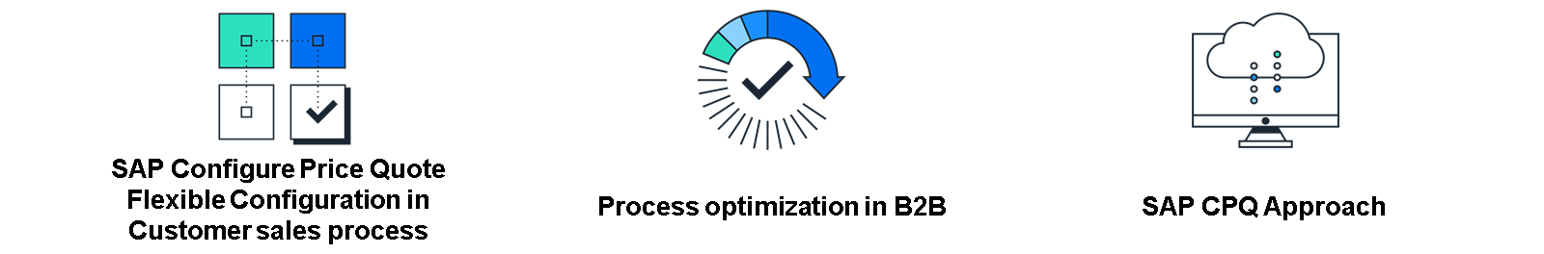
1. SAP Configure Price Quote Flexible Configuration in Customer Sales Process
Products can be easily found and configured by sales representatives, they are accurately priced ensuring error-free quotes, discount authorities are limited to protect profit margins, and all proposals are maintained at a professional standard.
2. Process Optimization in B2B
The integration of quote and fulfillment processes is seamless, incorporating the usage rating and invoicing in the SAP BRIM Solution, as well as change processes and renewals, into an interconnected system that incorporates subscriptions, sales and distribution, field service management, and service contract management.
3. SAP CPQ Approach
CPQ integrates the product catalog in SAP S/4HANA, involves master data integration with business partner and contract account, includes integration with solution business for quote fulfillment, and supports Pricing and invoicing with SAP S/4HANA BRIM processes.
Assessing Ordering Processes Supported by Solution Business
Objectives
After completing this lesson, you will be able to:
- Know the relevant SAP master data objects: Business Partner, Contract Account, Product, Solution Quotation, and Subscription Contract.
- Explain how to create a subscription contract starting in Solution Quotation document.
- Describe the application of High-Tech Business Example to Solution Quotation.
The Relevant SAP Master Data Objects
Business Partners
Business partner is the generic term used to refer to the parties involved in your interactions with customers.
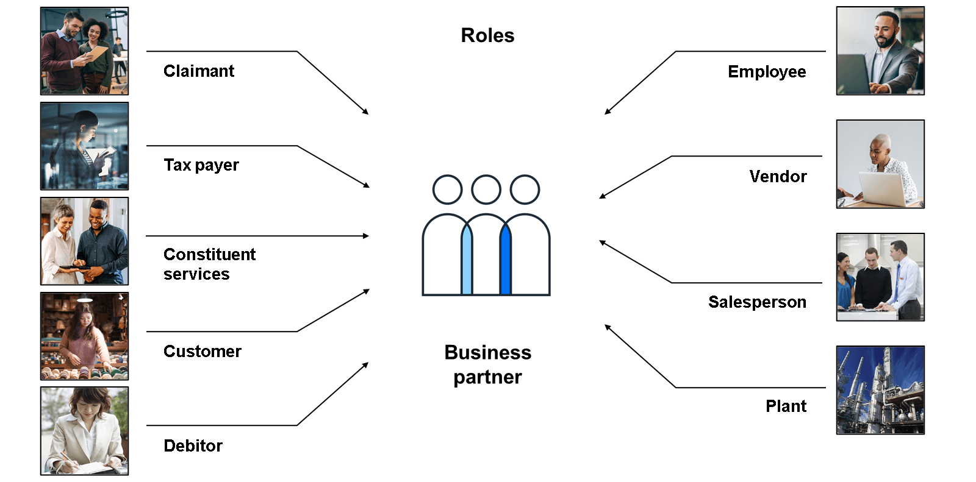
Business partner is the generic term used to refer to the parties involved in your interactions with customers. This term is used primarily in technical documentation and does not generally appear on the UI.
- A business partner contains central data, such as names, addresses, communication details, and bank details.
- A business partner represents a natural or a legal person with whom business relationships can be conducted.
- A business partner is used in the roles sold-to-party/contract partner.
A business partner role (for example, contact, sold-to party, or supplier) classifies a business partner in terms of business function.
The roles that are assigned to a business partner reflect the functions it has and the business transactions in which it is likely to be involved. A business partner role is used for classification purposes during data exchange with SAP ERP.
The classification of a business partner as a natural person (for example, a private person), group or organization (a legal person or part of a legal person, for example, department) is called the business partner category. It can be a person, a group, or an organization.

A group specifies a shared living arrangement, a married couple, or an executive board.
The organization represents units such as a company, a department of a company, a club, or an association.

In addition to a legal person, parts of a legal person can be mapped as a business partner.
The business partner type refers to the classification of B2C customers and B2B customers.
Note
In general terms, a business partner is called an "Account".
In our example, the company CutAbove is defined as an existing business customer.
Contract Account
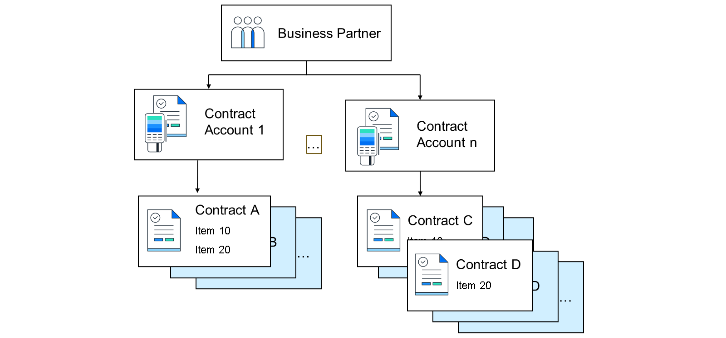
As you can see from the previous graphic, multiple Contract Accounts can be assigned to a single business partner. A single contract account can be used in multiple provider contracts.
Contract accounts can also be used on an item level, as previously shown through "Contract Account N". Let’s see how you can use contract accounts to store controlling data.
Using a Contract Account to Store Controlling Data

You use a contract account to store controlling data for long-term business relationships with a business partner.
This data controls processes in Invoicing, Contract Accounts Receivable and Payable (FI-CA), taxation, and correspondence processing.
You can define several contract accounts for each business partner, create one or more contract accounts for each of your business partners, and use them to save data relevant to business transactions with the respective business partner.
For a specific contract account, you can enter payment-related information, such as: Terms of payment.
For example, cash discount percentage rates and payment deadline: Bank details or card ID to be used for incoming and outgoing payments.
The customer can specify that a different bank account or card be used for incoming payments than the account or card used for outgoing payments.
Now that you have been introduced to Contract Accounts, it is time to learn about the Subscription Products that make up a Cloud Selection Service. Once again, we use the O2C Company and their customer CutAbove as examples of this.
Subscription Contract Creation
Business Example

Lena is an order management administrator for the O2C Company. Her main responsibilities in this role involve:
- Check subscription order (created by CPQ)​
- Accept subscription order​
- Check subscription order fulfillment
Once the preceding tasks are completed, depending on the service chosen by the customer, she must return one month later to:
- Change subscription contract​
- Change technical resource
- Change monthly price​
- Give allowances in a marketing activity​
- Cancel subscription contract​s
- Renew subscription contract​s
- Change product selection from silver to gold​
As you can see from Lena’s list of tasks as order management administrator for the O2C Company, she must be organized to ensure that customers receive the correct service order.
The following video shows the Contract BRIM data model.
Business Example
Now that you know the data model of the BRIM solution , let’s return to our customer CutAbove. Their IT Department have decided to order the product "Cloud Selection Service" in the variant "Gold".
Before the O2C Company can set up the Contract Account, business partners must be identified by CutAbove so they can be assigned to the Cloud Selection Service.
The Application of High-Tech Business Example to Solution Quotation
Business Example
The O2C Company has offered the preceding four cloud selection service infrastructure. Each product is a subscription and is paid monthly by CutAbove to the O2C Company. The product has a minimum duration for the subscription of 24 months, which is paid monthly.
CutAbove discussed the service levels offered to their staff and agreed that the Gold selection service satisfies their needs. Through this service, CutAbove receive free volume level Gold and Usage Tariff Gold. Here is a breakdown of the Usage Tariff Gold:
Breakdown of the Usage Tariff Gold
Object | Content
Surcharge | EUR 3,000
CPU | 10,000 free and EUR0.035/CPU hour
RAM | 20,000 free and EUR0.03/hour
Bandwidth | - 1200 free GB  - 0-10,000 – EUR4  - 10,000 – 50,000 – EUR3  - 50,000 – Unlimited EUR2
Monthly Base Fee: EUR1,000
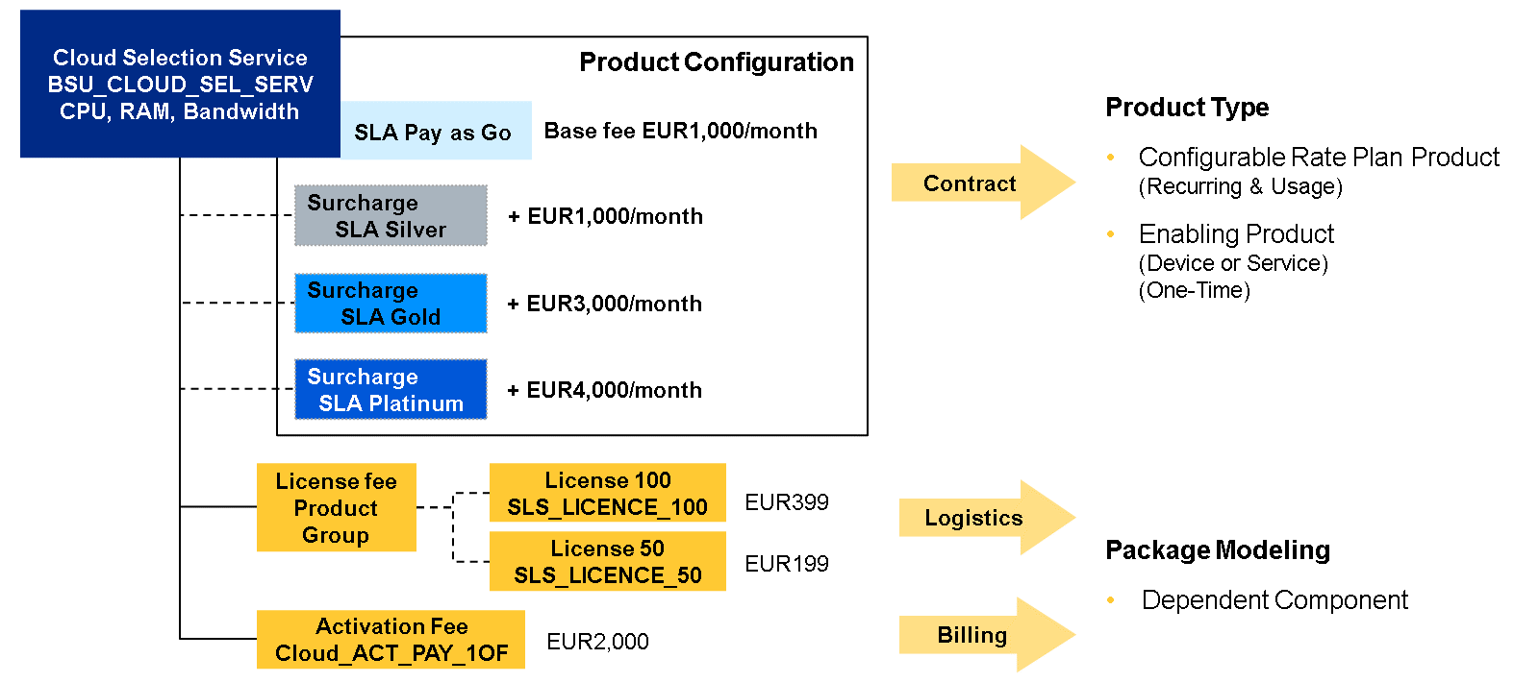
In Subscription Order Management, products can be either services or physical goods (such as a PC). You can use subscription products to subscribe to such a service, especially if this service is paid by a pay-per-use model.
You can use subscription products to define the following:
- Subscriptions to services with a payment model of recurring fees and consumption-based fees (pay-per-use).
- One-time services, like an activation or a change fee (one-off fees).
- Physical goods, such as a PC.
- Bundles modeling sales bundles or contract bundles.
The product master (aka material master) provides you with all information for the products your company purchases or sells. It is the central source from which product-specific data can be retrieved.
For subscription products, you can manage the terms of duration, billing cycles, discounts, and charges, among other core attributes. The product master can be maintained via the Manage Product Master Data app or the respective APIs.
However, not all product data required for subscription processing can be maintained in a product master, especially in the context of cross-catalog mapping (for example, to connect to SAP Convergent Charging). You can also use it to assign discount or charge keys used and processed in Convergent Invoicing, using the subscription product-specific data object.
Before you are shown how to create a solution order, it is important that you understand the definition of the solution quotation and subscription contracts.
What Is a Solution Quotation?
Solution quotations are legally binding offers with fixed conditions.
With a solution quotation, you can offer your customers solutions that combine different types of products (physical goods, services, subscriptions). These combinations are modeled as product bundles in your master data. When you enter product bundles as items in a quotation, the bundle components are displayed automatically as subitems.
The end values for prices in solution quotation items for recurring fees are calculated dependent on quantity and contract runtime. Once a quotation is released and accepted, follow-up transactions are generated automatically and subscription items in the quotation are copied into a subscription contract. When you accept a solution quotation, the subscription items for one-offs creates a one-off BIT.
Hint
Access the SAP Fiori app, Manage Solution Quotation and create a new Solution Quotation.
What Is a Subscription Contract?
A subscription contract is represented by a main subscription contract item within a subscription contract document. A subscription contract document contains one or more subscription contracts, where the individual subscription contracts are not dependent on each other.
A typical subscription contract contains important information, such as technical resources (technical IDs/references of services), contract history (an overview of all the changes related to the contract and previously created orders), subscription contract options (subitems of a subscription contract, containing their own data), and business partner data (for example, alternative addresses for specific address types).
Contract-relevant data is copied from the solution quotation into the contract document. Solution quotation items become subscription contract items in the subscription contract document. You can only change a subscription contract using change processes.
What Is a Solution Order?
A solution order is a special sales order that can be used to sell product bundles that consist of physical products and services. Subscription order has extra data structure, like technical data, billing cycle, contract start date, and contract duration. In connection with the subscription contract, it supports the sale of special products and services, in the way that they are assembled and offered.
When the subscription order has been released, a new subscription contract is automatically created, whereby items with a short lifetime, such as, sales items or one-time fees stay in the order and items with a long lifetime, become part of the contract. In the first step, you log on to the SAP Fiori Launchpad and go to the Subscription Order Management section. Here, you select the Manage Subscription Order app.
Managing Subscription Contract Lifecycle Management Processes
Objective
After completing this lesson, you will be able to detail the contract change process for subscription contracts.
Detail the Contract Change Process for Subscription Contracts
Business Example
A month has now passed since CutAbove purchased the cloud service from the O2C Company. CutAbove has realized that they use the cloud service intensively, so more free volume and a lower tariff for more usage would be an advantage. Therefore, they have decided to upgrade the subscription contract from gold to platinum.
Let’s remind ourselves of the subscription contracts available and what they include:
Change Management

O2C’s order management administrator, Lena, is responsible for changing the subscription contract for CutAbove from gold to platinum. The following graphic outlines the contract changes that Lena can make in SAP Billing and Revenue Innovation Management, Subscription Order Management.
Change Processes
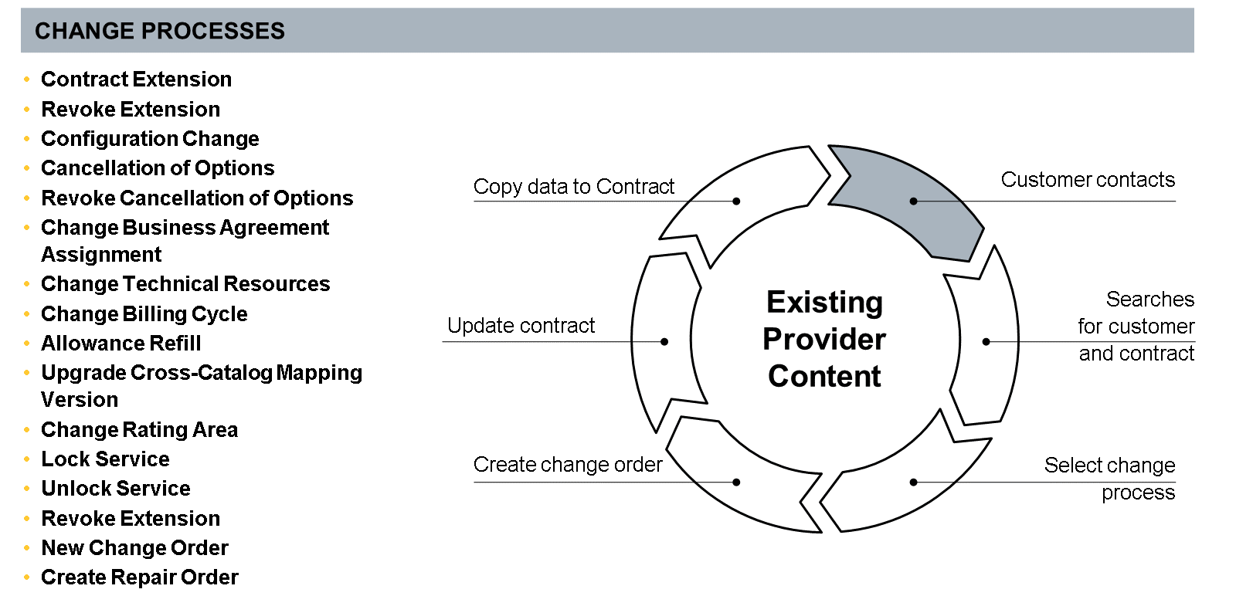
All contract change processes for existing customers are handled via change orders. This means that, if an agent triggers a change process, an order is created based on the contract. Within this order, the changes are applied and afterwards written back into the contract. Change orders can also be scheduled in the future and can include one or several of the following change processes.
Change Processes
Contract Extension | Revoke Extension | Configuration Change
Cancellation of Options | Revoke Cancellation of Options | Business Agreement Assignment
Change Technical Resources | Change Billing Cycle | Allowance Refill
Upgrade Cross-Catalog Mapping | Change Rating Area | Lock/Unlock Service
Revoke Extension | New Change Order | Create Repair Order
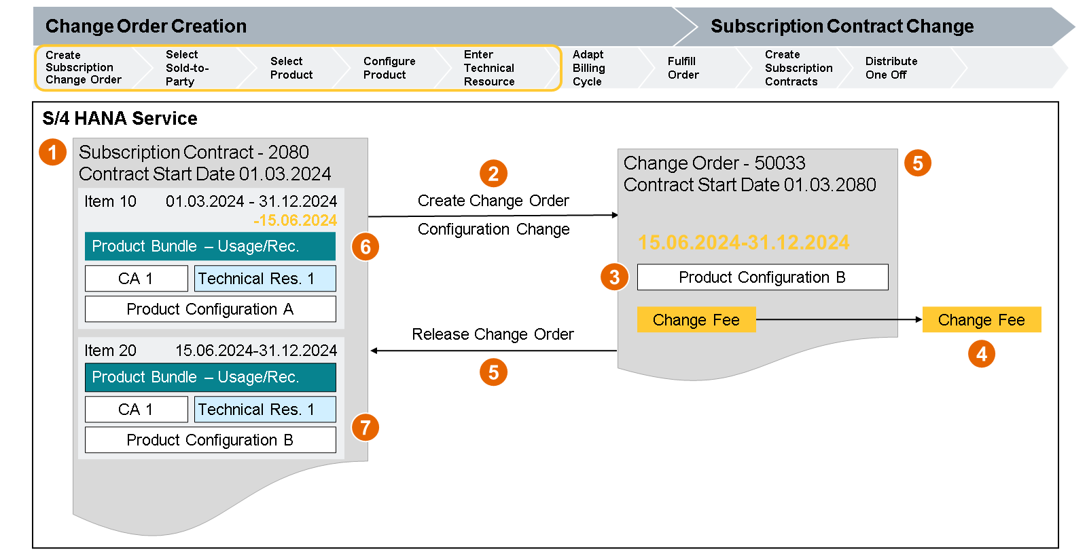
- Current Subscription Contract 2060. Contract Start Date 15.2.2020.
- Start Product Configuration Change for Product Configuration A.
- Product Configuration B is done. Time Slice beginning at 15.2.2020.
- Change Fee is created.
- Change Order is released and created.
- Changed item 10 is set to End Date 15.2.2020.
- Subscription Contract 2060 now has been changed, to item 20
From the contract, all relevant data is copied to the change order. The change order changes the validity dates of the existing contract item and copies the new data of the change order to a new contract item with relevant dates to the contract. The technical object is linked from the old contract item to the new contract item.
All contract changes are used to apply the changes to the contract. Therefore, the contract will always retain its previous ID and the related change processes are stored in detail as a contract history.
Changes that should be performed in the future can also be scheduled in the change order for a future date. When the date is reached, the order applies the changes to the contract.
Identifying the Key Capabilities of SAP S/4HANA Solution Quotation for a Cloud Selection Service
Objective
After completing this lesson, you will be able to identify the key capabilities of SAP S/4HANA Solution Quotation for Cloud Selection Service.
Key Capabilities of SAP S/4HANA Solution Quotation for Cloud Selection Service
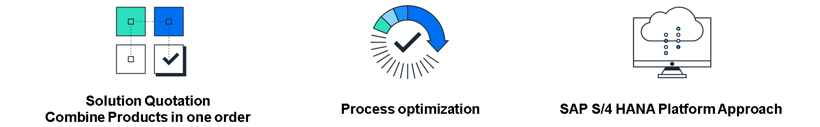
1. Solution Quotation Combines Products in One Order
The design and selling of solutions containing physical goods, services, projects, and subscriptions can be seamlessly combined in one order. Understanding the intricacies involved necessitates robust support of complex pricing models to cater to diverse needs. To ensure a smooth experience, holistic order orchestration of all solution quotation items is essential, enabling efficient and accurate processing.
2. Process Optimization
Seamless integration into fulfillment processes encompasses various aspects such as Sales and Distribution, Field Service Management, and Service Contract Management. It also includes Convergent Charging with capabilities for Rating and Charging. Also, Integrated Billing ensures that one invoice covers the complete solution quotation, enhancing efficiency and customer satisfaction.
3. SAP S/4 HANA Platform Approach
Solution Quotation is an integral part of SAP S/4HANA, offering an API for seamless integration with other software components. It uses a master data platform that includes Product, Business Partner, Invoice, and Finance information. Also, it supports integration with CPQ (Configure, Price, Quote) systems for a comprehensive and streamlined approach.
Analyzing Mediation and Collection of Usage Data
Objectives
After completing this lesson, you will be able to:
- Describe the collection of usage data for different services.
- Explore validation as process step in collection.
- Use convergent mediation for quality improvement before rating.
Collection of Usage Data for Different Services
Now that O2C’s order management administrator, Lena, has created CutAbove’s subscription contract and changed the service level to platinum, it is time to understand the usage data for their cloud selection service.
Use of the cloud service product creates usage data records for different services in different technical systems. Usages of cloud service are collected from different technical systems, enriched, and checked for the further process of rating.
Lena now passes CutAbove’s subscription contract to the billing specialist at the O2C Company.
Meet Karen

Karen is the billing specialist at O2C Company. She monitors usage collection as a preparation for rating and billing. Her primary responsibility is to ensure that invoices are accurately generated and sent out in a timely manner. They use systems like SAP Convergent Invoicing to streamline the process.
Karen’s tasks involve:
- Creating monthly recurring fees from Billing plans assigned to the subscription contracts​.
- Checking if rated usage is available for Billing.​
- Setting up Billing and Invoicing Jobs.​
- Checking Single Invoice. ​
SAP Convergent Mediation is used to complete these tasks. Let’s get a deeper understanding of SAP Convergent Mediation before we learn how the O2C Company uses it for CutAbove’s subscription contract.
Overview of Convergent Mediation

SAP Convergent Mediation makes it easy to gather, transform, and mediate usage data from various network and service sources across industries.
The main goal of SAP Convergent Mediation is to support businesses in efficiently processing and managing high volumes of transactional data. It offers various features that can help businesses capture and assess usage data, provide real-time reporting, and ensure accurate billing information. It can also ensures accurate and configurable routing of processed data to various downstream systems including charging, billing, analytical or operational systems.
The Process Step Validation in Collection
Key Features of SAP Convergent Mediation
1. Data Collection
- Description: Collect raw usage data from various network elements and systems (for example, switches, routers, application servers).
- Importance: Ensures that all relevant usage information is gathered for processing.
2. Data Normalization
- Description: Convert the collected raw data into a standardized format.
- Importance: Ensures consistency and compatibility of data from different sources.
3. Data Validation
- Description: Check the integrity and accuracy of the normalized data, verifying fields such as timestamps, user identifiers, and service types.
- Importance: Ensures that only valid and accurate data is processed further.
4. Data Enrichment
- Description: Enhance the usage records with more information such as customer details, service plans, and geographical data.
- Importance: Provides comprehensive context for each usage event, aiding in accurate billing and analysis.
5. Data Aggregation
- Description: Summarize or combine multiple usage records into a single record if necessary, based on predefined rules.
- Importance: Reduces the volume of data and simplifies processing while maintaining essential usage details.
The main goal of SAP Convergent Mediation is to support businesses in efficiently processing and managing high volumes of transactional data. It offers various features that can help businesses capture and assess usage data, provide real-time reporting, and ensure accurate billing information. It can also ensures accurate and configurable routing of processed data to various downstream systems including charging, billing, analytical, or operational systems.
Duplicated or erroneous data can occur as a result of incorrect configuration or malfunctioning data sources, such as link failures. A sudden drop of incoming data can also indicate failures in the data sources.
The error detection functionality of SAP Convergent Mediation helps service providers to ensure quality, prevent incorrect billing, and pinpoint problems related to malfunctioning and incorrectly configured data sources.
SAP Convergent Mediation enriches data using lookups in external repositories and databases. This enables transformation of the data to information adapted for the business logic of the downstream systems.
Data sources and target systems typically have different formats. More often than not, two systems using formats based on the same standards still need formatting to integrate due to vendor differences in interpretation of specifications and different versions of the standards. SAP Convergent Mediation provides an intuitive environment for configuring new formats on the fly.
Usage of the Convergent Mediation for Quality Improvement before Rating
Business Example
Now that you have been introduced to Convergent Mediation, let’s return to our business example.
For the O2C Company, the source for the cloud selection service is, for example, different machines providing events pertaining to CPU and RAM usage. The consumed bandwidth comes from network elements, but source events also come from tracking devices that hold information about, for example, video streaming and to which business partner the event belongs. Binding these different usage events to the correct owner is key.
The problems become obvious when O2C wants to design an agile business platform to offer new, attractive service offerings and competitive pricing models, as well as being in control of their revenue, while fighting fraud attempts.
O2C is in need of a mediation layer that can model this and take advantage of their customer data.
Usage Data Record in SAP Convergent Mediation
In the following video, our SAP Convergent Charging consultant Finn explains the key components of a Usage Data Record (UDR) and the purpose of Usage Data Records in SAP Convergent Mediation.
Examples for Industry-Specific Usage Data Records
In our business example, use of the cloud service product creates UDRs for different services in different technical systems. Usages of cloud service are collected from different technical systems, enriched, and checked for the further process of rating. For CPU usage, the consumption is recorded in the number of CPUs and hours. For bandwidth usage, it is recorded in Gigabytes.

In the parcel industry, key fields in a UDR include the timestamp, which logs the exact date and time of each event in the parcel's journey, crucial for tracking and delivery timelines.
The parcel identifier, such as a tracking number, is essential for associating events and status updates with the correct shipment.
Also, the location data, which records the geographic points of each event, is vital for monitoring the parcel's route and ensuring accurate delivery and relevant sizes of the parcel as there are length, width, and weight.

In the telecommunications industry, key fields in a UDR include the timestamp, which records the exact date and time of the usage event, crucial for billing cycles and time-based charges.
The user identifier, such as a phone number or IMSI, is vital for associating usage with the correct customer account. Also, the service type and usage quantity fields, which specify the type of service used (for example, voice, SMS, data) and the amount consumed, are essential for accurate billing and service analysis.
Rating via SAP Convergent Charging Acquisition Connector
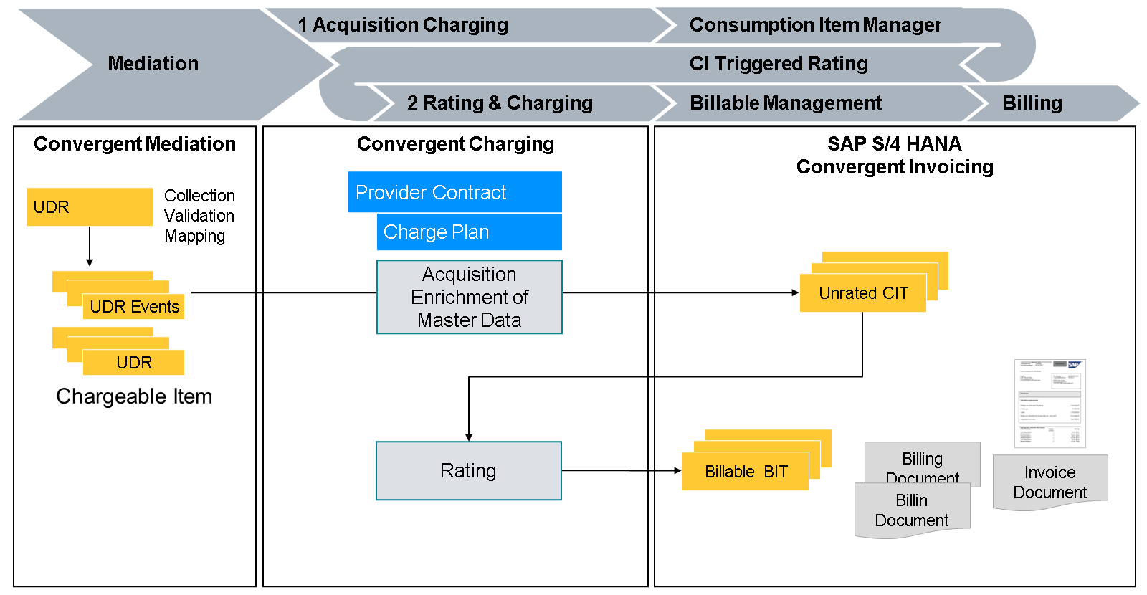
- SAP Convergent Mediation collects UDRs from different network systems. After validation and mapping of the data to the corresponding output format, it sends the so-called chargeable items to SAP Convergent Charging.
- Chargeable items are enriched with master data in SAP Convergent Charging and sent to SAP Convergent Invoicing for storing as a consumption Item.
- Consumption items will be held there waiting to be rated.
- When the rating process was triggered, all consumption items are sent in batch to SAP Convergent Charging for rating.
- At the end of the rating process, the rated items can then be loaded as Billable Items (BIT) into SAP Convergent Invoicing.
- SAP Convergent Invoicing uses billable items for billing and invoicing to generate the invoice document.
Workflows in SAP Convergent Mediation
Workflows in SAP Convergent Mediation are vital for processing and transforming data from network sources or other external systems. A workflow is essentially a sequence of steps or a pipeline that defines the process of how network data is processed.
These workflows could include steps for receiving data, validating data, enriching data, aggregating collected data records, triggering actions based on specific conditions, and forwarding processed data to various modules or systems for further services like charging, billing, or reporting.
Furthermore, a user can customize these workflows to optimize the process according to specific business needs, ensuring flexibility and agility in the rapidly changing business models or market requirements.
These workflows could also be reused, which enhances productivity and reduces the recurring efforts to design similar processes.
SAP Convergent Mediation provides a GUI-based rule builder that allows technical and non technical users to modify and enhance data processing rules as per their requirements.
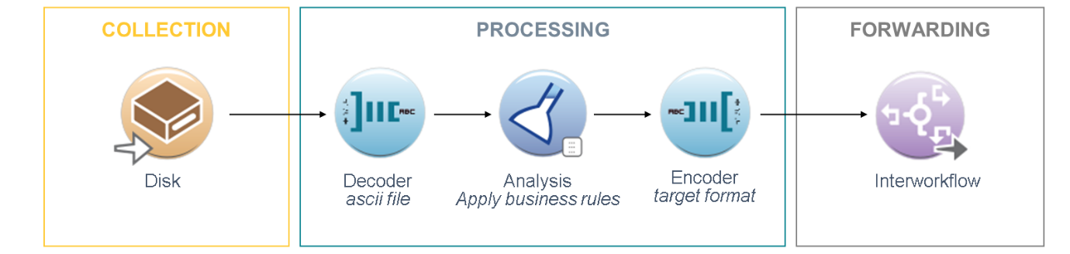
The workflows in SAP Convergent Mediation play a crucial role in defining how data is processed.
1. Data Collection
It is the starting point of the workflow where the data is gathered from different sources like network switches, routers, servers, and so on.
2. Processing
In this stage, the collected data is transformed into a universal format for further processing. This may include data cleaning, validation, and authentication. Mediation is the core process where the preprocessed data is sent through a set of rules and regulations. These rules can be modified or enhanced as per the requirements. The role of mediation is to convert the raw data into meaningful information that can be used for charging/billing.
3. Forwarding
In the end, the data is appropriately formatted and distributed to the respective recipient system. This could be a billing system or any other system that needs this data for further processing.
Identifying SAP Convergent Mediation Key Capabilities
Objective
After completing this lesson, you will be able to understand SAP Convergent Mediation Key Capabilities.
SAP Convergent Mediation Key Capabilities
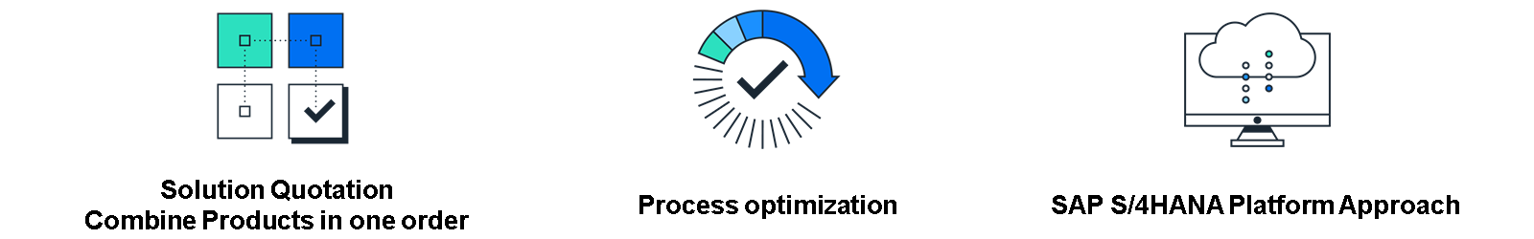
1. Convergent Mediation
Application Integration
Convergent Mediation collects multiple data streams or sources, including CPU, RAM, and Bandwidth, and enables conditional forwarding based on meta information or content.
Data Enrichment
Convergent Mediation enriches data through combination with any other information or data sources. It also adds, removes, or reformats content in real-time.
2. Process Quality Improvement
Error Detection
Convergent Mediation deduplicates inputs, filters out erroneous data, and possesses an alarm and monitoring management feature.
Data Format Standardization
Preprocess and create new or unified data formats before forwarding to target systems. Convergent Mediation also translates protocols or formats to any other format where needed.
3. SAP BRIM Platform Approach
Monetization and Revenue Management
SAP Convergent Mediation possesses out-of-the-box integration to SAP Billing & Revenue Management for batch and real-time monetization of mission-critical applications. SAP Convergent Mediation also offers online and offline data stream optimization and preserved information granularity leads to minimized revenue loss.
Identifying SAP Convergent Mediation Key Capabilities
Objective
After completing this lesson, you will be able to understand SAP Convergent Mediation Key Capabilities.
SAP Convergent Mediation Key Capabilities
1. Convergent Mediation
Application Integration
Convergent Mediation collects multiple data streams or sources, including CPU, RAM, and Bandwidth, and enables conditional forwarding based on meta information or content.
Data Enrichment
Convergent Mediation enriches data through combination with any other information or data sources. It also adds, removes, or reformats content in real-time.
2. Process Quality Improvement
Error Detection
Convergent Mediation deduplicates inputs, filters out erroneous data, and possesses an alarm and monitoring management feature.
Data Format Standardization
Preprocess and create new or unified data formats before forwarding to target systems. Convergent Mediation also translates protocols or formats to any other format where needed.
3. SAP BRIM Platform Approach
Monetization and Revenue Management
SAP Convergent Mediation possesses out-of-the-box integration to SAP Billing & Revenue Management for batch and real-time monetization of mission-critical applications. SAP Convergent Mediation also offers online and offline data stream optimization and preserved information granularity leads to minimized revenue loss.
Executing the Process from Consumption Items to Customer Invoice
Objective
After completing this lesson, you will be able to execute the process from consumption items to customer invoice.
The Process from Consumption Items to Customer Invoice
Business Example
CutAbove use the three services CPU, RAM, and Bandwidth for their Cloud Selection service.
The consumptions are stored in Convergent Invoicing and triggered to be rated in Convergent Charging. For the first invoice, a recurring fee for the service is created from the Billing Plan in Convergent Invoicing.
Let's see how this is done.

We return to Karen, O2C’s billing specialist. She creates recurring fees for the billing plans for CutAbove's new provider contract. CutAbove has a Subscription Contract for Cloud Selection Service Level Platinum. The Contract was closed on 01.03.2024. For each month, a recurring Fee of EUR1,000 and a recurring fee of EUR4,000 for Service level agreement platinum are created.
Later, Karen runs a rating for consumption items from the cloud storage usage.
All billable items from consumption and recurring are consolidated in one invoice for CutAbove.
Where Are We in the Process?
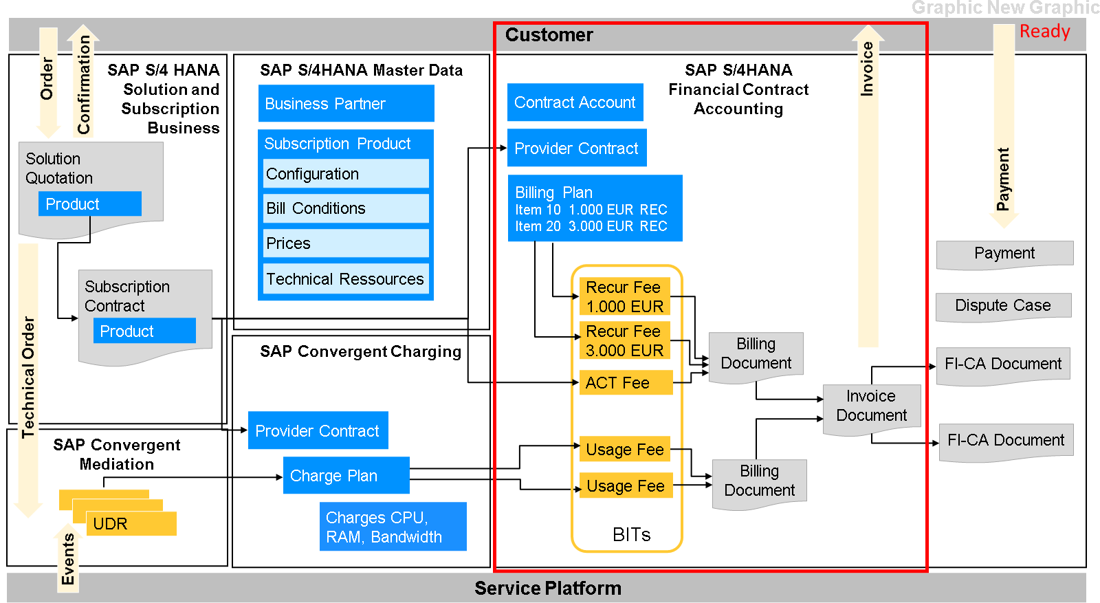
Convergent Invoicing Overview
As you explore new markets and new digital business models, regardless of industry, being able to accurately invoice your customers while compensating your partners in creative and sometimes complex revenue sharing agreements is critical. Both customers and partners are asking for the same invoicing capabilities: accuracy, personalization, comprehension, flexibility, and availability at every touchpoint. Customers want to easily check their invoices and to monitor their consumption in real-time, on any device.
When they subscribe to multiple services, they want to consolidate them into a single (= convergent) invoice overview, including discounts, taxes, and other billing variations as, for example, itemized details.
SAP BRIM offers a flexible solution for automating the billing and invoicing process. Consolidate service pricing from multiple sources to produce easily understandable invoices and discounts that drive loyalty, enhance cash flow, and increase customer engagement.
The invoicing component of SAP BRIM pulls rated events, or even complete bills, from several upstream, multivendor rating or billing streams, and then consolidates the information into a single converged invoicing document.
The resulting document can then be enriched with flexible discounts, multiple aggregations, different levels of detail, and notifications about prior payment activity or late payments.
Convergent Invoicing Definitions
Billable Item
A billable item (BIT) is a priced event transaction received by SAP Convergent Invoicing from a source system which is to be applied to a customer statement of invoice. BITs are stored and processed in SAP Convergent Invoicing.
In the business example for each usage record of CPU, one billable item is created.
Billing Plan
A Billing Plan in Convergent Invoicing is a definition of a scheduled plan for creation of billable items. It is assigned to a FI-CA provider contract item.
A Billing Plan can either create charges, credits, down payment requests, or a combination. For recurring billing plan items, refer to a billing cycle which can have a periodicity of monthly, quarterly, or yearly.
Requesting Billing Plan Item Process
The following video outlines the requesting billing plan item process and item storage in SAP Convergent Invoicing:
In SAP Convergent Invoicing, we have the option to store billable items and consumption items. The storage of billable items is the starting point in SAP Convergent Invoicing, while the decision to store consumption items in SAP Convergent Invoicing is a solution architecture decision depending on the use cases.
Keep all invoice-relevant data in one system for consistency purposes.
One more hierarchy level is available regarding consumption items that are a source for billable items.
- One more option for aggregation is possible.
- Structured consumption item information on the invoice.
- Correction of consumption items in the SAP Convergent Invoicing correction workbench.
- Manual capturing of consumption in SAP Convergent Invoicing.
- Aggregation of consumption items before rating for the reduction of billable item volume.
Identifying SAP Convergent Invoicing Key Capabilities
Objective

After completing this lesson, you will be able to identify SAP Convergent Invoicing key capabilities.
SAP Convergent Invoicing Key Capabilities
The figure illustrates the SAP Convergent Invoicing Key Capabilities, which are explained in the following text.
1. Convergent Invoicing
Convergent Invoicing provides informative summaries and details. It can converge existing systems onto a single bill and adapt to industry fields (CPU, RAM, Bandwidth).
2. Process Automation to Easily Handle High Volume
All mass processes run automatically in SAP Convergent Invoicing. Error correction and reversal processes are included to handle outages or configuration errors.

3. SAP S/4HANA Platform Approach
SAP Convergent Invoicing offers integration with Contract Accounting for open item lifecycle management and SAP Revenue Recognition. It also offers accounting aggregation before posting in the General Ledger. Lastly, it allows full traceability with transparent document flow from General Ledger postings down to a single item.
Identifying Financial Contract Accounting Processes
Objectives
After completing this lesson, you will be able to:
- Outline the document lifecycle of an FI-CA document.
- Describe how to post, change, and display documents.
- Provide a FI-CA process overview and navigate in Account Balance Display.
- Execute the Dunning Process.
The Document Lifecycle of an FI-CA Document
Business Example
The invoice of customer CutAbove is posted on their contract account in subledger FI-CA on the contract account of CutAbove. CutAbove must pay their invoice. Karen now passes the contract to O2C’s accounts executive.

Amir is an accounts executive for the O2C Company. His tasks involve creating background processes for:
- Running payment lots.
- Run clearing on contract accounts.
- Run dunning process for open items.
He also checks the customer account for complaints from the customer. Lastly, Amir explains open items and calls the customer requesting open items.
Business Needs for Financial Contract Accounting
Contract Accounting capability comprises the functions of Contract Accounts Receivable and Payable (application component FI-CA) used for subledger accounting, implementing typical functions of accounts receivable accounting such as posting, payments, and dunning, and is set up to process large numbers of documents.
You can integrate Contract Accounts Receivable and Payable as an integral part of Finance with capabilities in Finance and other solutions to accomplish more business tasks.
Where Are We in the Process Flow?
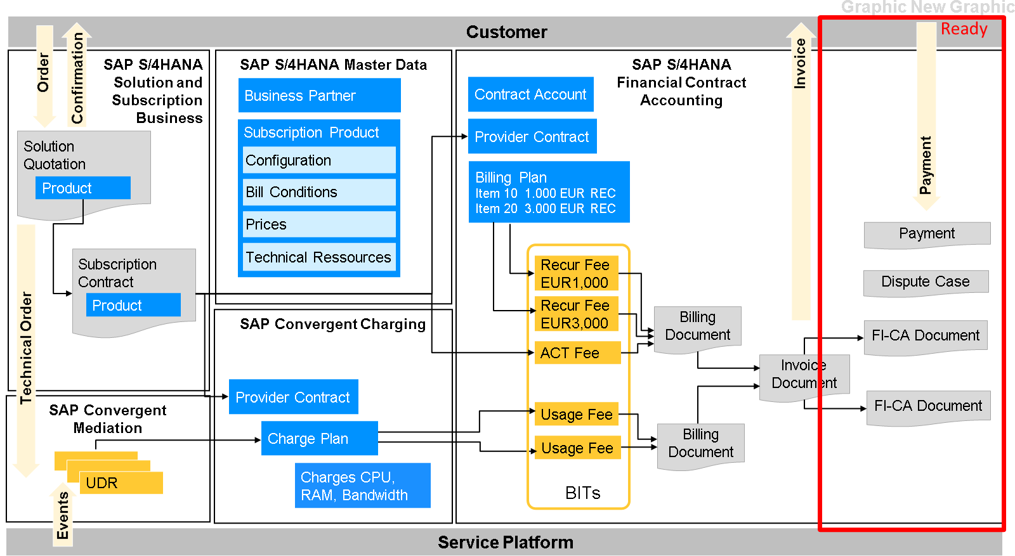
Introducing SAP Financial Contract Accounting
We now return to our SAP Billing Innovation Revenue Management Consultant, Finn. In the following video, Finn introduces the process steps involved in SAP Financial Contract Accounting.
SAP FI-CA (Contract Accounts Receivable and Payable) is a subledger for managing high-volume business transactions. It helps businesses manage simplified, customer-specific processes such as posting and document management.
Accounting Pain Points
Accounting pain points in high-volume companies are as follows:
- Inaccurate and nontransparent accounting.
- Controlling and reporting are associated with difficult reconciliation and audit assurance.
These pain points can be eased by SAP's optimized key business capability for integrating all internal and external accounting aspects into one aligned solution that follows accounting principles and reconciliation needs.
Industry Specific Operations
Missing industry-specific expertise in other subledger systems is not the subject of accounting in SAP Billing and Revenue Innovation Management (SAP BRIM). Industry-specific operations and features have been adopted to the solution in the past and are still in focus for further developments to lower Total Cost of Ownership (TCO) in implementations and adjustments.
Deal with a Large Volume of Data
Dealing with a mass volume of data and different payment channels, it is difficult to handle the import of masses of payments in various formats and the assignment of them to the appropriate receivables items in subledger.
Huge manual effort is required to clarify the payment assignment, which makes this process slow and expensive. SAP Receivables Management and Payment Handling consider all possible payment channels, and provides a sophisticated and flexible clearing control to assign individual clearing strategies.
In the end, the transparency of the actual outstanding receivables results in better collections and higher customer satisfaction.
Credit and Collection Management Function
The credit and collection management functions of the SAP Customer Financial Management package helps you to make credit decisions and perform collections that are individually tailored to your customers. With the software, you can initiate and monitor internal and external collection activities, and generate strategic credit and collection reports.
Financial Contract Accounting Definitions
Contract Account
The contract account is a unit that groups business partner postings. Before a document can be posted, a contract account must be assigned to a business partner in the role MKK. The contract account data controls the FI-CA processes:
- The clearing category controls payment allocation and the clearing of receivables.
- The dunning procedure determines the dunning levels and the dunning activities.
- The account determination ID is used to determine the general ledger accounts.
- The payment term determines the due date and the cash discount deadline.
- The creditworthiness reflects a business partner's payment patterns.
- The interest key determines the conditions for interest calculation.
- The tolerance group defines limits for payment differences.
FI-CA Document
A FI-CA document represents a business transaction that results in the update of the subledger and subsequent applications like general ledger, controlling, and cash management.
The business view of a document shows:
- Document header
- Business partner items
- General ledger items
Document types classify different business transactions.
Examples:
- Posting document: for example, open items can be posted in invoicing.
- Payment document: for example, can be posted during incoming payment.
- Write-Offs documents.
- Charges and Discounts documents.
Posting, Changing, and Displaying Documents
Business Transactions in Financial Contract Accounting
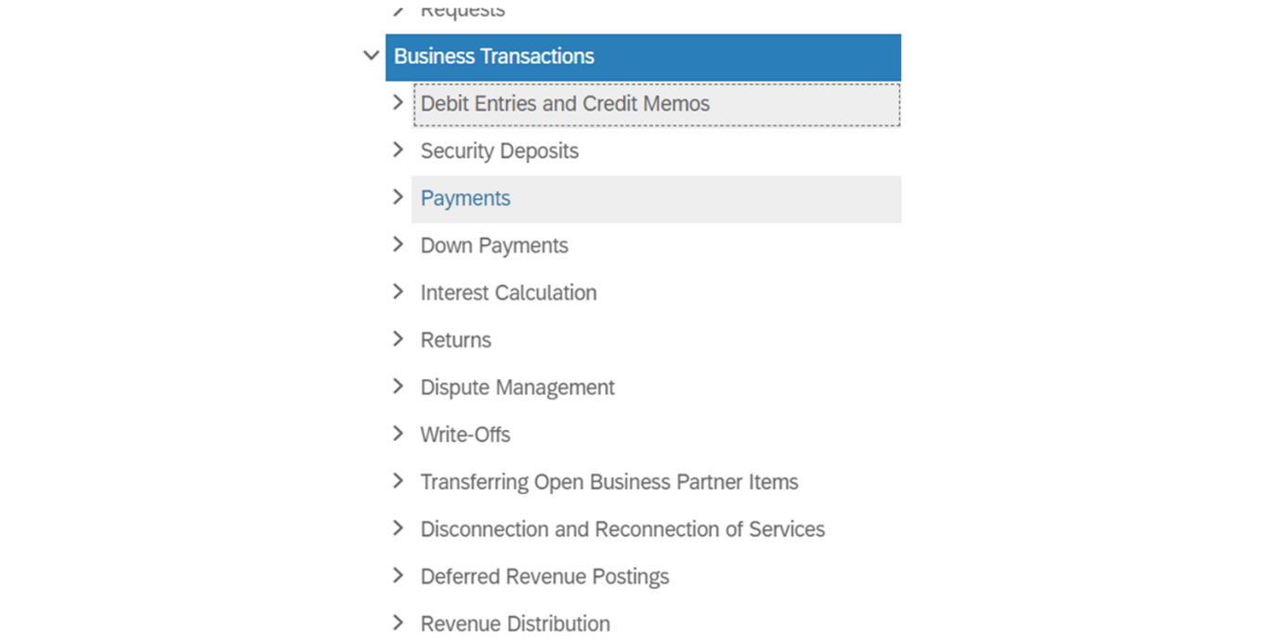
The Lifecycle of an Open Item
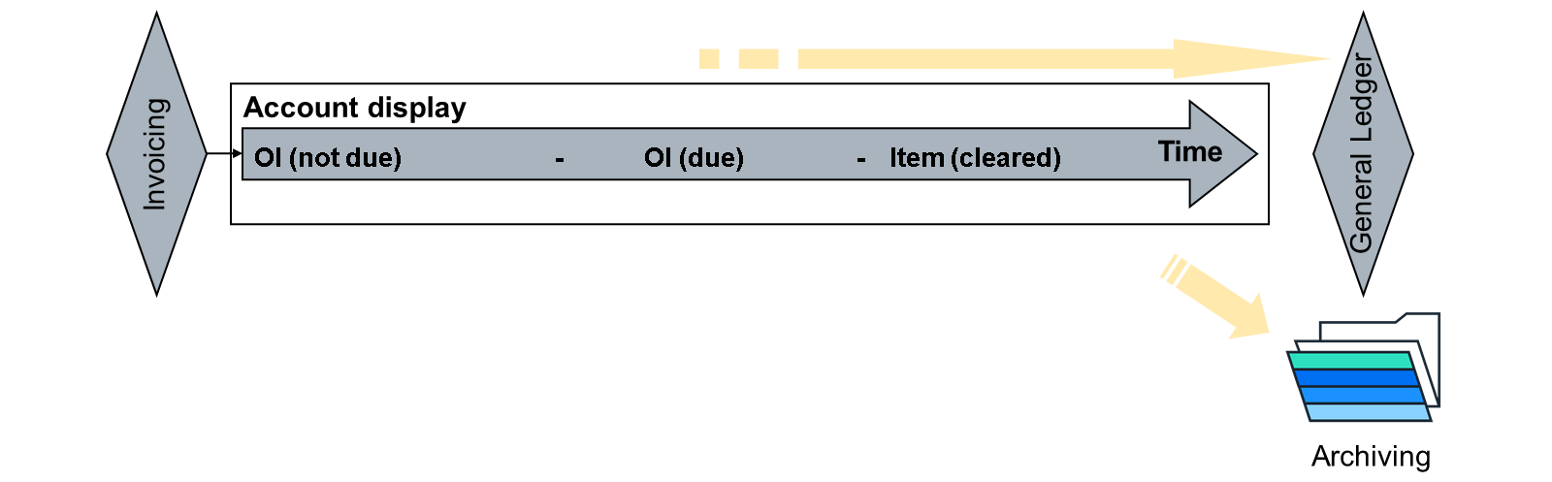
The lifecycle of receivable item in Contract Accounts Receivable and Payable clearly indicates the Contract Accounts Receivable and Payable processes that are handled in FI-CA. These processes include:
- Open items (OI) can be posted in invoicing, dunning, or returns processing. Alternatively, open items can be posted manually in subledger accounting.
- Items relevant for the general ledger are regularly compressed and transferred to the general ledger.
- Cleared documents that have expired can be archived.
- Open and cleared items can be displayed in the account display function.
The FI-CA Process Overview and Navigation
FI-CA Processes Overview
The document lifecycle clearly indicates the FI-CA processes:
- Documents can be posted as receivables (usual form) and sometimes as payables.
- Documents can be posted in invoicing (usual form), dunning, or returns processing.
- Documents can be posted manually as well.
- Cleared and open items are regularly compressed and transferred to the general ledger.
- Cleared and open items can be displayed using the account balance display.
- Cleared documents that have expired can be archived.
Executing the Dunning Process
Credit and Collections Management
Credit and Collections Management enables your company to operate centralized credit management and process delayed payments.

Dunning is a process carried out to give reminders to customers for their overdue payments. In SAP FI-CA, you can conduct the dunning process and generate dunning letters to be sent out to customers. The system uses parameters like dunning levels, dunning areas, dunning charges, and so on, to govern this mechanism. With each successive parameter change (like an increased dunning level), the tone of the dunning letter becomes more serious.
Why Could a Business Partner Be Dunned?
- Overdue Receivables
- Other Receivables (dunning charges, dunning interest)
Note
Dunning runs are carried out in two stages:
- Dunning Proposal Run (FPVA): All due items are identified and grouped together.
- Dunning Activity Run (FPVB): Dunning activities are carried out.
The Process of Dunning by Collection Strategy
Dunning by collection strategy is based on business rules that are evaluated at run-time. This allows for a flexible evaluation of a broad range of parameters:
- A collection strategy is assigned on master data level.
- Contract accounts can be treated individually or can be grouped together.
- The evaluation of the business rules within the strategy return the next collection step (and related activities) to be carried out.
- The specific circumstance of an account determines the next collection step.
- The data that can be evaluated in the rules engine include, for example the dunning data, dunning history, credit risk data.
In the following, the process of dunning by collection strategy is described.
- The Dunning Proposal run takes place.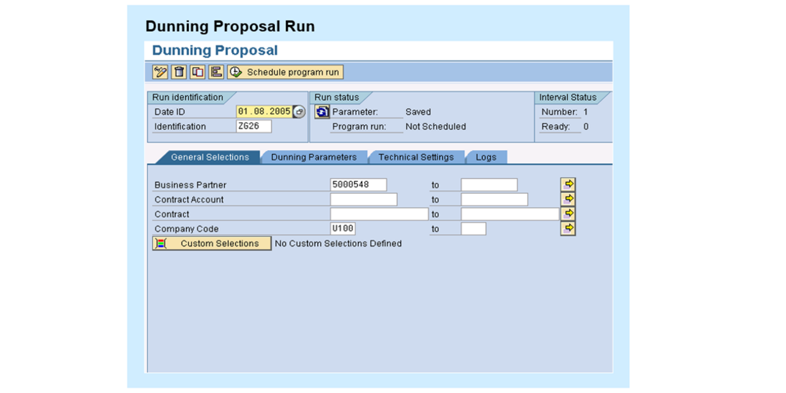
The previous screenshot shows the Dunning Proposal Run (FPVA) where all due items are identified and grouped together. The following business rules determine the next collection step before beginning the Dunning Activity Run.
- As next, the Business Rules Framework comes into place.
Business Rules Framework
Apply rules for contract accounts or group of contract accounts.
Collection Step
Determine Dunning Activity, dunning interval, charges, and interest as well as alternative Collection Steps​.
Organization management
Clerk Determination (Role and Task assignment).​
Capacity planning and workload balancing
Determination of a maximum number of reminder letters in a dunning activity​.
These business rules frameworks, collection steps, and dunning activities ultimately increase the efficiency of the collections process but also can help maintain positive customer relationships even in the face of payment difficulties. Let’s see what a dunning activity run looks like in the system.
- Based on the rules, the Dunning Activity is created.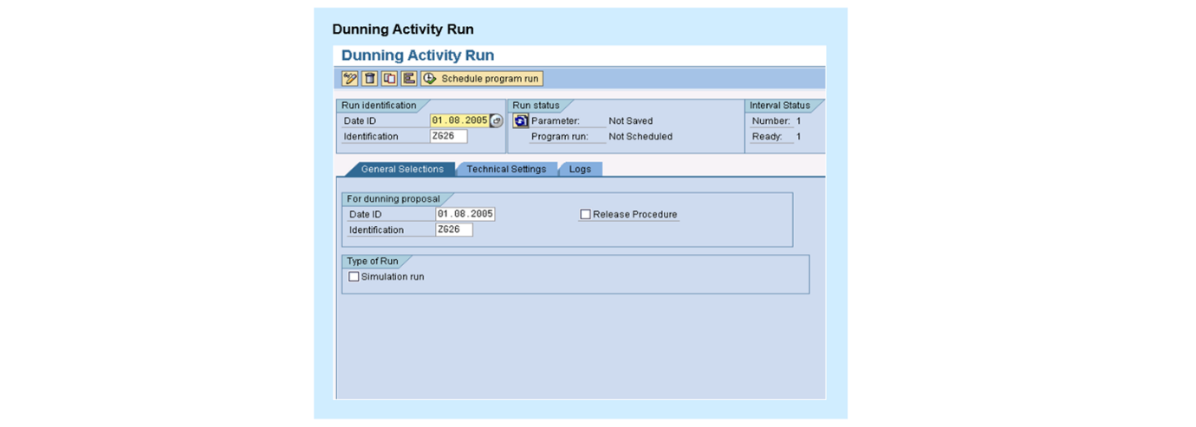
Collection
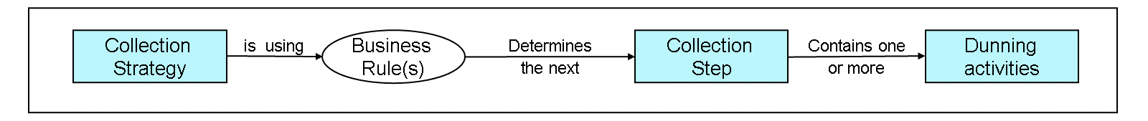
Collection is a more advanced stage of dunning.
The process of collection in SAP FI-CA (Financial Accounting - Contract Accounting) is designed to help businesses manage their incoming payments more efficiently. This module aids in identifying overdue payment or outstanding items, classifies them into different collection segments based on defined criteria such as risk category or days in arrears, and automatically initiates the appropriate collection activities.
Collection activities can include automatically generated reminders, dunning letters, or even escalation to a collections agency. SAP FI-CA also allows for individualized management of each debtor. This means that collection strategies can be customized based on the debtor's payment history, credit rating, or other defined parameters. This not only increases the efficiency of the collections process but also helps to maintain positive customer relationships even in the face of payment difficulties.
Furthermore, SAP FI-CA provides comprehensive reporting and analytical tools to monitor the effectiveness of collections activities and to identify trends or issues that can require changes to the collection strategy. These can then be addressed promptly to ensure optimal debtor management and cash flow for the business.
Identifying the Key Capabilities of SAP S/4HANA Financial Contract Accounting for Cloud Selection Service
Objective
After completing this lesson, you will be able to identify the key capabilities of SAP S/4HANA Financial Contract Accounting for Cloud Selection Service.
The Key Capabilities of SAP S/4HANA Financial Contract Accounting for Cloud Selection Service
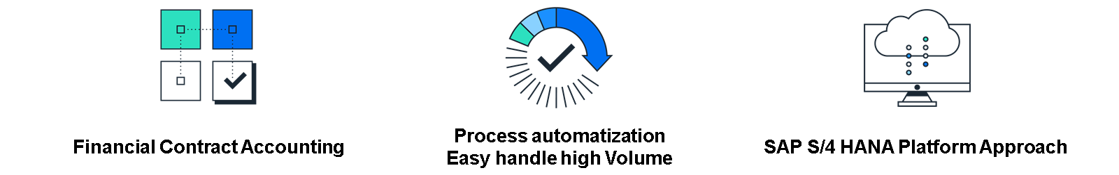
1. Financial Contract Accounting
- High automatization of payment processes through fast, automated, and accurate payment handling, ultimately increasing customer satisfaction and allowing transparency of outstanding receivables.
- Credit and collection processes provide a standard report and multilevel collection strategies.
2. Process Automatization Allows Easy Handling of High Volumes
- All mass processes run automatically.
- Error correction and reversal processes included to handle outstages or configuration errors.
- Included access control and audit mechanisms.
3. SAP S/4HANA Platform Approach
- Collect multiple data streams or sources.
- Merge asynchronous data together.
- Summarization of general ledger information (total records).
- Integration FI-GL, Integration FI-RA
SAP BRIM – Comprehensive Guide
May 9, 2026 by saptutorials
Modern digital businesses are rapidly moving from traditional one-time product sales to recurring subscription-based revenue models. Organizations now require scalable, flexible, and intelligent billing systems capable of handling millions of transactions in real time. This is where SAP BRIM becomes a game-changing enterprise solution.
SAP BRIM (Billing and Revenue Innovation Management) is designed to support high-volume billing, subscription management, usage-based charging, invoicing, collections, and financial processing. It helps businesses manage complex pricing models while delivering seamless customer experiences.
Industries such as telecommunications, SaaS, utilities, streaming platforms, and financial services rely heavily on SAP BRIM to automate revenue operations and support digital transformation initiatives.
Table of Contents
- Introduction to SAP BRIM
- Understanding the Digital Subscription Economy
- Why Organizations Need SAP BRIM
- SAP BRIM Architecture Overview
  - Subscription Order Management (SOM)
  - Convergent Charging (CC)
  - Convergent Invoicing (CI)
  - FI-CA (Contract Accounts Receivable & Payable)
- End-to-End SAP BRIM Process Flow
  - Step 1: Order Capture
  - Step 2: Contract Creation
  - Step 3: Usage Charging
  - Step 4: Billing and Invoicing
  - Step 5: Payment and Collections
- Deep Dive into Subscription Order Management
  - Subscription Lifecycle Management
  - Subscription Contract Management
  - SOM Integration Capabilities
- Master Data in SAP BRIM
  - Business Partner (BP)
  - Contract Account
  - Product Master
- Subscription Billing Models Supported by SAP BRIM
- Solution Quotation in SAP BRIM
  - Key Features
  - Subscription Contract Management
  - Integration with BRIM Components
  - Master Agreements in BRIM
  - B2B Example
  - Contract Change Processes
  - Supported Change Processes
  - Workflow Automation
- Financial and Revenue Management in BRIM
  - Revenue Recognition
- Benefits of SAP BRIM
- Industries Using SAP BRIM
- SAP BRIM Integration with SAP S/4HANA
- Challenges in SAP BRIM Implementation
  - Common Challenges
  - Performance Optimization
- Best Practices for Successful SAP BRIM Projects
  - Start with Clear Business Requirements
  - Focus on Master Data Quality
  - Adopt Scalable Architecture
  - Use Agile Implementation Approaches
- Future of SAP BRIM in the Subscription Economy
- Conclusion
- Frequently Asked Questions
  - What is SAP BRIM used for?
  - What are the main components of SAP BRIM?
  - Which industries use SAP BRIM?
  - What is SOM in SAP BRIM?
  - How does SAP BRIM support subscription billing?
  - Is SAP BRIM integrated with SAP S/4HANA?
  - Share this:
  - Like this:
  - Related
Introduction to SAP BRIM
SAP BRIM is an integrated platform that enables organizations to manage the entire quote-to-cash lifecycle for subscription and consumption-based business models.
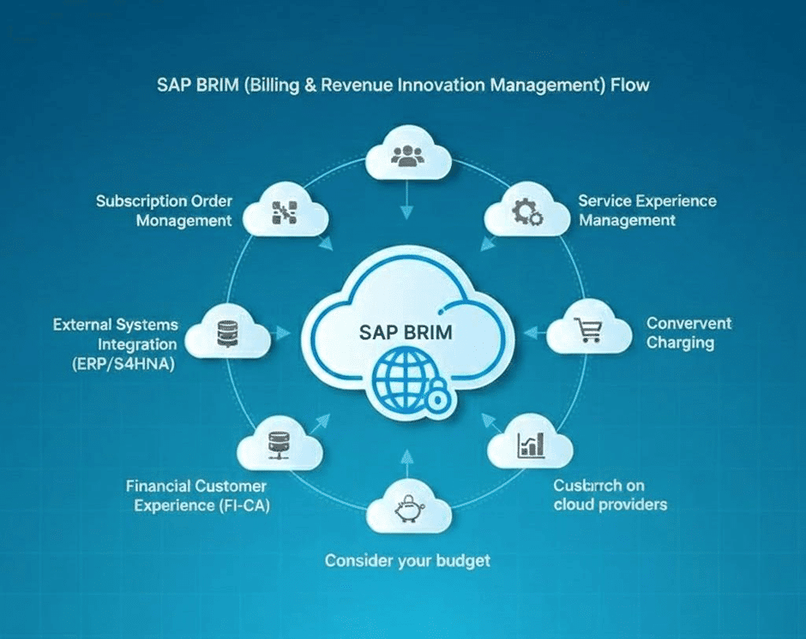
The solution combines multiple SAP components into one unified ecosystem that supports:
- Subscription management
- Usage-based charging
- Real-time billing
- Revenue accounting
- Collections and receivables
- Flexible pricing structures
SAP BRIM allows enterprises to transform from product-centric businesses into service-oriented digital organizations.
Some common examples of businesses using subscription or usage models include:
- Streaming platforms like Netflix
- Telecom operators
- Cloud service providers
- SaaS companies
- Utility providers
These organizations require systems that can efficiently process recurring payments, dynamic pricing, and large-scale invoicing.
Understanding the Digital Subscription Economy
The global economy has shifted dramatically toward digital services and recurring revenue models.
Traditional business model:
- Sell product once
- Recognize revenue immediately
Modern subscription model:
- Offer ongoing services
- Generate recurring monthly or yearly revenue
- Maintain continuous customer engagement
Examples include:
Business Type | Revenue Model
Streaming Services | Monthly subscription
Telecom Providers | Usage-based billing
Cloud Platforms | Consumption pricing
SaaS Companies | Recurring licensing
Utilities | Metered usage
This shift introduces several operational challenges:
- Complex billing cycles
- Frequent pricing changes
- Customer upgrades and downgrades
- High transaction volumes
- Real-time charging requirements
SAP BRIM addresses these challenges through automation and integrated revenue management.
Why Organizations Need SAP BRIM
Modern enterprises require billing platforms capable of adapting quickly to evolving market demands.
SAP BRIM helps organizations:
Support Multiple Revenue Models
Discover more
Compare ERPs
Try Office Apps
data
Businesses can simultaneously support:
- Prepaid billing
- Postpaid billing
- Hybrid models
- Subscription billing
- Usage-based billing
Handle Complex Pricing
SAP BRIM supports:
- Tiered pricing
- Discounts
- Promotions
- Bundled services
- Dynamic pricing rules
Improve Customer Experience
Customers gain access to:
- Self-service subscription portals
- Unified invoices
- Transparent billing details
- Personalized offers
Increase Scalability
The platform handles:
- Millions of transactions
- Large customer bases
- Real-time processing
- High-volume invoicing
SAP BRIM Architecture Overview
SAP BRIM consists of four tightly integrated core components.
Subscription Order Management (SOM)
SOM manages subscription orders and orchestrates the entire customer lifecycle.
Key responsibilities include:
- Order capture
- Subscription creation
- Contract lifecycle management
- Product upgrades/downgrades
- Renewals and cancellations
SOM acts as the central orchestration layer within SAP BRIM.
Convergent Charging (CC)
Convergent Charging handles real-time usage rating and charging.
Functions include:
- Usage mediation
- Real-time charging
- Rating calculations
- Usage aggregation
- Pricing determination
For example, telecom providers use CC to calculate charges based on call duration or internet data consumption.
Convergent Invoicing (CI)
Convergent Invoicing consolidates charges from multiple systems into unified customer invoices.
Core capabilities:
- Invoice generation
- Bill consolidation
- Tax calculations
- Invoice formatting
- Billing dispute handling
CI enables organizations to provide a single invoice across multiple services.
FI-CA (Contract Accounts Receivable & Payable)
FI-CA manages the financial side of customer billing.
Key functions include:
- Payment processing
- Collections management
- Dunning procedures
- Credit checks
- Financial postings
FI-CA integrates seamlessly with SAP S/4HANA Finance.
End-to-End SAP BRIM Process Flow
SAP BRIM follows a structured quote-to-cash process.
Step 1: Order Capture
Customers place orders through:
- Web portals
- CRM systems
- Sales channels
- Mobile applications
SOM captures and validates the subscription request.
Step 2: Contract Creation
Subscription contracts are generated containing:
- Pricing terms
- Billing cycles
- Contract duration
- Service eligibility
Step 3: Usage Charging
Convergent Charging rates customer usage based on pricing rules.
Examples:
- Data consumption
- Streaming hours
- API calls
- Cloud resource utilization
Step 4: Billing and Invoicing
Convergent Invoicing generates customer invoices.
Invoices may contain:
- Recurring subscription charges
- Usage fees
- Taxes
- Discounts
Step 5: Payment and Collections
FI-CA handles:
- Payment posting
- Outstanding balances
- Collection activities
- Financial reconciliation
Deep Dive into Subscription Order Management
Subscription Order Management is one of the most critical components in SAP BRIM.
It serves as the orchestration engine for subscription-based business operations.
Subscription Lifecycle Management
SOM manages the full lifecycle of subscriptions, including:
- New subscriptions
- Renewals
- Suspensions
- Cancellations
- Product modifications
This ensures smooth customer onboarding and lifecycle automation.
Subscription Contract Management
SOM creates and maintains subscription contracts containing:
- Pricing conditions
- Billing plans
- Contract durations
- Product configurations
- Service entitlements
Contracts can evolve over time using time-slice management.
SOM Integration Capabilities
SOM integrates with:
- SAP CRM
- SAP S/4HANA
- Convergent Charging
- Convergent Invoicing
- External applications
This integration ensures seamless data synchronization across enterprise systems.
Master Data in SAP BRIM
Master data is the foundation of SAP BRIM processes.
Business Partner (BP)
The Business Partner represents the customer in SAP BRIM.
Common BP roles include:
Role | Purpose
FLCU00 | Financial customer
FLCU01 | Sales customer
Contract Partner | FI-CA relationship
Business Partner data supports:
- Billing
- Communication
- Contracts
- Payments
Contract Account
The Contract Account stores financial information related to the customer.
It tracks:
- Open invoices
- Payments
- Outstanding balances
- Credit information
Contract Accounts are heavily used in FI-CA.
Product Master
Products define the services being sold.
Examples include:
- Telecom plans
- Streaming packages
- SaaS subscriptions
- Cloud services
Product configuration contains:
- Pricing details
- Billing frequency
- Discounts
- Subscription duration
Subscription Billing Models Supported by SAP BRIM
SAP BRIM supports multiple billing models.
Model Type | Description | Example
Fixed Subscription | Periodic recurring fee | Netflix
Unlimited Usage | Flat-rate unlimited consumption | Amazon Prime
Usage-Based | Charges based on usage | Telecom data plans
Freemium | Free basic + paid upgrades | Dropbox
Hybrid Model | Subscription + usage charges | Cloud platforms
Organizations can configure highly flexible pricing strategies based on customer needs.
Solution Quotation in SAP BRIM
A Solution Quotation is a legally binding commercial offer.
It can include:
- Subscription services
- Physical products
- One-time services
- Recurring services
Key Features
Solution Quotations support:
- Follow-up tracking
- External purchase order references
- Multi-item quotations
- Integration with master agreements
This functionality is especially useful in B2B sales scenarios.
Subscription Contract Management
After order confirmation, subscription contracts are generated.
Key Contract Attributes
Contracts include:
- Contract account
- Billing cycle
- Pricing conditions
- Discount structures
- Service eligibility
Integration with BRIM Components
Contracts are distributed to:
- Convergent Charging
- Convergent Invoicing
This ensures synchronized billing and charging operations.
Master Agreements in BRIM
Master Agreements define pre-negotiated terms for enterprise customers.
These agreements commonly include:
- Pricing structures
- Discount conditions
- Service limitations
- Eligibility rules
B2B Example
A telecom provider may create a master agreement for multiple subsidiaries of a corporate customer.
This ensures standardized pricing across all related contracts.
Contract Change Processes
Business requirements change constantly, and SAP BRIM supports flexible contract modifications.
Supported Change Processes
Organizations can manage:
- Address changes
- Payment method updates
- Subscription upgrades
- Downgrades
- Renewals
- Cancellations
Workflow Automation
SAP BRIM provides:
- Predefined workflows
- Custom workflow configuration
- Approval management
- Automated validations
This improves operational efficiency while reducing manual effort.
Financial and Revenue Management in BRIM
Financial operations are critical in subscription-based businesses.
SAP BRIM provides robust financial management capabilities.
Key Features
- Automated receivables management
- Revenue sharing
- Credit risk management
- Collection automation
- Financial reconciliation
Revenue Recognition
Integration with SAP S/4HANA enables accurate revenue recognition according to accounting standards.
This is particularly important for SaaS and subscription businesses.
Benefits of SAP BRIM
SAP BRIM offers several strategic advantages.
- Scalability:Handles millions of transactions efficiently.
- Real-Time Billing:Supports immediate charging and invoicing.
- Flexible Pricing:Enables innovative monetization models.
- Customer-Centric Billing:Provides unified invoices and transparent billing.
- Strong SAP Integration:Works seamlessly with SAP S/4HANA and other SAP solutions.
Industries Using SAP BRIM
Many industries depend on SAP BRIM for digital revenue management.
Industry | Use Case
Telecommunications | Usage-based billing
Media & Entertainment | Streaming subscriptions
Utilities | Metered consumption billing
SaaS & Cloud | Recurring subscriptions
Financial Services | Digital service billing
SAP BRIM Integration with SAP S/4HANA
SAP BRIM integrates closely with SAP S/4HANA.
Integration areas include:
- Financial accounting
- Revenue recognition
- General ledger postings
- Customer management
- Analytics and reporting
This integration creates a unified enterprise platform.
For official SAP product information, visit SAP BRIM Official Page
Challenges in SAP BRIM Implementation
Despite its benefits, SAP BRIM implementations can be complex.
Common Challenges
- Integration complexity
- Large data migration efforts
- Pricing model configuration
- High customization requirements
- Change management
Performance Optimization
High-volume billing environments require careful:
- Infrastructure planning
- Database optimization
- Interface monitoring
Best Practices for Successful SAP BRIM Projects
Organizations should follow proven implementation strategies.
Start with Clear Business Requirements
Define:
- Revenue models
- Billing scenarios
- Customer journeys
- Pricing strategies
Focus on Master Data Quality
Clean master data improves:
- Billing accuracy
- Customer experience
- Reporting quality
Adopt Scalable Architecture
Prepare systems for future growth and digital expansion.
Use Agile Implementation Approaches
Incremental deployment reduces project risks and accelerates value delivery.
Future of SAP BRIM in the Subscription Economy
The future of digital business depends heavily on recurring revenue models.
SAP BRIM is expected to play a central role in enabling:
- AI-driven pricing
- Real-time monetization
- IoT billing
- 5G charging
- Cloud consumption billing
As organizations continue shifting toward “Everything-as-a-Service” models, SAP BRIM will remain a critical enterprise platform.
Conclusion
SAP BRIM is a powerful and scalable enterprise solution built for the modern subscription economy. Organizations transitioning toward digital, subscription-based, and usage-driven business models require intelligent platforms capable of handling complex pricing, billing, invoicing, and revenue management processes.
With components such as SOM, Convergent Charging, Convergent Invoicing, and FI-CA, SAP BRIM provides end-to-end revenue lifecycle management. Its flexibility, scalability, and deep integration with SAP ecosystems make it an ideal solution for enterprises managing large customer bases and evolving monetization strategies.
As digital transformation accelerates globally, SAP BRIM continues to help businesses innovate, automate, and optimize revenue operations efficiently.
Frequently Asked Questions
What is SAP BRIM used for?
SAP BRIM is used for subscription billing, usage-based charging, invoicing, collections, and revenue management in digital businesses.
What are the main components of SAP BRIM?
The four core components are:
Subscription Order Management (SOM)
Convergent Charging (CC)
Convergent Invoicing (CI)
FI-CA
Which industries use SAP BRIM?
Industries include:
Telecommunications
SaaS
Utilities
Media & Entertainment
Financial services
What is SOM in SAP BRIM?
Subscription Order Management (SOM) manages subscription orders, contract lifecycles, renewals, and customer subscriptions.
How does SAP BRIM support subscription billing?
SAP BRIM supports recurring billing cycles, flexible pricing, discounts, renewals, and usage-based charging models.
Is SAP BRIM integrated with SAP S/4HANA?
Yes, SAP BRIM integrates tightly with SAP S/4HANA for finance, revenue recognition, reporting, and accounting operations.

