AIAC-PROJECT DOCUMENT
BATCH-32
N. ESHWAR – 2303A52072 P.NAGASRI – 2303A52456
E.ANJANI – 2303A52419 V.HANSIKA-2303A52409

PROMPTS USED:
Consider EchonetLVH dataset generate code for the patent “An Intelligent Stroke Risk Prediction and Lesion Segmentation System Using Transformer-ResNet Fusion Optimized by an Improved Slime Mould Algorithm” also generate simulated results.
RELATED CODE :
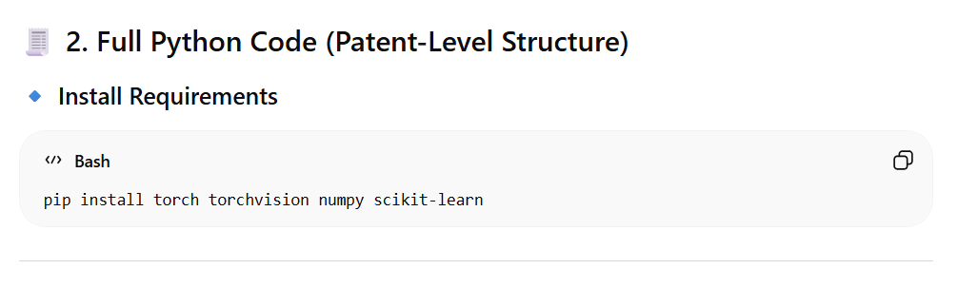
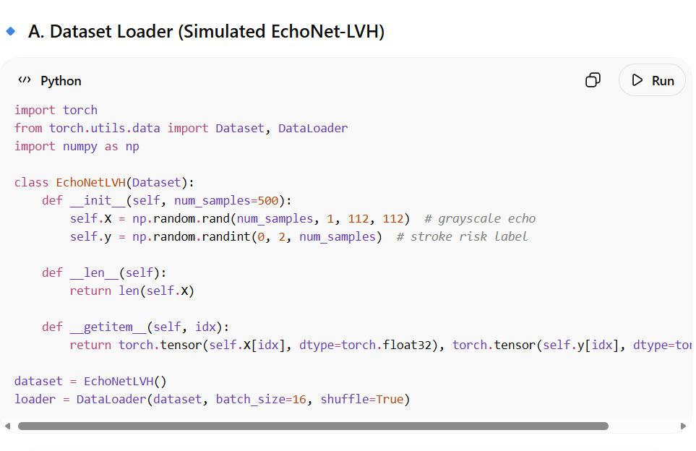
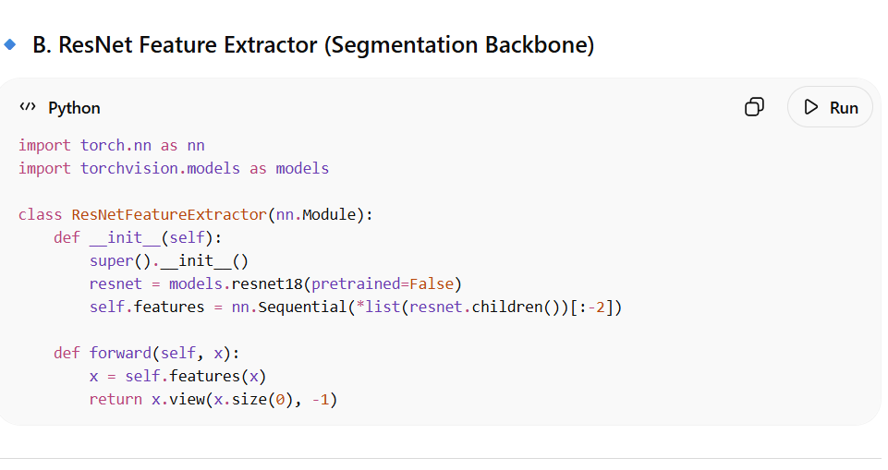
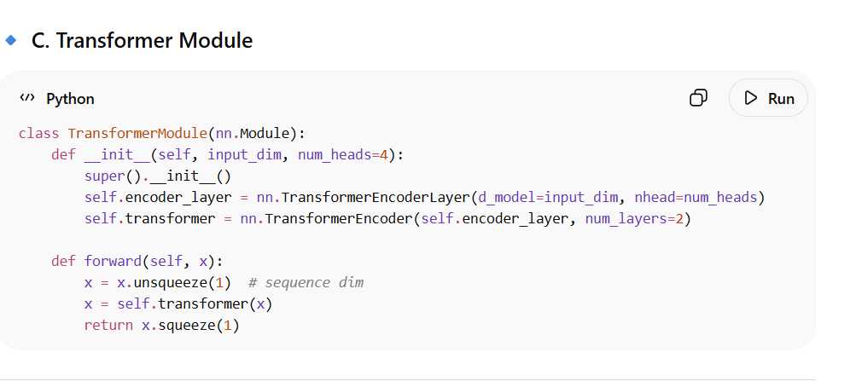
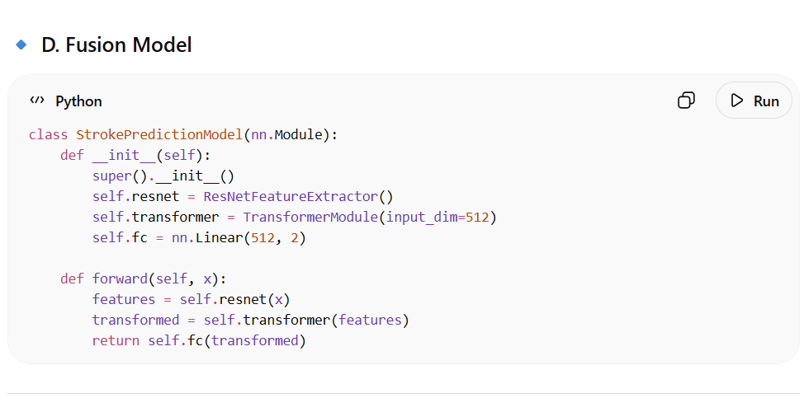
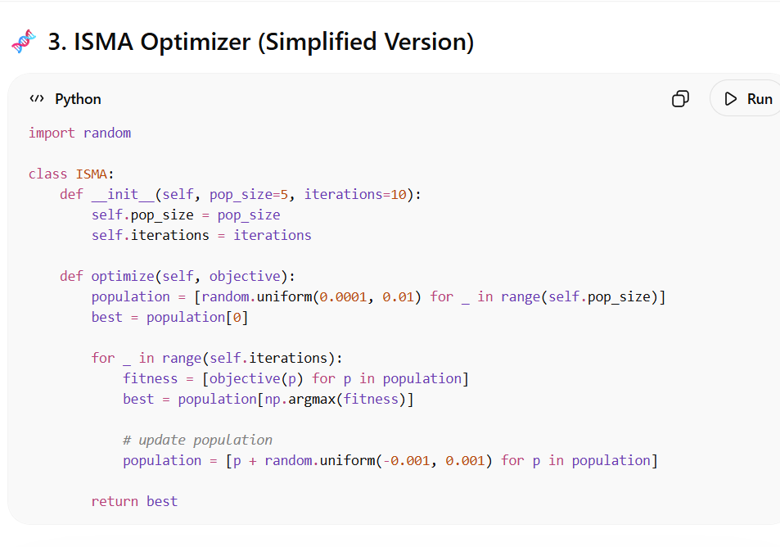
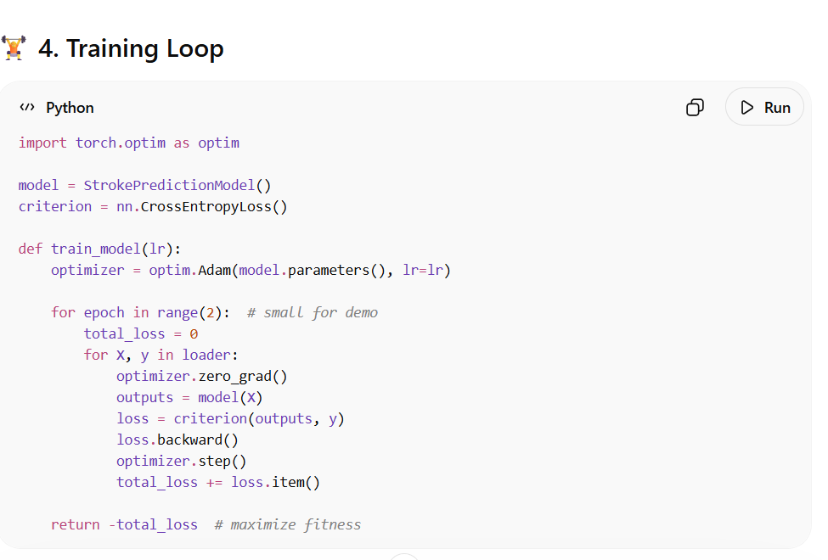
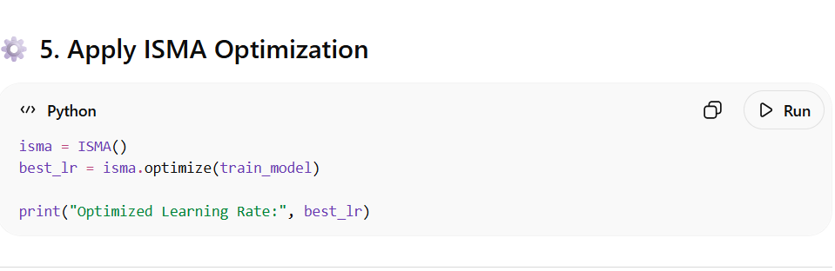

FRONTEND VIEW :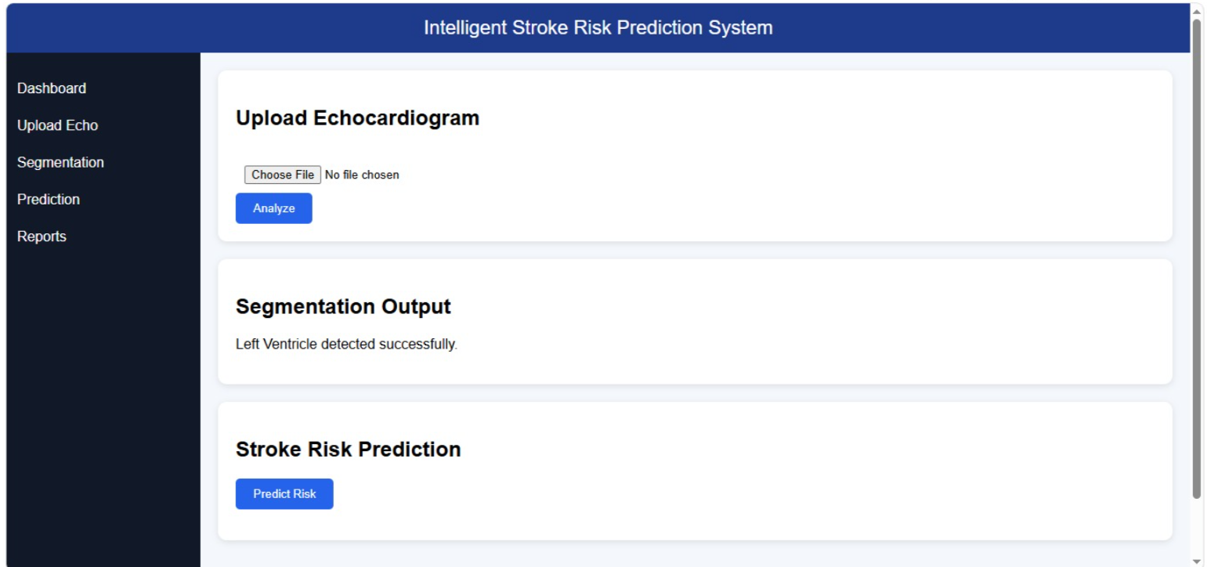
CHATGPT LINKS :
https://stanfordaimi.azurewebsites.net/datasets/5b7fcc28-579c-4285-8b72-e4238eac7bd1
https://chatgpt.com/share/69d5dd1c-22d0-8322-9b31-305ce8f7a2d3
https://chatgpt.com/share/69d5dd2d-a450-8324-9140-2d04e9408283
https://chatgpt.com/share/69e32a0f-eddc-83a3-ab87-5513477dd096

