ShopEZ E-Commerce Platform
Developed by: Vudatha Eshwar Prasad

1. Introduction
When our team first gathered to brainstorm ideas for our software engineering project, we wanted to build something that people use every single day. We decided that an electronic commerce platform would be the perfect challenge. We named our project ShopEZ. The primary objective was to create an intuitive, secure, and robust online shopping environment that bridges the gap between buyers and sellers through seamless digital interactions.
Project Title: ShopEZ E-Commerce Platform.
Team Members: Eshwar Prasad acts as the Lead Developer and Systems Architect. The team collaborated to handle database modeling, frontend user interface design, and backend serverless deployment.

2. Project Overview
Purpose: ShopEZ was built to address the complexities of modern online retail. Traditional e-commerce platforms often suffer from monolithic architectures that are difficult to scale. Our purpose was to adopt a decoupled, component-driven frontend combined with a stateless backend architecture, allowing the application to scale infinitely during high-traffic shopping events while maintaining incredibly fast load times.
Features: The application highlights several key functionalities. It includes secure JWT-based authentication to protect user accounts. It features a massive, dynamic product catalog populated with realistic imagery and deep filtering options. It includes a dynamic shopping cart that instantly recalculates totals across the entire application using global state management. Furthermore, it implements role-based access control, ensuring that only verified sellers and administrators can upload products or view the order dashboard.

3. Architecture
We selected the MERN stack for our architecture, meaning we wrote the entire application using JavaScript from top to bottom.
Frontend: We built the frontend architecture using React. Instead of relying on traditional DOM manipulation, which is notoriously slow, React utilizes a Virtual DOM to ensure highly optimized render cycles. We managed our global application state using React's native Context API.
Backend: The backend architecture is powered by Node.js and Express.js. Node.js provides a non-blocking, asynchronous runtime environment, which is perfect for an API that needs to handle thousands of concurrent database requests. Express.js acts as the framework that structures these requests.
Here is an example of the core server initialization code we wrote for the backend to start the Express application and handle Cross-Origin Resource Sharing (CORS):
const express = require('express');
const cors = require('cors');
const cookieParser = require('cookie-parser'); require('dotenv').config();
const app = express();
app.use(express.json());
app.use(cookieParser());
app.use(cors({ origin:
['http://localhost:5173', 'https://shopez-fullstack.vercel.app'], credentials: true }));
const PORT = process.env.PORT || 5000; app.listen(PORT, () => { console.log(`Server is running on port ${PORT}`); });
Database: For our database schema and interactions, we utilized MongoDB. Because e-commerce products have highly variable attributes, a NoSQL document database was far superior to a rigid SQL table. We interacted with MongoDB using the Mongoose ORM. To ensure our serverless deployment did not crash the database, we wrote a highly optimized connection caching script:
const mongoose = require('mongoose');
let cached = global.mongoose;
if (!cached) {
cached = global.mongoose = { conn: null, promise: null };
}
const connectDB = async () => {
if (cached.conn)
return cached.conn;
if (!cached.promise) {
cached.promise = mongoose.connect(process.env.MONGO_URI, { serverSelectionTimeoutMS: 5000, }).then((mongoose) => { return mongoose; });
}
cached.conn = await cached.promise;
return cached.conn;
};
module.exports = connectDB;

4. Setup Instructions
To ensure any new developer could easily contribute to ShopEZ, we standardized the local setup process.
Prerequisites: Before starting, a developer must have Node.js installed on their machine to run the JavaScript environment. They also need a Git client to clone the repository, and a MongoDB Atlas account to host their database cluster.
Installation: First, the developer opens their terminal and uses the git clone command pointing to the ShopEZ repository. Once downloaded, they navigate into the backend directory and run npm install. They then create a local .env file. The code inside the .env file should look exactly like this:
PORT=5000 MONGO_URI=mongodb+srv://:@cluster0.mongodb.net/?appName=Cluster0 JWT_SECRET=shopez_super_secret_jwt_key_2024 NODE_ENV=development
Finally, they open a separate terminal, navigate into the frontend directory, and run npm install again to fetch the React dependencies.

5. Folder Structure
A clean folder structure is the hallmark of a maintainable software project.
Client: The React frontend is organized inside the client directory. The src folder contains the core application. Inside src, we created a components folder that holds isolated, reusable UI elements like the Product Card and the Navigation Bar. We created a pages folder to hold the main visual views.
Server: The Node.js backend is organized logically inside the server directory. We created a models folder to hold the Mongoose schema definitions that dictate how our data looks in the database. For example, here is the exact code we wrote to structure the Product schema:
const mongoose = require('mongoose');
const productSchema = new mongoose.Schema(
{
name: { type: String, required: true, trim: true },
description: { type: String, required: true },
price: { type: Number, required: true, min: 0 },
category: { type: String, required: true, enum: ['Electronics', 'Fashion', 'Home & Kitchen', 'Books', 'Sports', 'Beauty', 'Toys', 'Groceries', 'Other'] },
images: [{ type: String }],
seller: { type: mongoose.Schema.Types.ObjectId, ref: 'User', required: true },
stock: { type: Number, required: true, default: 0 }
},
{ timestamps: true }
);
module.exports = mongoose.model('Product', productSchema);
We also created a controllers folder to hold the complex business logic functions, and a routes folder that simply maps URL paths to those specific controller functions.

6. Running the Application
To start the application locally, the developer needs to initialize both the client and the server simultaneously. The following commands are used in the terminal.
Frontend: To start the React application, the developer must open a terminal, navigate into the frontend directory, and execute the Vite development server script. The code entered in the terminal is:
cd frontend npm run dev
Vite instantly spins up a local web server on port 5173. Vite also provides Hot Module Replacement, meaning any code the developer types will instantly appear in the browser without requiring a manual refresh.
Backend: To start the Express server, the developer opens a second terminal, navigates into the backend directory, and executes the Node runtime. The code entered in the terminal is:
cd backend node server.js
This executes the Node environment, which reads the variables, connects to the MongoDB database, and begins listening for incoming HTTP requests on port 5000.

7. API Documentation
The backend exposes a highly structured RESTful API. Every endpoint expects and returns data in JSON format.
Our authentication endpoints include a POST request to /api/auth/register, which requires a name, email, and password. The POST request to /api/auth/login requires an email and password, and returns the authenticated user data.
Here is an example of the controller code we wrote to handle fetching all products via a GET request to /api/products, including search functionality and pagination:
const getProducts = async (req, res) => {
try {
const pageSize = 20;
const page = Number(req.query.page) || 1;
const keyword = req.query.keyword ? { name: { $regex: req.query.keyword, $options: 'i' } } :{};
const count = await Product.countDocuments({ ...keyword });
const products = await Product.find({ ...keyword }) .limit(pageSize) .skip(pageSize * (page - 1));
res.json({ products, page, pages: Math.ceil(count / pageSize) });
} catch (error) {
res.status(500).json({ message: "Server Error fetching products" });
}
};
Our cart and order endpoints include a GET request to /api/cart to retrieve the user's active shopping session, and a POST request to /api/cart requiring a product ID and quantity integer to add an item. Finally, the POST request to /api/orders reads the user's current cart and processes the checkout.

8. Authentication
We designed our authentication system to be entirely stateless and highly secure using JSON Web Tokens (JWT) and HTTP-Only cookies.
When a user successfully logs in, the backend uses the bcrypt library to compare password hashes, and then generates a secure token. Here is the exact authentication code we implemented to handle a secure user login:
const loginUser = async (req, res) => {
const { email, password } = req.body;
try {
const user = await User.findOne({ email });
if (!user)
return res.status(400).json({ message: 'Invalid credentials' });
const isMatch = await bcrypt.compare(password, user.password);
if (!isMatch)
return res.status(400).json({ message: 'Invalid credentials' });
const token = jwt.sign( { id: user._id, role: user.role }, process.env.JWT_SECRET,
{expiresIn: '30d'});
res.cookie('token', token, { httpOnly: true, secure:
process.env.NODE_ENV === 'production', sameSite: 'none', maxAge: 30 * 24 * 60 * 60
* 1000 });
res.json({ _id: user._id, name: user.name, email: user.email, role: user.role });
}
catch (error) {
res.status(500).json({ message: error.message });
}
};
To protect secure routes, we wrote a custom middleware function that intercepts incoming requests, extracts the cookie, and verifies the JWT signature before allowing the request to proceed to the database.

9. User Interface
The user interface was crafted to provide a premium, modern aesthetic using React components. We utilized a clean Light Mode theme with strict attention to typography and whitespace. The interface relies heavily on high-quality, realistic product imagery.
Here is an example of the React JSX code we wrote for the Product Card component to dynamically render the product details on the screen:
import React from 'react';
import { Link } from 'react-router-dom';
const ProductCard = ({ product }) => { return (

{product.name}{product.category}
${(product.price).toFixed(2)}
Add to Cart
); };
export default ProductCard;
We implemented subtle CSS hover effects across all these components, so that when a user moves their mouse over a product card or a checkout button, the element gently elevates with a drop shadow, providing immediate visual feedback.

10. Testing
Our testing strategy was divided into two distinct phases to ensure maximum application stability.
First, we conducted extensive manual API testing using a tool called Postman. Before integrating the frontend, we sent dozens of simulated HTTP requests directly to our backend server. We intentionally sent malformed data, such as missing email fields or invalid passwords, to ensure that our Express error-handling middleware caught the mistakes and returned graceful 400-level error messages rather than crashing the Node.js process.
Second, we performed rigorous end-to-end user flow testing directly in the browser. We simulated the exact path a human user would take: registering a new account, navigating the product catalog, filtering by category, adjusting item quantities in the shopping cart, and finalizing the checkout. We repeated this process across multiple modern browsers, including Google Chrome and Mozilla Firefox, to verify that our React context state remained synchronized and our CSS layouts rendered flawlessly.

11. Screenshots or Demo
The application has been successfully deployed to a live production environment using Vercel's global edge network.

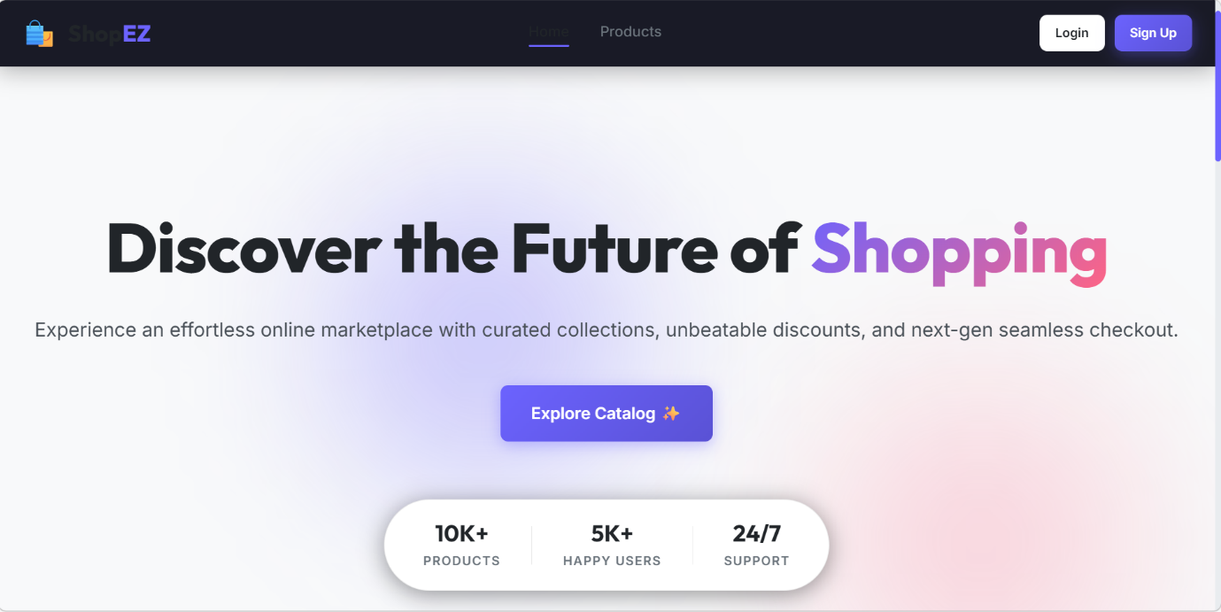

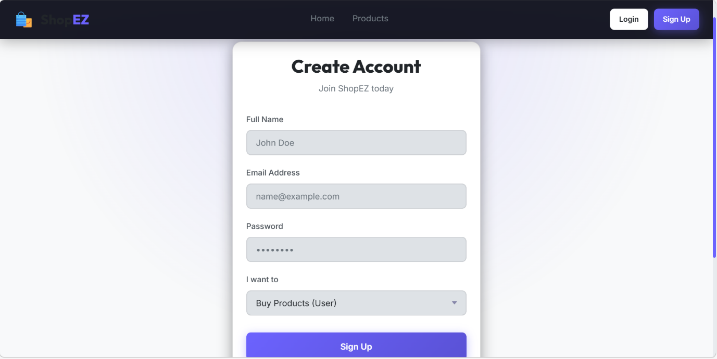

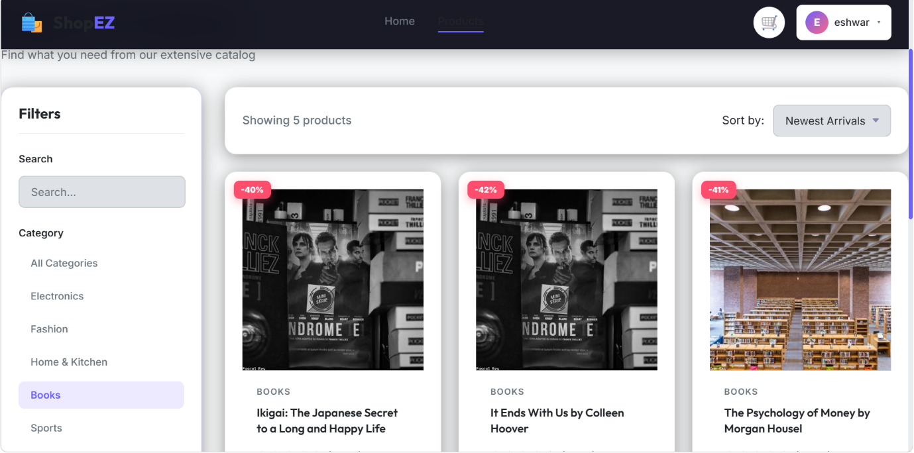

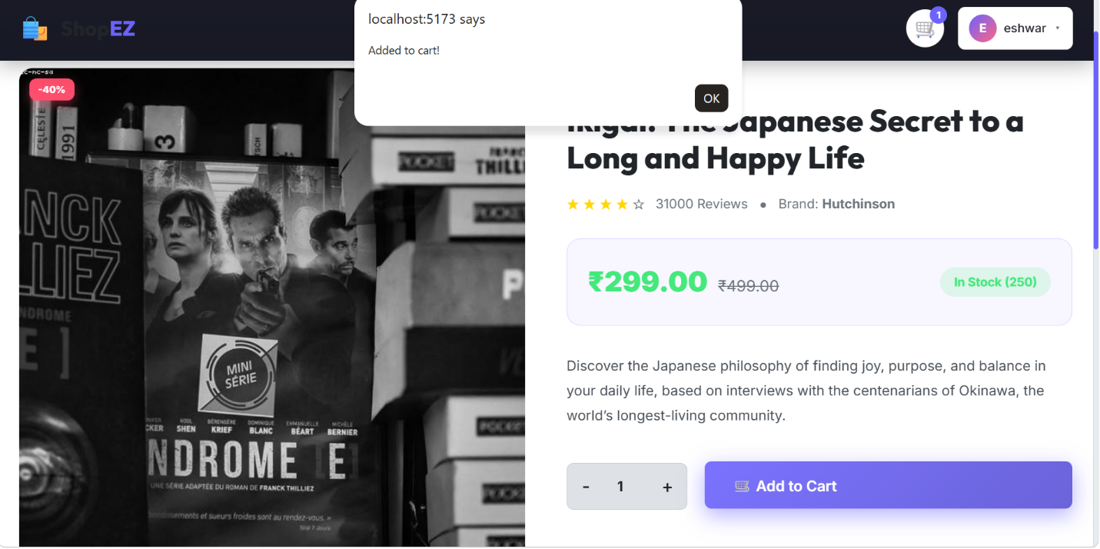

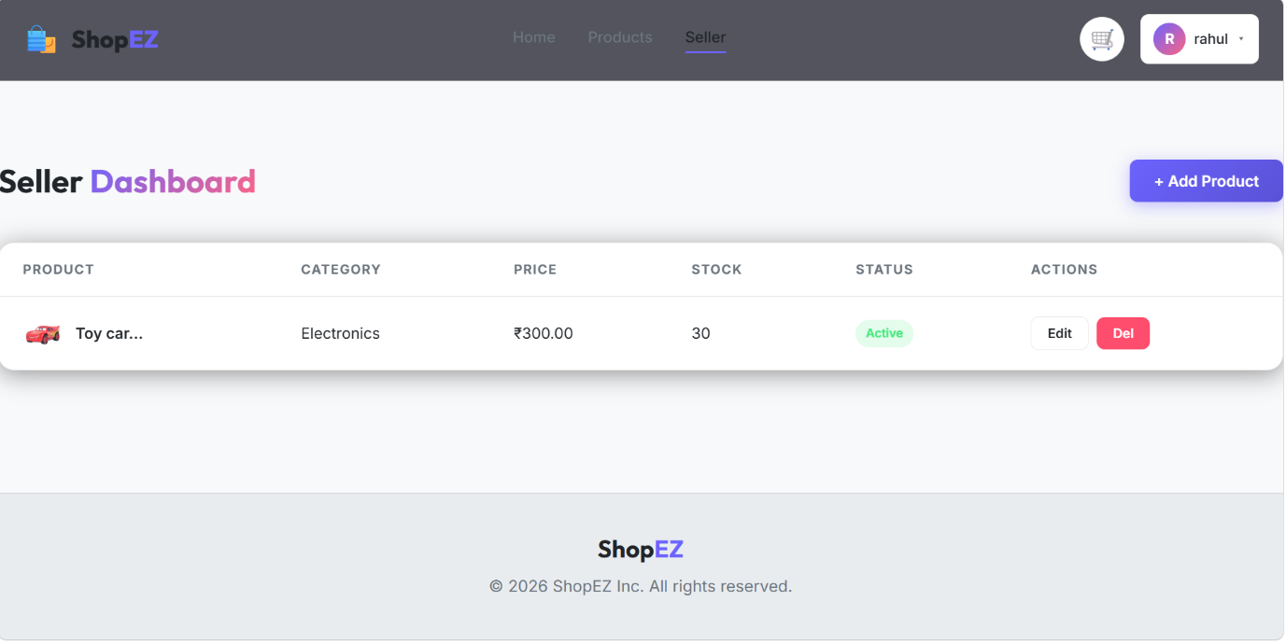

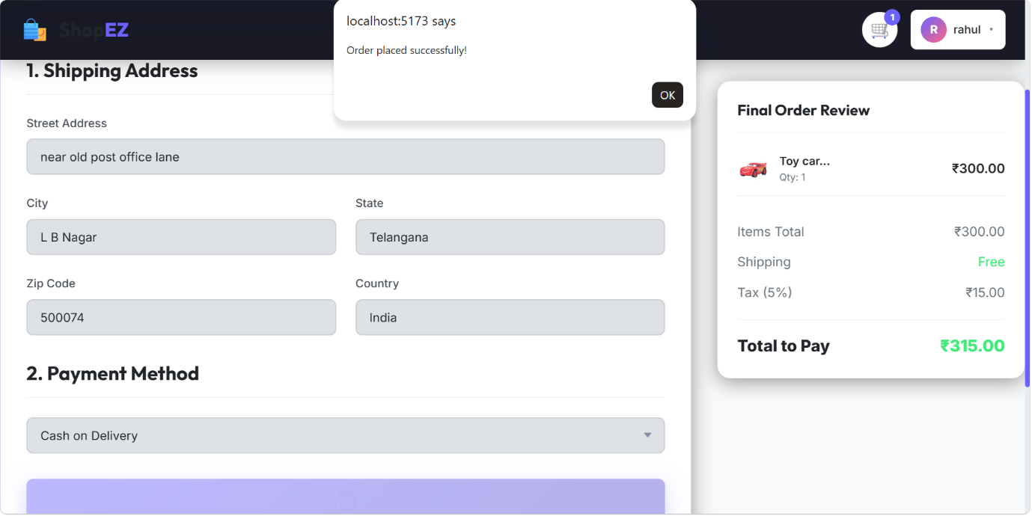

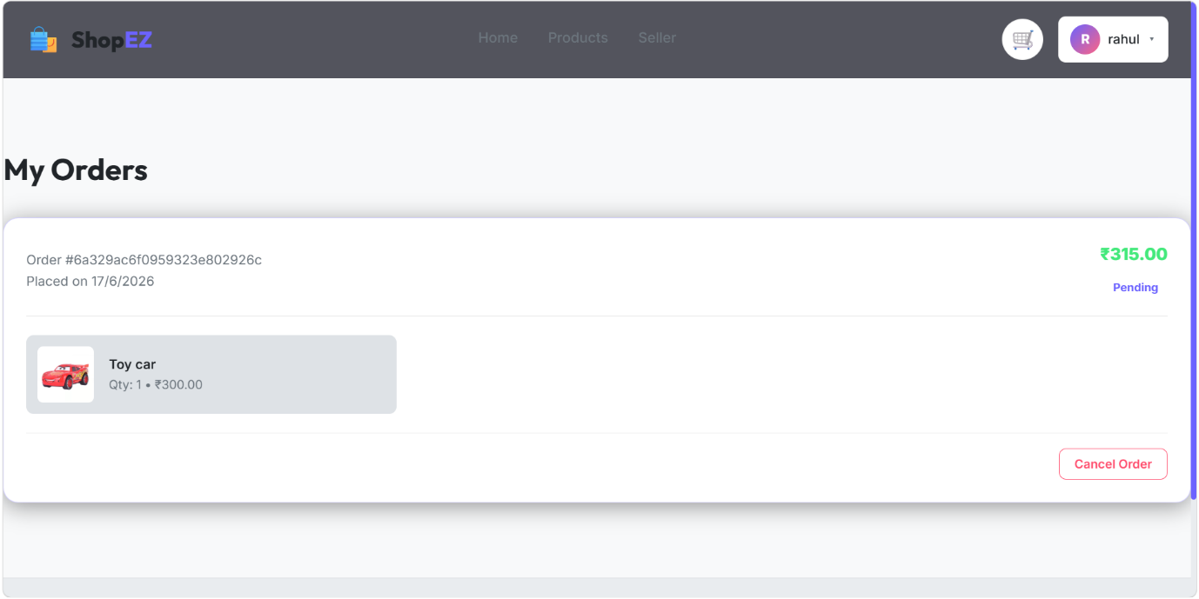

12. Known Issues
There are a few known issues inherent to our deployment architecture that developers should be aware of.
The most prominent issue involves Serverless Cold Starts. Because Vercel puts our backend functions to sleep when no users are active, the very first API request made after a period of inactivity may take an additional one to two seconds to resolve. This delay occurs because the serverless function has to wake up, execute the Node runtime, and establish a fresh connection to the MongoDB Atlas cluster before it can answer the frontend.
Additionally, developers running massive database seeding scripts locally might encounter connection timeouts. Free-tier MongoDB Atlas clusters strictly limit the number of maximum parallel connections. If a script attempts to insert thousands of products simultaneously without batching, the database will throttle the request, resulting in a dropped connection.

13. Future Enhancements
While the current platform is incredibly robust, we have outlined several potential future features that would elevate the project even further.
The most crucial enhancement is the integration of a real Payment Gateway. Currently, the checkout flow handles the logical creation of an order in the database, but we plan to implement the Stripe API to securely process real credit card transactions in a fully compliant manner.
We also intend to implement Email Notifications. By integrating a service like SendGrid or Nodemailer, we can write backend triggers that automatically send a beautifully formatted order confirmation email to the user the exact moment their checkout is completed.
Finally, we want to add Real-Time Analytics and User Reviews. We will build a chart-based dashboard allowing sellers to visualize their sales volume over time. Concurrently, we will expand the Product schema to allow verified buyers to leave textual reviews and star ratings, significantly enhancing the social proof and overall credibility of the store's inventory.

