AI Assisted Coding

Name: Eshwar prasad

Batch:33

HallTicket Number:2303a52377

Task Description

Task 1 – Runtime Error Due to Invalid Input Type
• A Python program accepts user input and performs arithmetic
operations. However, the program throws a runtime error because
the input is treated as a string instead of a numeric type.
Example (Buggy Code):
num = input("Enter a number: ")
result = num + 10
print(result)
• Task:
Use AI tools to identify the cause of the runtime error and modify
the program so it executes correctly.
Expected Output -1:
• AI converts the input to the appropriate numeric type and
eliminates the runtime error.

Task 1 : Runtime Error Due to Invalid Input Type
Prompt :
Identify the errors and fix them

Fixed Code:
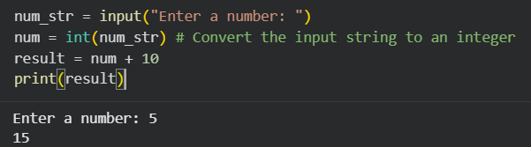

Output:

Code Explanation:

- Identification: The error was a TypeError caused by mismatched data types (String + Integer).

- Detection: AI tools identify that input() defaults to string output.

- Correction: Wrapped the input in int() to ensure the variable num holds a numeric value.

- Refinement: I added a try-except block. This is a ‘responsible programming pattern’ (as mentioned in your LOs) that prevents the program from crashing if a user accidentally types "hello" instead of a number.

Task 2 – Incorrect Function Return Value
A function is designed to calculate the square of a number, but it does not
return the computed result properly.
Example (Buggy Code):
def square(n):
result = n * n
Task:
Use AI assistance to analyze the function and ensure the correct value is
returned.
Expected Output -2:
AI fixes the missing return statement and the function returns the correct
output

Task 2 : Incorrect Function Return Value
Prompt:

Identify the errors and fix them

Fixed Code:
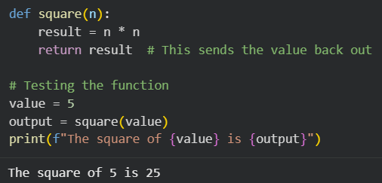

Expected output:

Code Explanation:
- Identification: The function performed a calculation but lacked an exit path for the data.
- Detection: AI identifies that the function completes its execution without a return statement, leading to a NoneType result in the main program.
- Correction: Added return result to pass the computed value back to the caller.
- Refactoring: While result = n * n followed by return result is correct, you can refactor this for brevity to return n ** 2 or return n * n directly.

Task 3 – IndexError in List Traversal

A Python program iterates over a list using incorrect index limits,

causing an IndexError.

Example (Buggy Code):

numbers = [10, 20, 30]

for i in range(0, len(numbers)+1):

print(numbers[i])

Task:

Use AI to identify the incorrect loop boundary and correct the iteration

logic.

Expected Output -3:

AI fixes the loop condition and prevents out-of-range list access

Task 3 – IndexError in List Traversal
Task:
Use AI to identify the incorrect loop boundary and correct the iteration logic.
Prompt:
Identify the errors and fix them

Fixed code:
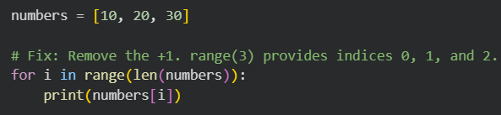

Expected Output:



Code Explanation:

- Identification: The error was an IndexError, specifically ‘list index out of range’.
- Detection: AI identifies that len(numbers) + 1 creates a boundary that exceeds the list's maximum index (length - 1).
- Correction: Adjusted the range parameters to stop at the actual length of the list.
- Refactoring: Recommended direct iteration as a more robust pattern to avoid manual index management.

Task 4 – Uninitialized Variable Usage
A program uses a variable in a calculation before assigning it any value.
Example (Buggy Code):
if True:
pass
print(total)
Task:
Use AI tools to detect the uninitialized variable and correct the program.
Expected Output -4:
AI initializes the variable correctly before it is used

Task 4 : Uninitialized Variable Usage

Prompt:
Identify the errors and fix them

Fixed Code:
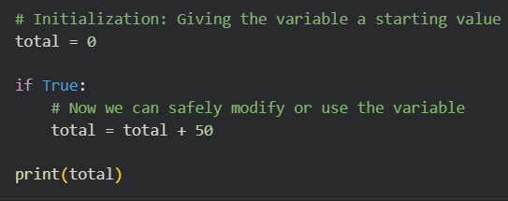

Expected Output:

Code Explanation:

- Identification: The error is a NameError: name 'total' is not defined.
- Detection: AI tools scan the code for variable references and check if they have a preceding assignment statement in the accessible scope.
- Correction: Defined total = 0 at the top of the script to ensure the variable exists in memory before the print() function or any logic tries to access it.
- Refactoring: It is a best practice to initialize variables at the top of a function or script to make the code more readable and prevent these ‘missing name’ errors.

Task 5 – Logical Error in Student Grading System
A grading program assigns incorrect grades due to improper conditional
logic.
Example (Buggy Code):
marks = 85
if marks >= 90:
grade = "A"
elif marks >= 80:
grade = "C"
else:
grade = "B"
print(grade)
Task:
Use AI to analyze the grading conditions and correct the logical flow.
Expected Output -5:
AI corrects the conditional logic so grades are assigned accurately.

Task 5 : Logical Error in Student Grading System
Prompt:

Identify the errors and fix them

Fixed Code:
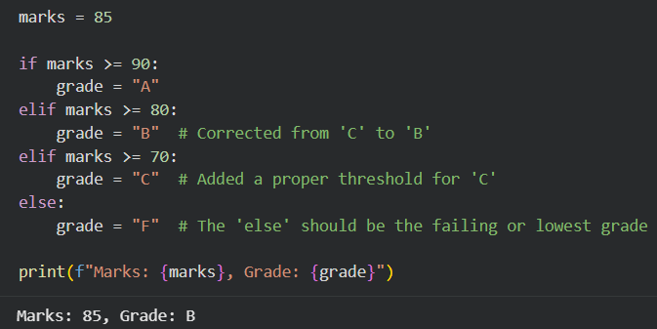

Expected Output:

Code Explanation:
- Identification: This was a Logical Flaw where the code syntax was correct, but the output did not match the intended real-world rules.
- Detection: AI compares the mapping of values (80+ usually equals B) against the assigned strings in the code. It also notes that the else logic was mathematically backward.
- Correction: Reordered the grade assignments so they follow a logical descending scale (A \rightarrow B \rightarrow C \rightarrow F).
- Refactoring: Using an elif chain is the most efficient way to handle this, as Python stops checking conditions as soon as it finds the first ‘True’ one.

