**WAD ASSIGNMENT**

**Name:** Eshwari Pravin Tambat

**Roll no:** 61

**Package name:** Agenda

**Illustrate the need for Agenda** **Package:**

**Agenda:**

The agenda is job scheduling library for nodejs. It provides simple and flexible way to schedule and execute jobs at specific times and requests.

**The agenda package is useful in Node.js applications for various reasons:**

**1.Job Scheduling:** agenda allows you to schedule jobs to run at specific times or intervals, such as every minute, every hour, or on specific dates.

**2.Recurring Jobs:** You can define recurring jobs that repeat at specified intervals, such as every day, every week, or every month.

**3.Job Persistence:** agenda provides integration with MongoDB to persist job information, allowing you to store and manage scheduled jobs.

**4.Job Dependencies:** Jobs can have dependencies on other jobs, ensuring that a job runs only after its dependencies have completed.

**5.Error Handling:** agenda allows you to handle job failure and define retry strategies for failed jobs.

**6.Event-driven Architecture:** The library is built with an event-driven architecture, allowing you to listen for events such as job completion, job failures, or job progress updates.

**7.MongoDB Integration:** agenda integrates seamlessly with MongoDB, a widely adopted NoSQL database. It uses MongoDB as the backend for storing job information, allowing you to persist jobs and their metadata. This integration leverages the power and scalability of MongoDB for efficient job management and persistence.

**8.Simplicity:** agenda provides a simple and intuitive API for scheduling and managing jobs. It has a straightforward syntax for defining jobs and scheduling them at specific times or intervals. The package focuses on the core functionality of job scheduling, making it easy to understand and use.

**9. Active Community and Support:** agenda has an active and supportive community of users and contributors. It is a well-established package with regular updates and improvements. The community provides assistance, documentation, and examples, making it easier to learn and utilize the package effectively.

**Agenda.js:**

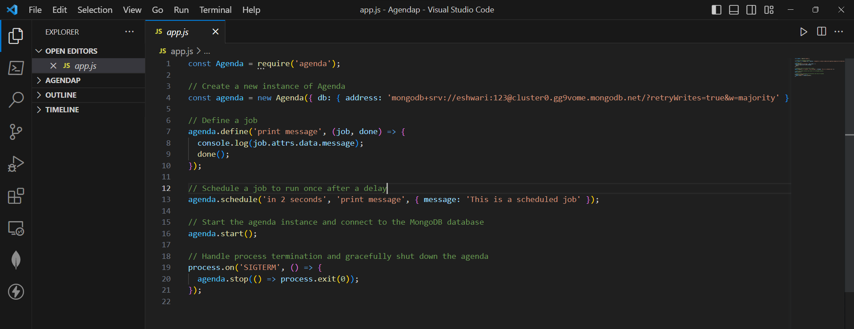

**Illustrate the need for code of ethics:**

The need for a code of ethics arises from several important considerations. Here are some key illustrations of why a code of ethics is necessary:

1. Guidance for Decision Making: A code of ethics provides individuals and organizations with a framework and principles to guide their decision-making processes. It establishes a set of standards and values that help individuals navigate ethical dilemmas and make choices aligned with ethical principles.
2. Establishing Trust and Credibility: A code of ethics helps build trust and credibility among stakeholders, including customers, clients, employees, and the general public. By adhering to a code of ethics, individuals and organizations demonstrate their commitment to ethical conduct, which enhances their reputation and fosters trust in their actions and operations.
3. Setting Expectations and Accountability: A code of ethics outlines the expected behaviour and conduct for individuals within an organization or profession. It establishes clear expectations, rules, and responsibilities, ensuring that individuals are aware of the ethical standards they are expected to uphold. This promotes accountability and provides a basis for evaluating and addressing ethical breaches.
4. Protecting Stakeholder Interests: A code of ethics helps protect the interests and well-being of various stakeholders. It ensures that individuals and organizations prioritize the rights, safety, and needs of stakeholders over personal or organizational gain. By following ethical principles, potential harm or exploitation of stakeholders can be minimized or prevented.
5. Safeguarding Integrity and Professionalism: A code of ethics upholds and preserves the integrity and professionalism of individuals and organizations. It promotes honest and transparent behaviour, discourages unethical practices, and encourages individuals to act in a manner consistent with the highest professional and moral standards.
6. Compliance with Laws and Regulations: A code of ethics often incorporates legal and regulatory requirements, ensuring that individuals and organizations operate within the boundaries of the law. It provides guidance on legal and ethical obligations, helping individuals understand and fulfil their legal responsibilities while maintaining ethical integrity.
7. Fostering a Positive Organizational Culture: A code of ethics contributes to the development of a positive organizational culture characterized by integrity, respect, and fairness. It sets the tone for ethical behaviour and serves as a unifying force, aligning individuals and teams towards a shared ethical purpose.
8. Adapting to Changing Contexts and Challenges: A code of ethics can be a dynamic document that evolves with changing social, cultural, and technological landscapes. It allows for the consideration and inclusion of emerging ethical issues and challenges, ensuring that individuals and organizations adapt and respond ethically to new circumstances