PROJECT IMPLEMENTATION PLAN
Supermarket Sales Analysis Using Python
Dataset: 20 supermarket transactions | Tools: Python, Google Colab, Excel
1. Project Title
Supermarket Sales Analysis Using Python
2. Technology Used in Project
Python, Google Colab, Microsoft Excel, Pandas, NumPy, Matplotlib and Seaborn.
Python is used for data cleaning, analysis and visualization. Excel is used as the input dataset, and Google Colab is used to execute the Python code.
3. Working of the Project / Objectives
Working: The Excel dataset is imported into Google Colab using Pandas. The data is inspected, cleaned and transformed. Statistical analysis and group-based analysis are then performed to understand sales, products, branches, customers and payment methods. Finally, the findings are presented through Python charts.
Objectives:
• Analyze supermarket sales data.
• Identify high-performing product categories.
• Compare branch and city performance.
• Analyze customer types and payment methods.
• Analyze customer ratings.
• Visualize important patterns and relationships.
• Generate useful data-driven insights.
4. Problems Faced During the Project
• Raw datasets may contain missing or duplicate records.
• Columns can have inappropriate or inconsistent data types.
• Date information needs to be converted before time-based analysis.
• Raw tables make patterns difficult to identify.
• Manual comparison of products, branches and customers is time-consuming.
5. How the Problem Is Solved
• Pandas is used to import, inspect and manipulate the dataset.
• isnull() is used to identify missing values.
• duplicated() and drop_duplicates() are used to check and remove duplicates.
• pd.to_datetime() converts the Date column to datetime format.
• groupby(), sum(), mean(), value_counts() and sort_values() are used for analysis.
• Matplotlib and Seaborn are used to present the analysis visually.
6. Insights, Benefits and Advantages
Insights from the sample dataset are shown in the Output/Results section below.
Benefits:
• Converts raw transaction data into understandable information.
• Helps compare product and branch performance.
• Helps understand customer and payment patterns.
• Supports data-driven decision making.
Advantages:
• Simple and reproducible Python workflow.
• Easy to extend to a larger dataset.
• Charts make patterns easier to communicate.
• The cleaned dataset can be reused for further analysis.
7. Output / Result
The Python analysis produced the following key numerical outputs from the 20-row sample dataset:
Metric | Output
Total Sales | 3522.23
Average Transaction Value | 176.11
Total Quantity Sold | 66
Total Transactions | 20
Average Customer Rating | 8.30
Highest-Sales Product Line | Electronics
Highest-Sales Branch | B
Most Frequently Used Payment | Ewallet
Highest-Rated Product Line | Clothing
Charts generated using Python:
Sales by Product Line
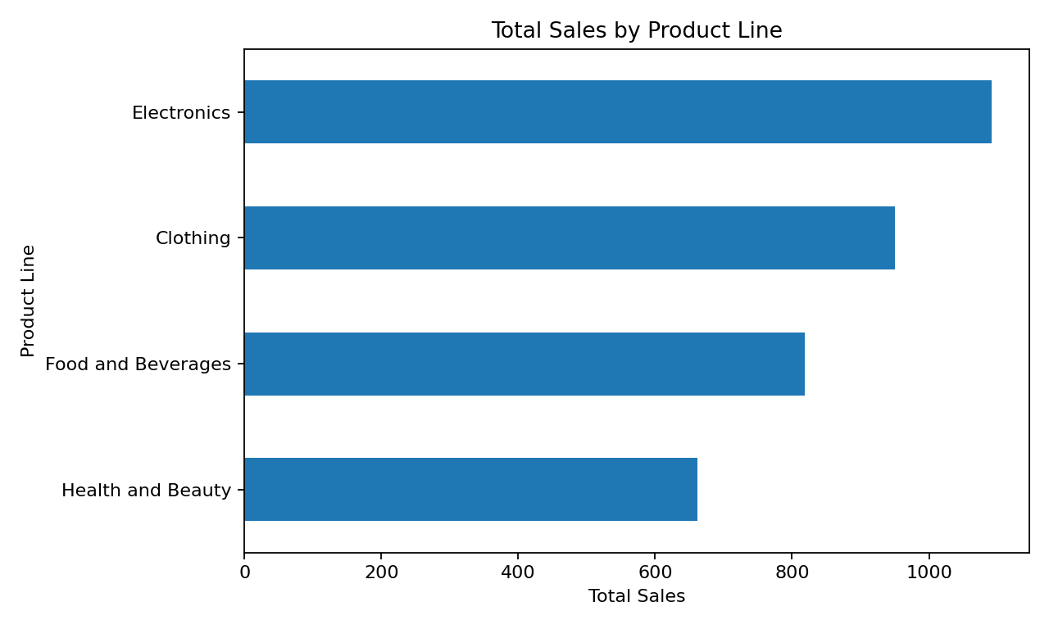
Sales by Branch
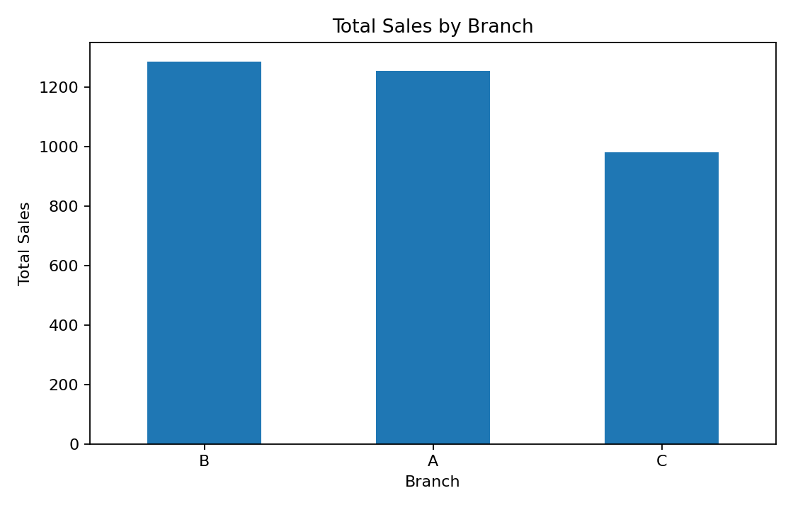
Payment Method Distribution
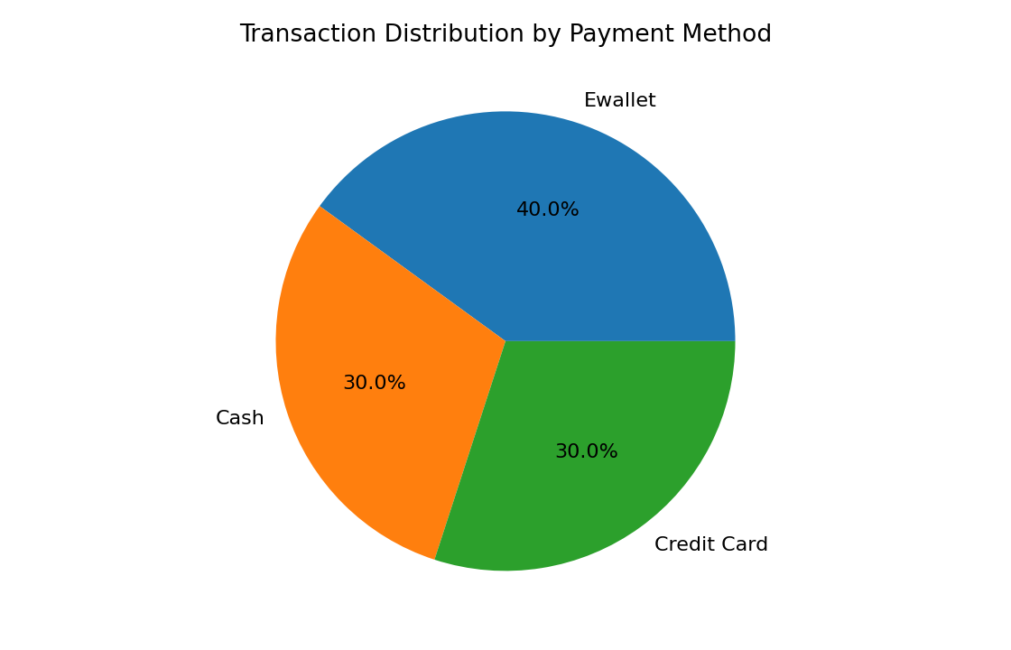
Sales by Customer Type
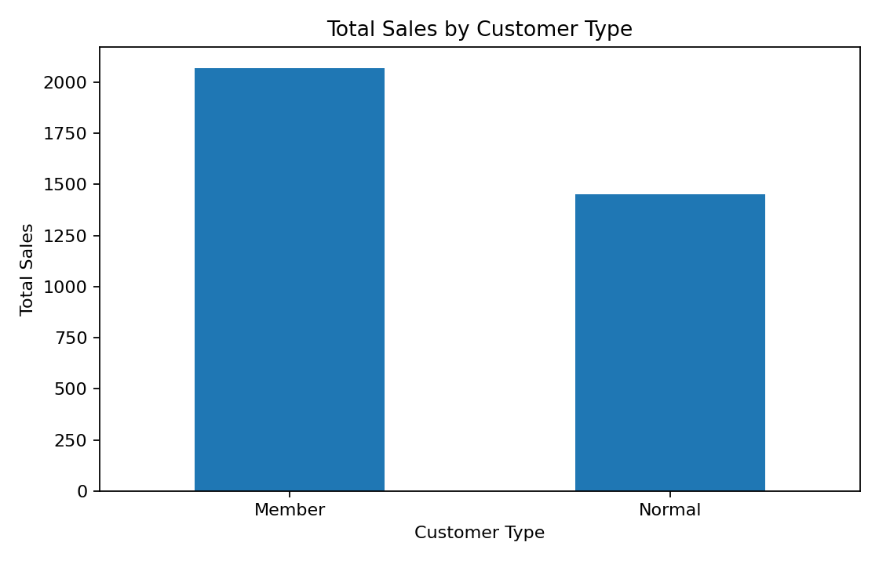
Average Rating by Product Line
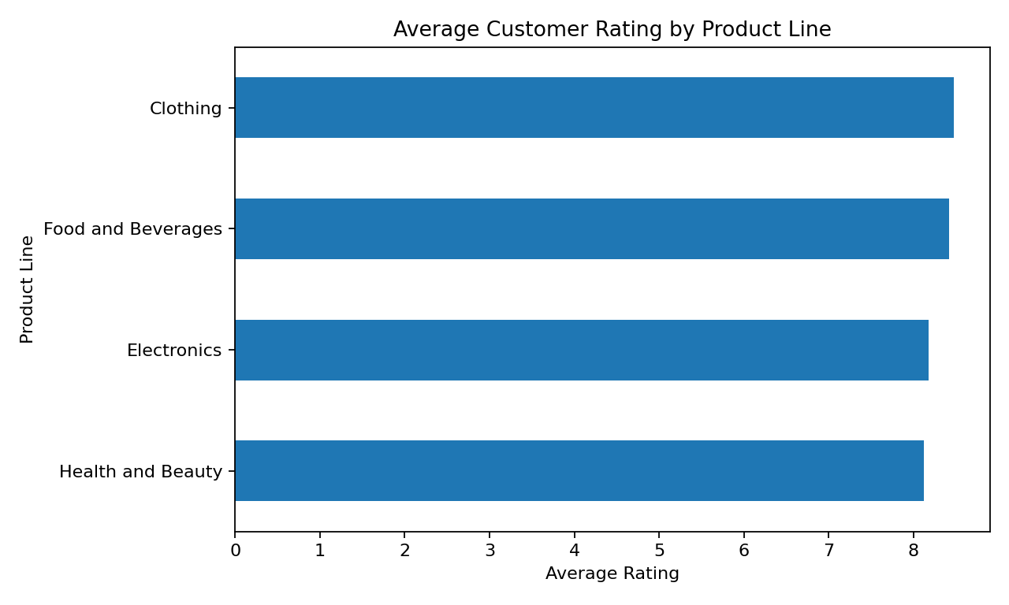
Quantity vs Total Sales
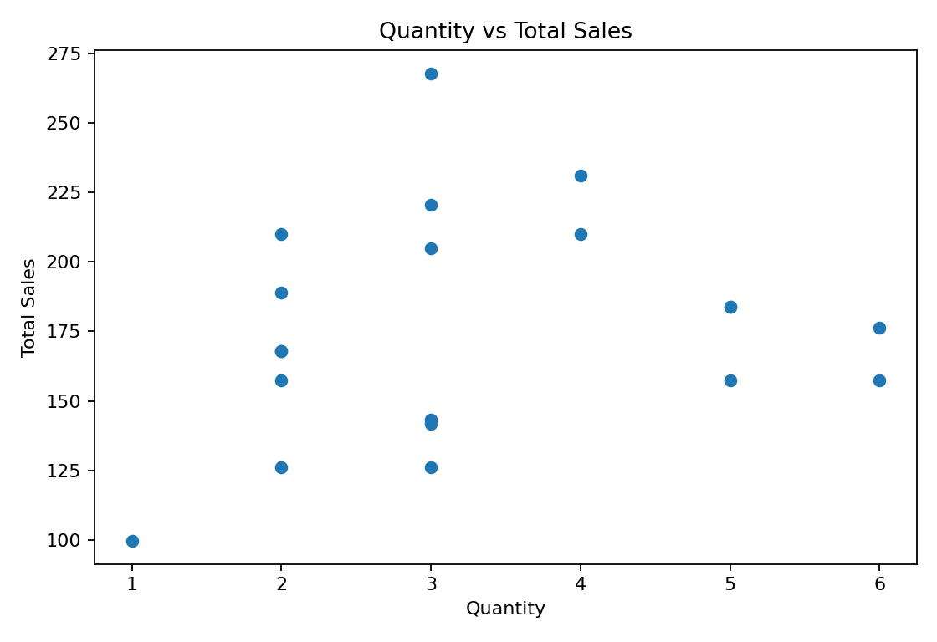
Note: These outputs are based on the small 20-transaction learning dataset. They demonstrate the Python analytics workflow and should not be interpreted as representative of a real supermarket's overall performance.
Key Observations from the Sample
• Electronics has the highest total sales among the product lines in the sample.
• Branch B has the highest sales among the three branches in the sample.
• Ewallet is the most frequently used payment method in the sample.
• Member customers contribute the higher total sales between the two customer types.
• Clothing has the highest average customer rating in the sample.
8. Push the Code to GitHub
Create a repository named: supermarket-sales-analysis-python
Upload the Google Colab notebook (.ipynb), original Excel dataset (.xlsx), cleaned CSV file and README.md.
Suggested repository structure:
• supermarket_sales_analysis.ipynb
• supermarket_sales_python_project.xlsx
• cleaned_supermarket_sales.csv
• README.md
Project Workflow
Excel Dataset
↓
Google Colab
↓
Python + Pandas
↓
Data Cleaning
↓
Exploratory Data Analysis
↓
Visualization
↓
Insights
↓
Final Result

