Eshwar Lal
eshwarlal.bscsf24@iba-suk.edu.pk

Name: Eshwar Lal
CMS-ID: 023-24-0186
Class: BS (CS)-V ---“F”
Course: Web Engineering
Instructor: Sir Junaid Ali
Class activity A — draw the client server diagram

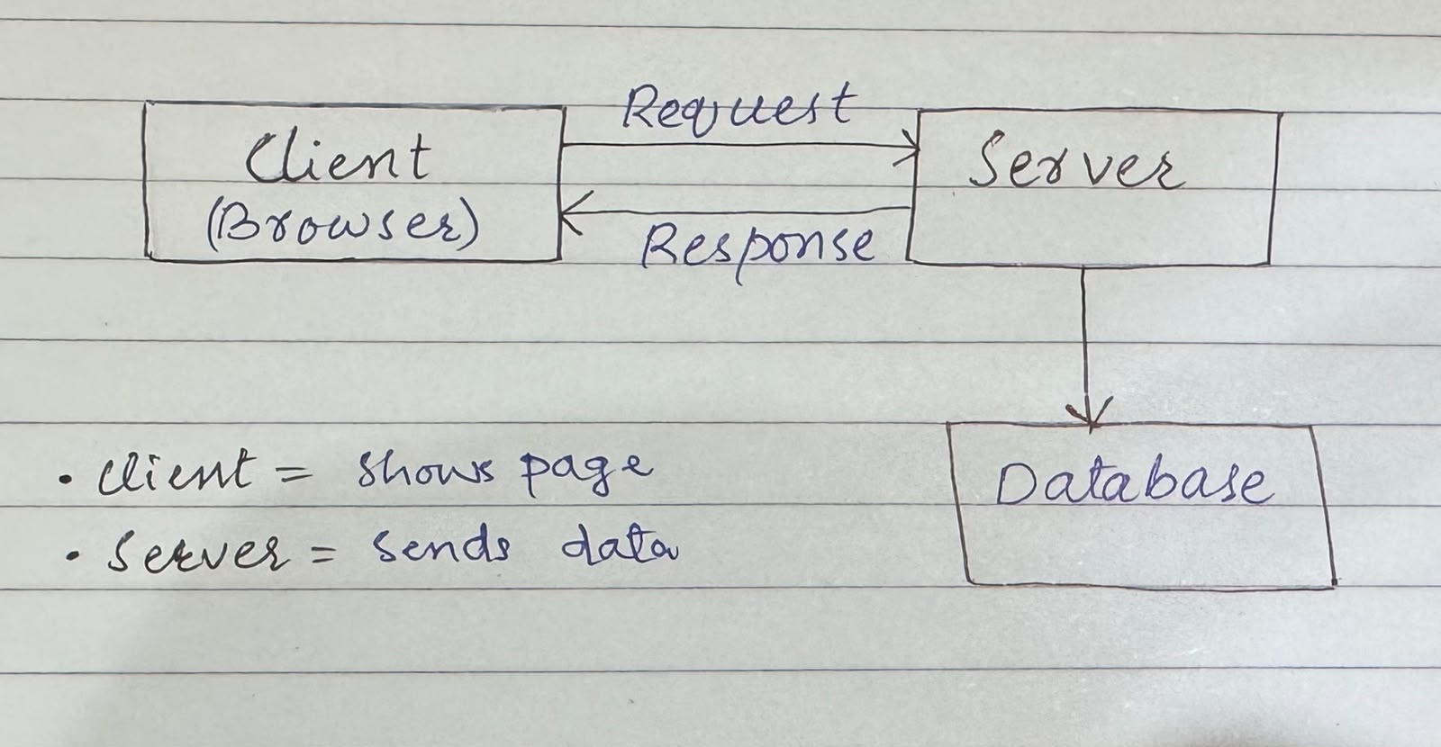

Class activity B — URL teardown
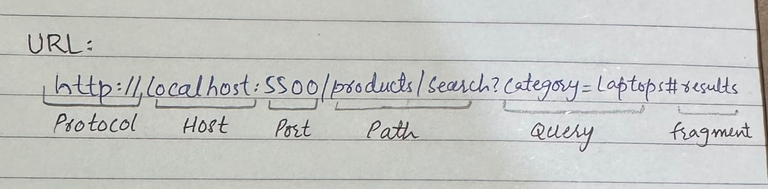

Class activity C — HTTP Status Code Activity
2xx → Success
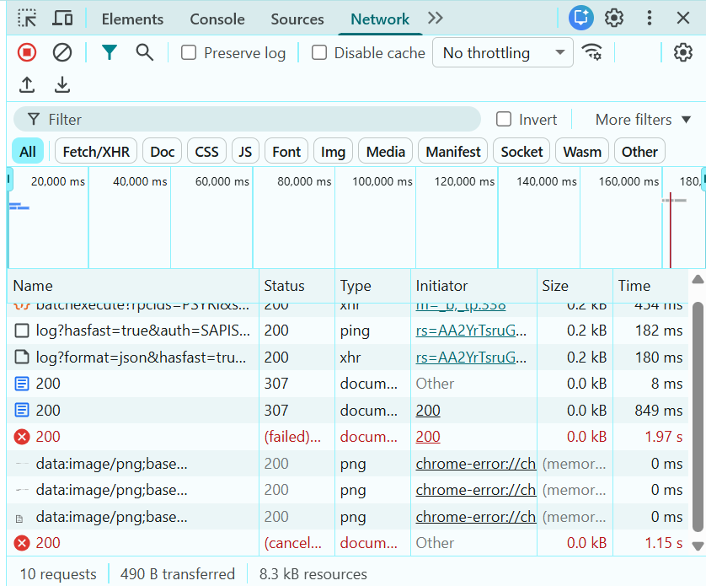
- Status Code: 200 OK
- Meaning: Request Succeeded, server returned the data.
3xx → Redirection
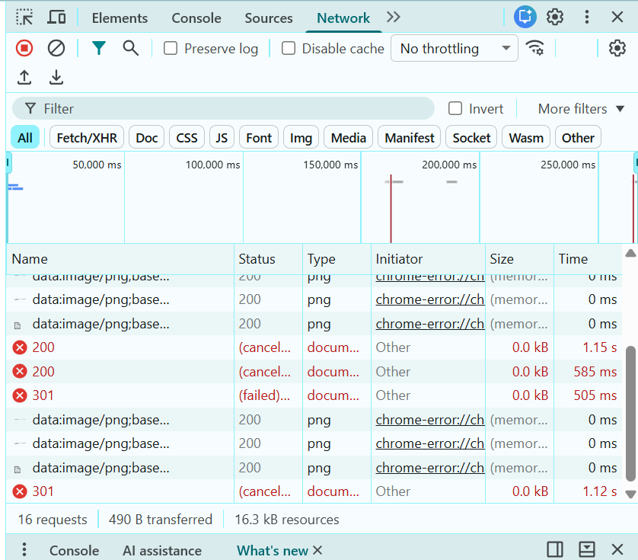
- Status Code: 301 moved permanently
- Meaning: Resource moved to a new URL, redirected automatically.
4xx → Client Error
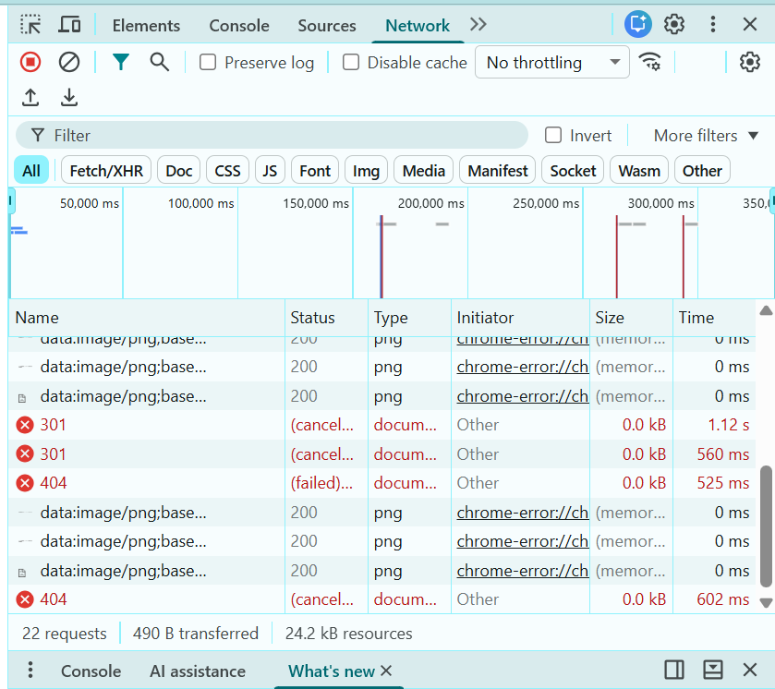
- Status Code: 404 not found
- Meaning: Page or resource not found on a server.
5xx → Server Error
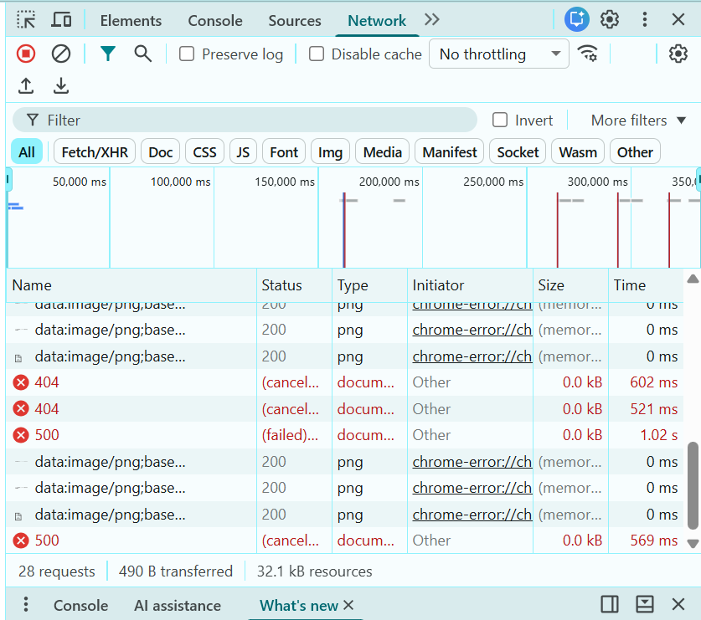
- Status Code: 500 Internal server error
- Meaning: Server failed to process the request due to an error.
Class activity D — Tools Installation & Setup Activity
These are the versions of Node.js, npm, and Git.
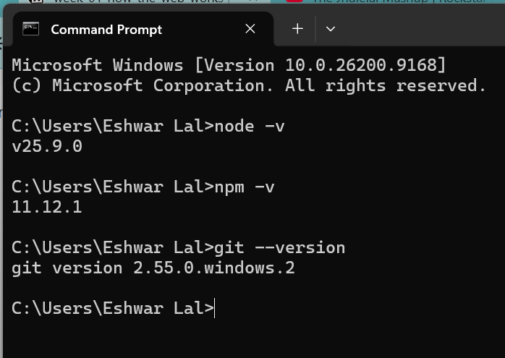

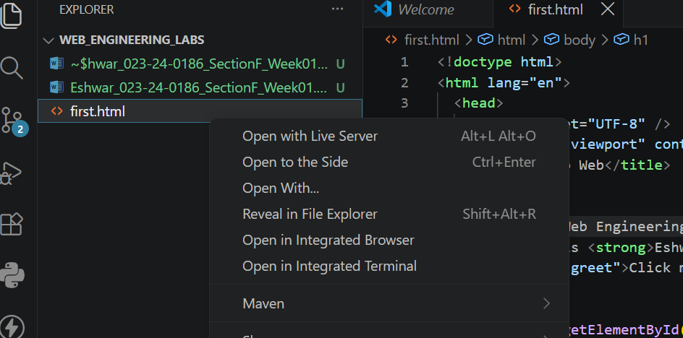
Make sure Live Server is installed:

Make sure Prettier Formatter is installed and working:
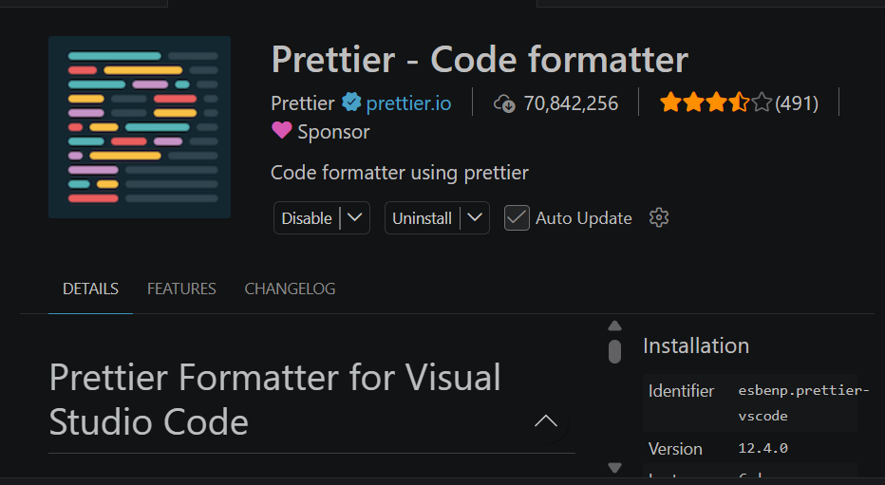

Test Prettier by writing messy code, saving the file, and checking that it formats automatically:

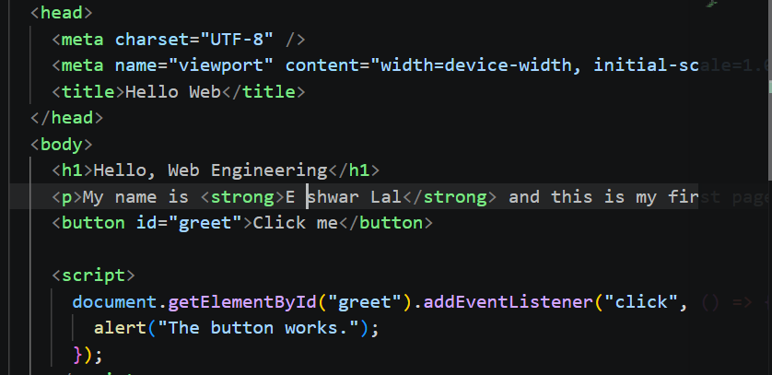
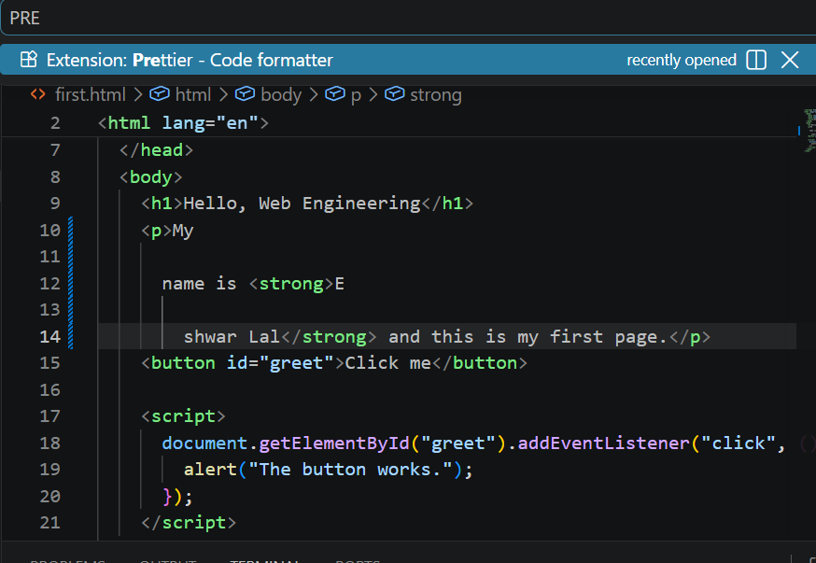

- Successfully done with shortcut key: shift+alt+F

Class activity E — personalize and serve:

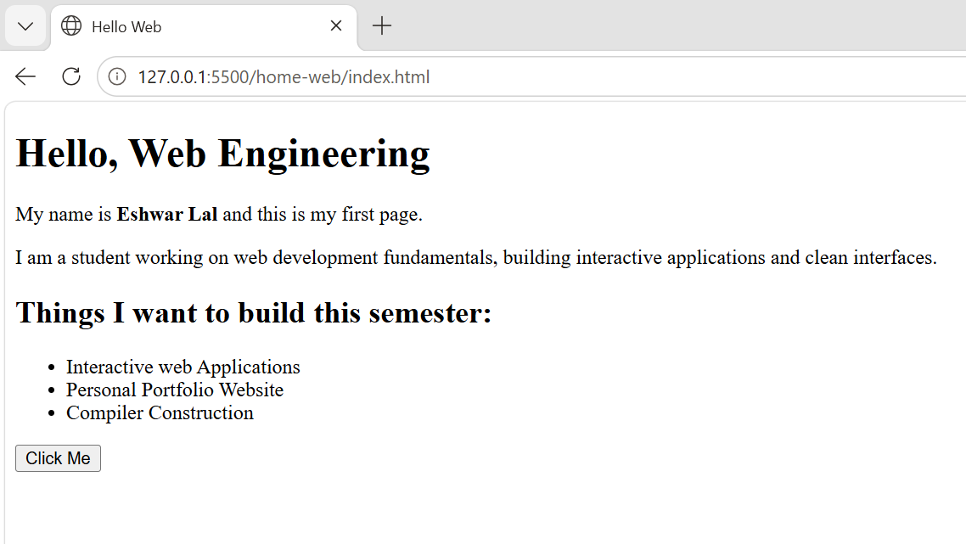

Class activity F — three DevTools drills:
Network:
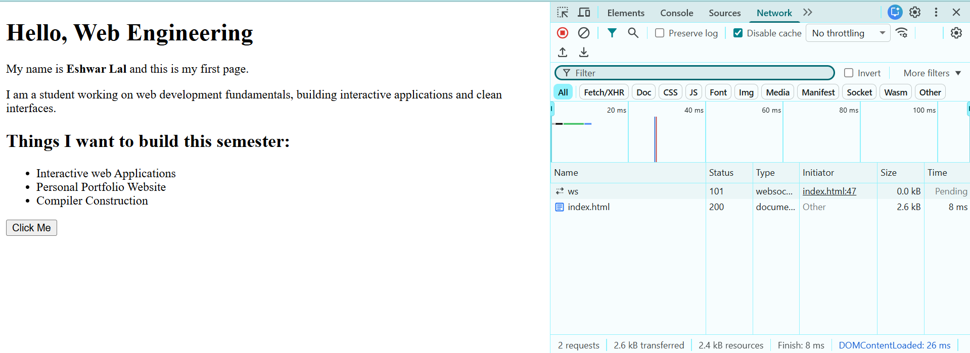

Console:
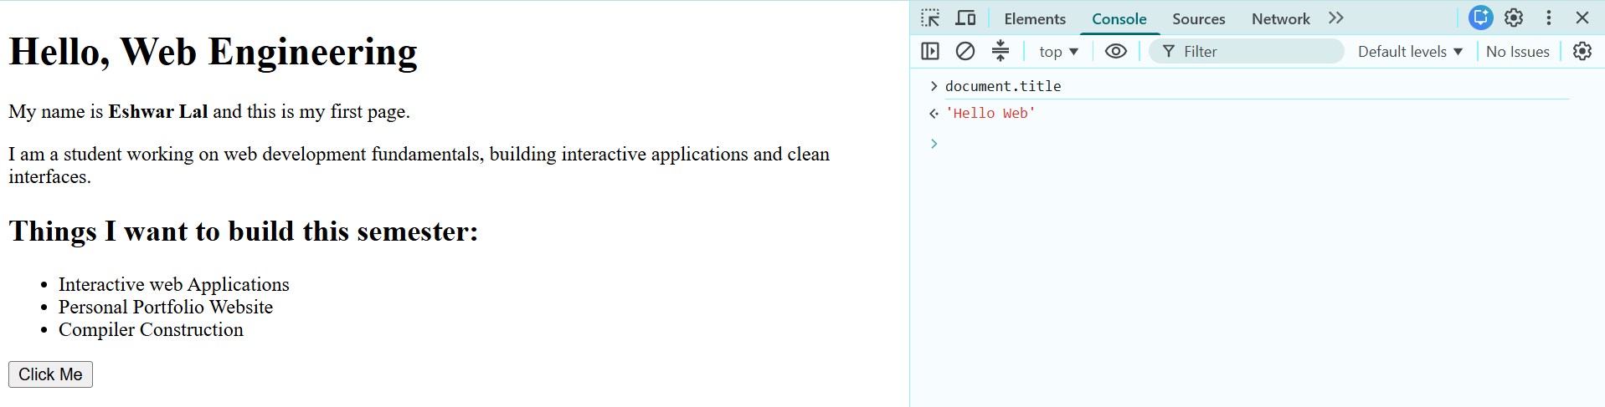

Elements:
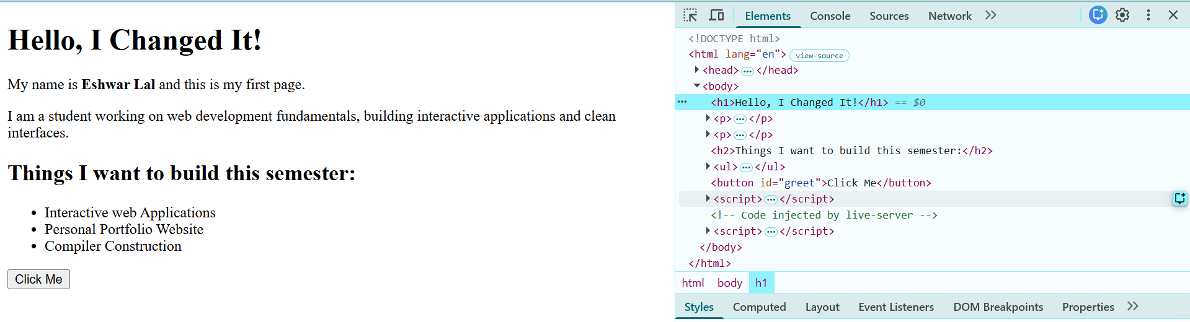
Lab (in class) — first page + proof of DevTools:
- <!DOCTYPE html>
- <html lang="en">
- <head>
- <meta charset="UTF-8"/>
- <meta name="viewport" content="width=device-width, initial-scale=1.0"/>
- <title> Hello Web </title>
- </head>
- <body>
- <h1>Hello, Web Engineering</h1>
- <p>My name is <strong>Eshwar Lal</strong> and this is my first page.</p>
- <p>I am a student working on web development fundamentals, building interactive applications and clean interfaces.</p>
- <h2>Things I want to build this semester:</h2>
- <ul>
- <li>Interactive web Applications</li>
- <li>Personal Portfolio Website</li>
- <li>Compiler Construction</li>
- </ul>
- <button id="greet">Click Me</button>

- <script>
- document.getElementById("greet").addEventListener("click", () => {
- alert("The button works.");
- });
- </script>
- </body>
- </html>

- Button that alerts on click
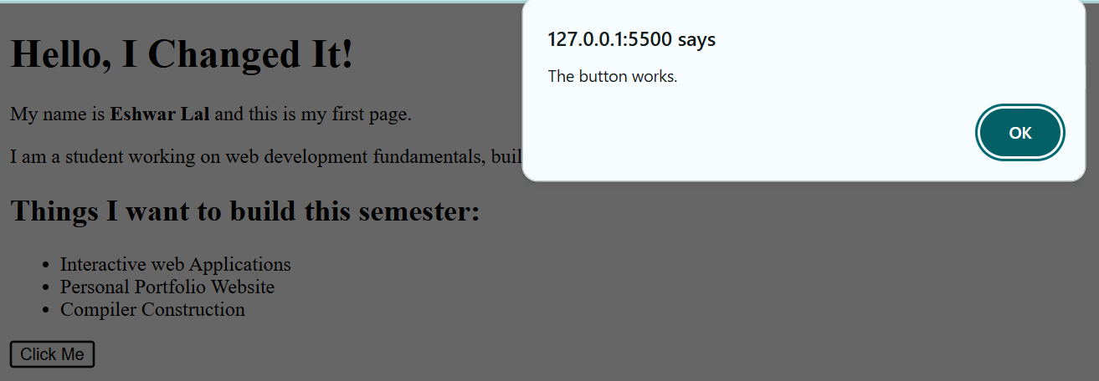
- One deliberate Console error explained in one sentence
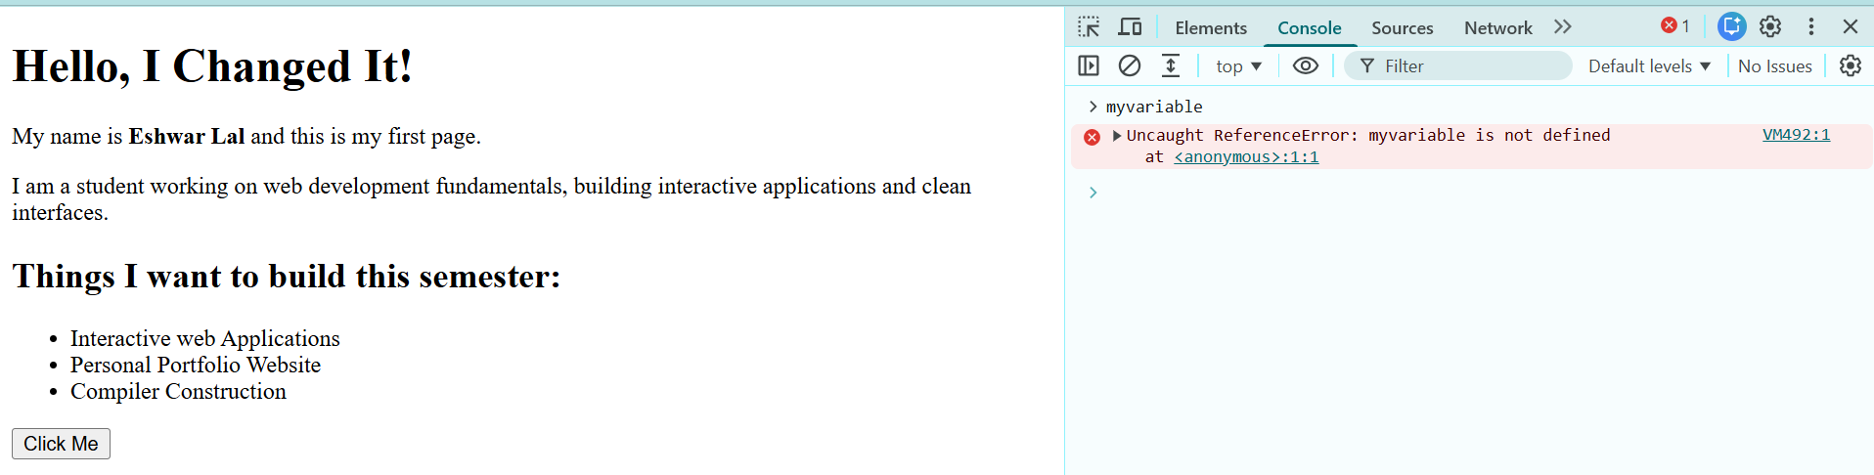

Note: Other all requirements are done already in previous activities

Task 1 — Prove the toolchain:

Submit: a single message or screenshot with all three outputs visible. (DONE THE SCREENSHOT)

Task 2 — Network detective:
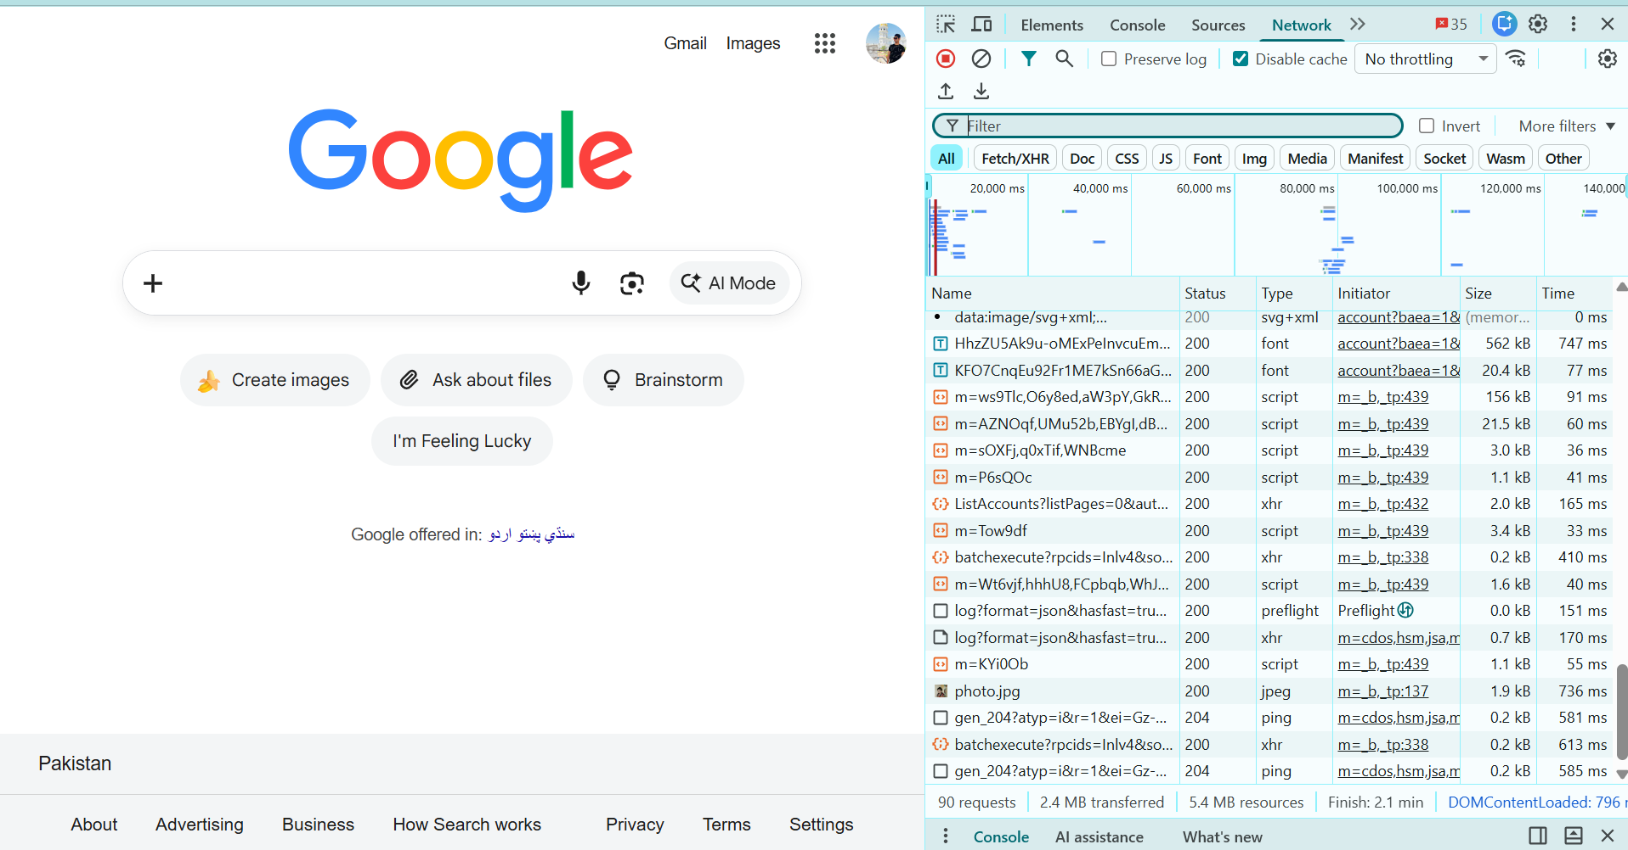
Website: Google
- How many requests did the page make?
  - The page made 90 requests.
- What is the largest file, and what type is it (JS, image, CSS…)?
  - The largest visible file is HhzZU5Ak9u-0MExPe..., with a size of 562 kB. Its type is Font.
- Find one request that is not 200. What status is it, and what do you think happend?
  - One request, gen_204?... has status 204. This means the request was successful, but the server did not send any content back.

