SOFTWARE REQUIREMENTS SPECIFICATION

Adaptive Memory-Augmented Language Model
with Selective Retention and Forgetting

(AM-LLM)

Submitted to

DEPARTMENT OF COMPUTER SCIENCE AND ENGINEERING
(Artificial Intelligence & Machine Learning)

By

Student Name | Roll Number
G. Eshwarsai | 245323733152
B. Shreehith | 245323733137
P. Sudhanva | 245323733175

Under the Guidance of

Dr. B. Krishna
Professor, CSE (AIML)

Department of Computer Science and Engineering
NEIL GOGTE INSTITUTE OF TECHNOLOGY
Kachavanisingaram Village, Hyderabad, Telangana – 500058
Academic Year: 2025–2026
ABSTRACT
Large Language Models (LLMs) are powerful, but they come with a well-known limitation — they can only work with information that fits inside their fixed context window. Once a conversation grows longer than that window, older information simply disappears. This creates a real problem when we want AI systems to remember important details across extended interactions, the way a thoughtful colleague or assistant naturally would.
This project addresses that gap by proposing an Adaptive Memory-Augmented Language Model (AM-LLM) — a system that does not just store information passively, but actively manages it, much like human memory does. At the heart of our approach are three interconnected mechanisms. First, a memory importance scoring function evaluates every piece of incoming information based on how relevant, how frequently referenced, and how contextually significant it is — ensuring that only genuinely useful knowledge earns a place in long-term storage. Second, a hierarchical memory compression module periodically reviews stored memories, identifies ones that are semantically similar or redundant, and consolidates them into compact, high-fidelity representations. Third, a time-aware forgetting mechanism gradually decays the relevance score of memories that have not been accessed recently, allowing the system to gracefully let go of outdated information rather than accumulating noise indefinitely.
The overall architecture maintains two distinct memory tiers — a short-term contextual memory for immediate reasoning and a long-term external memory for persistent knowledge — coordinated by an adaptive controller that governs all read and write operations. When evaluated on personalized dialogue and long-context reasoning tasks, the AM-LLM demonstrates meaningful improvements in response relevance, memory efficiency, and robustness over baseline memory-augmented and retrieval-based systems.
In essence, this work transforms memory in language models from a passive storage bin into an active, self-regulating cognitive process. Drawing deliberate inspiration from how human memory works — what we remember, what we compress into schemas, and what we forget — our approach offers a scalable and principled foundation for the next generation of personalized AI systems.

TABLE OF CONTENTS
S.No | Chapter / Section Title | Page No.
1 | Introduction | 4
1.1 | Purpose of the Document | 4
1.2 | Scope of the Project | 4
1.3 | Definitions, Acronyms, and Abbreviations | 5
1.4 | References | 5
2 | Overall Description | 6
2.1 | Product Perspective | 6
2.2 | Product Functions | 6
2.3 | User Classes and Characteristics | 7
2.4 | Operating Environment | 7
2.5 | Design and Implementation Constraints | 7
2.6 | Assumptions and Dependencies | 8
3 | Specific Requirements | 8
3.1 | Functional Requirements | 8
3.2 | External Interface Requirements | 11
3.3 | Non-Functional Requirements | 12
4 | System Models and Design Aspects | 13
4.1 | Use Case Diagram | 13
4.2 | Use Case Descriptions | 14
4.3 | Activity Diagram | 16
4.4 | Sequence Diagram | 17
4.5 | Class Diagram | 18
4.6 | Data Flow Diagram | 19
5 | Data Requirements | 20
6 | Machine Learning Project-Specific Details | 20
7 | Feasibility Study | 23
8 | Project Planning | 24
9 | Conclusion | 25

CHAPTER 1: INTRODUCTION
1.1 Purpose of the Document
This Software Requirements Specification (SRS) document has been prepared for the mini project titled 'Adaptive Memory-Augmented Language Model with Selective Retention and Forgetting (AM-LLM)'. It serves as the primary reference for understanding what the system is expected to do, how it should behave, and what constraints it must operate within. The document describes all functional and non-functional requirements of the proposed system, the interfaces it will expose, the data it will handle, and the design models that capture its intended behaviour.
1.2 Scope of the Project
The AM-LLM project aims to design and prototype a memory management layer for Large Language Models that mimics key aspects of human cognition — specifically the ability to selectively remember, compress, and forget information over time. The system sits between a base language model and the user, augmenting the model's effective context with an intelligently curated long-term memory store.
- To develop a memory importance scoring mechanism that ranks incoming information by relevance and significance.
- To implement a hierarchical compression module that reduces storage overhead without losing informational quality.
- To design a time-aware forgetting mechanism that decays the relevance of stale memories in a principled manner.
- To evaluate the resulting system on personalized dialogue and long-context reasoning benchmarks.
The intended users are AI/ML researchers, university-level project teams, and developers working on conversational AI. The project is an academic prototype intended for desktop or server-side deployment. Real-time deployment at scale, multi-modal input beyond text, and integration with proprietary commercial APIs are explicitly outside scope.

1.3 Definitions, Acronyms, and Abbreviations
Term | Meaning
LLM | Large Language Model
AM-LLM | Adaptive Memory-Augmented Language Model
SRS | Software Requirements Specification
ML | Machine Learning
NLP | Natural Language Processing
API | Application Programming Interface
UI | User Interface
FAISS | Facebook AI Similarity Search
BERT | Bidirectional Encoder Representations from Transformers
RAG | Retrieval-Augmented Generation
STM | Short-Term Memory
LTM | Long-Term Memory
DFD | Data Flow Diagram
GPU | Graphics Processing Unit
1.4 References
- Karpukhin et al. (2020). Dense Passage Retrieval for Open-Domain Question Answering. EMNLP 2020.
- Lewis et al. (2020). Retrieval-Augmented Generation for Knowledge-Intensive NLP Tasks. NeurIPS 2020.
- Graves, A. (2014). Neural Turing Machines. arXiv:1410.5401.
- HuggingFace Transformers Documentation. https://huggingface.co/docs/transformers
- FAISS Library Documentation. https://faiss.ai/
- Neil Gogte Institute of Technology — Mini Project Guidelines, 2025-2026.

CHAPTER 2: OVERALL DESCRIPTION
2.1 Product Perspective
The AM-LLM is a new academic system, not an enhancement of an existing product. It operates as a standalone prototype that wraps a pre-trained language model with a custom memory management layer. The memory layer is designed to be model-agnostic — it communicates with the base LLM through standard input-output text interfaces, making it portable across different underlying models.
2.2 Product Functions
- Memory Ingestion — capturing and scoring incoming text fragments from user sessions.
- Importance Scoring — evaluating memory candidates based on relevance, recency, and frequency of reference.
- Long-Term Memory Write — storing high-importance memories as vector embeddings in an external memory store.
- Memory Compression — periodically merging semantically similar memories into compact representations.
- Time-Aware Forgetting — decaying memory relevance scores over time and pruning entries below a threshold.
- Memory Retrieval — querying the external memory store at inference time to augment the model's context.
- Response Generation — passing enriched context to the base LLM for response generation.
- Evaluation and Logging — recording performance metrics such as memory hit rate, response relevance, and storage usage.
2.3 User Classes and Characteristics
Researcher / Developer: Interacts at the module level, configures parameters, runs experiments, and analyses evaluation outputs. Expected to have working knowledge of Python and ML workflows.
End User (Dialogue Participant): Interacts through a simple text interface. Not expected to have any technical background; all complexity is hidden behind the conversational front-end.
2.4 Operating Environment
Component | Specification
Operating System | Ubuntu 20.04 LTS / Windows 10 or above
Programming Language | Python 3.10+
Base LLM | GPT-2 / LLaMA-2 (open-source variants)
Embedding Model | BERT / Sentence-BERT
Vector Store | FAISS
ML Libraries | PyTorch, HuggingFace Transformers, scikit-learn
Front-End (optional) | Streamlit / Flask
Database | SQLite (logs), FAISS index (memory store)
Hardware (Minimum) | Intel Core i5, 8 GB RAM, 20 GB Storage
Hardware (Recommended) | NVIDIA GPU (4 GB VRAM), 16 GB RAM
2.5 Design and Implementation Constraints
- Prototype operates on English-language text only.
- No access to large-scale GPU clusters; all experiments run on consumer-grade hardware.
- Base language model is used in inference mode only — no fine-tuning of the LLM itself.
- Memory store size is bounded by local disk and RAM.
- Strictly a prototype — not hardened for production security or reliability standards.
2.6 Assumptions and Dependencies
- A compatible pre-trained LLM is available and its inference API is accessible from Python.
- The FAISS library is correctly installed and configured on the target machine.
- Input data is available in clean, UTF-8-encoded text form.
- Development machine meets at least the minimum hardware specifications listed above.
- All team members have working Python environments with required libraries installed.

CHAPTER 3: SPECIFIC REQUIREMENTS
3.1 Functional Requirements
3.1.1 User Session Management
- The system shall allow a user session to be initiated with a unique session identifier.
- The system shall maintain a rolling short-term memory buffer for the duration of an active session.
- The system shall allow a session to be closed, at which point session memories are evaluated for long-term retention.
3.1.2 Memory Ingestion
- The system shall accept natural language text fragments as input for memory consideration.
- The system shall convert input text into dense vector representations using a sentence embedding model.
- The system shall store candidate memories in a staging buffer prior to importance evaluation.
3.1.3 Memory Importance Scoring
- The system shall compute an importance score for each candidate memory based on three weighted criteria: contextual relevance, reference frequency, and novelty relative to existing stored memories.
- The system shall use a configurable threshold score to determine whether a candidate memory is promoted to long-term storage.
- The system shall log the importance score and decision for each evaluated memory.
3.1.4 Long-Term Memory Write
- The system shall store memories that pass the importance threshold as vector embeddings in a persistent FAISS index.
- Each stored memory entry shall carry metadata including: original text, embedding vector, importance score, creation timestamp, and access count.
- The system shall avoid storing near-duplicate memories by checking cosine similarity before writing.
3.1.5 Memory Compression
- The system shall periodically scan the long-term memory store and identify clusters of semantically similar entries.
- The system shall merge memories within a similarity cluster into a single consolidated entry, preserving the most informative attributes.
- The system shall update the FAISS index to reflect the consolidated memory and remove redundant entries.
3.1.6 Time-Aware Forgetting
- The system shall maintain a relevance decay score for each memory entry, reducing it over time as a function of elapsed time since last access.
- The system shall periodically evaluate all memory entries against a minimum relevance threshold.
- The system shall remove memory entries whose relevance score falls below the threshold, logging each deletion.
3.1.7 Memory Retrieval
- At inference time, the system shall encode the current user query as a vector and perform a top-k similarity search against the long-term memory store.
- The system shall return the top-k retrieved memories as context snippets ranked by relevance score.
3.1.8 Response Generation
- The system shall construct an augmented context by concatenating retrieved memory snippets with the current user input, respecting the base LLM's maximum input token limit.
- The system shall update the access count and last-accessed timestamp of all memories used in the current inference step.
3.1.9 Evaluation and Logging
- The system shall record memory hit rate per session and track memory store size over time.
- The system shall export evaluation logs in structured CSV format for offline analysis.
3.2 External Interface Requirements
3.2.1 User Interface
- A text input field for natural language queries and a response display area.
- An optional sidebar panel showing memory store statistics.
- Clear error messages for invalid inputs or system failures.
3.2.2 Hardware Interface
- Minimum Intel Core i5; NVIDIA GPU with 4 GB VRAM recommended.
- Minimum 20 GB free disk space for model weights, FAISS index, and logs.
3.2.3 Software Interface
- HuggingFace Transformers (v4.x), FAISS (v1.7.x), PyTorch (v2.x), scikit-learn, SQLite, Streamlit (optional).
3.2.4 Communication Interface
- All components communicate via in-process Python function calls. If Streamlit is enabled, HTTP on localhost (port 8501).
3.3 Non-Functional Requirements
3.3.1 Performance
- Memory retrieval (top-5 search) shall complete within 200 ms for a store of up to 10,000 entries.
- End-to-end response generation shall complete within 5 seconds on recommended hardware.
3.3.2 Reliability
- The system shall handle malformed or empty input gracefully.
- The FAISS index shall be persisted to disk at the end of each session.
3.3.3 Usability
- Configuration parameters shall be exposed in a single YAML file.
- The system shall provide a brief on-screen summary of memory activity at session end.
3.3.4 Security
- All session data and memory entries shall be stored locally by default.
3.3.5 Maintainability
- The codebase shall be organised into clearly separated modules, each independently testable.
- Substituting the base LLM or embedding model shall require changes only to configuration.
3.3.6 Portability & Scalability
- The system shall run on any machine with Python 3.10+ and Windows 10+ / Linux.
- The FAISS index shall support up to 100,000 memory entries without architectural changes.

CHAPTER 4: SYSTEM MODELS AND DESIGN ASPECTS
4.1 Use Case Diagram
The diagram below identifies the two primary actors — the End User who drives conversational interactions, and the System Administrator who manages configuration and maintenance tasks — along with their respective use cases.

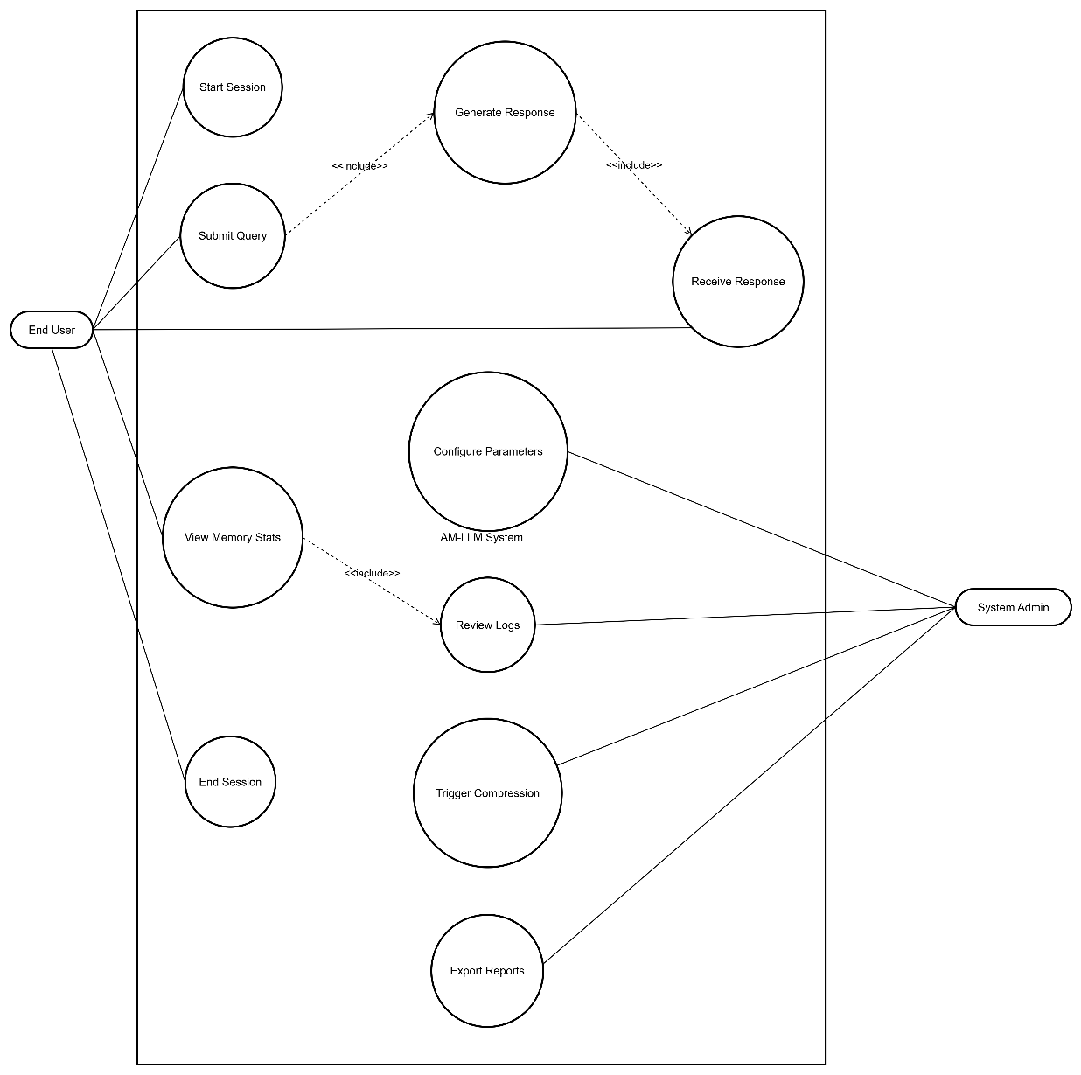
Figure 4.1 — Use Case Diagram for the AM-LLM System
4.2 Use Case Descriptions
Use Case 1 — Submit Query and Receive Response
Use Case Name | Submit Query and Receive Response
Actor | End User
Pre-condition | A session has been started. The long-term memory store has been initialised.
Main Flow | 1. User enters a query. 2. System encodes it as a vector. 3. System retrieves top-k memories from FAISS. 4. System builds augmented context. 5. Base LLM generates a response. 6. Response is displayed. 7. Memory access counts are updated.
Alternate Flow | If no memories are found, the system proceeds with the query alone. If the LLM fails, an error message is shown.
Post-condition | Response is displayed. Memory access logs are updated.

Use Case 2 — Memory Compression
Use Case Name | Trigger Memory Compression
Actor | System (scheduled) / System Administrator
Pre-condition | Long-term memory store has been active for at least one compression cycle interval.
Main Flow | 1. System scans all entries and computes pairwise cosine similarities. 2. Entries above the merge threshold are clustered. 3. Each cluster is merged into one consolidated entry. 4. FAISS index is rebuilt. 5. Deletion log is updated.
Alternate Flow | If only one entry exists in a cluster, no merge is performed. If rebuild fails, the original index is retained.
Post-condition | Memory store size is reduced. Consolidated entries are available for future retrievals.

Use Case 3 — Forgetting Stale Memories
Use Case Name | Forget Stale Memories
Actor | System (scheduled)
Pre-condition | At least one memory entry exists in the long-term store.
Main Flow | 1. System computes current relevance score for each entry. 2. Entries below the minimum threshold are flagged. 3. Flagged entries are logged and removed from the FAISS index.
Alternate Flow | If no entries fall below the threshold, no action is taken.
Post-condition | Stale entries are removed. Memory store is leaner for future retrievals.
4.3 Activity Diagram
The activity diagram below traces the end-to-end flow of a single user query — from input through memory retrieval and response generation, to the background memory maintenance processes of compression and forgetting.

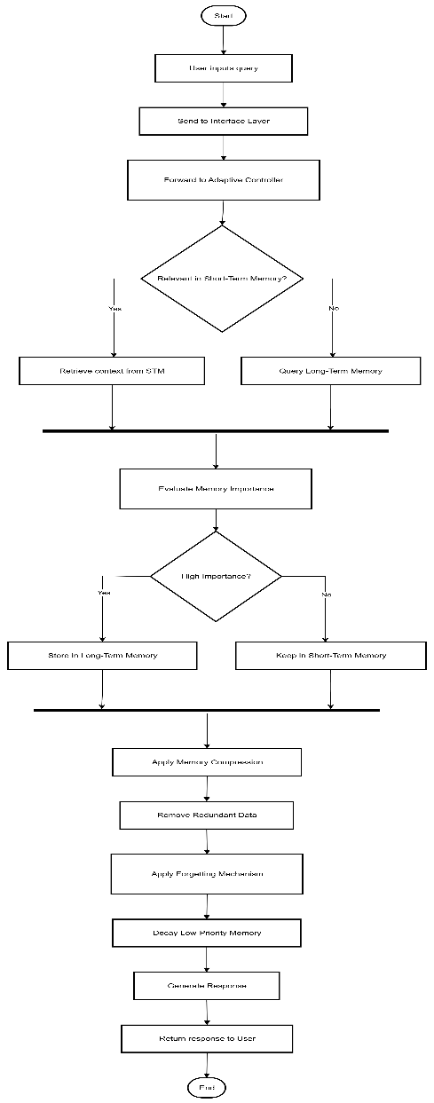
Figure 4.3 — Activity Diagram for AM-LLM Query Processing
4.4 Sequence Diagram
The sequence diagram captures the message exchanges between the system components — User, UI Layer, Memory Controller, FAISS Index, Compressor/Forgetter, and Base LLM — during a single complete inference cycle.

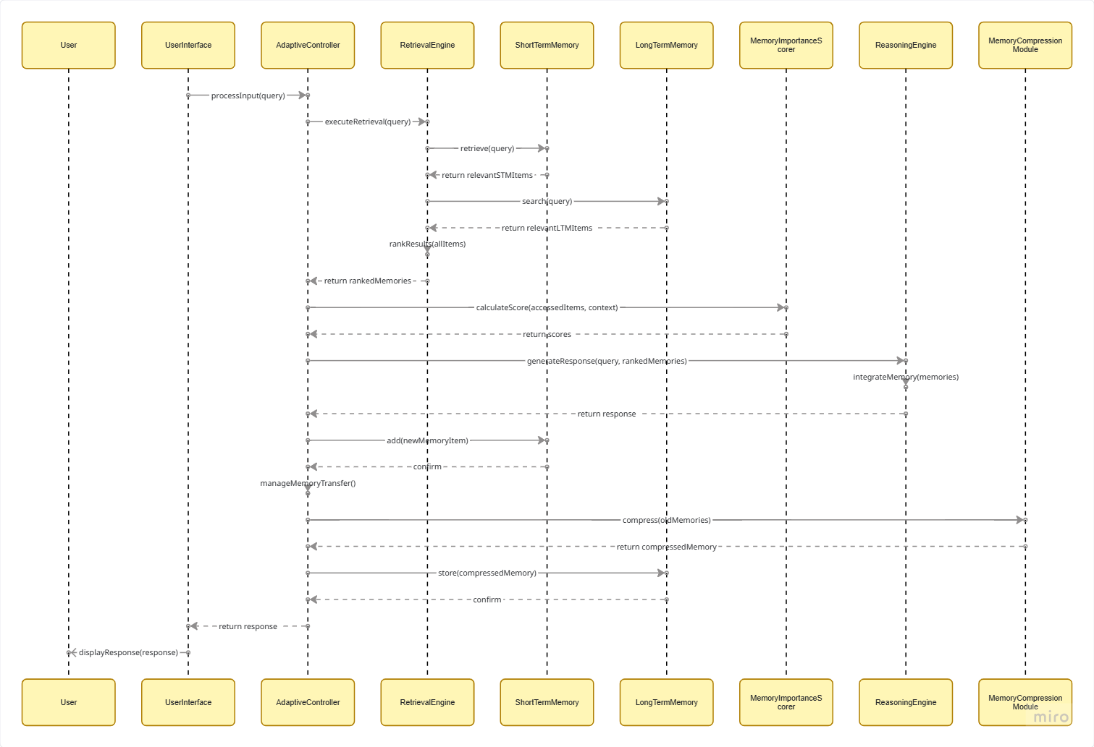
Figure 4.4 — Sequence Diagram for AM-LLM Inference
4.5 Class Diagram
The class diagram below identifies the core software classes, their attributes, methods, and relationships within the AM-LLM architecture. The MemoryController serves as the central coordinator, delegating to specialised modules for scoring, compression, forgetting, and FAISS indexing.

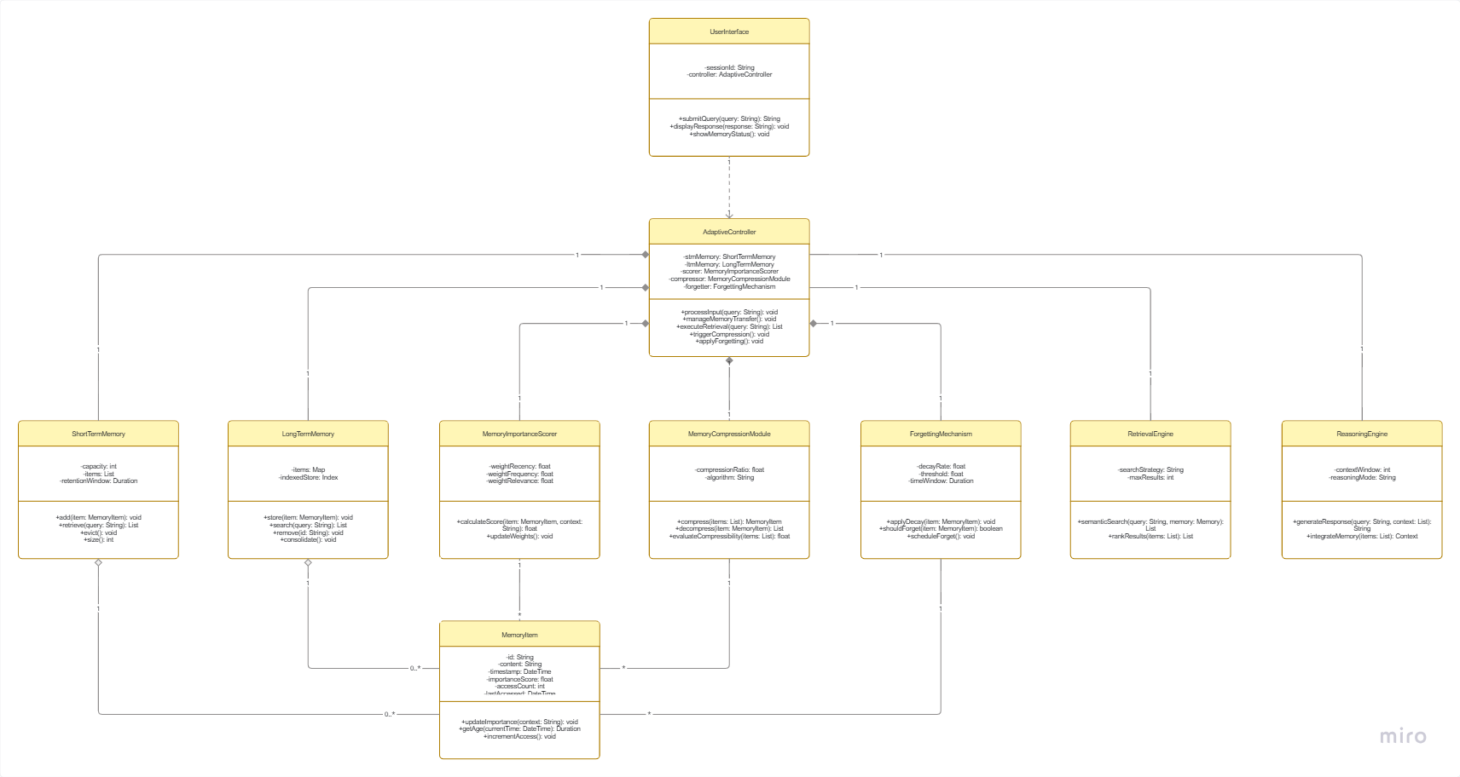
Figure 4.5 — Class Diagram for AM-LLM Core Modules
4.6 Data Flow Diagram
Level-0 DFD (Context Diagram)
The Level-0 DFD shows the system as a single process, illustrating the data that flows in from external entities and the outputs produced.

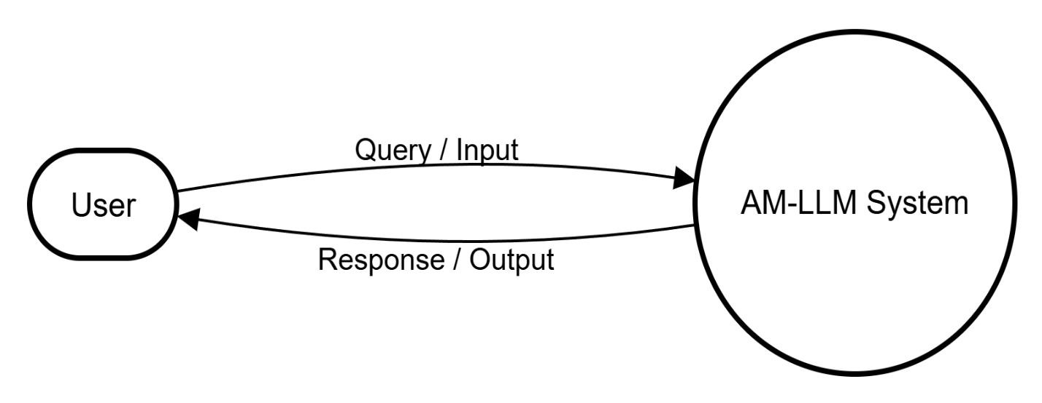
Figure 4.6a — Level-0 DFD (Context Diagram)
Level-1 DFD
The Level-1 DFD decomposes the system into its nine internal processes, showing how data flows between them and the two data stores — the FAISS Long-Term Memory index and the Session/Evaluation Log database.

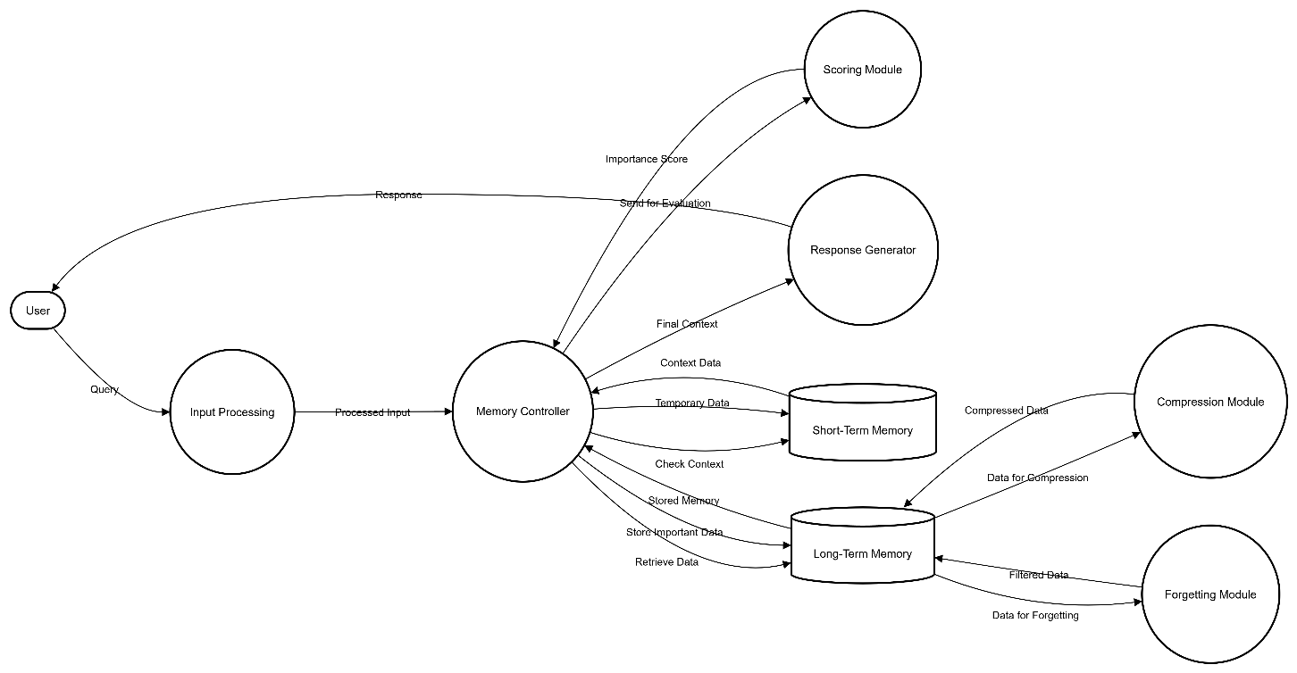
Figure 4.6b — Level-1 DFD for AM-LLM Internal Processes

CHAPTER 5: DATA REQUIREMENTS
5.1 Input Data Description
Attribute | Description
Source | PersonaChat, DailyDialog (HuggingFace Datasets), QuALITY benchmark
Format | Plain text (.txt) or JSON (.json) with utterance-level structure
Volume | ~50,000 dialogue turns for evaluation; variable for live sessions
Features | Speaker turn, utterance text, session ID, timestamp
Target Variable | Response relevance score (automated or human-annotated)
Language | English only (current prototype)
Preprocessing | Tokenisation, sentence segmentation, UTF-8 normalisation
5.2 Output Data Description
- Generated natural language responses, displayed to the user in real time.
- Memory store state: list of active memory entries with metadata.
- Evaluation metrics per session: memory hit rate, response relevance, compression ratio, forgetting rate.
- CSV-format evaluation log with one row per session.
- Optional visualisation plots: memory relevance distribution, store size trend.

CHAPTER 6: MACHINE LEARNING PROJECT-SPECIFIC DETAILS
6.1 Problem Statement
Large Language Models cannot retain information beyond their fixed context window. This project aims to build a memory management layer that enables an LLM to selectively remember, compress, and forget information across extended interactions — improving response quality on tasks that require long-term reasoning without growing memory unboundedly.
6.2 Dataset Details
Attribute | Details
Primary Dataset | PersonaChat (Zhang et al., 2018)
Secondary Dataset | DailyDialog (Li et al., 2017)
Evaluation Benchmark | QuALITY long-context QA dataset
Samples | ~10,000 dialogue sessions (PersonaChat); ~13,000 dialogues (DailyDialog)
Labels | Continuous relevance scores (regression task for evaluation)
Key Features | Speaker turns, persona descriptions, conversation history
Access | Openly available via HuggingFace Datasets library
6.3 Data Preprocessing Techniques
- Sentence segmentation using NLTK to split dialogue turns into individual memory candidates.
- Dense vector encoding using Sentence-BERT (all-MiniLM-L6-v2) to convert text to 384-dimensional embeddings.
- Normalisation of embedding vectors to unit length for cosine similarity computation.
- Deduplication of near-identical text fragments before ingestion into the memory store.
- Timestamp injection for every memory entry to support time-aware relevance decay.
6.4 Algorithm(s) Used
Component | Algorithm / Model
Base LLM | GPT-2 (default) / LLaMA-2-7B (extended experiments)
Embedding Model | Sentence-BERT (all-MiniLM-L6-v2)
Memory Retrieval | FAISS HNSW approximate nearest-neighbour search
Importance Scoring | Weighted linear combination (relevance, frequency, novelty)
Memory Compression | Agglomerative clustering (scikit-learn) + centroid merging
Relevance Decay | Exponential time decay: score *= exp(-lambda * delta_t)
6.5 Model Evaluation Criteria
- Memory Hit Rate — proportion of retrieved memories rated as contextually relevant.
- Response Relevance Score — cosine similarity between generated and ground-truth response embeddings.
- Memory Efficiency Ratio — meaningful memories retained relative to total memories ingested.
- Compression Ratio — reduction in memory store size after each compression cycle.
- BLEU / ROUGE-L — standard n-gram overlap metrics for response quality on benchmark datasets.
6.6 Limitations of the Model
- The importance scoring function relies on heuristic weights tuned on a small validation set and may not generalise to all domains.
- Sentence-BERT embeddings may not capture nuanced factual distinctions, leading to occasional false merges.
- The base LLM is used in frozen, inference-only mode; fine-tuning could improve performance but is out of scope.
- Large-scale human evaluation is not feasible within the project timeline.
6.7 Future Enhancements
- Integration with larger open-source LLMs (e.g., Mistral-7B, LLaMA-3) for improved generation quality.
- Training a neural importance scorer on annotated data, replacing the current heuristic function.
- Extending support to multi-modal memory (text + images) for richer conversational AI.
- Real-time deployment via a REST API with cloud-hosted vector storage (e.g., Pinecone, Weaviate).
- A graphical dashboard for memory inspection, allowing users to view, edit, and delete specific entries.

CHAPTER 7: FEASIBILITY STUDY
7.1 Technical Feasibility
All core technologies required for this project — Python, PyTorch, HuggingFace Transformers, FAISS, and Sentence-BERT — are mature, well-documented, and freely available. The team members have prior experience with Python and machine learning workflows through their coursework. The hardware available is sufficient for the prototype scale, and there are no technical barriers to implementing the proposed architecture within the project timeline.
7.2 Economic Feasibility
The entire software stack is open-source and free to use. Pre-trained models are available at no cost through HuggingFace. Datasets used for evaluation are publicly accessible. Cloud compute is not required; all experiments can run on local hardware. The only costs involved are electricity and time investment of the development team.
7.3 Operational Feasibility
The system is designed with simplicity of operation in mind. A researcher with basic Python knowledge can configure and run the system using a single configuration file and a command-line entry point. End users who interact through the optional Streamlit interface require no technical background. The modular design means individual components can be updated or replaced without disrupting the overall system.
7.4 Schedule Feasibility
The project is scoped as a semester-long mini project. The work breakdown in Chapter 8 demonstrates that all major milestones — literature review, design, implementation, evaluation, and documentation — can be completed within the available seven-week window. The use of pre-trained models eliminates the need for long training runs, which is a common scheduling risk in ML projects.

CHAPTER 8: PROJECT PLANNING
8.1 Module-wise Work Distribution
S.No | Student Name | Roll No. | Responsibility
1 | G. Eshwarsai | 245323733152 | Memory Importance Scoring Module, FAISS Integration, System Integration & Testing
2 | B. Shreehith | 245323733137 | Memory Compression Module, Time-Aware Forgetting Module, Evaluation Metrics
3 | P. Sudhanva | 245323733175 | Memory Retrieval & Response Generation, User Interface (Streamlit), Documentation & Reporting
8.2 Development Schedule
Week | Activity | Responsible
Week 1 | Literature survey, problem definition, and finalisation of architecture | All
Week 2 | Dataset collection, environment setup, and initial embedding experiments | G. Eshwarsai
Week 3 | SRS preparation, design diagrams, and configuration framework | All
Week 4 | Implementation of importance scoring, FAISS write/read pipeline | G. Eshwarsai
Week 5 | Implementation of compression and forgetting modules | B. Shreehith
Week 6 | Response generation integration, UI development, end-to-end testing | P. Sudhanva
Week 7 | Evaluation runs, metric computation, final documentation, presentation prep | All

CHAPTER 9: CONCLUSION
This Software Requirements Specification document provides a comprehensive and structured account of the requirements, design models, data considerations, and project plan for the Adaptive Memory-Augmented Language Model (AM-LLM) mini project. The document has been prepared in accordance with the formatting and content guidelines issued by the Department of Computer Science and Engineering, NGIT.
The AM-LLM addresses a genuinely important limitation of current language models — their inability to maintain and intelligently manage long-term memory across conversations. By combining importance scoring, hierarchical compression, and time-aware forgetting within a dual-memory architecture, the proposed system offers a principled and scalable approach to this challenge.
The requirements documented here — spanning functional modules, interface specifications, non-functional quality attributes, system models, machine learning details, and feasibility analysis — collectively define what the system must do and how well it must do it. They will serve as the primary reference for all development and testing activities that follow.
The team is confident that the proposed scope is technically achievable, economically practical, and operationally straightforward within the constraints of the academic mini project programme. With the foundation established by this SRS, the implementation phase will be carried out with clarity of purpose and a shared understanding of the system's goals.

— End of Document —

